**Day 7 –**

**Write an email to your client explaining why your team chose open source software for your project and how you are planning to manage your OLAP and OLTP systems.**

**Email Writing**

**From –** [aitha.kowshik3@gmail.com](mailto:aitha.kowshik3@gmail.com)

**To**  ­ **-**  [sandboxtechnologies@gmail.com](mailto:sandboxtechnologies@gmail.com)

**Subject -** Importance of OLAP and OLTP and the open-source software.

**Body –**

**Open-source** development offers the potential for a more flexible technology and quicker innovation. It is said to be more reliable since it typically has thousands of independent programmers testing and fixing bugs of the software.

**Salient features –**

1. Easier vendor vetting
2. Longevity form independence
3. Security
4. More customer focuses
5. Better support
6. Better Licensing

**Advantages –**

1. Less hardware costs
2. High-quality software
3. No vendor lock-in
4. Integrated management
5. Simple license management
6. Lower software costs
7. Abundant support
8. Scaling and Consolidating

**Disadvantages –**

**Open-source software** may benefit many businesses. However, it can also pose several significant challenges – from unexpected costs and steep learning curve to complex compatibility issues.

1. **The difficulty of use –** Some open source applications may be tricky to set up and use. Others may lack user-friendly interface or features that your staff may be familiar with. This can affect productivity and prevent your staff from adopting or using programs with ease.
2. **Compatibility issues –** Many types of proprietary hardware need specialized drivers to run open source programs, which are often only available from the equipment manufacturer. This can potentially add to the cost of your project. Even if an open source driver exists, it may not work with your software as well as the proprietary driver.
3. **Liabilities and warranties –** With proprietary software, the developer usually provides indemnification and warranty as part of a standard license agreement. This is because they fully control and copyright the product and its underlying code. Open source software licenses typically contain only limited warranty and no liability or infringement indemnity protection.
4. **Hidden Costs –** Software that is free up-front but later costs money to run can be a major burden, especially if you haven’t considered hidden costs from the outset.

**Differences Between OLAP and OLTP –**

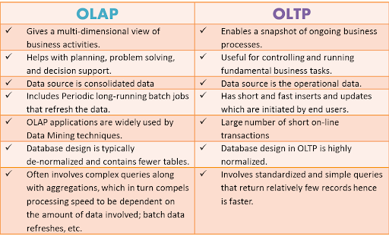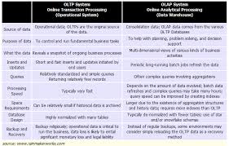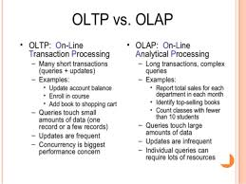

**OLTP – Online Transaction Processing**

These systems have detailed day to day transaction data which keeps changing.

**OLAP – Online Analytical Processing**

These systems have data for analysis purpose. The input for this system is from OLTP systems. The data from the OLTP systems is made use to prepare the data for analysis purpose.

**The best open source software’s for OLTP –**

1. Apache Spark, Apache Pulsar, Apache Beam, Apace Solr
2. Jupyter Lab
3. KNIME Analytics Platform
4. Cockroach DB
5. Vitess
6. TiDB
7. YugaByte DB
8. Neo4j
9. Influx DB

**The best open source software’s for OLAP –**

1. Xplenty
2. IBM Cognos
3. Micro Strategy
4. Palo OLAP Server
5. Apache Kylin
6. icCube
7. Pentaho BI
8. Mondrian
9. OBIEE
10. JsHyperCube
11. Jedox
12. SAP AG
13. DBxtra
14. HOLOS
15. Clear Analytics
16. Bizzscore
17. NECTO
18. Phymyolap
19. Jmagallanes
20. HUBSPOT

Thanks and Regards,

Kowshik.