**Day 8 – Write a code in JavaScript to perform following activities.**

* **Include following user input validations:**
  + **Username should not be blank**
  + **Password should not be blank**
* **A “Clear” Button which clears the username/password entered by the user i.e., once you click on the “Clear” button, username and password should be blank.**

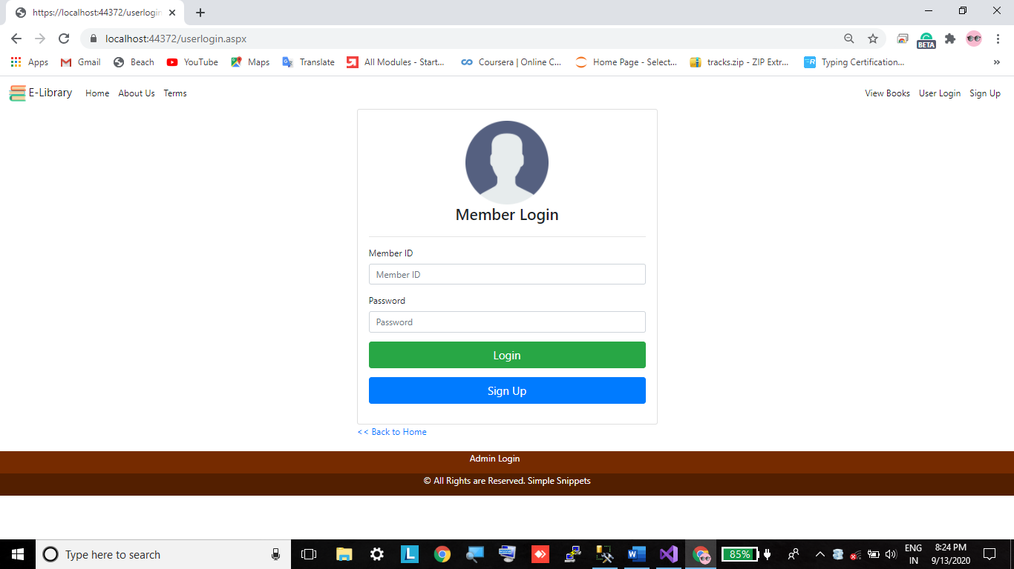

**Source Code Using Asp.net C#**

**Userlogin.aspx**

<%@ Page Title="" Language="C#" MasterPageFile="~/Site1.Master" AutoEventWireup="true" CodeBehind="userlogin.aspx.cs" Inherits="WebApplication1.WebForm2" %>

<asp:Content ID="Content1" ContentPlaceHolderID="head" runat="server">

</asp:Content>

<asp:Content ID="Content2" ContentPlaceHolderID="ContentPlaceHolder1" runat="server">

<div class="container">

<div class="row">

<div class="col-md-6 mx-auto">

<div class="card">

<div class="card-body">

<div class="row">

<div class="col">

<center><img src="imgs/generaluser.png" width="150px" /></center>

</div>

</div>

<div class="row">

<div class="col">

<center><h3> Member Login </h3></center>

</div>

</div>

<div class="row">

<div class="col">

<hr />

</div>

</div>

<div class="row">

<div class="col">

<div class="form-group">

<label> Member ID </label>

<asp:TextBox CssClass="form-control" ID="TextBox1"

runat="server" placeholder="Member ID"></asp:TextBox>

</div>

<div class="form-group">

<label> Password </label>

<asp:TextBox CssClass="form-control" ID="TextBox2"

runat="server" placeholder="Password" TextMode="Password"></asp:TextBox>

</div>

<div class="form-group">

<asp:Button ID="Button1" runat="server" Text="Login"

class="btn btn-success btn-block btn-lg" OnClick="Button1_Click"/>

</div>

<div class="form-group">

<a href="usersignup.aspx"><input id="Button2" type="button" value="Sign Up"

class="btn btn-primary btn-block btn-lg"/></a>

</div>

</div>

</div>

</div>

</div>

<a href="homepage.aspx"> << Back to Home</a>

<br />

<br />

</div>

</div>

</div>

</asp:Content>

**Userlogin.aspx.cs**

using System;

using System.Collections.Generic;

using System.Configuration;

using System.Data;

using System.Data.SqlClient;

using System.Linq;

using System.Web;

using System.Web.UI;

using System.Web.UI.WebControls;

namespace WebApplication1

{

public partial class WebForm2 : System.Web.UI.Page

{

string strcon = ConfigurationManager.ConnectionStrings["con"].ConnectionString;

protected void Page_Load(object sender, EventArgs e)

{

}

protected void Button1_Click(object sender, EventArgs e)

{

try

{

SqlConnection con = new SqlConnection(strcon);

if(con.State == ConnectionState.Closed)

{

con.Open();

}

SqlCommand cmd = new SqlCommand("SELECT * FROM member_master_tbl WHERE member_id='" + TextBox1.Text.Trim() + "' AND password='" + TextBox2.Text.Trim() + "'", con);

SqlDataReader dr = cmd.ExecuteReader();

if (dr.HasRows)

{

while (dr.Read())

{

Response.Write("<script>alert('Login Successful');</script>");

Session["username"] = dr.GetValue(8).ToString();

Session["fullname"] = dr.GetValue(0).ToString();

Session["role"] = "user";

Session["status"] = dr.GetValue(10).ToString();

}

Response.Redirect("homepage.aspx");

}

else

{

Response.Write("<script>alert('Invalid Credentials');</script>");

}

}

catch(Exception ex)

{

Response.Write("<script>alert('" + ex.Message + "');</script>");

}

}

}

}

**Source Code – Using Html and Javascript**

Loginpage.html

<!DOCTYPE html>

<html lang="en">

<head>

<meta charset="UTF-8">

<meta name="viewport" content="width=device-width, initial-scale=1.0">

<title> Forms 2 </title>

</head>

<body>

<h1> Login Page</h1>

<form action="#" id = 'myForm' name = 'myForm' onsubmit="return validation()">

<div>

<br><br>

<label for="name" style="word-spacing: 50px;"> Name </label>

<input type="text" name="name" id="name">

<span id="namemsg" style="color:magenta"></span>

</div>

<div>

<br>

<label for="email" style="word-spacing: 49px;"> Email </label>

<input type="text" name="email" id="email">

<span id="emailmsg" style="color:magenta"></span>

</div>

<div>

<br>

<label for="pass" style="word-spacing: 28px;"> Password </label>

<input type="password" name="pass" id="pass" >

<br><br>

<!-- An element to toggle between password visibility. -->

<input type="checkbox" onclick="myFunction()"> Show Password

<span id="passmsg" style="color:magenta"></span>

</div>

<div>

<br><br>

<input type="submit" name="submit" value="Submit">

</div>

</form>

<div>

<p style="color:purple" id="msg"></p>

</div>

<script src="Loginpage.js"></script>

</body>

</html>

**Loginpage.js**

**console.log('Welcome to the Day8 ');**

**function validation() {**

**const username = document.getElementById('name').value;**

**const email = document.getElementById('email').value;**

**const namemsg = document.getElementById('namemsg');**

**const emailmsg = document.getElementById('emailmsg');**

**if(username == '') {**

**namemsg.innerHTML = 'Username cannot be empty';**

**return false;**

**}**

**if(username.length < 4) {**

**namemsg.innerHTML = 'Username cannot be less-than 4 characters';**

**return false;**

**}**

**if(email == '') {**

**emailmsg.innerHTML = 'email cannot be empty';**

**return false;**

**}**

**if(!email.includes('@')) {**

**emailmsg.innerHTML = 'email should contain @';**

**return false;**

**}**

**}**

**function myFunction() {**

**let x = document.getElementById('pass');**

**if(x.type == 'password') x.type = 'text';**

**else x.type = 'password';**

**}**