**Day 9 – Develop a “Add User” HTML Page with the following fields.**

* Username
* Password
* Mobile
* Email Id
* City
* Postal Code
* State
* Country
* Address

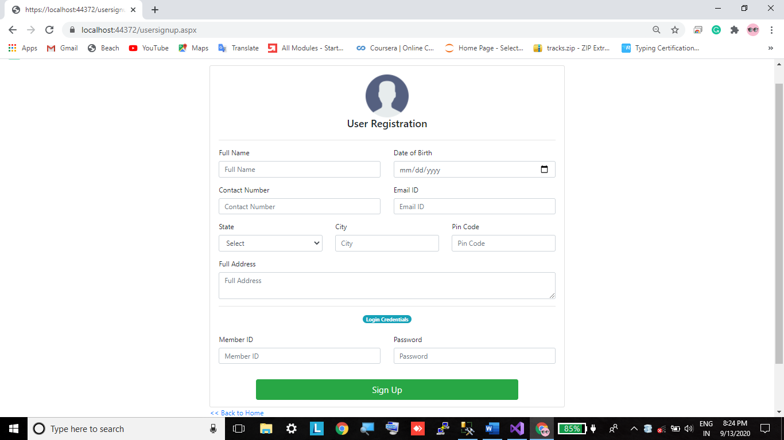

**Source Code Using Asp.net C#**

**Usersignup.aspx**

<%@ Page Title="" Language="C#" MasterPageFile="~/Site1.Master" AutoEventWireup="true" CodeBehind="usersignup.aspx.cs" Inherits="WebApplication1.usersignup" %>

<asp:Content ID="Content1" ContentPlaceHolderID="head" runat="server">

</asp:Content>

<asp:Content ID="Content2" ContentPlaceHolderID="ContentPlaceHolder1" runat="server">

<div class="container">

<div class="row">

<div class="col-md-9 mx-auto">

<div class="card">

<div class="card-body">

<div class="row">

<div class="col">

<center><img src="imgs/generaluser.png" width="100px" /></center>

</div>

</div>

<div class="row">

<div class="col">

<center><h4> User Registration </h4></center>

</div>

</div>

<div class="row">

<div class="col">

<hr />

</div>

</div>

<div class="row">

<div class="col-md-6">

<label>Full Name </label>

<div class="form-group">

<asp:TextBox CssClass="form-control" ID="TextBox1"

runat="server" placeholder="Full Name"></asp:TextBox>

</div>

</div>

<div class="col-md-6">

<div class="form-group">

<label>Date of Birth </label>

<asp:TextBox CssClass="form-control" ID="TextBox3"

runat="server" TextMode="Date"></asp:TextBox>

</div>

</div>

</div>

<div class="row">

<div class="col-md-6">

<label>Contact Number </label>

<div class="form-group">

<asp:TextBox CssClass="form-control" ID="TextBox2"

runat="server" placeholder="Contact Number" TextMode="Number"></asp:TextBox>

</div>

</div>

<div class="col-md-6">

<div class="form-group">

<label>Email ID </label>

<asp:TextBox CssClass="form-control" ID="TextBox4"

runat="server" placeholder="Email ID" TextMode="Email"></asp:TextBox>

</div>

</div>

</div>

<div class="row">

<div class="col-md-4">

<label>State </label>

<div class="form-group">

<asp:DropDownList class="form-control" ID="DropDownList1"

runat="server">

<asp:ListItem Text="Select" Value="select" />

<asp:ListItem Text="Andhra Pradesh" Value="Andhra Pradesh" />

<asp:ListItem Text="Arunachal Pradesh" Value="Arunachal Pradesh" />

<asp:ListItem Text="Assam" Value="Assam" />

<asp:ListItem Text="Bihar" Value="Bihar" />

<asp:ListItem Text="Chhattisgarh" Value="Chhattisgarh" />

<asp:ListItem Text="Dry State" Value="Dry State" />

<asp:ListItem Text="Rajasthan" Value="Rajasthan" />

<asp:ListItem Text="Goa" Value="Goa" />

<asp:ListItem Text="Gujarat" Value="Gujarat" />

<asp:ListItem Text="Haryana" Value="Haryana" />

<asp:ListItem Text="Himachal Pradesh" Value="Himachal Pradesh" />

<asp:ListItem Text="Jammu and Kashmir" Value="Jammu and Kashmir" />

<asp:ListItem Text="Jharkhand" Value="Jharkhand" />

<asp:ListItem Text="Karnataka" Value="Karnataka" />

<asp:ListItem Text="Kerala" Value="Kerala" />

<asp:ListItem Text="Madhya Pradesh" Value="Madhya Pradesh" />

<asp:ListItem Text="Maharashtra" Value="Maharashtra" />

<asp:ListItem Text="Manipur" Value="Manipur" />

<asp:ListItem Text="Meghalaya" Value="Meghalaya" />

<asp:ListItem Text="Mizoram" Value="Mizoram" />

<asp:ListItem Text="Nagaland" Value="Nagaland" />

<asp:ListItem Text="Odisha" Value="Odisha" />

<asp:ListItem Text="Punjab" Value="Punjab" />

<asp:ListItem Text="Rajasthan" Value="Rajasthan" />

<asp:ListItem Text="Sikkim" Value="Sikkim" />

<asp:ListItem Text="Tamil Nadu" Value="Tamil Nadu" />

<asp:ListItem Text="Telangana" Value="Telangana" />

<asp:ListItem Text="Tripura" Value="Tripura" />

<asp:ListItem Text="Uttar Pradesh" Value="Uttar Pradesh" />

<asp:ListItem Text="Uttarakhand" Value="Uttarakhand" />

<asp:ListItem Text="West Bengal" Value="West Bengal" />

</asp:DropDownList>

</div>

</div>

<div class="col-md-4">

<div class="form-group">

<label>City </label>

<asp:TextBox class="form-control" ID="TextBox6"

runat="server" placeholder="City"></asp:TextBox>

</div>

</div>

<div class="col-md-4">

<div class="form-group">

<label>Pin Code </label>

<asp:TextBox class="form-control" ID="TextBox7"

runat="server" placeholder="Pin Code" TextMode="Number"></asp:TextBox>

</div>

</div>

</div>

<div class="row">

<div class="col">

<label>Full Address </label>

<asp:TextBox class="form-control" ID="TextBox5"

runat="server" placeholder="Full Address" TextMode="MultiLine"></asp:TextBox>

</div>

</div>

<div class="row">

<div class="col">

<hr />

<center><span class="badge badge-pill badge-info"> Login Credentials </span></center>

<br />

</div>

</div>

<div class="row">

<div class="col-md-6">

<label>Member ID </label>

<div class="form-group">

<asp:TextBox CssClass="form-control" ID="TextBox8"

runat="server" placeholder="Member ID"></asp:TextBox>

</div>

</div>

<div class="col-md-6">

<div class="form-group">

<label>Password </label>

<asp:TextBox CssClass="form-control" ID="TextBox9"

runat="server" placeholder="Password" TextMode="Password"></asp:TextBox>

</div>

</div>

</div>

</div>

<div class="row">

<div class="col-9 mx-auto">

<div class="form-group">

<asp:Button ID="Button1" runat="server" Text="Sign Up"

class="btn btn-success btn-block btn-lg" Onclick="Button1_Click"/>

</div>

</div>

</div>

</div>

<a href="homepage.aspx"><< Back to Home</a>

</div>

</div>

<br />

<br />

</div>

</asp:Content>

**Usersignup.aspx.cs**

using System;

using System.Collections.Generic;

using System.Configuration;

using System.Data;

using System.Data.SqlClient;

using System.Linq;

using System.Web;

using System.Web.UI;

using System.Web.UI.WebControls;

namespace WebApplication1

{

public partial class usersignup : System.Web.UI.Page

{

// 1st step is to connect the connection string

string strcon = ConfigurationManager.ConnectionStrings["con"].ConnectionString;

protected void Page_Load(object sender, EventArgs e)

{

}

// Signup button click event

protected void Button1_Click(object sender, EventArgs e)

{

if(checkMemberExists())

{

Response.Write("<script>alert('Member Already Exists with the same memberID, try another different ID');</script>");

}

else

{

signUpNewUser();

}

}

// User Defined Method

bool checkMemberExists()

{

try

{

SqlConnection con = new SqlConnection(strcon);

if (con.State == ConnectionState.Closed)

{

con.Open();

}

SqlCommand cmd = new SqlCommand("SELECT * FROM member_master_tbl WHERE member_id='"+ TextBox8.Text.Trim() + "';", con);

SqlDataAdapter da = new SqlDataAdapter(cmd);

DataTable dt = new DataTable();

da.Fill(dt);

if (dt.Rows.Count >= 1)

{

return true;

}

else

{

return false;

}

}

catch (Exception ex)

{

Response.Write("<script>alert('" + ex.Message + "');</script>");

return false;

}

}

// User Defined Method

void signUpNewUser()

{

// Response.Write("<script>alert('Testing')</script>");

// Always use try catch. It will helps a lot

try

{

SqlConnection con = new SqlConnection(strcon);

if (con.State == ConnectionState.Closed)

{

con.Open();

}

SqlCommand cmd = new SqlCommand("INSERT INTO member_master_tbl(full_name,dob,contact_no,email,state,city,pincode,full_address,member_id,password,account_status) values(@full_name,@dob,@contact_no,@email,@state,@city,@pincode,@full_address,@member_id,@password,@account_status)", con);

cmd.Parameters.AddWithValue("@full_name", TextBox1.Text.Trim());

cmd.Parameters.AddWithValue("@dob", TextBox3.Text.Trim());

cmd.Parameters.AddWithValue("@contact_no", TextBox2.Text.Trim());

cmd.Parameters.AddWithValue("@email", TextBox4.Text.Trim());

cmd.Parameters.AddWithValue("@state", DropDownList1.SelectedItem.Value);

cmd.Parameters.AddWithValue("@city", TextBox6.Text.Trim());

cmd.Parameters.AddWithValue("@pincode", TextBox7.Text.Trim());

cmd.Parameters.AddWithValue("@full_address", TextBox5.Text.Trim());

cmd.Parameters.AddWithValue("@member_id", TextBox8.Text.Trim());

cmd.Parameters.AddWithValue("@password", TextBox9.Text.Trim());

cmd.Parameters.AddWithValue("@account_status", "Pending");

cmd.ExecuteNonQuery();

con.Close();

Response.Write("<script>alert('Signed Up Successfully. Go To User Login Page.');</script>");

}

catch (Exception ex)

{

Response.Write("<script>alert('" + ex.Message + "');</script>");

}

}

}

}

**Source Code Using Html and JavaScript**

**Signup Page.html**

<!DOCTYPE html>

<html lang="en">

<head>

<meta charset="UTF-8">

<meta name="viewport" content="width=device-width, initial-scale=1.0">

<title> Forms 2 </title>

</head>

<body>

<h1> SignUp Page</h1>

<form action="#" id = 'myForm' name = 'myForm' onsubmit="return validation()">

<div>

<br><br>

<label for="name" style="word-spacing: 70px;"> Name </label>

<input type="text" name="name" id="name" placeholder="Ex: John Wick">

<span id="namemsg" style="color:magenta"></span>

</div>

<div>

<br><br>

<label for="email" style="word-spacing: 69px;"> Email </label>

<input type="text" name="email" id="email" placeholder="Ex: John@gmail.com">

<span id="emailmsg" style="color:magenta"></span>

</div>

<div>

<br><br>

<label for="country" style="word-spacing: 57px;"> Country </label>

<input type="text" name="country" id="country" placeholder="Ex: Australia">

<span id="countrymsg" style="color:magenta"></span>

</div>

<div>

<br><br>

<label for="state" style="word-spacing: 79px;"> State </label>

<input type="text" name="state" id="state" placeholder="Ex: New York">

<span id="statemsg" style="color:magenta"></span>

</div>

<div>

<br><br>

<label for="city" style="word-spacing: 84px;"> City </label>

<input type="text" name="city" id="city" placeholder="Ex: Chicago">

<span id="citymsg" style="color:magenta"></span>

</div>

<div>

<br><br>

<label for="postalcode" style="word-spacing: 40px;"> PostalCode </label>

<input type="text" name="postalcode" id="postalCode" placeholder="Ex: 516001">

<span id="postalmsg" style="color:magenta"></span>

</div>

<div>

<br><br>

<label for="address" style="word-spacing: 62px;"> Address </label>

<input type="text" name="address" id="address" placeholder="Ex: 5/72 Chicago">

<span id="addmsg" style="color:magenta"></span>

</div>

<div>

<br><br>

<label for="mobile" style="word-spacing: 70px;"> Mobile </label>

<input type="text" name="mobile" id="mobile" placeholder="Ex: +1 77777 77777">

<span id="mobilemsg" style="color:magenta"></span>

</div>

<div>

<br><br>

<label for="pass" style="word-spacing: 57px;"> Password </label>

<input type="password" name="pass" id="pass" placeholder="Enter Password">

<br><br>

<!-- An element to toggle between password visibility. -->

<span id="passmsg" style="color:magenta"></span><br>

<input type="checkbox" onclick="myFunction()"> Show Password

</div>

<div>

<br><br>

<!-- <input type="submit" name="submit" value="Submit" onclick="mySubmit()"> -->

<button onclick="mySubmit()"> Submit </button>

</div>

</form>

<div>

<p style="color:purple" id="msg"></p>

</div>

<script src="Signuppage.js"></script>

</body>

</html>

**Signup Page.js**

console.log('Welcome to the Day9 ');

function validation() {

const username = document.getElementById('name').value;

const email = document.getElementById('email').value;

const pass = document.getElementById('pass').value;

// const country = document.getElementById('country').value;

// const state = document.getElementById('state').value;

// const city = document.getElementById('city').value;

// const postal = document.getElementById('postalcode').value;

// const address = document.getElementById('address').value;

// const mobile = document.getElementById('mobile').value;

const namemsg = document.getElementById('namemsg');

const emailmsg = document.getElementById('emailmsg');

const passmsg = document.getElementById('passmsg');

// const countrymsg = document.getElementById('countrymsg');

// const statemsg = document.getElementById('statemsg');

// const citymsg = document.getElementById('citymsg');

// const postalmsg = document.getElementById('postalmsg');

// const addmsg = document.getElementById('addmsg');

// const mobilemsg = document.getElementById('mobilmsg');

if(username == '') {

namemsg.innerHTML = 'Username cannot be empty';

return false;

}

if(username.length < 4) {

namemsg.innerHTML = 'Username cannot be less-than 4 characters';

return false;

}

if(email == '') {

emailmsg.innerHTML = 'email cannot be empty';

return false;

}

if(!email.includes('@')) {

emailmsg.innerHTML = 'email should contain @';

return false;

}

if(pass == '') {

passmsg.innerHTML = 'Password cannot be empty';

return false;

}

return true;

// if(country == '') {

// countrymsg.innerHTML = 'Country name Should not be empty';

// return false;

// }

// if(state == '') {

// statemsg.innerHTML = 'State name should not be empty';

// return false;

// }

// if(city == '') {

// citymsg.innerHTML = 'City name cannot be empty';

// return false;

// }

// if(postal == '') {

// postalmsg.innerHTML = 'postal Code cannot be empty';

// return false;

// }

// if(address == '') {

// addmsg.innerHTML = 'Address cannot be empty';

// return false;

// }

// if(mobile == '') {

// mobilemsg.innerHTML = 'Mobile number cannot be empty';

// return false;

// }

// if(!mobile.includes('+')) {

// mobilemsg.innerHTML = 'Mobile number should contain +';

// return false;

// }

}

function myFunction() {

let x = document.getElementById('pass');

if(x.type == 'password') x.type = 'text';

else x.type = 'password';

}

function mySubmit(){

if(validation()){

alert("Registration is Completed successfully.");

}

else{

alert("Registration is not Completed successfully.");

}

}