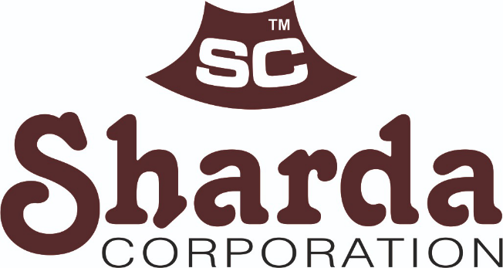

QUALITY POLICY

SHARDA CORPORATION IS COMMITTED TO ASSURANCE REGARDING QUALITY, PRICE AND DELIVERY TO ITS CUSTOMERS BY ENSURING SUPPLY OF QUALITY STAINLESS STEEL AND BAGASSE PRODUCTS BY INVOLVEMENT OF EMPLOYEES AND SUPPORT OF SUPPLIERS.

WE ARE COMMITTED TO CONTINUAL IMPROVEMENT OF QUALITY MANAGEMENT SYSTEM, COMPANY PERFORMANCE AND CUSTOMER SATISFACTION.

WE ARE COMMITTED TO SATISFY ALL APPLICABLE REQUIREMENTS INCLUDING LEGAL REQUIREMENTS.

WE ARE COMMITTED TO ADDRESSING RELEVANT VALUES, SOCIAL AND CULTURAL ISSUES, INCLUDING COMPLIANCE WITH APPLICABLE LABOUR LAWS.

QUALITY OBJECTIVES

IN PURSUANCE OF ABOVE QUALITY POLICY, THE COMPANY WILL ENDEAVOUR TO ADHERE TO FOLLOWING OBJECTIVES FOR QUALITY:

- TO ADD NEW CUSTOMERS ANNUALLY (AT LEAST ONE).
- TO DEVELOP NEW SUPPLIER ANNUALLY (AT LEAST ONE).
- TO ACHIEVE QUALITY BY ENSURING CUSTOMER COMPLAINTS ARE MAINTAINED AT NIL.
- TO DEVELOP NEW PRODUCTS ANNUALLY (AT LEAST TWO).
- TO INCREASE ANNUAL SALES TURNOVER (BY 10%).
- TO ACHIEVE ON TIME DELIVERY OF AT LEAST 90%.
- TO ACHIEVE CUSTOMER SATISFACTION OF AT LEAST 80%.
- TO ACHIEVE LESS THAN 5% STOCK DEVIATION DURING STOCK ASSESSMENT.
- TO CONDUCT PLANNED TRAINING ATLEAST 90%.
- TO KEEP THE REJECTION OF PURCHASE BELOW 10% ANNUALLY.

CEO/PARTNER

SC/MRM/06 REV/01 REV DATE: 01.04.2025

