AI- AISSESTED CODING
ASSIGNMENT – 9.1
2303A51759
BATCH-28

Problem 1:
Consider the following Python function: def find_max(numbers): return max(numbers) Task:
• Write documentation for the function in all three formats:
- Docstring
- Inline comments
- Google-style documentation
- Critically compare the three approaches. Discuss the advantages, disadvantages, and suitable use cases of each style.
- Recommend which documentation style is most effective for a mathematical utilities library and justify your answer.

Function: find_max(numbers):
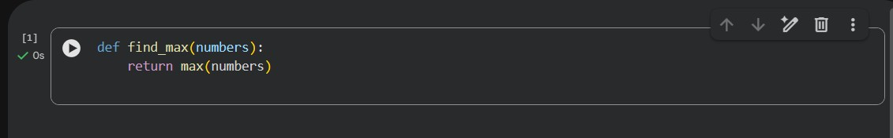

- Docstring Format
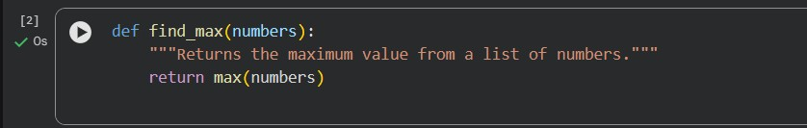
- Inline Comments
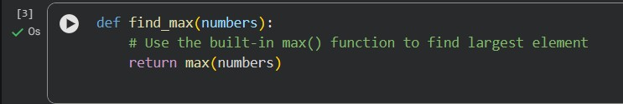
- Google-Style Documentation
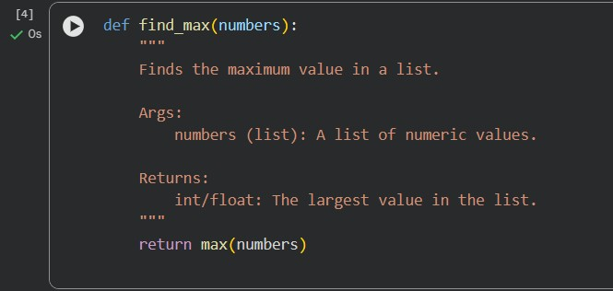
Critical Comparison:
- Docstring Advantages
  - Simple and built into Python
  - Can be accessed using help()
  - Good for quick understanding Disadvantages
  - Often too brief
  - No parameter explanation
Use Case
  - Small scripts and simple functions.

- Inline Comments:
Advantages
  - Explain logic line by line
  - Easy for beginners
Disadvantages
  - Can clutter code
  - Not structured
  - Cannot be extracted by tools like pydoc
Use Case
  - Explaining complex logic inside functions.

- Google-Style:
Advantages
  - Structured and professional
  - Describes parameters and return values
  - Supported by documentation generators
Disadvantages
  - More writing effort
Use Case
  - Large projects and libraries.
Recommendation:
For a mathematical utilities library,
➡ Google-style documentation is most effective because:
- Functions need clear parameter types
- Many developers will reuse them
- Tools like Sphinx/pydoc can generate manuals
- Improves maintainability

Problem 2: Consider the following Python function: def login(user, password, credentials): return credentials.get(user) == password Task:
- Write documentation in all three formats.
- Critically compare the approaches.
- Recommend which style would be most helpful for new developers onboarding a project, and justify your choice.

Problem 2 – Function: login()

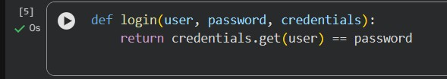

- Docstring:
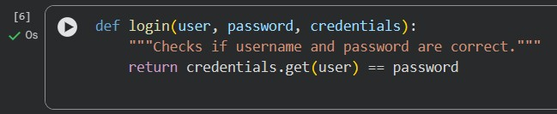
- Inline Comments:
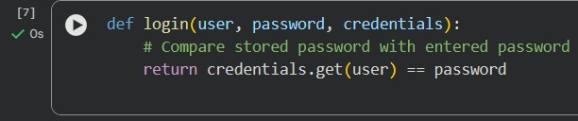
- Google-Style:
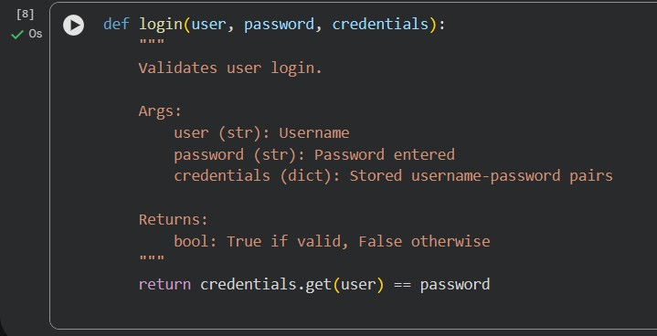
Comparison:
Style Readability Structured Tool Support
Docstring Medium Low Medium
Inline Low None None
Google High High Excellent

Recommendation for New Developers
➡ Google-style is best for onboarding Because:
- Explains parameters clearly
- Shows expected data types
- Reduces confusion
- Acts as mini-tutorial
Problem 3: Calculator (Automatic Documentation Generation) Task: Design a Python module named calculator.py and demonstrate automatic documentation generation.
Instructions:
1. Create a Python module calculator.py that includes the following functions, each written with appropriate docstrings: o add(a, b) – returns the sum of two numbers o subtract(a, b) – returns the difference of two numbers o multiply(a, b) – returns the product of two numbers o divide(a, b) – returns the quotient of two numbers 2. Display the module documentation in the terminal using Python’s documentation tools.
3. Generate and export the module documentation in HTML format using the pydoc utility, and open the generated HTML file in a web browser to verify the output.

Problem 3 – Automatic Documentation:
Step 1: Create calculator.py
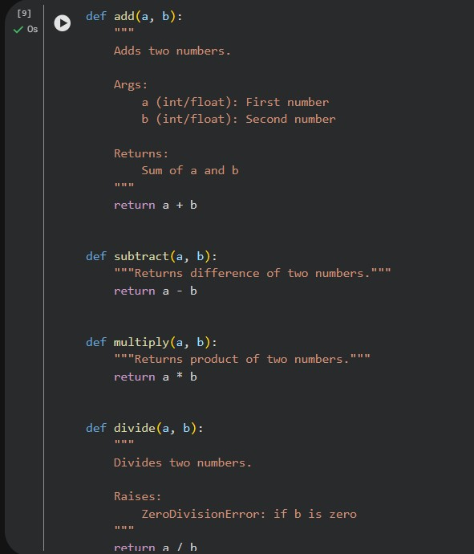
Step 2: Display Documentation in Terminal:
python -m pydoc calculator This shows:
- Module description
- All functions
- Docstrings

• Step 3: Generate HTML Documentation
python -m pydoc -w calculator OUTPUT:
wrote calculator.html

Problem 4: Conversion Utilities Module
Task:
1. Write a module named conversion.py with functions: o decimal_to_binary(n) o binary_to_decimal(b)
o decimal_to_hexadecimal(n)
2. Use Copilot for auto-generating docstrings.

1. Create conversion.py

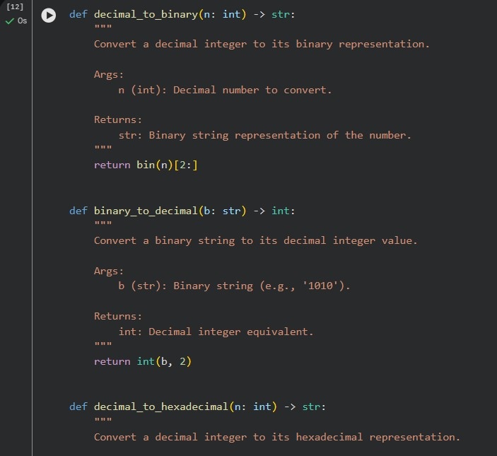

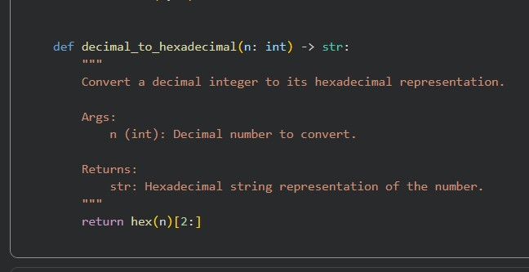

Problem 5 – Course Management Module
Task:
- Create a module course.py with functions: o add_course(course_id, name, credits) o remove_course(course_id) o get_course(course_id)
- Add docstrings with Copilot

