AI ASSISTED CODING
ASSIGNMENT-3.1
2303A51759
J.KOWSHIK
BATCH-28
Question 1: Zero-Shot Prompting (Palindrome Number Program)
Write a zero-shot prompt (without providing any examples) to generate
a Python function that checks whether a given number is a palindrome.

PROMPT:
Write a Python function that checks whether a given integer is a palindrome.
The function should return True if the number is a palindrome and False otherwise.
Do not convert the number to a string.
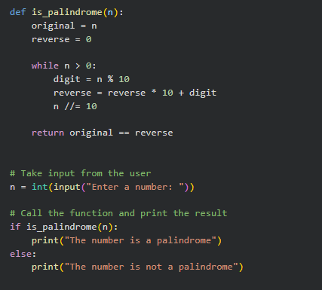

OUTPUT:
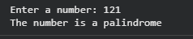

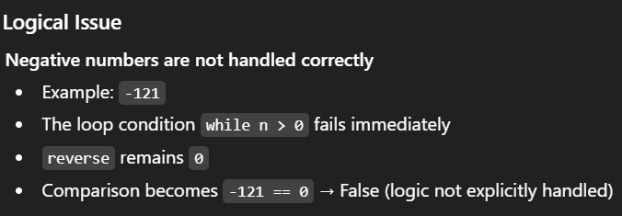
Inputs:
Input | Expected Output | Actual Output
121 | True | True
123 | False | False
0 | True | True
7 | True | True
1221 | True | True
1001 | True | True
-121 | False | Incorrect
10 | False | False

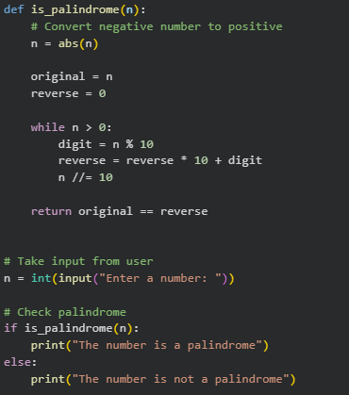
Improved Version (Fixing the Issue)

OUTPUT:
EXPLANATION:
This program checks whether a given number is a palindrome by first converting any negative input into a positive number using the absolute value. It then reverses the number using arithmetic operations without converting it into a string. The reversed number is compared with the original value to determine whether they are the same. If both values match, the number is identified as a palindrome. This approach allows the program to handle both positive and negative inputs effectively.

Question 2: One-Shot Prompting (Factorial Calculation)
Write a one-shot prompt by providing one input-output example and
ask the AI to generate a Python function to compute the factorial of a
given number.
ONE SHOT:
PROMPT:
Example:
Input: 5
Output: 120
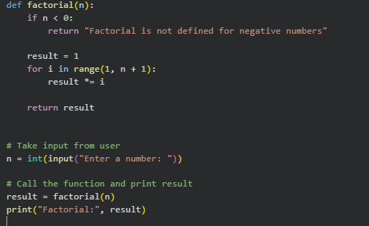
Now write a Python function that takes an integer as input and returns the factorial of that number.Handle invalid inputs such as negative numbers appropriately.
OUTPUT:
ZERO-SHOT:
PROMPT:
Write a Python function to compute the factorial of a given number.
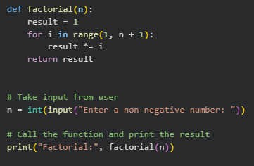
OUTPUT:
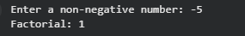
Comparison:
Aspect | Zero-Shot Solution | One-Shot Solution
Example provided | No | Yes (5 → 120)
Handling negative input | Not handled | Handled
Code clarity | Basic | More explicit
Correctness | Partial | More robust
Output reliability | Lower | Higher
Improvements in clarity and correctness.
One-shot prompting helps the AI generate clearer and more complete logic by providing an explicit input–output example. This guidance improves output format, correctness, and inclusion of edge-case handling such as negative inputs. Overall, one-shot prompting results in more structured and reliable code compared to zero-shot prompting.
Question 3: Few-Shot Prompting (Armstrong Number Check)
Write a few-shot prompt by providing multiple input-output examples
to guide the AI in generating a Python function to check whether a
given number is an Armstrong number.
Prompt:
Example 1:
Input: 153
Output: Armstrong Number
Example 3:
Input: 123
Output: Not an Armstrong Number
Now write a Python function that takes an integer as input and checks whether it is an Armstrong number. The function should print "Armstrong Number" if it is, otherwise "Not an Armstrong Number".
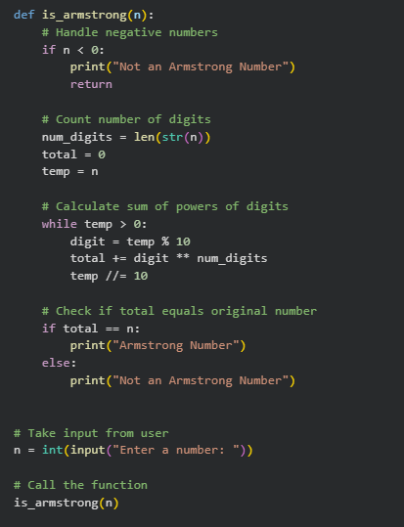

OUTPUT:
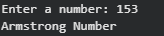

Input | Output
153 | Armstrong Number
370 | Armstrong Number
123 | Not an Armstrong Number
9474 | Armstrong Number
9475 | Not an Armstrong Number
-153 | Not an Armstrong Number
0 | Armstrong Number

Analysis:
examples clarify the output format (“Armstrong Number” vs “Not an Armstrong Number”)
The AI includes edge-case handling (negative numbers, zero)
Code is more structured, readable, and accurate compared to zero-shot or one-shot prompting
Accuracy improves because AI can generalize from several examples rather than just one

EXPLANATION:
Few-shot prompting improves clarity, correctness, and robustness of the generated code. By providing multiple examples, the AI better understands the task requirements, handles edge cases, and produces code that matches the expected output format reliably.

Question 4: Context-Managed Prompting (Optimized Number
Classification)
Design a context-managed prompt with clear instructions and
constraints to generate an optimized Python program that classifies a
number as prime, composite, or neither.
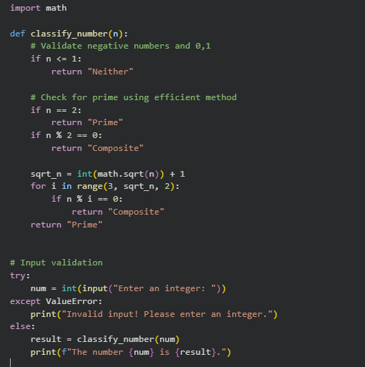

OUTPUT:

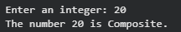

Strategy | Accuracy | Clarity | Optimization | Edge-Case Handling
Zero-Shot | Moderate | Basic | Not optimized | Limited
One-Shot | Better | Clearer | Some optimization | Limited
Few-Shot | High | Structured | Moderate | Handles examples provided
Context-Managed | Highest | Very Clear | Optimized (sqrt(n)) | Handles all edge cases & input validation

EXPLANATION:
Context-managed prompting provides precise instructions and constraints, leading to highly optimized, robust, and readable code. It outperforms zero-shot, one-shot, and few-shot strategies by explicitly guiding the AI on efficiency, input validation, and output formatting.

Question 5: Zero-Shot Prompting (Perfect Number Check)
Write a zero-shot prompt (without providing any examples) to
generate a Python function that checks whether a given number is a
perfect number.

PROMPT:
Write a Python function that checks whether a given number is a perfect number.
The function should return True if the number is perfect, otherwise False.
Do not provide any examples.

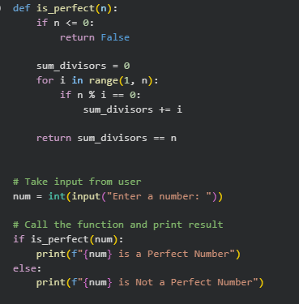
OUTPUT:
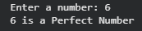
Input | Expected Output | Actual Output
6 | True | True
28 | True | True
12 | False | False
1 | False | False
0 | False | False
-6 | False | False
Missing Conditions / Inefficiencies
Inefficient: Checks all numbers from 1 to n-1 → Can be optimized by checking up to n//2 (since no proper divisor is greater than n/2)
Could include input validation to ensure integer input
Could be optimized further using square root method for large numbers
Question 6: Few-Shot Prompting (Even or Odd Classification with
Validation)
Write a few-shot prompt by providing multiple input-output
examples to guide the AI in generating a Python program that
determines whether a given number is even or odd, including proper
input validation.
Examples:
• Input: 8 → Output: Even
• Input: 15 → Output: Odd
• Input: 0 → Output: Even

PROMPT:
Example 1:
Input: 8
Output: Even

Example 2:
Input: 15
Output: Odd

Example 3:
Input: 0
Output: Even
Now write a Python program that:
1. Takes user input.
2. Validates that the input is an integer.
3. Prints "Even" if the number is even and "Odd" if it is odd.
4. Handles negative numbers correctly.
5. Handles invalid (non-integer) inputs gracefully.
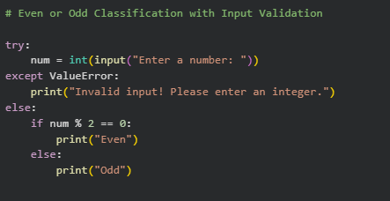
OUTPUT:


ANALYSIS:
Providing multiple input-output examples helps the AI understand the expected behavior and output format more clearly. For instance, showing examples with positive numbers, zero, and odd numbers guides the model to classify numbers correctly in all these cases. It also signals that the program should handle edge cases, such as negative numbers or zero. Furthermore, including examples implicitly emphasizes the importance of consistent output formatting (“Even” vs “Odd”) and encourages input validation to manage non-integer inputs. Overall, examples make the generated code more robust, user-friendly, and aligned with expected results compared to zero-shot prompting.

EXPLANATION:
Few-shot prompting provides multiple input-output examples, which helps the AI understand the task requirements clearly. It guides the program to handle edge cases like zero and negative numbers correctly. Examples also ensure consistent output formatting, such as printing “Even” or “Odd” as expected. Including these examples encourages input validation, so non-integer inputs are handled gracefully. Overall, few-shot prompting produces code that is robust, accurate, and user-friendly compared to zero-shot prompting.

