**Title of the project**

**Padma Bridge Toll Collection System**

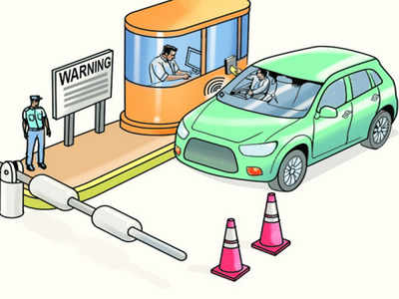

**Problem Statement**

The Padma Bridge Toll Management System Project aims to create a modern toll collection and management system for the Padma Bridge, a large infrastructure project connecting the southwestern region of Bangladesh with the rest of the country. The project aims to address several key challenges related to toll collection, traffic management, and revenue collection, including:

**Traffic congestion:** The Padma Bridge is expected to handle a large volume of traffic, and without proper management, traffic congestion could become a major issue. The project aims to implement a traffic management system that will help to reduce congestion and ensure smooth flow of traffic.

**Revenue leakage:** With manual toll collection, there is a risk of revenue leakage, as toll collectors may not report all the tolls collected. The project aims to implement a system that will ensure all tolls are collected and reported accurately, thereby increasing revenue collection.

**ABSTRACT**

This project will be helpful for all troll collectors working on Padma Bridge. In most of the bridges in Bangladesh, the traditional method of troll collection is still kept on paper and pen. As a result, it is easy to keep track of how many times each vehicle is crossing in a day, or how much money a vehicle is paying to troll. It would not have been possible. Through this system created by us, they can easily keep track of how many cars and how much money is trolled from a particular class of cars. Through this system, a troll collector will be able to keep track of every vehicle at the end of the day. As a result, their time and effort will be reduced a lot. They can easily collect all the tabors from these systems. In this system all the currently scheduled vehicles of Padma Bridge are attached as trolls. If there is any change in these trolls then the system must be updated.

**Features**

* Login
* View Toll List
* Pay Toll.
* Toll Collector Officer Entry Toll.
* TCO view Daily Toll Report.
* Logout.

**Methodology**

* Java Class.
* Java Object.
* Java Methods.
* Java Encapsulation.
* Java Inheritance
* Java Polymorphism.
* Java Abstraction

**Summary**

The Padma Bridge Toll Collection System Project in Java is aimed at creating a modern toll collection and management system for the Padma Bridge in Bangladesh. The project addresses the challenges related to toll collection, traffic management, and revenue collection by implementing a modern toll collection system that is efficient, reliable, and transparent. The project also includes a traffic management system that helps reduce congestion and ensure the smooth flow of traffic, and a revenue collection system that ensures all tolls are collected and reported accurately, thereby increasing revenue collection for the government.

**Reference**

“Padma Bridge Toll Collection System" - Dhakatribune.

<https://www.dhakatribune.com/bangladesh/2022/06/25/padma-bridge-toll-rates>

End