Project Design Submission:

19CSE495 PROJECT PHASE-1
Group Number: C7
Team Members:
Roll No. | Student Name
Ch. Dinesh | AM.EN.U4CSE22215
P. Kowshik | AM.EN.U4CSE22245
Thota Rahul | AM.EN.U4CSE22257
P. Teja | AM.EN.U4CSE22271
Project Guide: Dr. Simi Surendran
Project Title:
Enhancing Rural Healthcare: An AI System for Lung Nodule Screening in Health ATMs

Novelty:
This project introduces a comprehensive, software-only lung CT analysis system tailored for rural healthcare settings where resources are limited. Unlike conventional hospital-based tools, our solution is purposely designed to run in offline mode within Health ATMs, making it practical for underserved regions. Its main innovations include:
- Grounded, Bilingual Reporting – A template-driven language model that produces both structured clinician reports and simplified patient summaries in English and Hindi, ensuring accuracy by relying strictly on validated findings rather than generating unsupported text.
- Transparent Trust – The system incorporates explainability methods (segmentation masks, Grad-CAM++) along with uncertainty estimation, so that any low-confidence results are automatically flagged for mandatory review by a radiologist.
- Native Interoperability – All outputs are exported in standard FHIR formats (DiagnosticReport and ImagingStudy), enabling direct and seamless integration with India’s Ayushman Bharat Digital Mission (ABDM) ecosystem.

Objectives:
Phase I (S7) Objectives
- Develop the Core AI Pipeline – Design and train a lightweight, edge-ready UNet-based model for detecting, segmenting, and classifying lung nodules. The target performance is set at a Dice score of at least 0.80 and an AUC of 0.90 or higher on benchmark datasets such as LIDC and LUNA16.
- Integrate Reliable Explainability – Add Grad-CAM++ visualizations to highlight areas influencing malignancy predictions and measure their accuracy, ensuring the model’s decisions remain transparent.
- Build the Grounded Reporting Engine – Develop a reporting system that converts the findings JSON into structured RSNA-style clinician reports and easy-to-understand summaries for patients in both English and Hindi, ensuring that outputs stay consistent with the model’s results.
- Develop Prototype UI and Backend – Implement a FastAPI backend with an asynchronous job queue and a simple frontend (Streamlit/React) to support the complete workflow, including DICOM upload, processing, and report display.
Phase II (S8) Objectives
- Optimize for Edge Deployment – Apply INT8 quantization and performance profiling to ensure analysis is completed within 60 seconds per study on RTX 4060 hardware. Strengthen offline-first functionality and add recovery mechanisms for network outages.
- Clinical Validation and Usability Testing – Carry out a focused study with around 50 cases reviewed by radiologists to assess the value of explainability features, alongside patient testing to check comprehension of bilingual summaries.
- Ensure ABDM/FHIR Compliance – Finalize and test the exporter that generates FHIR-compliant DiagnosticReport and ImagingStudy bundles, validating them in the ABDM sandbox environment.
- Prepare for Deployment and Publication – Deliver a final release-ready version of the software with clear documentation, a reproducible training pipeline, and a manuscript describing the system’s design, performance, and validation results.

Novelty – Objective Mapping
- Grounded, Bilingual Reporting
  - Phase I (S7.3): Develop the reporting engine that generates both clinician and patient-friendly reports.
  - Phase II (S8.2): Test and refine patient summaries to ensure clarity and comprehension.
- Transparent Trust
  - Phase I (S7.2): Incorporate Grad-CAM++ explainability into the pipeline.
  - Phase II (S8.2): Evaluate the usefulness of explainability features through radiologist feedback.
- Native Interoperability
  - Phase II (S8.3): Implement and validate ABDM/FHIR compatibility in the sandbox environment.
- Rural-Ready, Offline-First
  - Phase I (S7.1 & S7.4): Build the AI pipeline and prototype interface optimized for rural contexts.
  - Phase II (S8.1): Enhance efficiency with edge hardware optimization and ensure robust offline functionality.

Scope of the Project (S7)
Inclusions
- Complete processing of chest CT scans in DICOM format
- An AI pipeline capable of detecting, segmenting, and classifying lung nodules with malignancy risk scores
- Creation of explainability outputs, including segmentation masks and Grad-CAM++ visual overlays
- Structured findings stored in a JSON file as the single, authoritative source of results
- Automatic generation of clinician-oriented reports (in English) and simplified patient summaries (in English and Hindi)
- A functional prototype with a user interface that demonstrates the full end-to-end workflow
Exclusions
- Real-time processing during CT acquisition
- On-device training or federated learning (considered for future scalability, not part of Phase I)
- Detection or reporting of non-nodule pathologies such as emphysema or fibrosis
- Support for imaging modalities other than CT, such as chest X-rays
Deliverables
- A working prototype showcasing the complete analysis pipeline on benchmark datasets
- A version-controlled source code repository with clean documentation
- Project reports, including this design document and the final consolidated report
Boundaries & Limitations
- Models trained only on public datasets like LIDC and LUNA16, which may not fully reflect rural Indian patient demographics or scanner variations
- Performance goals benchmarked specifically on NVIDIA RTX 4060 hardware
- Quality of multilingual reporting validated using a limited review set of about 100–200 cases
Expected Outcomes
- A prototype meeting technical targets for Phase I: Dice score ≥ 0.80 and AUC ≥ 0.90
- Clinician and patient reports generated directly from model findings, ensuring factual accuracy
- An operator-friendly interface that enables scan upload, processing, and visualization of outputs including overlays, reports, and metrics

Project Design
The system follows a modular, service-oriented architecture that emphasizes scalability, ease of maintenance, and clear separation of responsibilities across components.
The overall design is structured into three complementary views:
- High-Level Data Pipeline – Outlines how data flows from the initial input stage through processing to the final outputs.
- Sequence of Operations – Explains the step-by-step interactions between users, backend services, and the AI models during the analysis workflow.
- Technical Component Architecture – Defines the modular containers and core components, showing how each part of the system is organized and integrated.

High-Level Block Diagram (End-to-End Pipeline)

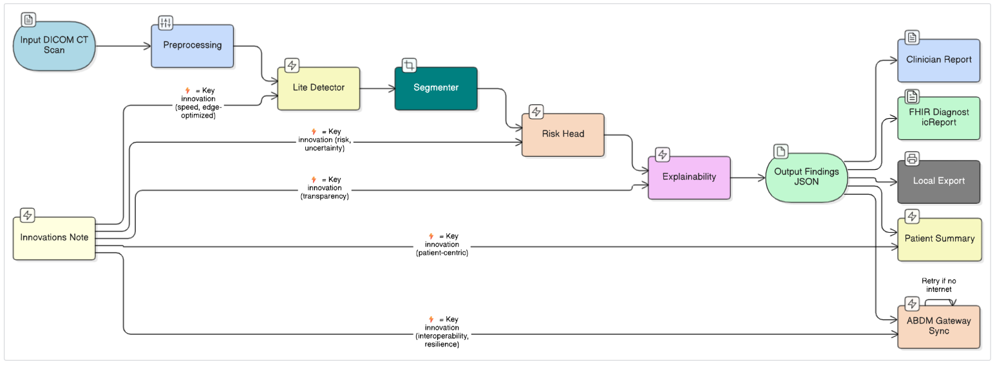Flow Diagram (Sequence of Operations)

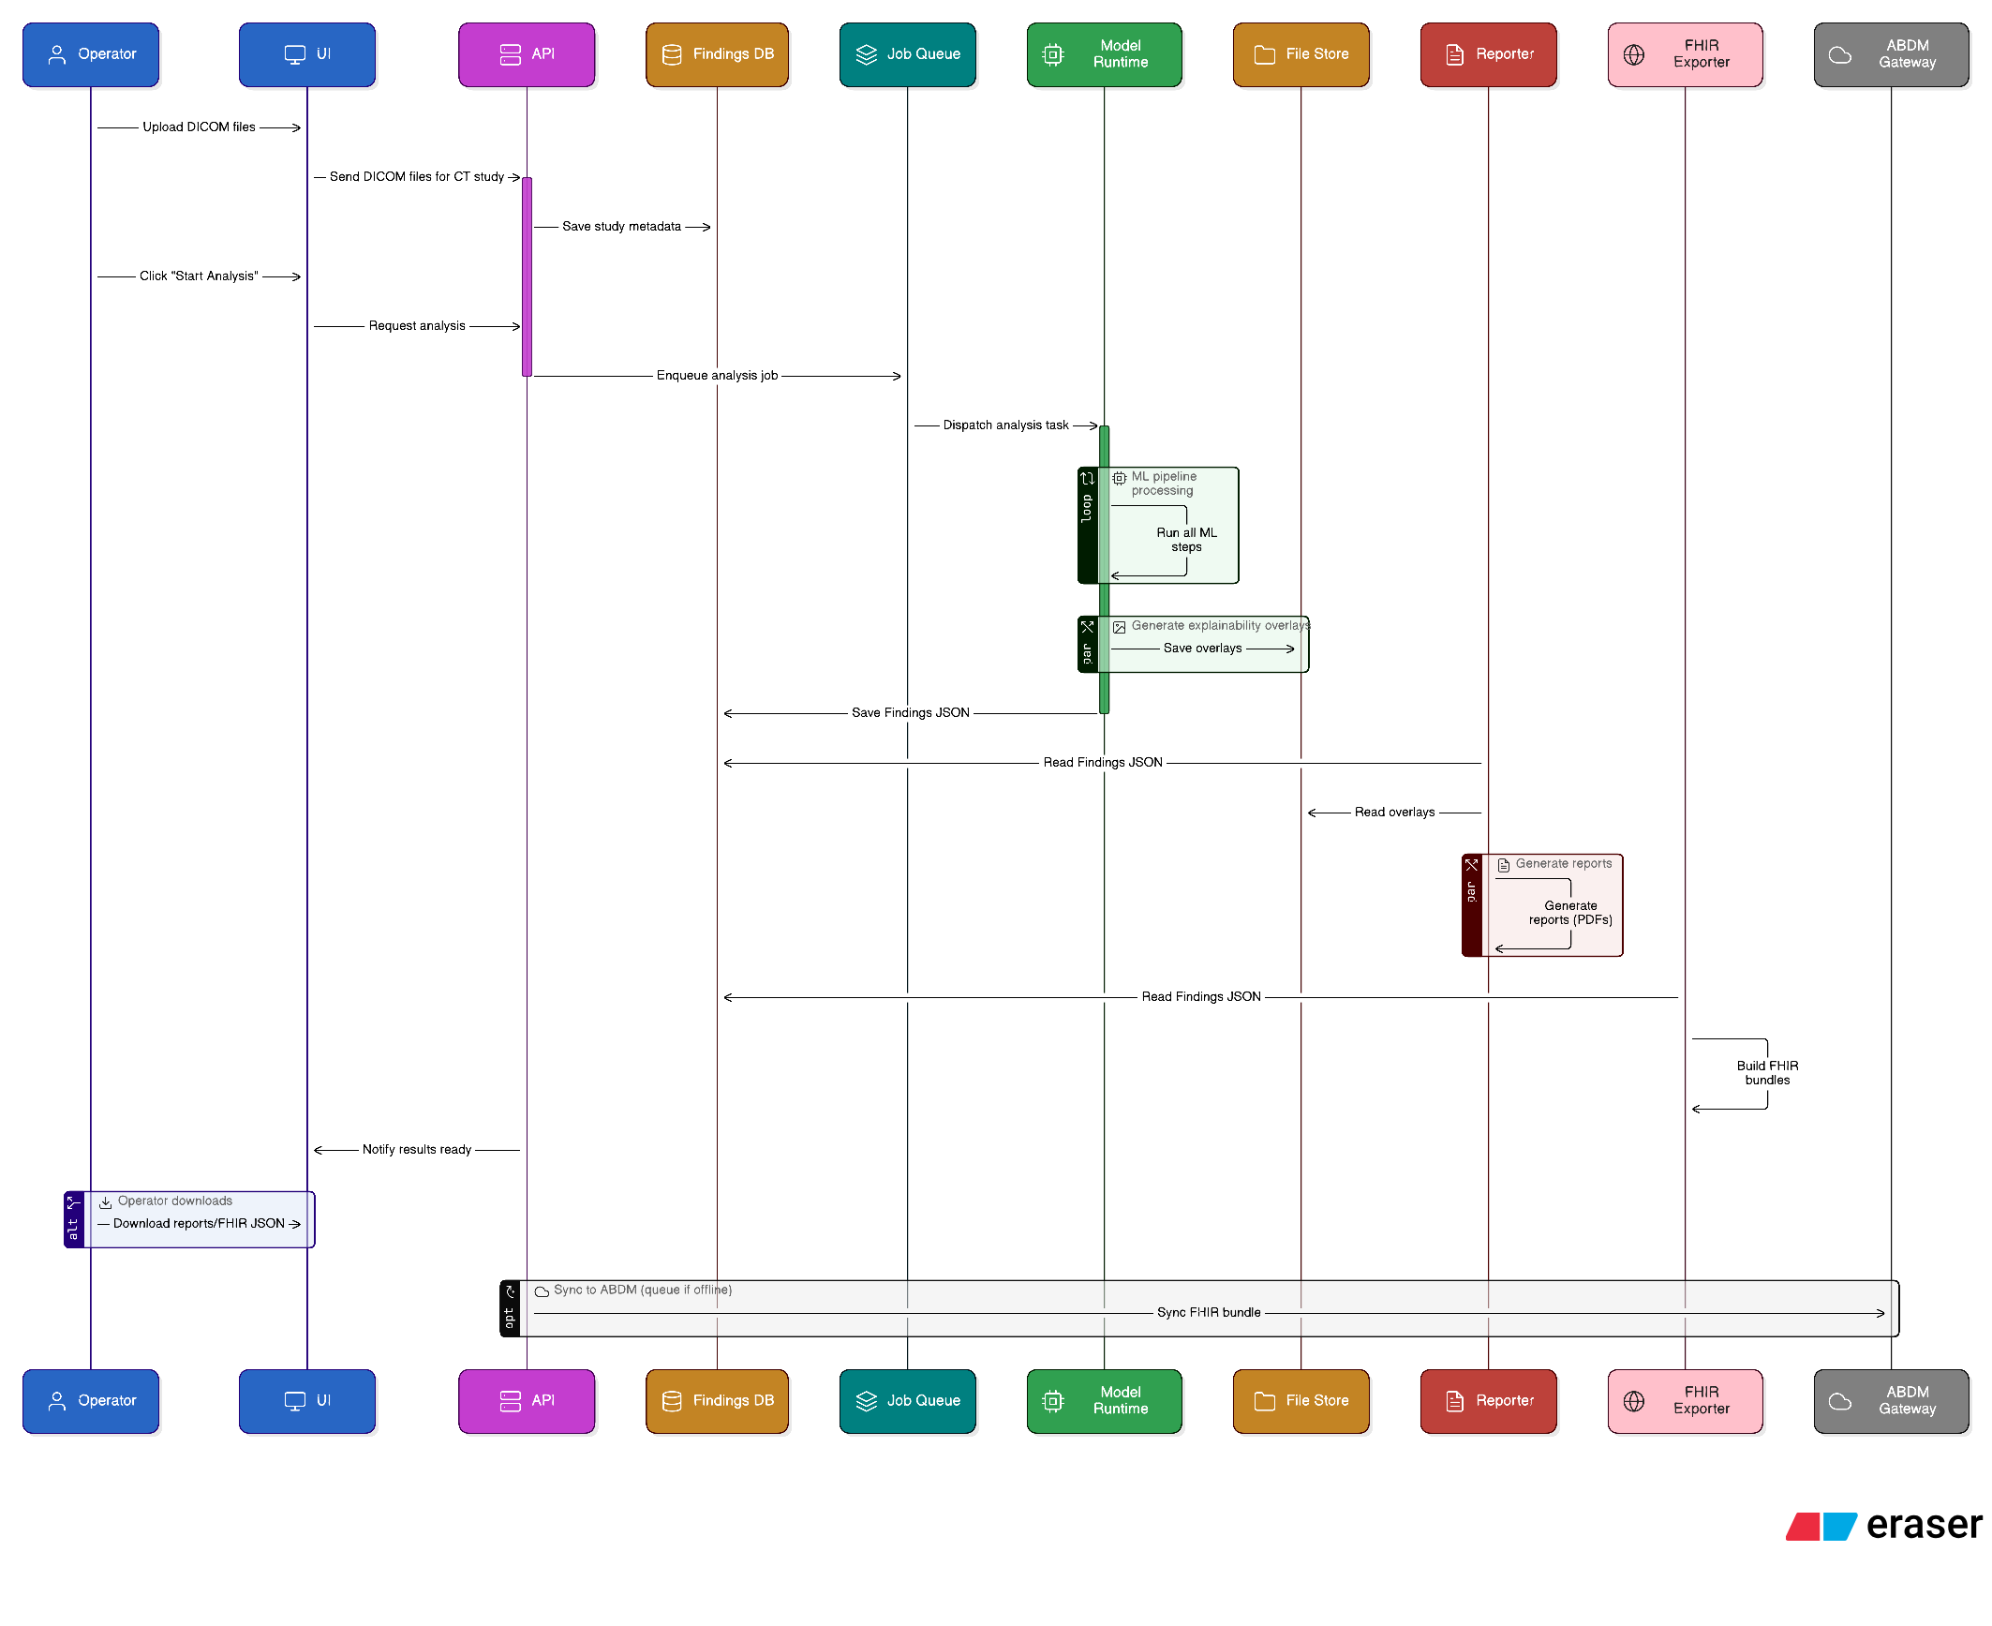

Architecture Diagram (Containers & Components)

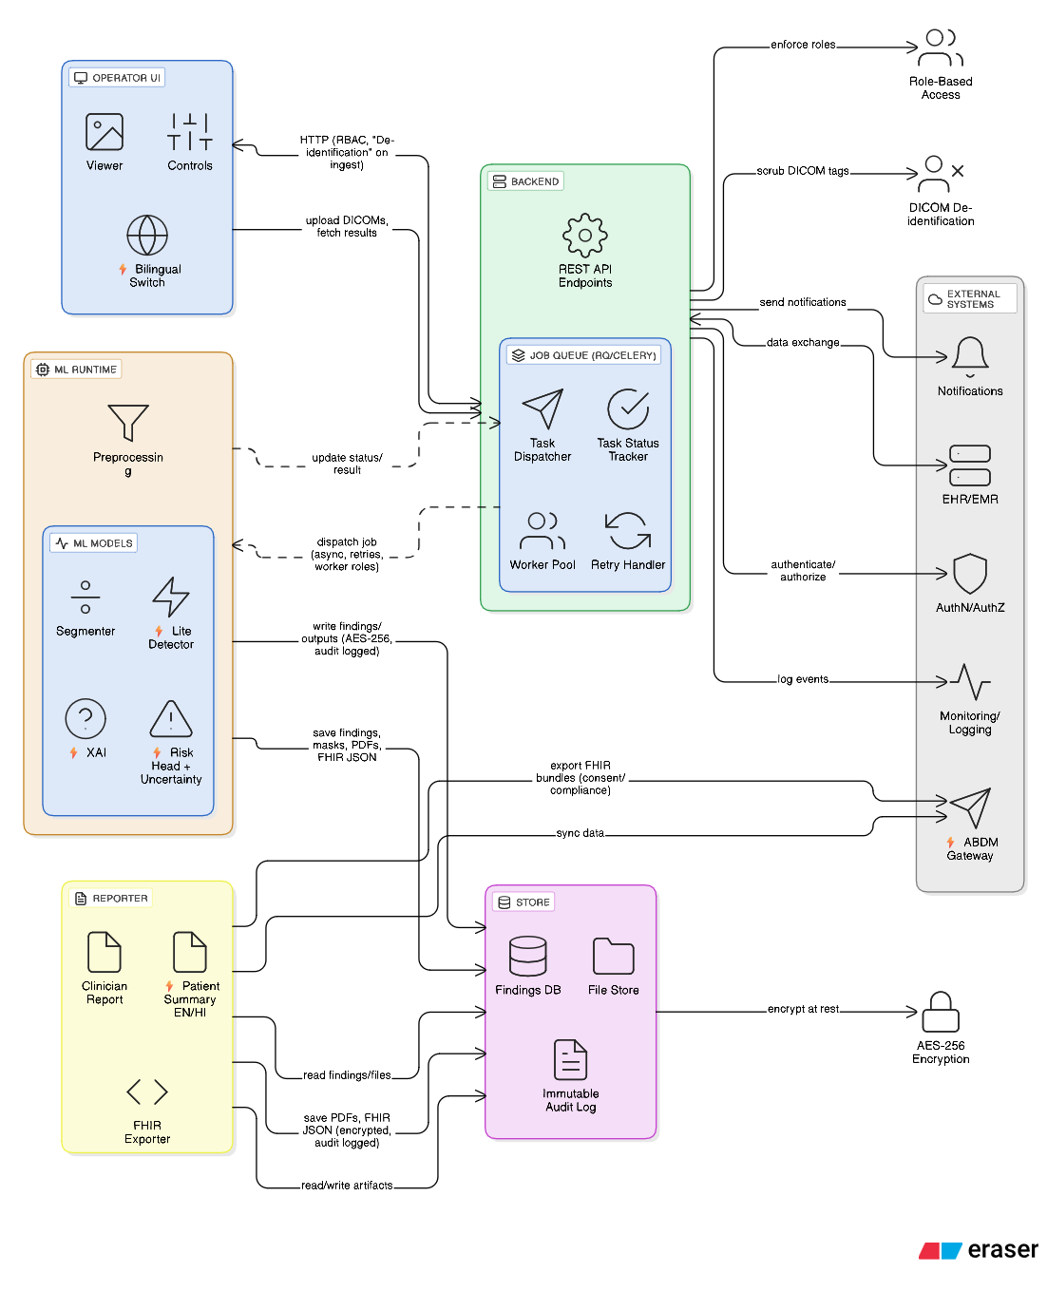

Design - Objective Mapping
• ML Runtime (Detector, Segmenter, Risk Head) → Linked to S7.1, fulfilling the development of the core AI pipeline.
• ML Runtime (XAI – Grad-CAM++) → Supports S7.2, implementing explainability features within the system.
• Store (Findings JSON) & Reporter → Corresponds to S7.3, establishing the reporting engine for structured outputs.
• UI, Backend, Job Queue, and ML Runtime → Addresses S7.4, delivering a complete end-to-end prototype with asynchronous workflow management.

