# Traffic Light Controller System

**Objective:** Traffic Lights or Traffic Signals are signaling devices that are used to control the flow of traffic. These control systems consists of electro mechanical controllers with clockwork mechanisms or modern solid state computerized systems with easy setup and maintenance. The aim of the project is to implement a simple traffic light controller using Arduino UNO, where the traffic is controlled in a pre-defined timing system.

**Procedure:** Working of the Traffic Light Controller Project: In this project, a simple traffic light system for a 4 way intersection is implemented using Arduino UNO. Consider the following gif image showing a loop of traffic light operations. The project is also implemented in the same manner.

In that, first the Lane 1 gets its Green light turned. Hence, in all the other Lanes, their corresponding Red lights are turned on. After a time delay of predefined time say 5 seconds, the Green light in the Lane 3 must be turned on and the Green light in the Lane 1 must be turned off.

As a warning indicator, the Yellow light in Lane 1 is tuned on indicating that the red light is about to light up. Similarly, the yellow light in the Lane 3 is also turned as an indication that the green light about to be turned on. The yellow lights in Lanes 1 and 3 are turned for a small duration say 2 seconds after with the red light in the Lane 1 is turned on and green light in Lane 3 is also turned on. The green light in Lane 3 is also turned on for a predefined time and the process moves forward to Lane 4 and finally Lane 2.

The system then loops back to Lane 1 where the process mentioned above will be repeated all over again.

**Circuit Figure:** All the connections are made as per the circuit diagram. The complete wiring diagram of the circuit is shown below.

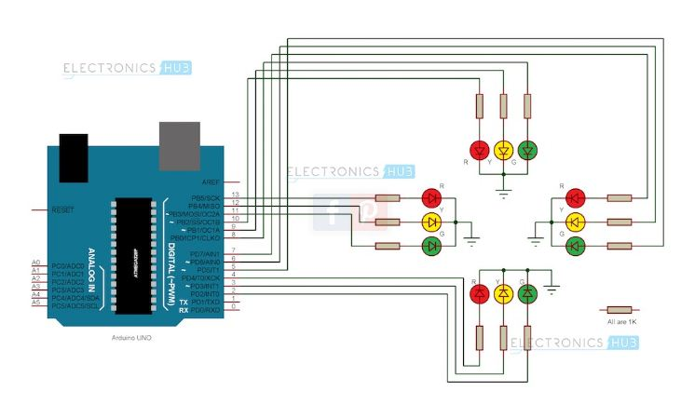

**Hardware Requirements:**

i) Arduino UNO.

ii) 1KΩ Resistor X 12

iii) Red LEDs X 4.

iv) Yellow LEDs X 4.

v) Green LEDs X4.

vi) Connecting wires.

vii) Prototyping board.

viii) Power adapter.

#### ****Software Requirements:****

i) Arduino Soft.