

**DISSECTING THE DIGITAL LANDSCAPE: A COMPREHENSIVE ANALYSIS OF SOCIAL MEDIA**

**NAAN MUDHALVAN**

### PROJECT REPORT

***Submitted By***

|  |  |
| --- | --- |
| **KESAVAN S** | **611220104071** |
| **KOWSHIKRAJ K** | **611220104077** |
| **MOHANA N** | **611220104086** |
| **NITHYAPRIYA V** | **611220104098** |

***in partial fulfilment for the award of the degree of***

BACHELOR OF ENGINEERING

***in***

**COMPUTER SCIENCE AND ENGINEERING**

KNOWLEDGE INSTITUTE OF TECHNOLOGY,

### SALEM-637504

 **DISSECTING THE DIGITAL LANDSCAPE: A COMPREHENSIVE ANALYSIS OF SOCIAL MEDIA**

**NAAN MUDHALVAN**

### PROJECT REPORT

***Submitted By***

|  |  |
| --- | --- |
| **KESAVAN S** | **611220104071** |
| **KOWSHIKRAJ K** | **611220104077** |
| **MOHANA N** | **611220104086** |
| **NITHYAPRIYA V** | **611220104098** |

***in partial fulfilment for the award of the degree of***

BACHELOR OF ENGINEERING

***in***

**COMPUTER SCIENCE AND ENGINEERING**

KNOWLEDGE INSTITUTE OF TECHNOLOGY,

### SALEM-637504

BONAFIDE CERTIFICATE

Certified that this project report titled **“DISSECTING THE DIGITAL LANDSCAPE: A COMPREHENSIVE ANALYSIS OF SOCIAL MEDIA”** is the bonafide work of **“KESAVAN S (611220104071), KOWSHIKRAJ K (611220104077), MOHANA N (611220104086), NITHYAPRIYA V (611220104098)”** who carried out the project work under my supervision.

|  |  |
| --- | --- |
| **SIGNATURE** | **SIGNATURE** |
| Dr. V. KUMAR M.E., Ph.D., | Mr.J.MURUGESAN ,B.E.,M.E. |
| **HEAD OF THE DEPARTMENT** | **FACULTY MENTOR** |
| **PROFESSOR** | **ASSISTANT PROFESSOR** |
| Department of Computer Science | Department of Information Technology, |
| and Engineering, |  |
| Knowledge Institute of Technology, | Knowledge Institute of Technology, |
| Kakapalayam, | Kakapalayam, |
| Salem- 637 504. | Salem- 637 504. |

|  |  |
| --- | --- |
| ----------------------------------------------- | ----------------------------------------------- |
| **SPOC** | **HEAD OF THE DEPARTMENT** |

### ACKNOWLEDGEMENT

At the outset, we express our heartfelt gratitude to **GOD,** who has been our strength to bring this project to light.

At this pleasing moment of having successfully completed our project, we wish to convey our sincere thanks and gratitude to our beloved president **Mr.C.Balakrishnan,** who has provided all the facilities to us.

We would like to convey our sincere thanks to our beloved Principal **Dr.PSS.Srinivasan,** for forwarding us to do our project and offering adequate duration in completing our project.

We express our sincere thanks to our Head of the Department **Dr.V.Kumar,** Department of Computer Science and Engineering for fostering the excellent academic climate in the Department.

We express our pronounced sense of thanks with deepest respect and gratitude to our Faculty Mentor **Mr.J.Murugesan** ,Department of Information Technology for their valuable and precious guidance and for having amicable relation.

With deep sense of gratitude, we extend our earnest and sincere thanks to our SPOC **Mr. T. Karthikeyan,** Assistant Professor, Department of Computer Science and Engineering for his guidance and encouragement during this project.

We would also like express our thanks to all the faculty members of our Department, friends and students who helped us directly and indirectly in all aspects of the project work to get completed successfully.

**TABLE OF CONTENTS**

|  |  |  |  |  |
| --- | --- | --- | --- | --- |
| **CHAPTER**  **NO.** | **TITLE** | | | **PAGE**  **NO.** |
|  | **ABSTRACT** | | | **I** |
|  | **LIST OF FIGURES** | | | **II** |
|  | **LIST OF ABBREVIATIONS** | | | **III** |
| **1** | **INTRODUCTION** | | | **1** |
|  | 1.1 | PROJECT OVERVIEW | | **1** |
|  | 1.2 | PURPOSE | | **1** |
| **2** | **LITERATURE SURVEY** | | | **2** |
| **3** | **IDEATION & PROPOSED SOLUTION** | | | **4** |
|  | 3.1 | PROBLEM STATEMENT DEFINITION | | 4 |
|  | 3.2 | EMPATHY MAP CANVAS | | 5 |
|  | 3.3 | IDEATION & BRAINSTORMING | | 6 |
|  | 3.4 | PROPOSED SOLUTION | | 9 |
| **4** | **REQUIREMENT ANALYSIS** | | | **11** |
|  | 4.1 | FUNCTIONAL REQUIREMENTS | | 11 |
|  | 4.2 | | NON -FUNCTIONAL REQUIREMENTS | 12 |
| **5** | **PROJECT DESIGN** | | | **13** |
|  | 5.1 | | DATA FLOW DIAGRAMS | 13 |
|  | 5.2 | | SOLUTION & TECHNICAL ARCHITECTURE | 13 |
|  | 5.3 | | USER STORIES | 14 |
| **6** | **CODING & SOLUTIONING** | | | **16** |
|  | 6.1 | | FEATURE 1 | 16 |
|  | 6.2 | | FEATURE 2 | 17 |
| **7** | **RESULTS** | | | **19** |
|  | **7.1** | | PERFORMANCE METRICS | 19 |
| **8** | **ADVANTAGES & DISADVANTAGES** | | | **29** |
| **9** | **CONCLUSION** | | | **31** |
| **10** | **FUTURE SCOPE** | | | **32** |
| **11** | **APPENDIX** | | | **A1** |
|  | 11.1 | | SOURCE CODE & SCREENSHOTS | A1 |
|  | 11.2 | | GITHUB & PROJECT VIDEO DEMO LINK | **A6** |
| **12** | **REFERENCES** | | | **R1** |

**ABSTRACT**

**ABSTRACT**

"Dissecting the Digital Landscape: A Comprehensive Analysis of Social Media" provides a detailed and in-depth analysis of various social media platforms, including Facebook, Twitter, Instagram, YouTube, and LinkedIn. The analysis covers a wide range of topics related to social media, such as the history and evolution of social media, the demographics of social media users, the impact of social media on communication and society, the role of social media in politics and activism, and the challenges and opportunities of social media for businesses and organizations. The paper draws on a wide range of research studies, surveys, and data sources to provide a comprehensive overview of the digital landscape and its implications for individuals, organizations, and society as a whole. Overall, the paper aims to provide a comprehensive and up-to-date understanding of the complex and dynamic world of social media(twitter as an example), and to inform future research, policy, and practice in this rapidly evolving field.

**LIST OF FIGURES**

|  |  |  |
| --- | --- | --- |
| **FIGURE NO** | **NAME OF FIGURE** | **PAGE NO.** |
| 3.2 | EMPATHY MAP | 5 |
| 3.3.1 | IDEATION & BRAINSTROMING | 6 |
| 3.3.2 | IDEATION & BRAINSTROMING | 7 |
| 3.3.3 | IDEATION & BRAINSTROMING | 8 |
| 5.1 | DATA FLOW DIAGRAMS | 12 |
| 5.2 | SOLUTION & TECHNICAL ARCHITECTURE | 12 |

**LIST OF ABBREVIATIONS**

|  |  |
| --- | --- |
| **ABBREVIATION** | **EXPANSION** |
| **DFD** | DATA FLOW DIAGRAM |
| **FR** | FUNCTIONAL REQUIREMENT |
| **NFR** | NON-FUNCTIONAL REQUIREMENT |
| **PS** | PROBLEM STATEMENT |
|  |  |

**INTRODUCTION**

**CHAPTER – 1**

**INTRODUCTION**

* 1. **PROJECT OVERVIEW**

Drawing from a vast array of research studies, surveys, and data sources, this research paper aspires to provide a comprehensive panoramic view of the ever-evolving digital landscape and its far-reaching implications for individuals, organizations, and society at large. Its ultimate objective is to offer a thorough and contemporary comprehension of the intricate and dynamic universe of social media, using Twitter as a prominent exemplar, and to offer invaluable insights to steer future research, inform policy decisions, and guide best practices in this rapidly evolving field. Its primary goal is to provide an up-to-date understanding of the intricate and dynamic world of social media, using Twitter as a prominent example, while offering insights to guide future research, inform policies, and drive best practices in this rapidly evolving field.

**1.2 PURPOSE**

The purpose of "Dissecting the Digital Landscape: A Comprehensive Analysis of Social Media" is to conduct a thorough analysis of the constantly evolving world of social media, with a specific focus on popular platforms such as Facebook, Twitter, Instagram, YouTube, and LinkedIn. The goal is to gain valuable insights into various aspects of social media, backed by extensive research data. The knowledge gained through this analysis is intended to inform future research efforts, influence policy decisions, and promote best practices in this rapidly changing field.

**LITERATURE SURVEY**

**CHAPTER – 2**

**LITERATURE SURVEY**

1. **INTRODUCTION TO SOCIAL MEDIA ANALYTICS(2010 KAPLAN, A. M., & HAENLEIN, M.).**

It provides a comprehensive overview of the burgeoning field of social media and highlights both the challenges and opportunities it presents. In a world where social media platforms were gaining significant traction, the authors recognized the need to understand the implications and potential benefits of this evolving digital landscape. The authors begin by introducing the concept of social media as platforms that enable user-generated content, interaction, and collaboration, emphasizing its transformational impact on communication and information dissemination. They underline the shift from traditional one-way communication to a more interactive, participatory, and user-driven model, heralding a new era in digital engagement. In this paper, outlines the challenges associated with social media, such as the management of vast amounts of user-generated content, the need to filter relevant information from the noise, and privacy concerns.

1. **APPLICATIONS OF SOCIAL MEDIA ANALYTICS WITH IBM COGNOS (2010 LAPPAS, T., LIU, K., & TERZI, E).**

Lappas et al.'s research explores the application of social media analytics in identifying teams of experts within social networks. The primary aim is to leverage the structure of social connections and user-generated content to discover groups of individuals with specialized knowledge or expertise in specific domains. The study introduces a novel algorithmic approach to this problem. Social networks like Twitter and LinkedIn are rich sources of information about individuals' interests, affiliations, and contributions. The authors propose a method that combines both network topology and content analysis to find communities of experts. By considering the links between users and the content they produce or share, the algorithm identifies clusters of individuals who demonstrate a high degree of expertise in particular areas.

1. **SOCIAL MEDIA DATA COLLECTION AND PROCESSING (2011 GRUZD, A., WELLMAN, B., & TAKHTEYEV, Y.)**

This research by Gruzd, Wellman, and Takhteyev delves into the concept of Twitter as an "imagined community." The study explores how users on the social media platform, Twitter, form connections and construct a sense of belonging and identity. The authors examine the interactions and information sharing within this virtual community. They argue that Twitter functions as an imagined community in a way similar to Benedict Anderson's concept, where people who may never meet in person feel a sense of belonging due to shared interests, communication, and information exchange. The paper emphasizes the role of Twitter in connecting individuals with similar interests and how this connection is built around topics or hashtags. It discusses the idea of a "follow network" where users follow others based on shared interests. From a data collection and processing perspective, this study sheds light on the dynamics of social media interaction.

1. **CHALLENGES AND FUTURE DIRECTIONS (2007 DAVENPORT, T. H., & HARRIS, J.)**

In "Competing on Analytics," Davenport and Harris present a pioneering perspective on how organizations can harness the power of data analytics to gain a competitive edge. They argue that data analytics is evolving into a strategic asset, and organizations should not just rely on intuition or historical data but actively compete on their analytical capabilities. The authors emphasize that while many organizations have access to vast amounts of data, the challenge lies in effectively using that data to make informed decisions. They propose that companies should build a culture that values data-driven decision-making and invest in the necessary technology and talent to support this culture. Through case studies and real-world examples, the book highlights how organizations across various industries have successfully leveraged data analytics to improve their operations, customer service, and overall performance.

1. **Ethical Considerations in Social Media Analytics (2012 boyd, danah, & Crawford, K.)**

The authors highlight the significant societal impact of big data, particularly in the realm of social media. They contend that while big data offers immense potential for understanding and influencing human behavior, it also raises crucial ethical questions. One central theme of the article is the issue of privacy. Boyd and Crawford discuss the extent to which data collected from social media and other digital platforms can infringe on individuals' privacy. They argue that individuals often unwittingly share vast amounts of personal data online, and this data can be used to create detailed profiles, raising concerns about surveillance and data mining. The authors also point out that big data analytics can lead to the creation of categories and stereotypes that may result in discrimination.

**IDEATION & PROPOSED SOLUTION**

**CHAPTER** - **3**

**IDEATION & PROPOSED SOLUTION**

**3.1 PROBLEM STATEMENT DEFINITION**

|  |  |  |  |  |  |
| --- | --- | --- | --- | --- | --- |
| **Problem**  **Statement**  **(PS)** | **I am**  **(Customer)** | **I’m**  **trying**  **to** | **But** | **Because** | **Which**  **Makes me**  **feel** |
| PS-1 | User-1 | I strive to engage with my community. | online harassment creates an unsafe environment. | leaving me feeling vulnerable and discouraged from meaningful interactions. | Vulnerable |
| PS-2 | User-2 | I pursue meaningful bonds. | The pervasive culture of comparison and social validation creates an atmosphere of insecurity. | leading to a sense of isolation and diminished self-worth. | it makes me feel emotionally drained and socially isolated. |

**3.2 EMPATHY MAP CANVAS**

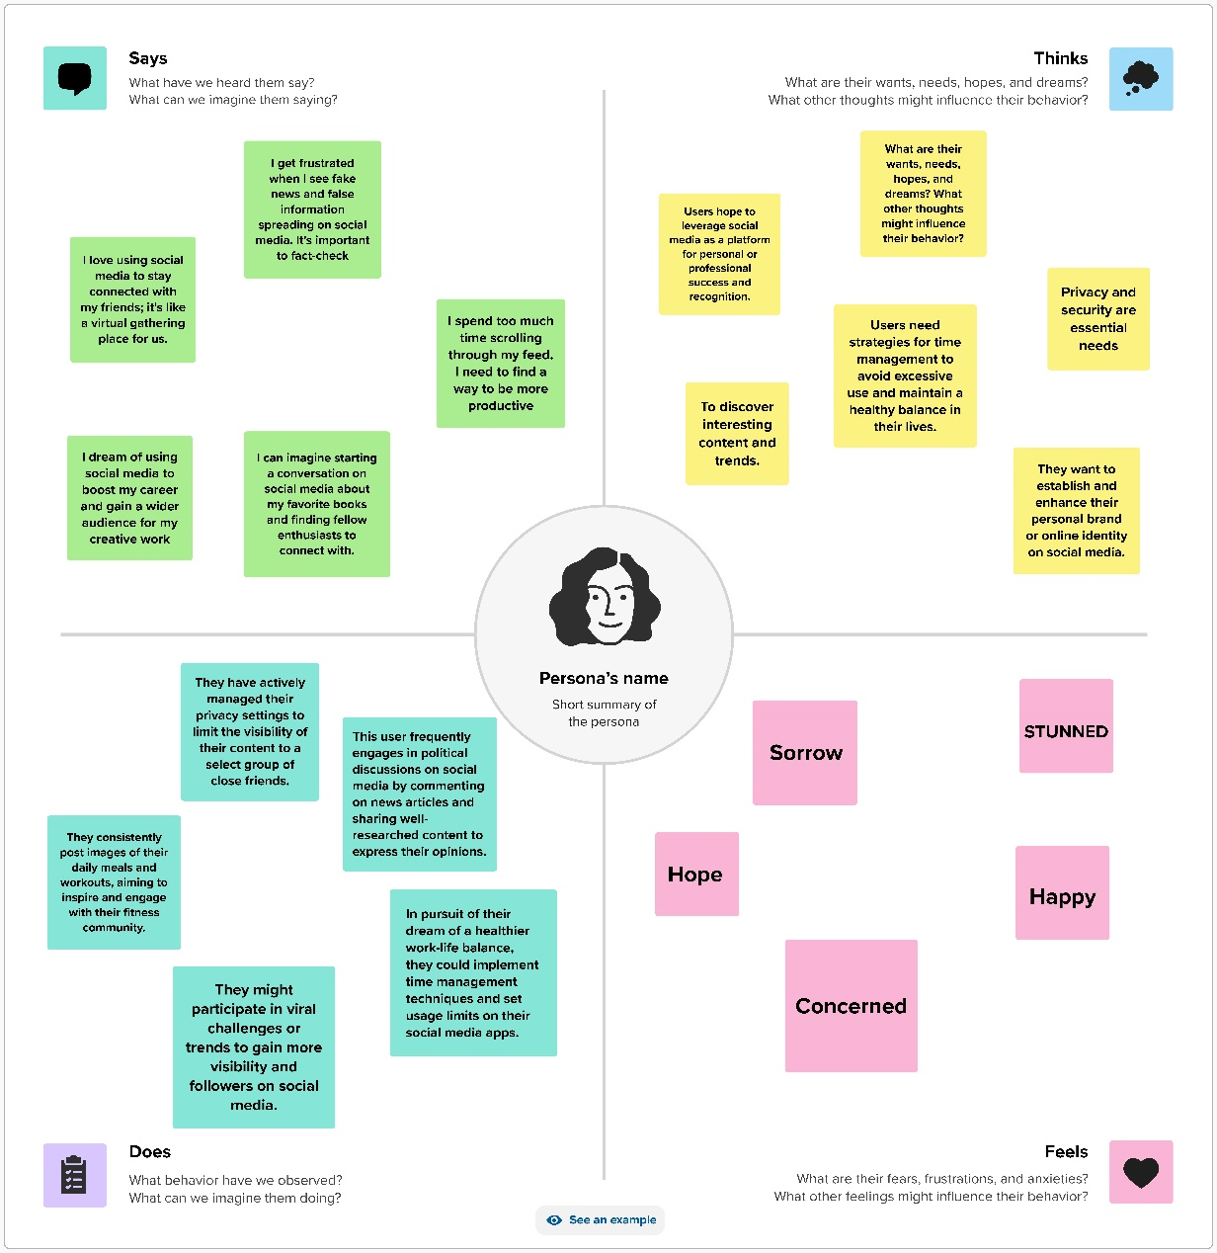

**Fig.No. 3.2 EMPATHY MAP**

**3.3 IDEATION & BRAINSTORMING**

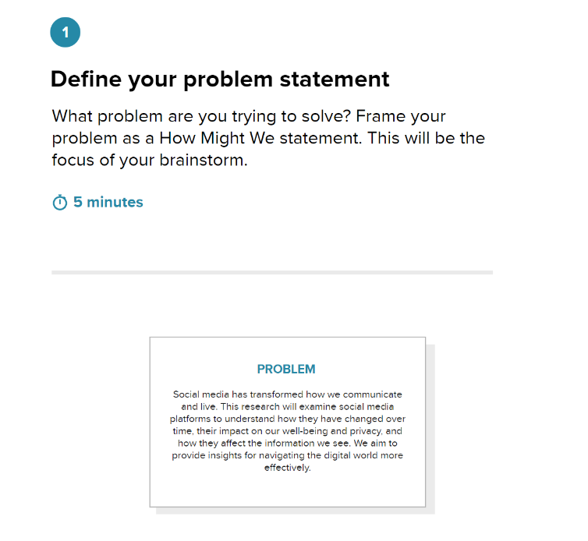

**Fig. No. 3.3.1 BRAINSTROMING & IDEA PRIORITIZATION**

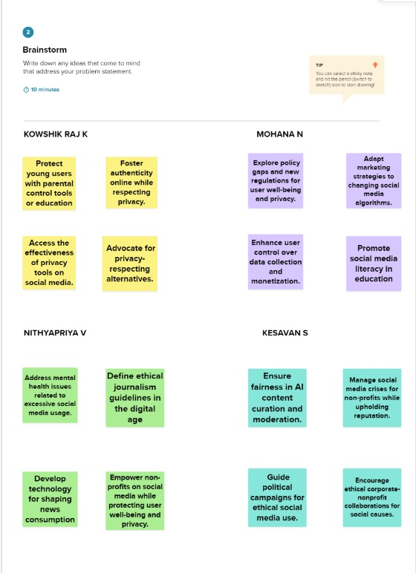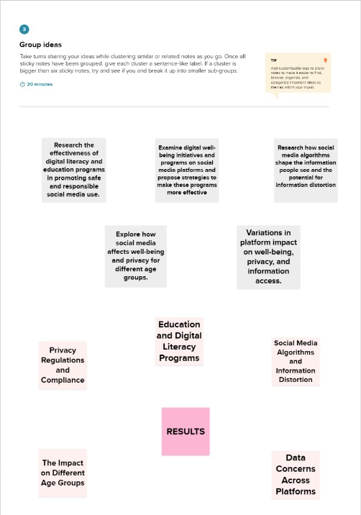  **Fig. No. 3.3.2 BRAINSTROMING & IDEA PRIORITIZATION**

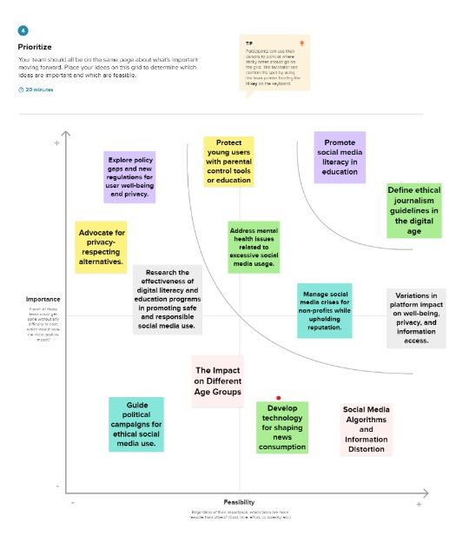

**Fig. No. 3.3.3 BRAINSTROMING & IDEA PRIORITIZATION**

**3.4 PROPOSED SOLUTION**

|  |  |  |
| --- | --- | --- |
| **S.No.** | **Parameter** | **Description** |
| 1. | Problem Statement (Problem to be solved) | Our approach includes ongoing monitoring, predicting trends, and providing detailed reports, giving those involved the information they need to understand and navigate the dynamic social media environment. |
| 2. | Idea / Solution description | Our research initiative, "Dissecting The Digital Landscape: A Comprehensive Analysis Of Social Media," aims to provide a thorough understanding of the ever-changing social media environment. We gather data, assess psychological impacts, analyze algorithms, monitor trends, address ethical concerns, and explore opportunities and risks. |
| 3. | Novelty / Uniqueness | A Comprehensive Analysis Of Social Media" apart is its holistic approach to understanding the complex social media ecosystem. Unlike singular studies, our research combines data analysis, psychology, ethics, and trend monitoring to offer a 360-degree view of this dynamic digital landscape. |
| 4. | Social Impact / Customer Satisfaction | It is designed to have a significant social impact while enhancing customer satisfaction. By offering in-depth insights, it empowers individuals, businesses, and policymakers to make informed decisions in the digital realm, increasing their satisfaction with online engagement strategies. |
| 5. | Business Model (Revenue Model) | Our revenue model for "Dissecting The Digital Landscape: A Comprehensive Analysis Of Social Media". It comprises research subscription services, consulting, sponsored research, data licensing, educational programs, event hosting, advertising, and premium content. |
| 6. | Scalability of the Solution | It is highly scalable due to its adaptable structure. We can readily accommodate increasing data volumes, expand research topics, and engage with a wider audience. As demand grows, we can enhance our research capabilities, offer more specialized services, and extend our reach to a global audience. |

**REQUIREMENT ANALYSIS**

**CHAPTER** - **4**

**REQUIREMENT ANALYSIS**

**4.1 FUNTIONAL REQUIREMENTS**

|  |  |  |
| --- | --- | --- |
| **FR No.** | **Functional Requirement (Epic)** | **Sub Requirement (Story / Sub-Task)** |
| FR-1 | **User Registration** | Registration through Form  Registration through Gmail  Registration through LinkedIN |
| FR-2 | **User Confirmation** | Confirmation via Email Confirmation via OTP |
| FR-3 | **Login** | Users must use valid credentials to log in to the system. |
| FR-4 | **Dataset** | Upload dataset into the analytics tool. |
| FR-5 | **Analysis** | The project entails collecting comprehensive data, analyzing and uncovering insights, and discovering patterns within the information for valuable insights. |
| FR-6 | **Create Dashboard** | Create Charts, Graphs, Tables, etc. |
| FR-7 | **Reporting** | The reporting feature empowers users with comprehensive control over their business operations. It gathers up-to-the-minute data and presents it through a user-friendly and intuitive interface. |

**4.2 NON - FUNTIONAL REQUIREMENTS**

|  |  |  |
| --- | --- | --- |
| **NFR No.** | **Non-Functional Requirement** | **Description** |
| NFR-1 | **Usability** | Resource optimization makes it accessible to all. |
| NFR-2 | **Security** | Access to Dashboards/Templates is granted to anyone with the correct login credentials. |
| NFR-3 | **Reliability** | Templates are dependable since we upload and access them via the cloud. |
| NFR-4 | **Performance** | It exhibits top-tier performance and exceptional efficiency. |
| NFR-5 | **Availability** | It is accessible to anyone interested in sales data at no charge. |
| NFR-6 | **Scalability** | The dashboards and templates are highly scalable, allowing users to customize metrics at their discretion. |

**PROJECT DESIGN**

**CHAPTER** - **5**

**PROJECT DESIGN**

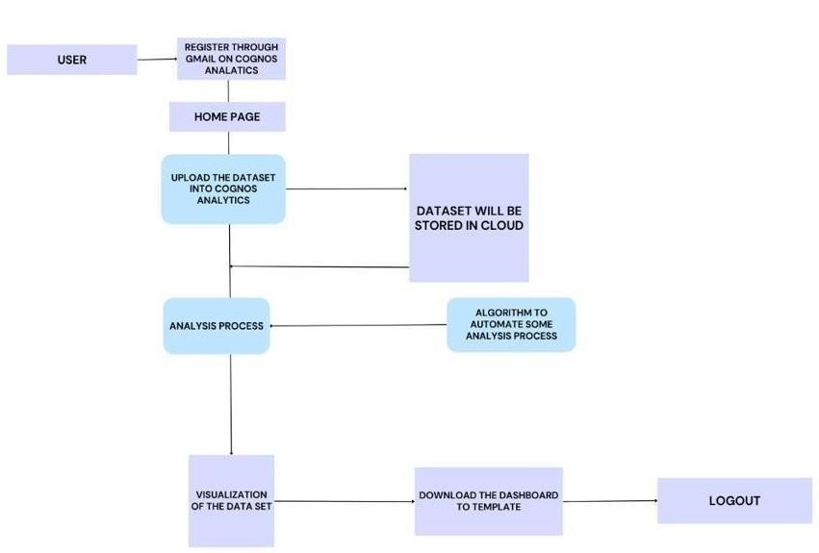**5.1 DATA FLOW DIAGRAMS**

**Fig. No. 5.1 DATA FLOW DIAGRAMS**

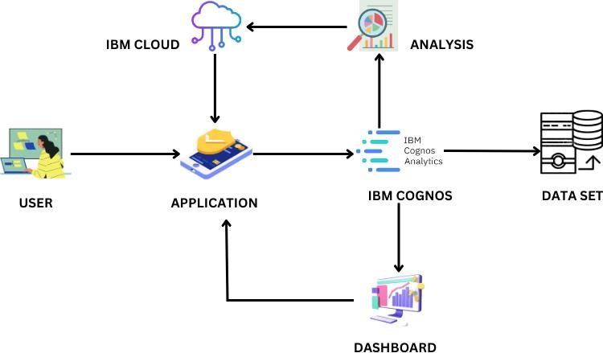**5.2 SOLUTION & TECHNICAL ARCHITECTURE**

**Fig. No. 5.2. SOLUTION ARCHITECTURE**

**5.3 USER STORIES**

|  |  |  |  |  |  |  |
| --- | --- | --- | --- | --- | --- | --- |
| **User Type** | **Functional requirements** | **Release** | **User**  **Number story** | **User Story** | **Acceptance Criteria** | **Priority** |
| Customer  (Web  User) | User  Authentication | Sprint 1 | USN-1 | As a user, I want to create an account with personal email. | Users should be able to register with a valid email address. | High |
|  | Data  Collection and  Integration | Sprint 1 | USN-2 | As a user, I want to import social media records from our database. | The system should provide an option to import social media record from a CSV file. | High |
|  | Dashboard and  Reporting | Sprint 2 | USN-3 | As a user, I want to see a dashboard that displays the number of unique visualizations. |  | Low |
|  | User  Profile  Management | Sprint 2 | USN-4 | As a user, I want to update my user records in my profile and I want to add new details to the system. | User receive confirmation message successful update | Medium |
| Admin | Login | Sprint 6 | USN-8 | As an admin, I can login to the application by  entering  username &  password |  | High |
|  | Dashboard | Sprint 7 | USN-9 | As an admin, I can view the dashboard and other activities of the application | I can access the dashboard | High |

**CODING & SOLUTIONING**

**+**

**CHAPTER** - **6**

**CODING & SOLUTIONING**

**6.1 FEATURE 1**

**DASHBOARD**

<!DOCTYPE html>

<html lang="en">

<head>

<meta charset="UTF-8">

<meta name="viewport" content="width=device-width, initial-scale=1.0">

<title>Dissecting The Digital Landscape: A Comprehensive Analysis Of Social Media</title>

<link rel="stylesheet" href="app.css">

</head>

<body>

<div class="dashboard" id="dashboard">

<h1>Dashboard</h1>

<iframe src="https://us3.ca.analytics.ibm.com/bi/?perspective=dashboard&amp;pathRef=.my_folders%2FSocial%2Bmedia_dashboard&amp;closeWindowOnLastView=true&amp;ui_appbar=false&amp;ui_navbar=false&amp;shareMode=embedded&amp;action=view&amp;mode=dashboard&amp;subView=model0000018b3bf9cbea_00000000" frameborder="0" gesture="media" allow="encrypted-media" allowfullscreen=""></iframe>

</div>

</body>

</html>

**6.2 FEATURE 2**

**REPORT**

<!DOCTYPE html>

<html lang="en">

<head>

<meta charset="UTF-8">

<meta name="viewport" content="width=device-width, initial-scale=1.0">

<title>Dissecting The Digital Landscape: A Comprehensive Analysis Of Social Media</title>

<link rel="stylesheet" href="app.css">

</head>

<body>

<div class="report" id="report">

<h1>Report</h1>

<iframe src="https://us3.ca.analytics.ibm.com/bi/?pathRef=.my_folders%2FSocial%2BMedia_run%2Breport&amp;closeWindowOnLastView=true&amp;ui_appbar=false&amp;ui_navbar=false&amp;shareMode=embedded&amp;action=run&amp;format=HTML&amp;prompt=false" frameborder="0" gesture="media" allow="encrypted-media" allowfullscreen=""></iframe>

</div>

</body>

</html>

**6.3 FEATURE 3**

**STORY**

<!DOCTYPE html>

<html lang="en">

<head>

<meta charset="UTF-8">

<meta name="viewport" content="width=device-width, initial-scale=1.0">

<title>Dissecting The Digital Landscape: A Comprehensive Analysis Of Social Media</title>

<link rel="stylesheet" href="app.css">

</head>

<body>

<div class="story" id="story">

<h1>Story</h1>

<iframe src="https://us3.ca.analytics.ibm.com/bi/?perspective=story&amp;pathRef=.my_folders%2FSocial%2BMedia%2Bstory&amp;closeWindowOnLastView=true&amp;ui_appbar=false&amp;ui_navbar=false&amp;shareMode=embedded&amp;action=view&amp;sceneId=model0000018b3ce551f5_00000000&amp;sceneTime=0" frameborder="0" gesture="media" allow="encrypted-media" allowfullscreen=""></iframe>

</div>

</body>

</html>

**RESULTS**

**CHAPTER** - **7**

**RESULTS**

**7.1 PERFORMANCE METRICS**

**7.1.1 Utilization of Data Filters**

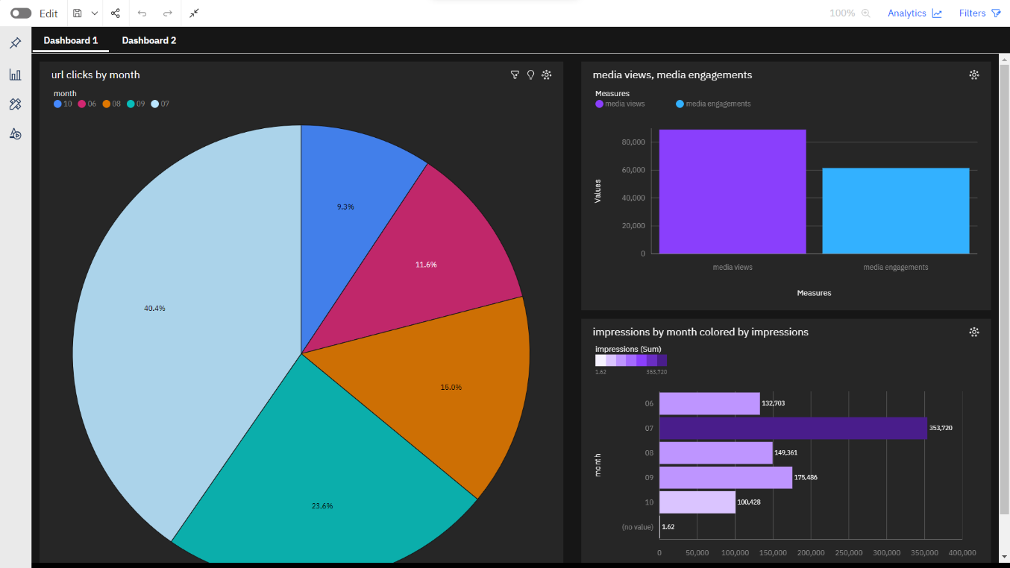**Dashboard**

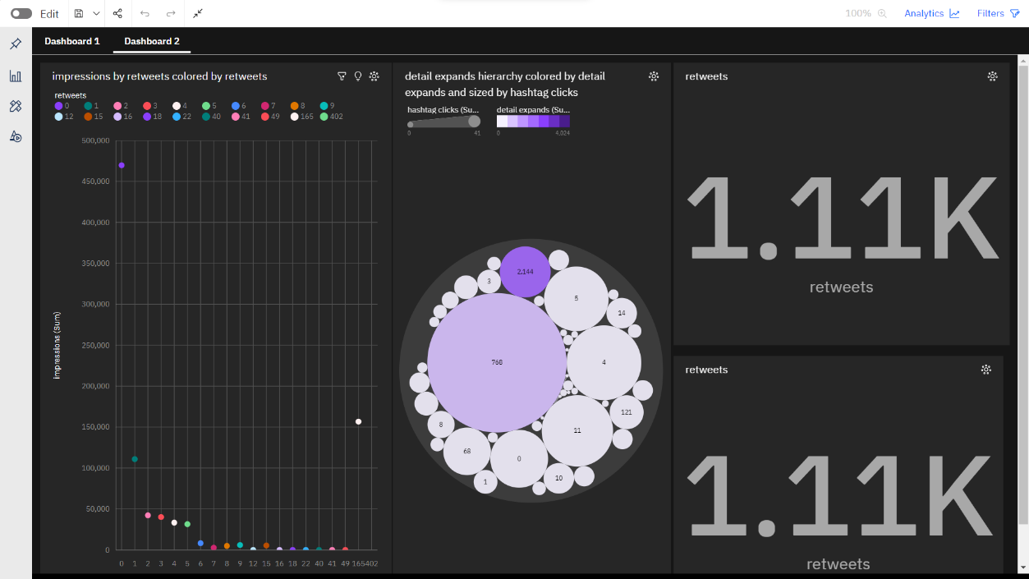

**Story**

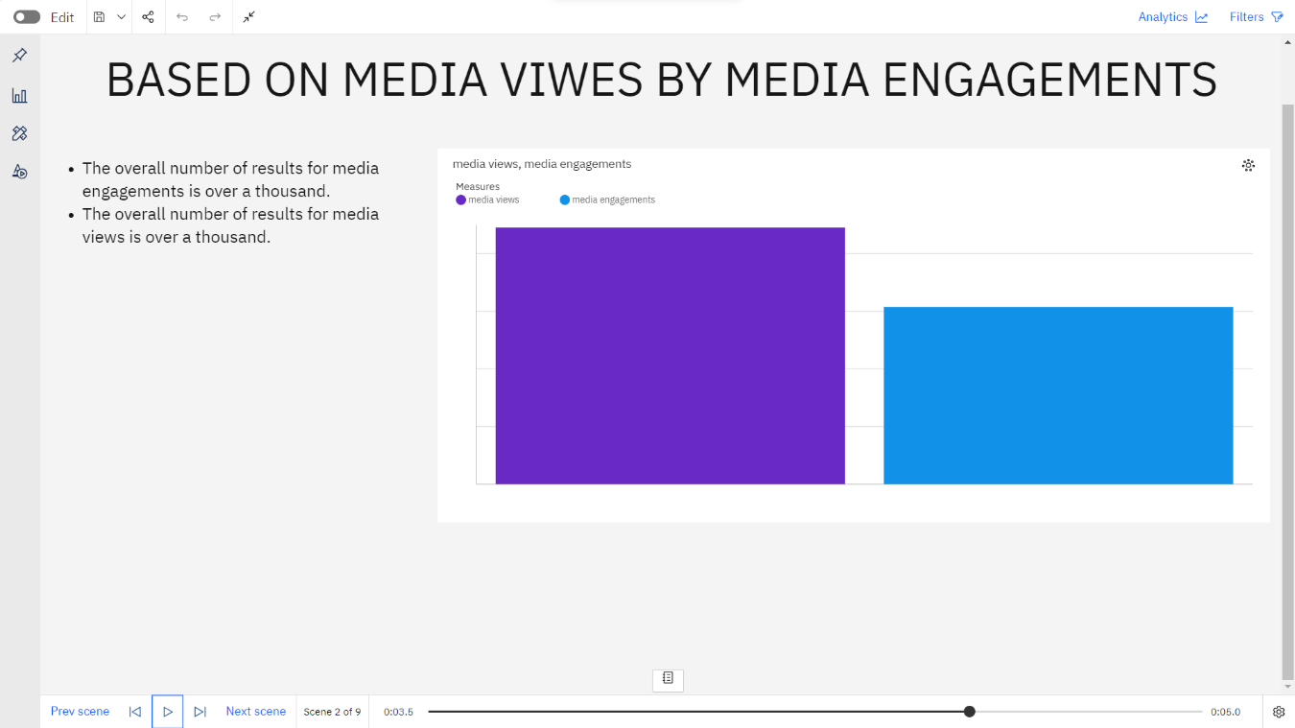

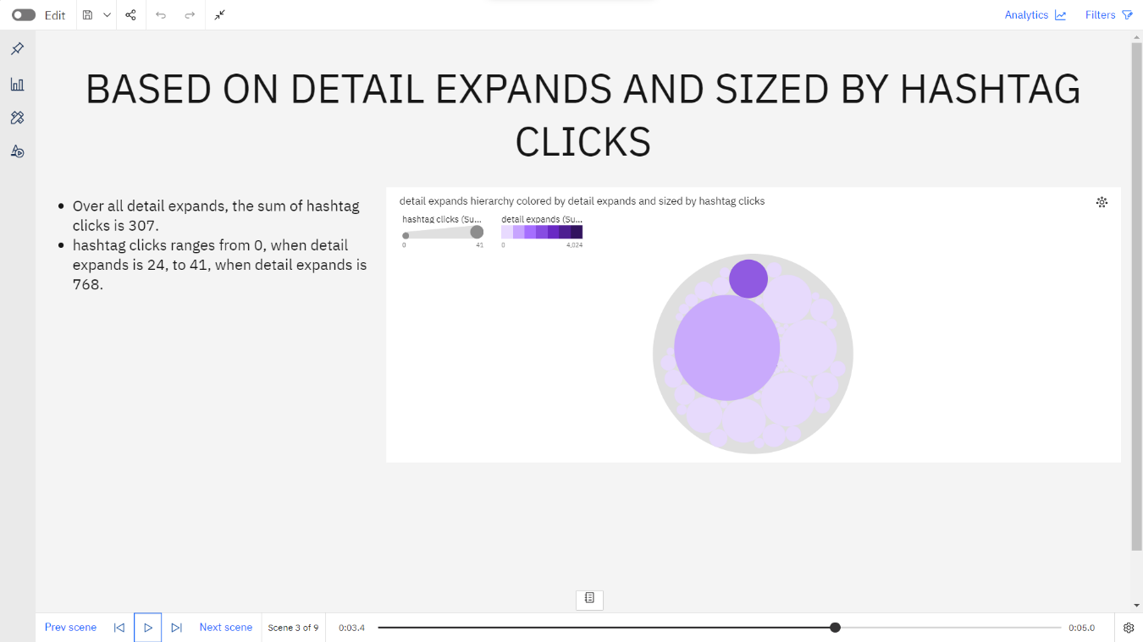

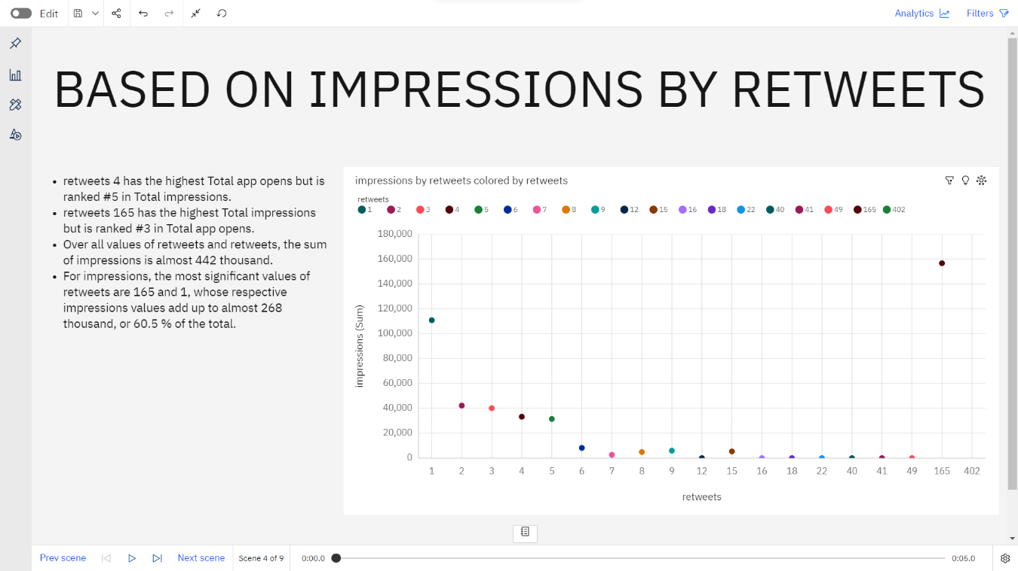

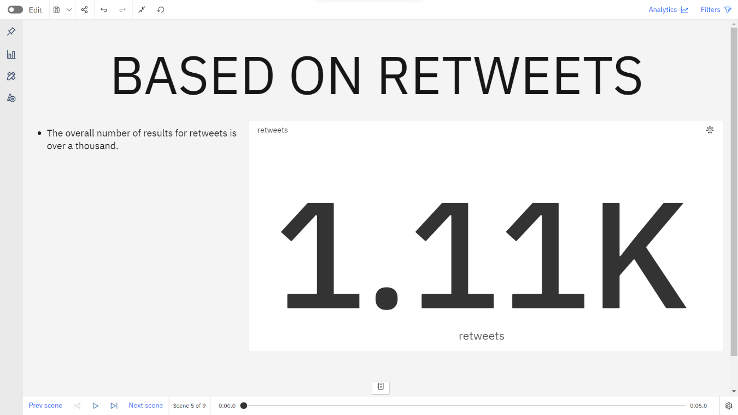

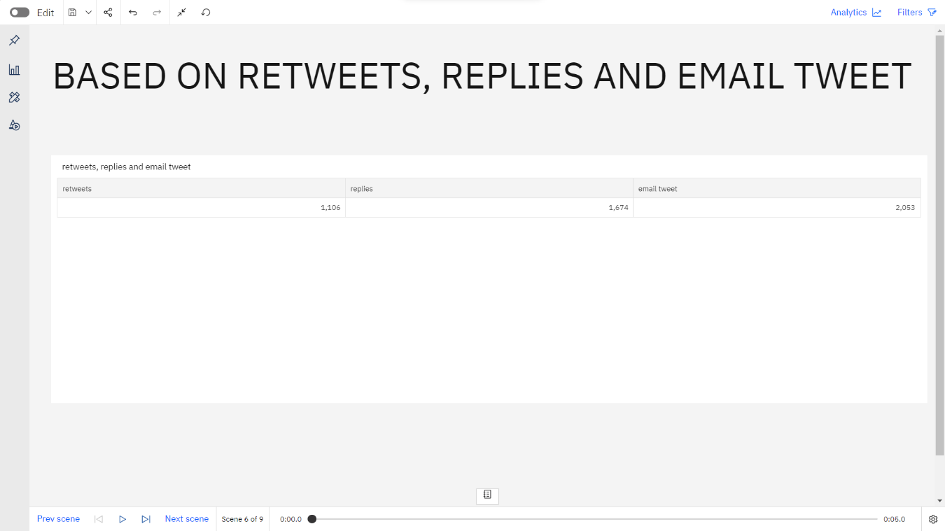

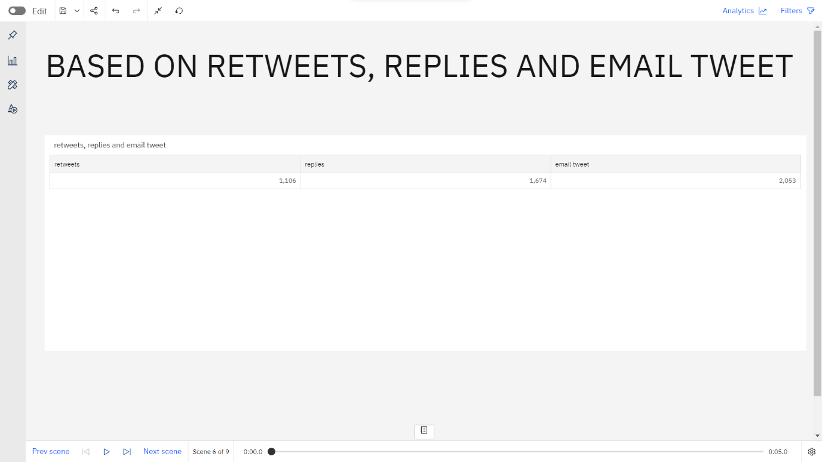

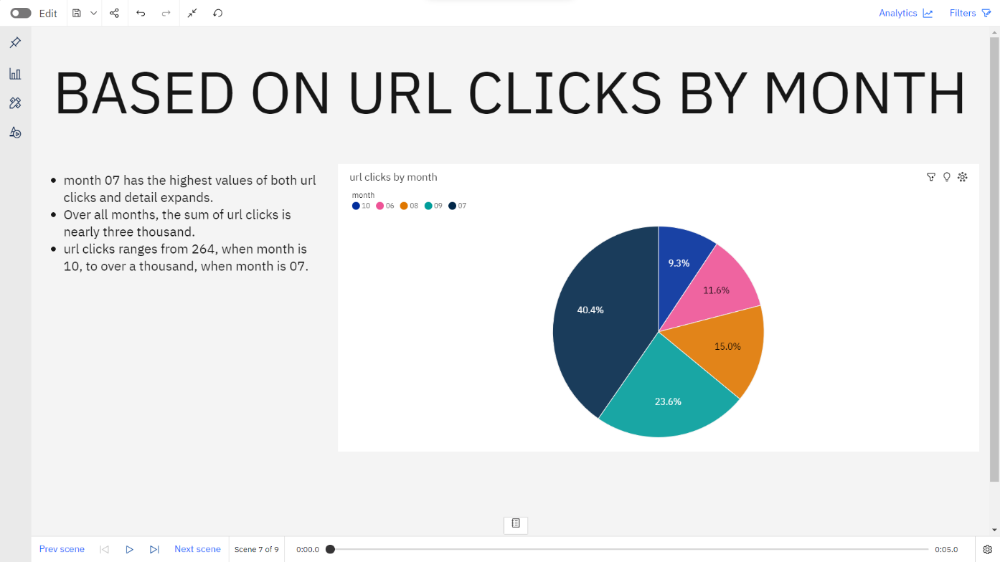

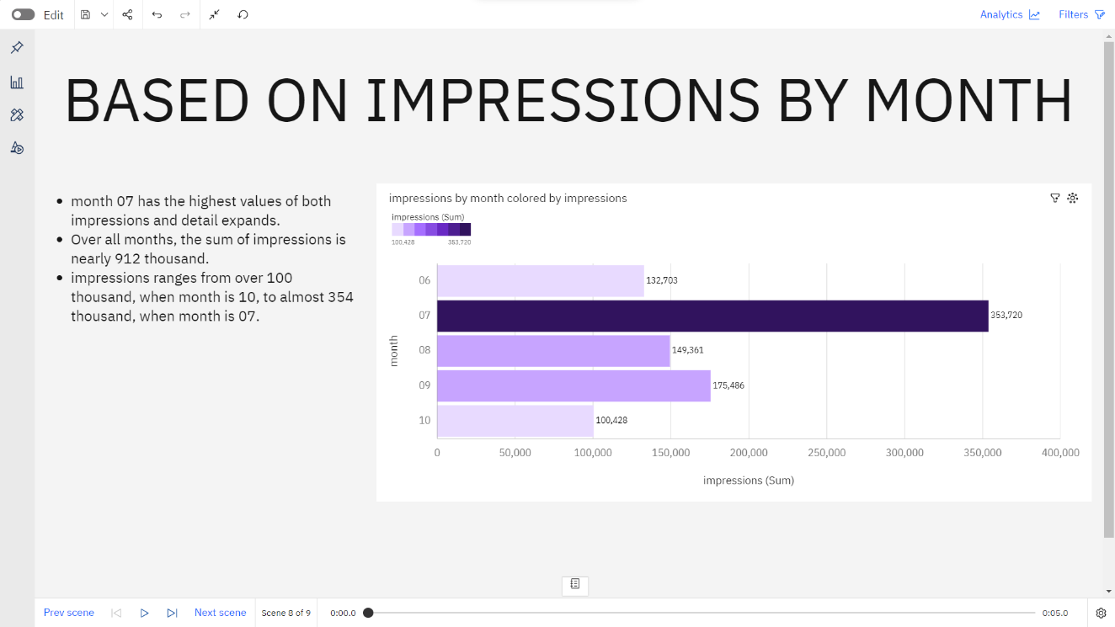

**Report**

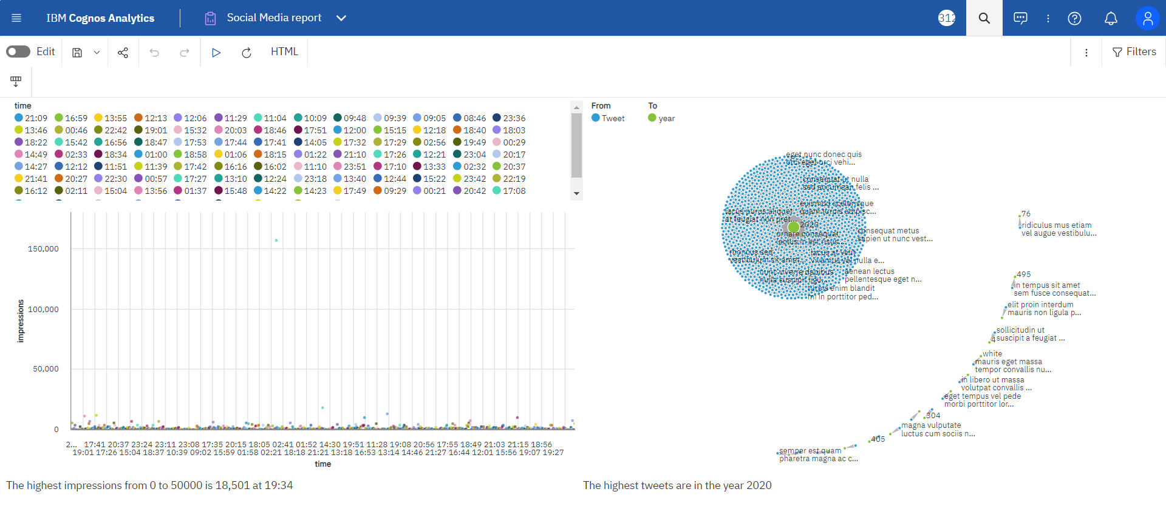

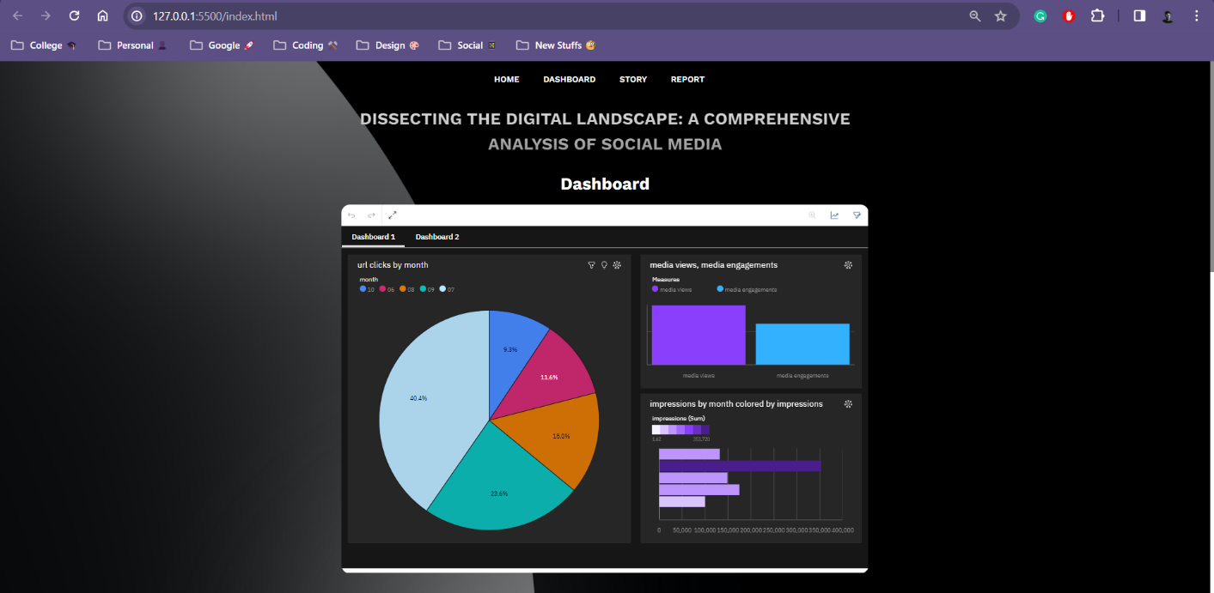

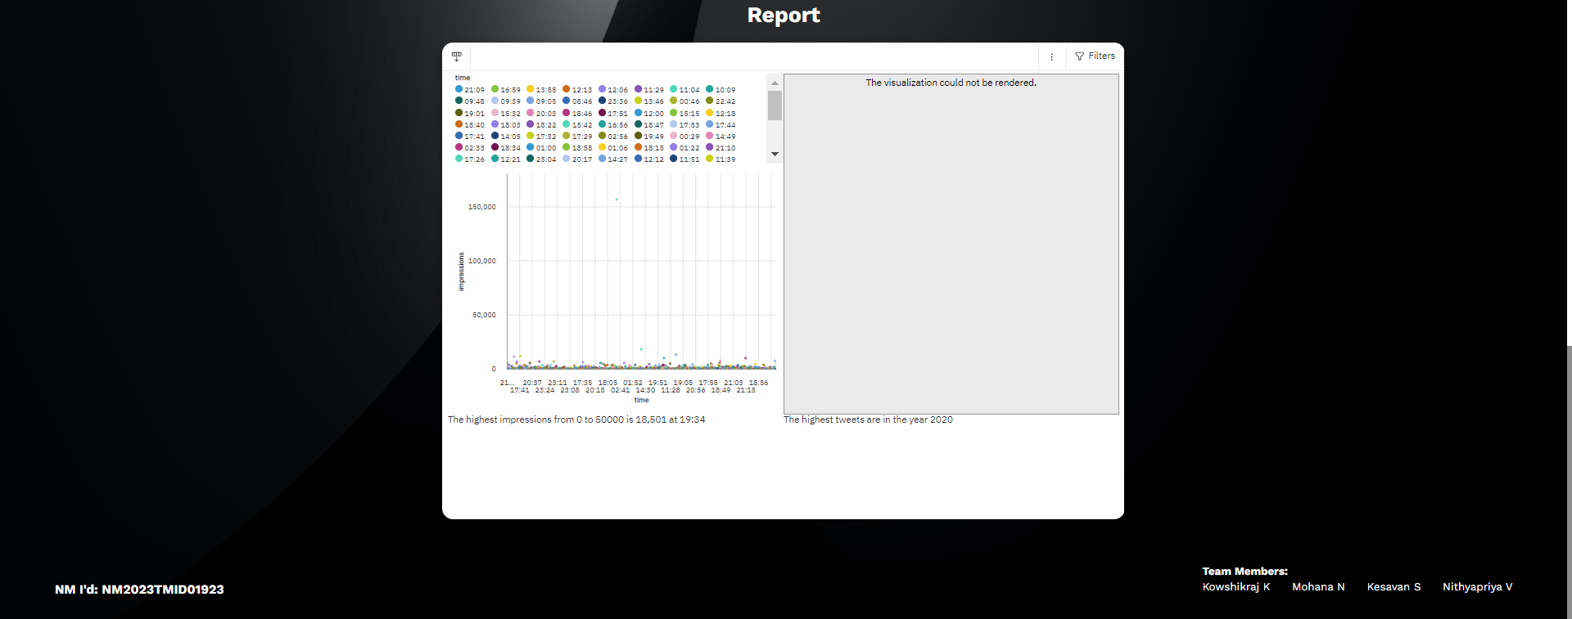

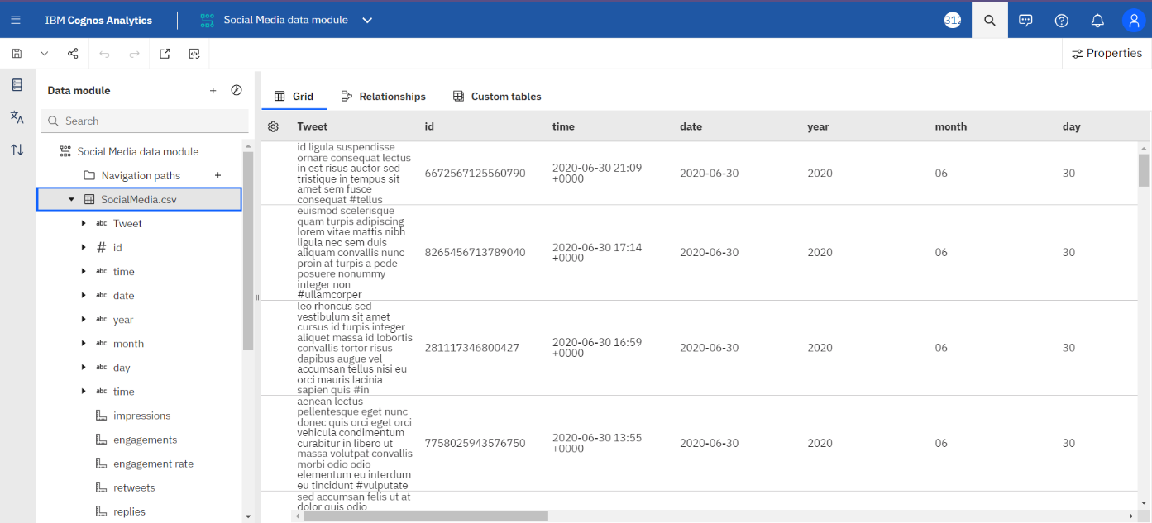**7.1.2 No. of Calculation Fields**

**7.1.2 No. of Visualizations/Graphs**

1. Based On url clicks by month

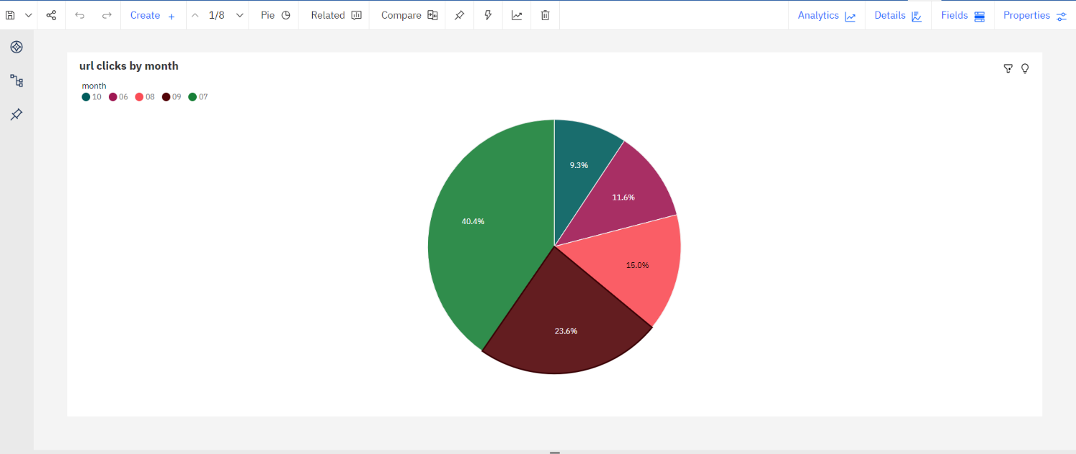

2. Based On media views, media engagements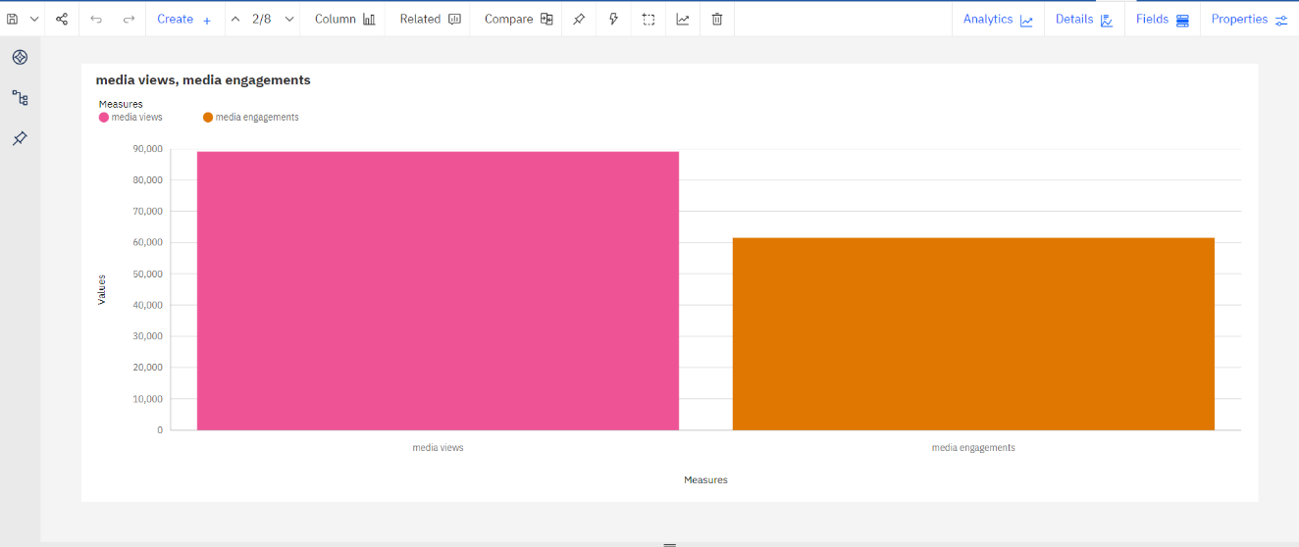

3. Based On impressions by month colored by impressions 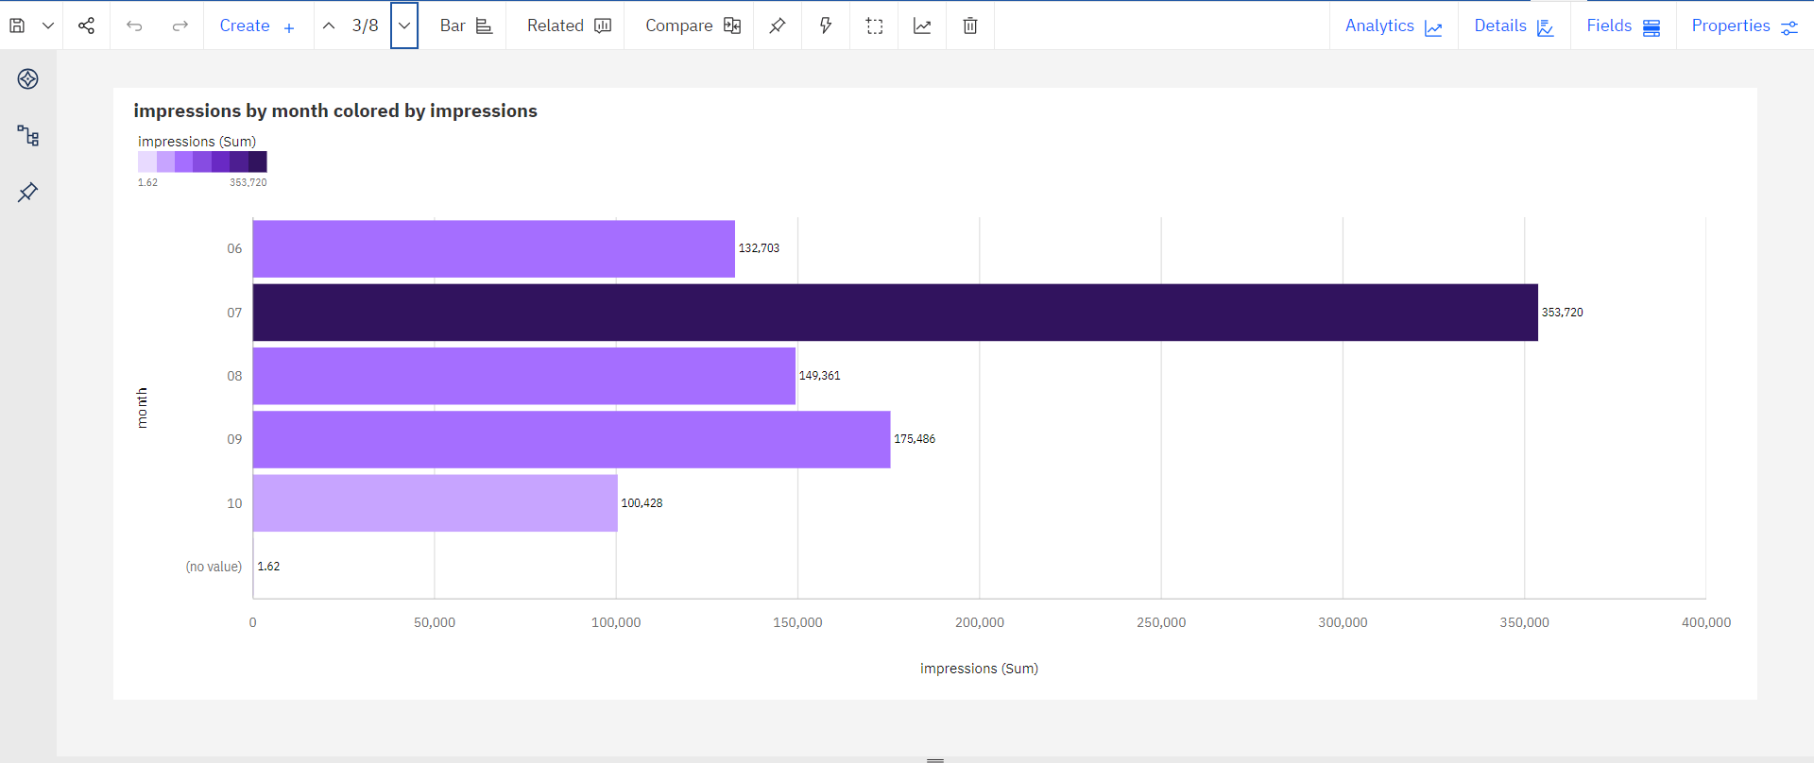

4. Based On impressions by retweets colored by retweets

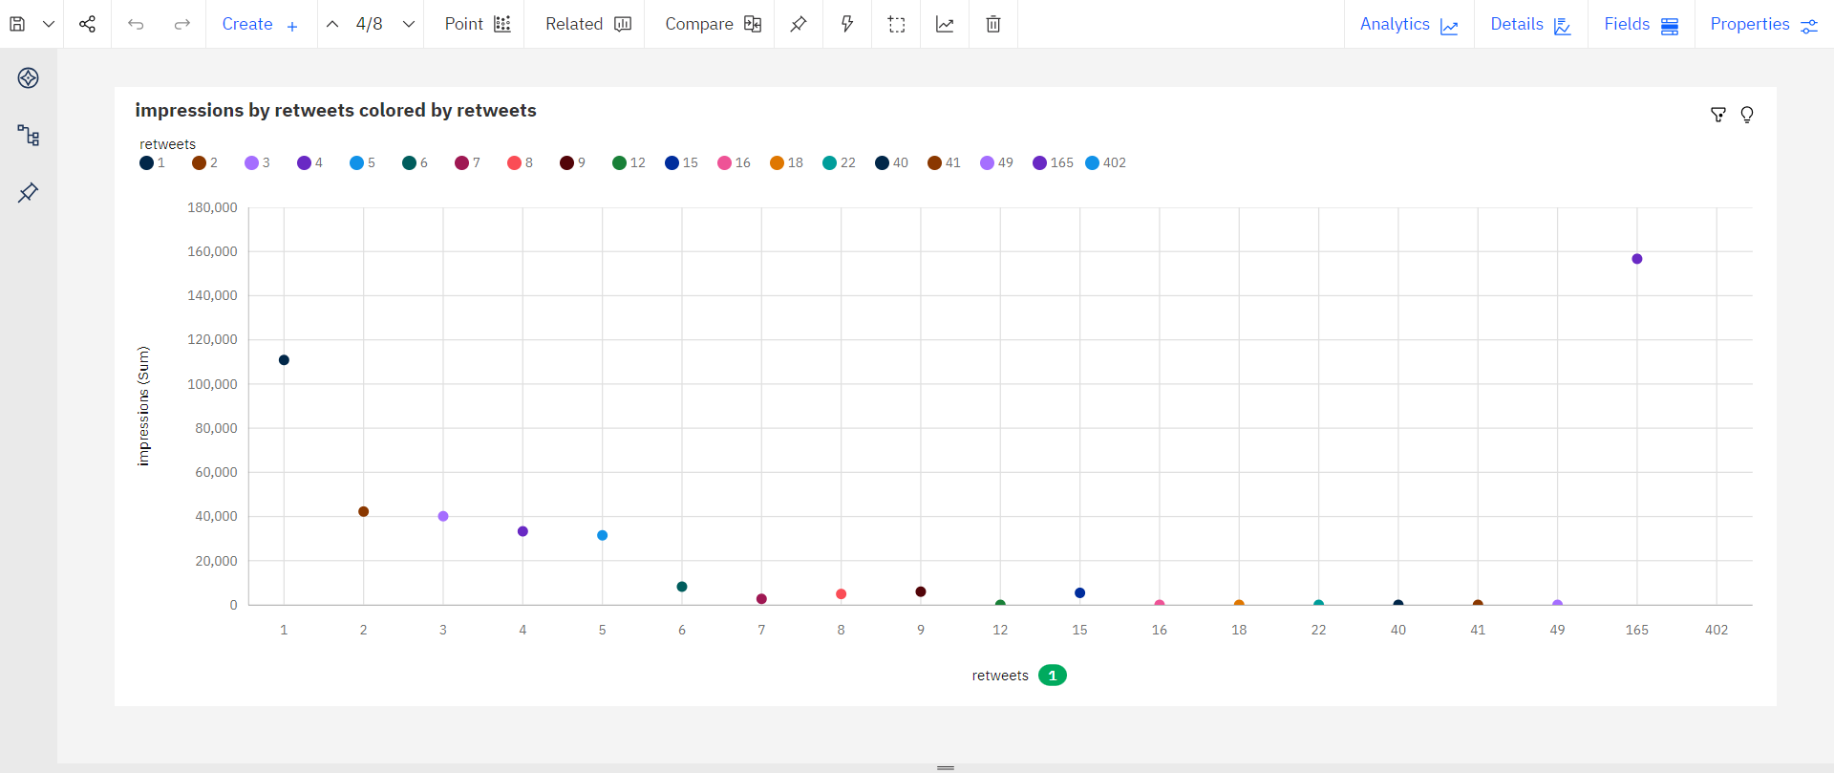

5. Based On engagements by retweets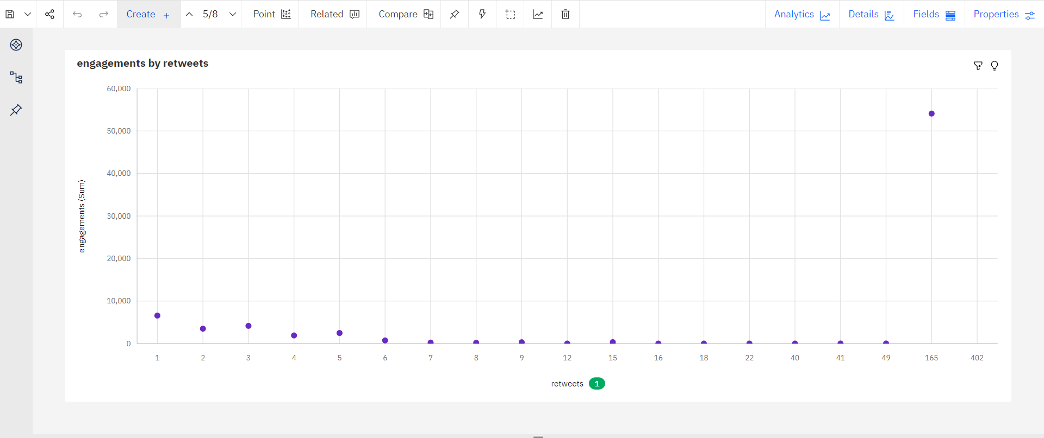

6. Based On detail expands and sized by hashtag clicks

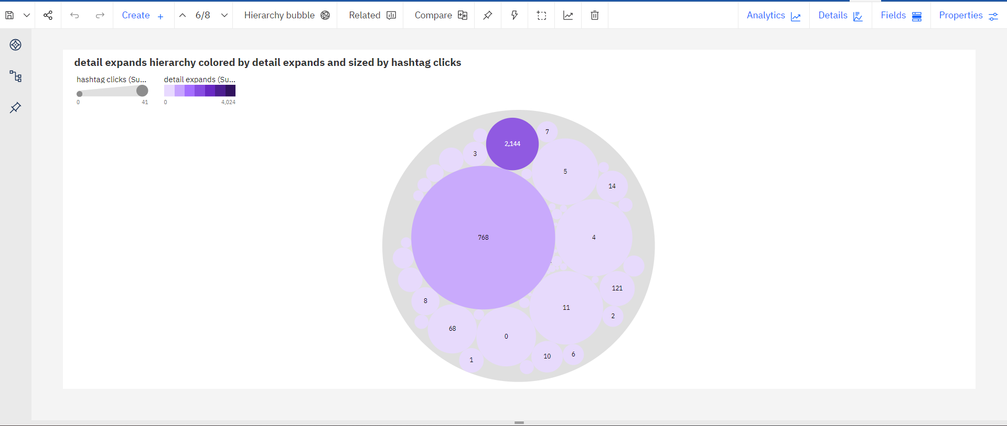

7. Based on retweets, replies and email tweet

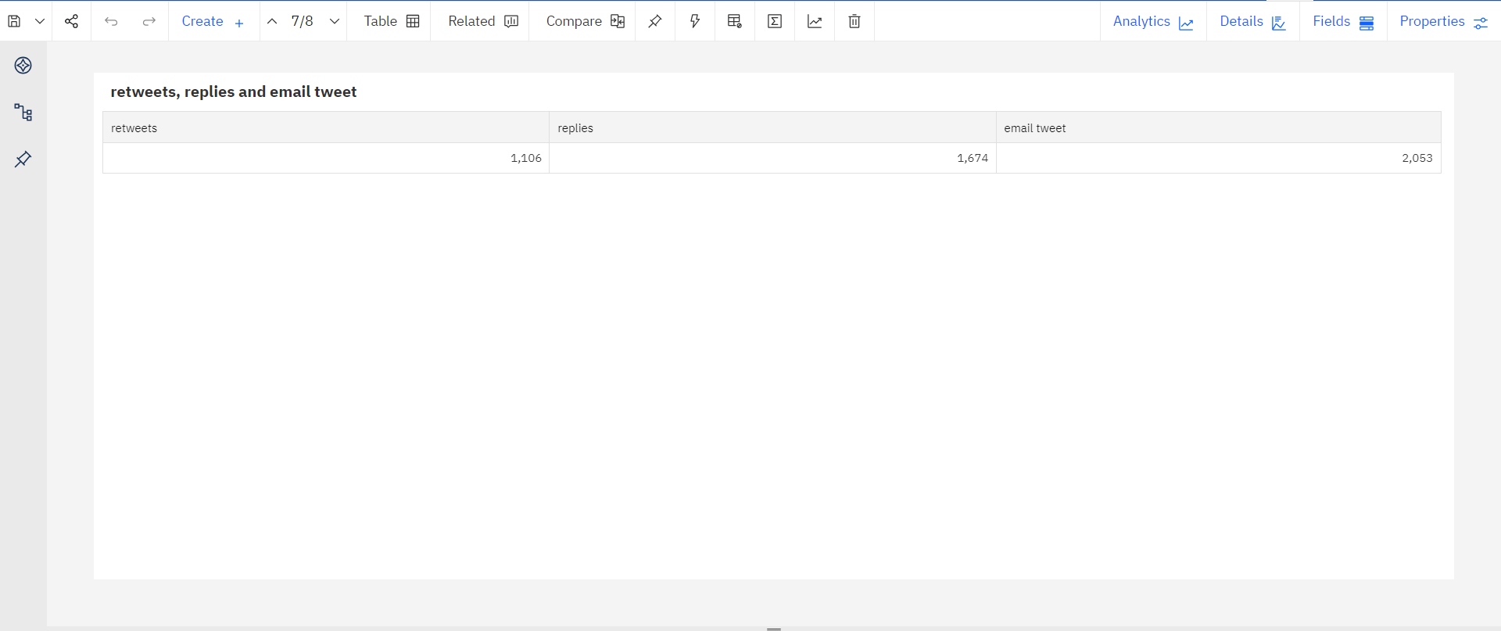

8. Based on retweets

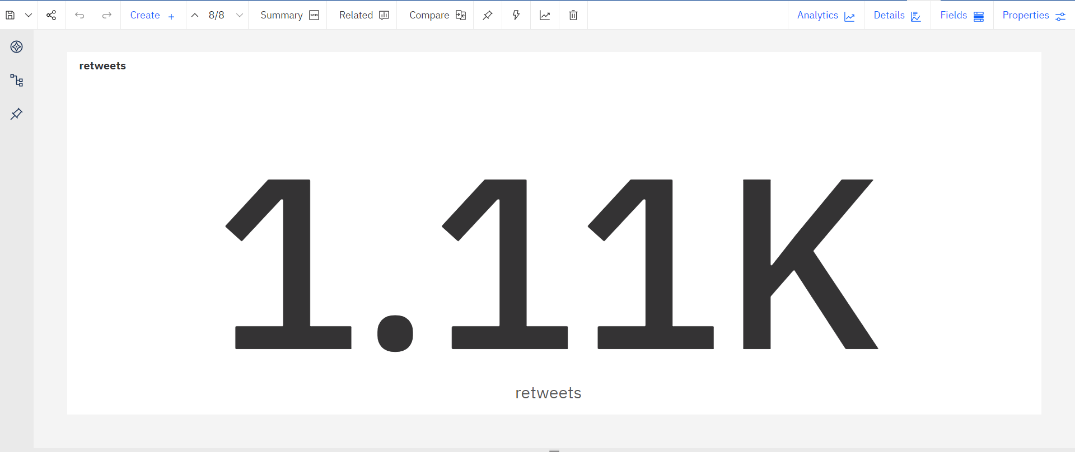

**ADVANTAGES & DISADVANTAGES**

**CHAPTER** - **8**

**ADVANTAGES & DISADVANTAGES**

**ADVANTAGES:**

**Enhanced Communication:** Social media facilitates instant communication and helps people stay connected globally.

**Increased Awareness:** Social media platforms provide a platform for spreading awareness about important issues, events, and social causes.

**Educational Opportunities:** Social media offers a wealth of educational resources and platforms for online learning, making education accessible to a broader audience.

**Business Growth:** Social media serves as a powerful marketing tool, allowing businesses to reach a wider audience, increase brand awareness, and drive sales.

**Community Building:** Social media fosters the creation of online communities based on shared interests, connecting like-minded individuals worldwide.

**DISADVANTAGES:**

**Privacy Concerns:** Social media platforms often collect personal data, raising concerns about privacy breaches and unauthorized use of information.

**Mental Health Issues:** Excessive use of social media can lead to anxiety, depression, and feelings of inadequacy due to social comparison and cyberbullying.

**Spread of Misinformation:** Social media can be a breeding ground for fake news and misinformation, leading to public confusion and misinformation.

**Social Isolation:** Paradoxically, while social media connects people online, it can lead to a sense of social isolation in the real world, reducing face-to-face interactions.

**Cyberbullying and Harassment:** Social media platforms can be misused for cyberbullying, harassment, and online abuse, causing emotional distress and trauma to victims.

**CONCLUSION**

**CHAPTER** - **9**

**CONCLUSION**

In conclusion, the transformative influence of social media on our lives is undeniable, reshaping how we communicate, interact, and perceive the world around us. Through a comprehensive examination of social media platforms, this research has delved into their evolving nature over time, shedding light on their profound impacts on individual well-being, privacy, and the information landscape.

Our exploration has revealed the dual nature of social media. While it enhances connectivity and democratizes information, it also raises critical concerns. Privacy breaches, the amplification of misinformation, and the potential negative effects on mental health have surfaced as significant challenges. It is evident that a balanced approach is necessary to harness the benefits of social media while mitigating its adverse effects.

By understanding the intricate dynamics of social media, we have laid the groundwork for navigating the digital world more effectively. Insights garnered from this research pave the way for informed policies, digital literacy initiatives, and user-focused platform enhancements. Empowering individuals with knowledge about privacy settings, critical thinking, and responsible online behavior becomes paramount.

**FUTURE SCOPE**

**CHAPTER** – **10**

**FUTURE SCOPE**

In future, Exploring the influence of augmented reality and virtual reality on social media experiences could uncover novel dimensions. Investigating the interplay between social media and mental health, particularly in vulnerable demographics, offers vital insights. Future studies might also focus on global social media trends and their regional impacts, informing targeted interventions. Moreover, the development of innovative privacy-preserving technologies and the assessment of their effectiveness in real-world scenarios hold promise. Collaborative international research endeavors are essential to anticipate and address the evolving challenges and opportunities in the dynamic realm of social media.

**APPENDIX**

**CHAPTER** - **11**

**APPENDIX**

**11.1 SOURCE CODE**

**HTML**

<!DOCTYPE html>

<html lang="en">

<head>

<meta charset="UTF-8">

<meta name="viewport" content="width=device-width, initial-scale=1.0">

<title>Dissecting The Digital Landscape: A Comprehensive Analysis Of Social Media</title>

<link rel="stylesheet" href="app.css">

</head>

<body>

<nav>

<div class="navbar">

<a href="#home">Home</a>

<a href="#dashboard">Dashboard</a>

<a href="#story">Story</a>

<a href="#report">Report</a>

</div>

</nav>

<div class="wrapper">

<h1 class="title" id="home">Dissecting The Digital Landscape: A Comprehensive Analysis Of Social Media</h1>

<div class="dashboard" id="dashboard">

<h1>Dashboard</h1>

<iframe src="https://us3.ca.analytics.ibm.com/bi/?perspective=dashboard&amp;pathRef=.my_folders%2FSocial%2Bmedia_dashboard&amp;closeWindowOnLastView=true&amp;ui_appbar=false&amp;ui_navbar=false&amp;shareMode=embedded&amp;action=view&amp;mode=dashboard&amp;subView=model0000018b3bf9cbea_00000000" frameborder="0" gesture="media" allow="encrypted-media" allowfullscreen=""></iframe>

</div>

<div class="story" id="story">

<h1>Story</h1>

<iframe src="https://us3.ca.analytics.ibm.com/bi/?perspective=story&amp;pathRef=.my_folders%2FSocial%2BMedia%2Bstory&amp;closeWindowOnLastView=true&amp;ui_appbar=false&amp;ui_navbar=false&amp;shareMode=embedded&amp;action=view&amp;sceneId=model0000018b3ce551f5_00000000&amp;sceneTime=0" frameborder="0" gesture="media" allow="encrypted-media" allowfullscreen=""></iframe>

</div>

<div class="report" id="report">

<h1>Report</h1>

<iframe src="https://us3.ca.analytics.ibm.com/bi/?pathRef=.my_folders%2FSocial%2BMedia_run%2Breport&amp;closeWindowOnLastView=true&amp;ui_appbar=false&amp;ui_navbar=false&amp;shareMode=embedded&amp;action=run&amp;format=HTML&amp;prompt=false" frameborder="0" gesture="media" allow="encrypted-media" allowfullscreen=""></iframe>

</div>

</div>

<footer>

<div class="info">

<h3>NM I'd: NM2023TMID01923</h3>

<div class="right">

<h4>Team Members:</h4>

<ul>

<li>Kowshikraj K</li>

<li>Mohana N</li>

<li>Kesavan S</li>

<li>Nithyapriya V</li>

</ul>

</div>

</div>

</footer>

</body>

</html>

**CSS**

@import url('https://fonts.googleapis.com/css2?family=Work+Sans:wght@400;500;600;700;800;900&display=swap');

::-webkit-scrollbar{

width: 0.5rem;

}

::-webkit-scrollbar-track{

background: transparent;

}

::-webkit-scrollbar-thumb{

background: rgb(140,140,140);

}

::-webkit-scrollbar-thumb:hover{

background: rgb(39, 39, 39);

}

*{

margin: 0;

padding: 0;

box-sizing: border-box;

font-family: 'Work Sans', sans-serif;

scroll-behavior: smooth;

}

body{

background-image: url('./bg.jpg');

background-size: cover; /* or 'contain' depending on your preference */

background-repeat: no-repeat;

background-position: center center;

width: 100%;

height: 100%;

}

nav{

padding: 1.6rem;

display: flex;

align-items: center;

justify-content: center;

}

.navbar a {

text-transform: uppercase;

font-size: 1rem;

padding: 10px 20px;

color: rgb(255, 255, 255);

font-weight: 600;

text-decoration: none;

}

.navbar a:hover {

color: gray;

}

.title{

background: -webkit-linear-gradient(#e5e5e5, #8e8e8e);

-webkit-background-clip: text;

-webkit-text-fill-color: transparent;

width: 1000px;

line-height: 3rem;

text-align: center;

margin-top: 1rem;

text-transform: uppercase;

}

img{

z-index: -9;

}

.wrapper{

display: flex;

flex-direction: column;

align-items: center;

justify-content: center;

padding-bottom: 2rem;

}

.wrapper div h1{

color: white;

text-align: center;

margin-top: 2rem;

margin-bottom: 1.4rem;

}

.wrapper iframe{

width: 1000px;

height: 700px;

border-radius: 1rem;

}

.wrapper iframe:hover{

box-shadow: rgba(0, 0, 0, 0.35) 0px 5px 15px;

}

.info{

display: flex;

color: white;

align-items: end;

justify-content: space-between;

gap: 2rem;

}

footer{

margin: 2rem 5rem;

}

.info ul{

display: flex;

gap: 2rem;

}

.info li{

list-style: none;

line-height: 1.8rem;

}

@media (max-width: 1181px) {

.wrapper iframe{

width: 600px;

height: 600px;

}

.title{

font-size: 1.6rem;

}

}

@media (max-width: 480px) {

.wrapper iframe{

width: 400px;

height: 00px;

}

.title{

font-size: 1.2rem;

}

}

**11.2 GITHUB & PROJECT VIDEO DEMO LINK**

**GITHUB LINK:**

<https://github.com/KowshikrajK/NaanMudhalvan_DataAnalytics_NM2023TMID01923>

**PROJECT VIDEO DEMO LINK**

[https://drive.google.com/file/d/1zQnmXWKJK1I8VclDLEuPQmYe7ruCU1xV/view?usp=share_link](https://drive.google.com/file/d/1zQnmXWKJK1I8VclDLEuPQmYe7ruCU1xV/view?usp=share_link%0c)

**REFERENCES**

**CHAPTER – 12**

**REFERENCES**

1. Kaplan, A. M., & Haenlein, M. (2010). Users of the world, unite! The challenges and opportunities of Social Media. Business Horizons, 53(1), 59-68.2007 Asia and South Pacific Design Automation Conference
2. IBM Cognos Official Documentation and Whitepapers (IBM's official website).
3. Gruzd, A., Wellman, B., & Takhteyev, Y. (2011). Imagining Twitter as an imagined community. American Behavioral Scientist, 55(10), 1294-1318.
4. Chua, A. Y. K., & Banerjee, S. (2015). Customer knowledge management via social media: the case of Starbucks. Journal of Knowledge Management, 19(2), 137-145.
5. Davenport, T. H., & Harris, J. (2007). Competing on analytics: The new science of winning. Harvard Business Press.