- PROJECT OVERVIEW
The Grocery Store Web Application is a full-stack MERN project designed to allow users to browse grocery items, add them to a cart, and proceed with a dummy payment. The system includes an admin side for managing products using MongoDB Atlas, and a user-facing side built with React.
The project aims to:
- Provide a simple UI for purchasing groceries online
- Store product data securely in MongoDB
- Handle navigation using React Router
- Demonstrate CRUD operations (Create/Read)
- Implement reusable components and clean architecture
Target Users:
- Regular users who browse and order grocery items
- Admin users who manage the product list (future upgrade)
- PROJECT REQUIREMENTS

Functional Requirements
- User Authentication
  - Login system (dummy login or actual DB login)
  - Route protection (optional)
- Product Management
  - Fetch product list from backend
  - Display items with image, name, price, unit
  - Filter products by category (veg/fruit/non-veg/dairy)
- Shopping Cart
  - Add product to cart
  - Increase/Decrease quantity
  - Remove product
  - Show cart total price
- Payment
  - Dummy payment confirmation page
  - Show total price, payment success message
- Navigation
  - Home → Cart → Payment
  - Go back to Home
  - WIREFRAMES/ SCREENSHOT
- Login Page
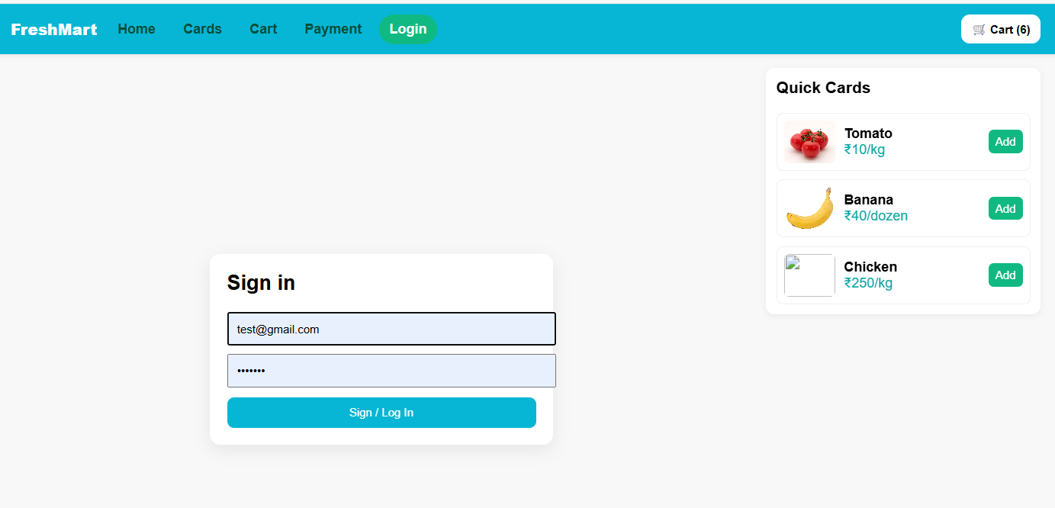
- Home Page
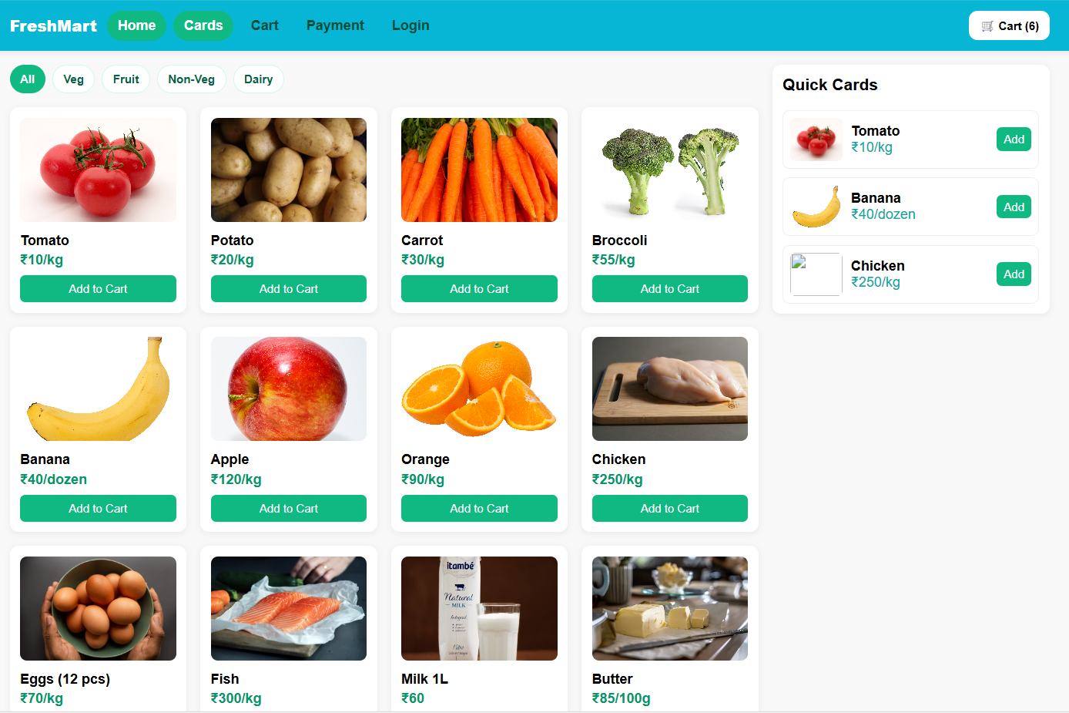
- Product List
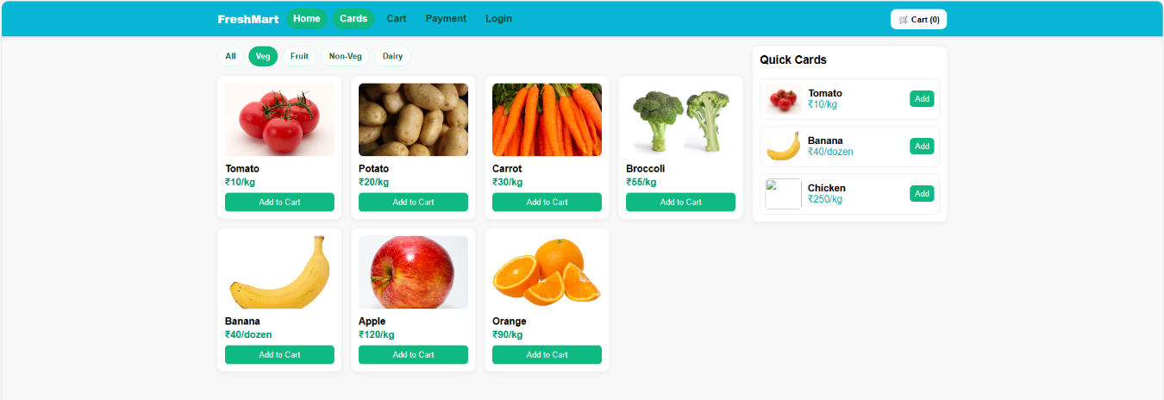
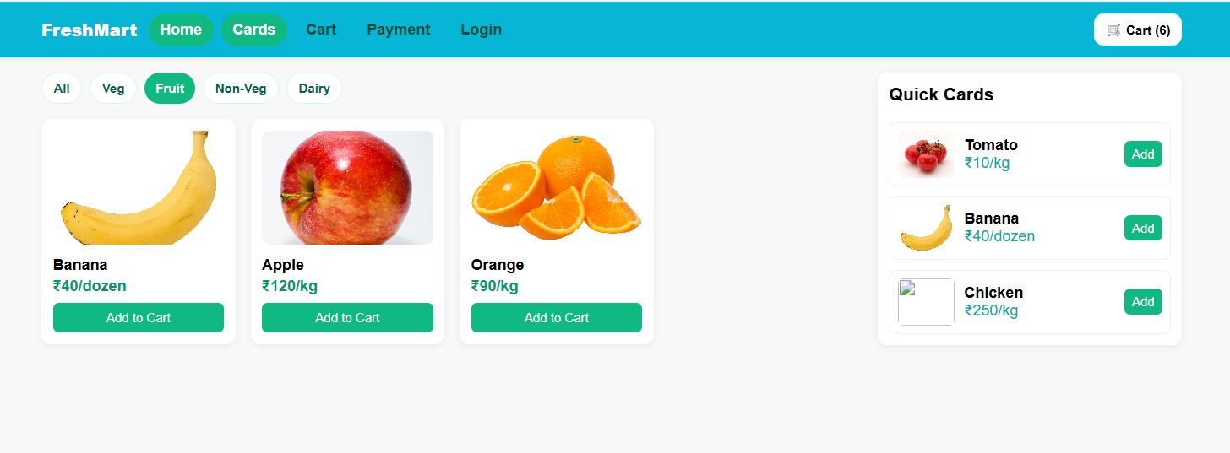
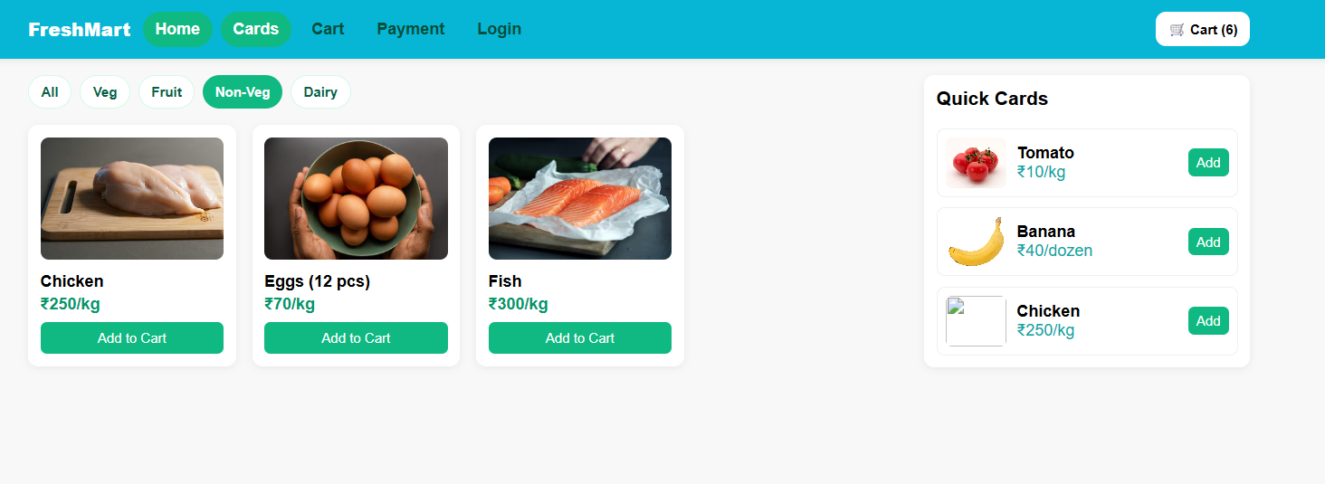
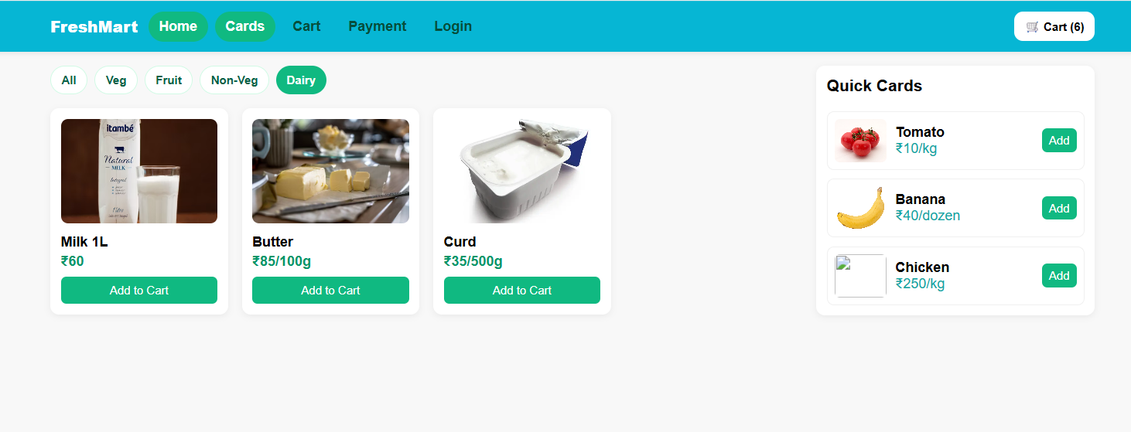
- Cart UI
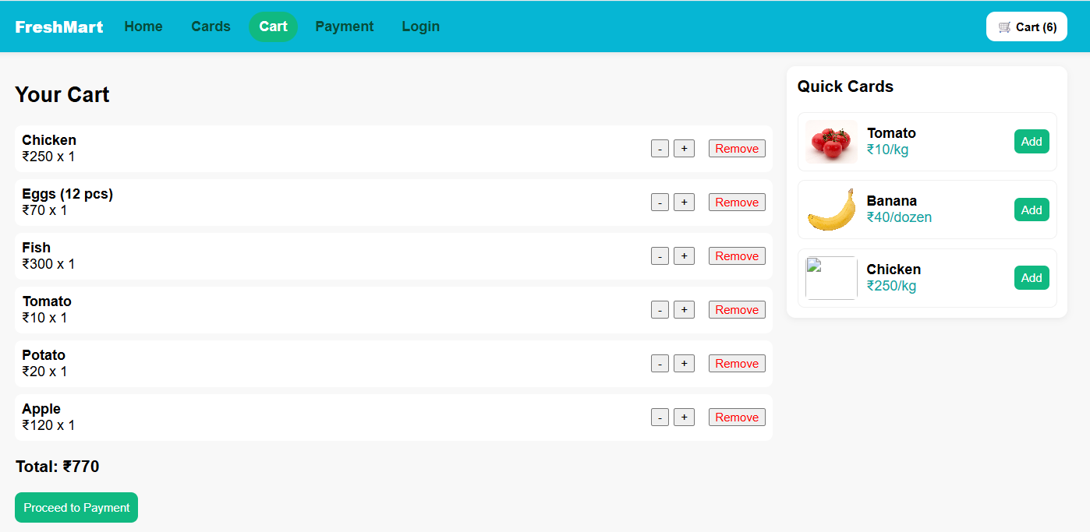
- Payment page
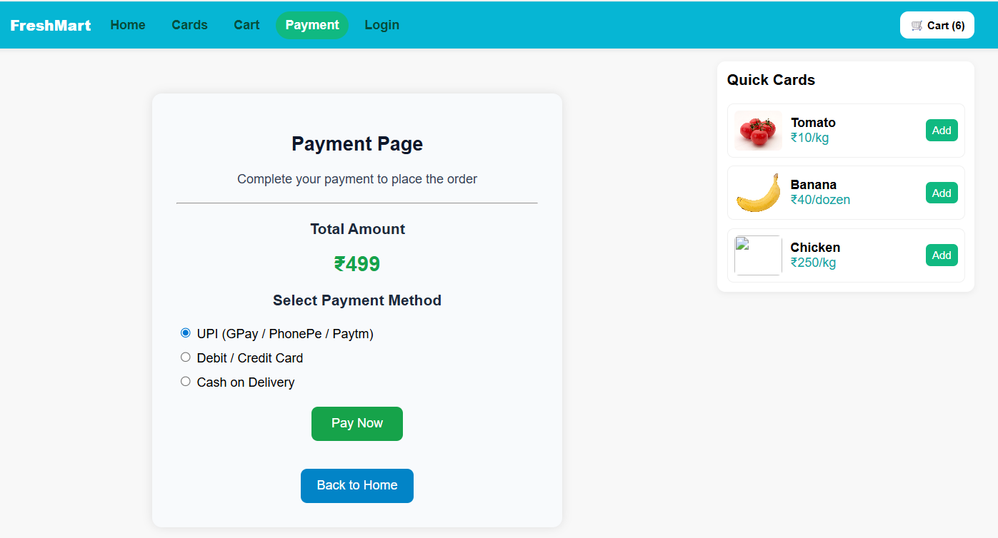
  - FUNCTIONAL REQUIREMENT USE CASES

Use Case 1 — User Login
Element | Description
Actor | User
Precondition | Valid credentials
Steps | Enter email/password → Click Login
Output | Redirect to Home page

Use Case 2 — Browse Products
Step | Description
1 | User opens Home page
2 | React fetches /api/products from Node server
3 | Products displayed in card layout
4 | User filters by category

Use Case 3 — Add to Cart
Step | Description
1 | User clicks “Add to Cart”
2 | Item stored in CartContext
3 | Cart icon updates count

Use Case 4 — View Cart
Step | Description
1 | User opens Cart page
2 | Shows list of added items
3 | Shows total amount

Use Case 5 — Payment
Step | Description
1 | User clicks “Proceed to Payment”
2 | Payment page displays total
3 | User confirms → success message

3. TECHNICAL DETAILS

Frontend
- React.js – UI creation
- React Router – page navigation
- CSS / Tailwind (optional) – styling
- Fetch API – to call backend APIs

Backend
- Node.js – runtime
- Express.js – API creation
- Mongoose – MongoDB object modeling

Database
- MongoDB Atlas – cloud storage of products, users, cart items

Tools
- VS Code
- Postman (optional)
- GitHub
3.1 TECH STACK

Frontend
Technology | Purpose
ReactJS | Build UI components
React Router | Navigation (Login → Home → Cart → Payment)
Context API | Manage Cart globally
CSS | Styling
Vite | React build tool

Backend
Technology | Purpose
Node.js | Server environment
Express.js | Create REST API routes
Mongoose | MongoDB integration

Database
Technology | Purpose
MongoDB Atlas | Cloud database to store products, users, cart

3.2 ARCHITECTURE DIAGRAM
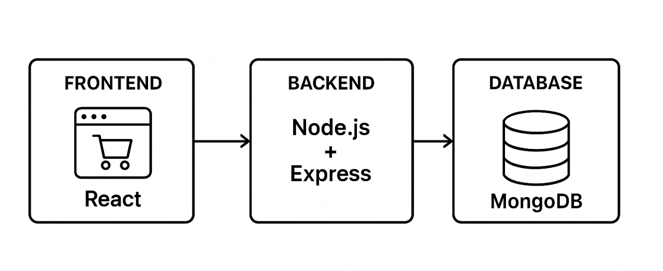

3.3 DESIGN PATTERNS

1. Component-Based Architecture (React)
The app UI is split into reusable components:
- Navbar
- ProductCard
- CartPage
- PaymentPage
- LoginPage
Helps maintain modularity and scalability.

2. MVC Pattern in Backend
- Model → Mongoose schemas
- View → React frontend
- Controller → Express route handlers
This separates logic → UI → database.

3. REST API Design
All backend requests follow REST principles:
GET /api/products
POST /api/login
POST /api/cart

4. Router Pattern
React Router handles all page navigation:
<Login />
<Home />
<Cart />
<Payment />

📌 4. Project Folder Structure
grocery-app/
grocery-app/
│
├── backend/
│ ├── server.js
│ ├── package.json
│ ├── .env (DO NOT UPLOAD — keep private!)
│ ├── models/
│ ├── routes/
│ ├── controllers/
│ └── config/
│
├── frontend/
│ ├── src/
│ ├── public/
│ ├── package.json
│ └── vite.config.js
│
└── README.md (GitHub main README file)

5. Important Code Explanations

main.jsx — Uses
- This is the entry point for the React application.
- It connects the App component to the root HTML div.
- It wraps the app with:
  - BrowserRouter → enables navigation
  - CartContextProvider → global state

React Router — Uses
React Router helps us switch pages without reloading the browser,
e.g.:
/ → Home/cart → Cart Page /payment → Payment Page
Benefits:
- Fast navigation
- Better user experience
- Cleaner URL structure

6. Deployment Options
You can deploy:
- Frontend → Netlify / Vercel
- Backend → Render / Cyclic
- DB → MongoDB Atlas

7. Future Improvements
- Real payment gateway (Razorpay/Stripe)
- Admin dashboard for product control
- JWT Authentication
- User order history
- Mobile app version
8. Conclusion
This project demonstrates a clean full-stack MERN workflow with a responsive frontend, functional product system, cart management, and MongoDB integration. It is suitable for learning, internships, academic submissions, and GitHub portfolio building.

