What is Deltalake in databricks?
Delta Lake is the optimized storage layer that provides the foundation for tables in a lakehouse on Databricks. Delta Lake is open source software that extends Parquet data files with a file-based transaction log for ACID transactions and scalable metadata handling. Delta Lake is fully compatible with Apache Spark APIs, and was developed for tight integration with Structured Streaming, allowing you to easily use a single copy of data for both batch and streaming operations and providing incremental processing at scale.
Delta Lake is the default format for all operations on Databricks. Unless otherwise specified, all tables on Databricks are Delta Lake tables. Databricks originally developed the Delta Lake protocol and continues to actively contribute to the open source project. Many of the optimizations and products in the Databricks platform build upon the guarantees provided by Apache Spark and Delta Lake. For information on optimizations on Databricks, see Optimization recommendations on Databricks.
For reference information on Delta Lake SQL commands, see Delta Lake statements.
The Delta Lake transaction log has a well-defined open protocol that can be used by any system to read the log.
DeltaLake powers:
• 1. ACID Transactions (No Half-Baked Data) Imagine a user is trying to donate a 10-volume encyclopedia set, but trips and drops them midway. In a regular data lake, you might end up with only volumes 1 to 5 on the shelf, leaving the data incomplete and broken. Delta Lake ensures all-or-nothing. If an update fails halfway through, it rolls back completely so your data never gets corrupted.
• 2. Time Travel (Data Versioning) The Delta Lake librarian keeps a meticulous master ledger (called a transaction log). If you accidentally overwrite a file or want to see what your data looked like exactly three weeks ago, you can literally "query" the past. It’s like an Undo button for your entire database.
• 3. Schema Enforcement (The Gatekeeper) If someone tries to stick a random piece of cardboard into the biography section, the librarian stops them. Delta Lake ensures that incoming data matches the exact format (columns and data types) it's supposed to. If the data is messy or wrong, it gets rejected before it ruins your clean storage.
• 4. Unified Batch and Streaming It can handle a massive delivery of 10,000 books at midnight (Batch) while simultaneously checking in individual books being dropped off every second at the front desk (Streaming) without breaking a sweat.

Differentiate the database,data warehouse,data lake,delta lake

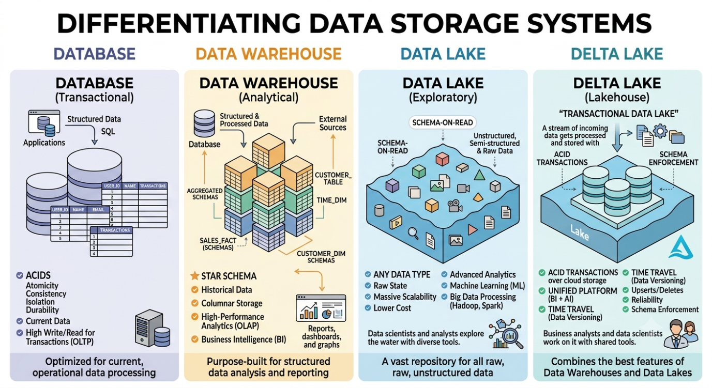

Here is a clear breakdown of how these four storage systems differ, moving from the most traditional transactional databases to modern hybrid architectures.

The Core Differences at a Glance
Feature | Database (OLTP) | Data Warehouse (OLAP) | Data Lake | Delta Lake (Lakehouse)
Primary Purpose | Day-to-day operations & business transactions. | Historical analysis & business intelligence. | Storing massive amounts of raw, diverse data cheaply. | Bringing reliability, safety, and speed to a Data Lake.
Data Type | Highly structured (Tables, Rows). | Highly structured & optimized (Star/Snowflake schema). | Any data (Structured, Semi-structured, Unstructured). | Any data, but organizes it into reliable, structured tables.
Data Quality | High (Strict validation rules). | Very High (Cleaned, transformed, curated). | Low to Medium (Raw, "as-is" data). | High (Enforces rules and fixes data corruption).
Users | Software applications, end-users, cashiers. | Data analysts, business executives. | Data scientists, big data engineers. | Data scientists, data engineers, and BI analysts.

1. Database (The Operational Engine)
A standard relational database is designed to handle immediate, real-time operations. Think of it as the system powering a bank's ATM or an e-commerce website's checkout cart.
- How it works: It processes millions of small transactions (reads and writes) every day. It uses ACID properties to guarantee that transactions are processed safely (e.g., if you transfer money, it leaves your account only if it successfully arrives in the destination account).
- Limitation: It is optimized for the present moment. If you try to run a massive query analyzing ten years of sales trends, it will slow down your operational application.

2. Data Warehouse (The Analyst's Library)
A Data Warehouse takes data from various databases, cleans it, structures it, and aggregates it specifically for complex analytical querying (OLAP).
- How it works: Data goes through an ETL (Extract, Transform, Load) pipeline. By the time the data lands in the warehouse, it is highly structured, perfectly formatted, and ready for tools like PowerBI or Tableau.
- Limitation: It is expensive to scale and rigid. If you suddenly want to store raw video files, social media audio streams, or unformatted PDF logs, a data warehouse cannot handle it efficiently.

3. Data Lake (The Massive Dumpster/Storage Room)
To solve the high cost and rigid structure of a data warehouse, the Data Lake was invented. It is a massive, inexpensive storage repository built on cloud storage (like AWS S3 or Azure ADLS).
- How it works: It accepts everything—structured tables, semi-structured JSON files, and completely unstructured data like images, logs, and videos. It uses a philosophy called Schema-on-Read, meaning you just dump the data raw and figure out how to parse it later when you actually need it.
- Limitation: Because there are no gatekeepers, data lakes easily turn into "Data Swamps." Files get corrupted, multiple people writing data at the same time cause conflicts, and there is no easy way to "undo" a bad data upload.

4. Delta Lake (The Best of Both Worlds)
A Delta Lake is an open-source storage layer that sits on top of your Data Lake to bring the reliability and structure of a Data Warehouse to the cheap scalability of a Data Lake. This hybrid concept is called a Lakehouse.
- How it works: It stores data in open file formats (like Parquet) but adds a hidden Transaction Log. This log acts like a master ledger, tracking every single change made to the files.
- Key Superpowers:
  - ACID Transactions: Ensures data pipelines never leave half-written or corrupted data in your lake.
  - Time Travel: Because of the log, you can query your data exactly as it looked at a specific timestamp in the past (data versioning).
  - Schema Enforcement: It rejects data that doesn't match your structural rules, preventing the lake from turning into a swamp.

Summary Analogy
- Database: The cash register at a grocery store tracking today's individual sales.
- Data Warehouse: A highly curated, neatly organized corporate spreadsheet tracking monthly revenue and profits across regions.
- Data Lake: A massive, chaotic warehouse where pallets of raw crops, unboxed goods, and random paperwork are dumped on the floor.
- Delta Lake: That same massive warehouse, but now run by a highly automated robotic management system that labels everything, prevents collisions, and tracks every item's history.

