Cloud Computing:

Cloud computing is defined by the International Organization for Standardization (ISO) as "a paradigm for enabling network access to a scalable and elastic pool of shareable physical or virtual resources with self-service provisioning and administration on demand".^{[1]} It is commonly referred to as "the cloud".^{[2]}

Cloud computing is the on-demand delivery of computing resources—such as servers, storage, databases, networking, software, and analytics—over the internet, with a pay-as-you-go pricing model. Instead of owning physical infrastructure, organizations rent resources from providers like AWS, Microsoft Azure, or Google Cloud.
Key Characteristics include:
- On-Demand Self-Service – Provision resources without human intervention.
- Broad Network Access – Accessible from any device via standard internet protocols.
- Resource Pooling – Multi-tenant model with dynamically assigned resources.
- Rapid Elasticity – Scale resources up or down quickly.
- Measured Service – Pay only for what you use.

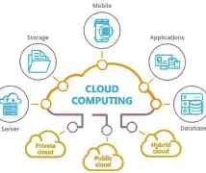
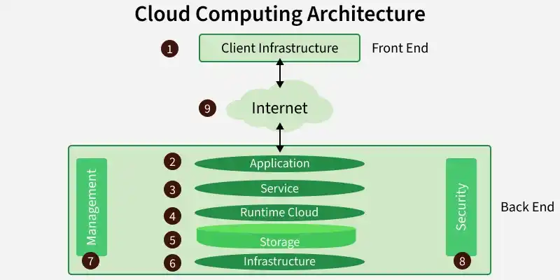

Advantages of Azure:

1. Scalability and Flexibility
One of the most compelling benefits of Microsoft Azure is its on-demand scalability. Azure's scalability ensures optimal performance without the need for over-provisioning infrastructure.
Additionally, Azure supports a flexible pay-as-you-go pricing model, making it ideal for startups, SMBs, and large enterprises alike. This flexibility allows businesses to experiment, innovate, and expand their operations without long-term financial commitments.

2. Global Reach and Availability
Azure boasts a massive global footprint, with data centers in over 60+ regions across the world — more than any other cloud provider. This global presence ensures low-latency access, data residency compliance, and business continuity for international organisations.
Whether your business operates in North America, Europe, Asia, or Africa, Azure offers localised services and ensures high availability with built-in redundancy and geo-replication capabilities

3. Robust Security Infrastructure
Security is a top priority for any organisation in the digital age. Microsoft Azure is built on a multi-layered security model that includes physical data center security, identity management, threat detection, and network protection.
Azure is also compliant with more than 100 industry standards and certifications, including ISO 27001, HIPAA, FedRAMP, GDPR, and SOC 1-3. It incorporates advanced security tools like Azure Defender for Cloud, Azure Defender, and Sentinel, providing real-time threat monitoring, AI-driven threat detection, and automated response capabilities.
Azure also leverages Microsoft’s $1 billion annual investment in cybersecurity R&D, ensuring customers benefit from state-of-the-art protection.

4. Seamless Integration with Microsoft Products
For organisations already invested in the Microsoft ecosystem (such as Office 365, Windows Server, Active Directory, or Dynamics 365), Azure offers seamless integration. This creates a unified IT environment, simplifying identity management, data sharing, and app development.
Microsoft Entra ID allows single sign-on (SSO) and multi-factor authentication (MFA), improving security while maintaining user convenience. Azure's tight integration with tools like Visual Studio, GitHub, and Power Platform also makes it an excellent choice for developers and DevOps teams.
This familiarity with Microsoft products reduces the learning curve and speeds up the transition to the cloud.

5. Advanced Analytics and Intelligence
Data-driven decision-making is central to digital transformation, and Azure provides an array of tools for analytics, AI, and machine learning. Services like Azure Synapse Analytics, Azure Data Lake, Azure Machine Learning, and Power BI empower businesses to extract insights from data and drive smarter business strategies.
Azure’s AI services include natural language processing, image recognition, bot services, and cognitive APIs — all powered by Microsoft’s industry-leading AI research. These capabilities enable organisations to build intelligent apps and automate business processes with ease.
Whether you're exploring big data, real-time analytics, or predictive modelling, Azure offers the tools to do it at scale.

6. Hybrid Cloud Capabilities
One of Azure’s standout features is its robust hybrid cloud support. With Azure Arc, Azure Stack, and Azure Site Recovery, organisations can seamlessly extend their on-premises data centers to the cloud.
Azure enables consistent application development, management, and security across on-premises, multi-cloud, and edge environments. This is critical for businesses with legacy systems, regulatory requirements, or data sovereignty needs.
Hybrid capabilities also allow businesses to modernise gradually, leveraging existing infrastructure while benefiting from the cloud's scalability and flexibility.

7. High Availability and Disaster Recovery
Downtime can be detrimental to business operations. Azure ensures 99.99% availability through its fault-tolerant architecture, load balancing, and automatic failover mechanisms.
Services like Azure Backup and Azure Site Recovery provide comprehensive disaster recovery solutions. These tools allow businesses to create automated backup schedules, geographically distributed replicas, and instant recovery options, ensuring business continuity even in the face of unexpected events.
By using Azure, organisations can meet their RTO (Recovery Time Objectives) and RPO (Recovery Point Objectives) with confidence and peace of mind.

8. Cost Efficiency and Transparent Pricing
Azure’s consumption-based pricing means you only pay for what you use, which can significantly reduce infrastructure costs. Azure offers tools like Azure Cost Management, Pricing Calculator, and Total Cost of Ownership (TCO) estimator to help businesses monitor, forecast, and optimise spending.
Azure also provides Reserved Instances, Spot pricing, and hybrid benefits that allow organisations to save up to 72% compared to pay-as-you-go pricing models. This flexibility in pricing makes Azure accessible to a wide range of businesses — from bootstrapped startups to multinational enterprises.
Moreover, Microsoft regularly updates Azure’s pricing and offers promotions, making cloud investment even more attractive and predictable.

9. Developer-Friendly Environment
Azure is a developer-centric platform that supports a wide variety of programming languages, frameworks, and tools. Whether you're working in .NET, Java, Python, Node.js, or PHP, Azure provides SDKs, APIs, and integrations that make development faster and more efficient.
Azure’s support for DevOps, CI/CD pipelines, and container orchestration (via Azure Kubernetes Service) ensures developers can build, test, and deploy applications quickly. Integration with GitHub Actions, Azure DevOps, and Terraform further streamlines the development lifecycle.
For teams embracing agile and DevOps practices, Azure is a natural choice.
What is Hosting in Azure?
Azure Hosting is a cloud-computing service offered by Microsoft that helps you access Virtual Machines, databases, networking, and advanced security systems to deploy, implement, and integrate your on-premises or public cloud workloads to Azure.
With Azure hosting, you get scalability, which means you can utilize the cloud resources based on the demand of your workloads, and pay for the resources you use. All-in-all, MS Azure helps you with a complete architecture to thrive your business operations with flexibility, at a cost-effective manner.

What Features Can You Get with Azure Hosting Services?

1. Azure Web Hosting
Microsoft Azure web hosting is classified into multiple sections, based on the two factors, i.e., who will manage functionality and who is responsible for managing infrastructure. For instance, if you opt for simplified hosting, then you need to focus on the functionality of a website, including code, and more, whereas Azure will manage the infrastructure.
The other ways for hosting web applications on Azure are Balanced, Controlled, Serverless, and Cloud Edge.
With Microsoft Azure web hosting, you can host a collection of websites to scale, manage, and configure them efficiently, and let them be grouped automatically in the Azure environment.

2. Azure Virtual Machine
Develop your apps or services on your preferred operating system using a range of VM-series. With Azure managed disks and the scalability feature, you can work flawlessly without worrying about data storage, as the disks are created and managed in the Azure environment automatically.
A virtual machine accessible from Azure cloud hosting is highly advanced, GPU-enabled helps you to perform your workloads effectively and manage them in real-time using the Azure Monitor feature.

3. Azure Kubernetes Service
Deploy and manage your containerized applications with ease using Azure Kubernetes Service (AKS). In this platform, you need to create a cluster, and thereafter, the node management task will be carried out by Azure. With the container insights feature, you can monitor the performance of clusters and limit the cluster resources by just integrating Kubernetes RBAC in the environment.

4. Azure Database Hosting
Azure offers multiple databases hosting services, including Database for MySQL, Database for PostgreSQL, SQL Database, Oracle Database, Azure Cosmos DB for NoSQL, and many more. With this range of databases embedded with AI, you can manage your data effectively.
Azure SQL database is ideal for PaaS, where you just need to focus on your core database. For faster app development with a single database embedded with automatic management and pitching, you can rely on Azure Cosmos DB.

5. Azure Backups
Store your data in a highly secure Recovery Service Vault of Azure using the backup feature. You can back up your on-premises, virtual machine, SQL database, and many more on the Azure cloud. Your data with Azure is in safe hands because it relies on multiple forms, including Locally Redundant Storage (LRS), Geo-redundant storage (GRS), and Zone-redundant storage (ZRS).
The existence of the backup copy is the basic difference between these three storages. LRS stores 3 copies locally, whereas GRS keeps your copies in different regions, and ZRS retains your backup copies in a zone that guarantees your data residency.
Iaas,Paas,Saas:
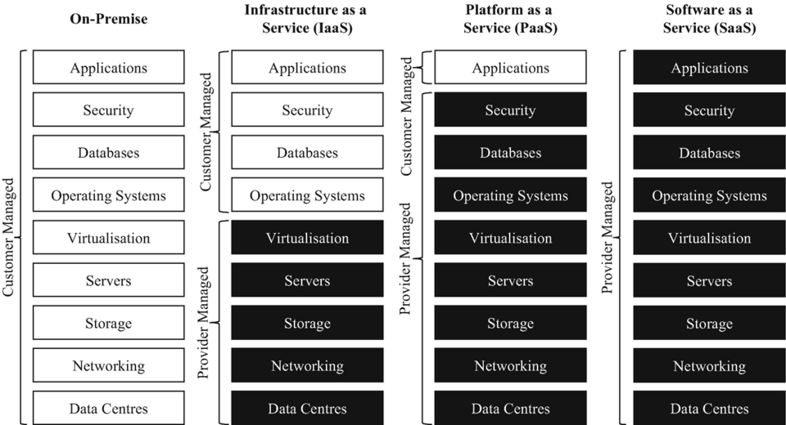

1. Infrastructure as a Service (IaaS)
IaaS provides virtualized computing resources such as servers, storage, and networking over the internet on a pay-as-you-go basis. It offers the highest level of control and flexibility, acting as the digital foundation for your IT operations.
How it works: It is like renting an empty plot of land. The provider gives you the space and the utilities (hardware, network, storage), but you are entirely responsible for building the house (installing the OS, middleware, and applications).
Characteristics:
- Eliminates the capital expense of buying physical servers.
- Offers complete control over operating systems, applications, and development frameworks.
- Resources can be scaled up or down instantly based on traffic spikes.
Real-World Use Case: A tech startup experiencing rapid growth can use IaaS to instantly increase their server capacity to handle web traffic without needing to purchase, house, or wire expensive physical hardware.
Target Audience: IT Administrators, Network Architects, and DevOps teams.
Popular Providers: Amazon Web Services (AWS EC2), Microsoft Azure (Virtual Machines), Google Compute Engine (GCE), DigitalOcean.

2. Platform as a Service (PaaS)
PaaS offers a complete, managed cloud environment specifically designed for developing, testing, running, and managing applications. It abstracts the underlying infrastructure so developers can focus purely on writing code.
How it works: It is like renting an unfurnished house. The foundation, plumbing, and electricity are already built and maintained by the landlord; you just need to bring your furniture and decorate (write and deploy your code).

Characteristics:
- Acts as a complete toolkit for developers, providing pre-built tools, libraries, and development environments.
- The cloud provider handles all backend infrastructure, including server provisioning, OS patching, and network routing.
- Automates deployment workflows and allows for easy team collaboration.
Real-World Use Case: A software development team building a mobile app can use PaaS to write their code and automatically connect it to managed databases and authentication services without ever having to configure a backend server.
Target Audience: Software Developers and Application Delivery Teams.
Popular Providers: AWS Elastic Beanstalk, Google App Engine, Heroku, Microsoft Azure App Service.

3. Software as a Service (SaaS)
SaaS is the most user-friendly and widely used cloud model. It delivers fully functional, ready-to-use software applications over the internet, typically on a subscription basis.
How it works: It is like staying in a fully furnished, serviced hotel room. Everything is provided, maintained, and cleaned for you; you simply walk in and use it.

Characteristics:
- Applications are ready to use immediately directly through a web browser or mobile app.
- The cloud provider handles absolutely everything: infrastructure, software updates, bug fixes, and security maintenance.
- Requires minimal technical expertise to operate.
Real-World Use Case: A global sales team uses a cloud-based CRM to track leads and communicate with clients. They simply log in via their browsers; they don't need to worry about where the data is hosted or how the software is updated.
Target Audience: End-users, Business Professionals, and Consumers.
Popular Providers: Salesforce, Google Workspace (Gmail, Docs), Microsoft 365, Zoom, Slack.

