Cluster-group of computer
Cluster manager - handle the group of worker node
Spark context- everything runs on context
Pyspark - Instead of using local computer we rely on the multiple computer server these group of computer called cluster and manager by the cluster manager.

Transforming – cleaning the data
Load- make sense out of the data
Outlier – something is abnormal

Use cases:
- Data Processing
- ETL
- Machine Learning
- Real Time Analytics – on the spot , Google login mail from different location and device
Benefits:
Scalabilty – as many servers and workers can be added
Fast
Versality
Cost efficient
Challenges:
Resource Management
Learning curve
Integeration with existing system
Ipynb-interactive python notebook

Big data primarily refers to data sets that are too large or complex to be dealt with by traditional data-processing software. Data with many entries (rows) offers greater statistical power, while data with higher complexity (more attributes or columns) may lead to a higher false discovery rate.^{[1]}
Big data encompasses three main categories:
- Structured data, which is organized and easy to query, such as rows in a customer database
- Unstructured data, which lacks a fixed format and often includes social media posts, video and audio files, photos, or emails
- Semi-structured data, which sits in between the previous two and often uses formats like JSON or XML that have some structure but not a rigid schema
5v’s
- Volume
- Volume is one of the top defining features of big data. In the past, businesses dealt with data measured in megabytes or gigabytes. Now, we’re talking about terabytes, petabytes, or even zettabytes—millions or billions of times larger.
- Streaming platforms, for example, like Netflix, store data on every show watched by millions of users every day. Similarly, telecom companies log trillions of phone calls and text messages. That’s volume.

Velocity
- Big data doesn’t just sit around waiting to be collected. It’s constantly flowing in, often in real time. This is what we refer to as velocity. Data is being generated nonstop from many sources: people shopping online, swiping on apps, streaming content, or using connected devices like smartwatches or industrial sensors.
- Self-driving cars, for example, rely on big data’s velocity and use the constant flow of data in real time in order to make decisions on the road. The challenge in this case is analyzing data quickly enough to respond in time.

Variety
- As mentioned earlier, not all data is the same: some of it is structured and fits neatly into tables, some is semi-structured and follows a loose format, and then there’s unstructured data that doesn’t follow any fixed layout.
- Big data brings all these types together, often within the same project. For example, a single marketing campaign might rely on structured data to track customer demographics, semi-structured data to understand user behavior on a website, and unstructured content like online reviews or shared videos to gauge public sentiment.
- 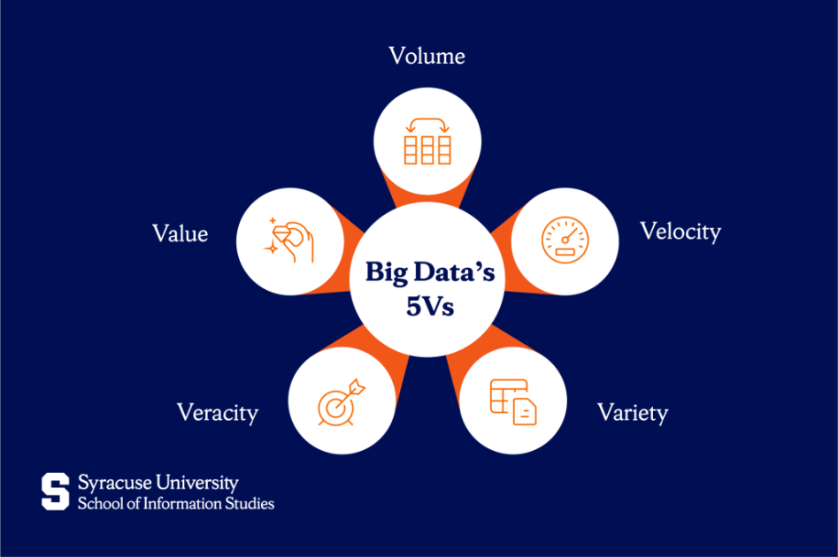

Veracity
- When data comes from many sources and at high velocity, there’s always a risk that some of it isn’t accurate. It might be outdated, incomplete, duplicated, or just plain wrong. This is the issue of veracity, or, to put it simply, how trustworthy the data is.
- Imagine a weather sensor that malfunctions and sends wrong temperature readings or a social media post that includes sarcasm but gets misinterpreted by an algorithm. Without knowing the data’s quality, it’s easy to come to the wrong conclusions. Because of this, big data systems must include processes to clean and verify the data before it’s used.

Value
- The whole purpose of working with data is to gain insights. Volume, speed, variety, and reliability are crucial for big data, but they don’t mean much unless that data can be used to improve decision-making, solve a problem, or provide some other valuable insight.
- Therefore, big data also prioritizes value. A retailer might find that certain products sell better together and use that insight to create promotions. This value is found in the ability to turn raw data into smarter choices.

Variability
- As a bonus “V,” variability refers to how inconsistent or unpredictable data can be. Sometimes, data behaves differently depending on the situation or context. For example, online conversations might spike suddenly during an event, or a word that means something positive today might mean something negative tomorrow.
- This change in context naturally affects how data should be interpreted. A sentiment analysis tool, for instance, needs to understand that the same phrase might carry a different tone

Pyspark:
PySpark is the Python API for Apache Spark, designed for big data processing and analytics. It lets Python developers use Spark's powerful distributed computing to efficiently process large datasets across clusters. It is widely used in data analysis, machine learning and real-time processing.
Important Facts to Know
- Distributed Computing: PySpark runs computations in parallel across a cluster, enabling fast data processing.
- Fault Tolerance: Spark recovers lost data using lineage information in resilient distributed datasets (RDDs).
- Lazy Evaluation: Transformations aren’t executed until an action is called, allowing for optimization.

PySpark lets you use Python to process and analyze huge datasets that can’t fit on one computer. It runs across many machines, making big data tasks faster and easier. You can use PySpark to:
- Perform batch and real-time processing on large datasets.
- Execute SQL queries on distributed data.
- Run scalable machine learning models.
- Stream real-time data from sources like Kafka or TCP sockets.
- Process graph data using GraphFrames.
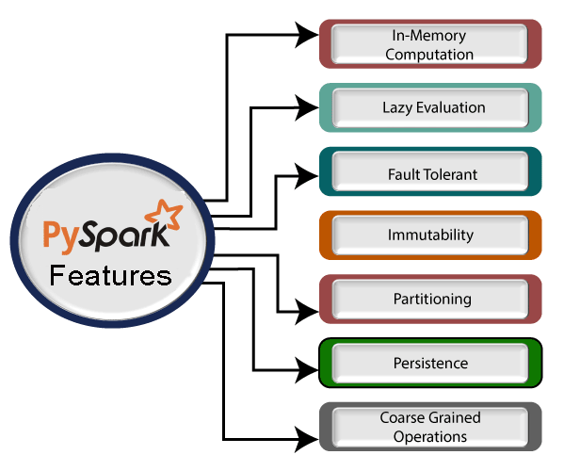

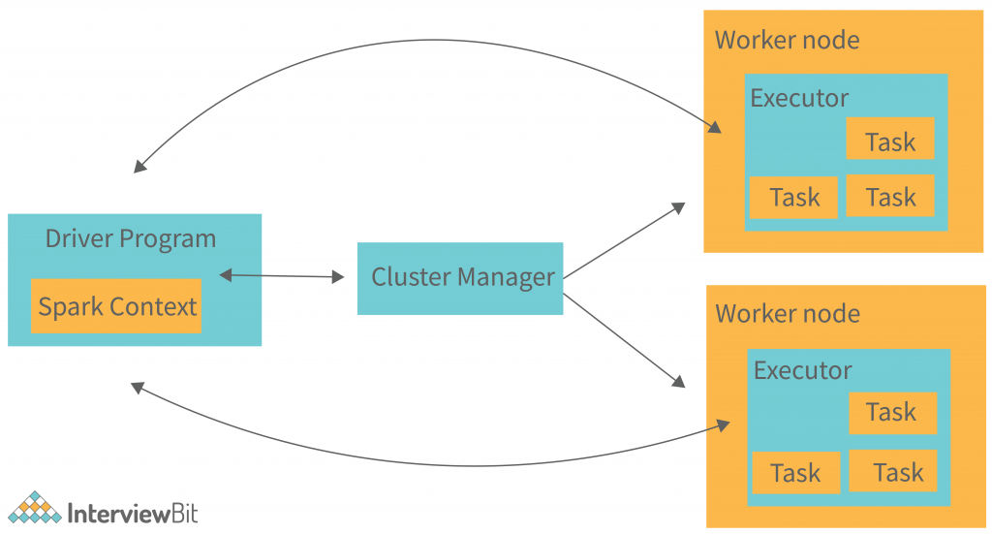

The Spark driver
The master node (process) in a driver process coordinates workers and oversees the tasks. Spark is split into jobs and scheduled to be executed on executors in clusters. Spark contexts (gateways) are created by the driver to monitor the job working in a specific cluster and to connect to a Spark cluster. In the diagram, the driver programmes call the main application and create a spark context (acts as a gateway) that jointly monitors the job working in the cluster and connects to a Spark cluster. Everything is executed using the spark context.
Each Spark session has an entry in the Spark context. Spark drivers include more components to execute jobs in clusters, as well as cluster managers. Context acquires worker nodes to execute and store data as Spark clusters are connected to different types of cluster managers. When a process is executed in the cluster, the job is divided into stages with gain stages into scheduled tasks.

The Spark executors
An executor is responsible for executing a job and storing data in a cache at the outset. Executors first register with the driver programme at the beginning. These executors have a number of time slots to run the application concurrently. The executor runs the task when it has loaded data and they are removed in idle mode. The executor runs in the Java process when data is loaded and removed during the execution of the tasks. The executors are allocated dynamically and constantly added and removed during the execution of the tasks. A driver program monitors the executors during their performance. Users’ tasks are executed in the Java process.

Cluster Manager
A driver program controls the execution of jobs and stores data in a cache. At the outset, executors register with the drivers. This executor has a number of time slots to run the application concurrently. Executors read and write external data in addition to servicing client requests. A job is executed when the executor has loaded data and they have been removed in the idle state. The executor is dynamically allocated, and it is constantly added and deleted depending on the duration of its use. A driver program monitors executors as they perform users’ tasks. Code is executed in the Java process when an executor executes a user’s task.

Worker Nodes
The slave nodes function as executors, processing tasks, and returning the results back to the spark context. The master node issues tasks to the Spark context and the worker nodes execute them. They make the process simpler by boosting the worker nodes (1 to n) to handle as many jobs as possible in parallel by dividing the job up into sub-jobs on multiple machines. A Spark worker monitors worker nodes to ensure that the computation is performed simply. Each worker node handles one Spark task. In Spark, a partition is a unit of work and is assigned to one executor for each one.

What is SparkSession?
`SparkSession` is the entry point to programming with Spark. It provides a single point of entry to interact with Spark functionality and to create DataFrame and DataSet.

Why use SparkSession?
1. Unified Interface: It combines the old `SQLContext`, `HiveContext`, and `SparkContext` into a single point of entry.
2. Ease of Use: Simplifies the process of starting and configuring a Spark application.
Example:
Here’s how to create a `SparkSession` in PySpark:
— — — — — — — — — — — — — — — — — — — — — — -python
from pyspark.sql import SparkSession
#Create a SparkSession
spark = SparkSession.builder \
.appName(“example_spark_session”) \
.getOrCreate()
— — — — — — — — — — — — — — — — — — — — — — -
Cluster mode: Cluster mode is the most frequent way of running Spark Applications. In cluster mode, a user delivers a pre-compiled JAR, Python script, or R script to a cluster manager. Once the cluster manager receives the pre-compiled JAR, Python script, or R script, the driver process is launched on a worker node inside the cluster, in addition to the executor processes. This means that the cluster manager is in charge of all Spark application-related processes.
Client mode: In contrast to cluster mode, where the Spark driver remains on the client machine that submitted the application, the Spark driver is removed in client mode and is therefore responsible for maintaining the Spark driver process on the client machine. These machines, usually referred to as gateway machines or edge nodes, are maintained on the client machine.

