What is Devops?
DevOps is a practice that combines development and operations to build, test and release software faster and more reliably. It focuses on automation, collaboration and continuous delivery to improve software quality and speed.
- Helps teams release software faster with automation
- Reduces manual errors and improves reliability
- Enables continuous integration and deployment
- Improves collaboration between development and operations teams

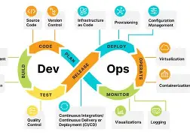

Tools in particular area used in Devops
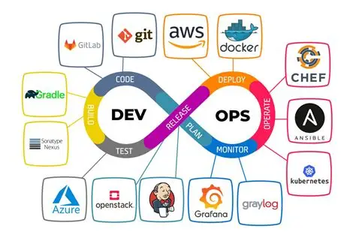

Core Principles
  - Collaboration and Culture: DevOps promotes cross-team communication, shared ownership, and a customer-first focus, ensuring all roles contribute to planning, development, delivery, and operations
  - Automation: Automating repetitive tasks such as builds, tests, deployments, and monitoring reduces errors and accelerates delivery
  - Continuous Integration and Delivery (CI/CD): Code changes are automatically integrated, tested, and deployed to multiple environments, enabling faster and more reliable releases
  - Rapid Feedback and Monitoring: Continuous monitoring and feedback loops help detect issues early, improve quality, and maintain system reliability .
  - Agility and Continuous Improvement: DevOps encourages iterative development, frequent releases, and adaptation based on user feedback

DevOps Lifecycle
The DevOps lifecycle spans multiple phases:

- Planning: Define requirements, prioritize tasks, and align with business goals.
- Development: Write and manage code using version control systems like Git.
- Build and Test: Automate builds and run tests to ensure code quality.
- Release and Deployment: Deploy applications to production environments using automated pipelines.
- Operations and Monitoring: Monitor performance, detect issues, and provide feedback for continuous improvement.

Benefits of DevOps

- Faster Time-to-Market: Accelerates software delivery through automation and continuous deployment.
- Improved Quality and Reliability: Early detection of issues and automated testing enhance code quality.
- Enhanced Collaboration: Breaks down silos between teams, fostering shared responsibility.
- Scalability and Flexibility: Supports cloud-native development and integration with AI tools like GitHub Copilot
- Security Integration: DevSecOps ensures security is embedded throughout the development lifecycle

1. Stabilizes the Workplace
DevOps reduces the stress of constant updates and changes. This creates a more stable work environment. Quick DevOps feedback loops and efficient processes help teams work together smoothly, keeping operations balanced.

2. Enables Faster Deployment
Faster deployment lets you launch new features and improvements more often. This keeps customers happy and helps you stay competitive. DevOps streamlines deployment, making updates consistent and reliable.

3. Improves Product Quality
DevOps builds better products by gathering feedback frequently and testing throughout development. Automation ensures issues are caught early. This lets teams focus on delivering high-quality features and reduces costly fixes.

4. Quick and Reliable Issue Resolution
DevOps makes problem-solving faster and more reliable. Continuous monitoring and smaller, frequent releases help teams catch and fix issues quickly. This reduces downtime and keeps software running smoothly.

5. Increases Agility and Flexibility
DevOps encourages collaboration across teams, breaking down silos and creating flexibility. This adaptable work environment lets companies respond to changes quickly and stay competitive.

6. Encourages Innovation with Automation
By automating repetitive tasks, DevOps frees up teams to think creatively. With fewer manual tasks to manage, developers can focus on new ideas and innovations, making work more rewarding.

7. Ensures Continuous Delivery
DevOps enables teams to deliver updates and new features continuously by making quality and reliability a shared priority.
With automated testing, streamlined workflows, and close collaboration, each code change is thoroughly tested and quickly deployed. This approach allows organizations to release updates at a faster pace, providing users with frequent improvements while maintaining stability and minimizing risk.

8. Reduces Production Costs
DevOps combines updates and maintenance, improving coordination and reducing costs. By preventing costly rework, DevOps makes better use of resources. This boosts productivity and profitability.

9. Maximizes Productivity with Transparency
DevOps fosters open communication and collaboration. It reduces time spent on redundant tasks. When everyone can work on what matters, productivity goes up, and team members find more meaning in their work.

10. Minimizes Errors
DevOps catches mistakes early with frequent code releases and continuous testing. The shorter development cycle allows issues to be identified and fixed quickly. This helps teams avoid major problems and maintain software quality.

11. Enhanced Security and Compliance
DevOps integrates security practices (DevSecOps) throughout the development lifecycle. It ensures that security is prioritized from the start.
Automated compliance checks and security protocols protect sensitive data, reducing vulnerabilities and safeguarding the software.

12. Increased Customer Satisfaction
By accelerating release cycles and responding quickly to user feedback, DevOps helps deliver a more user-focused product.
Continuous updates and improvements increase customer satisfaction as end-users receive new features and bug fixes more frequently.

13. Improved Collaboration Across Teams
DevOps creates a culture of shared responsibility and open communication between development, operations, and other teams.
This collaboration reduces bottlenecks and creates a more cohesive environment. This allows teams to work together more effectively and productively.

14. Streamlined Resource Management
With automation and streamlined workflows, DevOps helps teams use resources wisely. By cutting out repetitive tasks and optimizing processes, organizations can save time and make better use of their infrastructure and talent.

15. Continuous Monitoring and Real-Time Insights
DevOps includes continuous monitoring tools that provide real-time feedback on system performance and user interactions. Teams can spot and address issues immediately, leading to a smoother, more reliable user experience.
Agile Methodology is a way to manage projects by breaking them into smaller parts. It focuses on working together and making constant improvements. Teams plan, work on the project, and then review in a repeating cycle.
- It focuses on delivering smaller pieces of work regularly instead of one big launch.
- This allows teams to adapt to changes quickly and provide customer value faster.
- Major companies like Facebook, Google, and Amazon use Agile because of its adaptability and customer-focused approach.
- Prioritize flexibility, collaboration, and customer satisfaction.
- In the traditional waterfall model, we first get all client requirements and do not allow changes during the project. Please refer Agile vs Tradition Waterfall for details.

Key Principles of Agile Methodology
Agile is guided by 12 simple principles that help teams work better, adapt quickly, and deliver value to customers. These focus on collaboration, flexibility, and continuous improvement.
- Customer Satisfaction: Deliver valuable software early and continuously to keep customers happy.
- Welcome Change: Accept changing requirements even in later stages of development.
- Frequent Delivery: Deliver working software in short, regular intervals.
- Collaboration: Ensure daily cooperation between business teams and developers.
- Motivated Teams: Build projects around skilled, trusted, and motivated individuals.
- Face-to-Face Communication: Prefer direct communication for better clarity and understanding.
- Working Software: Measure progress based on functional software, not just documentation.
- Sustainable Pace: Maintain a consistent and manageable development speed.
- Technical Excellence: Focus on good design and high-quality coding practices.
- Simplicity: Minimize unnecessary work and keep solutions simple.
- Self-Organizing Teams: Encourage teams to take ownership and make decisions.
- Continuous Improvement: Regularly reflect and improve processes for better results.

What is scrum?
Scrum is a widely used Agile framework for managing complex projects, especially in software development. It helps teams collaborate, adapt to change, and deliver high-quality results efficiently.
- Breaks work into small iterations called sprints for step-by-step delivery.
- Promotes collaboration, continuous feedback, and improvement.
- Developed by Ken Schwaber and Jeff Sutherland in the early 1990s.

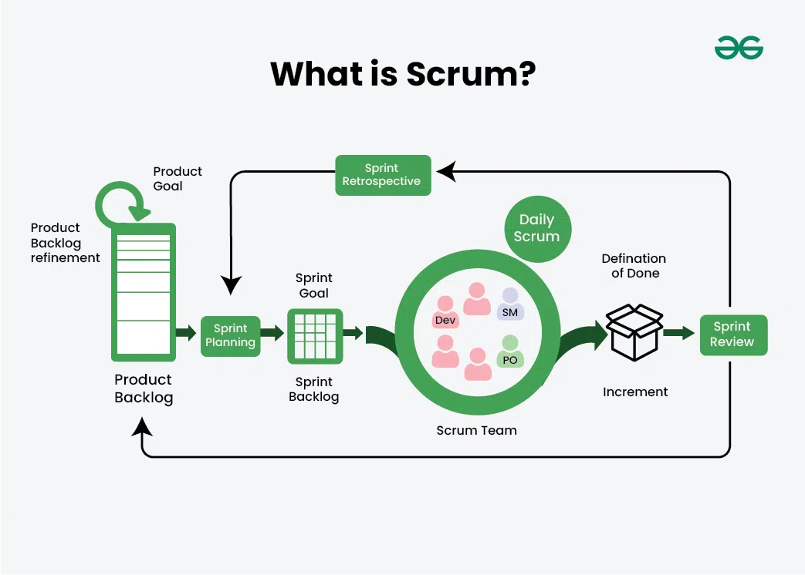
In Scrum, the term "Scrum meeting" usually refers to one of the four formal, recurring events (plus the backlog refinement) that structure a sprint. Each serves a specific purpose to keep the team aligned, unblocked, and continuously improving.
Here is a breakdown of what makes each of these meetings important and what should happen during them:

1. Daily Scrum (The Standup)
This is a quick, 15-minute daily check-in for the developers to align on the next 24 hours. It is not a status report for managers, but a planning session for the team.
- What makes it important: It flags blockers early and ensures the team is collaborating, not working in silos.
- The Focus:
  - What did I do yesterday that helped the team meet the Sprint Goal?
  - What will I do today to help the team meet the Sprint Goal?
  - Do I see any impediments (blockers) preventing me or the team from meeting the Sprint Goal?

2. Sprint Planning
Held at the very beginning of a sprint, this meeting defines what can be delivered in the upcoming sprint and how that work will be achieved.
- What makes it important: It establishes a clear focus and a realistic commitment for the next few weeks.
- The Focus:
  - The Why: What is the Sprint Goal?
  - The What: Which items from the Product Backlog are we pulling into this sprint?
  - The How: How are we going to build these items? (Breaking stories down into tasks).

3. Sprint Review (The Demo)
Held at the end of the sprint, the team showcases what they actually "Done" to stakeholders and gets immediate feedback.
- What makes it important: It builds trust with stakeholders and ensures the product is moving in the right direction based on real feedback.
- The Focus:
  - Demonstrating the working increment of the product.
  - Discussing what went well and what challenges were faced.
  - Collaborating on what to do next based on feedback and any changes to the market.

4. Sprint Retrospective
This happens at the very end of the sprint, after the review but before the next planning session. It’s an internal meeting for the Scrum Team to inspect itself and create a plan for improvements.
- What makes it important: This is the core driver of continuous improvement (kaizen) in Agile. Without it, teams repeat the same mistakes.
- The Focus:
  - What went well regarding people, relationships, process, and tools?
  - What didn't go so well or could be improved?
  - Actionable steps: Committing to 1–2 concrete improvements to implement in the next sprint.
💡 The Golden Rule of Scrum Meetings: Every meeting must have a clear relationship to the Sprint Goal. If the discussion doesn't help the team move closer to delivering that goal or improving how they work together, it should be taken offline.

