The 13 essential types of meetings
Below are 13 meeting types that cover most workplace needs.

1. The status update meeting/Daily Stand up meetings
Let’s start with the classic: the status update. This meeting should be treated less like a casual chat and more like a Formula 1 pit stop; fast, precise, and focused only on what matters right now. If it requires a projector and comfortable seating, you’re doing it wrong.
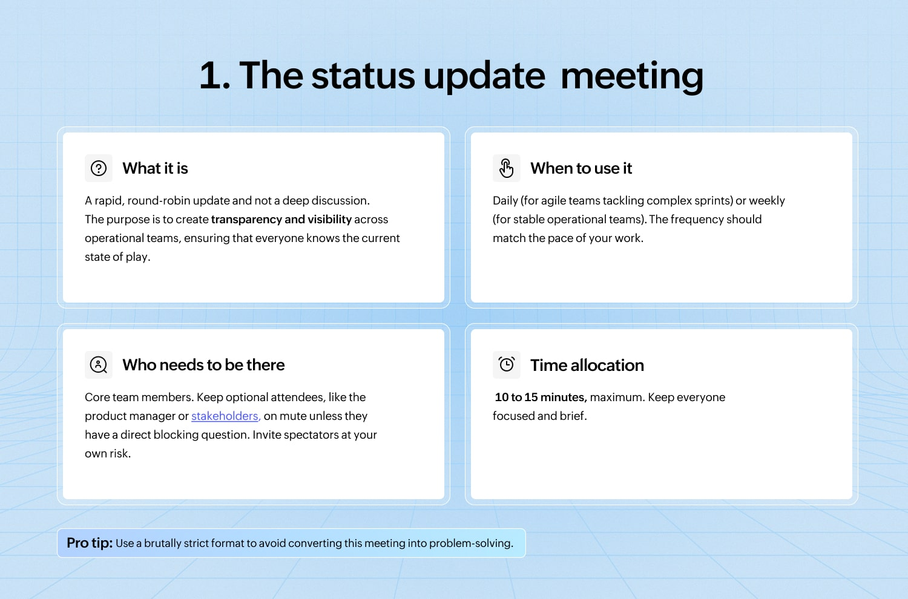
The agenda
Each team member answers only these three things:
- What did I accomplish since the last update? (The win.)
- What will I focus on today/next? (The commitment.)
- What are my blockers? (The problem I need help with.)

2. The planning and strategy meeting
The planning and strategy meeting is where you lay the tracks before the train leaves the station. Fail here, and the entire team will spend the next quarter sprinting in beautifully coordinated, but ultimately wrong, directions.
It is crucial for the execution of the whole project breaking down the epics with the brainstroming sessions for features and the tasks.
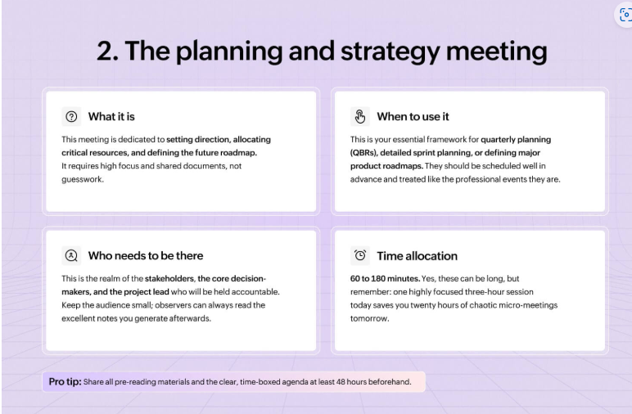

3. The brainstorming/ideation meeting
The brainstorming meeting is where the magic (and sometimes utter madness) happens. The goal here is simple: generate as many ideas as humanly possible, regardless of how ridiculous they initially sound.

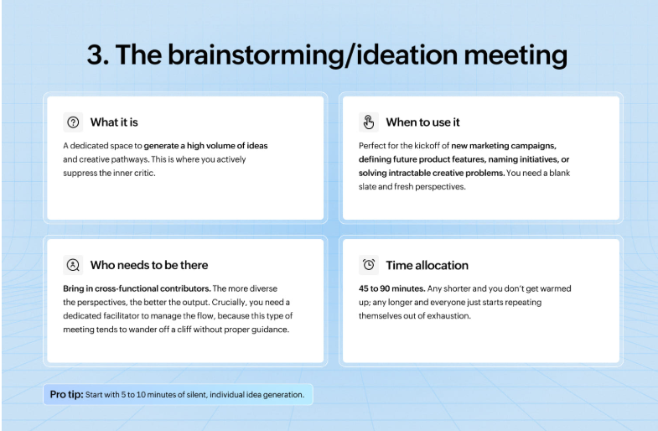

The decision-making meeting

This meeting is where the talking ends and the action begins. The decision-making meeting isn’t the place to generate options; it’s the place to kill off the bad ones and commit to the best one.

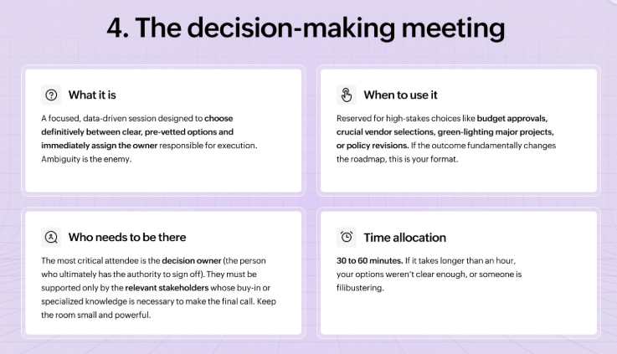

5. The problem-solving meeting
When things have gone spectacularly wrong—a production outage, a massive customer escalation, or a process failure—you need the problem-solving meeting.
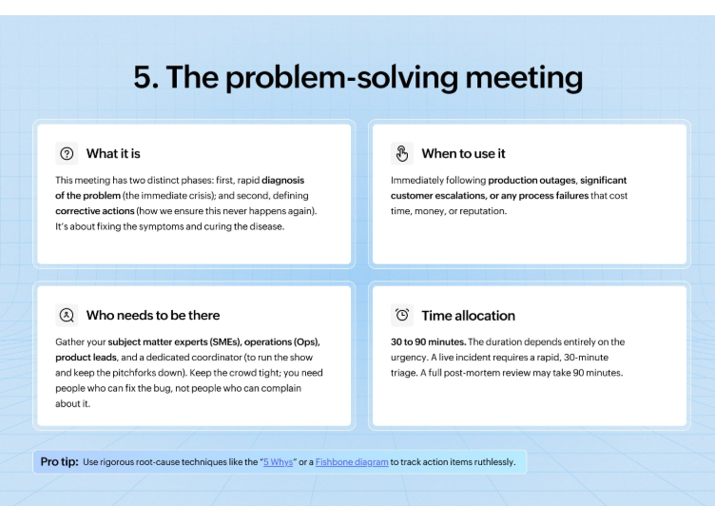

6. The training and onboarding session
This is where you officially transform a bright-eyed new hire into a competent member of the organization. If done poorly, you can end up overwhelming them until they quietly retreat to the comfort of their old job applications.
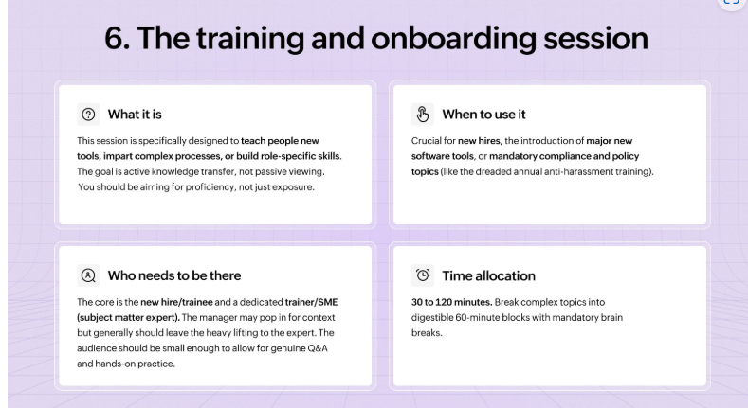

7. The one-on-one meeting
The 1:1 isn’t just an informal chat; it’s a dedicated investment in professional development, stress reduction, and crucial feedback exchange.

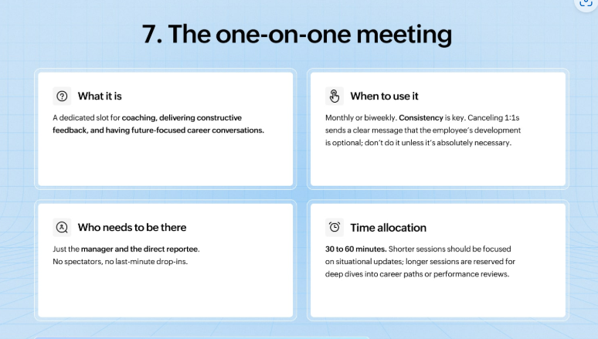

8. The client/sales meeting
Client and sales meetings require a delicate balance of professional polish, strategic preparation, and just enough charisma to seal the deal.
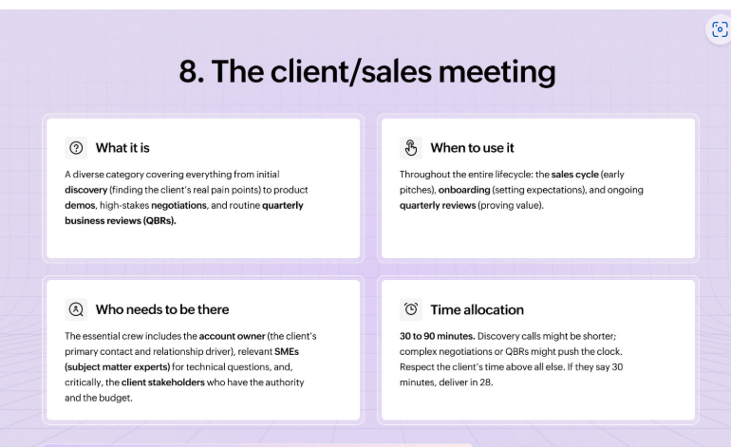

9. The retrospective meeting
The retrospective meeting is where we collectively stop, breathe, and confess our sins. The core purpose is to learn, not to point fingers.
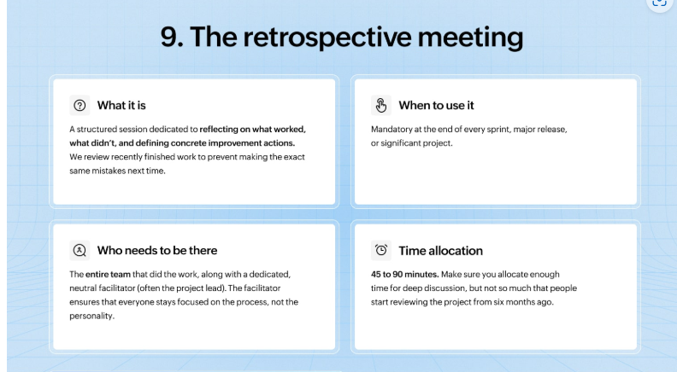

10. The town hall meeting
The town hall meeting is where the entire organization theoretically aligns on vision and celebrates success.
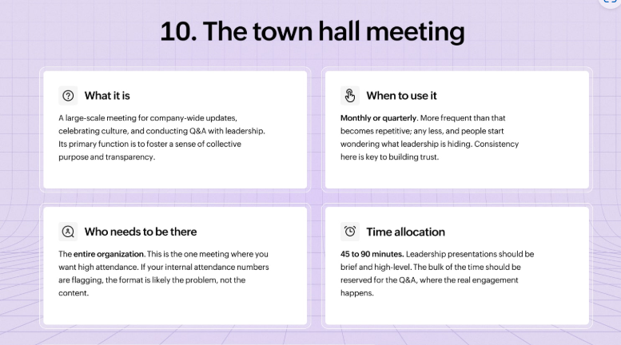

11. The creative review meeting
The creative review meeting must be a space for brutal honesty without becoming a personal attack. This is where creative work—be it a marketing campaign, a new UI design, or a complex data visualization—is put under the microscope.

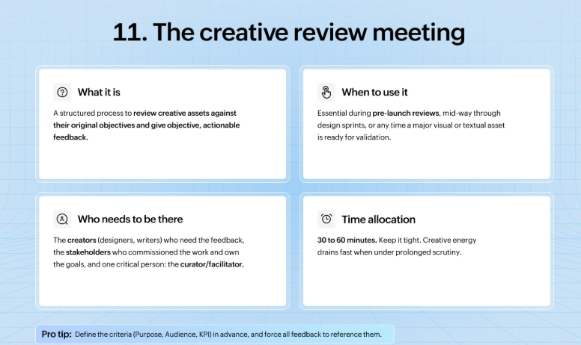

12. The crisis/incident response meeting
When the proverbial server is actively on fire, the client is on the phone screaming, or the CEO just sent an all-caps email, you enter the crisis response meeting, often affectionately called the “war room.” It’s a time for rapid coordination, clear command, and saving the day.
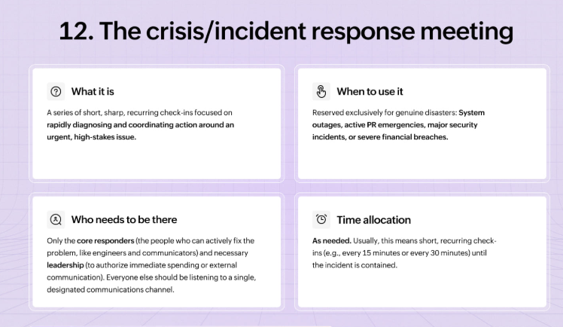

13. The cross-functional sync meeting
The cross-functional sync is the meeting dedicated to ensuring that the marketing team isn’t launching a product that the engineering team hasn’t actually finished, and that sales isn’t selling a feature the legal team hasn’t approved.
This meeting is crucial for large organizations; it’s the glue that prevents internal chaos.
