Elevation QA Review Report

Project: Contract ID:

Liaison: Partner(s): Contractor:

Data Delivery Date: Date Data Reviewed:

Reviewer: Total Square Miles Reviewed:

Elevation Type: Format: Grid Spacing: Tile size:

Projection: Zone: Datum: Units:

Licensing: Metadata:

Materials Received:

Vertical Accuracy Test Performed: Test Point Source: RMSE:

Vertical Accuracy Test Notes:

QA Review Summary:

Yukon Flats AK.

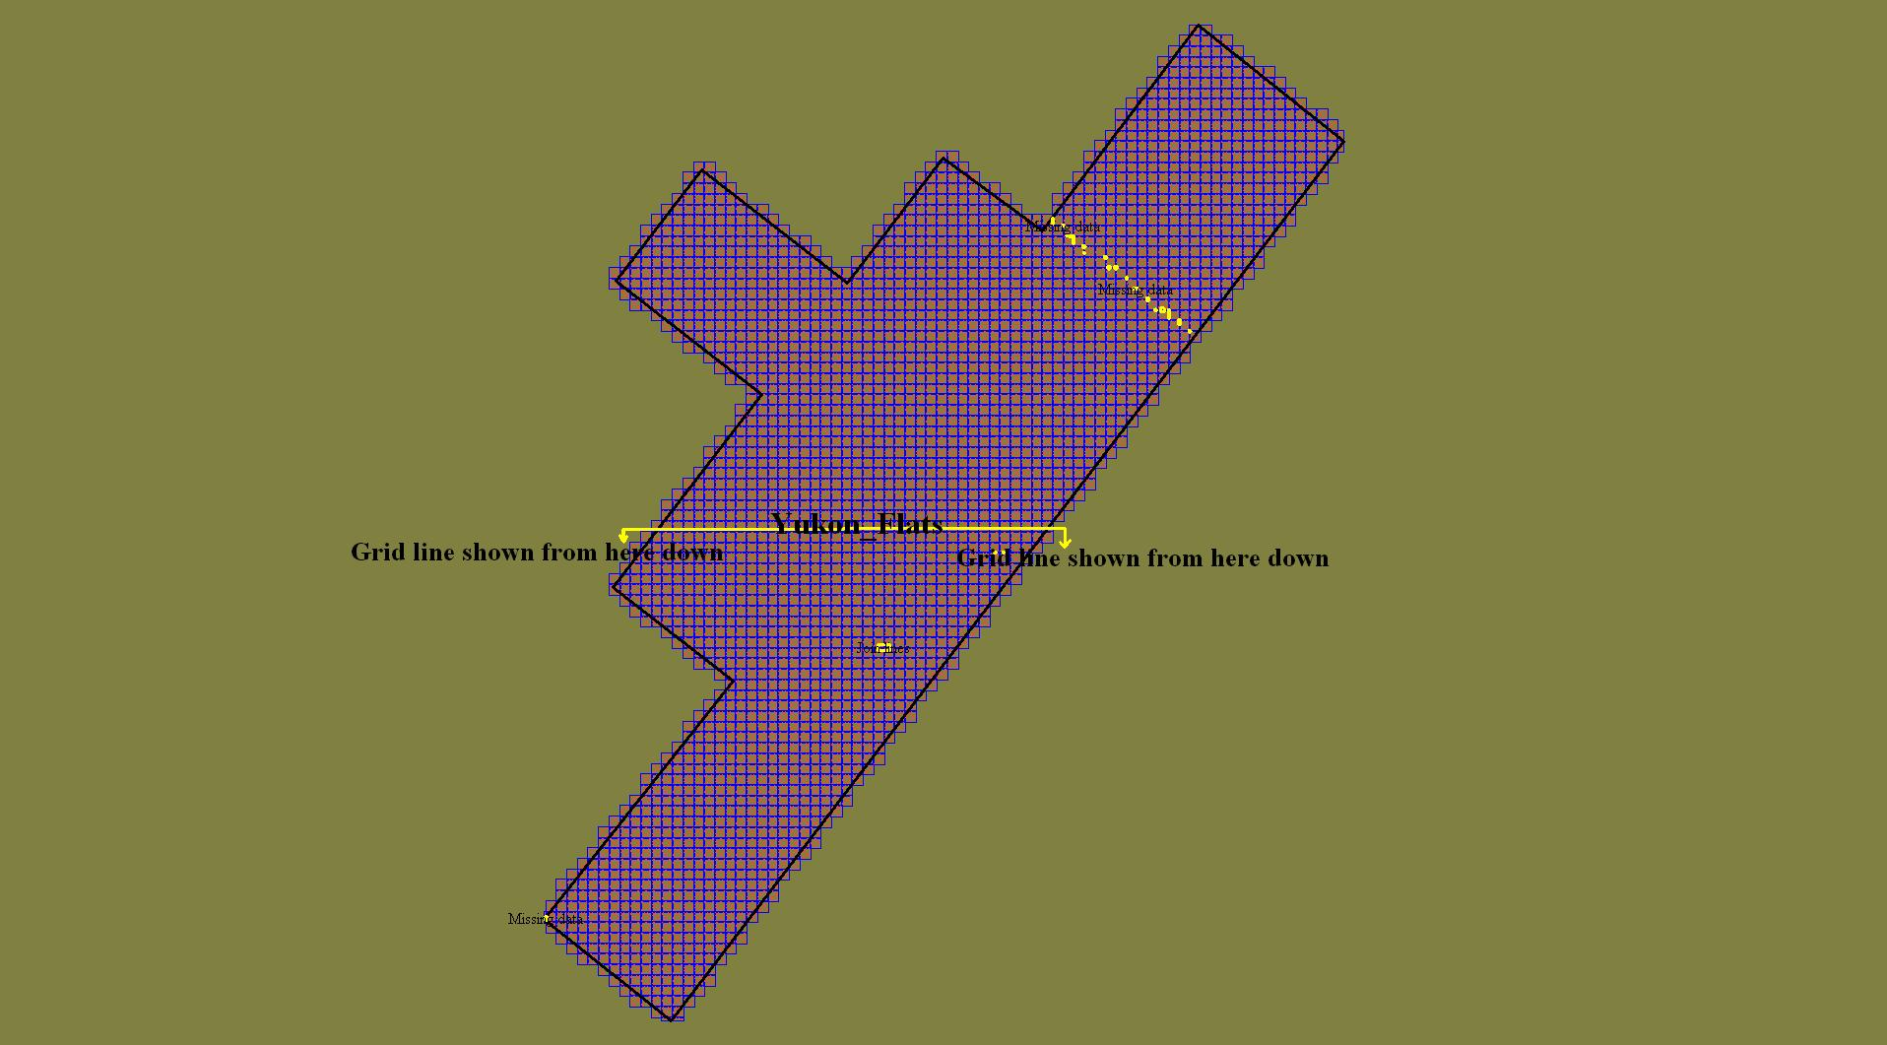

Yukon Flats AK. seam lines 1

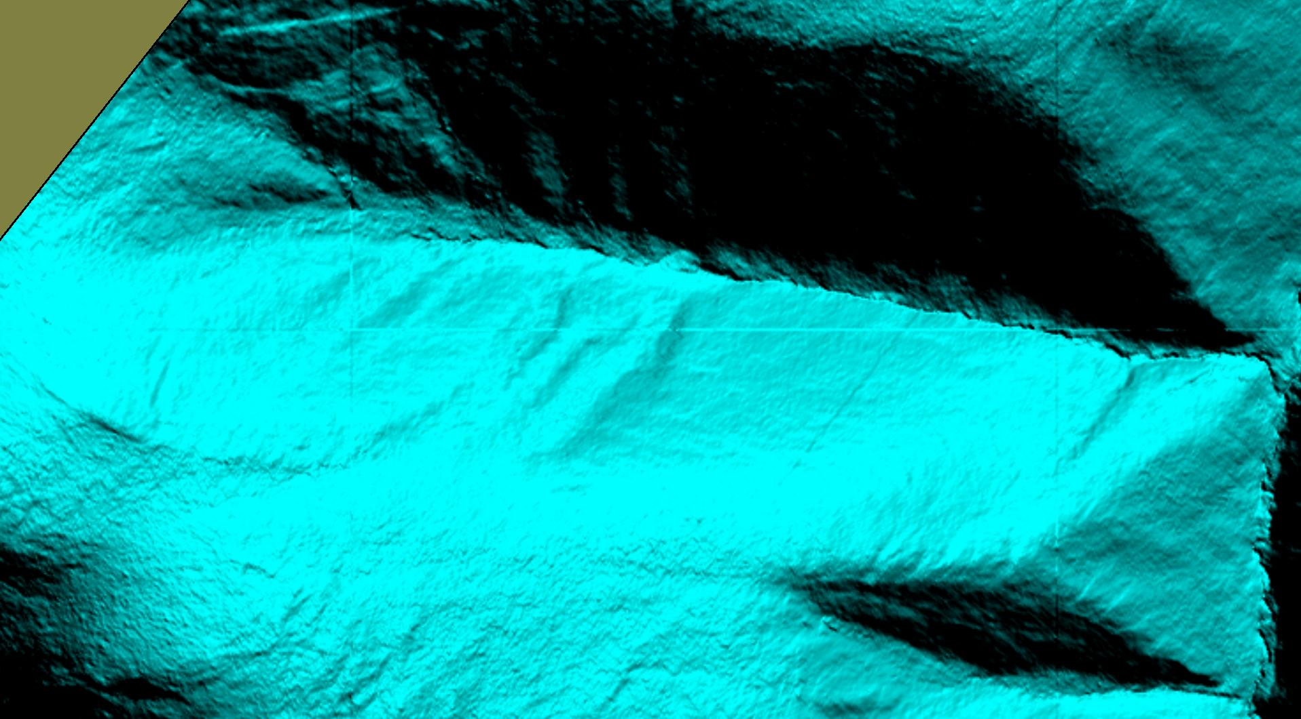

Yukon Flats AK. Seam lines 2

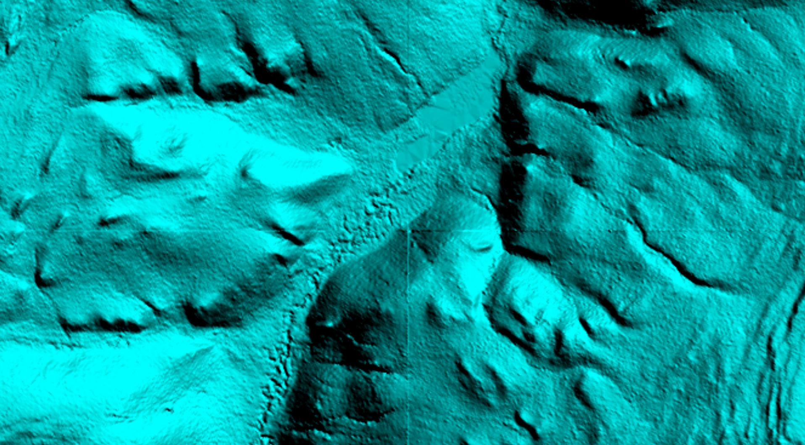

Yukon Flats AK. Seam lines 2

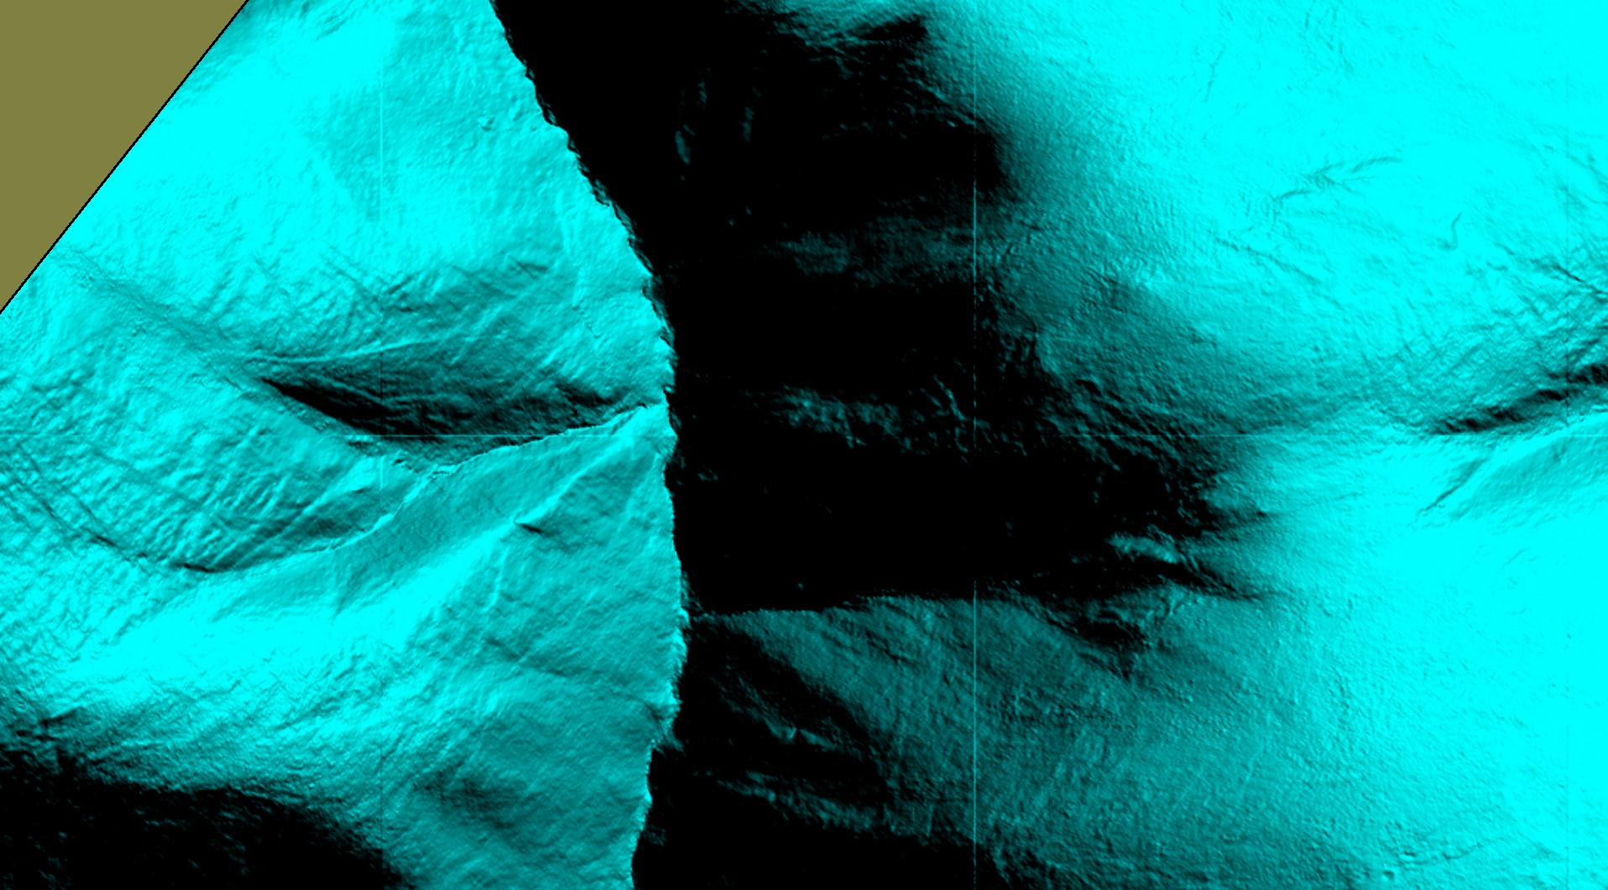

Yukon Flats AK. Missing data

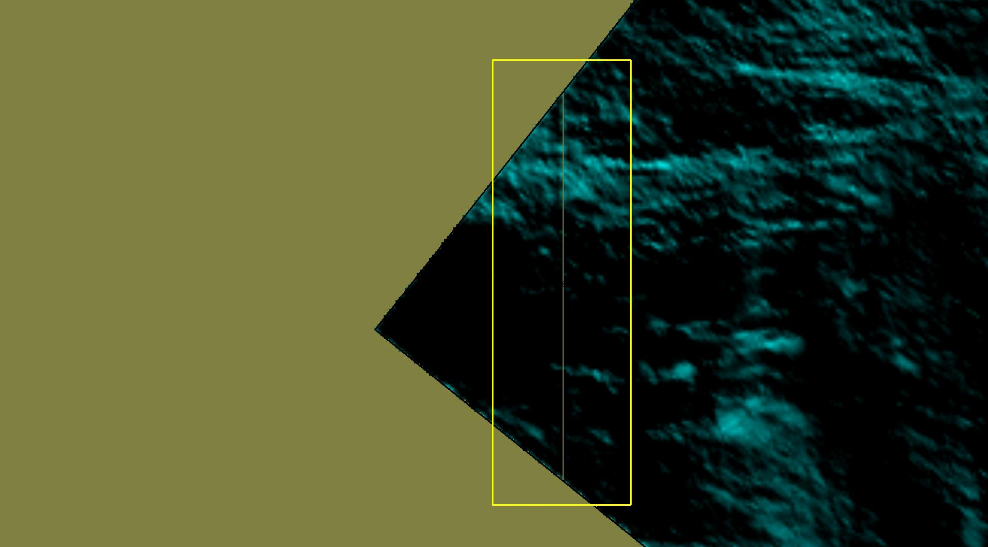

Yukon Flats AK. Missing data fixed

