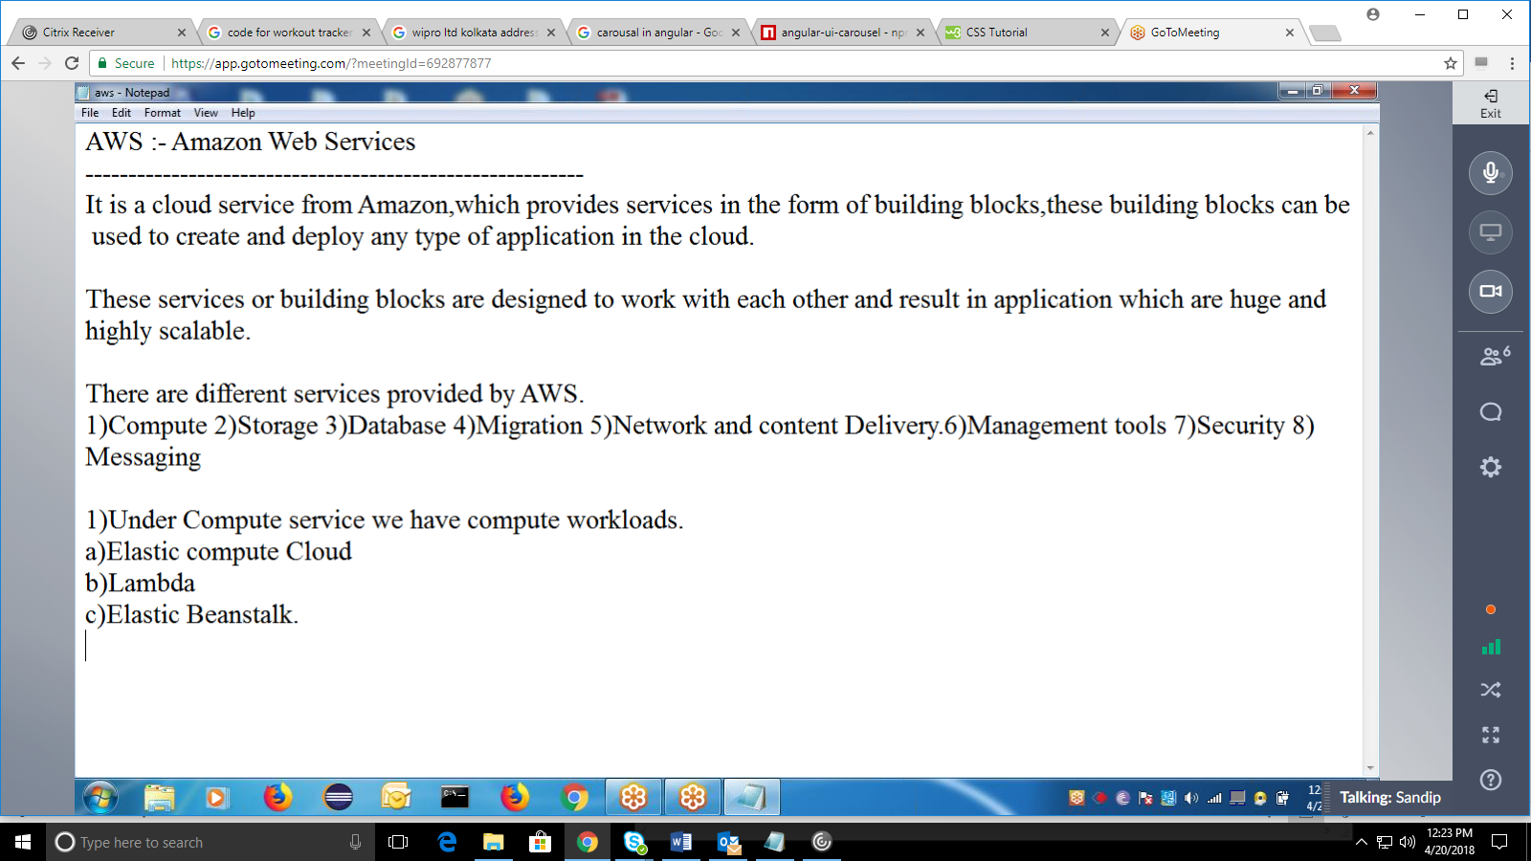

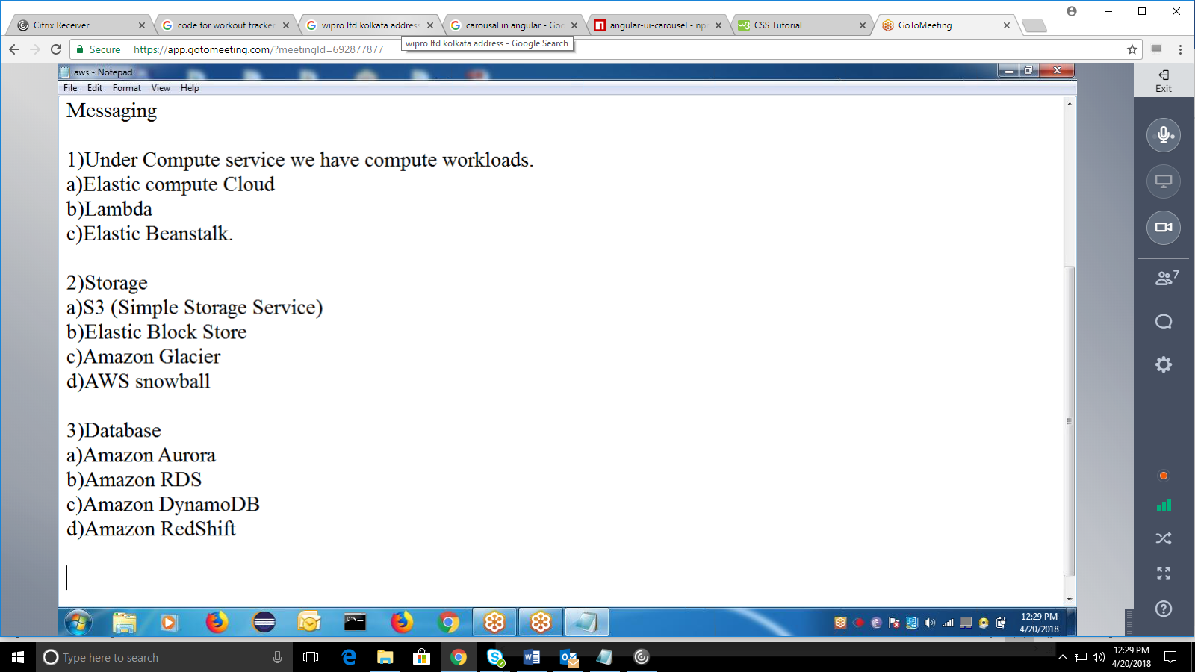

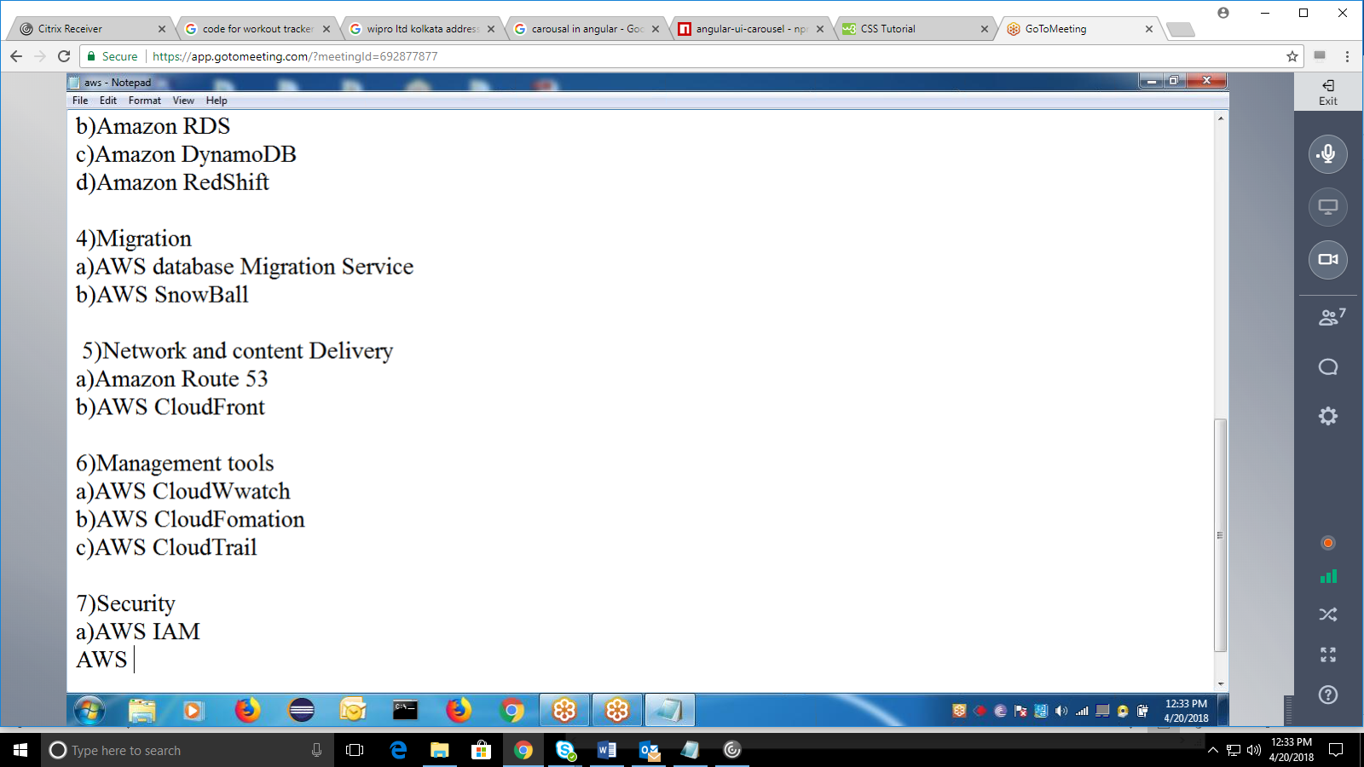

04/25/2018:

<https://github.com/sandipmohapatra/sandipSpring>

[www.aws.amazon.com](http://www.aws.amazon.com/)  
[www.mlab.com](http://www.mlab.com/)