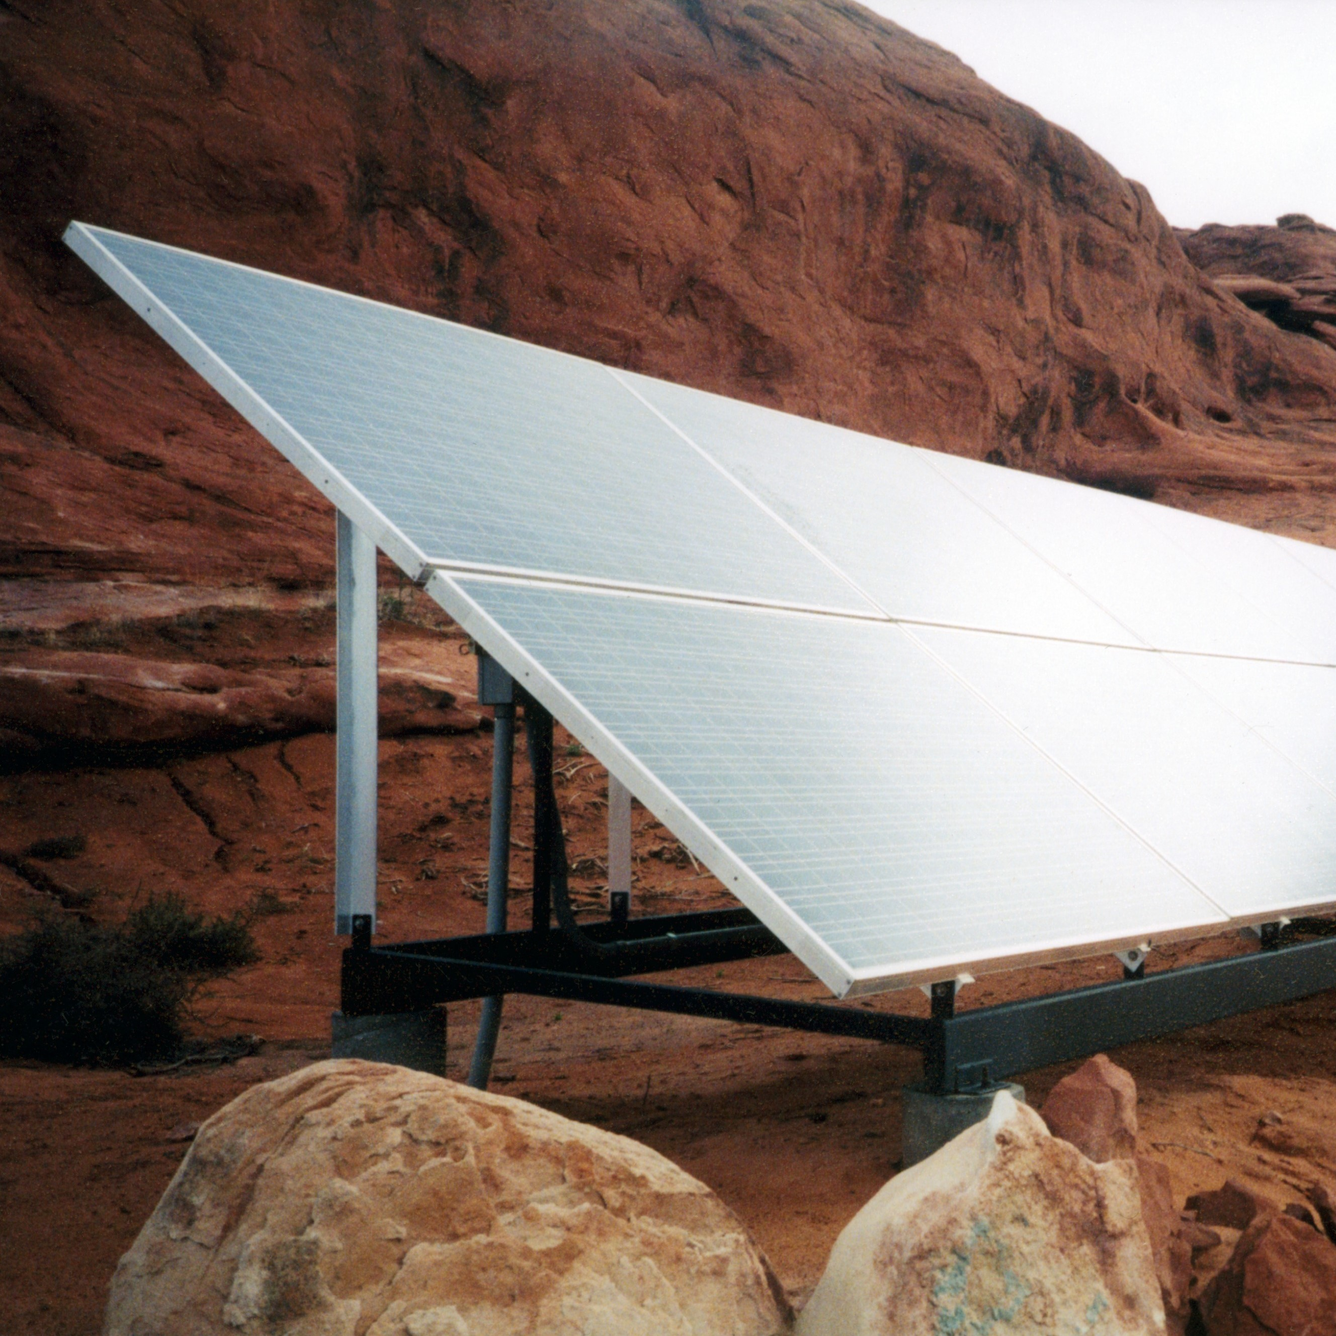 | 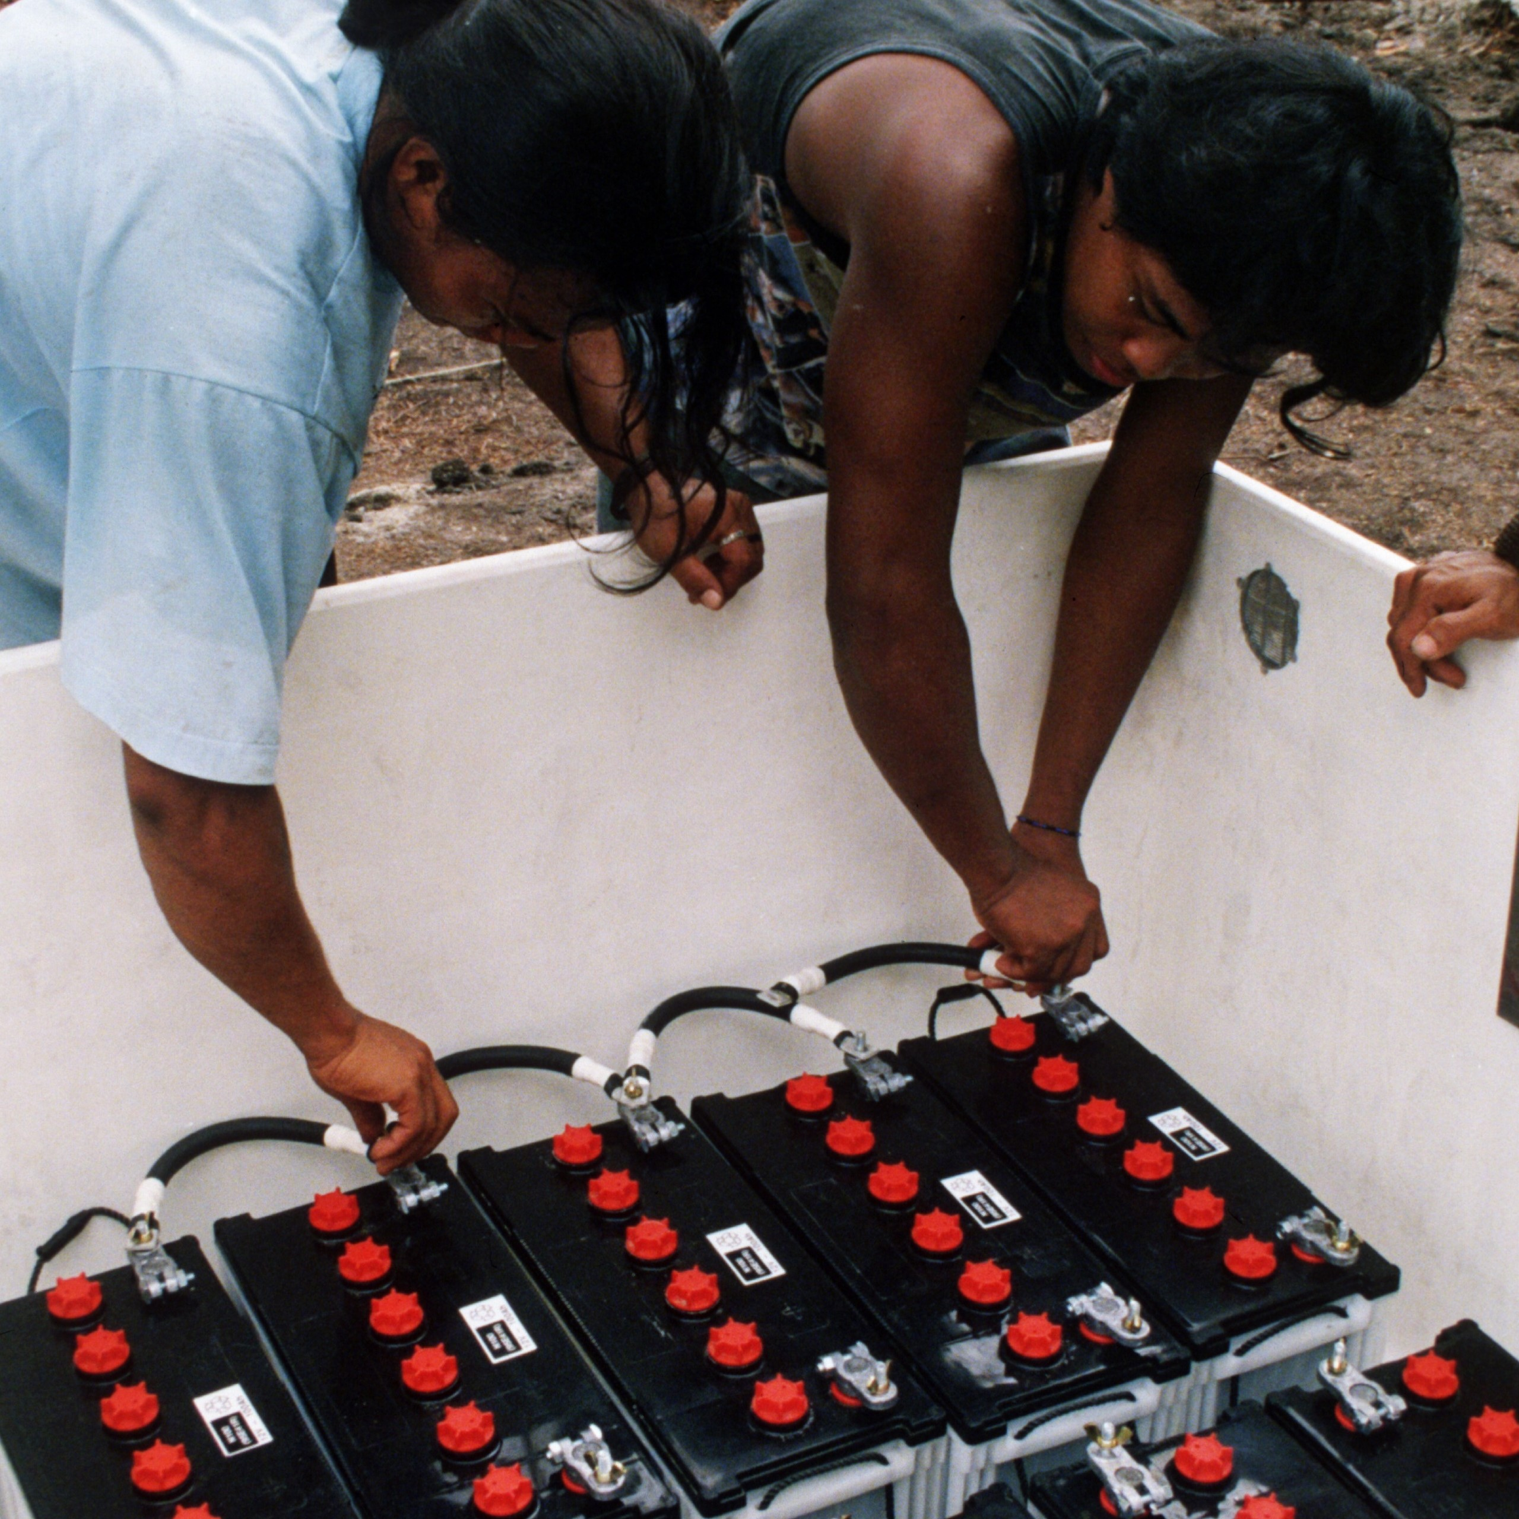
Microgrid Proposal | PREPARED FOR:  Szpital referencyjny - obiekt modelowy, Praca dyplomowa inzynierska ZUT  plac Żołnierza Polskiego 1, 70-413 Szczecin, Poland  PREPARED BY:  Your NameHlieb Snitko, Your TitleDyplomant OZE, ZUT w Szczecinie  Your Company Name, Your Email  Your Phone Number

This proposal was generated using HOMER Pro, a dynamic software engine that runs complex simulations of your hybrid electrical system’s energy data and system components to determine the least-cost solution and most effective risk-mitigation strategies. Originally developed at the US Department of Energy’s National Renewable Energy Laboratory (NREL), HOMER software set the global standard for optimizing microgrid design. More than 200,000 HOMER Pro users worldwide have produced economic feasibility studies, system design, engineering insight, and energy cost savings.

Project Summary 3
About Your Company Name 4
Consumption Summary 5
Engineering Details 6
Cashflow Section 9
Glossary and Abbreviations 10
HOMER Energy Section 11
CURRENT SYSTEM | 
The electric and thermal needs of plac Żołnierza Polskiego 1, 70-413 Szczecin, Poland are met with . Your operating costs for energy are currently $238,513 per year.
PROPOSED SYSTEM | 
We propose adding 150 kW of PV and 200 kWh of battery capacity. This would reduce your operating costs to $231,708/yr. Your investment has a payback of N/A years and an IRR of N/A%.
 | Simple payback: | N/A |  | Net Present Value: | -$119,030
 | Return on Investment: | -0.714 % |  | Capital Investment: | $207,000
 | Internal Rate of Return: | N/A |  | Annualized Savings: | $6,805

ABOUT YOUR COMPANY NAME
Use this section to introduce your company name and explain what your business does, where you operate (or the markets you serve), and how long you’ve been doing it for. About Us page is the ideal place to accommodate several objectives:
• Communicate the story of your business and why you started it.
• Describe the customers or the cause that your business serves.
• Explain your business model or how your products are made
Customer Testimonials
Use this space to provide statements made about your company by satisfied customers.
Quotes and positive comments are valuable to prospective clients as they evaluate their options and decide whether your company’s services provide the best solution to fit their needs. Testimonial statements demonstrate how others have benefited from your company’s services, making them a powerful tool for establishing trust and encouraging potential clients to take action.
—John J. Client, CEO - Your Happy Client, Inc.
Electric Consumption

This microgrid requires 2718 kWh/day and has a peak of 160 kW. In the proposed system, the following generation sources serve the electrical load.

Thermal Consumption

This microgrid requires 4951 kWh(th)/day and has a peak of 537 kW. In the proposed system, the following generation sources serve the thermal load.

PV: Generic flat plate PV

 | The Generic PV system has a nominal capacity of 150 kW. The annual production is 139,687 kWh/yr.
 | Rated Capacity | 150 kW |  | Total Production | 139,687 kW
 | Capital Cost | $120,000 |  | Maintenance Cost | 1,500 $/yr
 | Specific Yield | 931 kWh/kW |  | LCOE | 0.0772 $/kWh
 | PV Penetration | 14.0 %

Storage: Generic 100kWh Li-Ion

 | The Generic storage system's nominal capacity is 200 kWh. The annual throughput is 120 kWh/yr.
 | Rated Capacity | 200 kWh |  | Expected Life | 15.0 yr
 | Annual Throughput | 120 kWh/yr |  | Capital Costs | $60,000
 | Maintenance Cost | 2,000 $/yr |  | Losses | 12.6 kWh/yr
 | Autonomy | 1.05 hr

Grid

The annual energy purchased from the grid is 865,010 kWh and the annual energy sold to the grid is 0 kWh.

Month | Energy Purchased (kWh) | Energy Sold (kWh) | Net Energy Purchased (kWh) | Peak Load (kW) | Energy Charge | Demand Charge | Total
January | 74,981 | 0 | 74,981 | 154 | $7,498 | $0.00 | $7,498
February | 70,896 | 0 | 70,896 | 148 | $7,090 | $0.00 | $7,090
March | 73,115 | 0 | 73,115 | 145 | $7,311 | $0.00 | $7,311
April | 65,447 | 0 | 65,447 | 140 | $6,545 | $0.00 | $6,545
May | 63,801 | 0 | 63,801 | 132 | $6,380 | $0.00 | $6,380
June | 66,793 | 0 | 66,793 | 140 | $6,679 | $0.00 | $6,679
July | 73,870 | 0 | 73,870 | 151 | $7,387 | $0.00 | $7,387
August | 75,080 | 0 | 75,080 | 151 | $7,508 | $0.00 | $7,508
September | 68,107 | 0 | 68,107 | 140 | $6,811 | $0.00 | $6,811
October | 71,933 | 0 | 71,933 | 137 | $7,193 | $0.00 | $7,193
November | 76,642 | 0 | 76,642 | 147 | $7,664 | $0.00 | $7,664
December | 84,346 | 0 | 84,346 | 153 | $8,435 | $0.00 | $8,435
Annual | 865,010 | 0 | 865,010 | 154 | $86,501 | $0.00 | $86,501

Converter: System Converter

 | Capacity | 90.0 kW |  | Hours of Operation | 4,384 hrs/yr
 | Mean Output | 14.5 kW |  | Energy Out | 127,024 kWh/yr
 | Minimum Output | 0 kW |  | Energy In | 133,709 kWh/yr
 | Maximum Output | 90.0 kW |  | Losses | 6,685 kWh/yr
 | Capacity Factor | 16.1 %

Boiler: Generic Boiler

 | Power output from the boiler system is 1,800,000 kWh/yr.
 | Total production | 1,800,000 kWh/yr |  | Hours of operation | 8,760 h/yr
 | Boiler Fuel | Natural Gas |  | Boiler Fuel Price | 0.650 $/m³
 | Boiler Fuel Consumption | 214,445 m3/yr

Project Lifetime | 25 years | Expected Inflation Rate | 2.0%
Nominal Discount Rate | 8.0% | Real Interest Rate | 5.9%

Year | 0 | 1 | 2 | 3 | 4 | 5 | 6 | 7 | 8 | 9
Generic 100kWh Li-Ion | ($60,000) | ($2,000) | ($2,000) | ($2,000) | ($2,000) | ($2,000) | ($2,000) | ($2,000) | ($2,000) | ($2,000)
Generic Boiler | $0.00 | ($139,389) | ($139,389) | ($139,389) | ($139,389) | ($139,389) | ($139,389) | ($139,389) | ($139,389) | ($139,389)
Generic flat plate PV | ($120,000) | ($1,500) | ($1,500) | ($1,500) | ($1,500) | ($1,500) | ($1,500) | ($1,500) | ($1,500) | ($1,500)
Grid | $0.00 | ($86,501) | ($86,501) | ($86,501) | ($86,501) | ($86,501) | ($86,501) | ($86,501) | ($86,501) | ($86,501)
System Converter | ($27,000) | $0.00 | $0.00 | $0.00 | $0.00 | $0.00 | $0.00 | $0.00 | $0.00 | $0.00

Year | 10 | 11 | 12 | 13 | 14 | 15 | 16 | 17 | 18 | 19
Generic 100kWh Li-Ion | ($2,000) | ($2,000) | ($2,000) | ($2,000) | ($2,000) | ($62,000) | ($2,000) | ($2,000) | ($2,000) | ($2,000)
Generic Boiler | ($139,389) | ($139,389) | ($139,389) | ($139,389) | ($139,389) | ($139,389) | ($139,389) | ($139,389) | ($139,389) | ($139,389)
Generic flat plate PV | ($1,500) | ($1,500) | ($1,500) | ($1,500) | ($1,500) | ($1,500) | ($1,500) | ($1,500) | ($1,500) | ($1,500)
Grid | ($86,501) | ($86,501) | ($86,501) | ($86,501) | ($86,501) | ($86,501) | ($86,501) | ($86,501) | ($86,501) | ($86,501)
System Converter | $0.00 | $0.00 | $0.00 | $0.00 | $0.00 | ($27,000) | $0.00 | $0.00 | $0.00 | $0.00

Year | 20 | 21 | 22 | 23 | 24 | 25
Generic 100kWh Li-Ion | ($2,000) | ($2,000) | ($2,000) | ($2,000) | ($2,000) | $18,000
Generic Boiler | ($139,389) | ($139,389) | ($139,389) | ($139,389) | ($139,389) | ($139,389)
Generic flat plate PV | ($1,500) | ($1,500) | ($1,500) | ($1,500) | ($1,500) | ($1,500)
Grid | ($86,501) | ($86,501) | ($86,501) | ($86,501) | ($86,501) | ($86,501)
System Converter | $0.00 | $0.00 | $0.00 | $0.00 | $0.00 | $9,000

Net Present Value
The total net present cost (NPC) of a system is the present value of all the costs the system incurs over its lifetime, minus the present value of all the revenue it earns over its lifetime. Costs include capital costs, replacement costs, O & M costs, fuel costs, emissions penalties, and the costs of buying power from the grid. Revenues include salvage value and grid sales revenue. HOMER calculates the total NPC by summing the total discounted cash flows in each year of the project lifetime.

Total Annualized Cost
- is the annualized value of the total net present cost. The annualized cost of a component is the cost that, if it were to occur equally in every year of the project lifetime, would give the same net present cost as the actual cash flow sequence associated with that component. HOMER calculates annualized cost by first calculating the net present cost, then multiplying it by the capital recovery factor.

Simple payback
- is the number of years at which the cumulative cash flow of the difference between the current system and base case system switches from negative to positive. The payback is an indication of how long it would take to recover the difference in investment costs between the current system and the base case system.

Return on Investment (ROI)
- is the yearly cost savings relative to the initial investment. The ROI is the average yearly difference in nominal cash flows over the project lifetime, divided by the difference in capital cost.

Internal rate of return (IRR)
- is the discount rate at which the base case and current system have the same net present cost. HOMER calculates the IRR by determining the discount rate that makes the present value of the difference of the two cash flow sequences equal to zero.

Refer to HOMER Pro Online Help Manual

Abbreviations
Gen | Autosize Genset
100LI | Generic 100kWh Li-Ion
PV | Generic flat plate PV
Converter | System Converter
BOILER | Generic Boiler

About HOMER Pro
HOMER® Pro simulates engineering and economic feasibility of microgrid or distributed energy systems that are off-grid or tied to an unreliable grid and enables the design of least-cost electrical systems and risk-mitigation strategies. The software provides insight into cost-effectively combining conventional and renewable energy, storage, grid resources (where available), and load management.

In a single data run, HOMER Pro simulates the operation of a hybrid microgrid or distributed energy system for an entire year, evaluating and optimizing the electrical system design, load profiles, components, fuel costs, and environmental variables. The simulation produces key information on technical performance, risk-mitigation, and projected cost-savings to inform system design and optimization. Results are presented in a succinct Microgrid Proposal. For more information, visit HomerEnergy.com.

About HOMER Energy by UL
 |  | HOMER software is used by more than 200,000 users in 193 different countries.
HOMER Energy by UL is the developer and distributor of HOMER software, a global standard for energy modeling tools that analyze solar-plus-storage, microgrids, and other distributed energy projects.

HOMER software helps engineers and project developers navigate the complexities of designing cost-effective and reliable microgrids that combine traditional and renewable generation sources. The company makes two software platforms: HOMER Pro for the design of least-cost hybrid microgrid or distributed energy systems for use off-grid or when tied to an unreliable grid; and HOMER Grid, which helps design behind-the-meter solar-plus-storage systems to reduce costs and lower carbon footprints.

Since its founding in Boulder, Colorado in 2009, HOMER Energy software has proven effective for analyzing complex distributed energy systems, including grid-tied hybrid renewable microgrids and situations where the grid is insufficiently reliable, such as islands and remote communities. In 2019, HOMER Energy was acquired by UL. More than 200,000 HOMER Pro users in over 190 countries have produced economic feasibility studies, system design, engineering insight, and energy cost savings. Learn more at www.homerenergy.com.

