Training: JUnit 5
Workbook
(edition 1.0, September, 2018)

Training: JUnit 5
The author: | Cătălin Tudose (ftudose@luxoft.com)
Product version: | JUnit 5

Exercise 1
Move an existing application to JUnit 5

Project
lab1

Duration
60 min

Objectives
Move an existing application to JUnit 5. Understand the business logic, introduce the needed dependencies and write the tests to verify the functionality. Correct the possible discovered bugs. Refactor the application and check that it maintains its functionality with the help of the written tests.

Description
The input program of the exercise manages credit offers and customers. The bank maintains a policy regarding adding and removing a customer to an offer.
The offers may be of a few types - economy and business are known at the time. We may consider adding other types at a later time.
You are required move the application to JUnit 5, to check the existing functionality, correct it, and refactor the application.

Tasks
We assume that we are joining the development of a program to manage credit offers and customers.
The bank maintains a policy regarding adding and removing a customer to an offer. The offers may be of a few types - economy and business are known at the time, but we consider that we may add other types at a later time, depending on the requirements.
If the offer is an economy one, both VIP customers and usual ones may be added to it. If the offer is a business one, only VIP customers may be added to it.
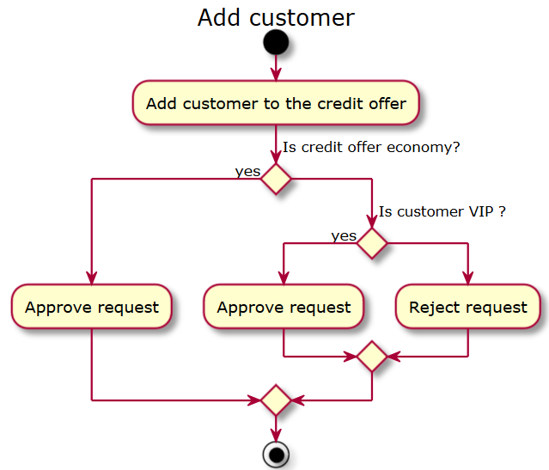

And there is also a policy for removing a customer from an offer. It also involves answering to yes/no questions.

A usual customer may be removed from an offer, a VIP customer cannot be removed. As we see from these two activity diagrams, the initial business logic focuses on decision making.

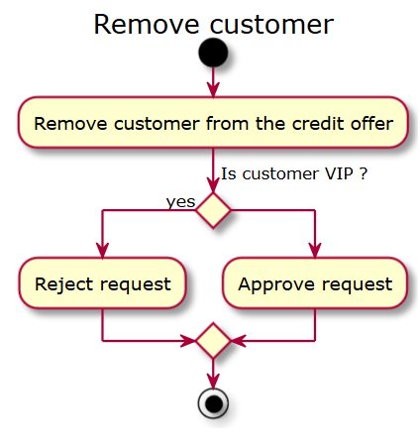

We maintain a field called creditOfferType inside the CreditOffer class. Based on its value, we have to write the behavior of the addCustomer and removeCustomer methods. The programmer will have to focus on decision making at the level of the code of these two methods.

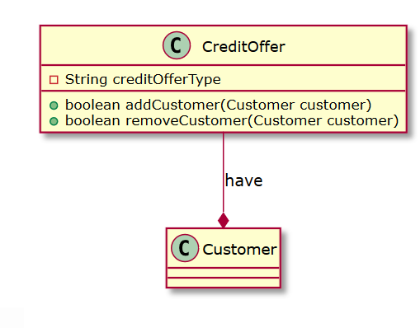

Move the application to use JUnit 5 by introducing the needed Maven dependencies.
<dependencies>
<dependency>
<groupId>org.junit.jupiter</groupId>
<artifactId>junit-jupiter-api</artifactId>
<version>5.0.1</version>
<scope>test</scope>
</dependency>
<dependency>
<groupId>org.junit.jupiter</groupId>
<artifactId>junit-jupiter-engine</artifactId>
<version>5.0.1</version>
<scope>test</scope>
</dependency>
</dependencies>
</project>

Create the tests that will check the business logic of the application and that will cover all presented scenarios.

Verify each scenario and, in case of any bugs into the initial behavior, do the corrections.

Insert the JaCoCo plugin into the pom.xml Maven configuration.

<plugin>
<artifactId>maven-surefire-plugin</artifactId>
<version>2.19.1</version>
<dependencies>
<dependency>
<groupId>org.junit.platform</groupId>
<artifactId>junit-platform-surefire-provider</artifactId>
<version>1.0.1</version>
</dependency>
</dependencies>
</plugin>
<plugin>
<groupId>org.jacoco</groupId>
<artifactId>jacoco-maven-plugin</artifactId>
<version>0.7.9</version>
<executions>
<execution>
<goals>
<goal>prepare-agent</goal>
</goals>
</execution>
<execution>
<id>report</id>
<phase>test</phase>
<goals>
<goal>report</goal>
</goals>
</execution>
<execution>
<id>jacoco-check</id>
<phase>test</phase>
<goals>
<goal>check</goal>
</goals>
<configuration>
<rules>
<rule>
<element>PACKAGE</element>
<limits>
<limit>
<counter>LINE</counter>
<value>COVEREDRATIO</value>
</limit>
</limits>
</rule>
</rules>
</configuration>
</execution>
</executions>
</plugin>

From the command line, execute mvn test.

Expand the target/site/jacoco folder and open the index.html file, study the code coverage report.
- Refactor the application according to the diagram below.
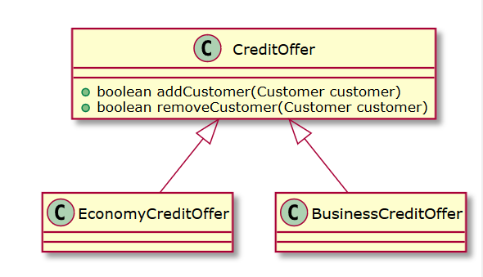

- Re-run the tests in order to make sure that the functionality has been kept.
- Run mvn test and inspect the new code coverage.
Exercise 2
Use JUnit 5 more effectively

Project
lab2

Duration
45 min

Objectives
Use new JUnit 5 features. Move the already built tests to use JUnit 5 more effectively.

Description
Build a hierarchy of labeled nested tests using the @Nested and @DisplayName annotations.

Tasks
Redesign the existing tests to use a hierarchy of annotated classes and tests.
The top-level test class should be named BankTest.
The BankTest class must contain two nested test classes, EconomyCreditOfferTest and BusinessCreditOfferTest.
Each of these two ones should contain two nested classes, called UsualCustomer and VipCustomer. Each test nested class should be annotated with @Nested and @DisplayName.
Each of these most inner four ones should have one single test. These ones must be annotated using @DisplayName.
You must use, instead of a series of assertEquals verifications, an assertAll to check all conditions.
Make sure that the tests are still successfully running and measure the code coverage.
The hierarchy of test classes and their annotations should generate the following execution:

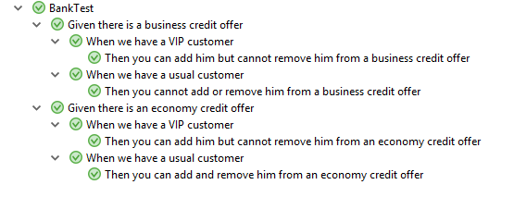
Exercise 3
Use JUnit 5 to introduce a new credit type offer

Project
lab3

Duration
45 min

Objectives
Add new functionality to the application, defining first the business logic, writing the corresponding tests with the help of JUnit 5 and its features, then fix the tests by writing the expected behavior.

Description
Introduce a new credit offer type, Premium, and a policy concerning this credit offer type. Extend the existing tests using JUnit 5 and its features. Fix the tests by implementing the functionality.

Tasks
Introduce a new class, PremiumCreditOffer. The hierarchy will look this way:

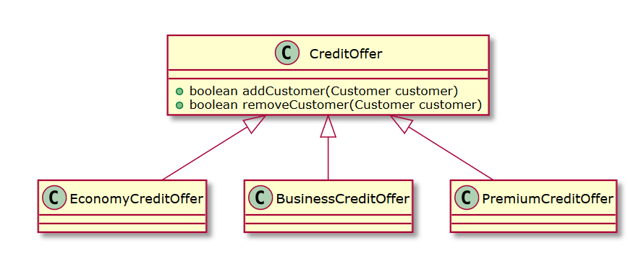
The functionality of the PremiumCreditOffer is described into the following activity diagrams:

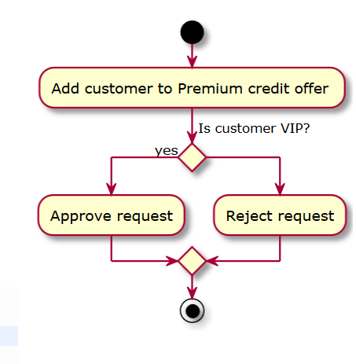

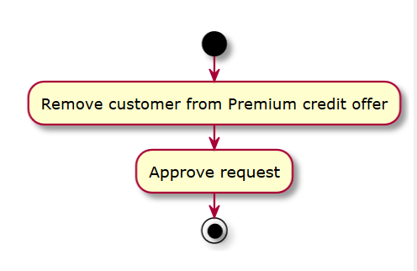

Extend the existing BankTest class to a new nested PremiumCreditOfferTest class. This one will contain two other nested classes, UsualCustomer and VipCustomer, each one containing one single test, which will check the functionality described by the diagrams above. The tests should initially fail.
Implement the new required functionality so that the tests will pass. Measure the code coverage. Annotate the newly added test classes and test so that the execution will look like this:
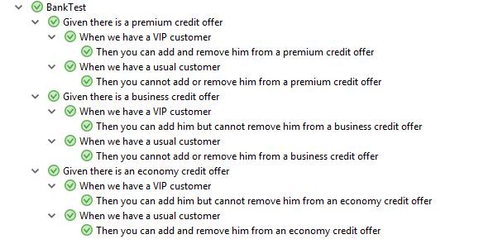
Exercise 4
Implement the unicity of customers added to a credit offer with the help of JUnit 5

Project
lab4

Duration
45 min

Objectives
Add new functionality to the application: a customer cannot be assigned to a credit offer more than once. Define the business logic, write the corresponding tests with the help of JUnit 5 and its features, then fix the tests by writing the expected behavior.

Description
Introduce a new policy concerning the unicity of customers added to a credit offer type. Extend the existing tests using JUnit 5 and its features. Fix the tests by implementing the functionality.

Tasks
The new functionality can be described this way:
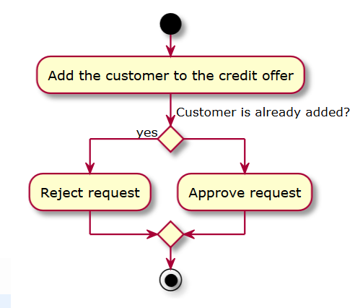

Write the tests that will check that a customer cannot be added to a credit offer more than once. In order to make the verification, try to repeatedly execute the same test that intends to add the same customer by annotating it with @RepeatedTest. The tests should initially fail.
Implement the new required functionality so that the tests will pass. One suggested solution is to keep the customers as a set and not as a list – this will ensure the unicity. Measure the code coverage. Annotate the newly added test classes and test so that the execution will look like this:
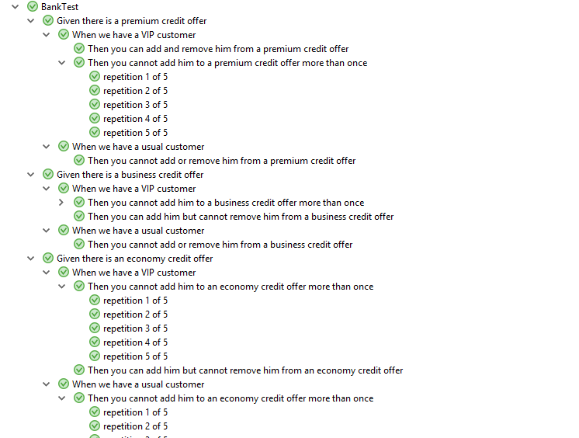
Exercise 5
Implement the bonus points policy with the help of JUnit 5

Project
lab5

Duration
120 min

Objectives
Add new functionality to the application: a customer may receive bonus points depending on the amount of credit offer that he has applied for. Define the business logic, write the corresponding tests with the help of JUnit 5 and its features, then fix the tests by writing the expected behavior.

Description
Introduce a new policy concerning the bonus points provided for customers that applied for credit offers. Extend the existing tests using JUnit 5 and its features (parameterized tests). Fix the tests by implementing the functionality.

Tasks
The new functionality can be described this way:
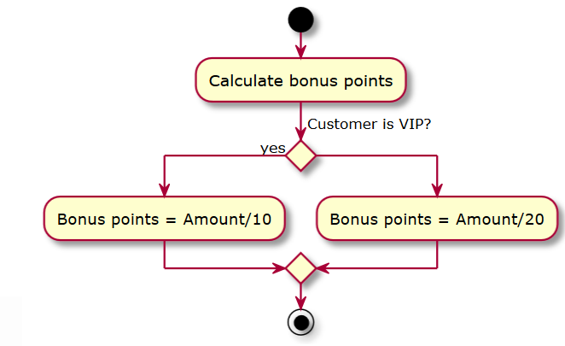
Add a new amount int field to the CreditOffer class.
The input data will come as strings, like this:
1; e; Mike; false; 30000
2; b; John; true; 200000
This will mean that:
- Customer Mike, with id 1, which is not a VIP, has applied for an economy credit offer of 30000
- Customer John, with id 2, which is a VIP, has applied for a business credit offer of 200000
Add a new Bonus class that will keep the map of customers and amounts and the map of customers and bonus points.
Add the following dependency to the pom.xml file:
<dependency>
<groupId>org.junit.jupiter</groupId>
<artifactId>junit-jupiter-params</artifactId>
<version>5.0.1</version>
<scope>test</scope>
</dependency>
Create a converter class that will convert from strings to CreditOffer. The class must extend org.junit.jupiter.params.converter.SimpleArgumentConverter and implement the convert method.

public class CreditOfferArgumentConverter
extends SimpleArgumentConverter {
@Override
protected Object convert(Object source,
Class<?> targetType)

Using the @ParameterizedTest and @ValueSource annotations and the CreditOfferArgumentConverter, write a test that will check the assignment of bonus points to the customers.

@ParameterizedTest
@ValueSource(strings = { "1; e; Mike; false; 30000", "2; b; John; true; 200000", "3; e; Mike; false; 10000", "4; p; John; true; 80000", "5; e; Mike; false; 60000", "6; e; John; true; 90000"})
void checkGivenPoints(@ConvertWith(CreditOfferArgumentConverter.class) CreditOffer creditOffer)

Using the @ParameterizedTest and @CsvFileSource annotations and the CreditOfferArgumentConverter, write another test that will check the assignment of bonus points to the customers and will take the input data from the credit_offer_information.csv file.

@ParameterizedTest
@CsvFileSource(resources = "/credit_offer_information.csv")
void checkGivenPointsWithCsvInput(@ConvertWith(CreditOfferArgumentConverter.class) CreditOffer creditOffer)

The tests should initially fail. Implement the new required functionality so that the tests will pass. Measure the code coverage.
Exercise 6
Use JUnit 5 with Mockito to control the access to a database

Project
lab5

Duration
60 min

Objectives
Add new functionality to the application: provide secure access to the database using substitute objects. Define the business logic, write the corresponding tests with the help of JUnit 5 and Mockito, then fix the tests by writing the expected behavior.

Description
Introduce the controlled access to a database by using a substitute to emulate its functionality. Extend the existing tests using JUnit 5 and Mockito. Fix the tests by implementing the functionality.

Tasks
The new functionality can be described this way:

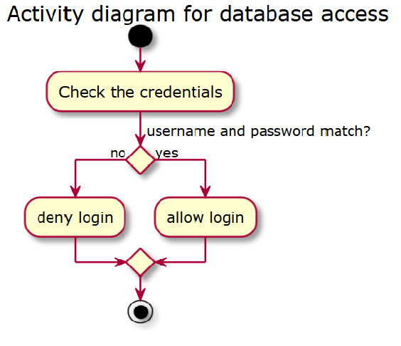

Add the Mockito dependency into the Maven pom.xml file.

<dependency>
<groupId>org.mockito</groupId>
<artifactId>mockito-core</artifactId>
<version>2.11.0</version>
<scope>test</scope>
</dependency>

Add the MockitoExtension file to your project. The file can be found in the JUnit 5 user guide (http://junit.org/junit5/docs/current/user-guide/).
Create two classes, Credentials and Database.
The Credentials class will contain the login and password.
The Database class will contain a map of registered users (key: login; value: password) and a login method.
Create a DatabaseAccessTest class that will check the successful and failed logins. This class will use a Database object annotated with @Mock, and whose behavior may be fixed for each test. The tests should initially fail.
Implement the new required functionality so that the tests will pass. The login method from the Database object will must check that the introduced login and password are on the database side.
Measure the code coverage.

