Unproductive Clockwork Pixel

00957162 - 鍾偉生

00957060 - 何天勝  
  
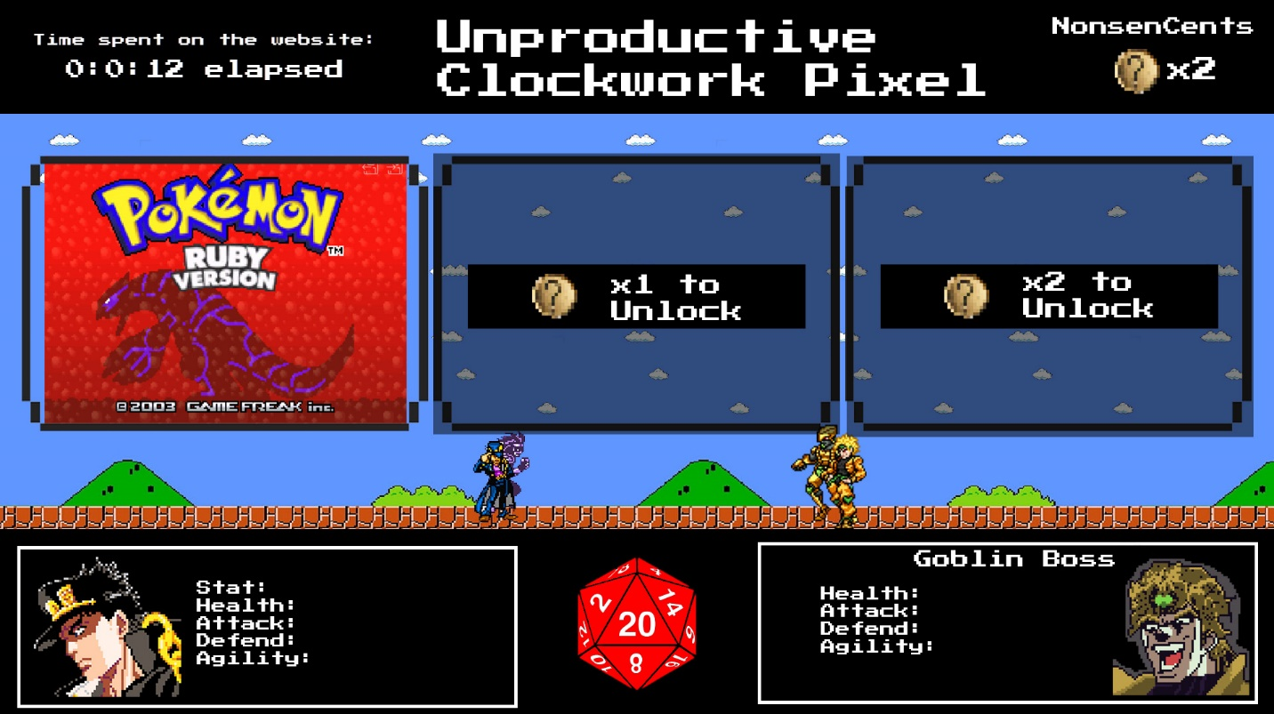

Introduction:

We are retro game enthusiasts who have taken notice of the disappearance of retro 8-bit style games. In response to this, we have made a unique website with an 8-bit old-school theme. Observing the increasing levels of stress in society, we have created this website as a viable option for stress relief, offering users a unique and enjoyable experience to unwind and escape from the pressures of everyday life.

Features:

1. Big Timer Display:



- A prominent countdown timer, akin to a count-up display, serves as a visual representation of the time spent on the platform.

2. Level up while you play!

- Users accumulate time points as they engage in gameplay.

- Time can be used to level up the user's chosen "hero," enhancing their capabilities for defeating bosses.

3. Retro Gaming Library:

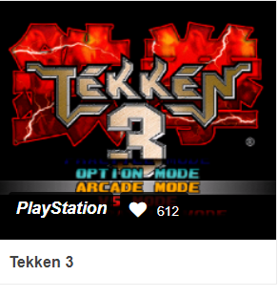 - Enjoy a variety of retro games with an authentic 8-bit user interface.

4. Penalty & currency System:

- Failing to defeat the boss, the user will suffer stat lost, therefore they have to grind for more stats before challenging the boss again.

- Defeating bosses will reward user with “NonsenCents” the currency that is used

To unlock more games.

5. Stats Checker:

- Users can access a detailed statistics checker, displaying upgraded features and achievements.  
  


6. Dice:

- Using 20-sided dice, to make the attack multiplier.

The bigger the dice number, the bigger the damage dealt

Objective: Our goal is to provide a fun and nostalgic space where users can unwind, destress, and relive the joy of retro gaming. The platform's unique features, such as the experience points system, life limitations, and the gacha-style unlocking mechanism, add an element of excitement and progression to the user experience.

By incorporating these elements, Unproductive Clockwork Pixel aims to create an engaging and stress-relieving environment for computer science enthusiasts and retro game lovers alike. Join us on this journey down memory lane, where stress fades away, and the joy of gaming takes center stage.

We use HTML5/ JS/ CSS/ DOM