## Table of contents

*ABOUT

* [Project General info](# Project-info)

* [Technologies for Internship](#technologies Guidance)

* handwritten digits

## My_Interest

Data Analyst, Data Science, Big Data, Machine Learning.

Python is the most demanded language in the field of ML, DL, DS.

## Project info

The Project Name:

KhadeerPasha_Project_Handwritten_Digit_Identification_using_DL_RegexSoftware.

Some of key functionalities:

* visual pattern recognition handwritten digits.
* how a perceptron works!
* learning algorithms
* which can automatically tune
* the weights and biases of a network of artificial neurons
* a three-layer neural network
* sigmoid neuron
* Activation function
* cost function
* rule gradient descent algorithm
* hyper-parameters of the neural network

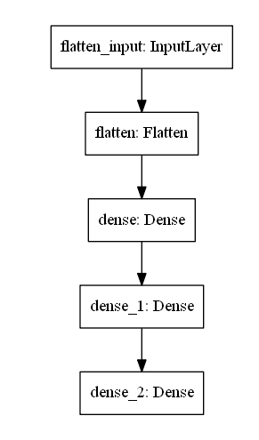

## Technologies Guidance

Project is created with:

* Regex Software

## Setup

To run this project

install TensorFlow

mnist_dataset

python 3.x with following modules installed

1. numpy
2. seaborn
3. tensorflow
4. keras
5. opencv2