Κωνσταντίνος Περίφανος 03120134

Table of Contents
1 Thesis goal 2
1.2 Thesis Structure 2
2 Timeseries 2
2.1 Timeseries definition 3
3 Comfort 3
3.1 Definition 3
3.2 Thermal Comfort 3
3.3 Indoor Air Quality (IAQ) 4
3.4 Acoustic Comfort 5
3.5 Visual Comfort 5
3.6 Our Study Case 6
4 Heat pump disaggregation 11
5 Thesis direction – In progress work 14
Bibliography 14

- Thesis goal
The main goal of this thesis is to optimize the load scheduling of households and buildings based on user preference, using machine learning and reinforcement learning algorithms, focusing on HVAC load shifting to achieve either:
- Maximum comfort for residents, by taking into account temperature indoors, CO₂ concentration, PM 2.5 levels and relative humidity or
- Maximize cost savings by utilizing PV energy to its fullest and conserving electricity bills caused by increased grid usage.

Based on user input the system optimizes either cost savings or comfort for the next day.

1.2 Thesis Structure
The main structure follows an introduction to timeseries analysis, machine learning and neural networks, as well as theoretical foundation about Photovoltaics, comfort metrics and optimization with reinforcement learning and load shifting. Then we move on to our case study and present the methodology employed and the results. The thesis concludes by analyzing the finding and considers future directions.

- Timeseries
In this chapter, we will examine timeseries data, a very important aspect of machine learning and data analysis. We begin by understanding what timeseries is in a fundamental way, while also explaining its various features like seasonality, trends and their effect in forecasting. Then, we will cover various ways to preprocess timeseries data, as well as handling normalization, which is an important step in handling noise and outliers in our data.

  - Timeseries definition
A time series is a sequence of data points that occur in successive order over some period of time. Time series analysis is used for non-stationary data—things that are constantly fluctuating over time or are affected by time. Industries like finance, retail, and economics frequently use time series analysis because currency and sales are always changing. Stock market analysis is an excellent example of time series analysis in action, especially with automated trading algorithms. Likewise, time series analysis is ideal for forecasting weather changes, helping meteorologists predict everything from tomorrow’s weather report to future years of climate change.

- Comfort

3.1 Definition
Comfort is a very generic term that might mean something different depending on perspective, though generally defined as a condition of well-being determined by sensorial perceptions in an environment, including temperature, humidity, noise, and brightness. It is a topic inherently related to indoor environmental quality (IEQ), which affects our health and productivity. With the development of smart homes, modern research has been emphasizing the importance of balancing occupant satisfaction with energy efficiency. In an attempt to quantify comfort for the average person, building standards have set an acceptable range of about 80% or more to be considered as satisfactory. In modern smart buildings, sensors are used to monitor and predict comfort levels in real time, with the help of machine learning to balance energy efficiency and user-centric comfort.
The four primary categories involved in IEQ are:
- Thermal Comfort
- Indoor air quality (IAQ)
- Acoustic Comfort
- Visual Comfort

3.2 Thermal Comfort
Thermal comfort is defined as "that condition of mind expressing satisfaction with the thermal environment, assessed by subjective evaluation". It relies on the interplay between objective variables (air temperature, mean radiant temperature, operating temperature, relative humidity, and air velocity) and subjective variables (individual physical and psychological characteristics, such as clothing and metabolic rate). Because of these factors, thermal comfort is complex: for example, a lightly clothed person in still air might prefer a warmer temperature than a person in warmer clothing or with a fan blowing.
The most prevalent metrics to evaluate thermal comfort are the Predicted Mean Vote (PMV) and Predicted Percentage of Dissatisfied (PPD). PMV, standardized in ISO 7730 and incorporated in ASHRAE 55, predicts the average thermal sensation vote of a large group of people on a seven-point scale (from -3 = cold, -2 = cool, -1 = slightly cool, 0 = neutral, +1 = slightly warm, +2 = warm, +3 = hot). Using the environmental and personal factors, the PMV model computes a value on this scale. From PMV, one can derive the Predicted Percentage of Dissatisfied (PPD) – an estimate of what fraction of occupants would be dissatisfied (too hot or too cold) at those conditions. Notably, at PMV = 0 (neutral), there is still a minimum PPD of about 5%, recognizing you can never satisfy everyone​.
Another important model is the Adaptive thermal comfort model. The adaptive model is based on field studies showing that people in real buildings can adapt to a wider range of temperatures, especially when they have control (opening windows, adjusting clothing, etc.) and when outdoor conditions influence their expectations. Instead of a fixed temperature range, the adaptive model specifies a comfortable indoor temperature band that shifts with recent outdoor temperatures. For example, ASHRAE 55 adaptive model might allow an indoor temperature of 26–30 °C when the mean outdoor temperature is around 30 °C, whereas on a cooler day the acceptable indoor range would be lower. In residences (especially without air-conditioning), this adaptive approach is very relevant .

3.3 Indoor Air Quality (IAQ)
Air quality comfort refers to the occupant’s satisfaction with the freshness and cleanliness of the air. Even if temperature is ideal, stuffy or polluted air can cause discomfort (and health issues). Key factors include CO₂ (carbon dioxide) levels, which are a proxy for human bio-effluent buildup and ventilation effectiveness, and other contaminants like volatile organic compounds (VOCs) from materials and furnishings, particulate matter (dust, PM_{2_5}), humidity (too dry or too humid air), and odors. Good IAQ generally means low concentrations of CO₂ and pollutants, as well as absence of unpleasant odors.
CO₂ itself at typical indoor levels is not a toxic concern, but it correlates with human occupancy and ventilation rate. Historically, 1000 ppm CO₂ has been used as a rule-of-thumb upper limit for “acceptable” indoor air quality in occupied rooms (ASHRAE).
Another IAQ comfort indicator is the level of Volatile Organic Compounds (VOCs), which can come from paints, cleaners, plastics, etc., and cause odors or irritation. There isn’t a single unified VOC comfort scale, but guidelines exist for total VOC (TVOC) concentration. Some health-oriented standards (like the WELL Building Standard or WHO guidelines) suggest keeping TVOC very low (e.g. below 300–500 µg/m³).
Humidity also plays a role in both thermal comfort and air quality comfort. Too low humidity (< ~30% RH) can cause dry skin and throat, while too high (> ~70% RH) feels stuffy and can promote mold. Standards often recommend keeping indoor relative humidity between 30% and 60% for comfort and health (this range is noted in ASHRAE guidelines). While humidity doesn’t have a “comfort index” of its own, it factors into thermal indices like PMV and into IAQ perception (very humid air can feel “stale”).

3.4 Acoustic Comfort
Acoustic or aural comfort is the satisfaction with the noise levels and sound quality in a space. In a comfortable home, background noise from HVAC, appliances, or outside traffic is low enough not to be disruptive, and the room’s acoustics do not cause excessive echo or muffling of desired sounds. Poor acoustic comfort can come from loud neighbors, echoes in large bare rooms, or constantly buzzing equipment.
The simplest measure is the sound pressure level in dB (decibels), typically A-weighted (dB(A)) to match human hearing sensitivity. Comfortable sound levels depend on the context: bedrooms, living rooms and offices have different standards that are also dependent on time of day.

3.5 Visual Comfort
Visual comfort relates to the appropriate quantity and quality of lighting necessary for occupants to perform tasks effectively without strain or discomfort. It involves managing daylight and artificial illumination to maintain sufficient brightness, uniform distribution, and the avoidance of glare (EN 12665). Metrics commonly employed include Illuminance, Daylight Factor, Color Rendering Index (CRI), Unified Glare Rating (UGR), and luminance ratios. These metrics ensure adequate lighting for visual tasks while minimizing discomfort.
Below are various studies and papers that propose an equation for comfort level extrapolation
$TEQE = 3.44 × lighting + 1.89 × acoustics + 2.29 × thermal + 2.38 × IAQ$

$IEI_{AHP}= 0.203 × S_{acoustics}+ 0.164 × S_{illumination}+ 0.208 × S_{thermal}+ 0.290 × S_{IAQ}+ 0.135 × S_{EMF}$

$IEI =\frac{\left(IAPI + IDI\right)}{2}$

$I = 1.24 + 0.39 × S_{w}+ 0.16 × S_{am}+ 0.12 × S_{h}+ 0.05 × S_{l}+ 0.13 × S_{n}+ 0.36 × S_{aq}$

$PDIEQ = 0.42 × PDTC + 0.09 × PDIAQ + 0.28 × PDAC$

$S = 0.075 + 0.316 × S_{T}+ 0.118 × S_{IAQ}+ 0.171 × S_{L}+ 0.224 × S_{A}$

$IEQ_{index}= 0.30 × TC_{index}+ 0.36 × IAQ_{index}+ 0.16 × L_{index}+ 0.18 × ACc_{index}$

$DEQI =\frac{\left(S_{T}+ S_{RH}+ S_{CO2}\right)}{3}$

$ICC = 0.35 × I_{PMV}+ 0.35 × I_{S}+ 0.30 × I_{VC}$

3.6 Our Study Case
Our data consist of various thermal, lighting and air quality metrics. Specifically:
- Temperature outdoors
- Temperature Indoors
- CO₂
- PM 2.5
- Relative humidity
- Lux (light)
- Various PM particles
Therefore, we lack acoustic metrics, which is why we will choose between IEI and DEQI.

Index Name | Thermal | IAQ | Acoustic | Visual | Others (if any)
TEQE | 23% | 24% | 19% | 34% | —
IEI(AHP) | 21% | 29% | 20% | 16% | EMF (14%)
IEI | 50% | 50% | — | — | —
Index (I) | 67% | 36% | 13% | 5% | —
PDIEQ | 42% | 9% | 28% | — | —
S | 32% | 12% | 22% | 17% | —
IEQindex | 30% | 36% | 18% | 16% | —
DEQI | 67% | 33% | — | — | —
ICC | 35% | — | 35% | 30% | —

We ended up choosing IEI and therefore create a comfort column for our dataset calculated with the equation:
$Thermal= \frac{\left( Tin+ RH\right)}{2}$
$IEQ= \frac{\left( CO_{2}+PM_{2.5}\right)}{2}$
$Comfort=\frac{\left(Thermal + IEQ\right)}{2}$
But to get the actual score of each individual metric we need certain guidelines. According to guidelines like ASHRAE, WHO, EPA there are certain ideal ranges per metric that we can assume translates to 100% comfort. Straying away from those values drops the comfort slowly to 0.

Metric | Optimal Comfort Range | Source/Reference
Indoor Temperature | 23–26°C (warmer climate and 20-24 maybe in winter time) | ASHRAE 55 Adaptive Comfort
Relative Humidity | 30–60% | ASHRAE 55, EN15251
CO₂ | ≤ 800–1000 ppm (optimal ≤600 ppm) | ASHRAE, WHO
PM2.5 | ≤ 15 µg/m³ (24-hour avg), optimal ≤12 µg/m³ | WHO Air Quality Guidelines

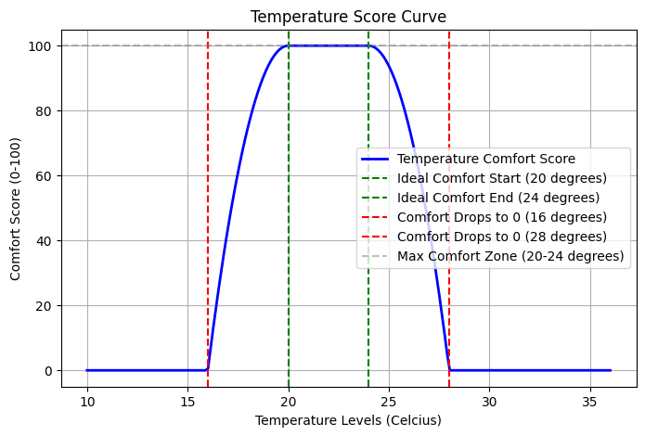
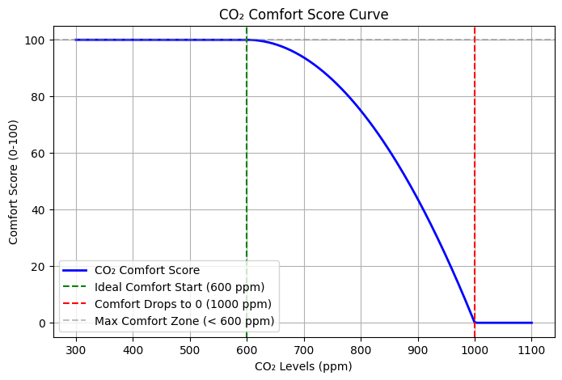
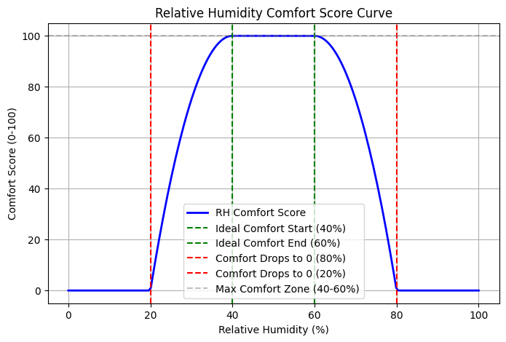
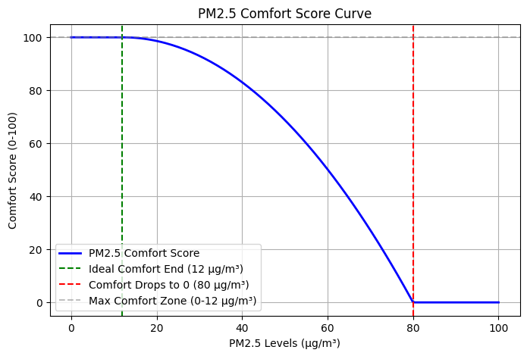
The resulting plots over 1 month of 2 rooms with our available data are shown below
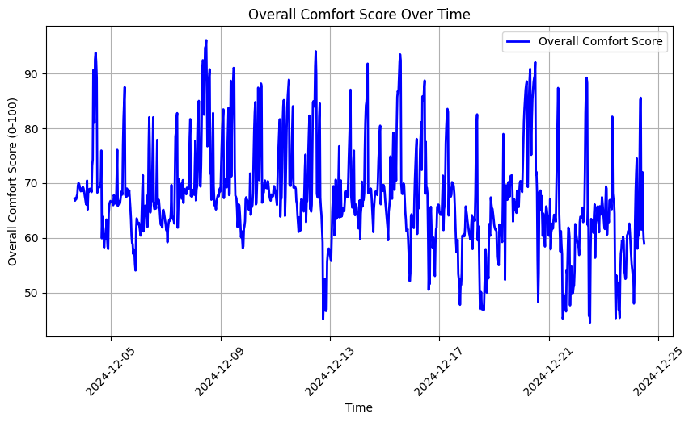
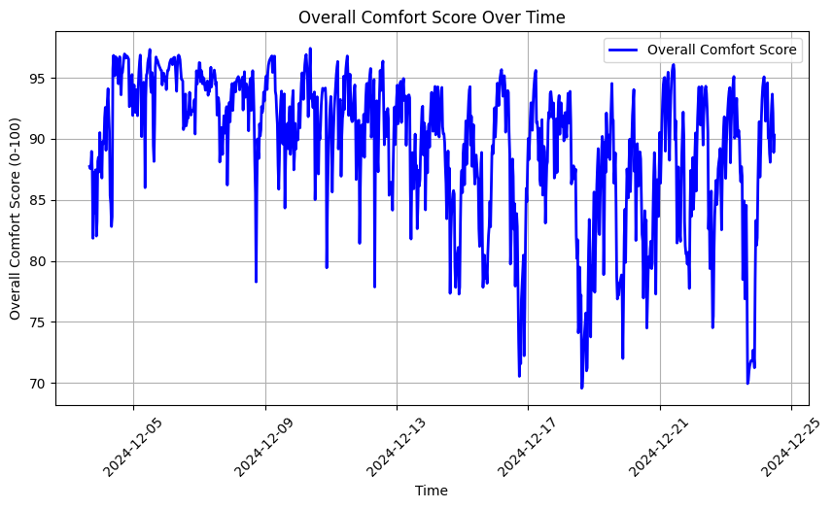

- Heat pump disaggregation
Isolating HVAC loads with minimal data and in unsupervised way is a challenging topic in the field of Nonintrusive load monitoring. Various studies tackle the problem using supervised approaches with ground truth heat pump data
Most NILM algorithms rely on high frequency data (sub 1 minute samples), whereas smart meter data provide lower frequency and less granular data (15, 30 minutes or even hourly data), making the application of NILM algorithms quite challenging.
Other papers tackle this problem with unsupervised clustering and find success with it. Similar to we apply clustering using kmeans, gmm and dbscan algorithms. Our main goal is the extraction of the heat pump’s activation cycles. We feed the algorithms the following features (some are feature engineered from total energy, temperature and timestamp data and using rolling windows):
Temperature hourly mean, rolling energy mean (hourly), hour of the day, month, daily energy diff (we subtract the minimum energy from the maximum energy of the day) and energy differential between consecutive timesteps. Missing values from the windows are padded using backwards fill method. We also use MinMaxScaler to normalize all the features.
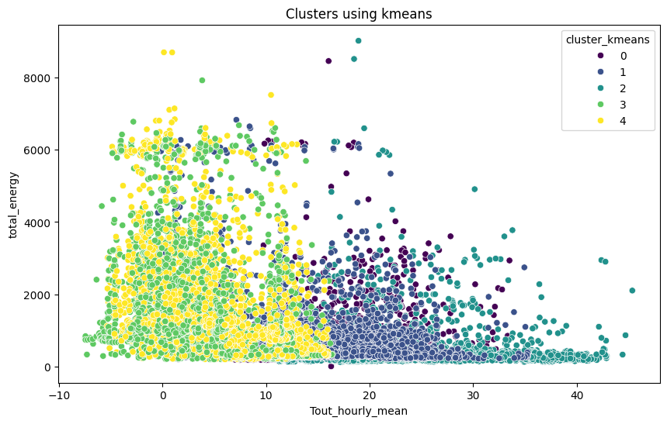
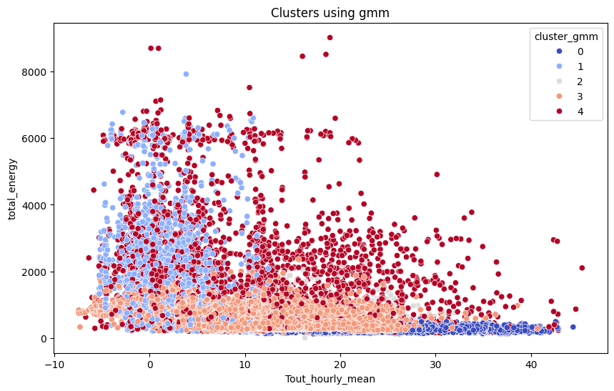
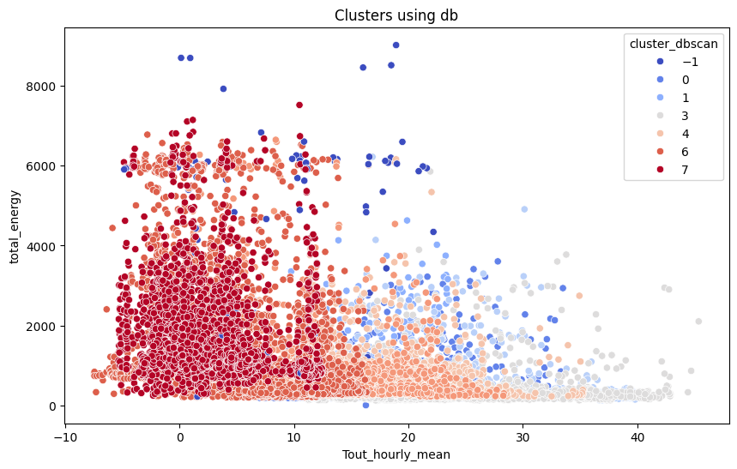

From those clusters we identify the lowest mean energy cluster and assume it as a baseline load. Subtracting this from the total energy we get a HVAC predicted load.
To test the proposed methodology we used a household dataset from Germany that uses heat pump for space and water heating and provides heat pump ground truth data (15 minutes sampling). Additionally, we assume that timesteps with an active power consumption with less than 100 W is stand-by operation (as the paper also denotes).
By applying the clustering methodology to identify heat pump active load periods we get 92% accuracy:
Class | Precision | Recall | F1-Score | Support
0 | 0.909 | 0.948 | 0.928 | 11,409
1 | 0.935 | 0.887 | 0.910 | 9,613
Accuracy | - | - | 0.920 | 21,022

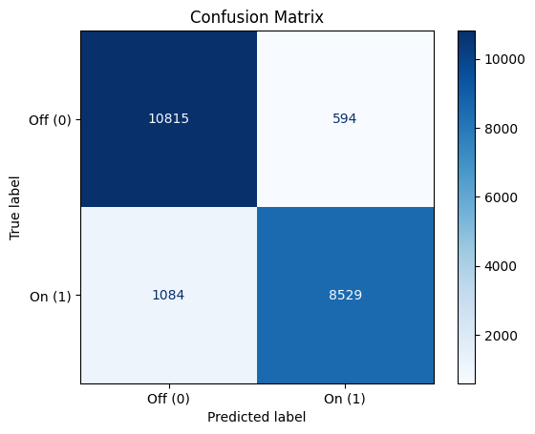

- Thesis direction – In progress work
We are now working on next day forecasting (energy and metrics) so that we can develop the optimization algorithm for next day load shifting. Finally,
we will develop an interface for user to easily control what mode of optimization they would like for the next day.

Bibliography

Stefano Riffelli, ‘Global Comfort Indices in Indoor Environments: A Survey’, Sustainability, 13.22 (2021), p. 12784, doi:10.3390/su132212784.
Md Islam and others, A Review on Machine Learning for Thermal Comfort and Energy Efficiency in Smart Buildings, 2023.
A.S.H.R.A.E., ‘ANSI/ASHRAE Standard 55-2020. Thermal Environmental Conditions for Human Occupancy’, 2021.
E.W. Shaw, ‘Thermal Comfort: Analysis and Applications in Environmental Engineering, by P. O. Fanger. 244 Pp. DANISH TECHNICAL PRESS. Copenhagen, Denmark, 1970. Danish Kr. 76, 50’, Royal Society of Health Journal, 92.3 (1972), pp. 164–164, doi:10.1177/146642407209200337.
‘ANSI/ASHRAE Standard 55-2020. Thermal Environmental Conditions for Human Occupancy’.
Fergus Nicol, Michael Humphreys, and Susan Roaf, Adaptive Thermal Comfort: Principles and Practice (Routledge, 2012), doi:10.4324/9780203123010.
Marc Fountain, Gail Brager, and Richard de Dear, ‘Expectations of Indoor Climate Control’, Energy and Buildings, 24.3 (1996), pp. 179–82, doi:10.1016/S0378-7788(96)00988-7.
J. F. Nicol and M. A. and Humphreys, ‘Thermal Comfort as Part of a Self-Regulating System’, Building Research and Practice, 1.3 (1973), pp. 174–79, doi:10.1080/09613217308550237.
Rabee Reffat and Edward Harkness, ‘Expert System for Environmental Quality Evaluation’, Journal of Performance of Constructed Facilities - J PERFORM CONSTR FACIL, 15 (2001), doi:10.1061/(ASCE)0887-3828(2001)15:3(109).
Che-Ming Chiang and Chi-Ming Lai, ‘A Study on the Comprehensive Indicator of Indoor Environment Assessment for Occupants’ Health in Taiwan’, Building and Environment, 37.4 (2002), pp. 387–92, doi:10.1016/S0360-1323(01)00034-8.
Demetrios Moschandreas and Sait Sofuoglu, ‘The Indoor Environmental Index and Its Relationship with Symptoms of Office Building Occupants’, Journal of the Air & Waste Management Association (1995), 54 (2004), pp. 1440–51, doi:10.1080/10473289.2004.10470999.
Michael Humphreys, ‘Quantifying Occupant Comfort: Are Combined Indices of the Indoor Environment Practicable?’, Building Research and Information - BUILDING RES INFORM, 33 (2005), pp. 317–25, doi:10.1080/09613210500161950.
Kwok Wai Mui and W. T. Chan, ‘A New Indoor Environmental Quality Equation for Air-Conditioned Buildings’, Architectural Science Review, 48.1 (2005), pp. 41–46, doi:10.3763/asre.2005.4806.
Shuanghua Cao and others, ‘A Review of Research on Dynamic Thermal Comfort’, Building Services Engineering Research & Technology, 42.4 (2021), pp. 435–48, doi:10.1177/01436244211003028.
Matiwaza Ncube and Saffa Riffat, ‘Developing an Indoor Environment Quality Tool for Assessment of Mechanically Ventilated Office Buildings in the UK – A Preliminary Study’, Building and Environment, 53 (2012), pp. 26–33, doi:10.1016/j.buildenv.2012.01.003.
Marina Laskari, Stavroula Karatasou, and Mat Santamouris, ‘A Methodology for the Determination of Indoor Environmental Quality in Residential Buildings through the Monitoring of Fundamental Environmental Parameters: A Proposed Dwelling Environmental Quality Index’, Indoor and Built Environment, 26 (2016), doi:10.1177/1420326X16660175.
C. Buratti and others, ‘A New Index Combining Thermal, Acoustic, and Visual Comfort of Moderate Environments in Temperate Climates’, Building and Environment, 139 (2018), pp. 27–37, doi:10.1016/j.buildenv.2018.04.038.
Barbara Hoffmann and others, ‘WHO Air Quality Guidelines 2021–Aiming for Healthier Air for All: A Joint Statement by Medical, Public Health, Scientific Societies and Patient Representative Organisations’, International Journal of Public Health, 66 (2021), p. 1604465, doi:10.3389/ijph.2021.1604465.
Tobias Brudermueller and others, ‘Large-Scale Monitoring of Residential Heat Pump Cycling Using Smart Meter Data’, Applied Energy, 350 (2023), p. 121734, doi:10.1016/j.apenergy.2023.121734.
Luyao Ma and others, ‘PUMPNET: A Deep Learning Approach to Pump Operation Detection’, Energy Informatics, 4.1 (2021), p. 1, doi:10.1186/s42162-020-00135-3.
Monica M. Eskander and Carlos A. Silva, ‘A Complementary Unsupervised Load Disaggregation Method for Residential Loads at Very Low Sampling Rate Data’, Sustainable Energy Technologies and Assessments, 43 (2021), p. 100921, doi:10.1016/j.seta.2020.100921.
Mikel Lumbreras and others, ‘Unsupervised Recognition and Prediction of Daily Patterns in Heating Loads in Buildings’, Journal of Building Engineering, 65 (2023), p. 105732, doi:10.1016/j.jobe.2022.105732.
Marlon Schlemminger and others, ‘Dataset on Electrical Single-Family House and Heat Pump Load Profiles in Germany’, Scientific Data, 9.1 (2022), p. 56, doi:10.1038/s41597-022-01156-1.

