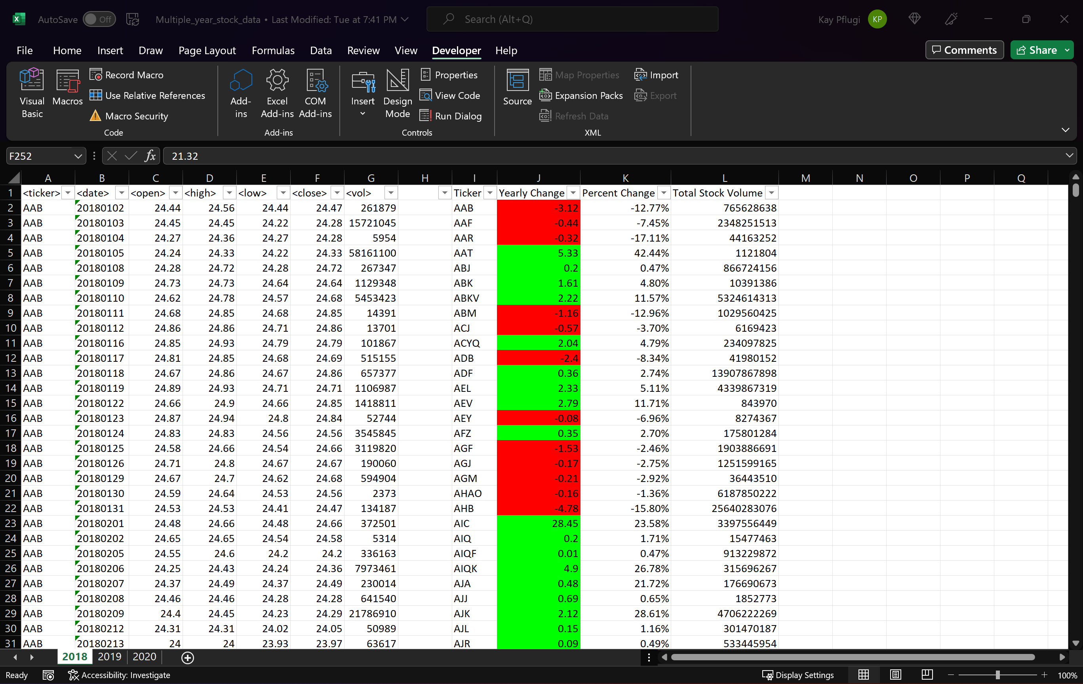

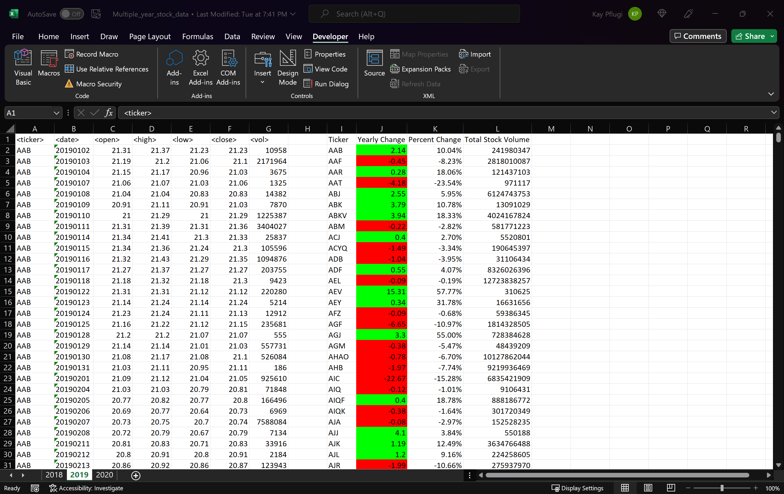

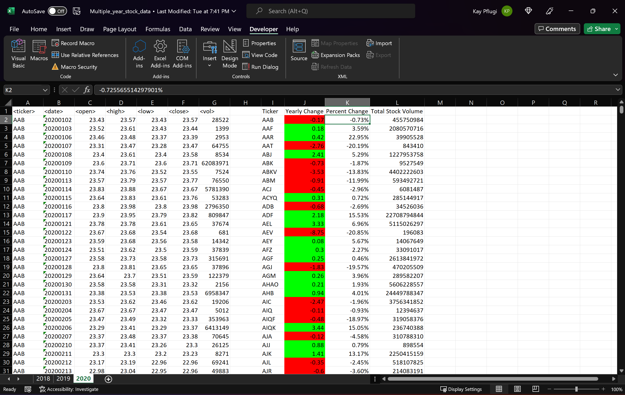

Sub StockMarket()

Dim TickerName As String

Dim YearlyChange As Double

Dim Summary_Table_Row As Integer

Dim Yearly_Close As Double

Dim Yearly_Open As Double

Dim PercentChange As Double

Dim TotalVolume As Double

Dim WS As Worksheet

For Each WS In Worksheets

WS.Activate

Cells(1, 9).Value = "Ticker"

Cells(1, 10).Value = "Yearly Change"

Cells(1, 11).Value = "Percent Change"

Cells(1, 12).Value = "Total Stock Volume"

Columns("I:L").EntireColumn.AutoFit

Columns("K:K").NumberFormat = "0.00%"

Summary_Table_Row = 2

Row1 = Cells(Rows.Count, 1).End(xlUp).Row

For i = 2 To Row1

If Cells(i + 1, 1).Value <> Cells(i, 1).Value Then

TickerName = Cells(i, 1).Value

End If

TotalVolume = TotalVolume + Cells(i, 7).Value

If Cells(i - 1, 1).Value <> Cells(i, 1).Value Then

Yearly_Open = Cells(i, 3).Value

End If

If Cells(i + 1, 1).Value <> Cells(i, 1).Value Then

Yearly_Close = Cells(i, 6).Value

YearlyChange = Yearly_Close - Yearly_Open

PercentChange = (YearlyChange / Yearly_Open)

Range("I" & Summary_Table_Row).Value = TickerName

Range("J" & Summary_Table_Row).Value = YearlyChange

Range("K" & Summary_Table_Row).Value = PercentChange

Range("L" & Summary_Table_Row).Value = TotalVolume

Summary_Table_Row = Summary_Table_Row + 1

TotalVolume = 0

End If

Next i

RowK = Cells(Rows.Count, 10).End(xlUp).Row

For j = 2 To RowK

If Cells(j, 10).Value > 0 Then

Cells(j, 10).Interior.ColorIndex = 4

ElseIf Cells(j, 10).Value < 0 Then

Cells(j, 10).Interior.ColorIndex = 3

End If

Next

Next WS

End Sub