****************************************************************

* SAN DIEGO STATE UNIVERSITY *

* DUC M LE 132485155 *

****************************************************************

DECLATION

I, DUC M LE, declare that the work presented in this final project submission is entirely my original work. I have not copied or used any unauthorized sources or assistance beyond what is acknowledged in the accompanying documentation. All code, documentation, and supporting files have been produced solely by me, and any external resources or references have been cited correctly in the report. I understand that any violation of the academic integrity policies will result in appropriate sanctions as per institutional guidelines.



Signature: ___________________________

Date: ___April 4, 2025__

Connect4TWS

**Date Progress: Jan 22, 2025**

**Description:** This game is a beginner-friendly C programming project to enhance foundational programming skills. The game features an 8x8 grid array where players compete to win with the following elements:

1. **Player Setup**: The user can choose the number of players for the game.
2. **Menu**: There will be a menu for user selection, either for coin flip or exit the game
3. **Unique Player Symbols**: The program uses x and o as a standard for better visualization.
4. **Wormholes and Traps**: There will be three traps and three wormhole spawns independently in each row and column, minus the 1 row and column.
   * **Wormhole**: Transports the player’s disc to another row.
   * **Trap**: Trap with another player disc.
5. **Snakes**: These are randomly spawned small cubes that remove a player’s disc from the grid when encountered.
6. **Coin Flip**: using the coin flip to randomly start for player 1 or 2, in a coin flip animation.
7. **Exit Option**: Players can type "exit" to quit the game anytime.
8. **Winner Recording**: The program outputs the winner(s) to a text file for record-keeping.
9. **Core Programming Concepts**:
   * Uses pointers and pass-by-value arrays for efficient memory handling.
   * Employs file I/O to save game results.
10. **Error Handling**: Provides user-friendly error messages for invalid inputs, such as choosing the same symbol or invalid commands.

**List of Core Functions**

**C code**

• **main()**

* Seeds the random number generator.
* Initiates the program by calling the menu function.

• **ShowMenu()**

* Clears the screen and displays a welcome banner.
* Presents a menu with two options: Start Game and Exit.
* Handles user input and directs flow based on choice:
  + On choosing Start, it initializes the game board, spawns challenge, performs a coin flip, and starts the main game loop.
  + Choosing Exit terminates the program.

• **coinFlipAnimation()**

* Simulates a coin-flip animation by rapidly displaying coin faces.
* Performs a final coin flip to decide which player will start the game.
* Returns 1 for Heads (Player 1) or 2 for Tails (Player 2).

• **getDebugFileName() & writeDebugLog()**

* **getDebugFileName()**: Constructs a filename based on the current date for logging purposes.
* **writeDebugLog()**: Writes debug messages to the generated log file.

• **logBoardState()**

* Logs the current state of the game board (both in a formatted grid and raw memory addresses) into the debug file for troubleshooting.

• **displayBoard()**

* Clears the screen.
* Prints the current board with row and column headers, showing the positions of discs and challenges.

• **Exit()**

* Provides a clean exit from the game when the user chooses to terminate the session.

• **Welcome()**

* Initializes an 8x8 game board (allocating a 2D array).
* Sets up the players’ symbols (typically 'x' and 'o').
* Displays an initialization message.

• **checkWinner()**

* Evaluates the board after each move to check for winning conditions horizontally, vertically, and diagonally.
* Returns a win status if four consecutive matching discs are found.

• **spawnChallenges()**

* Randomly places a specified number of traps ('T') and wormholes ('W') on the board.
* Ensures that challenges are not placed in row 0 and are placed only on empty cells.

• **setChallenge()**

* Places a particular challenge symbol at a random, valid location on the board.
* Logs the placement details for debugging.

• **teleportDisc()**

* Moves (teleports) a disc from its current location to a random empty cell.
* Logs and displays the board state after teleportation.

• **logPlayerDiscAddresses()**

* Logs the memory addresses of all player discs currently on the board.
* Useful for debugging memory allocation and board updates.

• **handleTrapLogic()**

* Implements the logic when a player lands on a trap ('T'):
  + Searches for the opponent’s discs and, if possible, places the current player's disc above them.
  + Logs the trap event and displays the updated board.

• **recordWinner()**

* Writes the game-winning event into a file with a timestamp.
* Records which player won and when.

• **snakeAttack()**

* Triggers a snake attack which randomly removes two of the current player's discs.
* Displays snake ASCII art and delays before resuming the game.
* Ensures that the removal is permanent for that game session.

• **MainGame()**

* Contains the main game loop:
  + Displays the board.
  + Handles user input for dropping discs.
  + Checks for snake attacks based on elapsed game time.
  + Applies trap and wormhole logic.
  + Checks for win conditions after each move.
  + Alternates between players and updates the game state.
  + Frees allocated memory at the end of the game.

**Mips Code**

### **Main Function**

* **main:**
  + Purpose: Entry point of the program. It calls ShowMenu to display the game menu and then exits.
  + Actions:
    - jal ShowMenu: Jumps to the ShowMenu procedure to display the menu and handle user input.
    - li $v0, 10 and syscall: Exits the program.

### **ShowMenu Procedure**

* **ShowMenu:**
  + Purpose: Displays the game menu and processes user input to either start the game or exit.
  + **Loops and Actions:**
    - **show_menu_loop:**
      * Displays the welcome message (welcome_msg), menu options (menu_prompt), and prompts for user input (get_userinput).
      * Reads an integer input (li $v0, 5; syscall) and stores it in $t0.
      * Branches based on input:
        + beq $t0, 1, start_game: If input is 1, jumps to start_game.
        + beq $t0, 2, exit_program: If input is 2, jumps to exit_program.
        + Otherwise, displays invalid_msg and loops back.
    - **start_game:**
      * Initializes the 8x8 game board with spaces:
        + **init_board_loop:**

Iterates 64 times (size of the board) using $t2 as a counter.

Stores a space character (' ') in each board position (sb $t3, 0($t1)).

Increments the board pointer ($t1) and decrements the counter ($t2) until zero.

* + - * Calls coinFlipAnimation to determine the starting player and stores the result in $s0.
      * Calls MainGame to start the game.
      * Jumps to end_show_menu.
    - **exit_program:**
      * Displays exit_msg and exits the program.
    - **end_show_menu:**
      * Restores the return address ($ra) and returns to main.

### **Coin Flip Animation Procedure**

* **coinFlipAnimation:**
  + Purpose: Simulates a coin flip animation to decide which player goes first (Player 1 or Player 2).
  + **Loops and Actions:**
    - Initializes random seed using system time (li $v0, 30; syscall) and sets it (li $v0, 40).
    - **flip_loop:**
      * Runs 5 times ($s0 as counter) to simulate coin flipping animation.
      * Generates a random number (0 or 1) using li $v0, 42; li $a1, 2; syscall.
      * If $t1 is 0, jumps to draw_tails_loop; otherwise, calls drawHeads.
      * **draw_tails_loop:**
        + Calls drawTails to draw the tails side of the coin.
      * **flip_continue:**
        + Displays a sequence of coin states with delays:

drawEdgeVertical (vertical edge), delay 500ms.

drawTails, delay 500ms.

drawEdgeHorizontal (horizontal edge), delay 500ms.

drawHeads, delay 500ms.

* + - * + Decrements $s0 and loops until zero.
    - Final flip:
      * Generates a final random number to determine the result.
      * If 0, calls drawTails, displays tails_result, and sets $v0 to 2 (Player 2 starts).
      * If 1, calls drawHeads, displays heads_result, and sets $v0 to 1 (Player 1 starts).
    - **end_coin_flip:**
      * Restores registers and returns $v0 (1 or 2).

### **Main Game Procedure**

* **MainGame:**
  + Purpose: Manages the core game loop, including player turns, disc placement, wormholes, traps, and win checking.
  + **Loops and Actions:**
    - **game_loop:**
      * Displays the board (jal displayBoard).
      * Prompts the current player (e.g., "Player 1x, enter column...") using $s1 (0 or 1) and the player symbol from players.
      * Reads user input into buffer:
        + If input is 'e', jumps to end_game.
        + Converts input to a column number ($t0 - '0') and validates (0-7); otherwise, jumps to invalid_input.
      * **find_spot_loop:**
        + Searches for the lowest empty spot in the chosen column ($s2):

Starts from row 7 ($t0 = 7) and moves up.

Calculates board index ($t1 = $t0 * 8 + $s2).

Checks if the spot is empty (' '); if so, jumps to place_disc.

If no empty spot is found (row < 0), jumps to invalid_input.

* + - * **place_disc:**
        + Places the player’s symbol ('x' or 'o') at the found position.
        + Calls checkWormholesAndTrap with row ($t0), column ($s2), and symbol ($t4):

If $v0 = 1, wormhole activated; jumps to wormhole_handled.

If $v0 = 2, trap activated; jumps to trap_handled.

* + - * + Displays the updated board.
        + Calls checkWinner with row ($s3) and column ($s2):

If $v0 = 1, a win is detected; displays the winner and ends the game.

* + - * **continue_game:**
        + Toggles the current player ($s1 = ($s1 + 1) % 2) and loops back.
      * **invalid_input:**
        + Displays invalid_col and loops back to prompt again.
      * **end_game:**
        + Restores registers and returns.

### **Display Board Procedure**

* **displayBoard:**
  + Purpose: Prints the current state of the 8x8 game board with row/column labels.
  + **Loops and Actions:**
    - **col_header_loop:**
      * Prints column numbers (0-7) with spacing (space_two and space).
      * Iterates $t0 from 0 to 7.
    - **row_loop:**
      * Iterates over rows (0-7) using $t0:
        + Prints the row number ($t0) and a '|' character.
        + **col_loop:**

Iterates over columns (0-7) using $t1:

Prints spacing (space), the board character at board[$t0*8 + $t1], and a '|' character.

Prints a newline after each row.

* + - Returns after printing the full board.

### **Check Wormholes and Trap Procedure**

* **checkWormholesAndTrap:**
  + Purpose: Checks if a placed disc lands on a wormhole entry or trap position and handles the action.
  + **Actions:**
    - Compares the placed position ($a0, $a1) with wormhole entries:
      * **check_w1_col:** If matches wormhole1_entry (2,3), jumps to wormhole1_activate.
      * **check_w2_col:** If matches wormhole2_entry (1,5), jumps to wormhole2_activate.
      * **check_w3_col:** If matches wormhole3_entry (4,1), jumps to wormhole3_activate.
    - **wormhole1_activate:**, **wormhole2_activate:**, **wormhole3_activate:**
      * Calls handleWormhole with the corresponding exit position.
      * If checkWinner returns 1, sets $v0 = 1 (wormhole activated) and ends.
    - **check_trap:**
      * If matches trap_pos (3,4), jumps to trap_activate.
    - **trap_activate:**
      * Calls removeTrapDisc to clear the trap position.
      * If trap is activated ($v0 = 1), calls trapOpponentDiscs and sets $v0 = 2.
    - **no_special:**
      * Sets $v0 = 0 if no wormhole or trap is triggered.
    - Returns $v0 (0, 1, or 2).

### **Handle Wormhole Procedure**

* **handleWormhole:**
  + Purpose: Teleports a disc from the entry position to the exit position if the exit is empty.
  + **Actions:**
    - Calculates the entry index ($s0 * 8 + $s1) and loads the disc ($t7).
    - Loads the exit position from $a0 (row $t3, col $t4) and calculates its index.
    - If the exit is empty (' '), moves the disc:
      * Clears the entry position (sb ' ', 0($t2)).
      * Places the disc at the exit (sb $t7, 0($t6)).
      * Displays wormhole_msg.
      * Checks for a win at the exit position (jal checkWinner).
    - Returns.

### **Remove Trap Disc Procedure**

* **removeTrapDisc:**
  + Purpose: Removes the disc at the trap position if it hasn’t been used yet.
  + **Actions:**
    - Checks if the trap is already used (trap_used != 0); if so, returns 0.
    - Verifies the position matches trap_pos (3,4).
    - If matched and unused:
      * Clears the position (sb ' ', 0($t2)).
      * Sets trap_used = 1.
      * Returns $v0 = 1.
    - Otherwise, returns $v0 = 0.

### **Trap Opponent Discs Procedure**

* **trapOpponentDiscs:**
  + Purpose: Places the current player’s disc above or below each opponent’s disc if possible.
  + **Loops and Actions:**
    - **trap_row_loop:**
      * Iterates over rows (0-7) using $t0.
      * **trap_col_loop:**
        + Iterates over columns (0-7) using $t1.
        + Checks if the position contains the opponent’s disc ($t4 = $s1).
        + If found:

**try_below:** Checks below (row + 1); if empty, places the player’s disc (sb $s0).

**try_above:** Checks above (row - 1); if empty, places the player’s disc.

* + - * + Skips if no empty spot is available.
    - Displays trap_msg and returns.

### **Check Winner Procedure**

* **checkWinner:**
  + Purpose: Checks for exactly 4 consecutive matching pieces in any direction from the placed disc.
  + **Loops and Actions:**
    - Loads the placed disc’s symbol ($s3).
    - **Horizontal Check:**
      * **horizontal_loop:** Counts left from $s1 until a mismatch or boundary.
      * **check_right:** Counts right until a mismatch or boundary.
      * Wins if total count ($t3) equals 4.
    - **Vertical Check:**
      * **vertical_loop:** Counts up from $s0.
      * **check_down:** Counts down.
      * Wins if total is 4.
    - **Forward Diagonal (Top-Left to Bottom-Right):**
      * **diagonal_forward_loop:** Counts up-left.
      * **check_down_right:** Counts down-right.
      * Wins if total is 4.
    - **Backward Diagonal (Top-Right to Bottom-Left):**
      * **diagonal_backward_loop:** Counts up-right.
      * **check_down_left:** Counts down-left.
      * Wins if total is 4.
    - Returns $v0 = 1 and $v1 = 1 (Player 1) or 2 (Player 2) if a win is detected; otherwise, $v0 = 0, $v1 = 0.

### **Draw Coin Flip Procedures**

* **drawHeads:**
  + Purpose: Draws the "heads" side of the coin (circle with an 'H').
  + **Loops:**
    - **clear_heads_loop:** Clears an 8x8 area with black.
    - **heads_row_loop:** and **heads_col_loop:**
      * Draws a silver circle with a yellow edge (radius ~3.5).
      * Adds a red 'H' in the middle row (cols 3 and 4).
* **drawTails:**
  + Purpose: Draws the "tails" side (circle with a 'T').
  + **Loops:**
    - **clear_tails_loop:** Clears the area.
    - **tails_row_loop:** and **tails_col_loop:**
      * Draws a silver circle with a yellow edge.
      * Adds a green 'T' in the middle row (col 3).
* **drawEdgeVertical:**
  + Purpose: Draws a vertical yellow line (coin edge).
  + **Loops:**
    - **clear_edge_v_loop:** Clears the area.
    - **edge_v_loop:** Draws a vertical line at x=15.
* **drawEdgeHorizontal:**
  + Purpose: Draws a horizontal yellow line (coin edge).
  + **Loops:**
    - **clear_edge_h_loop:** Clears the area.
    - **edge_h_loop:** Draws a horizontal line at y=15.

high-level description of your C code expressed in pseudo-code

**// MAIN PROGRAM FLOW**

**MAIN:**

**seed random number generator using current time**

**call ShowMenu()**

**exit program**

**// SHOW MENU**

**ShowMenu:**

**LOOP forever:**

**clear screen**

**display large welcome banner and menu options:**

**"1) Start Game"**

**"2) Exit"**

**prompt user for choice and read input**

**IF choice == 1 THEN:**

**clear screen**

**// Game Initialization**

**call Welcome() to:**

**- allocate an 8x8 board (2D array)**

**- initialize all cells to a blank space**

**- set up the players' symbols ('x' and 'o')**

**call spawnChallenges() to randomly place traps ('T') and wormholes ('W')**

**delay (simulate processing time)**

**startingPlayer = call coinFlipAnimation() // simulate coin flip and determine who goes first**

**delay (additional pause)**

**call MainGame(board, rows, cols, players, startingPlayer)**

**break out of the loop // game ends after MainGame finishes**

**ELSE IF choice == 2 THEN:**

**display "Exiting the program. Goodbye!"**

**exit program**

**ELSE:**

**display "Invalid choice. Please enter 1 or 2."**

**delay (allow user to read message)**

**continue loop**

**// COIN FLIP ANIMATION**

**coinFlipAnimation:**

**FOR a fixed number of flips:**

**generate random value (0 or 1)**

**clear screen**

**display "Flipping the coin..." and show corresponding ASCII art (heads or tails)**

**delay (simulate animation speed)**

**PERFORM final coin flip:**

**generate final random result (0 or 1)**

**clear screen**

**display final coin face (heads or tails)**

**RETURN value indicating starting player:**

**1 for Heads (Player 1)**

**2 for Tails (Player 2)**

**// WELCOME AND BOARD INITIALIZATION**

**Welcome:**

**display a message about initializing an 8x8 board for two players**

**allocate memory for a 2D board (8 rows × 8 columns)**

**initialize each board cell with a space (' ')**

**allocate memory for a players array and assign:**

**players[0] = 'x'**

**players[1] = 'o'**

**return board, row count, column count, and players**

**// MAIN GAME LOOP**

**MainGame(board, r, c, players, startingPlayer):**

**set currentPlayer based on startingPlayer (adjust index accordingly)**

**record the start time of the game**

**initialize snake attack timer (random interval between 10 and 30 seconds)**

**WHILE game is NOT over:**

**IF current time - last snake attack time >= snake interval AND snake count < limit:**

**call snakeAttack(board, r, c, currentPlayer’s disc)**

**update snake attack timer and count**

**continue to next iteration (skip regular turn)**

**call logBoardState(board, r, c) // optional debug logging**

**call logPlayerDiscAddresses(board, r, c) // optional debug logging**

**call displayBoard(board, r, c) to show current board**

**prompt current player:**

**"Player {number} ({disc}), enter column (0 to c-1) to drop your disc, or 'e' to quit: "**

**read input**

**IF input == 'e' THEN:**

**display exit message for current player**

**set game over flag to true**

**CONTINUE to exit loop**

**convert input to integer as column number**

**IF column number is invalid (not in range 0 to c-1):**

**display error "Invalid column! Choose between 0 and c-1."**

**continue loop (retry current player's turn)**

**find the lowest available row in the selected column:**

**FOR row from bottom (r - 1) upward:**

**IF board cell is empty OR contains a trap ('T') OR wormhole ('W'):**

**mark this row as the target**

**break loop**

**IF no valid row found (i.e., column is full):**

**display "Column is full! Try again."**

**continue loop**

**IF the target cell contains a trap ('T'):**

**call handleTrapLogic(board, r, c, row, col, currentPlayer’s disc)**

**ELSE IF the target cell contains a wormhole ('W'):**

**remove wormhole marker from board cell**

**call teleportDisc(board, r, c, row, col, currentPlayer’s disc)**

**ELSE:**

**place currentPlayer’s disc at the target cell**

**IF checkWinner(board, r, c, row, col, currentPlayer’s disc) returns TRUE THEN:**

**clear screen**

**display winning message indicating which player won**

**call recordWinner() to log the win event with timestamp**

**display final board state**

**set game over flag to true**

**IF game is not over:**

**switch currentPlayer to the other player (toggle between 0 and 1)**

**// End of game loop**

**call logBoardState(board, r, c) // final board logging**

**free allocated memory for board and players**

**display final thank-you message for playing**

**// ADDITIONAL FUNCTIONS**

**checkWinner:**

**check for four consecutive matching discs in:**

**- horizontal direction**

**- vertical direction**

**- diagonal directions (both \ and /)**

**return TRUE if a winning condition is met, otherwise FALSE**

**spawnChallenges:**

**randomly place a specified number of traps ('T') and wormholes ('W') on the board**

**ensure:**

**- traps and wormholes are not placed in row 0**

**- placement occurs only in empty cells**

**for wormholes, ensure they are placed in unique rows and columns**

**handleTrapLogic:**

**when a trap is activated:**

**search the board for opponent's discs**

**if found and an empty cell is available above, place the current player’s disc there**

**otherwise, place the disc in the trap cell**

**log the trap event for debugging**

**teleportDisc:**

**when a wormhole is encountered:**

**search for a random empty cell on the board**

**place the current player’s disc in that cell**

**log the teleportation event**

**display the board after teleportation**

**snakeAttack:**

**collect positions of current player's discs on the board**

**IF there are at least two discs:**

**randomly choose two distinct disc positions**

**remove (set to empty) those discs from the board**

**clear screen and display updated board with snake ASCII art**

**delay for a few seconds to show the effect**

**// The removed discs are permanently gone**

**recordWinner:**

**record the winning event (player number, disc, timestamp) in a log file for future reference**

**logBoardState, displayBoard, logPlayerDiscAddresses:**

**support debugging by printing/logging the current board state and memory details**

**C Code**

/*********************************************************************

* SAN DIEGO STATE UNIVERSITY *

* DUC M LE 132485155 *

**********************************************************************

-------------------------- END-OF-HEADER -----------------------------

*

* Connect4TWS.c

*

*

* Created on: Sep 6, 2024

* Update on: Mar 2, 2025

* Author: DUC M LE

*

* General: This game is a mashup of Wormhole, Tic-Tac Toe, Snake and Connect4. Whenever the user drops the disc into a wormhole,

* it teleports the disc into a random column and row. Whenever the user drop the disc into trap , it will trap other player. It also

* has snake spawn to take away player disc. There are 3 wormhole and one trap for standard interaction.

*

* Function: Uses board pointers to initialize and manage the game board.

*

* Feature added : Menu selection, coin flip.

*

* Note: This is a finish C for this game, there is not anymore to add for feature all the feature is consideration. Focus on MIPS. Clean the C program to look nice

* and professional.

*/

// Standard headers

**#include** <stdio.h>

**#include** <stdlib.h>

**#include** <time.h>

**#include** <string.h>

**#include** <stddef.h>

**#include** <unistd.h>

**#include** <sys/types.h>

**#include** <sys/stat.h>

// Custom headers

**#include** "Header.h"

/* ----------------------------------------------------------------

* MAIN

* - Shows a menu with two options: Start or Exit

* - If user chooses Start -> coin flip -> game

* - If user chooses Exit -> quits the program

* ----------------------------------------------------------------

*/

**int** **main**() {

// Seed the random number generator (for coinFlip)

**srand**((**unsigned** **int**)**time**(NULL));

ShowMenu(); // This will handle the user’s menu selection

**return** 0; // We'll usually never reach here if "Exit" is chosen

}

/* ----------------------------------------------------------------

* ShowMenu

* - Clears screen

* - Prints a large ASCII banner: "Welcome to Connect 4 TrapWormhole"

* - Offers two options: 1) Start 2) Exit

* - If user chooses 1, does coin-flip, then starts the game

* - If user chooses 2, exits the program

* ----------------------------------------------------------------

*/

**void** **ShowMenu**(**void**) {

**int** choice = 0;

**while** (1) {

**system**(CLEAR_SCREEN);

**printf**("=======================================================\n");

**printf**(" WELCOME TO CONNECT 4 TRAPWORMHOLE! \n");

**printf**("=======================================================\n");

**printf**(" A Twist on the Classic Game \n");

**printf**(" With Wormholes & Traps \n");

**printf**("=======================================================\n\n");

// Menu

**printf**("Menu:\n");

**printf**(" 1) Start Game\n");

**printf**(" 2) Exit\n\n");

**printf**("Enter your choice (1 or 2): ");

**scanf**("%d", &choice);

**if** (choice == 1) {

// Clear screen once user picks start

**system**(CLEAR_SCREEN);

// 1) Initialize board

**char** **board = NULL;

**int** r = 0, c = 0;

**char** *players;

Welcome(&board, &r, &c, &players);

// 2) Spawn 1 traps & 3 wormholes (not in row 0)

spawnChallenges(board, r, c, 1, 3);

// 3) Simulate a small delay (1200 ms)

SLEEP_MS(1200);

// 4) Coin flip -> decide who starts

**int** flipResult = coinFlipAnimation();

**if** (flipResult == 1) {

**printf**("Heads! Player 1 goes first.\n");

} **else** {

**printf**("Tails! Player 2 goes first.\n");

}

**int** startingPlayer = flipResult - 1; // (1->0 => P1, 2->1 => P2)

// Add 1000ms delay before showing the board

SLEEP_MS(1900);

// 5) Launch the main game loop

MainGame(board, r, c, players, startingPlayer);

// After game ends, break out

**break**;

}

**else** **if** (choice == 2) {

**printf**("Exiting the program. Goodbye!\n");

**exit**(0);

}

**else** {

**printf**("Invalid choice. Please enter 1 or 2.\n");

SLEEP_MS(1200);

}

}

}

/* ----------------------------------------------------------------

* coinFlipAnimation

* - Displays a quick coin-flip animation (~2 seconds)

* - Then does a final flip:

* 1 => Heads => Player 1

* 2 => Tails => Player 2

* ----------------------------------------------------------------

*/

**int** **coinFlipAnimation**(**void**) {

**const** **int** flips = 10;

**const** **int** delayMs = 200;

**const** **char**\* headsArt =

" _______\n"

" / \\ \n"

" | HEADS |\n"

" \\_______/\n";

**const** **char**\* tailsArt =

" _______\n"

" / \\ \n"

" | TAILS |\n"

" \\_______/\n";

**for** (**int** i = 0; i < flips; i++) {

**int** showHeads = **rand**() % 2; // 0 or 1

**system**(CLEAR_SCREEN);

**printf**("Flipping the coin...\n\n");

**if** (showHeads) {

**printf**("%s\n", headsArt);

} **else** {

**printf**("%s\n", tailsArt);

}

SLEEP_MS(delayMs);

}

// Final REAL flip

**int** finalFlip = **rand**() % 2;

**system**(CLEAR_SCREEN);

**printf**("\n\n");

**if** (finalFlip == 1) {

**printf**("%s\n", headsArt);

**return** 1; // Heads → Player 1

} **else** {

**printf**("%s\n", tailsArt);

**return** 2; // Tails → Player 2

}

}

/* ----------------------------------------------------------------

* getDebugFileName

* -Save file debug as a text to show detail log.

* ----------------------------------------------------------------

*/

**void** **getDebugFileName**(**char** *filename) {

time_t t = **time**(NULL);

**struct** tm tm = \***localtime**(&t);

sprintf(filename, "Debug%02d%02d%04d.txt", tm.tm_mon + 1, tm.tm_mday, tm.tm_year + 1900);

}

/* ----------------------------------------------------------------

* writeDebugLog

* -write debug log

* ----------------------------------------------------------------

*/

**void** **writeDebugLog**(**const** **char** *message) {

**char** filename[20];

getDebugFileName(filename); // e.g. "DebugMMDDYYYY.txt"

FILE *file = **fopen**(filename, "a"); // Open in append mode

**if** (file == NULL) {

**perror**("Error opening debug file");

**return**;

}

**fprintf**(file, "%s\n", message); // Write the debug message

**fclose**(file);

}

/* ----------------------------------------------------------------

* logBoardState

* -Show board state for each time player drop the disc and write into text file

* -Write into debug log for the board in the text file that is already open

* -With address and address of player disc.

* ----------------------------------------------------------------

*/

**void** **logBoardState**(**char** **board, **int** r, **int** c) {

**char** logMessage[DEBUG_LOG_SIZE];

sprintf(logMessage, "\nCurrent Board State:\n");

writeDebugLog(logMessage);

**for** (**int** i = 0; i < r; i++) {

sprintf(logMessage, "%2d |", i);

**for** (**int** j = 0; j < c; j++) {

sprintf(logMessage + **strlen**(logMessage), " %c |", board[i][j]);

}

writeDebugLog(logMessage);

}

sprintf(logMessage, " ");

**for** (**int** j = 0; j < c; j++) {

sprintf(logMessage + **strlen**(logMessage), " %d ", j);

}

writeDebugLog(logMessage);

// Log raw memory addresses (in the debug file)

writeDebugLog("\nDEBUG: Board Memory Layout (Address and Values)\n");

**for** (**int** i = 0; i < r; i++) {

**for** (**int** j = 0; j < c; j++) {

sprintf(logMessage, "Row %d, Col %d -> Address: %p, Value: '%c'",

i, j, (**void**\*)&board[i][j], board[i][j]);

writeDebugLog(logMessage);

}

}

}

/* ----------------------------------------------------------------

* displayBoard

* -Display the board in the console.

* ----------------------------------------------------------------

*/

**void** **displayBoard**(**char** **board, **int** r, **int** c) {

**system**(CLEAR_SCREEN); // Clear screen before displaying the board

**printf**(" ");

**for** (**int** j = 0; j < c; j++) {

**printf**(" %d ", j);

}

**printf**("\n");

**for** (**int** i = 0; i < r; i++) {

**printf**("%2d |", i);

**for** (**int** j = 0; j < c; j++) {

**printf**(" %c |", board[i][j]);

}

**printf**("\n");

}

**printf**(" ");

**for** (**int** j = 0; j < c; j++) {

**printf**(" %d ", j);

}

**printf**("\n");

}

/* ----------------------------------------------------------------

* Exit()

* -Exit the game when user hit e

* ----------------------------------------------------------------

*/

**void** **Exit**() {

**printf**("Exiting the game...\n");

**#ifdef** __APPLE__

**system**("osascript -e 'tell application \"Terminal\" to close first window' &");

**#endif**

}

/* ----------------------------------------------------------------

* Welcome

* -Welome player and do the setup of the board and setting up the player symbol x and o

* ----------------------------------------------------------------

*/

**void** **Welcome**(**char** ***board, **int** *r, **int** *c, **char** **players) {

// Print out a message about initializing the board

**printf**("\nInitializing 8x8 board for 2 players (x and o)...\n");

*r = 8;

*c = 8;

*board = (**char** **)**malloc**((*r) * **sizeof**(**char** *));

**if** (*board == NULL) {

**printf**("Memory allocation failed for board.\n");

**exit**(1);

}

**for** (**int** i = 0; i < *r; i++) {

(*board)[i] = (**char** *)**malloc**((*c) * **sizeof**(**char**)); // avoid using malloc memory allocation using fix array size

**if** ((*board)[i] == NULL) {

**printf**("Memory allocation failed for board row %d.\n", i);

**exit**(1);

}

}

**for** (**int** i = 0; i < *r; i++) {

**for** (**int** j = 0; j < *c; j++) {

(*board)[i][j] = ' ';

}

}

*players = (**char** *)**malloc**(2 * **sizeof**(**char**));

**if** (*players == NULL) {

**printf**("Memory allocation failed for players array.\n");

**exit**(1);

}

(*players)[0] = 'x';

(*players)[1] = 'o';

}

/* ----------------------------------------------------------------

* checkWinner

* -Check winner horizontal, vertical and diagonally

* ----------------------------------------------------------------

*/

**int** **checkWinner**(**char** **board, **int** r, **int** c, **int** row, **int** col, **char** disc) {

**int** count;

// Check horizontally

count = 0;

**for** (**int** j = 0; j < c; j++) {

**if** (board[row][j] == disc) {

count++;

**if** (count == 4) **return** 1;

} **else** {

count = 0;

}

}

// Check vertically

count = 0;

**for** (**int** i = 0; i < r; i++) {

**if** (board[i][col] == disc) {

count++;

**if** (count == 4) **return** 1;

} **else** {

count = 0;

}

}

// Check diagonally (\)

count = 0;

{

**int** i = row, j = col;

**while** (i >= 0 && j >= 0 && board[i][j] == disc) { i--; j--; }

i++; j++;

**while** (i < r && j < c && board[i][j] == disc) {

count++;

i++; j++;

**if** (count == 4) **return** 1;

}

}

// Check diagonally (/)

count = 0;

{

**int** i = row, j = col;

**while** (i >= 0 && j < c && board[i][j] == disc) { i--; j++; }

i++; j--;

**while** (i < r && j >= 0 && board[i][j] == disc) {

count++;

i++; j--;

**if** (count == 4) **return** 1;

}

}

**return** 0;

}

/* ----------------------------------------------------------------

* spawnChallenges

* - Places 'numTraps' traps ('T') and 'numWormholes' wormholes ('W')

* in random positions on the board, excluding row 0.

* - Board cells must be ' ' (empty).

* ----------------------------------------------------------------

*/

**void** **spawnChallenges**(**char** **board, **int** r, **int** c, **int** numTraps, **int** numWormholes) {

// Place 'T' for each trap

**for** (**int** i = 0; i < numTraps; i++) {

**int** row, col;

**do** {

row = **rand**() % r;

col = **rand**() % c;

} **while** (row == 0 || board[row][col] != ' ');

board[row][col] = 'T';

}

// Place 'W' for each wormhole ensuring they are in different rows and columns

**int** usedRows[r];

**int** usedCols[c];

memset(usedRows, 0, **sizeof**(usedRows));

memset(usedCols, 0, **sizeof**(usedCols));

**for** (**int** i = 0; i < numWormholes; i++) {

**int** row, col;

**do** {

row = **rand**() % r;

col = **rand**() % c;

} **while** (row == 0 || board[row][col] != ' ' || usedRows[row] || usedCols[col]);

board[row][col] = 'W';

usedRows[row] = 1;

usedCols[col] = 1;

}

}

/* ----------------------------------------------------------------

* setChallenge

*

* - Set challenge of the wormhole and trap and write into debug file

*

* ----------------------------------------------------------------

*/

**void** **setChallenge**(**char** **board, **int** r, **int** c, **char** symbol, **int** *outRow, **int** *outCol) {

**int** row, col;

**do** {

row = **rand**() % r;

col = **rand**() % c;

} **while** (board[row][col] != ' ');

*outRow = row;

*outCol = col;

board[row][col] = symbol;

**char** debugMessage[DEBUG_LOG_SIZE];

sprintf(debugMessage, "DEBUG: '%c' placed at row %d, column %d (board[%d][%d])",

symbol, *outRow, *outCol, row, col);

writeDebugLog(debugMessage);

}

/* ----------------------------------------------------------------

* teleportDisc

*

* - Telelporting player disc if the disc is landing on the W for teleporting.

*

* - Teleporting to random row and col with delay and banner and log that in to debug file

*

* ----------------------------------------------------------------

*/

**void** **teleportDisc**(**char** **board, **int** r, **int** c, **int** *row, **int** *col, **char** disc) {

**int** newRow, newCol;

**int** maxAttempts = r * c, attempts = 0;

**int** playerNumber = (disc == 'x') ? 1 : 2; // Determine player number

// Display teleportation banner and clear screen

**system**(CLEAR_SCREEN);

**printf**("\n=============================================\n");

**printf**(" Teleporting Player %d's disc now... \n", playerNumber);

**printf**("=============================================\n");

SLEEP_MS(1000); // 1000ms delay

**do** {

newRow = **rand**() % r;

newCol = **rand**() % c;

attempts++;

} **while** (board[newRow][newCol] != ' ' && attempts < maxAttempts);

**if** (board[newRow][newCol] == ' ') {

board[newRow][newCol] = disc;

*row = newRow;

*col = newCol;

// Log teleportation event

**char** debugMessage[DEBUG_LOG_SIZE];

sprintf(debugMessage, "DEBUG: Player %d's Disc teleported to Row %d, Column %d\n", playerNumber, *row, *col);

writeDebugLog(debugMessage);

}

// Show the current board after teleportation

displayBoard(board, r, c);

}

/* ----------------------------------------------------------------

* logPlayerDiscAddresses

*

* - Log player address for debug purposes.

*

* ----------------------------------------------------------------

*/

**void** **logPlayerDiscAddresses**(**char** **board, **int** r, **int** c) {

**char** filename[20];

getDebugFileName(filename);

FILE *file = **fopen**(filename, "a");

**if** (file == NULL) {

**perror**("Error opening debug file");

**return**;

}

**fprintf**(file, "\nDEBUG: Player Disc Memory Addresses\n");

**for** (**int** i = 0; i < r; i++) {

**for** (**int** j = 0; j < c; j++) {

**if** (board[i][j] == 'x' || board[i][j] == 'o') {

**fprintf**(file, "Row %d, Col %d -> Address: %p, Value: '%c'\n",

i, j, (**void**\*)&board[i][j], board[i][j]);

}

}

}

**fclose**(file);

}

/* ----------------------------------------------------------------

* handleTrapLogic

*

* - To handle trap when player disc is landing on the T

*

* - Showing banner

*

* - Trap other player disc by searching the board for player x or o and trap them with perspectively player turn.

*

* - Log the trap logic into text file

*

* ----------------------------------------------------------------

*/

**void** **handleTrapLogic**(**char** **board, **int** r, **int** c, **int** row, **int** col, **char** disc) {

**char** opponentDisc = (disc == 'x') ? 'o' : 'x';

**int** placed = 0;

**int** playerNumber = (disc == 'x') ? 1 : 2; // Determine player number

// Display trap banner and clear screen

**system**(CLEAR_SCREEN);

**printf**("\n=============================================\n");

**printf**(" Oh, Oh! Player %d landed on a TRAP! \n", playerNumber);

**printf**("=============================================\n");

SLEEP_MS(1000); // 1000ms delay

// Log trap activation

**char** filename[20];

getDebugFileName(filename);

FILE *file = **fopen**(filename, "a");

**if** (file != NULL) {

**fprintf**(file, "DEBUG: Player %d (%c) landed on a Trap at Row %d, Col %d\n", playerNumber, disc, row, col);

}

// Search entire row for opponent's discs and place player's disc on top of each

**for** (**int** j = 0; j < c; j++) {

**for** (**int** i = 0; i < r; i++) {

**if** (board[i][j] == opponentDisc && i > 0 && board[i - 1][j] == ' ') {

board[i - 1][j] = disc;

placed = 1;

**if** (file != NULL) {

**fprintf**(file, "DEBUG: Disc placed at Row %d, Col %d (above opponent at Row %d)\n", i - 1, j, i);

}

}

}

}

// Search entire column for opponent's discs and place player's disc on top of each

**for** (**int** i = 0; i < r; i++) {

**if** (board[i][col] == opponentDisc && i > 0 && board[i - 1][col] == ' ') {

board[i - 1][col] = disc;

placed = 1;

**if** (file != NULL) {

**fprintf**(file, "DEBUG: Disc placed at Row %d, Col %d (above opponent at Row %d)\n", i - 1, col, i);

}

}

}

// If no opponent disc was found, place at the trap location

**if** (!placed) {

board[row][col] = disc;

**if** (file != NULL) {

**fprintf**(file, "DEBUG: No opponent found, placed at trap location Row %d, Col %d\n", row, col);

}

}

// Remove the trap after it's used

board[row][col] = ' ';

// Close the debug file

**if** (file != NULL) {

**fclose**(file);

}

// Show the current board after trap logic

displayBoard(board, r, c);

}

**void** **recordWinner**(**int** playerNumber, **char** disc) {

**const** **char** *filePath = "/Users/admin/Desktop/Compe160-271/Connect4Wormhole/winner_record.txt";

FILE *file = **fopen**(filePath, "a");

**if** (file == NULL) {

**perror**("Error opening file");

**return**;

}

time_t rawtime;

**struct** tm * timeinfo;// avoid using struct

**char** timeStr[80];

**time**(&rawtime);

timeinfo = **localtime**(&rawtime);

**strftime**(timeStr, **sizeof**(timeStr), "%Y-%m-%d %H:%M:%S", timeinfo);

**fprintf**(file, "Player %d (%c) won the game at %s\n", playerNumber, disc, timeStr);

**fclose**(file);

}

/**

* snakeAttack - Permanently removes two discs from the current player

* (either 'x' or 'o') and displays only the current board.

*

* board, r, c: The game board & dimensions

* disc: The current player's disc ('x' or 'o')

*

* Steps:

* 1) Gather all positions of this player's discs.

* 2) If < 2 discs exist, do nothing (just return).

* 3) Otherwise pick 2 random discs, remove them from the board (set ' ').

* 4) Clear screen, display the updated board once, show snake ASCII, and wait 3s.

* 5) Discs are NOT restored.

*/

**void** **snakeAttack**(**char** **board, **int** r, **int** c, **char** disc) {

// 1) Collect the player's disc positions

**int** positions[1000][2];

**int** count = 0;

**for** (**int** i = 0; i < r; i++) {

**for** (**int** j = 0; j < c; j++) {

**if** (board[i][j] == disc) {

positions[count][0] = i;

positions[count][1] = j;

count++;

}

}

}

// If fewer than 2 discs => can't remove 2, do nothing

**if** (count < 2) {

**return**;

}

// 2) Pick two distinct random positions from that player's discs

**int** idx1 = **rand**() % count;

**int** idx2;

**do** {

idx2 = **rand**() % count;

} **while** (idx2 == idx1);

// row/col of the two discs

**int** row1 = positions[idx1][0];

**int** col1 = positions[idx1][1];

**int** row2 = positions[idx2][0];

**int** col2 = positions[idx2][1];

// 3) Permanently remove them

board[row1][col1] = ' ';

board[row2][col2] = ' ';

// 4) Clear screen and display updated board ONCE

**#ifdef** _WIN32

system("cls");

**#else**

**system**("clear");

**#endif**

**printf**("The Snake is about to grab TWO of Player %c's discs!\n\n", disc);

displayBoard(board, r, c); // Show only the current board with discs removed

// 5) Print snake ASCII

**printf**("\nThe Snake Slithers In and Strikes!!!\n\n");

**printf**(" __,__\n"

" .--. .--.\n"

" / \\ \\ \n"

"| >\\/7 |\n"

"| >\\/7 ,--'\n"

" \\ / /\n"

" `--' `--' \n"

" || || \n"

" || || \n"

" ~~ ~~ \n\n");

**fflush**(stdout);

// 6) Wait ~3 seconds

SLEEP_MS(3000);

// 7) Do NOT restore discs => they remain gone

// No additional board display here; the game loop will handle it

}

/* ------------------------------------------------------

* MainGame

* - Plays the Connect4 + Wormhole + Trap variant.

* - startingPlayer => 0 => P1, 1 => P2

* - Ensures only the current board is displayed after each action.

* ------------------------------------------------------

*/

**void** **MainGame**(**char** **board, **int** r, **int** c, **char** *players, **int** startingPlayer) {

**int** currentPlayer = startingPlayer;

**char** disc;

**int** col, row;

**char** input[10];

**int** gameOver = 0;

time_t gameStartTime = **time**(NULL); // Record game start time

// Initialize first random snake interval (10-30 seconds)

**if** (lastSnakeTime == 0) {

lastSnakeTime = gameStartTime;

nextSnakeInterval = (**rand**() % 21) + 10; // Random between 10 and 30 seconds

}

**while** (!gameOver) {

// Check for snake attack based on elapsed time

time_t currentTime = **time**(NULL);

**if** (snakeCount < 3 && (currentTime - lastSnakeTime) >= nextSnakeInterval) {

snakeCount++;

disc = players[currentPlayer];

snakeAttack(board, r, c, disc); // Snake updates and shows current board

// Reset for next snake attack

lastSnakeTime = currentTime;

nextSnakeInterval = (**rand**() % 21) + 10; // New random interval (10-30s)

// Optional: Log the event

**char** debugMessage[DEBUG_LOG_SIZE];

sprintf(debugMessage, "DEBUG: Snake attacked at %ld seconds into game",

currentTime - gameStartTime);

writeDebugLog(debugMessage);

// Skip the regular board display this turn since snakeAttack already showed it

**continue**;

}

// Log board state (optional, for debugging)

logBoardState(board, r, c);

logPlayerDiscAddresses(board, r, c);

// Display the current board for player turn

displayBoard(board, r, c);

// Prompt for player's action

disc = players[currentPlayer];

**printf**("Player %d (%c), enter column (0-%d) to drop your disc, or 'e' to quit: ",

currentPlayer + 1, disc, c - 1);

**scanf**("%s", input);

// Check if user wants to exit

**if** (**strcmp**(input, "e") == 0) {

gameOver = 1;

**printf**("Player %d (%c) has exited the game.\n", currentPlayer + 1, disc);

**continue**;

}

// Otherwise, assume user typed a column number

col = **atoi**(input);

**if** (col < 0 || col >= c) {

**printf**("Invalid column! Choose between 0 and %d.\n", c - 1);

**continue**;

}

// Find where to place the disc (from bottom up)

row = -1;

**for** (**int** i = r - 1; i >= 0; i--) {

**if** (board[i][col] == ' ' || board[i][col] == 'T' || board[i][col] == 'W') {

row = i;

**break**;

}

}

**if** (row == -1) {

**printf**("Column %d is full! Try again.\n", col);

**continue**;

}

// Handle traps correctly

**if** (board[row][col] == 'T') {

handleTrapLogic(board, r, c, row, col, disc);

}

// If there's a wormhole, teleport disc

**else** **if** (board[row][col] == 'W') {

board[row][col] = ' '; // remove wormhole

teleportDisc(board, r, c, &row, &col, disc);

}

// Otherwise, place disc normally

**else** {

board[row][col] = disc;

}

// Check if the move results in a win

**if** (checkWinner(board, r, c, row, col, disc)) {

**system**(CLEAR_SCREEN); // Clear screen before showing win message

**printf**("Player %d (%c) wins!\n", currentPlayer + 1, disc);

recordWinner(currentPlayer + 1, disc);

displayBoard(board, r, c); // Show final board state

gameOver = 1;

}

// Switch players if not game over

**if** (!gameOver) {

currentPlayer = (currentPlayer + 1) % 2;

}

}

// Final board state (already shown if a win occurred)

logBoardState(board, r, c);

// Free memory

**for** (**int** i = 0; i < r; i++) {

**free**(board[i]);

}

**free**(board);

**free**(players); // avoid using free

**printf**("Thank you for playing Wormhole Connect4!\n");

}

/*********************************************************************

* SAN DIEGO STATE UNIVERISTY *

* DUC M LE 132485155 *

**********************************************************************

-------------------------- END-OF-HEADER -----------------------------

*

* Header.h

*

* Created on: Oct 16, 2024

* Author: Duc Le

*/

**#ifndef** HEADER_H_

**#define** HEADER_H_

// Function Prototypes

**void** **ShowMenu**(**void**);

**void** **Exit**();

**void** **Welcome**(**char** ***board, **int** *r, **int** *c, **char** **players);

**void** **MainGame**(**char** **board, **int** r, **int** c, **char** *players, **int** startingPlayer);

**int** **checkWinner**(**char** **board, **int** r, **int** c, **int** row, **int** col, **char** disc);

**void** **setChallenge**(**char** **board, **int** r, **int** c, **char** symbol, **int** *outRow, **int** *outCol);

**void** **teleportDisc**(**char** **board, **int** r, **int** c, **int** *row, **int** *col, **char** disc);

**void** **recordWinner**(**int** playerNumber, **char** disc);

**void** **spawnChallenges**(**char** **board, **int** r, **int** c, **int** numTraps, **int** numWormholes);

**void** **handleTrapLogic**(**char** **board, **int** r, **int** c, **int** row, **int** col, **char** disc);

**void** **getDebugFileName**(**char** *filename);

**void** **writeDebugLog**(**const** **char** *message);

**void** **logBoardState**(**char** **board, **int** r, **int** c);

**int** **coinFlipAnimation**(**void**);

**void** **logPlayerDiscAddresses**(**char** **board, **int** r, **int** c);

**void** **snakeAttack**(**char** **board, **int** r, **int** c, **char** disc);

**void** **displayBoard**(**char** **board, **int** r, **int** c);

// End Function Prototypes

// Prototypes

**#define** DEBUG_LOG_SIZE 1024

// custom Clear Screen

**#ifdef** _WIN32

**#include** <windows.h> // For Sleep(ms) on Windows

**#define** CLEAR_SCREEN "cls"

**#define** SLEEP_MS(ms) Sleep(ms)

**#else**

**#define** CLEAR_SCREEN "clear"

**#define** SLEEP_MS(ms) usleep((ms) * 1000)

**#endif**

// Custom Global Declaration

**static** time_t lastSnakeTime = 0; // Time of the last snake attack

**static** **int** nextSnakeInterval = 0; // Seconds until next snake attack

**static** **int** snakeCount = 0; // Existing variable to limit snake appearances

// End Prototypes

**#endif** /* HEADER_H_ */

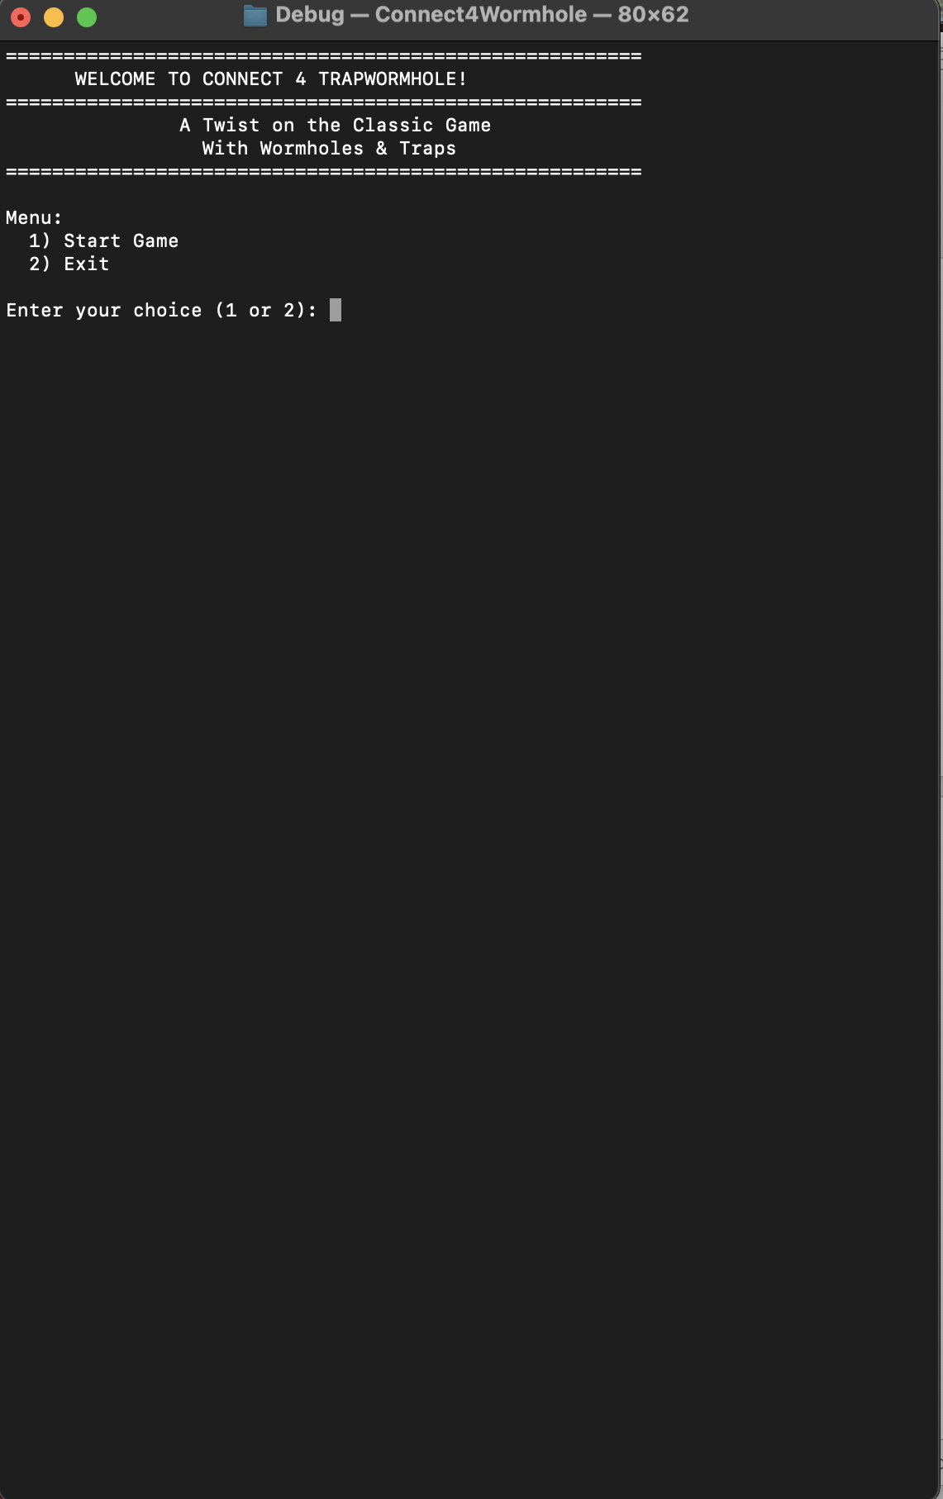**Screenshot of C Game**

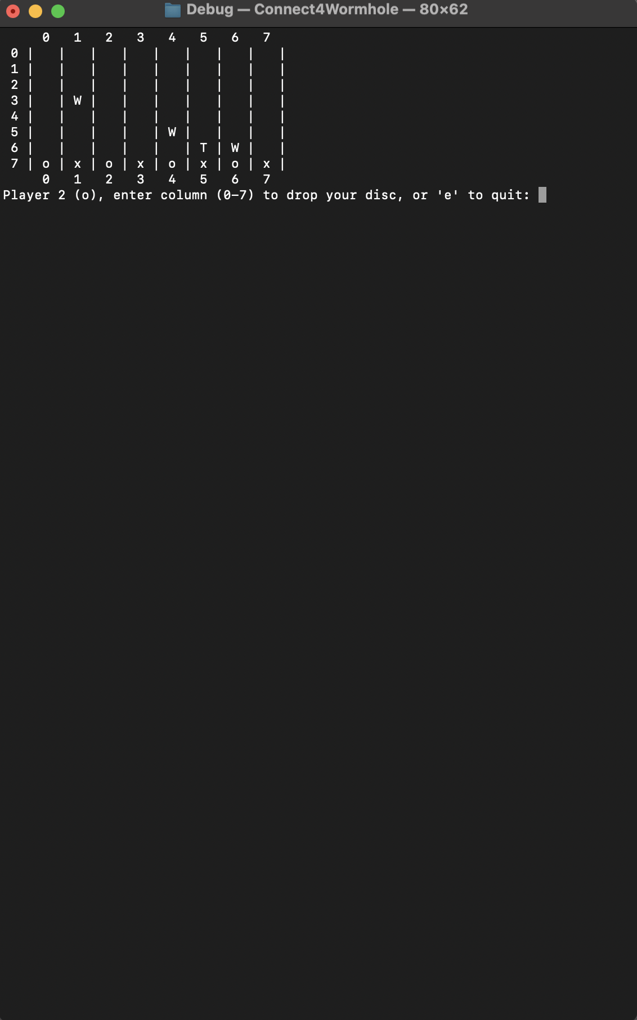

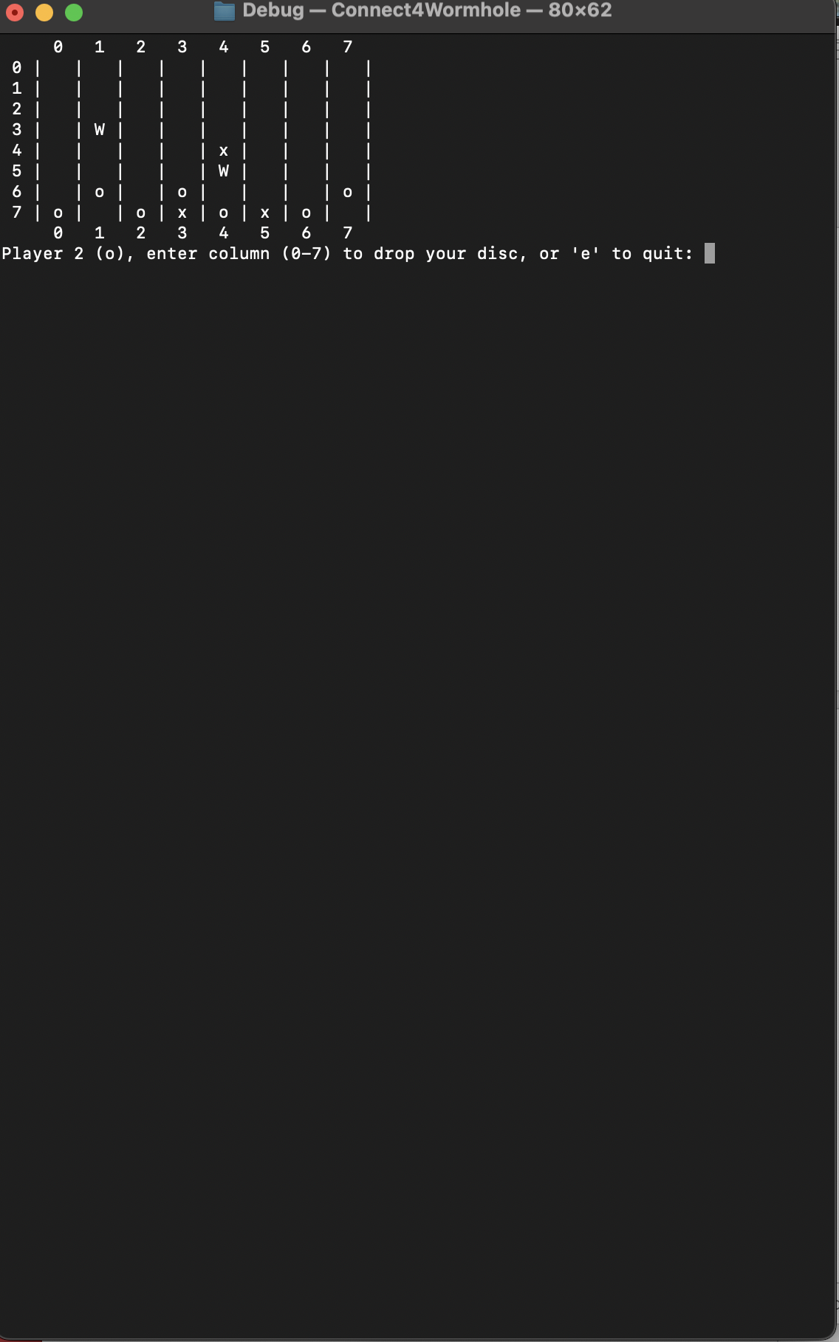

Task Report

Debug: Jan 22, 2025. For now, there are bugs with the address misplaced when the player places the disc in a certain number for the row to give an error. It is from the set trap and set wormhole function that I set to have multiple traps per row and column.

Debug Jan 23, 2025: The Trap and Wormhole should not be at index 0 of the array, which makes the row act complete when the player can’t drop the disc. Fix it, have the row -1 and the column -1

Debug: Jan 27, 2025: Finding out that the trap and wormhole did not function as expected, finding solution for it, might be caused by the addressing ram that could not let the function work correctly, or might be because of indexing -1

Debug: Jan 30, 2025: I discovered that the address is not set for T and W. When setting the trap, I thought it said it was activated at row 151587338, col 707406378. Just a column error. It should start from 0 to 7, not 1 to 8. Now it works well to go to the trap in the correct format, to where it should be. Now, to check for the logic function that the trap and wormhole are supposed to be.

Debug: Feb 6, 2025. Add the logic trap function and the head and tail player starter.

Debug: Feb 12, 2025: Implemented coin flip function, and every function seems to be working fine. Now, a snake as a little cue, to have an animation of a long cue moving and taking away the player disc. Winer has been recorded as a text file, and the debugging has been done for each memory, which also shows the array.

Debug: Feb 16, 2025. The trap function is not working as expected, but there is an address for each player disc. However, the address changes since using the function free in C programming changes each time. If able to manipulate the address to where it is searching the player disc, place an opponent disc on it for the whole row and column using the search function. Will be able to add a snake to take away the player disc randomly. The professor wants us to use the pointer array, not struct or malloc. Wanna asked him about that?

Debug: Feb 17, 2025. I figured out how to get the trap to work for searching the whole row and column, and I also added an invisible trap and wormhole so that if a player lands on it, it will have a banner for trapping and teleporting. Might add the snake to spawn randomly to take

Debug: Feb 18, 2025. Added a snake spawning function that takes away two discs of a player. It needs to be changed since it cannot do a time interval background for the spawning.

Debug Feb 27, 2025. Implementing it into MIPS to figure out the project, such as implementing seeding to generate a random number for the flip coin to give the player a fair chance to play. Although it is progress, it should work as a bare minimum. I also included the MIPS code for work as the backbone of the progress provided in the screenshot.

Debug March 16, 2025. Adding Trap and Wormhole to the board, and it is invisible to make the game look interesting. If either player lands on either wormhole or trap, it has interesting logic to transport and trap. Since the snake takes away the player’s disc, I have not implemented it yet, but I will add it to the game, and the check winner already has a function to check the winner board in multiple directions. I hope the game is turning out to be good and exciting for the players to play.

Debug March 24, 2025. Adding macro_file for the sound and bitmap.

Debug March 25, 2025. Adding a block to cover the trap and wormhole instead of the invisible. It makes more games more fun rather than a boring way of doing things. Also, implement the welcome and spawn challenge to spawn random boards for wormhole and trap and random exit. Complete the snake attack to align with the C program. Update teleporting disc to have banner and trap to have banner as well. Also before exiting prompt user if they want to play again or exit using recursive.

Debug March 27, 2025. We need to fix the diagonal when four pieces are detected. It seems that it does not detect four pieces.

Debug: April 4, 2025. Fix the game and everything is final good to goes.

MIPS CODE

Requirement:

* **Conditional Branches (if-else Equivalents)**
* **Use of a 2-D Array**
* **Subroutine Call Depth (At Least 3 Levels)**
* **Use of the Stack for Register Storage**
* **Additional Features and Notes**
* **Use of the stack function**

CODE

#/*********************************************************************

#* SAN DIEGO STATE UNIVERSITY *

#* DUC M LE 132485155

#* 44 55 43 20 4D 49 4E 48 20 4C 45 0A

#* 31 33 32 34 38 35 31 35 35 0A *

#**********************************************************************

.data

#**********************************************************************

#* SETUP BOARD PLAYER

#**********************************************************************

board: .space 64 # 8x8 grid

rows: .word 8 # Number of rows

cols: .word 8 # Number of columns

players: .byte 'x', 'o' # Player 1 = 'x', Player 2 = 'o'

#**********************************************************************

#**********************************************************************

#* MESSAGE FEED BACK

#**********************************************************************

welcome_msg: .asciiz "=======================================================\n WELCOME TO CONNECT 4 TRAPWORMHOLE! \n=======================================================\n"

wormhole_msg: .asciiz "Wormhole activated! Disc teleported.\n"

trap_msg: .asciiz "Trap activated! Opponent's disc trapped.\n"

win_msg: .asciiz " wins! Game Over.\n"

invalid_msg: .asciiz "Invalid choice. Please enter 1 or 2.\n"

exit_msg: .asciiz "Exiting the program. Goodbye!\n"

invalid_col: .asciiz "Invalid column number! Try again.\n"

#**********************************************************************

#**********************************************************************

#* PROMPT USER

#**********************************************************************

menu_prompt: .asciiz "Menu:\n 1) Start Game\n 2) Exit\n"

player_prompt:.asciiz "Player "

enter_col: .asciiz ", enter column (0-7) to drop your disc, or 'e' to quit: "

get_userinput:.asciiz "Please enter number to start game: "

#**********************************************************************

#**********************************************************************

#* FLIPPING COIN RESULT

#**********************************************************************

heads_result: .asciiz "Heads! Player 1 goes first.\n"

tails_result: .asciiz "Tails! Player 2 goes first.\n"

#**********************************************************************

#**********************************************************************

#* ROW AND COL SPACING

#**********************************************************************

newline: .asciiz "\n"

space: .asciiz " " # 4 spaces for wider spacing

space_two: .asciiz " " # 5 spaces for centering header numbers

#**********************************************************************

#**********************************************************************

#* TRAP AND WORMHOLE POSITION

#**********************************************************************

wormhole1_entry: .word 2, 3 # Row 2, Col 3

wormhole1_exit: .word 5, 3 # Row 5, Col 3

wormhole2_entry: .word 1, 5 # Row 1, Col 5

wormhole2_exit: .word 6, 2 # Row 6, Col 2

wormhole3_entry: .word 4, 1 # Row 4, Col 1

wormhole3_exit: .word 3, 6 # Row 3, Col 6

trap_pos: .word 3, 4 # Row 3, Col 4

#**********************************************************************

#**********************************************************************

#* MISC MESSAGE

#**********************************************************************

debug_msg: .asciiz "DEBUG: Checking win at position (row,col): "

comma_msg: .asciiz ","

debug_rand: .asciiz "DEBUG: Random value = "

buffer: .space 10 # Input buffer

trap_used: .word 0 # Flag to track if trap has been used (0 = not used, 1 = used)

debug_msg_t0_init: .asciiz "DEBUG: $t0 after initialization: "

debug_msg_t0_loop: .asciiz "DEBUG: $t0 in find_spot_loop: "

debug_msg_t0_after_wormhole: .asciiz "DEBUG: $t0 after checkWormholesAndTrap: "

debug_msg_a3: .asciiz "DEBUG: $a3 value: "

#**********************************************************************

#**********************************************************************

#* BIT MAP CONSTANTS

#**********************************************************************

# Bitmap constants

.eqv WIDTH 32 # 256 / 8 = 32 pixels wide

.eqv HEIGHT 32 # 256 / 8 = 32 pixels high

.eqv BLACK 0x00000000

.eqv YELLOW 0x00FFFF00 # For coin edge and flipping states

.eqv SILVER 0x00C0C0C0 # For coin face

.eqv RED 0x00FF0000 # For 'H'

.eqv GREEN 0x0000FF00 # For 'T'

#**********************************************************************

#**********************************************************************

#* INCLUDE FILES

.include "macro_file.asm" # Coin flip and utility macros

.include "MIDImacro_file.asm" # MIDI out macro

#**********************************************************************

#**********************************************************************

.text

#**********************************************************************

#* MAIN FUNCTION

main:

jal ShowMenu # jump a link into ShowMenu

li $v0, 10

syscall

#**********************************************************************

#**********************************************************************

#* SHOW MENU PROCEDURE

#**********************************************************************

ShowMenu:

addi $sp, $sp, -4

sw $ra, 0($sp)

show_menu_loop:

li $v0, 4

la $a0, welcome_msg

syscall

li $v0, 4

la $a0, menu_prompt

syscall

li $v0, 4

la $a0, get_userinput

syscall

li $v0, 5

syscall

move $t0, $v0

beq $t0, 1, start_game

beq $t0, 2, exit_program

li $v0, 4

la $a0, invalid_msg

syscall

j show_menu_loop

start_game:

# Initialize board

la $t1, board

li $t2, 64

li $t3, ' '

init_board_loop:

sb $t3, 0($t1)

addi $t1, $t1, 1

addi $t2, $t2, -1

bnez $t2, init_board_loop

jal coinFlipAnimation

move $s0, $v0 # $s0 holds starting player (1 for Player 1, 2 for Player 2)

jal MainGame

j end_show_menu

exit_program:

li $v0, 4

la $a0, exit_msg

syscall

li $v0, 10

syscall

end_show_menu:

lw $ra, 0($sp)

addi $sp, $sp, 4

jr $ra

#**********************************************************************

#**********************************************************************

#* COIN FLIP ANIMATION PROCEDURE

#**********************************************************************

coinFlipAnimation:

addi $sp, $sp, -8

sw $ra, 0($sp)

sw $s0, 4($sp)

li $v0, 30

syscall

move $a1, $a0

li $v0, 40

li $a0, 1

syscall

li $s0, 5

flip_loop:

li $v0, 42

li $a0, 1

li $a1, 2

syscall

move $t1, $a0

beqz $t1, draw_tails_loop

jal drawHeads

j flip_continue

draw_tails_loop:

jal drawTails

flip_continue:

delay(500000)

jal drawEdgeVertical

delay(500000)

jal drawTails

delay(500000)

jal drawEdgeHorizontal

delay(500000)

jal drawHeads

delay(500000)

addi $s0, $s0, -1

bnez $s0, flip_loop

li $v0, 30

syscall

move $a1, $a0

li $v0, 40

li $a0, 1

syscall

li $v0, 42

li $a0, 1

li $a1, 2

syscall

move $t1, $a0

beqz $t1, final_tails

jal drawHeads

li $v0, 4

la $a0, heads_result

syscall

li $v0, 1

j end_coin_flip

final_tails:

jal drawTails

li $v0, 4

la $a0, tails_result

syscall

li $v0, 2

end_coin_flip:

lw $ra, 0($sp)

lw $s0, 4($sp)

addi $sp, $sp, 8

jr $ra

#**********************************************************************

#**********************************************************************

#* MAIN GAME PROCEDURE

#**********************************************************************

MainGame:

addi $sp, $sp, -24

sw $ra, 0($sp)

sw $s0, 4($sp)

sw $s1, 8($sp)

sw $s2, 12($sp)

sw $s3, 16($sp)

sw $s4, 20($sp)

la $a0, board

lw $a1, rows

lw $a2, cols

la $a3, players

move $s4, $a3

move $s1, $s0 # $s1 = current player (1 or 2)

subi $s1, $s1, 1 # Adjust to 0-based index for player array

game_loop:

jal displayBoard

li $v0, 4

la $a0, player_prompt

syscall

li $v0, 1

addi $a0, $s1, 1 # Display player number (1 or 2)

syscall

li $v0, 11

addu $t2, $s4, $s1

lb $a0, 0($t2) # Display player symbol ('x' or 'o')

syscall

li $v0, 4

la $a0, enter_col

syscall

li $v0, 8

la $a0, buffer

li $a1, 10

syscall

lb $t0, buffer

beq $t0, 'e', end_game

subi $t0, $t0, '0'

blt $t0, 0, invalid_input

bge $t0, 8, invalid_input

move $s2, $t0 # $s2 = column

li $t0, 7 # Start from bottom row

find_spot_loop:

mul $t1, $t0, 8

add $t1, $t1, $s2

la $t2, board

add $t2, $t2, $t1

lb $t3, 0($t2)

beq $t3, ' ', place_disc

addi $t0, $t0, -1

bgez $t0, find_spot_loop

j invalid_input

place_disc:

addu $t4, $s4, $s1

lb $t4, 0($t4) # Load player symbol

sb $t4, 0($t2) # Place disc

move $s3, $t0 # Save row in $s3

move $a0, $t0 # Row

move $a1, $s2 # Column

move $a2, $t4 # Player's piece

jal checkWormholesAndTrap

beq $v0, 1, wormhole_handled

beq $v0, 2, trap_handled

# jal displayBoard #from this

# li $v0, 4

# la $a0, newline

# syscall

# li $v0, 4

# la $a0, debug_msg

# syscall

# li $v0, 1

# move $a0, $s3

# syscall # the commend part is for debug purposes

# li $v0, 4

# la $a0, comma_msg

# syscall

# li $v0, 1

# move $a0, $s2

# syscall

# li $v0, 4

# la $a0, newline

# syscall #To This

move $a0, $s3

move $a1, $s2

jal checkWinner

beqz $v0, continue_game

jal displayBoard # Display the final board state

li $v0, 4

la $a0, player_prompt

syscall

li $v0, 1

move $a0, $v1 # Winning player number

syscall

li $v0, 11

addu $t2, $s4, $s1

lb $a0, 0($t2) # Winning player symbol

syscall

li $v0, 4

la $a0, newline

syscall

li $v0, 4

la $a0, win_msg

syscall

play_victory_tune #sound for the winner declare

j end_game

continue_game:

addi $s1, $s1, 1

andi $s1, $s1, 1 # Toggle between 0 and 1

j game_loop

wormhole_handled:

addi $s1, $s1, 1

andi $s1, $s1, 1

j game_loop

trap_handled:

addi $s1, $s1, 1

andi $s1, $s1, 1

j game_loop

invalid_input:

li $v0, 4

la $a0, invalid_col

syscall

j game_loop

end_game:

lw $ra, 0($sp)

lw $s0, 4($sp)

lw $s1, 8($sp)

lw $s2, 12($sp)

lw $s3, 16($sp)

lw $s4, 20($sp)

addi $sp, $sp, 24

jr $ra

#**********************************************************************

#**********************************************************************

#* DISPLAY BOARD PROCEDURE

#**********************************************************************

displayBoard:

addi $sp, $sp, -4

sw $ra, 0($sp)

li $t0, 0

col_header_loop:

li $v0, 4

la $a0, space_two

syscall

li $v0, 1

move $a0, $t0

syscall

li $v0, 4

la $a0, space

syscall

addi $t0, $t0, 1

blt $t0, 8, col_header_loop

li $v0, 4

la $a0, newline

syscall

li $t0, 0

row_loop:

li $v0, 1

move $a0, $t0

syscall

li $v0, 11

li $a0, '|'

syscall

li $t1, 0

col_loop:

li $v0, 4

la $a0, space

syscall

mul $t2, $t0, 8

add $t2, $t2, $t1

la $t3, board

add $t3, $t3, $t2

lb $a0, 0($t3)

li $v0, 11

syscall

li $v0, 4

la $a0, space

syscall

li $v0, 11

li $a0, '|'

syscall

addi $t1, $t1, 1

blt $t1, 8, col_loop

li $v0, 4

la $a0, newline

syscall

addi $t0, $t0, 1

blt $t0, 8, row_loop

lw $ra, 0($sp)

addi $sp, $sp, 4

jr $ra

#**********************************************************************

#**********************************************************************

#* CHECK WORMHOLE AND TRAP PROCEDURE

#* Inputs:

#* $a0: Row of the move

#* $a1: Column of the move

#* $a2: Player's piece ('x' or 'o')

#* Outputs:

#* $v0: 0 (no special action), 1 (wormhole activated), 2 (trap activated)

#**********************************************************************

checkWormholesAndTrap:

addi $sp, $sp, -16

sw $ra, 0($sp)

sw $s0, 4($sp)

sw $s1, 8($sp)

sw $s2, 12($sp)

move $s0, $a0

move $s1, $a1

move $s2, $a2

lw $t4, wormhole1_entry

lw $t5, wormhole1_entry+4

beq $a0, $t4, check_w1_col

j check_wormhole2

check_w1_col:

beq $a1, $t5, wormhole1_activate

j check_wormhole2

wormhole1_activate:

la $a0, wormhole1_exit

jal handleWormhole

beq $v0, 1, win_detected_special

li $v0, 1

j end_check_wormholes

check_wormhole2:

lw $t4, wormhole2_entry

lw $t5, wormhole2_entry+4

beq $a0, $t4, check_w2_col

j check_wormhole3

check_w2_col:

beq $a1, $t5, wormhole2_activate

j check_wormhole3

wormhole2_activate:

la $a0, wormhole2_exit

jal handleWormhole

beq $v0, 1, win_detected_special

li $v0, 1

j end_check_wormholes

check_wormhole3:

lw $t4, wormhole3_entry

lw $t5, wormhole3_entry+4

beq $a0, $t4, check_w3_col

j check_trap

check_w3_col:

beq $a1, $t5, wormhole3_activate

j check_trap

wormhole3_activate:

la $a0, wormhole3_exit

jal handleWormhole

beq $v0, 1, win_detected_special

li $v0, 1

j end_check_wormholes

check_trap:

lw $t4, trap_pos

lw $t5, trap_pos+4

beq $a0, $t4, check_trap_col

j no_special

check_trap_col:

beq $a1, $t5, trap_activate

j no_special

trap_activate:

# Call removeTrapDisc to remove the disc at the trap position

move $a0, $s0 # Row of the move

move $a1, $s1 # Column of the move

jal removeTrapDisc

# Check if the trap was activated

beq $v0, $zero, no_special # If $v0 == 0, trap wasn't activated

# Call trapOpponentDiscs to trap opponent discs

move $a0, $s2 # Player's piece

jal trapOpponentDiscs

# Set return value to indicate trap activation

li $v0, 2

j end_check_wormholes

no_special:

li $v0, 0

win_detected_special:

j end_check_wormholes

end_check_wormholes:

lw $ra, 0($sp)

lw $s0, 4($sp)

lw $s1, 8($sp)

lw $s2, 12($sp)

addi $sp, $sp, 16

jr $ra

#**********************************************************************

#**********************************************************************

#* HANDLE WORMHOLE PROCEDURE

#**********************************************************************

handleWormhole:

addi $sp, $sp, -12

sw $ra, 0($sp)

sw $s0, 4($sp)

sw $s1, 8($sp)

mul $t1, $s0, 8

add $t1, $t1, $s1

la $t2, board

add $t2, $t2, $t1

lb $t7, 0($t2)

lw $t3, 0($a0)

lw $t4, 4($a0)

mul $t5, $t3, 8

add $t5, $t5, $t4

la $t6, board

add $t6, $t6, $t5

lb $t8, 0($t6)

bne $t8, ' ', skip_teleport

li $t9, ' '

sb $t9, 0($t2)

sb $t7, 0($t6)

li $v0, 4

la $a0, wormhole_msg

syscall

move $a0, $t3

move $a1, $t4

jal checkWinner

beq $v0, 1, win_detected_wormhole

skip_teleport:

j end_handle_wormhole

win_detected_wormhole:

j end_handle_wormhole

end_handle_wormhole:

lw $ra, 0($sp)

lw $s0, 4($sp)

lw $s1, 8($sp)

addi $sp, $sp, 12

jr $ra

#*********************************************************************

#**********************************************************************

#* REMOVE TRAP DISC PROCEDURE

#**********************************************************************

removeTrapDisc:

# Save registers

addi $sp, $sp, -12

sw $ra, 0($sp)

sw $s0, 4($sp)

sw $s1, 8($sp)

# Move arguments to saved registers

move $s0, $a0 # Row of the current move

move $s1, $a1 # Column of the current move

# Check if trap has already been used

lw $t0, trap_used

bne $t0, $zero, end_remove_trap # If trap_used != 0, skip trap logic

# Check if the current move is at the trap position (row 3, col 4)

la $t1, trap_pos

lw $t2, 0($t1) # Load trap row (3)

lw $t3, 4($t1) # Load trap col (4)

bne $s0, $t2, end_remove_trap # If current row != trap row, skip

bne $s1, $t3, end_remove_trap # If current col != trap col, skip

# Load the player's piece at the trap position (for reference)

mul $t1, $s0, 8

add $t1, $t1, $s1

la $t2, board

add $t2, $t2, $t1

lb $t7, 0($t2) # Load player's piece ('x' or 'o')

# Remove the disc at the trap position

li $t5, ' '

sb $t5, 0($t2) # Set the trap position to space

# Mark the trap as used

li $t0, 1

sw $t0, trap_used # Mark trap as used

# Return 1 to indicate the trap was activated

li $v0, 1

j end_remove_trap

end_remove_trap:

# If trap wasn't activated, return 0

beq $v0, 1, skip_return_zero

li $v0, 0

skip_return_zero:

# Restore registers

lw $ra, 0($sp)

lw $s0, 4($sp)

lw $s1, 8($sp)

addi $sp, $sp, 12

jr $ra

#**********************************************************************

#**********************************************************************

#* TRAP OPPONENT DISCS PROCEDURE

#* Scans the entire board (row by row, column by column) and traps

#* every opponent disc found by placing the current player's disc

#* above or below (if there's an empty space), without removing the opponent's disc.

#* Inputs:

#* $a0: Player's piece ('x' or 'o')

#* Outputs:

#* None (modifies the board directly)

#**********************************************************************

trapOpponentDiscs:

# Save registers

addi $sp, $sp, -12

sw $ra, 0($sp)

sw $s0, 4($sp)

sw $s1, 8($sp)

# Store player's piece

move $s0, $a0 # $s0 = player's piece ('x' or 'o')

# Determine opponent's piece

li $s1, 'x' # $s1 = opponent's piece

beq $s0, 'o', opponent_set

li $s1, 'o'

opponent_set:

# Print trap activation message

li $v0, 4

la $a0, trap_msg

syscall

# Initialize row counter

li $t0, 0 # $t0 = row counter

trap_row_loop:

li $t1, 0 # $t1 = column counter

trap_col_loop:

# Calculate board index: (row * 8) + col

mul $t2, $t0, 8

add $t2, $t2, $t1

la $t3, board

add $t3, $t3, $t2 # $t3 = address of board[row][col]

lb $t4, 0($t3) # $t4 = piece at board[row][col]

# Check if the piece is the opponent's

bne $t4, $s1, skip_trap # If not opponent's piece, skip

# Found an opponent's disc, try to trap it by placing player's disc above or below

# First, try to place player's disc above (row - 1)

blt $t0, 1, try_below # If row == 0, can't place above, try below

# Check the spot above (row - 1, col)

subi $t5, $t0, 1 # $t5 = row - 1

mul $t6, $t5, 8

add $t6, $t6, $t1

la $t7, board

add $t7, $t7, $t6 # $t7 = address of board[row-1][col]

lb $t8, 0($t7) # $t8 = piece at board[row-1][col]

beq $t8, ' ', place_above # If spot above is empty, place player's disc

try_below:

# If can't place above, try below (row + 1)

bge $t0, 7, skip_trap # If row == 7, can't place below, skip

# Check the spot below (row + 1, col)

addi $t5, $t0, 1 # $t5 = row + 1

mul $t6, $t5, 8

add $t6, $t6, $t1

la $t7, board

add $t7, $t7, $t6 # $t7 = address of board[row+1][col]

lb $t8, 0($t7) # $t8 = piece at board[row+1][col]

beq $t8, ' ', place_below # If spot below is empty, place player's disc

j skip_trap # If neither above nor below is empty, skip

place_above:

# Place player's disc above

sb $s0, 0($t7) # Place player's piece at board[row-1][col]

j skip_trap

place_below:

# Place player's disc below

sb $s0, 0($t7) # Place player's piece at board[row+1][col]

skip_trap:

# Move to the next column

addi $t1, $t1, 1

blt $t1, 8, trap_col_loop

# Move to the next row

addi $t0, $t0, 1

blt $t0, 8, trap_row_loop

end_trap_opponents:

# Restore registers

lw $ra, 0($sp)

lw $s0, 4($sp)

lw $s1, 8($sp)

addi $sp, $sp, 12

jr $ra

#**********************************************************************

#**********************************************************************

#* CHECK WINNER PROCEDURE

#* Checks for a win after placing a disc. Declares a win if the placed

#* disc results in exactly 4 consecutive matching pieces in any direction

#* (horizontal, vertical, forward diagonal, backward diagonal).

#* Inputs:

#* $a0: Row of the placed disc

#* $a1: Column of the placed disc

#* Outputs:

#* $v0: 1 if a win is detected, 0 otherwise

#* $v1: 1 if Player 1 ('x') wins, 2 if Player 2 ('o') wins, 0 if no win

#**********************************************************************

checkWinner:

addi $sp, $sp, -20

sw $ra, 0($sp)

sw $s0, 4($sp)

sw $s1, 8($sp)

sw $s2, 12($sp)

sw $s3, 16($sp)

move $s0, $a0 # Row of the placed disc

move $s1, $a1 # Column of the placed disc

la $s2, board # Base address of the board

mul $t2, $s0, 8

add $t2, $t2, $s1

add $t2, $t2, $s2

lb $s3, 0($t2) # Load the symbol at the placed position ('x' or 'o')

beq $s3, ' ', no_win # If the position is empty, no win possible

# Horizontal Check

li $t3, 1 # Total count (start with the placed disc)

move $t1, $s1 # Column iterator for left

move $t5, $s1 # Column iterator for right

horizontal_loop:

# Check left

addi $t1, $t1, -1

blt $t1, 0, check_right

mul $t6, $s0, 8

add $t6, $t6, $t1

add $t6, $t6, $s2

lb $t7, 0($t6)

bne $t7, $s3, check_right

addi $t3, $t3, 1

j horizontal_loop

check_right:

# Check right

addi $t5, $t5, 1

bge $t5, 8, horizontal_done

mul $t6, $s0, 8

add $t6, $t6, $t5

add $t6, $t6, $s2

lb $t7, 0($t6)

bne $t7, $s3, horizontal_done

addi $t3, $t3, 1

j check_right

horizontal_done:

beq $t3, 4, win_detected # Win if exactly 4 pieces are found

# Vertical Check

li $t3, 1 # Total count (start with the placed disc)

move $t1, $s0 # Row iterator for up

move $t5, $s0 # Row iterator for down

vertical_loop:

# Check up

addi $t1, $t1, -1

blt $t1, 0, check_down

mul $t6, $t1, 8

add $t6, $t6, $s1

add $t6, $t6, $s2

lb $t7, 0($t6)

bne $t7, $s3, check_down

addi $t3, $t3, 1

j vertical_loop

check_down:

# Check down

addi $t5, $t5, 1

bge $t5, 8, vertical_done

mul $t6, $t5, 8

add $t6, $t6, $s1

add $t6, $t6, $s2

lb $t7, 0($t6)

bne $t7, $s3, vertical_done

addi $t3, $t3, 1

j check_down

vertical_done:

beq $t3, 4, win_detected # Win if exactly 4 pieces are found

# Forward Diagonal (Top-Left to Bottom-Right)

li $t3, 1 # Total count (start with the placed disc)

move $t1, $s0 # Row iterator for up-left

move $t5, $s1 # Column iterator for up-left

move $t8, $s0 # Row iterator for down-right

move $t9, $s1 # Column iterator for down-right

diagonal_forward_loop:

# Check up-left

addi $t1, $t1, -1

addi $t5, $t5, -1

blt $t1, 0, check_down_right

blt $t5, 0, check_down_right

mul $t6, $t1, 8

add $t6, $t6, $t5

add $t6, $t6, $s2

lb $t7, 0($t6)

bne $t7, $s3, check_down_right

addi $t3, $t3, 1

j diagonal_forward_loop

check_down_right:

# Check down-right

addi $t8, $t8, 1

addi $t9, $t9, 1

bge $t8, 8, diagonal_forward_done

bge $t9, 8, diagonal_forward_done

mul $t6, $t8, 8

add $t6, $t6, $t9

add $t6, $t6, $s2

lb $t7, 0($t6)

bne $t7, $s3, diagonal_forward_done

addi $t3, $t3, 1

j check_down_right

diagonal_forward_done:

beq $t3, 4, win_detected # Win if exactly 4 pieces are found

# Backward Diagonal (Top-Right to Bottom-Left)

li $t3, 1 # Total count (start with the placed disc)

move $t1, $s0 # Row iterator for up-right

move $t5, $s1 # Column iterator for up-right

move $t8, $s0 # Row iterator for down-left

move $t9, $s1 # Column iterator for down-left

diagonal_backward_loop:

# Check up-right

addi $t1, $t1, -1

addi $t5, $t5, 1

blt $t1, 0, check_down_left

bge $t5, 8, check_down_left

mul $t6, $t1, 8

add $t6, $t6, $t5

add $t6, $t6, $s2

lb $t7, 0($t6)

bne $t7, $s3, check_down_left

addi $t3, $t3, 1

j diagonal_backward_loop

check_down_left:

# Check down-left

addi $t8, $t8, 1

addi $t9, $t9, -1

bge $t8, 8, diagonal_backward_done

blt $t9, 0, diagonal_backward_done

mul $t6, $t8, 8

add $t6, $t6, $t9

add $t6, $t6, $s2

lb $t7, 0($t6)

bne $t7, $s3, diagonal_backward_done

addi $t3, $t3, 1

j check_down_left

diagonal_backward_done:

beq $t3, 4, win_detected

j no_win

no_win:

li $v0, 0

li $v1, 0

j end_check_winner

win_detected:

li $v0, 1

beq $s3, 'x', player_1_win

li $v1, 2

j end_check_winner

player_1_win:

li $v1, 1

end_check_winner:

lw $ra, 0($sp)

lw $s0, 4($sp)

lw $s1, 8($sp)

lw $s2, 12($sp)

lw $s3, 16($sp)

addi $sp, $sp, 20

jr $ra

#**********************************************************************

#**********************************************************************

#* DRAW COIN FLIP PROCEDURE

#**********************************************************************

drawHeads:

addi $sp, $sp, -4

sw $ra, 0($sp)

li $t0, 12

li $t1, 12

li $t2, 0

clear_heads_loop:

li $t3, 0

clear_heads_col:

add $t4, $t0, $t3

add $t5, $t1, $t2

draw_pixel($t4, $t5, BLACK)

addi $t3, $t3, 1

blt $t3, 8, clear_heads_col

addi $t2, $t2, 1

blt $t2, 8, clear_heads_loop

li $t0, 12

li $t1, 12

li $t2, 0

heads_row_loop:

li $t3, 0

heads_col_loop:

add $t4, $t0, $t3

add $t5, $t1, $t2

subi $t6, $t4, 15

subi $t7, $t5, 15

mul $t6, $t6, $t6

mul $t7, $t7, $t7

add $t8, $t6, $t7

li $t9, 12

bgt $t8, $t9, heads_next_col

beq $t8, $t9, heads_edge

beq $t2, 4, heads_h

draw_pixel($t4, $t5, SILVER)

j heads_next_col

heads_edge:

draw_pixel($t4, $t5, YELLOW)

j heads_next_col

heads_h:

beq $t3, 3, heads_h_draw

beq $t3, 4, heads_h_draw

draw_pixel($t4, $t5, SILVER)

j heads_next_col

heads_h_draw:

draw_pixel($t4, $t5, RED)

heads_next_col:

addi $t3, $t3, 1

blt $t3, 8, heads_col_loop

addi $t2, $t2, 1

blt $t2, 8, heads_row_loop

lw $ra, 0($sp)

addi $sp, $sp, 4

jr $ra

drawTails:

addi $sp, $sp, -4

sw $ra, 0($sp)

li $t0, 12

li $t1, 12

li $t2, 0

clear_tails_loop:

li $t3, 0

clear_tails_col:

add $t4, $t0, $t3

add $t5, $t1, $t2

draw_pixel($t4, $t5, BLACK)

addi $t3, $t3, 1

blt $t3, 8, clear_tails_col

addi $t2, $t2, 1

blt $t2, 8, clear_tails_loop

li $t0, 12

li $t1, 12

li $t2, 0

tails_row_loop:

li $t3, 0

tails_col_loop:

add $t4, $t0, $t3

add $t5, $t1, $t2

subi $t6, $t4, 15

subi $t7, $t5, 15

mul $t6, $t6, $t6

mul $t7, $t7, $t7

add $t8, $t6, $t7

li $t9, 12

bgt $t8, $t9, tails_next_col

beq $t8, $t9, tails_edge

beq $t2, 4, tails_t

draw_pixel($t4, $t5, SILVER)

j tails_next_col

tails_edge:

draw_pixel($t4, $t5, YELLOW)

j tails_next_col

tails_t:

beq $t3, 3, tails_t_draw

draw_pixel($t4, $t5, SILVER)

j tails_next_col

tails_t_draw:

draw_pixel($t4, $t5, GREEN)

tails_next_col:

addi $t3, $t3, 1

blt $t3, 8, tails_col_loop

addi $t2, $t2, 1

blt $t2, 8, tails_row_loop

lw $ra, 0($sp)

addi $sp, $sp, 4

jr $ra

drawEdgeVertical:

addi $sp, $sp, -4

sw $ra, 0($sp)

li $t0, 12

li $t1, 12

li $t2, 0

clear_edge_v_loop:

li $t3, 0

clear_edge_v_col:

add $t4, $t0, $t3

add $t5, $t1, $t2

draw_pixel($t4, $t5, BLACK)

addi $t3, $t3, 1

blt $t3, 8, clear_edge_v_col

addi $t2, $t2, 1

blt $t2, 8, clear_edge_v_loop

li $t0, 15

li $t1, 12

li $t2, 0

edge_v_loop:

add $t5, $t1, $t2

draw_pixel($t0, $t5, YELLOW)

addi $t2, $t2, 1

blt $t2, 8, edge_v_loop

lw $ra, 0($sp)

addi $sp, $sp, 4

jr $ra

drawEdgeHorizontal:

addi $sp, $sp, -4

sw $ra, 0($sp)

li $t0, 12

li $t1, 12

li $t2, 0

clear_edge_h_loop:

li $t3, 0

clear_edge_h_col:

add $t4, $t0, $t3

add $t5, $t1, $t2

draw_pixel($t4, $t5, BLACK)

addi $t3, $t3, 1

blt $t3, 8, clear_edge_h_col

addi $t2, $t2, 1

blt $t2, 8, clear_edge_h_loop

li $t0, 12

li $t1, 15

li $t2, 0

edge_h_loop:

add $t4, $t0, $t2

draw_pixel($t4, $t1, YELLOW)

addi $t2, $t2, 1

blt $t2, 8, edge_h_loop

lw $ra, 0($sp)

addi $sp, $sp, 4

jr $ra

#**********************************************************************

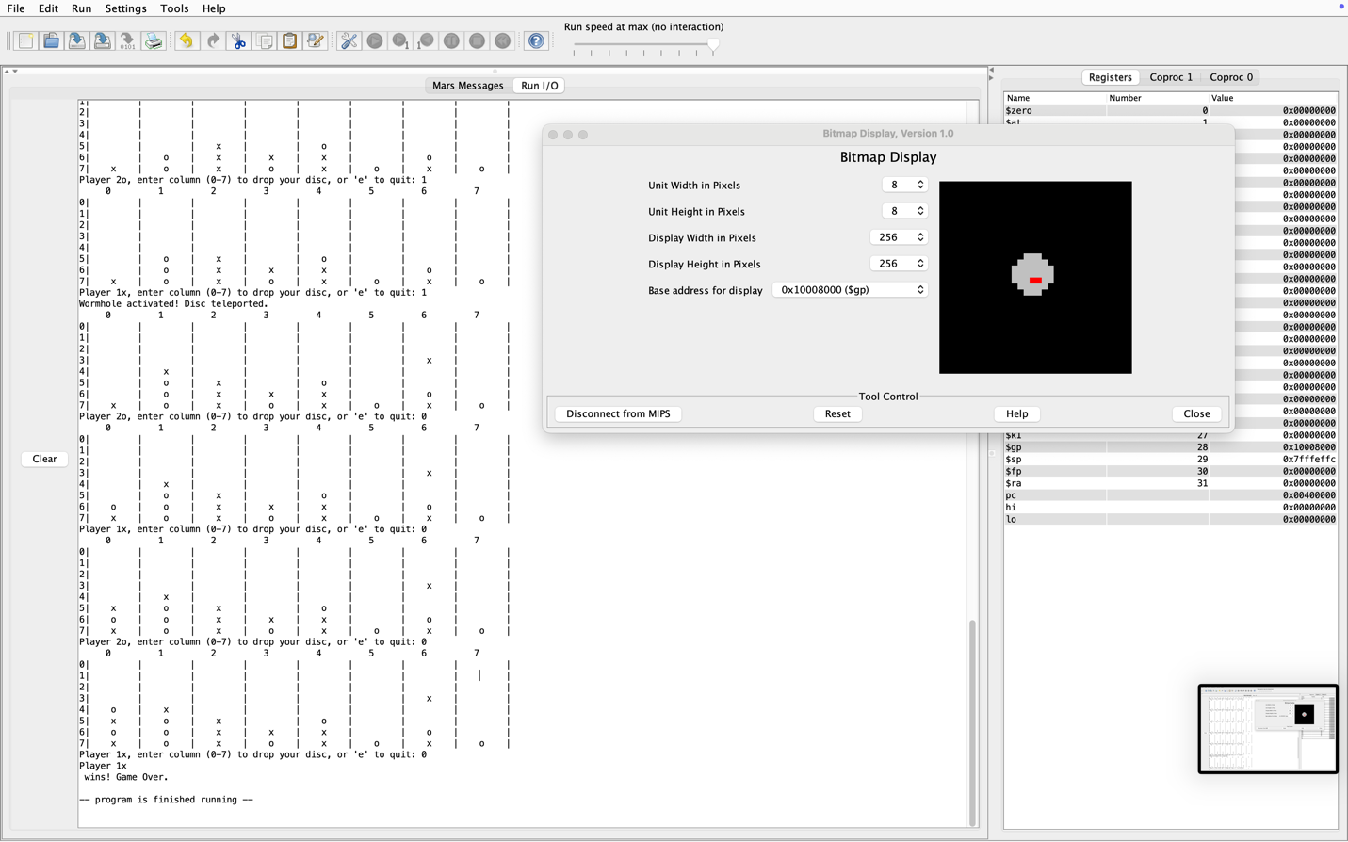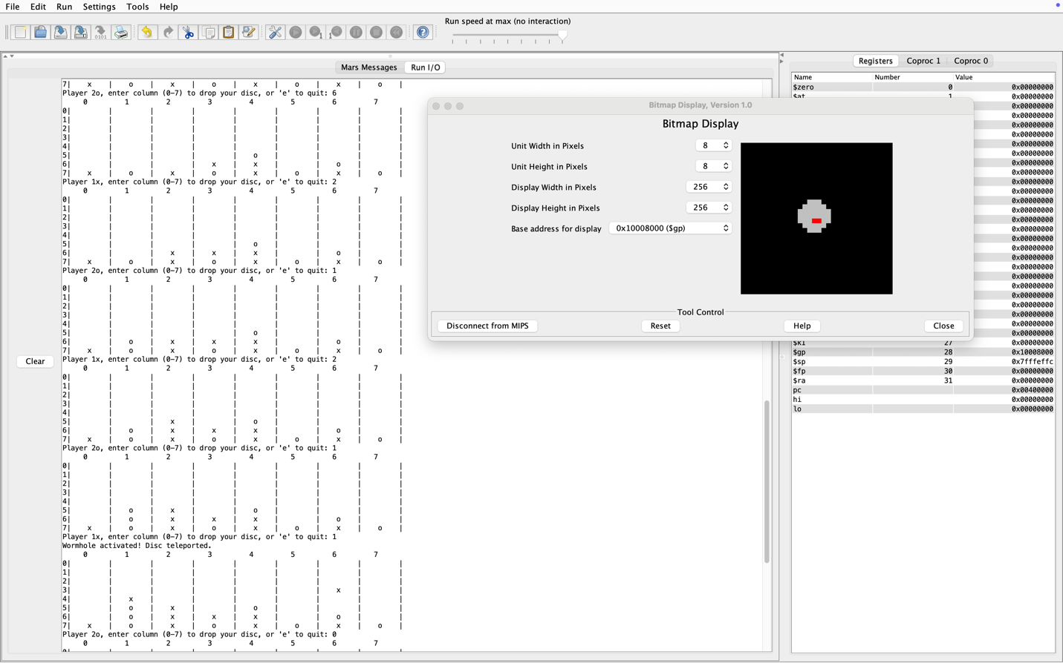

CONCLUSION

In short, if I had to do it over again, I would add more features to it, making sure that the code has more interesting options. Although it is a simple game, I do enjoy making and learning from it. I understand how MIPS works to better understand machine language. I hope that from this project, I can do more than just a game implementing finding hard drive serial numbers or finding a sort of sequential number.

TOTAL HOURS: ~ 2500 hours