CS3 Networks, Pac 1

Q1.
In how many ways do you personally connect to the Internet? List all of them, from the one you use the most to the one you use the least. Then describe each one, giving a reasonable amount of detail. (Mandatory info: system used; average, min and max download speeds; traffic cap/no cap; usability for real-time applications such as Skype or WhatsApp video, cost if any.)

Wi-Fi
Tethering
Ethernet
Mobile network
Bluetooth

Q2. (Protocol design)
From your Kurose / Ross textbook, with modifications:
“Design and describe an application-level protocol to be used between an automatic teller machine and a bank’s centralized computer. Your protocol should allow a user’s card and password to be verified, the account balance (maintained in the centralized computer) to be queried, and an account withdrawal to be made. Your protocol entities should the able to handle the case in which there is not enough money in the account to cover the withdrawal.
Specify your protocol by listing (some) of the messages exchanged and the action taken by the entities as a consequence of receiving each message. Sketch the operation of your protocol for the case of a simple withdrawal with no errors. Explicitly state the assumptions made by your protocol about the underlying end-to-end transport service”
(Do not spend too much time on this question, which is here simply to make you understand better the concept of ‘protocol’.)

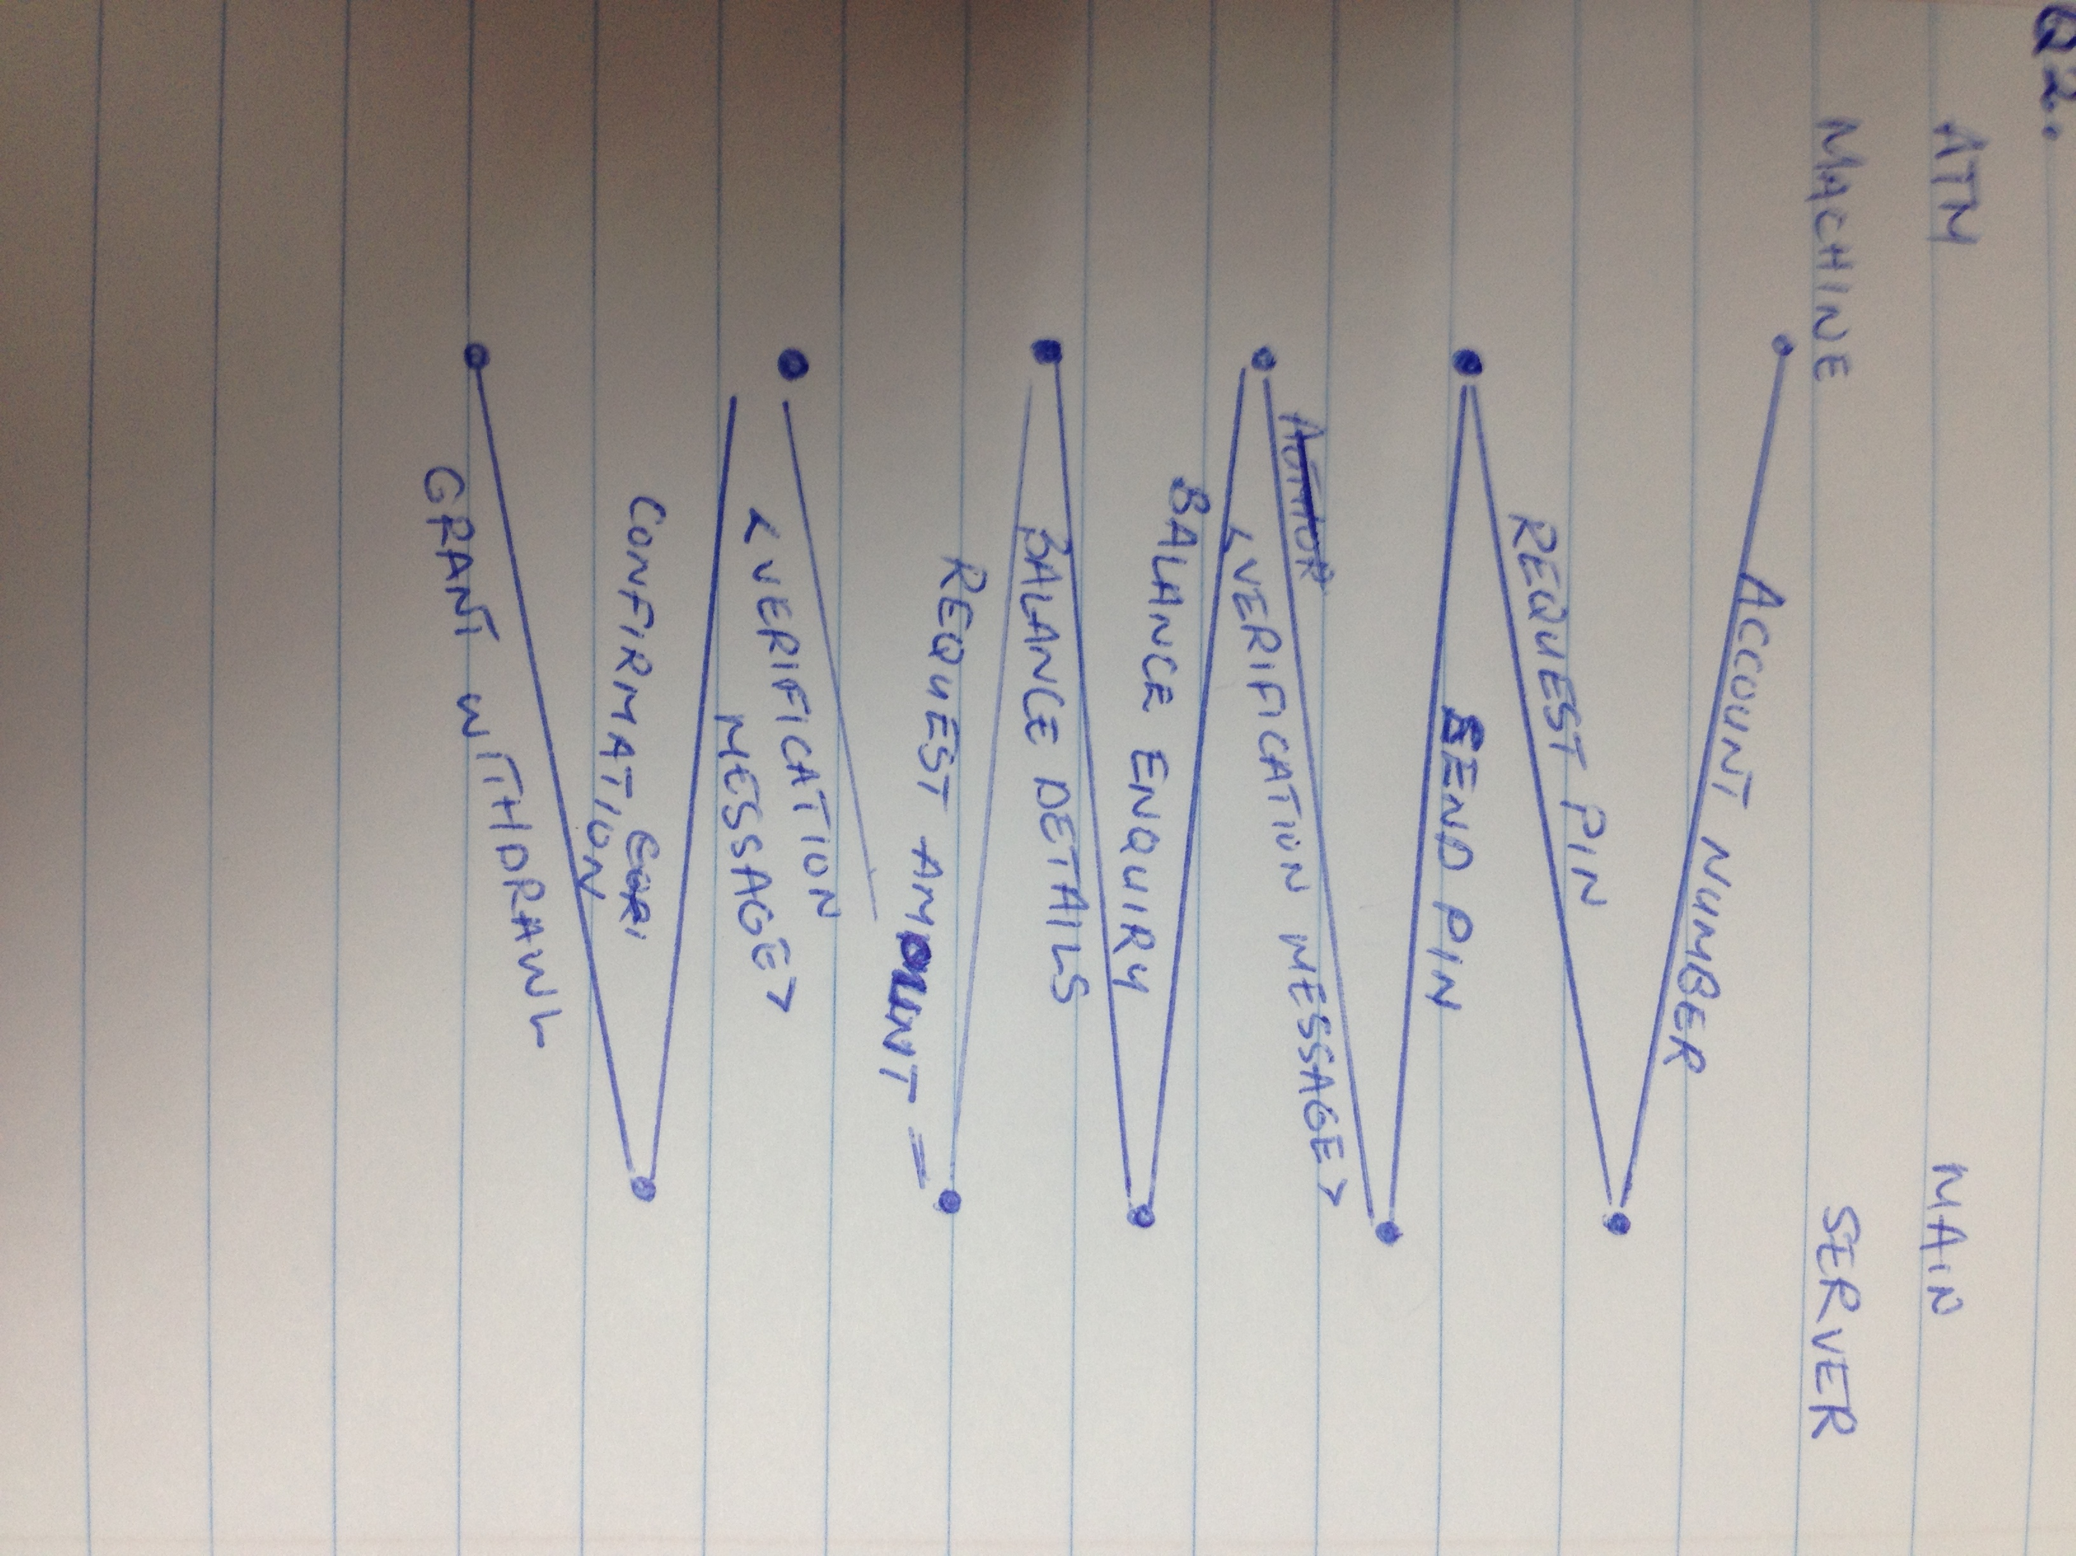

Q3. (End-to-end delay)
From your Kurose / Ross textbook:
“Consider a packet of length L which begins at end system a, travels over one link to a packet switch, and travels from the packet switch over a second link to a destination end system B. Let di, is and RI denote the length, propagation speed and the transmission rate of the link i, for i=1, 2. The packet switch delays each packet by drop. Assuming no queuing delays, in term of di, is and RI and L, what is the total end-to-end delay for the packet?
Suppose now that the packet is 1,000 bytes, the propagation speed on both links is 2.5*10^8 m/s, the transmission rate of both links is 1 Mbps, the packet switch processing is 1 ms for both switches, the length of the first link is 4,000 Km, and the length of the second link is 1,000 Km. What will be the end to end delay?”

dend-end = L/R1 + L/R2 + d1/s1 + d2/s2 + dproc
L/R1 = 8
L/R2 = 8
D1/s1 = 16
D2/s2 = 4
Dproc = 1

Therefore dend-end = 2(8) +16 +4 + 5
= 37 msec

Q4. (Route tracing)
From your Kurose / Ross textbook:
“Perform a traceroute between source and destination on the same continent at three different hours of the day.
a. Find the number of routers in the path at each of the three hours. Did the paths change during any of the hours?
b. Find the average and the standard deviation of the round-trip delays at each of the three hours.
c. Try to identify the number of ISP networks that the traceroute packets pass through from source to destination. (Routers with similar names and / or similar IP addresses should be considered as part of the same ISP.) In your experiments, do the largest delays occur at the peering interfaces between adjacent ISPs?
d. Repeat the above for a source and destination on different continents. Compare the intra-continent and the inter-continent results.”

- 4 routers, no it didn’t change
- Average : 1ms ; Standard Deviation : 0
- 2

Q5. (Segmentation)
From your Kurose / Ross textbook, with adaptations:
“In modern packet-switched networks, the source segments long application-layer messages (for example an image or a music file) into smaller packets and sends the packets into the network. The receiver then reassembles the packets back into the original message. We refer to this process as message segmentation. Imagine that system A has to transfer a message to B crossing to packet switches (so, there will be three links; draw the full network layout).
Assume size of message 8*10^6 bits long, speed of each link 2 Mbps. Ignore propagation, queuing and processing delays.
a. Consider sending the message from source to destination without message segmentation. How long does it take to move the message from A to the first packet switch? Keeping in mind that each switch uses store and forward packet switching, what is the total time to move the message for om A to B?
[…]
c. Now suppose that the message is segmented using packet of size 2*10^3 bits (this means that the whole message will use 4,000 packets to be sent through). How long does it take to move the first packet from A to the first switch? When the first packet is being sent from the first switch to the second, the second packet is being sent from A to the first switch. At what time will the second packet be fully received at the first switch? What is the total time to move the message from A to B?
d. Compare transmission with and without segmentation.”

