

PRODUCT DEVELOPMENT PROJECT
Report 1 – Project Introduction

Meloop

September 2026
Table of Contents
I. Record of Changes 6
II. Project Introduction 7
1. Overview 7
1.1 Project Information 7
1.2 Project Team 7
2. Product Background 7
2.1 Product Background and Usage Context 8
2.2 Product Design Foundation 8
2.2.1 Core Practice Loop 8
2.2.2 Progress and Motivation 8
2.2.3 Usability, Audio and Data Reliability 9
2.3 Legal and Regulatory Considerations 9
2.4 Applicable Standards and Guidelines 9
3. Existing Systems 11
3.1 Andante 11
3.2 Modacity 13
3.3 Existing Systems Comparison 15
4. Business Opportunity 16
5. Software Product Vision 16
6. Project Scope & Limitations 17
6.1 Major Features 17
6.1.1 Meloop Mobile Application 17
6.2 Limitations & Exclusions 19
6.2.1 Mobile Application Limitations 19
6.2.2 Features Deferred beyond the First Release 20
6.3 Operational and Quality Requirements 20
III. References 21

List of Tables
Table 1: Project Team 7
Table 2: Applicable Standards and Guidelines 9
Table 3: Pros and Cons of Andante 12
Table 4: Pros and Cons of Modacity 14
Table 5: Existing Systems Comparison 15

List of Figures
Figure 1. Andante Interface 11
Figure 2. Modacity Interface 13
Figure 3. Meloop Feature Overview (illustration pending) 19

Definitions and Acronyms
Term / Acronym | Definition
MVP | Minimum Viable Product
PM | Project Manager
QA | Quality Assurance
UI / UX | User Interface / User Experience
UC | Use Case; user interaction towards a goal
LI / EX / RQ | In-scope limit / Excluded scope / Shared requirement
BPM | Pulses per minute in the Meloop metronome
Hz | Hertz; frequency unit
SDK | Software Development Kit
SQLite | Embedded database engine used for local records
VI / EN | Vietnamese / English
VND / USD | Vietnamese dong / United States dollar
Pro | One-time paid entitlement; not an app account
AI | Artificial Intelligence
MIDI | Musical Instrument Digital Interface
UML | Unified Modeling Language
ISO / IEC / IEEE | International Organization for Standardization / International Electrotechnical Commission / Institute of Electrical and Electronics Engineers
Instrument profile | Journal container for one instrument or custom instrument type
Practice item | Named piece or exercise belonging to one instrument profile
Practice session | Saved date, positive duration and optional notes for one item
Practice plan | Reusable ordered list of item references and target durations
Practice recording | Local audio clip; not itself a completed session
Archive | Hide from active lists while preserving linked history; reversible
Streak | Consecutive local dates, each with a saved session of at least one minute
Weekly goal | Optional target of 1–7 qualifying days, Monday–Sunday
Next step | Learner-written note describing what to practise next
Monophonic | One pitched note at a time
Chromatic | Pitch measurement across the 12 semitones
Cent | Pitch interval equal to 1/100 of a semitone
Concert pitch | Actual sounding pitch, without instrument transposition

I. Record of Changes
Date | A*  M, D | In charge | Change Description
15/09/2026 | A | Vo Tran Minh Tri | Version 1.0: Initial Meloop project introduction; product scope, team, two reference apps, Free/Pro model and source list.
15/09/2026 | M | Vo Tran Minh Tri | Version 1.1: Replace FE catalogue with UC-01–UC-22; broaden instrument support, add weekly goals and reminders; separate limits, exclusions and quality requirements; reconcile Pro prices and related sections.
15/09/2026 | M | Vo Tran Minh Tri | Version 1.2: Refine UC names and boundaries; complete missing actions, glossary and document navigation; update contents, lists and source links.
*A - Added M - Modified D - Deleted

II. Project Introduction

1. Overview

1.1 Project Information
- Project name: Meloop: Music Practice Journal
- Short System Name: Meloop
- Software type: Mobile Application

1.2 Project Team
Table 1: Project Team
Full Name | Role | Email | Mobile
Vo Tran Minh Tri | PM | mtri.votran@gmail.com | 0907329348
Le Phuoc Loc | Front-end  Developer |  | 0399076845
Luu Chi Khanh | Back-end  Developer |  | 0779573949
Cheng Chih Wei | QA |  | 0921183265
Truong Hoang Huy | Marketing |  | 0332527290

2. Product Background
Meloop is a mobile music practice journal that helps learners record a session and return knowing what to practise next. This report defines the product context, reference applications, intended value and scope of the first release.
Practice information can be scattered across notebooks, phone notes, timers and audio files. The product hypothesis is that linking these records to a piece or skill will make it easier to remember difficulties and continue work in the next session.
The first release combines a practice journal with a timer, metronome, chromatic pitch checking, local audio recording, weekly goals and reminders. It supports Android and iOS through Flutter/Dart, with SQLite on each device [1], [2].
The initial audience is beginner-to-intermediate instrumental learners practising independently or between lessons. Journals and plans serve string, keyboard, wind and percussion practice; the separate pitch-detection boundary is defined in LI-03.
The delivery target is an MVP ready for submission to both app stores in approximately four weeks. Product value will be assessed through real practice sessions and return usage. Store approval and commercial success are separate outcomes.

2.1 Product Background and Usage Context
A typical learner has a short period available for practice but may not remember the exact passage, exercise or difficulty from the previous session. Searching old notes and recordings can interrupt the start of practice.
In Meloop, the learner opens a practice item and sees its latest next-step note. The learner can start a timer, use a practice tool and record what happened without creating an account.
For example, a guitar learner records a chord transition that remained difficult and a slower tempo to try next time. A piano learner records a passage to repeat with the left hand. These notes describe the learner’s own observations, not an automatic musical assessment.
The main workflow operates without an internet connection. Journal entries and audio stay on the device; purchasing and restoring Pro use the relevant app store and require connectivity.

2.2 Product Design Foundation
The proposed interaction follows a repeatable practice cycle: choose a specific task, practise, record an observation and decide the next task. The design makes this cycle visible without requiring a long form before every session.
The interface uses consistent controls, readable text, clear focus order and recoverable actions. Platform design and accessibility guidance inform the design; usability must also be checked with learners on real phones [3], [4].

2.2.1 Core Practice Loop
The core practice loop contains the following activities:
- Choose an instrument profile and a piece or skill to practise.
- Review the latest next-step note for that practice item.
- Start a timer or practise independently and enter the duration later.
- Use the metronome, chromatic pitch check or recorder when needed.
- Save the session with its duration, practice notes, difficulties and next step.
- Review the session in the history and progress view.
- Return to the practice item and continue from the saved next step.
The central value is continuity between sessions. A session log is useful when it helps the learner decide what to do on the next visit.

2.2.2 Progress and Motivation
A streak counts consecutive local practice dates with a saved session of at least one minute; it remains current when the latest date is today or yesterday. The seven-day chart and weekly goal reflect recorded activity. Count a date once per profile; recalculate totals after editing or deleting sessions.
These indicators describe practice activity, not musical ability. Listening to a previous recording and reading a difficulty note provide context that a time total alone cannot show.
The free experience includes the core journal and tools. Pro adds organisation across multiple instrument profiles, reusable practice plans and more detailed statistics. Upgrade prompts appear at relevant Pro features and can be dismissed.

2.2.3 Usability, Audio and Data Reliability
The main screens must remain readable on small phones and with larger system text. Required fields are visibly identified; optional notes can be left empty. Validation keeps the learner’s input available for correction.
Only one audio tool runs at a time: metronome, pitch check, recording or playback. The timer may run alongside a tool. Preserve drafts during interruptions and provide clear recovery when microphone permission is denied or storage is insufficient.
The app stores completed sessions locally and provides journal backup and restore. Destructive actions require confirmation. Error diagnostics exclude journal text and audio; purchase status is handled separately from practice data.

2.3 Legal and Regulatory Considerations
The team will use code, fonts, icons and audio assets that it owns or is licensed to distribute. Meloop does not include a sheet-music catalogue. Store materials must accurately describe the app and respect third-party intellectual property [5].
Microphone access is requested only for pitch checking or recording; notification permission is requested when reminders are enabled. The privacy policy and store disclosures cover actual data handling, including purchase and crash diagnostics [5], [6].
The first release does not require an app account or transmit journal content to a project-operated server. Local deletion and backup controls are included. The launch review must address target-audience declarations and any additional requirements for children in the selected markets [5], [6].
Pro is a one-time digital purchase through the platform store. The purchase screen must display the store-provided price, describe the unlocked features and provide purchase restoration. RevenueCat is the selected integration service [5], [7].

2.4 Applicable Standards and Guidelines
The following sources guide requirements, interface design, data handling and implementation. They are reference frameworks for the project; this report does not claim certification.
Table 2: Applicable Standards and Guidelines
Standard or guideline | Application to Meloop
ISO/IEC/IEEE 29148:2018 [10] | Structure requirements, identify constraints and make acceptance criteria verifiable.
Apple Human Interface Guidelines [3] | Use recognisable mobile navigation, controls, feedback and accessibility patterns.
Android accessibility guidance [4] | Check touch targets, text contrast, labels and reading order.
App Store Review Guidelines [5] | Prepare a complete build, accurate listing, privacy information and digital purchase flow.
Google Play User Data policy [6] | Document permissions and actual data handling, including integrated SDKs.
Flutter and SQLite documentation [1], [2] | Guide shared mobile implementation and local persistence.
RevenueCat restoration guidance [7] | Implement purchase restoration and test entitlement behaviour.
Use-case modeling guidance [11], [12] | Name user goals with a verb and object; trace features to actors and specifications.

3. Existing Systems
Andante and Modacity are the two reference applications for Meloop. Both are reviewed for practice organisation, journaling and integrated tools. The comparison uses their official product pages, accessed on 15 September 2026 [8], [9].
Competitor features below are documented capabilities. Fit limitations are project assessments, not a survey of user complaints. Unverified capabilities are marked explicitly; Meloop features describe the planned release.

3.1 Andante
Official website: https://andante.app/
Andante combines session logging with journaling, practice tools and progress indicators. It is a close reference for a compact personal practice companion [8].
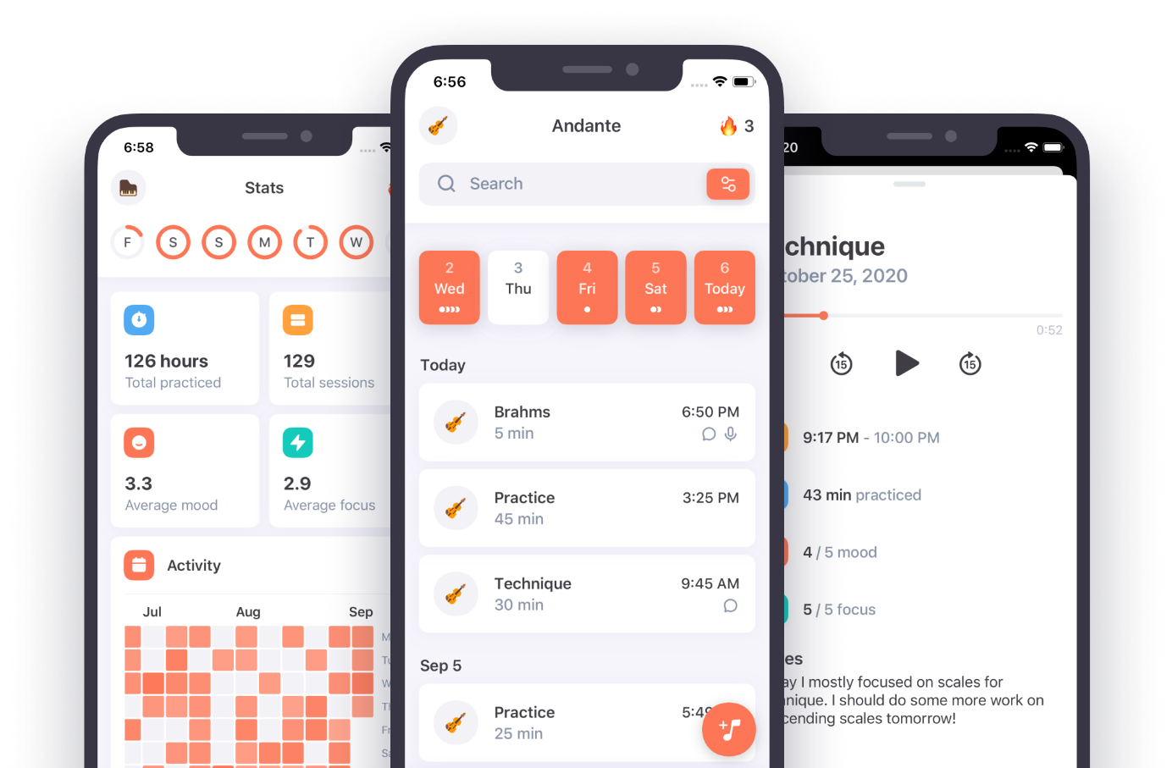
Figure 1. Andante Interface
System Actors:
- Learner: records personal practice and reviews progress.
Key Features:
- Sessions: timer-based practice and manual entry.
- Reflection: journal, notes, mood and focus.
- Tools: metronome, recording and a drone tuner.
- Motivation: goals, streaks, charts and reminders.
- Organisation: multiple profiles and data export.
Table 3: Pros and Cons of Andante
Pros | Cons / fit limitations
Session tools and reflection in one workflow. | Regular manual entries are still needed for useful reflection.
Mood, focus and activity history provide context. | Activity charts do not establish musical accuracy.
Profiles and export support personal organisation. | The cited page does not establish Vietnamese support or microphone pitch detection.

3.2 Modacity
Official website: https://www.modacity.co/
Modacity combines practice organisation, note taking and recording with a guided improvement process. It is a reference for connecting an exercise with reflection and the next practice action [9].
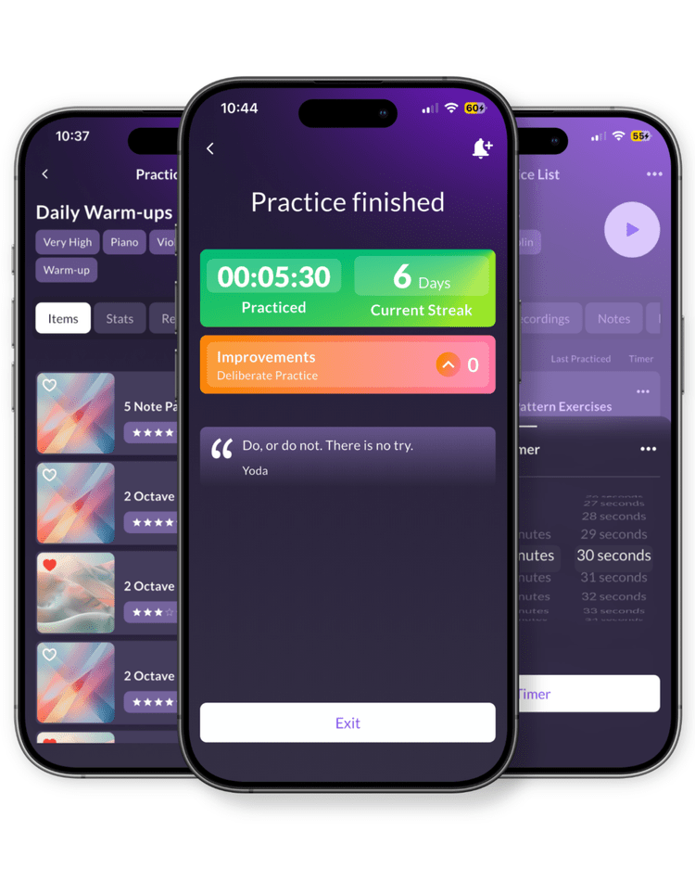
Figure 2. Modacity Interface

System Actors:
- Musician: organises practice items and reviews personal recordings.
Key Features:
- Organisation: practice playlists and time tracking.
- Tools: recorder, metronome and tone generator.
- Notes: practice notes available while practising.
- Reflection: replay and compare recordings.
- Improvement: a guided deliberate-practice mode.
- Progress: review time spent and set reminders.
Table 4: Pros and Cons of Modacity
Pros | Cons / fit limitations
Playlists organise several practice tasks. | Maintaining task lists requires learner input.
Recording comparison supports self-review. | Listening still requires the learner to interpret performance.
Guided reflection supports focused practice. | A guided workflow may add steps for quick logging; this needs a usability comparison.

3.3 Existing Systems Comparison
Table 5 compares the documented capabilities in the reviewed sources with Meloop’s intended first release. A question mark means the cited material does not establish the capability.
Table 5: Existing Systems Comparison
Feature | Andante | Modacity | Meloop
Practice timer | Yes | Yes | P
Manual session entry | Yes | ? | P
Practice notes | Yes | Yes | P
Audio recording | Yes | Yes | P
Metronome | Yes | Yes | P
Pitch tool | Drone tuner | Tone generator | P: chromatic pitch check
Streaks | Yes | ? | P
Practice time statistics | Yes | Yes | P
Vietnamese / English UI | ? | ? | P
Reusable practice plans | ? | Playlists | P: Pro
Next-step note per item | ? | ? | P
Note:
Yes: documented in the cited official source.
P: planned for Meloop, not an implemented or tested capability.
?: not established by the reviewed source; this does not mean that the feature is absent.
Tone and drone tools produce a reference sound; microphone-based pitch detection is a different capability.
The reviewed apps already cover much of the proposed feature set. Meloop must therefore demonstrate a useful practice workflow, reliable tools and a clear Vietnamese/English experience, rather than rely on having more features.
The differentiation to test is a visible next-step note linked to each practice item, combined with quick session capture and local data control. This is a product hypothesis, not a claim that competitors cannot support the same workflow.

4. Business Opportunity
The initial opportunity is to help learners who currently split practice records between paper, phone notes and separate utility apps. The first acquisition tests will use Vietnamese and English demonstrations of saving a session and returning to its next step.
Free includes one instrument profile, unlimited items and history within device storage, the timer, metronome, pitch check, local recording, seven-day progress, streaks, weekly goals, reminders, journal backup and audio export. Each clip is limited to ten minutes in both tiers.
Pro is a one-time upgrade. It adds multiple instrument profiles, reusable plans with ordered practice items and target durations, and statistics filtered by practice item, profile and date range. The initial test prices are VND 49,000 in Vietnam and USD 4.99 in the United States; final checkout prices come from each store.
The MVP has no advertisements or auto-renewing subscription. Learners can close upgrade prompts and continue using free functions. Existing journal records remain accessible if purchase status changes. Purchasing and restoration require a network connection.
The first validation target is 15 testers: at least 10 independently save a first session, and at least 5 of those return to save a second session within seven days. These are proposed experiment thresholds, not market evidence. Return usage and reasons for paying will inform further investment.

5. Software Product Vision
For people learning an instrument, Meloop is a mobile practice journal that keeps practice tasks, session notes and recordings together so the next session has a clear starting point.
The first release supports Android and iOS with Vietnamese and English interfaces. Journals, plans and general tools serve multiple instrument types, including custom instrument names. Pitch checking has a separate boundary in LI-03. Interface strings are separated for later translation.
The selected implementation uses Flutter/Dart, Riverpod for state management, SQLite for local journal records, private device storage for audio, RevenueCat for purchase entitlement and Firebase Crashlytics for technical diagnostics. No custom journal backend or user-facing website is included in the MVP.
Delivery planning uses four hours per person per working day, Monday to Friday, for four weeks. The PM owns scope and acceptance; the developers own implementation; QA verifies the release; marketing prepares recruitment and launch materials. The release target is submission of a tested build to both stores, subject to account readiness.

6. Project Scope & Limitations

6.1 Major Features

6.1.1 Meloop Mobile Application

A. Practice Journal
- UC-01: Manage Instrument Profiles
Create, rename, select, archive and reactivate an instrument profile. Choose guitar, piano, ukulele, violin, flute, percussion or a custom type. First use offers profile creation without an account. Free includes one profile; Pro allows multiple profiles. Archiving preserves history and does not free a profile slot.
- UC-02: Manage Practice Items
Create, rename, edit, search, archive and reactivate pieces or exercises within an instrument profile. An empty list offers creation of the first item. Each item has a name and optional passage, technique and target tempo. Archiving hides it from active lists but preserves sessions and recordings; the app supplies no lessons.
- UC-03: Log a Practice Session
Save one practice item, local practice date and positive duration, entered manually or taken from UC-04. Reject future practice dates. Practised content, difficulty, next step and achieved tempo are optional. One session belongs to one item; saving twice must not create a duplicate.
- UC-04: Time a Practice Session
Start, pause, resume and finish the single active timer for a selected item. Review active duration and save through UC-03 or discard the draft with confirmation. Paused time is excluded. Changing items requires finishing or discarding the current draft; running the timer alone creates no completed session.
- UC-05: Continue Practising an Item
Open an active practice item from recent activity and review its latest non-empty next-step note, passage and tempo. Start UC-04 or log through UC-03. If no next step exists, show item details. Choose the latest note by practice date, then creation time; saving a new session remains the responsibility of UC-03.
- UC-06: Manage Practice History
Browse saved sessions, filter by date or item, view details, and correct the item, date, duration or notes. Confirm deletion, including attached audio. Recalculate totals and next steps after changes. All history remains readable in Free; this feature manages individual records, while UC-12 summarises progress.

B. Practice Tools
- UC-07: Practise with a Metronome
Start and stop a steady pulse at 40–240 BPM, choose 1–12 equal pulses per cycle and accent the first pulse. Show the pulse visually and remember the last setting. BPM denotes pulses per minute, not automatic time-signature interpretation.
- UC-08: Check Note Pitch
Use the microphone to display a sustained single note, octave and deviation in cents from equal temperament at A4 = 440 Hz. Use chromatic note detection rather than guitar-only strings. Low-confidence input displays an unstable-signal state; see LI-03.
- UC-09: Record Practice Audio
Record one or more local clips for a draft or saved session, one clip at a time and up to ten minutes per clip. Preview and retain or discard a clip. Request microphone access when used; denial leaves the journal available. Recording alone does not count as a completed session.
- UC-10: Manage Practice Recordings
Browse recordings by session or recording date, then play, pause, seek, export a chosen file or confirm deletion. Also list local clips left unlinked after restoring a backup so they can be played, exported or deleted. Deleting a clip preserves its session. Playback is individual; audio editing and automatic comparison are excluded.

C. Progress and Planning
- UC-11: Manage Weekly Practice Goals
Set, change or disable a target of 1–7 practice days per week for the current instrument profile. Count each qualifying date once from Monday to Sunday. Reuse the target each week until changed or disabled. Changing a target never changes saved sessions; disabling it hides the target, not practice history.
- UC-12: Review Practice Progress
Free shows a seven-day chart, total minutes, session count and current streak for the selected profile, plus its weekly goal if enabled. Pro adds date-range, item and combined-profile filters. Both tiers show self-entered tempo history in item details. This is a read-only summary of saved sessions, not a musical-ability score.
- UC-13: Manage Practice Plans
Pro users create, rename and delete reusable plans; add, remove or reorder existing items and edit target durations. Select an available item to time it through UC-04 or log it through UC-03. Flag archived items without deleting history. Removing a plan or its entry preserves items and sessions; no automatic timed transitions are included.
- UC-14: Manage Practice Reminders
Enable, edit or disable one app-wide schedule with selected weekdays and one local time. Request notification permission when enabled; explain how to open system settings if denied. Tapping a notification opens practice home. Denial does not block practice; reminder messages are optional and use the selected interface language [14].

D. Settings and Data
- UC-15: Change the App Language
Switch the interface between Vietnamese and English without restarting or losing unsaved input. Localise controls, validation and status messages. User-written item names and journal notes remain unchanged.
- UC-16: Back Up Practice Data
Export a versioned backup of profiles, items, sessions, plans, goals and preferences to a user-selected file. State that audio and purchase entitlement are excluded. Export audio separately through UC-10; purchase restoration uses UC-22.
- UC-17: Restore Practice Data
Select a Meloop backup, validate its version and contents, then preview counts and confirm replacement. Failure leaves current data intact. Relink recordings only when their identifiers match local files; mark missing audio unavailable. Preserve unlinked local clips in UC-10. Imported Pro data remains readable; restore never grants Pro access.
- UC-18: Delete Local Practice Data
After explicit confirmation, delete all local profiles, journal records, plans, goals, recordings and drafts, and cancel reminders. State that exported files remain outside the app. This action does not refund a purchase or revoke store ownership of Pro.
- UC-19: View Privacy Information
Read the privacy notice and the purposes of microphone, notification, purchase and diagnostic data handling. Explain local storage and backup boundaries. The in-app notice remains readable offline.
- UC-20: Contact Support
Open the published support email in the device mail app or copy the address if no mail app is available. Include app version only with a preview; journal text, audio and diagnostics are not attached automatically.

E. Pro Purchase
- UC-21: Upgrade to Pro
Review Free/Pro benefits and the store-provided price, then make a one-time platform purchase. Unlock multiple profiles, reusable plans and advanced progress filters only after entitlement verification. Cancellation, pending payment and failure preserve Free access.
- UC-22: Restore Pro Access
Restore an eligible purchase using the same platform store account and verify access through the purchase service [7]. Report success, no eligible purchase or a retryable error. Journal backup never grants paid entitlement.
[ Meloop feature overview diagram to be added ]
Figure 3. Meloop Feature Overview (illustration pending)

6.2 Limitations & Exclusions

6.2.1 Mobile Application Limitations
- LI-01: Platforms and Languages
Android and iOS phone apps with Vietnamese and English interfaces. Additional instruments do not imply additional interface languages or dedicated tablet layouts.
- LI-02: Free and Pro Boundaries
Free: one instrument profile; unlimited items and session history within device storage. Pro: multiple profiles, reusable plans and advanced progress filters. Weekly goals, reminders, core tools, backup and audio export remain free. Pro is VND 49,000 in Vietnam and USD 4.99 in the United States, paid once; checkout uses the store price.
- LI-03: Pitch Detection Range
Release test range: C2–C6, one sustained pitched sound at a time, A4 = 440 Hz and concert pitch. Guitar, ukulele, violin and flute examples must be verified on real devices within this range. No automatic transposition for B-flat/E-flat instruments, piano-tuning procedure, unpitched percussion detection or universal-instrument accuracy claim [13].
- LI-04: Audio and Metronome Limits
One audio tool at a time: metronome, pitch check, recording or playback; the timer may run alongside it. Switching tools stops the previous one safely. Audio stops when the app enters the background or the screen locks; switching Meloop screens is not itself a background event. No compound subdivisions, polyrhythms, tempo ramps or Bluetooth latency compensation.
- LI-05: Recording and Backup Limits
Ten minutes per clip; total storage depends on the device. Backups contain journal data, not audio or Pro ownership; warn before restore about missing audio links on another device. Uninstalling may remove local data. Restore replaces rather than merges records and asks again before rescheduling reminders.
- LI-06: Progress and Reminder Rules
A qualifying day contains a saved session of at least one minute. Count a date once per profile using the local practice date stored with the session. Streaks remain current if the latest qualifying day is today or yesterday. One app-wide reminder schedule; operating-system settings can delay or suppress delivery.
- LI-07: Connectivity and Purchase Ownership
Core practice works offline. Buying and restoring Pro require connectivity; previously verified local access is not removed solely because the device is offline. Cross-platform ownership transfer is excluded. Data from locked Pro features stays readable and exportable; creating additional Pro content requires valid entitlement.

6.2.2 Features Deferred beyond the First Release
- EX-01: Accounts and Synchronisation
App accounts, cloud journals, cloud audio, shared editing and cross-device automatic synchronisation.
- EX-02: Automatic Musical Assessment
AI scoring, melody or chord recognition, audio-to-score transcription, MIDI input and automatic instrument identification. UC-08 only measures a single pitch.
- EX-03: Specialised Learning Content
Sheet-music imports and catalogues, copyrighted lesson libraries, fingering diagrams, ear-training courses and instrument-specific coaching.
- EX-04: Social and Sharing Features
Teacher portals, leaderboards, social feeds, referrals and designed progress-sharing cards. Manual audio export remains available through UC-10.
- EX-05: Additional Products and Monetisation
Web/desktop clients, administration portals, advertising, recurring subscriptions and paid streak recovery.

6.3 Operational and Quality Requirements
- RQ-01: Recover Interrupted Practice
Persist one session draft and timer state locally. After interruption or restart, offer resume, review or confirmed discard. Count background timer intervals only when elapsed time can be established reliably; uncertain intervals require user correction. Stop audio safely and explain unrecoverable partial clips. Tool-permission failures must leave manual journaling available.
- RQ-02: Preserve Data Integrity
Validate inputs and prevent duplicate saves. Failed save, backup or restore preserves existing data and recoverable input. App updates preserve local records through tested data migration. Archiving preserves sessions. Confirm session deletion with attached audio; exported files remain. Recalculate dependent statistics and next steps after edits or deletions.
- RQ-03: Keep Controls Accessible
Support screen-reader labels, system text scaling and readable small-screen layouts. Convey pulse, pitch and validation states through text or shape as well as colour; keep input visible when an error occurs [3], [4].
- RQ-04: Protect Privacy and User Choice
Request permissions in context. Exclude journal text and audio from diagnostics; show support-message content before handoff. No forced reminders, guilt messages, purchase prompts during active practice or penalties for rest days [3], [14].
- RQ-05: Verify Release Readiness
Verify the journal, draft recovery, audio permissions, backup round-trip and sandbox purchase/restore on real Android and iOS devices. Demonstrate audio feasibility before final delivery estimates. Stop release for data loss, incorrect entitlement or unstable core audio.

III. References
[1] Flutter, “Flutter documentation.”
[Online]. Available: https://docs.flutter.dev/
[Accessed: September 15, 2026].
[2] SQLite, “About SQLite.”
[Online]. Available: https://www.sqlite.org/about.html
[Accessed: September 15, 2026].
[3] Apple, “Human Interface Guidelines.”
[Online]. Available: https://developer.apple.com/design/human-interface-guidelines/
[Accessed: September 15, 2026].
[4] Google, “Make apps more accessible.”
[Online]. Available: https://developer.android.com/guide/topics/ui/accessibility/apps
[Accessed: September 15, 2026].
[5] Apple, “App Review Guidelines.”
[Online]. Available: https://developer.apple.com/app-store/review/guidelines/
[Accessed: September 15, 2026].
[6] Google, “User Data policy.”
[Online]. Available: https://support.google.com/googleplay/android-developer/answer/10144311
[Accessed: September 15, 2026].
[7] RevenueCat, “Restoring Purchases.”
[Online]. Available: https://www.revenuecat.com/docs/getting-started/restoring-purchases
[Accessed: September 15, 2026].
[8] Andante, “Andante Music Practice Journal.”
[Online]. Available: https://andante.app/
[Accessed: September 15, 2026].
[9] Modacity, “Music Practice Journal and Companion.”
[Online]. Available: https://www.modacity.co/
[Accessed: September 15, 2026].
[10] ISO, “ISO/IEC/IEEE 29148:2018 — Requirements engineering.”
[Online]. Available: https://www.iso.org/standard/72089.html
[Accessed: September 15, 2026].
[11] Ellen Gottesdiener, “Use Case Best Practices,” 2003 (IBM-hosted paper).
[Online]. Available: https://public.dhe.ibm.com/software/rational/web/whitepapers/2003/usecase_bp.pdf
[Accessed: September 15, 2026].
[12] OMG, “Unified Modeling Language 2.5.1.”
[Online]. Available: https://www.omg.org/spec/UML/2.5.1/About-UML
[Accessed: September 15, 2026].
[13] TonalEnergy, “TE Tuner User Guide.”
[Online]. Available: https://www.tonalenergy.com/tet-user-guide-android
[Accessed: September 15, 2026].
[14] Apple, “Human Interface Guidelines: Notifications.”
[Online]. Available: https://developer.apple.com/design/human-interface-guidelines/notifications
[Accessed: September 15, 2026].

