**CMSC140 Project 1**

**Name: Katya Alexandra Portillo Cabrera**

**Instructor: Professor Full Name**

**Class: CMSC 140**

**Course CRN: 2300**

**Due Date: 09/27/2021**

**Test plan**

|  |  |  |  |  |
| --- | --- | --- | --- | --- |
| **Cases** | **Input** | **Expected output** | **Actual output** | **Did the test pass?** |
| Case 1 | Visitor name: Katya  Age: 2  Number1: 4  Number2: 5 | Visitor name: Katya  Age: 2  Total months: 24  Total days: 720  Total hours: 17280  Total minutes:  1036800  Total seconds:  62208000  Dog age: 14  Goldfish age: 10  4+5 = 9  4/5 = 0  4.0 / 5.0 = 0.8 | Visitor name: Katya  Age: 2  Total months: 24  Total days: 720  Total hours: 17280  Total minutes:  1036800  Total seconds:  62208000  Dog age: 14  Goldfish age: 10  4+5 = 9  4/5 = 0  4.0 / 5.0 = 0.8 | **Yes** |
| Case 2 | Visitor name: Luzy  Age: 3  Number1: 3  Number2: 4 | Visitor name: Luzy  Age: 3  Total months: 36  Total days: 1080  Total hours: 25920  Total minutes:  15552000  Total seconds:  93312000  Dog age: 21  Goldfish age: 15  3 + 4 = 7  3 / 4 = 0  3.0 / 4.0 = 0.75 | Visitor name: Luzy  Age: 3  Total months: 36  Total days: 1080  Total hours:  25920  Total minutes:  15552000  Total seconds:  93312000  Dog age: 21  Goldfish age: 15  3 + 4 = 7  3 / 4 = 0  3.0 / 4.0 = 0.75 | **Yes** |
| Case 3 | Visitor name: Ana  Age: 1  Number1: 6  Number2: 5 | Visitor name: Ana  Age: 1  Total months: 12  Total days: 360  Total hours: 8640  Total minutes: 518400  Total seconds: 31104000  Dog age: 7  Goldfish age: 5  6 + 5 = 11  6 / 5 = 1  6.0 / 5.0 = 1.2 | Visitor name: Ana  Age: 1  Total months: 12  Total days: 360  Total hours: 8640  Total minutes:  518400  Total seconds: 31104000  Dog age: 7  Goldfish age: 5  6 + 5 = 11  6 / 5 = 1  6.0 / 5.0 = 1.2 | **Yes** |
| Case 4 | Visitor name: Lana  Age: 6  Number1: 2  Number2: 3 | Visitor name: Lana  Age: 6  Total months: 72  Total days: 2160  Total hours: 51840  Total minutes: 3110400  Total seconds: 186624000  Dog age: 42  Goldfish age: 30  2 + 3 = 5  2 / 3 = 0  2.0 / 3.0 = 0.67 | Visitor name: Lana  Age: 6  Total months: 72  Total days: 2160  Total hours: 51840  Total minutes: 3110400  Total seconds: 186624000  Dog age: 42  Goldfish age: 30  2 + 3 = 5  2 / 3 = 0  2.0 / 3.0 = 0.67 | **Yes** |
| Case 5 | Visitor name: totoro  Age: 42  Number1: 43  Number2: 22 | Visitor name: totoro  Age: 42  Total months: 504  Total days: 15120  Total hours: 36880  Total minutes: 21772800  Total seconds: 1306368000  Dog age: 294  Goldfish age: 210 | Visitor name: totoro  Age: 42  Total months: 504  Total days: 15120  Total hours: 362880  Total minutes: 21772800  Total seconds: 130636800  Dog age:294  Goldfish age: 210 | **Yes** |
| Case 6 | Visitor name: Portillo  Age: 20  Number1: 15  Number2: 2 | Visitor name: Portillo  Age: 20  Total months: 240  Total days: 7200  Total hours: 172800  Total minutes: 10368000  Total seconds: 622080000  Dog age: 140  Goldfish age: 100 | Visitor name:  Age: 20  Total months: 240  Total days: 7200  Total hours: 172800  Total minutes: 10368000  Total seconds: 622080000  Dog age: 140  Goldfish age: 100 | **Yes** |

**Case1:**

**Case 2:**

**Case 3:**

**Case 4:**

**Case 5:**

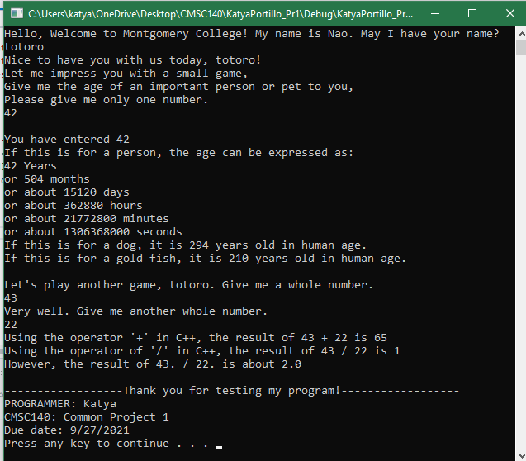

**Case 6:**

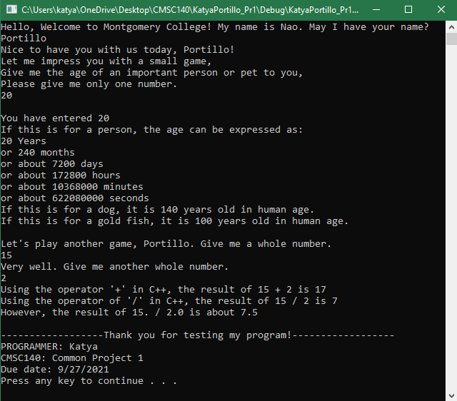

**Pseudocode:**

**The program must perform the following general steps:**

1. Ask for the visitor’s name
2. Ask the visitor the age of an important person or pet. Use this input to translate age to months, days, hours, minutes, seconds, dog year, and goldfish year.
3. Ask the visitor for two random whole numbers
4. Use the input to multiply and divide the input numbers.

*Ask the user to input their name*

*Ask the user to input an age of an important person or pet*

*Calculate months from given age*

*Calculate days from given age*

*Calculate hours from given age*

*Calculate minutes from given age*

*Calculate seconds from given age*

*Calculate dog year from given age*

*Calculate goldfish year from given age*

*Display calculated months*

*Display calculated days*

*Display calculated hours*

*Display calculated minutes*

*Display calculated seconds*

*Display calculated dog year*

*Display calculated goldfish year*

*Ask the user for two whole numbers*

*Calculate the sum of the two whole numbers*

*Calculate division of the two whole numbers*

*Display the sum of the two whole numbers*

*Display the total of the divided numbers*

*Display end of game*

**Flowchart:**

**Lessons Learned:**

* + - * + Write about your Learning Experience, highlighting your lessons learned and learning experience from working on this project.
        + What have you learned?
        + What did you struggle with?
        + What would you do differently on your next project?
        + What parts of this assignment were you successful with, and what parts (if any) were you not successful with?
        + Provide any additional resources/links/videos you used to while working on this assignment/project.

During project 1, some lessons I learned were how to initialize variables, how to use cin input, how to get input from user, how to show output from given input, and how to perform calculations with variables. I also learned how to use comments to organize my code better and make it easier to read and understand my code. Moreover, I learned how to create pseudocode and flowchart, which helped me organize my code and helped me know what my input and output for the code will be. This is important for programmers to do before starting to code because it can help you to know what to write in the code first and what variables I need to write. Without the pseudocode I would not have known what variables I would need for input and what I would need for output, which is important for me to start writing the program.

Some things I struggled with during project 1 was syntax errors like forgetting to put ‘;’ after “<<endl”. I was confused why I kept getting build errors and had to look at my code to see what I was doing wrong. Another problem I ran into was figuring out how to show trailing zeros for number1 and number2 for the second part of the game. At first my code read

“cout << "However, the result of " << static_cast<double>(number1) << " / " << static_cast<double>(number2) << setprecision(2) << showpoint << " is about " << static_cast<double>(number1) / number2 << endl;”.

When I ran the program, I saw that there was only a trailing zero after number 2 and I was confused why it was not showing trailing zeros for both numbers. Then, I figured out that to show trailing zeros for both numbers I needed to put setprecision(2) and showpoint before both numbers. So, my new code read

“cout << "However, the result of " << setprecision(2) << showpoint << static_cast<double>(number1) << " / " << static_cast<double>(number2) << " is about " << static_cast<double>(number1) / number2 << endl;”

This helped solve my problem because now it was showing trailing zeros for both number 1 and number 2. For my next Project, I would start working on it sooner so I can have more time for debugging and any build errors that I may come across. For project one, I was successful with showing output for the program since it was the easiest part of the program. I was unsuccessful with showing some of the calculations for number 1 and number 2 because I had problems with showing the correct answer.

Some resources I used for this project was Pearson Revel notes and a YouTube video that helped me fix my trailing zeros problem.

**Sources:**

Pearson Revel

**<https://www.youtube.com/watch?v=daBz8vFaCKo&ab_channel=DeborahS>**

**Check List**

|  |  |  |  |
| --- | --- | --- | --- |
| **Nr** |  | **Y/N** | **Comments** |
| **1** | **Source Code .cpp file:** FirstInitialLastNam_Pr1.cpp | **Y** |  |
| **2** | **Compressed Source Code .cpp file:** FirstInitialLastNam_Pr1.zip | **Y** |  |
| **3** | **Documentation File:** FirstInitialLastNam_Pr1.cpp |  |  |
| **4** | **Program compiles** | **Y** |  |
| **3** | **Program runs with desired outputs related to a Test Plan** | **Y** |  |
| **5** |  | **Y** |  |
| **6** | **Documentation files:** | **Y** |  |
|  | Title page | **Y** |  |
|  | Comprehensive Test Plan | **Y** |  |
|  | Screenshots based on Test Plan | **Y** |  |
|  | Algorithm (Pseudocode) | **Y** |  |
|  | Flowchart | **Y** |  |
|  | Lessons Learned | **Y** |  |
|  | Student Check List | **Y** |  |