Devops Tools Brief:
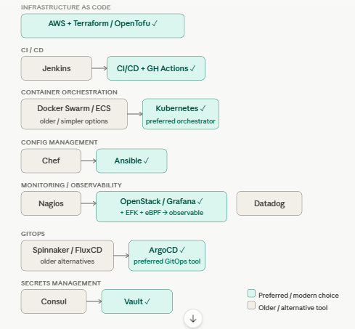

1. IaC — Infrastructure as Code
What: Define your servers, networks, databases as code files instead of clicking through UIs.
Tools:
- AWS — the cloud platform where infra lives (EC2, VPC, RDS, S3, etc.)
- Terraform / OpenTofu — declarative HCL files describing what infra you want; Terraform applies the diff. OpenTofu is the open-source fork after HashiCorp changed licensing.
Why: Reproducible infra, version-controlled, reviewable via PRs. "What if not?" → Manual provisioning, snowflake servers, no audit trail, environment drift.

2. CI/CD — Continuous Integration / Continuous Delivery
What: Automate build → test → deploy on every code push.
Tools:
- Jenkins — older self-hosted automation server; powerful but high ops overhead.
- GitHub Actions (✓) — YAML workflows in your repo, runs in GitHub's cloud. Zero infra to manage.
Why: Catch bugs early, ship faster, reduce human error in deployments. What if not? → Manual deploys, inconsistent environments, slow feedback loops.

3. COE — Container Orchestration
What: Run, scale, and heal containerized workloads across many machines.
Tools:
- Docker Swarm — simple clustering built into Docker, low learning curve but limited.
- ECS (AWS) — AWS-native container service, good but vendor-locked.
- Kubernetes (✓) — the industry standard. Handles scheduling, auto-scaling, self-healing, rolling deploys, secrets, networking.
Why Kubernetes wins: Massive ecosystem, cloud-agnostic, battle-tested at Google-scale. What if not? → Services go down with no auto-restart, scaling is manual, cross-team coordination breaks.

4. Config Management
What: Ensure every server has the right software, users, configs — consistently.
Tools:
- Chef — Ruby DSL, pull-based, powerful but steep learning curve.
- Ansible (✓) — agentless, YAML playbooks, push-based. Much simpler to get started.
Why Ansible wins: No agents to install, human-readable YAML, huge module library. What if not? → Config drift across servers, "works on my machine" problems, manual patching.

5. Monitoring / Observability
What: Know when things break, why they broke, and how performance trends over time.
Tools:
- Nagios — classic alerting tool (checks if services are up/down). Old UI, limited observability.
- Datadog — commercial SaaS, full observability (metrics, logs, traces) with great UX but expensive.
- Grafana (✓) — open-source dashboards, pairs with Prometheus for metrics.
- EFK stack — Elasticsearch + Fluentd + Kibana for log aggregation.
- eBPF — kernel-level observability; traces syscalls, network packets, without code changes.
- OpenStack — open-source cloud platform; sometimes used as infra under monitoring.
What if not? → You find out your system is down when users tweet at you. No post-mortem data.

6. GitOps
What: Git is the single source of truth for deployment state. Any merge to main triggers a sync to production.
Tools:
- Spinnaker — Netflix-built, multi-cloud CD platform. Complex to operate.
- FluxCD — lightweight GitOps operator for Kubernetes.
- ArgoCD (✓) — visual UI, declarative, Kubernetes-native. Watches Git, diffs vs cluster state, auto-syncs.
Why ArgoCD wins: Easy to audit ("what's deployed vs what's in Git"), great UI, supports app-of-apps patterns. What if not? → Config drift between Git and production, no rollback story.

7. Secrets Management
What: Store and distribute passwords, API keys, TLS certs — never hardcoded in code.
Tools:
- Consul — service discovery + distributed KV store (also used for service mesh). Not primarily a secrets tool.
- Vault (✓) — purpose-built secrets engine by HashiCorp. Dynamic secrets (generates DB creds on demand), lease expiry, audit logs.
Why Vault wins: Fine-grained access policies, secrets rotation, integrates with Kubernetes. What if not? → Secrets in environment variables or Git repos → credential leaks, breaches.

