3 tier application—example

Frontend
Backend
DB

Frontend ---communnicate with backend UrL
Backend===communicate with DB URL

3image-3 container

Need to create image-container—network

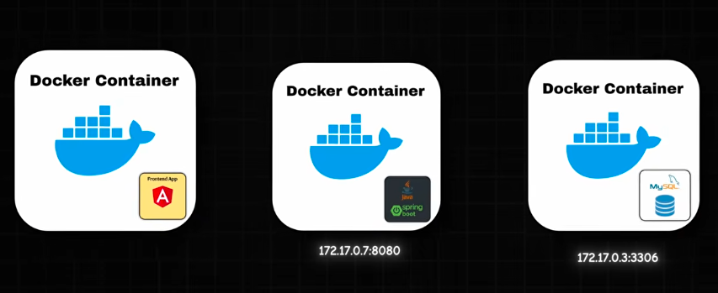

But nowadays all aplications in from of microservices
Small feature create a image—container---network---assume it time teious process

To solve this problem docker compose come into picture

Simple create dockercompse.yaml file

Docker image
Docker network
Env variable

Docker compose-up----sinle command

Will create docker image—network—conatiner—env variables

If you want delete ---docker compose-down

Code explanation

Top Level
version: "3.9"
- version
→ Specifies the Docker Compose file format version.
- "3.9"
→ Uses Compose specification version 3.9.

Services Section
services:
- services
→ Main section where all containers/services are defined.
Everything inside this block becomes a container.
You have 3 services:
- MySQL Database
- Backend Application
- Frontend Application

MYSQL SERVICE
mysql:
- mysql
→ Name of the service.
→ Docker Compose uses this name internally as hostname too.
So other containers can access MySQL using:
mysql
as the host.

Image
image: mysql:8.0
- image
→ Docker image to use.
- mysql:8.0
→ Pull MySQL version 8.0 from Docker Hub.
Equivalent command:
docker pull mysql:8.0

Container Name
container_name: mysql-db
- container_name
→ Custom name for the running container.
Instead of random names, container becomes:
mysql-db

Restart Policy
restart: always
- restart
→ Defines restart behavior.
- always
→ Restart container automatically:
  - if it crashes
  - if Docker restarts
  - if system reboots

Environment Variables
environment:
- environment
→ Defines environment variables inside container.

Root Password
MYSQL_ROOT_PASSWORD: simplybyte
- MYSQL_ROOT_PASSWORD
→ Sets MySQL root user password.
Root credentials:
username: root
password: simplybyte

Database Creation
MYSQL_DATABASE: simplybytedb
- MYSQL_DATABASE
→ Automatically creates database on startup.
Database created:
simplybytedb

Volumes
volumes:
- mysql_data:/var/lib/mysql
- volumes
→ Used for persistent storage.
Left Side
mysql_data
Named Docker volume.
Right Side
/var/lib/mysql
Internal MySQL data directory.
Meaning:
Store MySQL files permanently in mysql_data volume
Without this:
- database data is lost when container removed.

Ports
ports:
- "3307:3306"
- ports
→ Maps host machine ports to container ports.
Format:
HOST:CONTAINER
Meaning:
Host Machine | Container
3307 | 3306
You connect using:
localhost:3307
Inside container MySQL still runs on:
3306

Networks
networks:
- simplybyte
- networks
→ Connects container to Docker network.
- simplybyte
→ Network name.
Allows containers to communicate.

BACKEND SERVICE
backend:
Defines backend container.

Backend Image
image: simplybyte/simplybyte-backend:1.0
Uses custom backend Docker image.
Format:
username/repository:tag
Meaning:
- Docker Hub user → simplybyte
- repository → simplybyte-backend
- version → 1.0

Backend Container Name
container_name: simplybyte-backend
Container name becomes:
simplybyte-backend

Restart
restart: always
Auto restart enabled.

Depends On
depends_on:
- mysql
- depends_on
→ Start dependency first.
Meaning:
- Start MySQL
- Then start backend
IMPORTANT:
It does NOT guarantee MySQL is fully ready.
Only ensures startup order.

Backend Environment Variables
environment:
Variables passed to Spring Boot app.

Database URL
SPRING_DATASOURCE_URL: jdbc:mysql://mysql:3306/simplybytedb
Spring Boot database connection URL.
Breakdown:
Part | Meaning
jdbc:mysql:// | MySQL JDBC protocol
mysql | hostname (service name)
3306 | MySQL container port
simplybytedb | database name
Docker DNS resolves:
mysql
to MySQL container automatically.

Username
SPRING_DATASOURCE_USERNAME: root
Database username.

Password
SPRING_DATASOURCE_PASSWORD: simplybyte
Database password.

Backend Ports
ports:
- "8090:8090"
Maps:
Host | Container
8090 | 8090
Backend accessible at:
http://localhost:8090

Backend Network
networks:
- simplybyte
Backend joins same network.
So backend can talk to MySQL.

FRONTEND SERVICE
Your indentation is incorrect here.
Currently:
frontend:
is outside services: block.
It should be:
services:
frontend:
Otherwise Docker Compose throws error.

Correct structure:
services:
mysql:
backend:
frontend:

FRONTEND DETAILS
frontend:
Defines frontend container.

Frontend Image
image: simplybyte/simplybyte-ui:3.1
Uses frontend Docker image version 3.1.

Frontend Container Name
container_name: simplybyte-frontend
Container name.

Restart
restart: always
Auto restart.

Depends On
depends_on:
- backend
Start backend before frontend.

Volumes
volumes:
- ./config.json:/usr/share/nginx/html/assets/config.json
Bind mount.
Left Side
./config.json
Local file on host machine.
Right Side
/usr/share/nginx/html/assets/config.json
Path inside container.
Meaning:
- Replace container config file with local file.
Useful for:
- environment config
- API URLs
- runtime customization

Frontend Ports
ports:
- "80:80"
Maps:
Host | Container
80 | 80
Frontend accessible via:
http://localhost

Frontend Network
networks:
- simplybyte
Frontend joins same Docker network.

VOLUMES SECTION
volumes:
mysql_data:
Defines named volume.
Docker creates managed storage named:
mysql_data
Used by MySQL service.

NETWORKS SECTION
networks:
simplybyte:
driver:bridge
Defines custom Docker network.

Network Name
simplybyte:
Network identifier.

Driver
driver: bridge
Uses Docker bridge networking.
Bridge network:
- isolates containers
- allows communication
- provides internal DNS
Containers can access each other using service names.
Example:
backend -> mysql
frontend -> backend

FINAL FLOW
Your architecture becomes:
Browser
↓
Frontend (Port 80)
↓
Backend API (Port 8090)
↓
MySQL DB (Port 3306 internal)

