The Essentials of Text Editing in Linux
Text editing skills using the command line are one of the most crucial skills in Linux. In this section, you will learn how to use two popular text editors in Linux: Vim and Nano.
I suggest that you master any one text editor of your choice and stick to it. It will save you time and make you more productive. Vim and nano are safe choices as they are present on most Linux distributions.

5.1. Mastering Vim: The Complete Guide

Introduction to Vim
Vim is a popular text editing tool for the command line. Vim comes with its advantages: it is powerful, customizable, and fast. Here are some reasons why you should consider learning Vim:
- Most servers are accessed via a CLI, so in system administration, you don't necessarily have the luxury of a GUI. But Vim has got your back – it'll always be there.
- Vim uses a keyboard-centric approach, as it is designed to be used without a mouse, which can significantly speed up editing tasks once you have learned the keyboard shortcuts. This also makes it faster than GUI tools.
- Some Linux utilities, for example editing cron jobs, work in the same editing format as Vim.
- Vim is suitable for all – beginners and advanced users. Vim supports complex string searches, highlighting searches, and much more. Through plugins, Vim provides extended capabilities to developers and system admins that includes code completion, syntax highlighting, file management, version control, and more.
Vim has two variations: Vim (vim) and Vim tiny (vi). Vim tiny is a smaller version of Vim that lacks some features of Vim.

How to start using vim
Start using Vim with this command:
vim your-file.txt
your-file.txt can either be a new file or an existing file that you want to edit.

Navigating Vim: Mastering movement and command modes
In the early days of the CLI, the keyboards didn't have arrow keys. Hence, navigation was done using the set of available keys, hjkl being one of them.
Being keyboard-centric, using hjkl keys can greatly speed up text editing tasks.
Note: Although arrow keys would work totally fine, you can still experiment with hjkl keys to navigate. Some people find this this way of navigation efficient.
💡Tip: To remember the hjkl sequence, use this: hang back, jump down, kick up, leap forward.

The three Vim modes
You need to know the 3 operating modes of Vim and how to switch between them. Keystrokes behave differently in each command mode. The three modes are as follows:
- Command mode.
- Edit mode.
- Visual mode.
Command Mode. When you start Vim, you land in the command mode by default. This mode allows you to access other modes.
⚠ To switch to other modes, you need to be present in the command mode first
Edit Mode
This mode allows you to make changes to the file. To enter edit mode, press I while in command mode. Note the '-- INSERT' switch at the end of the screen.
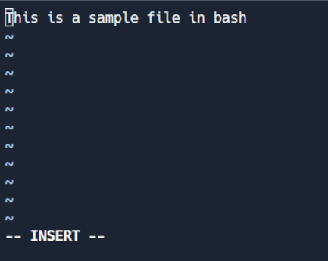
Visual mode
This mode allows you to work on a single character, a block of text, or lines of text. Let's break it down into simple steps. Remember, use the below combinations when in command mode.
- Shift + V → Select multiple lines.
- Ctrl + V → Block mode
- V → Character mode
The visual mode comes in handy when you need to copy and paste or edit lines in bulk.
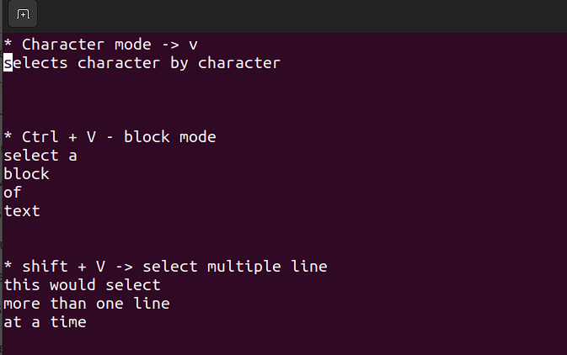
Extended command mode.
The extended command mode allows you to perform advanced operations like searching, setting line numbers, and highlighting text. We'll cover extended mode in the next section.
How to stay on track? If you forget your current mode, just press ESC twice and you will be back in Command Mode.

Editing Efficiently in Vim: Copy/pasting and searching
1. How to copy and paste in Vim
Copy-paste is known as 'yank' and 'put' in Linux terms. To copy-paste, follow these steps:
- Select text in visual mode.
- Press 'y' to copy/ yank.
- Move your cursor to the required position and press 'p'.
2. How to search for text in Vim
Any series of strings can be searched with Vim using the / in command mode. To search, use /string-to-match.
In the command mode, type :set hls and press enter. Search using /string-to-match. This will highlight the searches.
Let's search a few strings:
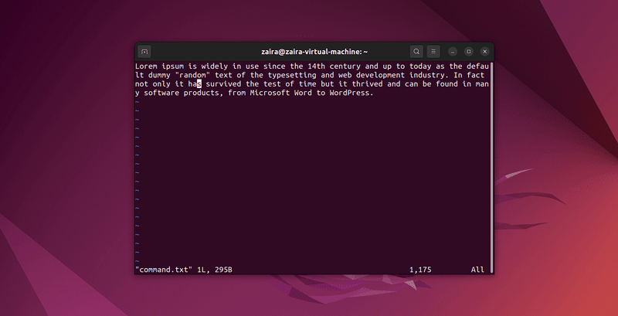
3. How to exit Vim
First, move to command mode (by pressing escape twice) and then use these flags:
- Exit without saving → :q!
- Exit and save → :wq!

Shortcuts in Vim: Making Editing Faster
Note: All these shortcuts work in the command mode only.
- Basic Navigation
  - h: Move left
  - j: Move down
  - k: Move up
  - l: Move right
  - 0: Move to the beginning of the line
  - $: Move to the end of the line
  - gg: Move to the beginning of the file
  - G: Move to the end of the file
  - Ctrl+d: Move half-page down
  - Ctrl+u: Move half-page up
- Editing
  - i: Enter insert mode before the cursor
  - I: Enter insert mode at the beginning of the line
  - a: Enter insert mode after the cursor
  - A: Enter insert mode at the end of the line
  - o: Open a new line below the current line and enter insert mode
  - O: Open a new line above the current line and enter insert mode
  - x: Delete the character under the cursor
  - dd: Delete the current line
  - yy: Yank (copy) the current line (use this in visual mode)
  - p: Paste below the cursor
  - P: Paste above the cursor
- Searching and Replacing
  - /: Search for a pattern which will take you to its next occurrence
  - ?: Search for a pattern that will take you to its previous occurrence
  - n: Repeat the last search in the same direction
  - N: Repeat the last search in the opposite direction
  - :%s/old/new/g: Replace all occurrences of old with new in the file
- Exiting
  - :w: Save the file but don't exit
  - :q: Quit Vim (fails if there are unsaved changes)
  - :wq or :x: Save and quit
  - :q!: Quit without saving
- Multiple Windows
  - :split or :sp: Split the window horizontally
  - :vsplit or :vsp: Split the window vertically
  - Ctrl+w followed by h/j/k/l: Navigate between split windows

