16. Design of 4 stage pipeline for multiplication and division of two numbers using
any high level language.
# 4 stage pipeline
counter=1
a=int(input("ENTER NUMBER-1-"))
counter=counter+1
b=int(input("ENTER NUMBER-2-"))
counter=counter+1
print("1-ADDITION 2-SUBTRACTION 3-MULTIPLICATION 4-DIVISION")
print("Enter Your Choice")
choice=int(input())
if choice==1:
print("Performing Addition...")
res=a+b
counter=counter+1
if choice==2:
print("Performing Subtraction...")
res=a-b
counter=counter+1
if choice==3:
print("Performing Multiplication")
res=a*b
counter=counter+1
if choice==4:
if b==0:
print("Denominator can't be Zero")
print("Performing Division")
res=a/b
counter=counter+1
if choice>=5:
print("Enter Correct Input")
print(res)
counter=counter+3
print("CYCLE VALUE IS:",counter)
ins=int(input("Enter the No.of instructions:"))
performance_measure =ins/counter
print("performance measure is:",performance_measure)
Input:enter two numbers
3
3
Output:
Mul:9
Div:1

17. Write a program to perform Booths multiplication of two signed numbers using any high
level language.
BOOTH ALGORITHM
#include <stdio.h>
#include <math.h>
int a = 0,b = 0, c = 0, a1 = 0, b1 = 0, com[5] = { 1, 0, 0, 0, 0};
int anum[5] = {0}, anumcp[5] = {0}, bnum[5] = {0};
int acomp[5] = {0}, bcomp[5] = {0}, pro[5] = {0}, res[5] = {0};
void binary(){
a1 = fabs(a);
b1 = fabs(b);
int r, r2, i, temp;
for (i = 0; i < 5; i++){
r = a1 % 2;
a1 = a1 / 2;
r2 = b1 % 2;
b1 = b1 / 2;
anum[i] = r;
anumcp[i] = r;
bnum[i] = r2;
if(r2 == 0){
bcomp[i] = 1;
}
if(r == 0){
acomp[i] =1;
}
}
//part for two's complementing
c = 0;
for ( i = 0; i < 5; i++){
res[i] = com[i]+ bcomp[i] + c;
if(res[i] >= 2){
c = 1;
}
else
c = 0;
res[i] = res[i] % 2;
}
for (i = 4; i >= 0; i--){
bcomp[i] = res[i];
}
//in case of negative inputs
if (a < 0){
c = 0;
for (i = 4; i >= 0; i--){
res[i] = 0;
}
for ( i = 0; i < 5; i++){
res[i] = com[i] + acomp[i] + c;
if (res[i] >= 2){
c = 1;
}
else
c = 0;
res[i] = res[i]%2;
}
for (i = 4; i >= 0; i--){
anum[i] = res[i];
anumcp[i] = res[i];
}
}
if(b < 0){
for (i = 0; i < 5; i++){
temp = bnum[i];
bnum[i] = bcomp[i];
bcomp[i] = temp;
}
}
}
void add(int num[]){
int i;
c = 0;
for ( i = 0; i < 5; i++){
res[i] = pro[i] + num[i] + c;
if (res[i] >= 2){
c = 1;
}
else{
c = 0;
}
res[i] = res[i]%2;
}
for (i = 4; i >= 0; i--){
pro[i] = res[i];
printf("%d",pro[i]);
}
printf(":");
for (i = 4; i >= 0; i--){
printf("%d", anumcp[i]);
}
}
void arshift(){//for arithmetic shift right
int temp = pro[4], temp2 = pro[0], i;
for (i = 1; i < 5 ; i++){//shift the MSB of product
pro[i-1] = pro[i];
}
pro[4] = temp;
for (i = 1; i < 5 ; i++){//shift the LSB of product
anumcp[i-1] = anumcp[i];
}
anumcp[4] = temp2;
printf("\nAR-SHIFT: ");//display together
for (i = 4; i >= 0; i--){
printf("%d",pro[i]);
}
printf(":");
for(i = 4; i >= 0; i--){
printf("%d", anumcp[i]);
}
}
void main(){
int i, q = 0;
printf("\t\tBOOTH'S MULTIPLICATION ALGORITHM");
printf("\nEnter two numbers to multiply: ");
printf("\nBoth must be less than 16");
//simulating for two numbers each below 16
do{
printf("\nEnter A: ");
scanf("%d",&a);
printf("Enter B: ");
scanf("%d", &b);
}while(a >=16 || b >=16);
printf("\nExpected product = %d", a * b);
binary();
printf("\n\nBinary Equivalents are: ");
printf("\nA = ");
for (i = 4; i >= 0; i--){
printf("%d", anum[i]);
}
printf("\nB = ");
for (i = 4; i >= 0; i--){
printf("%d", bnum[i]);
}
printf("\nB'+ 1 = ");
for (i = 4; i >= 0; i--){
printf("%d", bcomp[i]);
}
printf("\n\n");
for (i = 0;i < 5; i++){
if (anum[i] == q){//just shift for 00 or 11
printf("\n-->");
arshift();
q = anum[i];
}
else if(anum[i] == 1 && q == 0){//subtract and shift for 10
printf("\n-->");
printf("\nSUB B: ");
add(bcomp);//add two's complement to implement subtraction
arshift();
q = anum[i];
}
else{//add ans shift for 01
printf("\n-->");
printf("\nADD B: ");
add(bnum);
arshift();
q = anum[i];
}
}
printf("\nProduct is = ");
for (i = 4; i >= 0; i--){
printf("%d", pro[i]);
}
for (i = 4; i >= 0; i--){
printf("%d", anumcp[i]);
}
}
18. Write a program to perform Restoring Division of two numbers using any high level
language.
INTEGER RESTORATION DIVISON METHOD:
#include<stdlib.h>
#include<stdio.h>
int acum[100]={0} ;
void add(int acum[],int b[],int n);
int q[100],b[100];
int main()
{
int x,y;
printf("Enter the Number :");
scanf("%d%d",&x,&y);
int i=0;
while(x>0||y>0)
{
if(x>0)
{
q[i]=x%2;
x=x/2;
}
else
{
q[i]=0;
}
if(y>0)
{
b[i]=y%2;
y=y/2;
}
else
{
b[i]=0;
}
i++;
}
int n=i;
int bc[50];
printf("\n");
for(i=0;i<n;i++)
{
if(b[i]==0)
{
bc[i]=1;
}
else
{
bc[i]=0;
}
}
bc[n]=1;
for(i=0;i<=n;i++)
{
if(bc[i]==0)
{
bc[i]=1;
i=n+2;
}
else
{
bc[i]=0;
}
}
int l;
b[n]=0;
int k=n;
int n1=n+n-1;
int j,mi=n-1;
for(i=n;i!=0;i--)
{
for(j=n;j>0;j--)
{
acum[j]=acum[j-1];
}
acum[0]=q[n-1];
for(j=n-1;j>0;j--)
{
q[j]=q[j-1];
}
add(acum,bc,n+1);
if(acum[n]==1)
{
q[0]=0;
add(acum,b,n+1);
}
else
{
q[0]=1;
}
}
printf("\nQuoient : ");
for( l=n-1;l>=0;l--)
{
printf("%d",q[l]);
}
printf("\nRemainder : ");
for( l=n;l>=0;l--)
{
printf("%d",acum[l]);
}
return 0;
}
void add(int acum[],int bo[],int n)
{
int i=0,temp=0,sum=0;
for(i=0;i<n;i++)
{
sum=0;
sum=acum[i]+bo[i]+temp;
if(sum==0)
{
acum[i]=0;
temp=0;
}
else if (sum==2)
{
acum[i]=0;
temp=1;
}
else if(sum==1)
{
acum[i]=1;
temp=0;
}
else if(sum==3)
{
acum[i]=1;
temp=1;
}
}
}
INTEGER RESTORATION DIVISION
Enter the Number :8
3
Quoient : 0010
Remainder : 00010
OUTPUT:
Input:
15 7

Output:
Enter the Number :

Quoient: 0010
Remainder: 00001
19. Write a program to find the Hit ratio for the given number of Hits and Misses in Cache
memory using any high level language.
EX. 19 CACHE HIT RATIO AND CACHE MISS RATIO
#include <stdio.h>

int main() {
float cachehit, cachemiss;
float cachehitratio;
printf("\n enter the total number of cache hits:");
scanf("%d",&cachehit);
printf("\n enter the number of cache misses:");
scanf("%d",&cachemiss);
cachehitratio=cachehit/(cachehit+cachemiss);
printf("\n Cache Hit Ratio: %f",cachehitratio);
printf("\n Cache Miss Ratio: %f",1-cachehitratio);
return 0;
}
enter the total number of cache hits:43
enter the number of cache misses:11
Cache Hit Ratio: 0.796296
Cache Miss Ratio: 0.203704
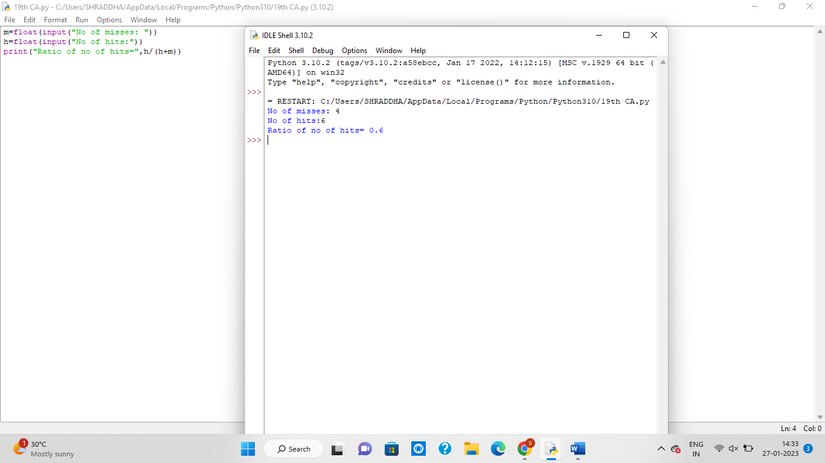
20. Write an assembly language program to find 1s and 2s complement of 8 bit number.

