Result of create movie API

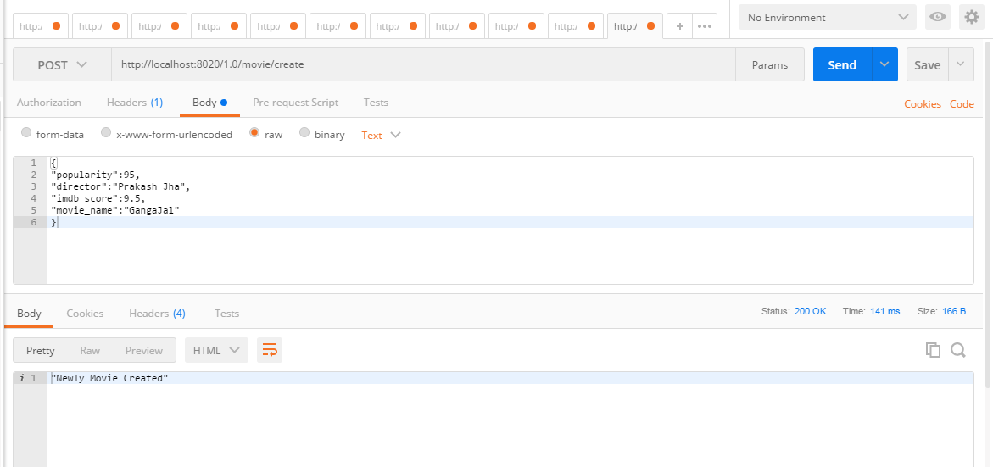

Result of create of API when the user (i.e. test) does not have the access.

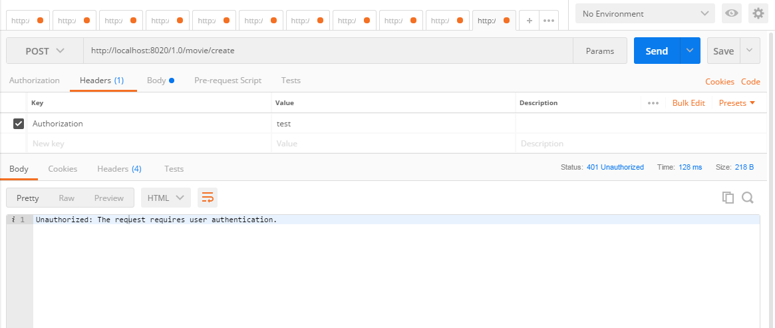

Result of Get movie API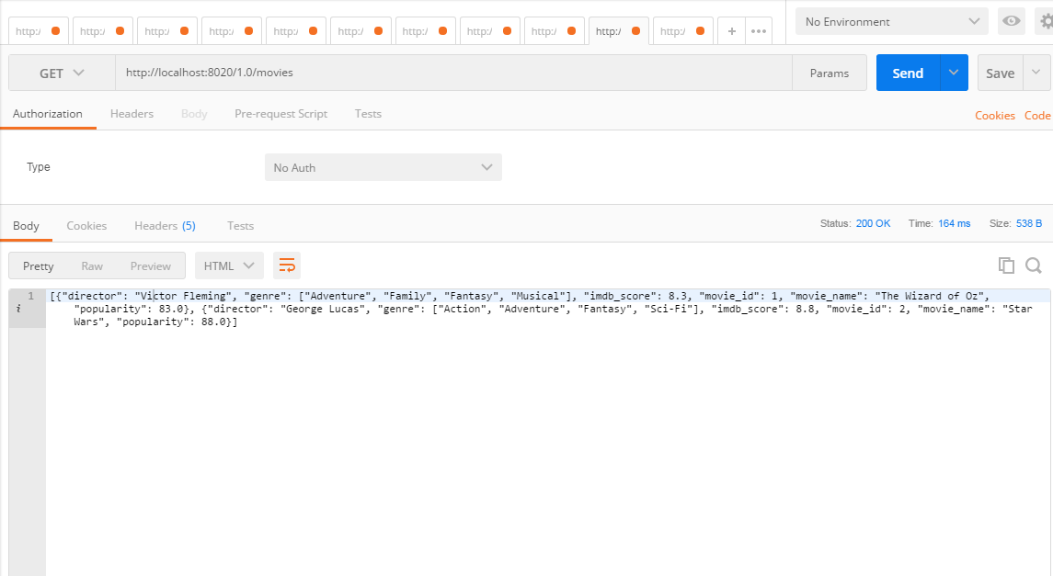

Result of API for editing / updating movie based on access level.

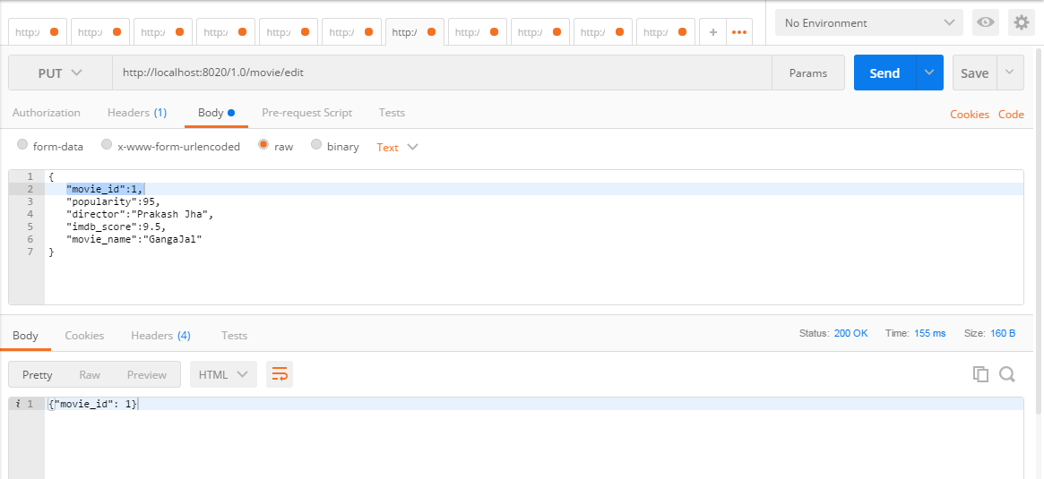

Result of API for editing / updating movie when the user (i.e. test) does not have the access.

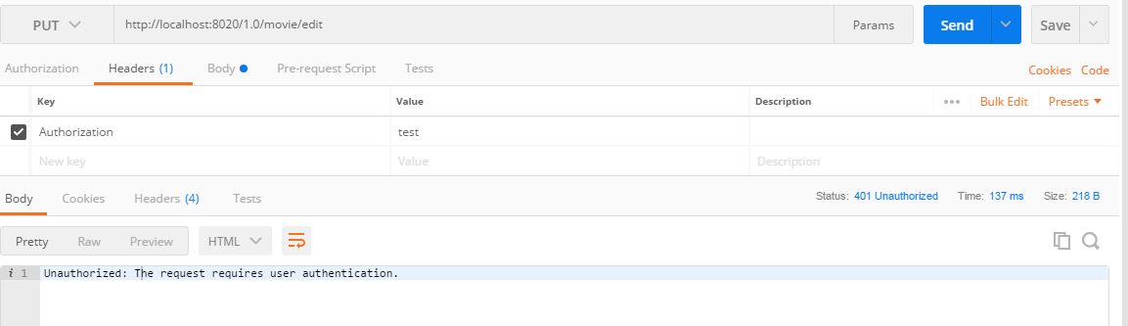

Result of API for deleting movie on access level.

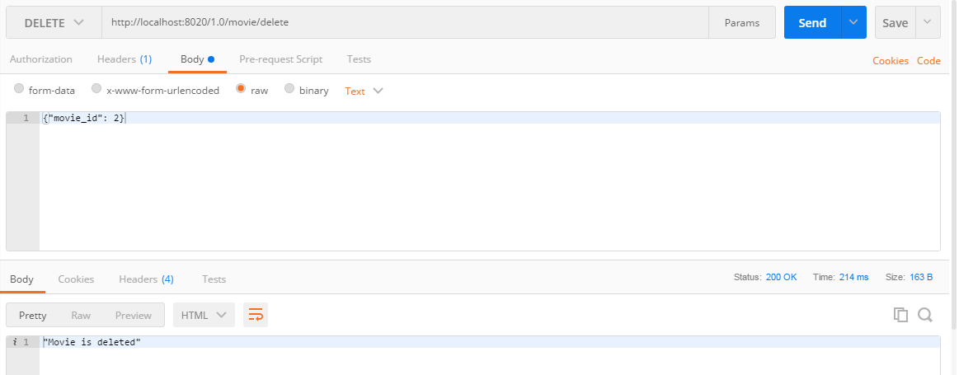

Result of API for deleting movie when the user (i.e. test) does not have the access.

