# MEGAeBin

# Terms & Conditions

Last Updated: September 15, 2015

Please read these Terms and Conditions “Terms” carefully before using the <http://www.megaebin.com/> Storage Services website operated by Virtual Stacks Systems, LLC, a Florida corporation (“Virtual Stacks”).

Your access to and use of the online storage site is conditioned on your acceptance of and compliance with these Terms. These Terms apply to all visitors, users and others who access or use the online storage site.

By accessing or using MEGAeBin, you agree to be bound by these Terms. If you disagree with any part of the Terms then you may not access the storage services.

**Termination**

We may terminate or suspend access to our Service immediately, without prior notice or liability, for any reason whatsoever, including without limitation if you breach the Terms. All provisions of the Terms which by their nature should survive termination shall survive termination, including, without limitation, ownership provisions, warranty disclaimers, indemnity and limitations of liability.

**Links to Other Web Sites**

Our Service may contain links to third-party web sites or services that are not owned or controlled by Virtual Stacks Systems™, Inc.

Virtual Stacks Systems™, Inc has no control over, and assumes no responsibility for, the content, privacy policies, or practices of any third party web sites or services. You further acknowledge and agree that Virtual Stacks Systems™ shall not be responsible or liable, directly or indirectly, for any damage or loss caused or alleged to be caused by or in connection with use of or reliance on any such content, goods or services available on or through any such websites or services.

We strongly advise you to read the terms and conditions and privacy policies of any third-party web sites or services that you visit.

**Governing Law**

These Terms shall be governed and construed in accordance with the laws of the United States of America, without regard to its conflict of law provisions.

Our failure to enforce any right or provision of these Terms will not be considered a waiver of those rights. If any provision of these Terms is held to be invalid or unenforceable by a court, the remaining provisions of these Terms will remain in effect. These Terms constitute the entire agreement between us regarding our Service, and supersede and replace any prior agreements we might have between us regarding the Service.

We reserve the right, at our sole discretion, to modify or replace these Terms at any time. If a revision is material we will try to provide at least a 15 day notice prior to any new terms taking effect. What constitutes a material change will be determined at our sole discretion.

By continuing to access or use our Service after those revisions become effective, you agree to be bound by the revised terms. If you do not agree to the new terms, please stop using MEGAeBin.

Contact Us

If you have any questions about these Terms and Conditions, please contact us.

# **MEGAeBin Privacy Policy**

Posted: September 15, 2015

Welcome and thank you for applying MEGAeBin! As your information and shared files are securely gathered and managed, we lay it all out here how we do it with your privacy in mind.

It is important to Virtual Stacks Systems, LLC., a Florida corporation (“Virtual Stacks”) to help our customers retain their privacy when they take advantage of all the Internet has to offer. Your privacy is important to you and to us. To protect your privacy, Virtual Stacks follows different principles in accordance with worldwide practices for customer privacy and data protection. Virtual Stacks may change this privacy policy from time to time by updating this page. You should check this page from time to time to ensure that you are happy with any changes. This privacy policy is effective from September 15, 2015. Virtual Stacks won’t sell or give away your name, mail address, phone number, email address or any other information concerning your privacy to anyone. Virtual Stacks uses security measures to protect your information from unauthorized users.

## **NOTICE**

MEGAeBin will ask you when we need information that personally identifies you (personal information) or allows us to contact you. Generally, this information is requested when you, engage Virtual Stacks, create a Registration ID on the site or when you download free software, enter a contest, order email newsletters or join a limited-access premium site. We use your privacy concerned Personal Information for four primary purposes: To make the site easier for you to use by not having to enter information more than once. To help you quickly find software, services or information. To help us create content most relevant to you. To alert you to product upgrades, special offers, updated information and other new services from Virtual Stacks.

## **CONSENT**

If you choose not to register or provide personal information, you may not be able to use many of our services and you will not be able to access areas that require registration. If you decide to register, you will be able to select the kinds of information you want to receive from us by subscribing to various services, like our electronic newsletters. If you do not want us to communicate with you about other offers regarding Virtual Stacks products, programs, events, or services by email, postal mail, or telephone, you may select the option stating that you do not wish to receive marketing messages from MEGAeBin. MEGAeBin occasionally allows other companies to offer our registered customers information about their products and services, using postal mail only. If you do not want to receive these offers, you may select the option stating that you do not wish to receive marketing materials from third parties.

## **ACCESS**

We will provide you with the means to ensure that your personal information is correct and current. You may review and update this information at any time at the Visitor Center. There, you can: View and edit personal information you have already given us. Tell us whether you want us to send you marketing information, or whether you want third parties to send you their offers by postal mail. Sign up for electronic newsletters about our services and products. Register. Once you register, you should not need to do it again. Wherever you go on Virtual Stacks, your information stays with you.

## **SECURITY**

Virtual Stacks has taken measures to protect the security of your personal information and to ensure that your choices for its intended use are honored. We take strong precautions to protect your data from loss, misuse, unauthorized access or disclosure, alteration, or destruction. We guarantee your e-commerce transactions to be 100% safe and secure. When you place orders or access your personal account information, you're utilizing secure server software SSL, which encrypts your privacy concerned information before it's sent over the Internet. SSL is one of the safest encryption technologies available. In addition, your transactions are guaranteed under the Fair Credit Billing Act. This Act states that your bank cannot hold you liable for more than $50.00 in fraudulent credit card charges. If your bank does hold you liable for $50.00 or less, we'll cover your liability provided the unauthorized, fraudulent use of your credit card resulted through no fault of your own and from purchases made from us over our secure server. In the event of unauthorized use of your credit card, you must notify your credit card provider in accordance with its reporting rules and procedures. Virtual Stacks protects your privacy and honors your choices for its intended use. We carefully protect your data from loss, misuse, unauthorized access or disclosure, alteration, or destruction. Your personal information is never shared outside the company without your permission, except under conditions explained above. Inside the company, data is stored in password-controlled servers with limited access. You also have a significant role in your information privacy. No one can see or edit your personal information without knowing your username and password, so do not share these with others.

## **NOTICE TO PARENTS**

Parents or guardians: we want to help you guard your children's privacy. We encourage you to talk to your children about safe and responsible use of their Personal Information while using the Internet. MEGAeBin’s site does not publish content that is targeted to children.

## **ENFORCEMENT**

If for some reason you believe MEGAeBin has not adhered to these principles, please notify us by email at info@megaebin.com, and we will do our best to determine and correct the problem promptly. Be certain the words Privacy Policy are in the Subject line.

## **ELECTRONIC PRODUCT REGISTRATION**

When you buy and install a new product, we may ask you to register your purchase electronically. When you do, we merge your registration information with any information you've already left with us (we call that information your personal profile). If you haven't previously registered with us, we create a personal profile for you from your product registration information. If you ever want to review or update that information, you can visit the Profile Center, click on Update Profile, and edit any of the Personal Information in your profile. If you haven't already created a Registration ID, we will ask you to do so. This ensures that only you can access your information.

## **CUSTOMER PROFILES**

As mentioned above, every registered customer has a unique personal profile. Each profile is assigned a unique personal identification number, which helps us ensure that only you can access your profile. When you register, we create your profile, assign a personal identification number, and then send this personal identification number back to your hard drive in the form of a cookie, which is a very small bit of code. This code is uniquely yours. It is your passport to seamless travel across our website, allowing you to download free software, order free newsletters, and visit premium sites without having to fill out registration forms with information you've already provided. Even if you switch computers, you won't have to re-register – just use your Registration ID to identify yourself.

## **WHAT WE DO WITH THE INFORMATION YOU SHARE**

When you join us, you provide us with your contact information, including your email address. We use this information to send you updates about your order, questionnaires to measure your satisfaction with our service and announcements about new and exciting services that we offer. When you order from us, we ask for your credit card number and billing address. We use this information only to bill you for the product(s) you order at that time. For your convenience, we do save billing information in case you want to order from us again, but we don't use this information again without your permission. We occasionally hire other companies to provide limited services on our behalf, including packaging, mailing and delivering purchases, answering customer questions about products or services, sending postal mail and processing event registration. We will only provide those companies the information they need to deliver the service, and they are prohibited from using that information for any other purpose. Virtual Stacks will disclose your privacy concerned personal information, without notice, only if required to do so by law or in the good faith belief that such action is necessary to: (a) conform to the edicts of the law or comply with legal process served on MEGAeBin or the site; (b) protect and defend the rights or property of Virtual Stacks and its family of websites, and, (c) act in urgent circumstances to protect the personal safety of users of MEGAeBin, its websites, or the public.

## **Blog**

### **I Cloud, They Cloud…Let’s All Cloud!**

September 17, 2015

In the business world, security is key and everyone promises it. Unless they can offer the limitlessness of cloud-based solutions, it’s a moot promise in today’s digital world. Consider the rise in Project Manager organizational infrastructures and then imagine a way to safely store and share files with an entire team and any interdepartmental executives in “the Know”. Hopefully you’re thinking of MEGAeBin!

MEGAeBin is a cloud-based file sharing and storage system brought to you by the brilliant Virtual Stacks Systems™ minds that brought you the [eZnet CRM](http://www.eznetcrm.com/) and the upcoming EZWebshare cloud software. MEGAeBin is the newest edition to the [Virtual Stacks repertoire](http://www.virtualstacks.com/) of top notch cloud hosting and solutions that promise 24/7/365 protection, uptime and accessibility.

### File Sharing

Businesses are increasingly uneasy with the unnerving openness of client data that they’ve agreed to protect via their privacy policies. There is also the matter of internal company information riding along the information highway with little to no guidance and encryption. Look into locking shared documents and media within a vast block of cloud space just your own.

## Accessibility

User-friendly interfaces make retrieving data from within safeguarded accounts an easy convenience. Download documents and media onto any capable device anywhere you are.

### Storage

Utilize up to 20GB with a free account! Choose to upgrade to more storage space with any of MEGAeBin’s storage packages. Storage in cloud software is not only next level, its adoption is becoming more and more a necessity.

### Reliability & Security

An automatic data backup system allows your personal choice of manual or automatic updates. Great perks include:

* Enhanced recovery
* Resilient business practices
* Solid Encryption
* Syncing to administer or partake in data dispersion

MEGAeBin for business is by far an exciting and refreshing choice in cloud-based storage solutions. Register your own account today for free and see all the great benefits to the newest member of the Virtual Stacks Systems™ family!

## **FAQs**

## What exactly is MEGAeBin?

MEGAeBin is a cloud-based file sharing and storage system of top notch applications and solutions that promise 24/7/365 protection, uptime and accessibility.

## How can MEGAeBin benefit my Business?

Security, sharing, and storage are the key benefits MEGAeBin brings any business. The accessibility alone is impressive as it increases efficiency and user satisfaction.

## I’m ready to get started, what should I do first?

First, welcome and thank you for joining the Virtual Stacks™ family! Merely choose a plan and create an account. It’s that simple. Then download and install (Hyperlink to Installation help instructions) MEGAeBin.

## I’ve signed up, now what should I do?

Welcome MEGAeBin rookie, click on My Account and let’s get your account information and profile set up. Create a New Folder for optimal organization. Now start uploading files and choose who you want them shared with.

## How many users can I share my account with?

As many as you want; user count is unlimited!

### Are any files prohibited from MEGAeBin?

Any file over a size of 20MB will not download.

## How often are backups?

Nightly to reduce interruptions in business operation flow.

## How do I move past MEGAeBin user files to a current user?

In the File Manager section, select the folder you want moved and click the Drop-Down arrow action button at the end of the listed Folder. Select Move and enter where it should be moved to.

## What can I share with other users?

You can share both files and entire folders and in turn have either option shared to you.

## Why is sharing files via MEGAeBin so necessary?

It is simple really; security. Share secure content, media and all files externally without fear.

# **Help or Getting Started**

# **Getting Started**

Welcome to MEGAeBin, we’re glad to have you join our cloud family. Let’s get your workflow moving smoother and faster!

Download and install MEGAeBin to your PC and any other devices you will need access from.

Getting started with MEGAeBin is simple and easy to maneuver. Either upload files from your PC or other device or save new files straight to MEGAeBin. You will be able to retrieve and share files form any device you log in from.

Start by choosing which storage plan is best for you and your business operations.



* Create an account. Click the **Sign Up** button.

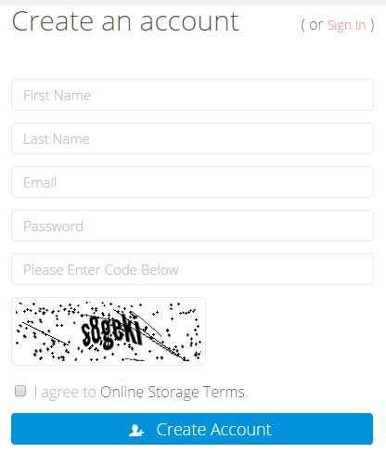

* Once you’ve created an account, log in.



1. Build your MEGAeBin profile by selecting **Profile** from the Drop-Down attached to your name. 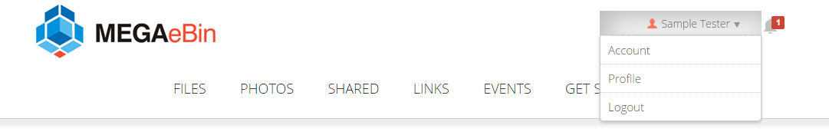

* Enter your credentials. Upload your picture so others can better acknowledge user distinction.

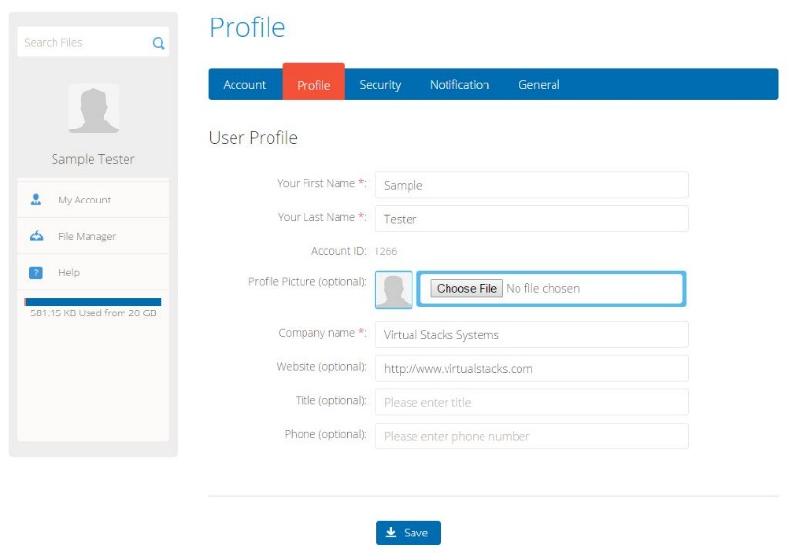

1. Specify your **Security** settings by selecting the tab next to the Profile section.

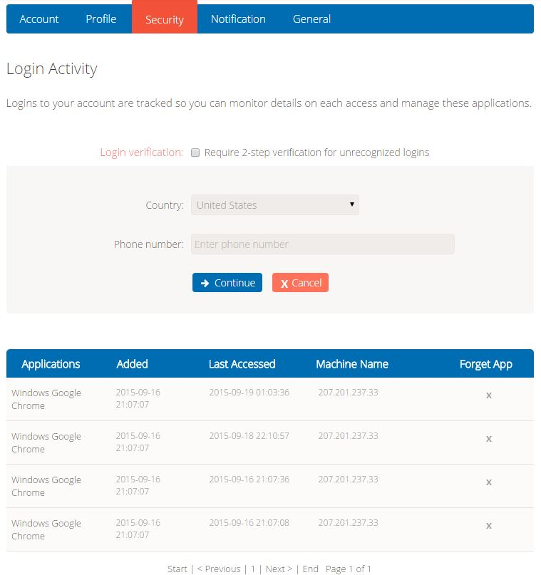

* For extra account security, click the Login Verification box to require additional verification for any unrecognized login devices or attempts.
* Select your business’ Country
* Enter a phone number for users to reach you via phone if you would like the additional communication.

Scroll down to view a log of all Logins.

1. From the **Notification** tab, request an Email Notification whenever your account is almost out of available storage space or when a new device has accessed your MEGAeBin account.

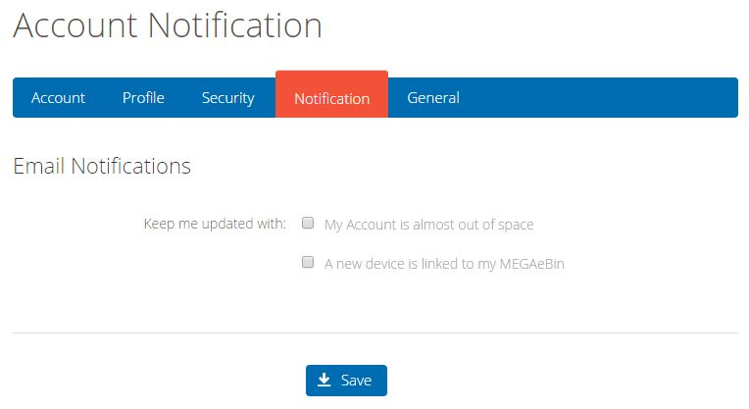

1. For General Information like Time Zone and Language metrics, select the **General** tab.
2. When you are ready to upgrade your storage space and MEGAeBin benefits, enter the **Account** section.

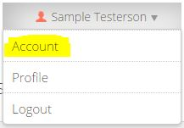

* Select it from the *Drop-Down box attached to your name* or the *My* *Account* section.

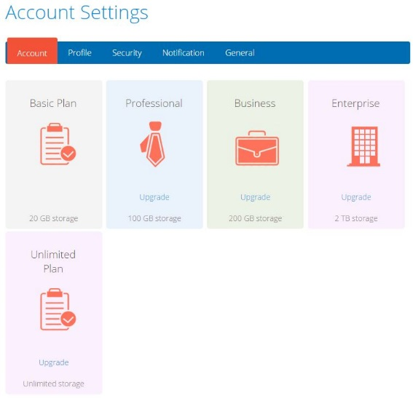

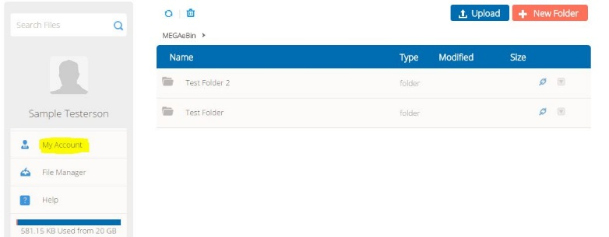

# **Adding Files to MEGAeBin**

There are multiple ways to add files to your MEGAeBin folders. *Folders are private until you choose to share them with others.

1. **Drag & Move** – From your desktop start menu, open the MEGAeBin folder and simply drag files into your computer’s desktop folder for MEGAeBin.
2. **Save As** – While working on files, use the Save As… selection to save the document straight to MEGAeBin folders.
3. **Upload from within MEGAeBin** – Log in to your MEGAeBin account.



* Click the **Upload** button. 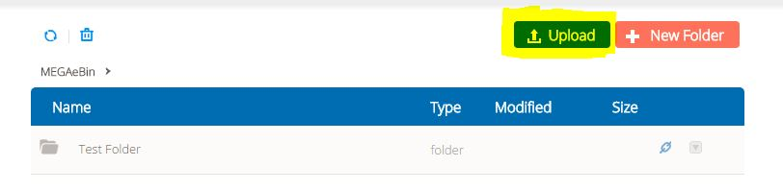
* Browse for and select the file from your computer that you wish to upload.

*Files must be 20GB or smaller. To add larger files, Drag & Move or Save As from the file document.