**Inventory**

**In Add Item**

**If yes is selected display all rows if no is selected only display**

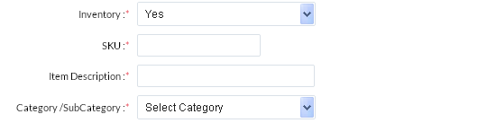



**Model and Generation**

When we select model we need to select generation as well so give the generation box after model (just like model but with geneartion values corresponding to model)

example if a Model A has generation 3.4,5,6 and Model B has generation A,B,C

then when we select model A we will see 3.4,5,6 ion Generation to Select and when we select Model B will have A,B,C to select.

Each model has Generation created in master

**Add Reorder Method(Value will come from reorder master) I dont see it anywhere**

Reorder Level

Min Stock Alert

Max Stock Alert

**These will be dropdown with values that will come from master Dont see master**

if reorder method is selected above then only that box should be available to have a value from the user not all 3

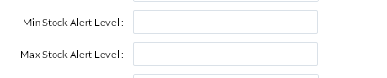

Settings

The list is getting too big can we come up with a better way to display icons?

