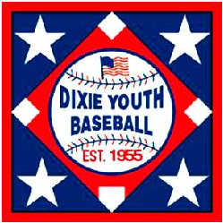
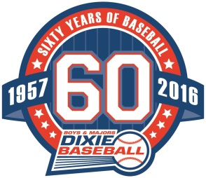

District All-Star Tournament:
* Please note that dates can change due to inclement weather.
*A-Ball (T-ball) (6U) Monday, June 15th – Friday, June 19 , 2015 @ West Seminole Baseball Complex
21 days from completed district to State tournaments
*AA Division (8U) , Monday, June 15th – Friday, June 19 , 2015 @ West Seminole Baseball Complex
21 days from completed district to State tournaments
*AAA Division (10U) Monday, June 22nd – Friday, June 26,, 2015 @ West Volusia Baseball Complex
21 days from completed district to State tournaments
*O-Zone division (12U) Monday, June 15th – Friday, June 19, 2015 @ West Seminole Baseball Complex
28 days from completed district to State tournaments
*Jr. Dixie Boys (13U) Monday, June 22nd – Friday, June 26, 2015 @ West Volusia Baseball Complex
14 days from completed district to State tournaments
*Dixie Boys (14U) Tuesday, June 23rd – Saturday, June 27, 2015 @ West Volusia Baseball Complex
14 days from completed district to State tournaments

Regionals: more information on next pages
Put a team together and join in the FUN!!!

*15U Regionals – June 4th – June 7th @ Sebring High School
Your 14 year olds can play up on the 15U team…no conflicts with district or State games for 14U players

*ages 15-17 Pre-Majors Regionals – July 10th – July 15 @ Marianna, Florida
Same time & location as Jr. Dixie Boys & Dixie Boys (State Tournament)

*ages 15-19 Majors Regionals – July 10th – July 15th @ Marianna, Florida
Same time & location as Jr. Dixie Boys & Dixie Boys (State Tournament)

State Tournaments:
*T-Ball (A-ball) (6U) - Opening day, Friday, July 10th @ Mulberry, Florida
*AA Machine Pitch (8U) - Opening Day, Friday, July 10th @ Sebring, Florida
*AAA (Minors)(10U) - Opening Day, Friday, July 17th @ Franklin County, Florida
*O-Zone (12U) - Opening Day, Friday, July 17th @ Franklin County, Florida
*Jr. Dixie Boys (13U) – Opening Day, Friday, July 10th @ Marianna, Florida
*Dixie Boys (14U) – Opening Day, Friday, July 10th @ Marianna, Florida
World Series: Brackets are posted on the Web Sites
*AA Machine Pitch (8U) – Sunday (Open Day) , August 2nd – Thursday, August 7th @ North Myrtle Beach, S.C.
*AAA (10U) – Friday (Open Day), August 7th – Thursday, August 13th @ Lexington, South Carolina
*O-Zone (12U) Friday (Open Day), August 7th – Thursday, August 13th @ Lexington, S.C.
*Jr. Dixie Boys (13U) Friday (Open Day), July 31 – Wednesday, August 5th @ Aiken, South Carolina
*Dixie Boys (14U) Friday (Open Day), July 31 – Wednesday, August 5th @ Aiken, South Carolina
*************************************************************************************
Regional Champions will advance to the Dixie Baseball World Series Event
Requirements for Entry: Must be a registered Dixie team - $60 per team / $120 minimum.
High School Summer Programs Are Welcome
Regionals:
*15U Regionals – June 4th – June 7th @ Sebring High School

*ages 15-17 Pre-Majors Regionals – July 10th – July 15 @ Marianna, Florida
*ages 15-19 Majors Regionals – July 10th – July 15th @ Marianna, Florida
World Series:
*15U - June 19th – June 21st @ Ozark, Alabama
Dixie Boys District games are not allowed until the completion of 15U games, per Dixie Boys
*************************************************************************************
*ages 15-17 Pre-Majors – July 25th @ Guntersville, Alabama
*ages 15-19 Majors – July 25th @ Ozark, Alabama

- More Information please visit: www.dixie.org/boys or contact
Frank Hagler Ronnie Jackson – Dixie Majors Denise Stallings
State Director Deputy Commissioner 407-509-0492
Dixie Boys & Dixie Majors Executive Board Chairman Asst. State Director
850-319-3858 jhagler@rocktnn.com 862-453-6178 (h) denisestallings44@gmail.com
jhagler@rocktnn.com 863-368-1158 (C)
dixiebbrj@hotmail.com

