Manage supplier change IFSC code to routing number
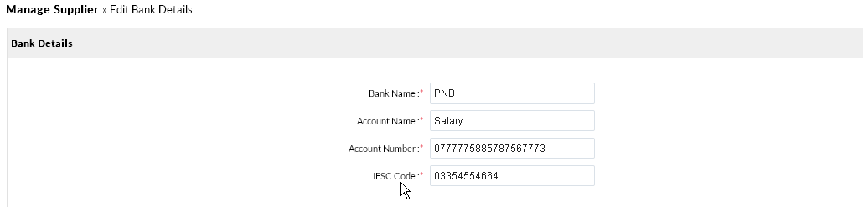
Finance
1. Chart of accounts ->add account
remove account code
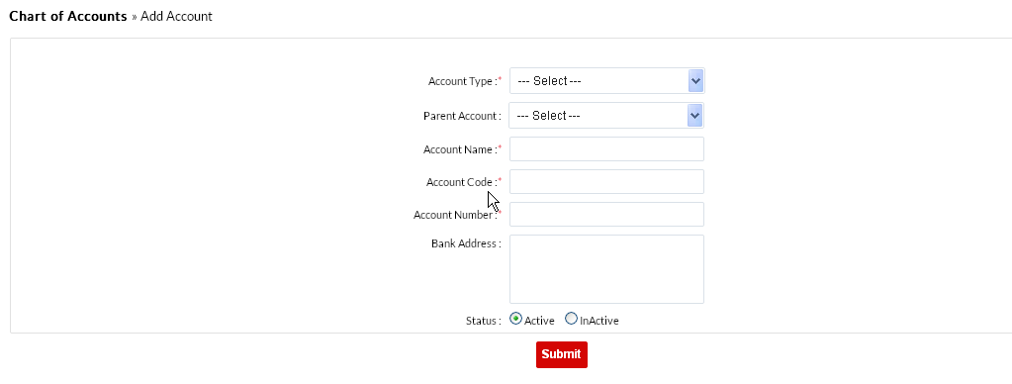
Comments: Development Status: Done, Testing Status: Done

2. Fix spelling
General Journal

Chane menu name other to Journal Entry
Comments: Development Status: Done, Testing Status: Done
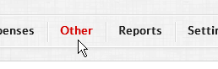

3. Add General Entry
remove Entity rows completeley
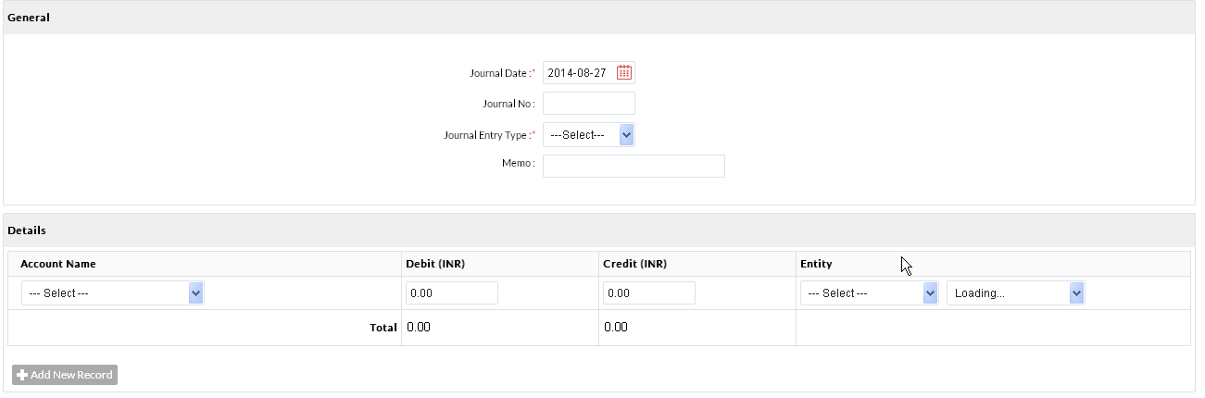
Comments: We will update this but this is an optional(non-mandatory), in future if we want add any General Entry for any customer or supplier then we can use it.

4. For Journal Entry add 2 rows for every entry
instead of 1 by default as one is credit and one is debit
Comments: Development Status: Done, Testing Status: Done

5. Rename Add Record to add rows

Comments: Development Status: Done, Testing Status: Done

6. Payment date in pay invoice should come from the system
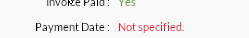
Comments: Not clear(Kindly send complete screen shot)

7. Rename sales in menu to AR
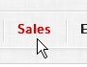
Comments: Development Status: Done, Testing Status: Done

8. Rename Expenses in Menu to AP

Comments: Development Status: Done, Testing Status: Done

9. Other Expenses
After a invoice is entered it doesnt show in purchase payments
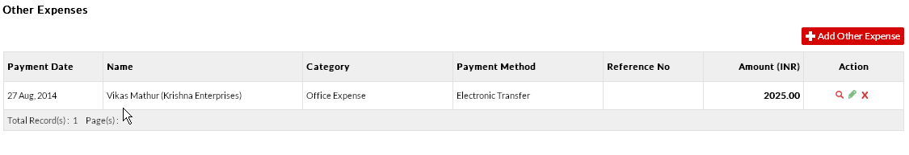
Comments: As per current functionality, on “Payment” page, all the PO's invoices are getting displayed(which comes from “Purchase” section) whether on “Invoice Entry” page, user is doing direct payment to Supplier(its a part of our other expenses). That why we are not showing this Invoice Entry on “Payment” page.
10. Expenses -Other Expenses
rename Other expenses to Invoice entry
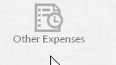
Comments: Development Status: Done, Testing Status: Done

11. Rename Purchase Payments to Payments
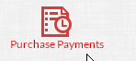
Comments: Development Status: Done, Testing Status: Done

12. In Purchase payments rename Pay invoice to Pay Vendor
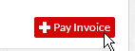
Comments: Development Status: Done, Testing Status: Done

13. When pay invoice is selected we should get a vendor list and selecting a vendor should show all open invoices and we can select all or one by a tick mark or partail pay a invoice by a certain amount in the batch .We should see the total of the invoices being paid in the bottom.
Once the invoices are selected for that vendor we need to specify payment method which we are paying by
1)Check -If check is selected that it should ask what bank we are paying from and also ask what format the check needs to be printed example check ,stub ,stub or stub,check stub etc
Comments: Can we discuss this on Call in detail.

2)elctronic transfer will be a separate discussion
Comments: OK

14. Add other expenses
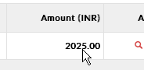
wont take decimal values so cant enter 20.25
Comments: Development Status: Done, Testing Status: Done

15. Sales Payments under sales rename to Cash Reciepts

Comments: Development Status: Done, Testing Status: Done

16. Remove other income from sales
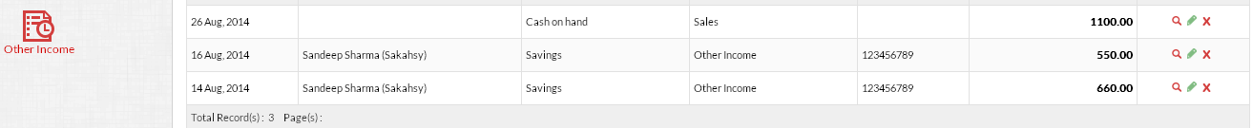
Comments: Development Status: Done, Testing Status: Done

17. Recieve Payments
We need a dropdown for customer ,selecting a customer would give another dropdown as open invoices or GL Account.
Selecting Open invoices will show all open invoices and we can select them one by one and a option to recieve partial payment on a invoice .
Comments: Can we discuss this on Call in detail.

