JMPORTAL 4.0.0版本源代码修改记录

更新包路径
svn://192.168.5.17/document/产品/JMPORTAL/SERVER/code/develop/JMPORTAL4.0.0/Release/update/20181012

需求描述
- 平台升级，支持ipv6，jdk 8
来源 | 产品需求
相关文件 | resources/cache.properties  resources/ehcache.xml  resources/messages_en_US.properties  resources/messages_zh_CN.properties  src/com/hanweb/complat/app/Attach.java  src/com/hanweb/complat/app/SystemMailSender.java  src/com/hanweb/complat/cache/QrcodeCache.java  src/com/hanweb/complat/constant/Settings.java  src/com/hanweb/complat/constant/StaticValues.java  src/com/hanweb/complat/controller/configuration/ConfigurationController.java  src/com/hanweb/complat/controller/configuration/OprEmailController.java  src/com/hanweb/complat/controller/configuration/OprLogInfoController.java  src/com/hanweb/complat/controller/group/ListGroupController.java  src/com/hanweb/complat/controller/group/OprGroupController.java  src/com/hanweb/complat/controller/interfaces/LdapController.java  src/com/hanweb/complat/controller/menu/SysConfigMenuController.java  src/com/hanweb/complat/controller/onlineuser/ListOnlineUserController.java  src/com/hanweb/complat/controller/onlineuser/OprOnlineUserController.java  src/com/hanweb/complat/controller/user/ListUserController.java  src/com/hanweb/complat/controller/user/ModifyPasswordForm.java  src/com/hanweb/complat/controller/user/OprUserController.java  src/com/hanweb/complat/controller/user/OprUserSelfController.java  src/com/hanweb/complat/dao/OutsideUserDAO.java  src/com/hanweb/complat/dao/UserDAO.java  src/com/hanweb/complat/entity/AccessLog.java  src/com/hanweb/complat/entity/SystemEmail.java  src/com/hanweb/complat/entity/User.java  src/com/hanweb/complat/interceptor/CsrfDefInterceptor.java  src/com/hanweb/complat/interceptor/LoginCheckInterceptor.java  src/com/hanweb/complat/interceptor/PwdCheckInterceptor.java  src/com/hanweb/complat/listener/OnlineUserListener.java  src/com/hanweb/complat/service/EmailService.java  src/com/hanweb/complat/service/GroupWsService.java  src/com/hanweb/complat/service/LdapService.java  src/com/hanweb/complat/service/OutsideUserService.java  src/com/hanweb/complat/service/OutSideUserWsService.java  src/com/hanweb/complat/service/UserLoginService.java  src/com/hanweb/complat/service/UserService.java  src/com/hanweb/complat/service/UserWsService.java  src/com/hanweb/complat/task/RestDynamicCodeTask.java  src/com/hanweb/complat/task/TempFileTask.java  src/com/hanweb/interceptor/PermissionInterceptor.java  src/com/hanweb/jmp/apps/controller/manage/PutAppIssueController.java  src/com/hanweb/jmp/cms/controller/matters/MatterMenuController.java  src/com/hanweb/jmp/cms/service/infos/InfoService.java  src/com/hanweb/jmp/interfaces/app/InfoContentController.java  src/com/hanweb/jmp/interfaces/app/OutSideUserController.java  src/com/hanweb/jmp/sys/controller/sites/OprSiteController.java  src/com/hanweb/jmp/sys/service/log/LogService.java  src/com/hanweb/jmp/task/AppSynchronizeTask.java  src/com/hanweb/jmp/util/CacheUtil.java  src/com/hanweb/setup/controller/BaseSetupController.java  src/com/hanweb/setup/controller/DbSetupController.java  src/com/hanweb/setup/controller/LogInOutController.java  src/com/hanweb/setup/interceptor/LoginCheckInterceptor.java  src/com/hanweb/setup/interceptor/PwdCheckInterceptor.java  src/com/hanweb/setup/service/DataInitService.java  src/com/hanweb/setup/service/UpgradeService.java  src/com/hanweb/sso/controller/LogInOutController.java  src/com/hanweb/support/controller/resetpwd/ResetpwdController.java  src/com/hanweb/support/controller/ComponentController.java  src/com/hanweb/support/controller/ErrorController.java  src/com/hanweb/support/controller/LogInOutController.java  src/com/hanweb/support/controller/MainFrameController.java  src/com/hanweb/support/controller/OrgSelectController.java  src/com/hanweb/weather/controller/interfaces/WeatherInterfaceController.java  src/com/hanweb/weather/service/WeatherService.java  WebContent/resources/complat/images/qrcode-bg.png  WebContent/resources/complat/support/login.css  WebContent/ui  WebContent/WEB-INF/config/security/upload.bin  WebContent/WEB-INF/config/component.xml  WebContent/WEB-INF/config/mq.xml  WebContent/WEB-INF/lib/beetl-2.2.5.jar  WebContent/WEB-INF/lib/commons-codec-1.10.jar  WebContent/WEB-INF/lib/commons-net-3.6.jar  WebContent/WEB-INF/lib/commons-pool-1.6.jar  WebContent/WEB-INF/lib/commons-pool2-2.4.2.jar  WebContent/WEB-INF/lib/Dm7JdbcDriver16.jar  WebContent/WEB-INF/lib/fst-1.58.jar  WebContent/WEB-INF/lib/google-auth-1.1.4.jar  WebContent/WEB-INF/lib/hanweb-cache.jar  WebContent/WEB-INF/lib/hanweb-cloudfile-old.jar  WebContent/WEB-INF/lib/hanweb-filter.jar  WebContent/WEB-INF/lib/hanweb-front.jar  WebContent/WEB-INF/lib/hanwebcore.jar  WebContent/WEB-INF/lib/jackson-annotations-2.6.7.jar  WebContent/WEB-INF/lib/jackson-core-2.6.7.jar  WebContent/WEB-INF/lib/jackson-databind-2.6.7.jar  WebContent/WEB-INF/lib/java_memcached-release_2.6.3.jar  WebContent/WEB-INF/lib/jedis-2.8.2.jar  WebContent/WEB-INF/lib/jisex311.jar  WebContent/WEB-INF/lib/json-path-2.2.0.jar  WebContent/WEB-INF/lib/kingbasejdbc4.jar  WebContent/WEB-INF/lib/spring-aop-4.3.16.RELEASE.jar  WebContent/WEB-INF/lib/spring-beans-4.3.16.RELEASE.jar  WebContent/WEB-INF/lib/spring-context-4.3.16.RELEASE.jar  WebContent/WEB-INF/lib/spring-core-4.3.16.RELEASE.jar  WebContent/WEB-INF/lib/spring-expression-4.3.16.RELEASE.jar  WebContent/WEB-INF/lib/spring-jdbc-4.3.16.RELEASE.jar  WebContent/WEB-INF/lib/spring-test-4.3.16.RELEASE.jar  WebContent/WEB-INF/lib/spring-tx-4.3.16.RELEASE.jar  WebContent/WEB-INF/lib/spring-web-4.3.16.RELEASE.jar  WebContent/WEB-INF/lib/spring-webmvc-4.3.16.RELEASE.jar  WebContent/WEB-INF/lib/xmemcached-2.4.0.jar  WebContent/WEB-INF/lib/zxing-core-2.2.jar  WebContent/WEB-INF/lib/zxing-javase-2.2.jar  WebContent/WEB-INF/pages/complat/configuration/config_menu.jsp  WebContent/WEB-INF/pages/complat/configuration/configuration_opr.jsp  WebContent/WEB-INF/pages/complat/configuration/email_opr.jsp  WebContent/WEB-INF/pages/complat/configuration/log_opr.jsp  WebContent/WEB-INF/pages/complat/user/user_list.jsp  WebContent/WEB-INF/pages/complat/user/user_modify_password.jsp  WebContent/WEB-INF/pages/complat/user/user_modify_self.jsp  WebContent/WEB-INF/pages/complat/user/user_opr.jsp  WebContent/WEB-INF/pages/setup/basesetup.jsp  WebContent/WEB-INF/pages/setup/dbsetup.jsp  WebContent/WEB-INF/pages/setup/login.jsp  WebContent/WEB-INF/pages/support/error/603.jsp  WebContent/WEB-INF/pages/support/error/error.jsp  WebContent/WEB-INF/pages/support/orgselect/orgselect_order.jsp  WebContent/WEB-INF/pages/support/attachment.jsp  WebContent/WEB-INF/pages/support/login.jsp  WebContent/WEB-INF/pages/support/upload.jsp  WebContent/WEB-INF/tag/hanweb-front-tags.tld  WebContent/WEB-INF/tag/hanweb-tags.tld  WebContent/WEB-INF/templates/front/grid-end.html  WebContent/WEB-INF/templates/front/grid-start.html  WebContent/WEB-INF/templates/grid.ftl  WebContent/WEB-INF/templates/multifile_upload.html  WebContent/WEB-INF/templates/systeminfo.ftl  WebContent/WEB-INF/ipsite.dat  WebContent/WEB-INF/springMVC-servlet.xml  WebContent/WEB-INF/web.xml
开发思路 | 升级产品更新包
修改人 | 刘国钦
- 信息同步优化
来源 | 产品需求
相关文件 | src/com/hanweb/jmp/cms/controller/cols/ColMenuController.java 控制栏目树模块  src/com/hanweb/jmp/cms/controller/cols/ListColController.java 栏目列表  src/com/hanweb/jmp/cms/controller/cols/OprColController.java 栏目逻辑  WebContent/WEB-INF/pages/jmp/cms/cols/col_list.jsp 栏目页面  WebContent/WEB-INF/pages/jmp/cms/cols/col_opr.jsp 栏目逻辑  WebContent/WEB-INF/pages/jmp/cms/cols/col_selectApp.jsp 栏目绑定应用
开发思路 | 升级产品更新包  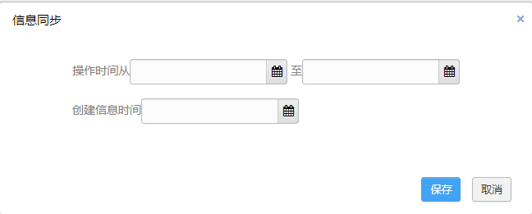  信息栏目同步新增创建信息时间，用于从创建时间角度删选信息  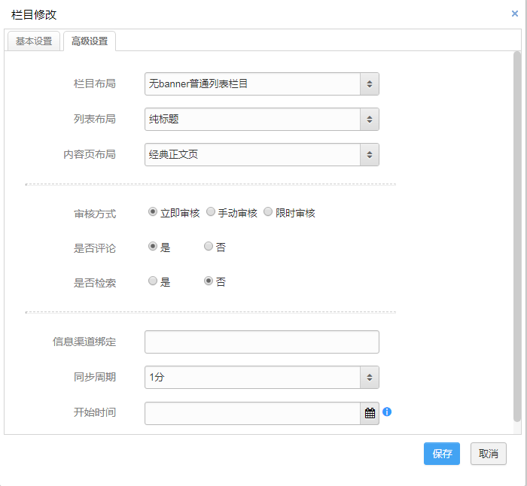  信息栏目，信息渠道绑定优化，解决同时绑定多个渠道时信息树错乱问题  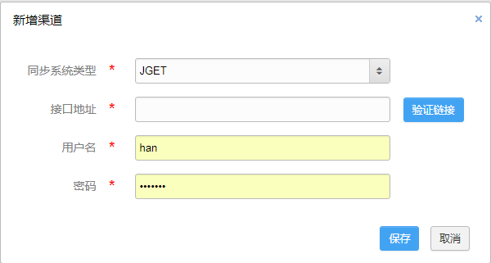  渠道模块支持接口地址相同
修改人 | 韩振振
- 支持多应用
来源 | 产品需求
相关文件 | src/com/hanweb/jmp/apps/controller/manage/ListLightAppController.java 应用list  src/com/hanweb/jmp/apps/controller/manage/ListLightAppForColController.java 应用对于栏目list  WebContent/WEB-INF/pages/jmp/cms/cols/col_selectApp.jsp 多选应用页面
开发思路 | 升级产品更新包  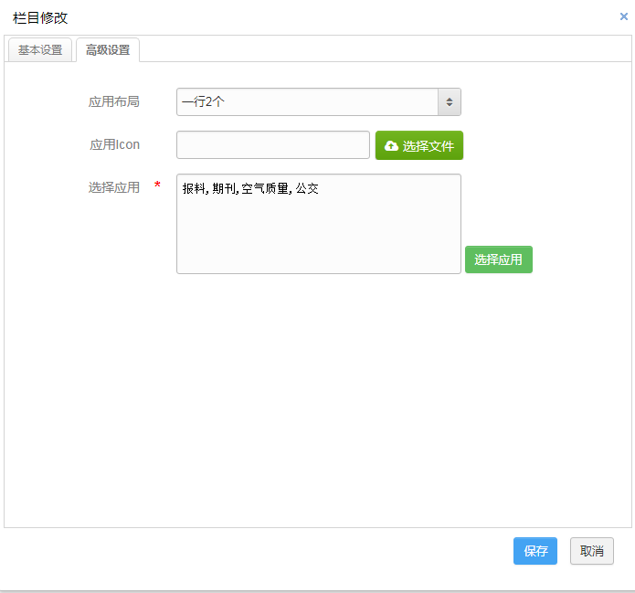  应用栏目支持选择多应用
修改人 | 韩振振

- 个人所得税查询
来源 |  | 产品需求
相关文件 |  | WebContent/resources/lightapps/apps/income_tax个人所得税查询轻应用
开发思路 |  | 升级产品更新包  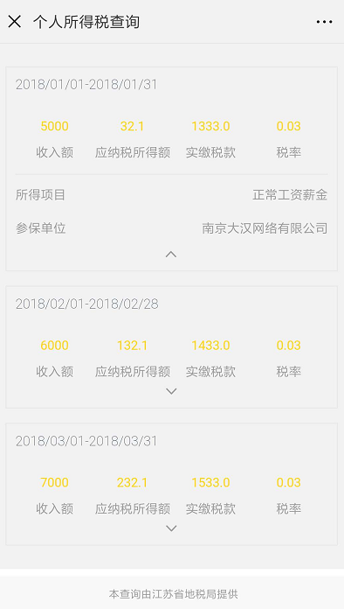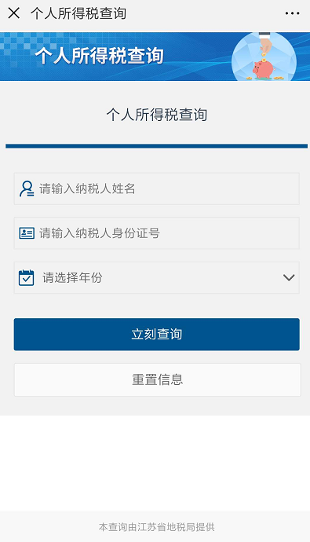
修改人 |  | 李庆
- 社保查询
来源 |  | 产品需求
相关文件 |  | WebContent/resources/lightapps/apps/social_security 社保查询轻应用
开发思路 |  | 升级产品更新包  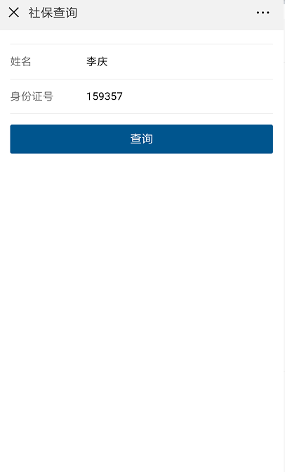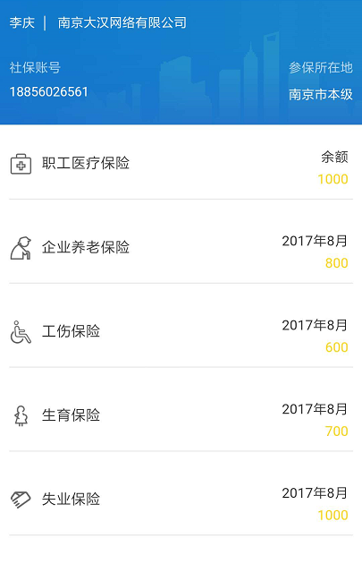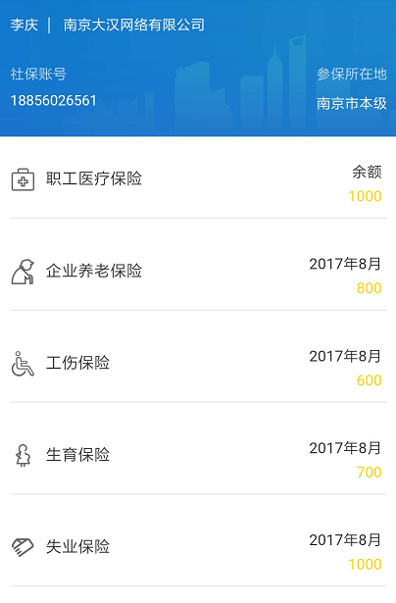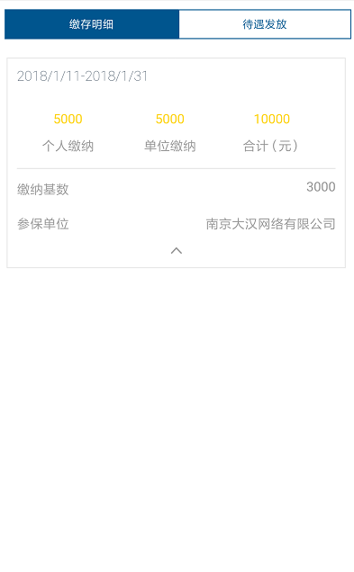
修改人 |  | 李庆
- 公积金查询
来源 |  | 产品需求
相关文件 |  | WebContent/resources/lightapps/apps/accumulation_money 公积金查询轻应用
开发思路 |  | 升级产品更新包  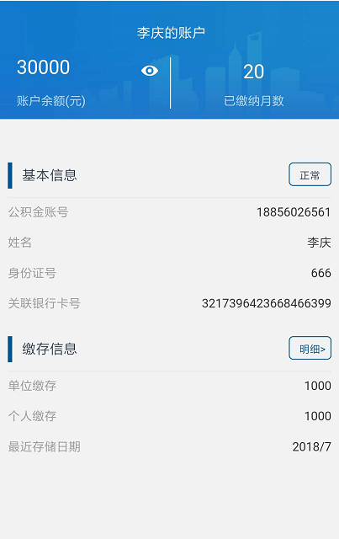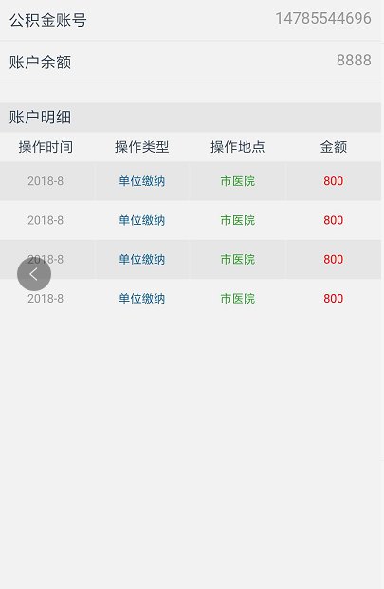
修改人
- 天气轻应用
来源 |  | 产品需求
相关文件 |  | WebContent/resources/lightapps/apps/weather 天气轻应用
开发思路 |  | 升级产品更新包  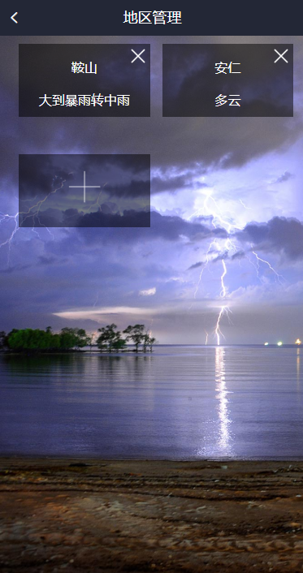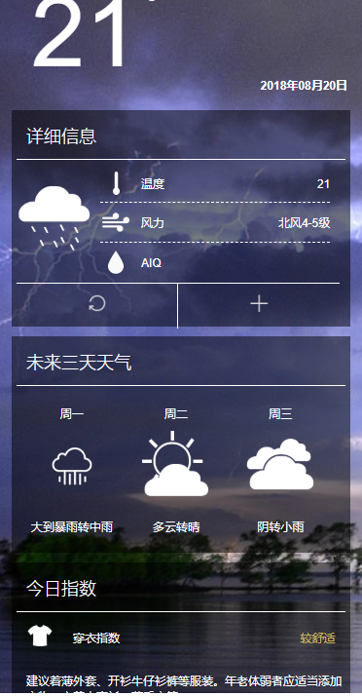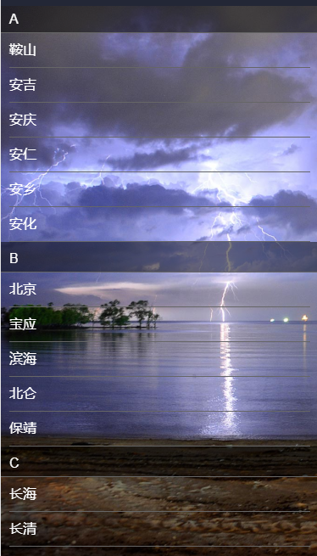
修改人 |  | 李庆
- 爆料轻应用
来源 |  | 产品需求
相关文件 |  | WebContent/resources/lightapps/apps/rebellion 爆料轻应用
开发思路 |  | 升级产品更新包  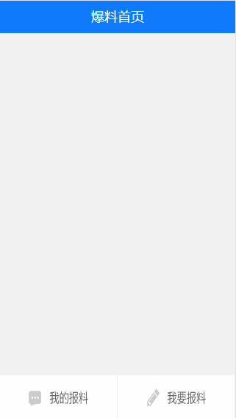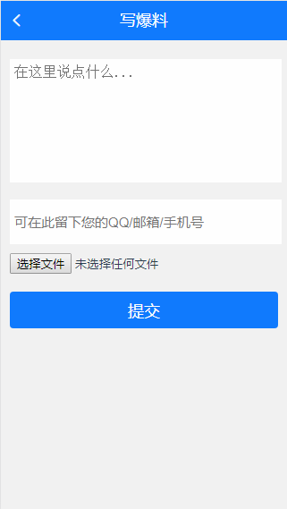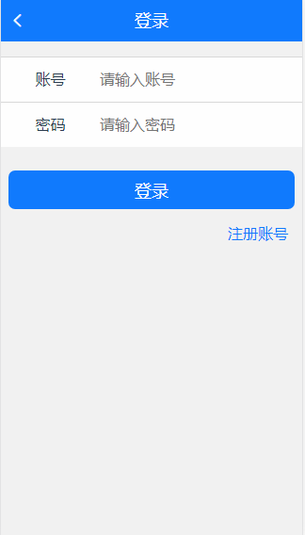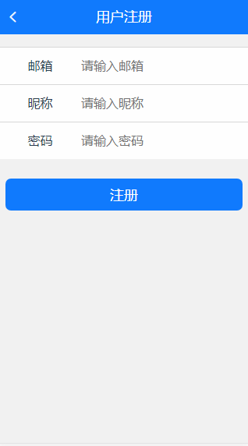
修改人 |  | 李庆
- 公交轻应用
来源 | 产品需求
相关文件 | WebContent/resources/lightapps/apps/bus 公交轻应用
开发思路 | 升级产品更新包  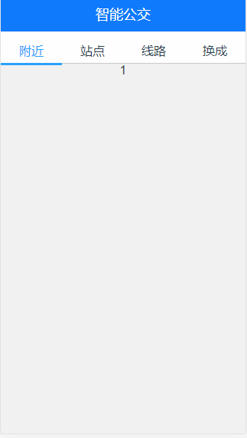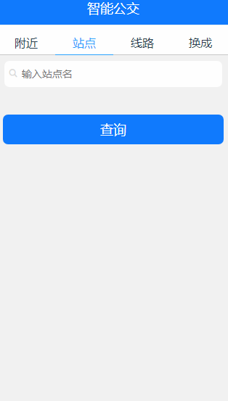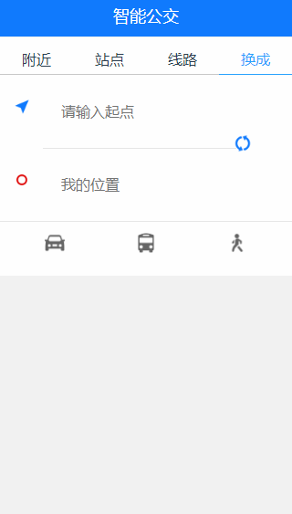
修改人 | 李庆

- 接口管理
来源 | 产品需求
相关文件 | src/com/hanweb/jmp/interfacesmanage/controller/ListInterfaceController.java src/com/hanweb/jmp/interfacesmanage/controller/OprInterfaceController.java  src/com/hanweb/jmp/interfacesmanage/menu/InterfaceMenuController.java  WebContent/WEB-INF/pages/jmp/interfacesmanage/interface_list.jsp  WebContent/WEB-INF/pages/jmp/interfacesmanage/interface_opr.jsp  WebContent/WEB-INF/pages/jmp/interfacesmanage/interface_menu.jsp  WebContent/WEB-INF/pages/jmp/interfacesmanage/interfaces_configure.jsp
开发思路 | 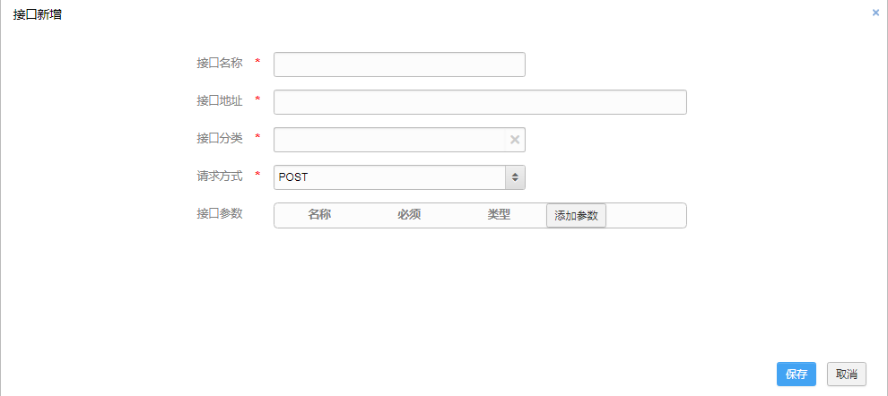  新增接口，get请求接口写到.do，默认post请求。参数与值点击添加参数添加  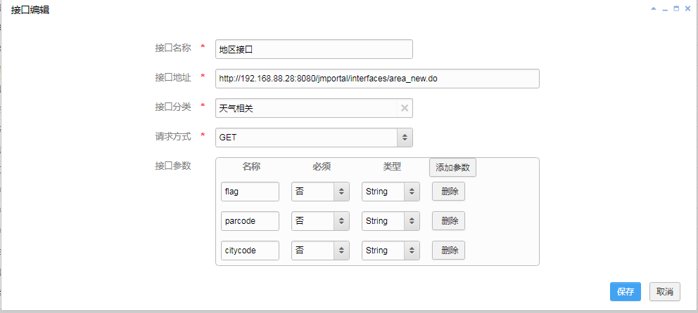  修改接口。
修改人 | 李宁

- 接口分类
来源 | 产品需求
相关文件 | src/com/hanweb/jmp/interfacesmanage/controller/ListInterfacsTypeController.java  src/com/hanweb/jmp/interfacesmanage/controller/OprInterfacsTypeController.java  src/com/hanweb/jmp/interfacesmanage/menu/InterfacesTypeMenuController.java  WebContent/WEB-INF/pages/jmp/interfacesmanage/interfaceType_list.jsp  WebContent/WEB-INF/pages/jmp/interfacesmanage/interfaceType_opr.jsp  WebContent/WEB-INF/pages/jmp/interfacesmanage/interfaceType_menu.jsp
开发思路 | 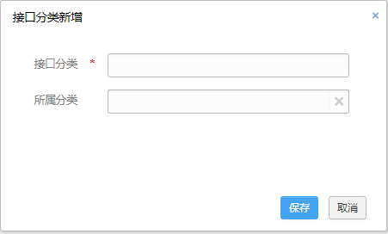  新增接口分类。  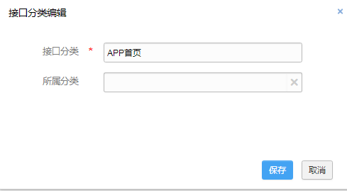  修改接口分类
修改人 | 李宁
- 信息同步优化
来源 | 产品需求
相关文件 | src/com/hanweb/jmp/cms/controller/cols/ColMenuController.java 控制栏目树模块  src/com/hanweb/jmp/cms/controller/cols/ListColController.java 栏目列表  src/com/hanweb/jmp/cms/controller/cols/OprColController.java 栏目逻辑  WebContent/WEB-INF/pages/jmp/cms/cols/col_list.jsp 栏目页面  WebContent/WEB-INF/pages/jmp/cms/cols/col_opr.jsp 栏目逻辑  WebContent/WEB-INF/pages/jmp/cms/cols/col_selectApp.jsp 栏目绑定应用
开发思路 | 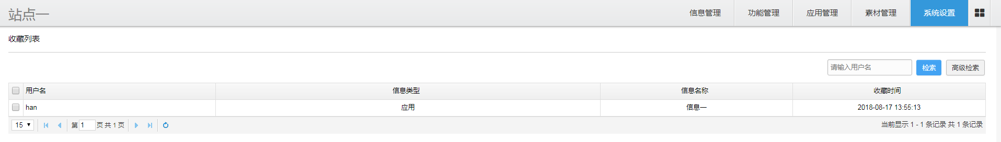  收藏管理模块，主要是展示用户收藏应用和信息的列表页，支持高级检索，目前数据的增删等功能仅支持客户端收藏与取消收藏
修改人 | 韩振振
- 消息推送
来源 | 产品需求
相关文件 | 修改src/com/hanweb/complat/constant/Tables.java  修改src/com/hanweb/complat/controller/role/ListRoleController.java  修改src/com/hanweb/complat/controller/user/OprUserController.java  修改src/com/hanweb/complat/dao/UserDAO.java  修改src/com/hanweb/complat/service/UserService.java  新增src/com/hanweb/jmp/apps/controller/allcount/TotalController.java  修改src/com/hanweb/jmp/cms/controller/infos/info/ListInfoController.java  修改src/com/hanweb/jmp/cms/controller/infos/info/OprInfoController.java  修改src/com/hanweb/jmp/cms/dao/infos/InfoDAO.java  修改src/com/hanweb/jmp/cms/entity/infos/Info.java  修改src/com/hanweb/jmp/cms/service/infos/InfoService.java  修改src/com/hanweb/jmp/constant/Configs.java  新增src/com/hanweb/jmp/constant/ErrorCode.java  修改src/com/hanweb/jmp/constant/Tables.java  修改src/com/hanweb/jmp/global/entity/PushThread.java  修改src/com/hanweb/jmp/global/service/XgPushService.java  新增src/com/hanweb/jmp/newspush下所有文件  修改src/com/hanweb/jmp/sys/controller/configuration/ConfigController.java  修改src/com/hanweb/jmp/task/PushTask.java  修改src/com/hanweb/support/controller/MainFrameController.java  修改src/com/hanweb/support/controller/OrgSelectController.java  新增WebContent/resources/jmp/html/shareinfo.html  新增WebContent/WEB-INF/pages/complat/user/user_show.jsp  修改WebContent/WEB-INF/pages/jmp/cms/infos/info_list.jsp  修改WebContent/WEB-INF/pages/jmp/cms/infos/push_opr.jsp  新增WebContent/WEB-INF/pages/jmp/newspush下所有文件  修改WebContent/WEB-INF/pages/support/orgselect/orgselect.jsp  修改WebContent/WEB-INF/springxml/project/common.xml  修改WebContent/WEB-INF/springxml/project/dao.xml  修改WebContent/WEB-INF/springxml/project/service.xml
开发思路 | 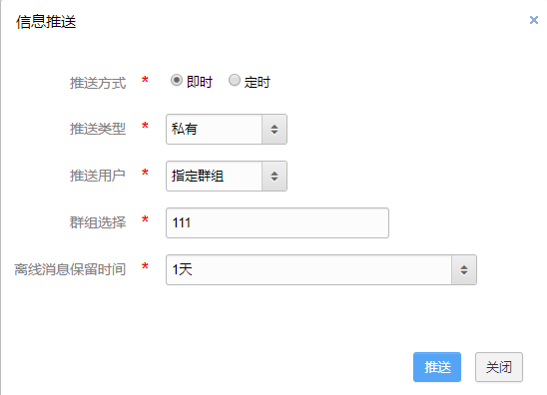
修改人 | 王建卫
- 消息管理
来源 | 产品需求
相关文件 | 新增src/com/hanweb/jmp/newspush/news/controller/ListNewsController.java  新增src/com/hanweb/jmp/newspush/news/controller/NewsMenuController.java  新增WebContent/WEB-INF/pages/jmp/newspush/news
开发思路 | 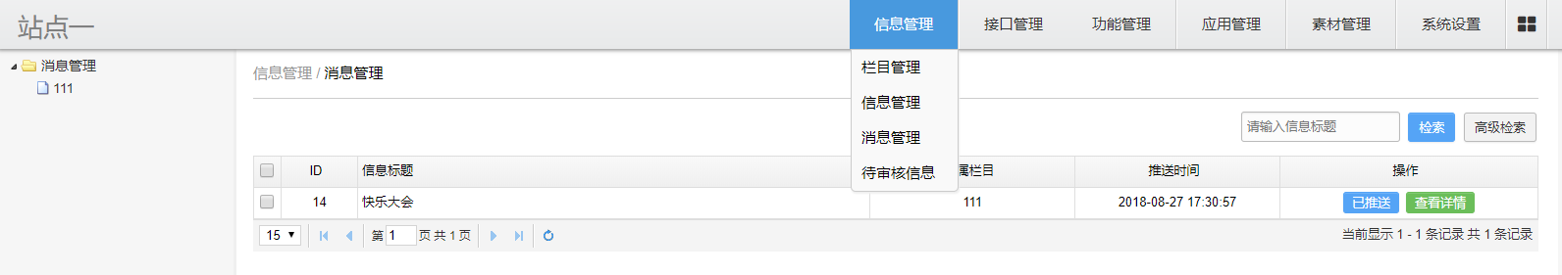
修改人 | 王建卫

BUG
- Jmportal栏目修改完成时保存报错
来源 | 产品缺陷_山东省政务服务综合APP
相关文件 | WebContent/WEB-INF/pages/jmp/cms/cols/col_opr.jsp
开发思路 | 当栏目类型不为信息列表时，提交栏目不验证限制审核时间
修改人 | 王建卫

注意事项
1、此次更新为大版本更新，更新前必须保证当前版本为3.2.2[U4]，并备份好系统文件 (切记！！！)
2、如果你项目中正在使用空气质量、报料、公交以及通讯录这四个应用并做过定制的话，你应该跳过使用说明中的第4步

使用说明
- 删除所有spring开头的jar包，删除所有jackson开头的jar包
- 删除jisex3.1.0.jar、beetl.1.26.02.jar、commons-codec-1.3.jar、Oracle10g-10.2.04.jar、jedis-2.7.0.jar、hanweb-j2cache-1.1.jar
- 删除WebContent/ui/widgets/plupload这个目录
- 删除WebContent/resources/lightapps/apps下 bus目录、mailbook目录、rebellion目录、weather目录
- 注释老版本jar包(jmp-3.2.2.jar)
- 更新更新包中WebContent目录下所有文件
- WebContent/WEB-INF/config/jmportal.properties新增 htpUrl 属性，值为当前域名以”/”结尾，如：http://192.168.88.29:8080/jmporatl4.0.0/
- 清除中间件缓存，启动程序
- 请按以下顺序执行update中的jsp文件
- update.jsp
- update_interfacestype.jsp
- update_interfaces.jsp
- update_interfacesparam.jsp
- update_lightappadd.jsp
- update_lightapp.jsp
- update_app.jsp
- update_col.jsp
- update_col1.jsp
- update_changeJsDomainUrl.jsp
- update_info.jsp
- update_pushthread.jsp
10、清除浏览器缓存

