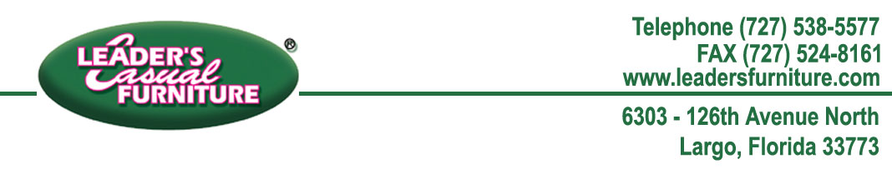

April 21, 2016

Mr. Joseph Rainier

1396 Wellington St.

Tarpon Springs, FL 34689

Dear Mr. Rainier,

Enclosed you will find a gift card in the amount of $299.60 for the value of the chaise lounge that we were not able to repair. You can bring this card into any of our Leader’s Casual Furniture® stores. One of our sales associates would be happy to assist you in making a purchase of items that will work for your lifestyle.

Thank you for giving us the opportunity to make things right for you. If you have any concerns in the future please do not hesitate to contact us.

Sincerely,

Lead Solutions Provider

877-538-5783 (toll free)

727-538-5783 (local)