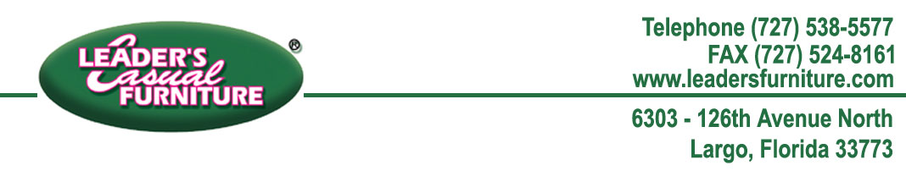

August 1, 2019

Mary Swartz

11354 S Cleveland Ave

Fort Myers FL 33907-2323

Dear Ms. Swartz,

We apologize for any inconvenience you have received from our company. Please accept the enclosed gift card as a token of our appreciation. We invite you to use this gift card towards any merchandise or service at any of our local Leaders Casual Furniture® stores.

You are a valued customer of ours and we look forward to restoring your faith within our company. If you have any concerns please do not hesitate to contact us.

Sincerely,

Lead Solutions Provider

877-538-5783 (toll free)

727-538-5783 (local)