SMART SOLUTIONS FOR ENERGY & GRID · PROBLEM STATEMENT
AI-Powered Renewable Generation Forecasting Platform
Forecasting What the Grid
Is About to Get
Probabilistic 24–72 hour solar and wind forecasting, with a decision layer that turns every forecast into a sized, priced and confidence-rated grid action.

TEAM NAME | ZERO BIAS
TEAM LEAD | KRISH PARMAR
THEME | Renewable energy forecasting · Grid stability · Decision support
APPROACH | Physics-informed hybrid forecasting with calibrated uncertainty
VALIDATION | Belgium (Elia, metered) → India (transfer demonstration)

Technical Proposal · September 2026

Executive Summary
Solar and wind output swings with the weather. Grid operators absorb that uncertainty by holding inflexible fossil generation in reserve — or by curtailing renewables outright. India curtailed 2.1 TWh of renewable electricity in FY 2025-26, and from 1 April 2026 the permitted forecast deviation for solar was halved from ±10% to ±5%. The cost of getting a forecast wrong roughly doubled this financial year.
We forecast regional solar and wind generation 24 to 72 hours ahead, and convert each forecast into a grid action.

Three ideas carry the design
 | Idea | Why it matters
1 | Physics does the deterministic work | A solar plant’s output at 11:00 on 14 March is ~90% determined by sun geometry and clear-sky radiative transfer — exactly computable today, with no training data. We compute it. Machine learning corrects only the residual: soiling, wake losses, local microclimate.
2 | Every forecast is a verified interval | Point forecasts cannot size a reserve. We emit P10/P50/P90 and apply conformal calibration so the 80% band demonstrably covers 80% of outcomes — and we publish the coverage plot that proves it.
3 | The output is an action, not a chart | Operators do not need a curve. They need to know that Tuesday 11:00–14:00 will be 340 MW over-generating with 80% confidence, that the battery absorbs 210 MWh, and what the remainder costs to curtail.

What this buys
Property | Consequence
Low data requirement | The residual is small and structured; the raw signal is large and seasonal.
Cold start | A region with zero generation history gets a usable forecast on day one, from site parameters alone.
Interpretability | SHAP on the residual answers “why is this forecast low?” with low cloud and soiling — not an opaque attribution.
Graceful degradation | If the learned model drifts or fails, the system falls back to physics, not to nothing.
Transferability | Moving to a new grid changes configuration — not the model architecture.

VALIDATION STRATEGY
We validate on Belgium, where metered 15-minute data and the grid operator’s own published day-ahead forecast both exist — so our accuracy claim is measured against a professional operational system rather than a baseline we chose ourselves. We then transfer the identical pipeline to Indian data to show it moves to a new grid in hours. Belgium carries the accuracy claim; India carries the relevance claim. Neither is asked to do the other’s job.

1 Understanding the Problem
“Forecast renewable output” is not one problem. It is five, and they fail in different ways. Naming them separately is what prevents a team from building one monolithic model and calling it a platform.
Sub-problem | The real question | Why it is hard
Weather → resource | Turn a weather prediction into irradiance or hub-height wind at this location | NWP grids are 9–25 km. The error is systematic bias, not noise.
Resource → power | Turn irradiance or wind speed into megawatts | Strongly non-linear: inverter clipping, soiling, wake losses, storm cut-out.
Uncertainty | How wrong might this be, at each hour? | Error is heteroscedastic — near zero at 03:00, very large on a broken-cloud afternoon.
Event detection | Where are the ramps and over-generation windows? | A 2% RMSE gain is worth less than catching one 40% ramp.
Action | Curtail, charge, discharge or commit backup — and why | Needs demand, must-run capacity, storage state and ramp limits.

The horizon decides the method
Forecast skill is governed by which information remains useful at a given lead time. The brief specifies 24–72 hours — which lands squarely in the band where numerical weather prediction is the only meaningful signal.
Horizon | Dominant signal | Past output helps? | Approach
0–30 min | Satellite cloud motion | Strongly | Persistence + advection
30 min – 6 h | Satellite, recent output | Usefully | Smart persistence, boosting on lags
6–72 hours | Weather forecast only | Barely | NWP post-processing
3–14 days | Ensemble NWP, climatology | No | Probabilistic ensemble

THE CONSEQUENCE MOST TEAMS MISS
At lead hour 48, yesterday’s last meter reading carries almost nothing. Any model trained on short autoregressive lags will score brilliantly in a naive backtest and fail completely in deployment, because the backtest leaked information the live system will never have. This reframes the project as NWP post-processing rather than time-series forecasting — the single most consequential decision in this proposal.

The problem, in measured quantities
Measure | Value | Source
Renewable electricity curtailed in India, FY 2025-26 | 2.1 TWh | Ember, June 2026
As a share of total renewable generation | 1.3% | Ember
Peak-hour curtailment of solar and wind, by April 2026 | 4% | Ember
Lost to transmission constraints, Q1 2026 alone | 300 GWh | Ember, 2026
Lost on the single worst day, 30 March 2026 | 34 GWh | Ember
Storage India needs to prevent current curtailment | ~10 GWh | Ember estimate
Permitted solar deviation band, from 1 April 2026 | ±10% → ±5% | CERC DSM
Permitted wind deviation band, from 1 April 2026 | ±15% → ±10% | CERC DSM

34 GWh lost in one day is roughly the daily electricity consumption of five million urban middle-class households. Meanwhile the CERC tolerance mechanism phases to zero by FY 2031, so the financial consequence of forecast error rises every year on a published schedule.

2 Proposed Solution
The core mechanism is a hybrid estimator. A physics engine converts weather to power deterministically using site parameters. A gradient-boosting model never has to learn that job — it sees only what physics got wrong, and predicts that residual at three quantiles.
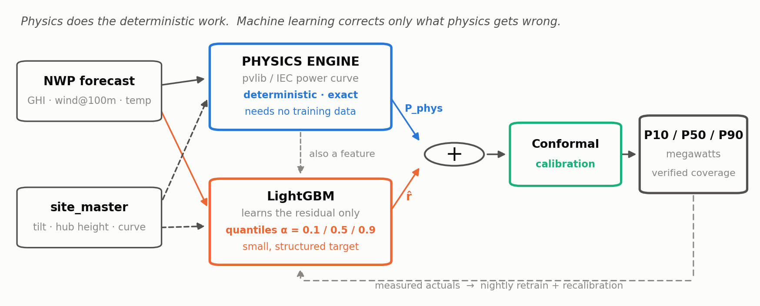
Figure 1 Physics-informed residual learning — the mechanism that earns the accuracy
Remove the physics block and the machine-learning model must re-derive orbital mechanics from a few months of data. Keep it, and the model has a small, structured target: soiling, wake losses, sensor drift, local microclimate.

Why not simply train a deep network end-to-end?
Objection | Response
“Why not an LSTM?” | At 24–72 hour lead, autoregressive lags carry almost no information. This is NWP post-processing, not time-series forecasting. GEFCom2014 — the reference academic competition on exactly this problem — was won by a tree ensemble.
“Isn’t physics too rigid?” | Physics handles only what is genuinely deterministic: sun position, clear-sky radiative transfer, panel geometry, the turbine power curve. Everything atmospheric and asset-specific is learned.
“Does deep learning get benchmarked?” | Yes — as a documented experiment in the final phase. A benchmark showing TFT and N-HiTS losing to gradient boosting on our data is a stronger result than a marginal win, because it proves we measured rather than assumed.

3 Technical Approach

3.1 Data strategy
Three inputs are required and rarely ship together: regional generation history, matching weather, and site parameters. One portal closes the loop — Elia publishes generation, its own forecast, and demand on a single 15-minute timebase with one join key.
Role | Source | What it gives
Solar & wind truth | Elia ods031/032, ods086/087 | Measured MW, monitored capacity, and the operator’s own day-ahead, week-ahead and P10/P90 forecasts
Demand | Elia ods001/002/003 | Measured and forecast total load — this is what makes the decision layer real rather than synthetic
Weather | Open-Meteo (ECMWF, ICON, GFS) | Identical variable names historically and forward, so training and serving cannot diverge. No API key.
Fleet parameters | site_master.yaml (authored) | Archetype rows: tilt, azimuth, hub height, power curve, capacity share
Transfer region | Zenodo 10.5281/zenodo.7824872 | Hourly Indian solar and wind capacity factors, state-level and gridded, 1979–2022, plus installed capacity

Every input is open, free and licence-clear. Nothing in the critical path requires a paid subscription, a commercial key or a data-sharing agreement — which means the result is reproducible by anyone, including an evaluator.

3.2 Regional scale changes the physics layer
A region has no single tilt or hub height, so two adaptations are required:
- Fleet archetypes. site_master becomes a weighted set of representative configurations — for Belgian PV, roughly rooftop-south 35°, rooftop east-west 20° and ground-mount 30°. The physics chain runs per archetype and is summed by capacity share. This is what reproduces the morning shoulder that east-west rooftop arrays produce and a single-tilt model underestimates every day of the year.
- Capacity-weighted weather grid. Weather is sampled at 5–10 coordinates across the region, each weighted by nearby installed capacity. A single centroid systematically misses frontal systems crossing the region. Spatial aggregation is also why regional forecasting is easier than plant forecasting — independent cloud noise partially cancels.

3.3 Feature families
Family | Representative features | Why it earns its place
Solar physics | clearsky_index_kt, poa_global, cell_temperature, thermal_derate, physics_pac_mw, clipping_headroom | Removes the deterministic 90%. The clear-sky index makes January and June comparable.
Wind physics | ws_hub, air_density, ws_density_corrected, power_curve_cf, dP_dv, cut-in/cut-out flags | Power goes as v³ — a 10% wind-speed error is a 33% power error. Density correction alone recovers several points of nRMSE.
NWP quality | lead_hours, model_disagreement, ensemble_spread, nwp_bias_lag_7d, cloud low/mid/high split | These features predict our own error. They are what turns a point forecast into an honest interval.
Temporal | hour_sin/cos, doy_sin/cos, mins_since_sunrise, holiday flags | Cheap. Captures residual diurnal patterns physics misses — fog burn-off, sea breeze, dust.
Autoregressive | power_lag_24h, power_lag_168h, rolling statistics | Slow state only: soiling build-up, partial outages. Lags under 24 hours are excluded as leakage.

THREE DATA TRAPS WE HANDLE BY NAME
Curtailed hours are censored labels — measured output is not what the weather allowed, so training on them teaches the model to under-forecast exactly during the events we exist to predict; we set sample_weight to zero there. Night rows are free accuracy — half a solar series is zeros, so we report daylight-only metrics. Random train/test splits leak, because adjacent hours are near-identical; all evaluation is walk-forward with a gap.

3.4 Model ladder
Each rung must beat the one below it on a held-out window, or be skipped with a stated reason.
# | Method | Role
0 | Persistence & climatology | The floor. Every reported number becomes a skill score against this. Non-negotiable.
1 | Pure physics | Second baseline, later a feature. Works with zero history — this is the cold-start answer.
2 | Gradient boosting (LightGBM) | The workhorse. Seconds to train, handles missing values natively, explainable via SHAP.
3 | Residual learning | Model predicts the physics error, not the raw target. Largest single accuracy gain for the least code.
4 | Quantile regression | Three heads at α = 0.1 / 0.5 / 0.9. Produces the interval the decision layer consumes.
5 | Conformal calibration | Distribution-free finite-sample coverage guarantee. Cheap, and almost nobody does it.
6 | Deep sequence models | N-HiTS, Temporal Fusion Transformer — benchmarked as a documented experiment, not assumed to win.

3.5 Uncertainty, in two stages
- Quantile heads. Three LightGBM models with pinball-loss objectives. This produces intervals whose width varies with conditions — narrow at 03:00, wide on a broken-cloud afternoon. Width is driven by lead time, model disagreement, low cloud, and the power-curve gradient.
- Split-conformal calibration. On a rolling recent window, nonconformity scores adjust the interval so empirical coverage matches nominal coverage — regardless of whether the underlying model is well-specified. We report PICP and publish the reliability diagram.

An 80% band that covers 55% of outcomes is not a conservative forecast. It is a false statement, and it will size reserves wrong.

4 System Architecture
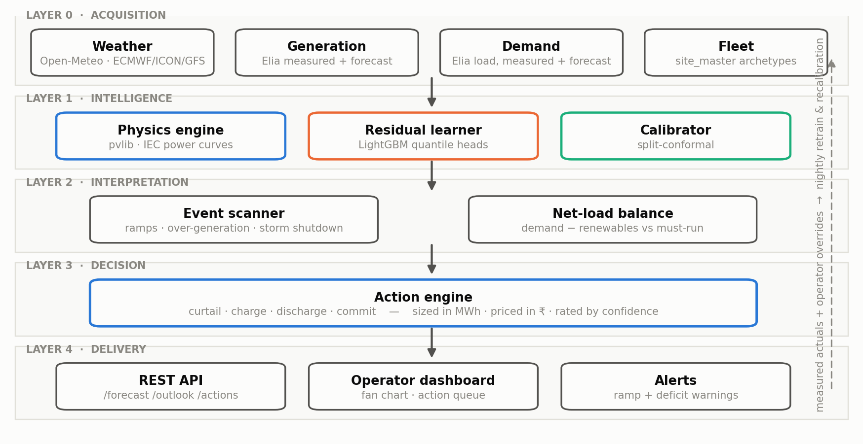
Figure 2 Five-layer platform architecture. The dashed loop is what makes it a platform rather than a notebook.
Measured actuals retrain the residual model nightly and recalibrate the intervals; operator decisions become labelled data. Training and inference call the identical feature code — which structurally removes the most common cause of deployed-model failure.

Module map
Module | Responsibility | Detail
M1 | Ingestion | Source adapters, scheduling, unit and timezone normalisation at the boundary
M2 | Quality | Range checks, frozen-sensor detection, gap filling, curtailment masking
M3 | Feature engine ★ | pvlib chain, shear extrapolation, density correction, power curves, cyclic encoding
M4 | Forecast engine ★ | Baselines, physics model, residual GBDT, multi-horizon fit, model registry
M5 | Uncertainty ★ | Quantile heads, conformal calibration, coverage reporting
M6 | Event scanner | Ramp, over-generation and storm-shutdown detection with lead time and severity
M7 | Decision engine ★ | Net-load balance, storage simulation, ranked and priced actions
M8 | Backtesting | Walk-forward evaluation, skill scores, drift detection, SHAP attribution
M9 | API | /forecast, /outlook, /events, /actions, /backtest — versioned, with provenance
M10 | Dashboard | Fan chart, net-load stack, event timeline, action queue, regional map

★ marks the critical path. Three interface contracts are fixed on day one — build_features, predict and recommend — so the team can work in parallel without collisions.

Decision engine
Two derived quantities drive everything. Net load is demand minus forecast renewables; headroom is net load minus must-run capacity. Negative headroom means the grid physically cannot absorb the renewable output.
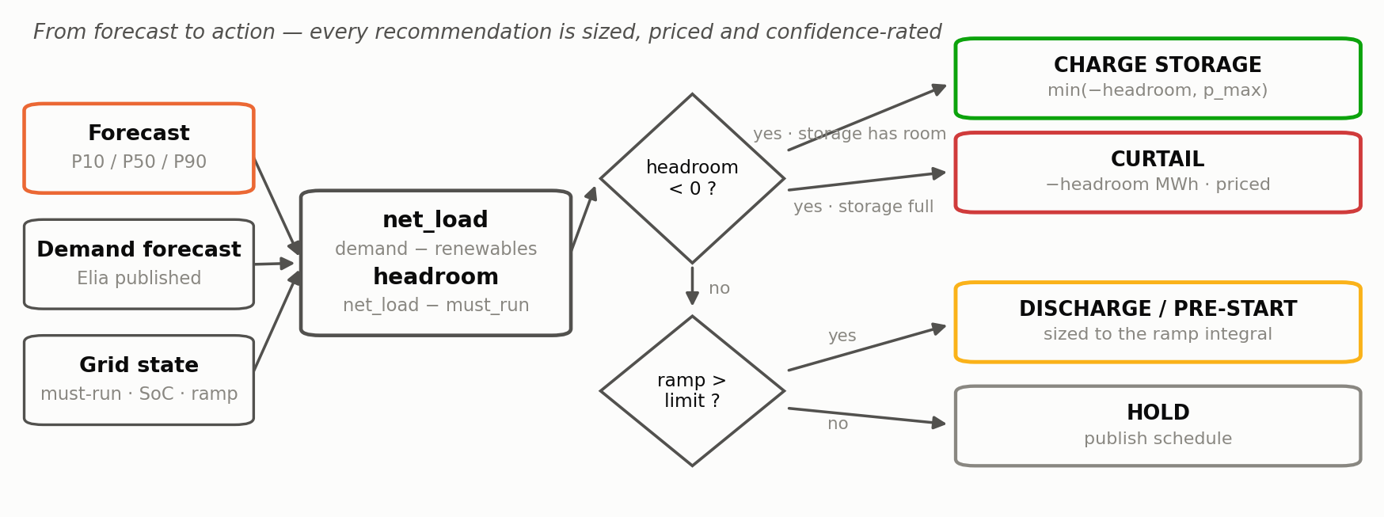
Figure 3 Forecast to action. The P10–P90 band is carried through, so each action inherits the forecast’s confidence.

The virtual battery — a constraint turned into an output
Neither region publishes a usable grid-scale storage dispatch series, so storage is declared in configuration and simulated: energy capacity, power rating, round-trip efficiency, state-of-charge bounds and response time. This is the honest option, and it is more useful than real data would have been — because a configurable battery lets us sweep capacity from 0 to 1000 MWh and answer a question the sector is actively asking: what size battery would this region need?

Technology stack
Layer | Choice | Why
Ingestion & validation | Python, httpx, APScheduler, pandera | Declarative schema contracts that fail loudly at every layer boundary
Storage | Parquet + DuckDB | Columnar, fast, zero-ops; TimescaleDB behind the same interface for production
Physics | pvlib-python, windpowerlib, IEC 61400-12 | Peer-reviewed reference implementations, not hand-rolled approximations
Models | LightGBM (quantile), MAPIE, SHAP, MLflow | Seconds to train, calibrated, explainable, version-tracked
Serving | FastAPI, Pydantic, React, Recharts/D3 | Typed contracts with automatic API documentation

DEPLOYMENT REALITY
The entire stack is open source — no licence cost, no vendor dependency in the critical path. It trains and serves on a laptop with no GPU. That is not just convenient: a system running on commodity hardware can be deployed at a state load dispatch centre without a procurement cycle.

5 Visualisation and Expected Results
The operator-facing output. The upper panel shows solar and wind forecasts with their P10–P90 bands against measured actuals; the lower panel converts them to net load and flags where the grid cannot absorb what is coming.
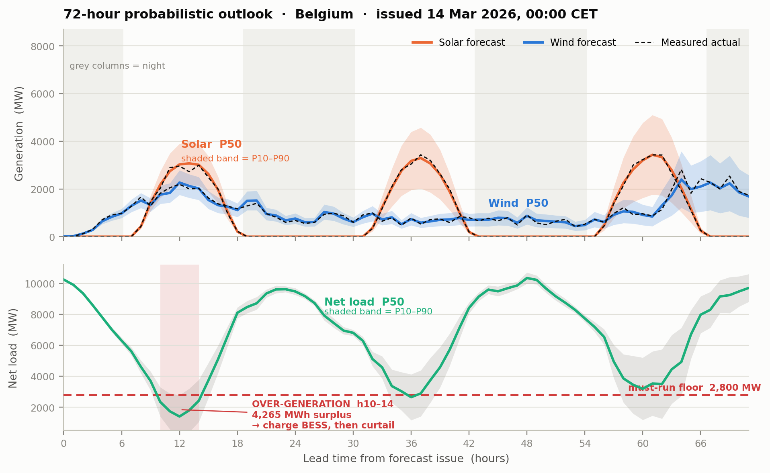
Figure 4 A 72-hour probabilistic outlook. The flagged window is an over-generation event detected two days ahead — charge the battery, then curtail the remainder.
Three things an evaluator should look for in this view: the band widens with lead time and with cloud, because uncertainty is not constant; the actuals stay inside the band, which is what calibration guarantees; and the over-generation window carries a megawatt-hour figure, not just a colour.

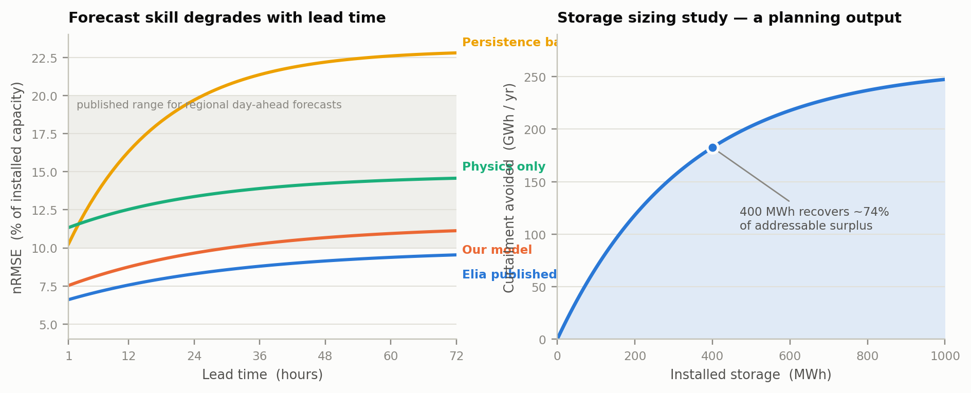
Figure 5 Left: forecast skill against published international benchmarks. Right: the storage sizing study — a planning output, not just an operational one.
The left panel is the chart that demonstrates understanding. A single 72-hour-average error number hides everything; the error-versus-lead-hour curve shows where skill actually comes from, and shows all four lines — persistence, physics-only, our model, and the operator’s own published forecast.

Accuracy targets, and why they are credible
Metric | Target | Basis
Regional solar, day-ahead nRMSE (daylight-only) | 8–13% | Published range for regional day-ahead forecasts is 10–20% of installed capacity
Regional wind, day-ahead nRMSE | 10–15% | Consistent with the 7–19% single-farm MAE band, aggregated
Skill score versus persistence | > 0.40 | Persistence is very weak at 24–72 hours
Gap to Elia’s published day-ahead forecast | within 10–25% | Elia is a professional system with proprietary inputs; parity is not the goal
Coverage of the nominal 80% band (PICP) | 0.78–0.82 | Conformal calibration provides a finite-sample guarantee

These targets are deliberately conservative and falsifiable. A target stated inside a published range, with the range cited, survives questioning. An impressive round number with no provenance does not.

Evaluation protocol — decided before any model is trained
Rule | Reason
Walk-forward splits, never random | Adjacent hours are near-identical; a random split leaks and inflates every number.
Metrics reported per lead hour | A 72-hour average hides where the skill is. The curve is the evidence.
Daylight-only for solar | Half a solar series is zeros. Including them halves the error and means nothing.
Normalised by installed capacity | Comparable across sites and regions of any size.
Matched information cutoff | Elia’s forecast is issued at a fixed time. Comparing against a different issue time is meaningless.
Curtailed intervals excluded | They are censored labels, not weather outcomes.

6 Feasibility and Viability

6.1 Can the data be obtained?
Yes — and this was resolved before any modelling was designed. Every critical input is open, free, licence-clear and confirmed accessible. The one material gap is stated rather than hidden: India does not publish an open, sub-hourly, metered regional renewable series. That is precisely why the two-region design exists.

6.2 Can the accuracy be achieved?
Published benchmark | Value
Day-ahead RMSE, regional aggregates | 10–20% of installed capacity
Single wind farm MAE, terrain-dependent | 7–19%
Mexico — wind: operators versus professional providers | 17% vs 13% MAE
Mexico — solar: operators versus professional providers | 9% vs 6% MAE
Share of world TSOs using centralised regional forecasting | ~80%
Optimal NWP combination | 5–6 models; minimum one global + one regional

Two findings shape our design directly. Error grows nearly linearly with horizon, which validates treating lead time as a first-class feature. And combination forecasts beat single models — our three-model ingest sits at the practical floor of the recommendation. The market-structure finding matters too: a regional, centralised, multi-asset platform is the configuration the sector has converged on.

6.3 Can it be operated?
Dimension | Assessment | Evidence
Compute | Trivial | Full model set trains in under 5 minutes on one CPU core. Inference under 1 second.
Operating cost | Negligible | One small VM. Entire stack open source.
Steady-state effort | Near-unattended | Automated ingestion, nightly retrain and recalibration. Human effort is review, not operation.
Scaling | Configuration only | A new region is a YAML file. No architectural rewrite for more regions, technologies or resolutions.
Engineering risk | Moderate | Archetype weighting is the genuine unknown; mitigated by a clear-sky fitting procedure.

6.4 Regulatory and market fit
The timing is unusually favourable. CERC halved the permitted deviation bands effective 1 April 2026 and is phasing the tolerance mechanism to zero by FY 2031. Forecast accuracy moved from an operational preference to a direct, escalating line item on every renewable generator’s P&L — in the current financial year. State commissions are moving in parallel.
Stated honestly: these regulations face active legal challenge, and the Karnataka High Court has stayed CERC’s revised mechanism. But the direction of travel — tighter tolerances, greater financial consequence for error — is consistent across CERC and multiple state commissions, and the curtailment problem exists regardless of settlement rules. The case does not rest on one regulation.

7 Impact and Benefits
Headline figures below are measured by third parties. Derived figures show their arithmetic and mark their assumptions, so any of them can be recomputed with a different input.

7.1 What better forecasting is worth — measured elsewhere
Study | Finding
NREL, Western U.S. | At 24% wind penetration, a 20% improvement in forecast accuracy yielded USD 195 million in annual operating cost savings.
Berkeley Lab | NWP-based solar forecasts cost USD 1.00/MWh in errors, versus USD 1.50/MWh for persistence — a 33% reduction in error cost.
CENACE, Mexico | Upscaled forecasting across the national fleet would correct 622 MW/hr of deviation.

7.2 Value model, with the arithmetic shown
Step | Value | Basis
India curtailment, FY 2025-26 | 2,100 GWh | measured
Share addressable by anticipation rather than physical limits | 25% | assumed
Recoverable with 24–72 h forecasting plus dispatchable storage | 40% | assumed
Recoverable energy | 210 GWh / yr | derived
Value at ₹3.00/kWh avoided cost | ≈ ₹63 crore / yr | derived
CO₂ avoided at 0.71 tCO₂/MWh | ≈ 149,000 t / yr | derived

The 25% assumption is deliberately conservative: Ember attributes roughly 64% of Q1 2026 curtailment to transmission constraints, leaving a ~36% residual. We use less than that residual rather than more.

7.3 Benefits by stakeholder
Stakeholder | Current pain | What they gain
Grid operators / SLDCs | Scheduling conventional plant against uncertain renewable output | 24–72 h net-load outlook with calibrated bands; ramp alerts with six hours of lead time
Renewable generators | Deviation exposure at ±5% from April 2026 | Higher-accuracy schedules and anticipated curtailment windows
Energy traders | Position-taking without quantified uncertainty | P10/P50/P90 for position sizing and risk limits
Storage operators | Charge and discharge timing set by heuristics | Optimised dispatch against a 72-hour outlook
Planners and regulators | Where to site storage and transmission | Regional curtailment analytics and the battery sizing curve

WHERE THESE CLAIMS STOP
Forecasting does not build transmission lines, and Ember attributes most Indian curtailment to transmission constraints. We address the anticipation-driven remainder only. The reserve-reduction benefit is the softest figure we publish, because it requires an operator to change institutional practice on the strength of a calibration plot — that is slow, and we do not pretend otherwise. Our accuracy claim is validated on Belgian metered data; Indian results demonstrate transferability, not measured accuracy.

8 Risks, Limitations and Roadmap
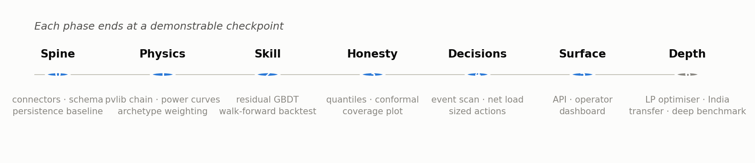
Figure 6 Build sequence. Each phase ends at a demonstrable checkpoint — a phase that ends with “the refactor is nearly done” is where long projects die.

Principal risks
Risk | Severity | Response
Train/serve skew — training on reanalysis, serving on forecasts | High | Same source and variable names both sides; a 7-day bias correction fitted on live forecasts; conformal recalibration on live errors. Residual skew remains — this is our largest honest limitation.
Curtailment unflagged in source data | Medium | Heuristic detection where output flat-lines below the physics estimate under good conditions; excluded from training.
Archetype weights fail to converge | Medium | Fall back to a single average archetype. Accuracy degrades; the pipeline stands. We report the degradation.
Cannot match the operator’s own forecast | Low | Never claimed. The target is to beat persistence and close the gap to a stated margin using only open data.
Live API failure during demonstration | Low | A replay mode serves a cached week of forecast runs and all model artifacts. We build the live path and present from cache.

What would change our mind
Each of these is a measurable outcome of the evaluation harness, not a matter of opinion. Building that harness in phase 0 is what makes it possible to be wrong in public and say so.
- If the physics baseline does not beat persistence at 24–72 hours, the physics-first thesis is wrong for this horizon.
- If the residual model does not beat a direct model on the raw target, residual learning adds nothing here and we simplify.
- If archetype weighting does not beat a single average archetype, the regional physics refinement is over-engineering and we remove it.
- If conformal intervals need more than half of capacity width, the problem may be too uncertain at 72 hours for reserve sizing, and we reduce the advertised horizon.

9 Research and References

Datasets
Source | Contents and access
Elia Open Data Portal | ods031/032 wind, ods086/087 solar, ods001/002/003 load. Measured generation, monitored capacity, operator day-ahead and week-ahead forecasts with P10/P90, and demand — all at 15 minutes, 2013 onward. Free, no API key. opendata.elia.be
Open-Meteo | Forecast and Historical APIs. Shortwave, direct-normal and diffuse radiation, global tilted irradiance, cloud cover by level, wind at 10/80/120/180 m, gusts. ECMWF, ICON, GFS and ensemble endpoints. No key for non-commercial use. open-meteo.com
Historical and modelled renewable energy production for India | University of Bristol. Hourly wind and solar capacity factors 1979–2022, state-level and 1°×1° gridded, installed capacity by state, georeferenced plant locations. CSV, NetCDF, GeoJSON. Zenodo DOI 10.5281/zenodo.7824872
Open Power System Data | 35 European countries, generation, capacity and load; Germany resolved to four TSO zones. Used as a cross-check region. data.open-power-system-data.org
SDWPF (KDD Cup 2022) | Baidu / Longyuan. 134 turbines, 4.7 million records, 10-minute interval, with turbine x/y coordinates enabling wake and graph modelling. arXiv:2208.04360
GEFCom2014 | The reference academic benchmark. Wind: 10 farms with ECMWF u/v at 10 m and 100 m. Solar: 3 plants with 12 ECMWF variables. Evaluated by pinball loss over 99 quantiles. Won by a generalized additive tree ensemble.

Methodology, standards and regulation
Source | What it establishes
GET.transform (2024), International Best Practices in Solar and Wind Power Forecasting | Accuracy benchmarks by country and context; error grows nearly linearly with horizon; ~80% of world TSOs use centralised forecasting; optimal NWP combination is 5–6 models; quantified operating-cost benefits (NREL, Berkeley Lab, CENACE).
Development of a day-ahead solar power forecasting model chain for a 250 MW PV park in India (2023) | ECMWF and NCMRWF over India carry systematic positive irradiance bias, correctable to near zero with 20–25 days of training. A linear combination of two NWP models outperformed either alone.
Conformal prediction literature, 2025–2026 | Climate-invariant conformal intervals for multi-horizon solar and wind; adaptive conformal inference for PV; conformalised quantile regression — the two-stage pattern used here.
IEC 61400-12; Ineichen–Perez; SAPM; Perez transposition; NREL SPA | The physical models underlying the feature engine, implemented via pvlib-python and windpowerlib.
CERC Deviation Settlement Mechanism, notified for 1 April 2026 | Solar and hybrid bands ±10% → ±5%; wind ±15% → ±10%. X factor phased 100% to 0% by FY 2031. Cited alongside the Karnataka High Court stay and industry objections.
Ember — India curtailment analysis, 2026 | 2.1 TWh curtailed FY 2025-26 (1.3% of renewable generation); 300 GWh of ~470 GWh in Q1 2026 from transmission constraints; 34 GWh lost on 30 March 2026; ~10 GWh of storage needed; coal cycling to ~55% of rated capacity at midday.

Citation practice — every external number carries its source and date; every derived number shows its arithmetic and marks its assumptions; contested sources are cited alongside the challenge, and limitations are stated before a reader finds them.

