Industrial Machine Instance Segmentation & CCTV Domain Adaptation Dossier
  - Architecture, Data Pipelines, Empirical Failure Modes, and Production Readiness for 9-Class YOLO26-seg

Project: Krish: 9-Class Industrial Woodworking Machinery Instance Segmentation & CCTV Domain Adaptation
Project Version 2.4 | Status: Active Engineering | Target: Factory Safety & Inventory
Document date: 23 October 2026 | Workspace: Krish\ project root (Windows 11, RTX 3070 Ti)
Prepared by: Claude (Claude Code), compiled from the project's own artifacts. Technical sign-off: Section 10.4.
Architectural discovery: how this dossier was sourced
Every number in this document was read from a project artifact: the results.csv and args.yaml of each run, the PR curves, docs/runsummary.md, docs/run7_analysis_report.md, docs/label_policy.md, docs/cctv_benchmark.md, docs/cctv_domain_adaptation_plan.md, docs/dataset_layout_9class.md, CHANGELOG_REORGANIZATION.md, scripts/train.py and the pipeline source in pipeline/pipeline/.
Where the authoring brief disagreed with an artifact, this document uses the artifact value. Every such difference is listed in Appendix A, so readers can see what changed and why.
Two facts changed while this dossier was being written. run8 is no longer “prepared”: it is training. Epoch 1 was logged on 2026-10-22 and the run was resumed on 2026-10-23 at 17:07. Also, the datasetchange curation of 2026-10-21 shrank the validation split from 461 to 450 images.
Contents
1. Executive Summary & System Overview
1.1 Purpose, Operational Scope & Safety Objectives
1.2 The 9-Class Taxonomy & Visual Differentiation Matrix
1.3 Chronological Milestones & Current State (October 2026)
1.4 Executive Scorecard: Run 1 through Run 8 Comparison
2. Infrastructure, Tooling & Technical Environment
2.1 Compute, GPU & Software Stack Specifications
2.2 Workspace Architecture & NTFS Junction Symlink Strategy
2.3 The YOLO26 Architecture: End-to-End Head vs Auxiliary NMS Head
2.4 Tooling Suite: Training, Evaluation Harness and Annotation Utilities
3. Automated Data Pipeline & Reference Scraping (I4I Engine)
3.1 The 6-Stage Web-to-Dataset Pipeline Architecture
3.2 OpenCLIP Filtering, Embedding Calibration & Diversity K-Selection
3.3 The CCTV Web Scrape Post-Mortem (2,677 Images Audit & Hardware Noise)
3.4 Reference Manifest Ingestion & Image Fingerprinting
4. Label Engineering, Spatial Policies & Dataset Sanitization
4.1 The 2026-10-21 Label Overhaul
4.2 Class Extent Policies: Edge Banders vs Fire Extinguishers
4.3 Deactivating Morphological Merge & Migrating to Instance Clustering
4.4 Zero-Shot Segmentation: SAM 2.1 Base vs SAM 2.1 Large Benchmarks
4.5 The 64 Quarantined Catalog Images & The 107 Hard Negative Mining Protocol
4.6 Integration of High-Angle Overhead Industrial Images
5. Model Training History & Quantitative Benchmarks
5.1 Run 1–4 Historical Context (23-Class to 38-Class Habitat Experiments)
5.2 Run 5: The Generalist Champion
5.3 Run 6: The “CCTV-Robust” Fine-tune & Uncovered Regressions
5.4 Run 7: CCTV Pilot Hybrid Experiment & Catastrophic Overfitting Breakdown
5.5 Master Training Metrics Matrix
6. Deep-Dive Failure Analyses & Empirical Case Studies
6.1 Case Study 1: The Workshop Clip Panel Saw Regression (Resolution vs Viewpoint)
6.2 Case Study 2: Camera 03 vs Camera 05 Memorization & Spatial Bias
6.3 Case Study 3: The Fire Extinguisher False-Alarm Explosion
6.4 Case Study 4: Catalog Catastrophic Forgetting During Unbalanced Fine-Tuning
7. Critical Bug Fixes, Gotchas & Engineering Lessons
7.1 The Silent Albumentations Bypass in Ultralytics 8.4
7.2 Albumentations 2.x API Compatibility & Parameter Traps
7.3 Wide-Angle CCTV Lens Barrel Distortion Emulation
7.4 Aspect Ratio Distortions: Managing 960×1080 “1080P Lite” Frames
7.5 NMS Independence in YOLO26 End2End Detection
8. Edge Deployment, Real-Time Inference & Video Processing
8.1 Ingestion Architecture: RTSP Main Stream vs Sub-Stream Analysis
8.2 Static Camera ROI Cropping Strategy (Why SAHI was Deprioritized)
8.3 Multi-Frame Temporal Filtering: ByteTrack Association & 8-of-15 Window Rules
8.4 Per-Class Operational Confidence Thresholds & Decision Logic
9. The Frozen Factory CCTV Benchmark & Production Verification Gates
9.1 Dataset Isolation Protocol: The 328-Frame Frozen Benchmark
9.2 Validation Rules: Zero-Tolerance Leakage Guardrails
9.3 Gate Criteria for Champion Model Deployment
10. Current Handoff Status, Outstanding Curation & Future Roadmap
10.1 Immediate Execution Tasks: Training Run 8 & Validating Curation Lists
10.2 Pending Class Boundary Refinements
10.3 Long-Term Roadmap: Multi-Camera Tracking, Night IR Adaptation & Worker Perimeter Zones
10.4 Document Revision History & Technical Ownership Sign-Off
Appendix A. Reconciliation of the Authoring Brief with Project Artifacts

1. Executive Summary & System Overview
This chapter states what the system is for, defines the nine classes and how they are told apart, lists the milestones to date, and compares every training run on one scorecard.

1.1 Purpose, Operational Scope & Safety Objectives
The Krish project trains an instance-segmentation model that finds and outlines nine object classes in footage from fixed CCTV cameras in woodworking and furniture factories. The classes are seven woodworking machines, one industrial press and the fire extinguisher. The model outputs a polygon mask, not just a box, because the downstream uses need each machine's footprint on the image.

Operational scope
- Machine inventory and presence. Confirm which machines each camera sees and that they stay in place. All nine classes are stationary objects, so the deployment design confirms presence per location; it does not track motion (Section 8.3).
- Safety perimeter zoning. The machine mask, dilated by a configurable margin, defines the hazard zone around saws, planers, jointers and presses. Detecting workers is not part of the 9-class model; Section 10.3 describes how it would be added.
- Fire-safety monitoring. Locate fire extinguishers and confirm that they remain at their wall positions.

Safety objectives and limits
- The system is an assistive monitoring signal, not a safety interlock. It must never gate machine power.
- A missing extinguisher detection must not raise a compliance alarm. run6 missed 46% of validation extinguishers, and recall falls to 39% in images that hold three or more of them (docs/runsummary.md §2.3).
- Target environment: dusty workshops, wall- or ceiling-mounted cameras, H.264 compression, recordings stored horizontally squeezed 2:1 (“1080P Lite”, 960×1080), and infrared greyscale at night.
Key finding: current state in one paragraph
No checkpoint transfers to the factory cameras yet. The champion, run5, scores mask mAP50 0.054 at imgsz 640 and 0.010 at imgsz 960 on the frozen 328-frame factory benchmark. The CCTV-specific runs (run6 and run7) either regressed on real footage or memorised one camera. run8 (cleaned labels, high-angle web images, targeted hard negatives and corrected Albumentations 2.x degradation) is training and has not been evaluated.

1.2 The 9-Class Taxonomy & Visual Differentiation Matrix
The class ids below are the ones in datasets/9class/data_9class.yaml. Typical physical sizes are general industry ranges, given for orientation; they were not measured in this project. The confusion evidence column cites measured results.
Table 1. Class taxonomy, identifiers and confusion risks
ID | Class | Typical size | Key visual identifiers | Main confusion risks (evidence)
0 | panel_saw | Carriage 2.6–3.8 m long; outrigger table up to ~3 m | Long sliding carriage, crosscut fence and outrigger, main and scoring blade, overhead guard | table_saw: run5 labels the held-out workshop sliding-table saw table_saw at up to 0.70 (run7 report §2)
1 | hydraulic_press | Frame 2–4 m wide, 2–3 m tall | Heavy steel frame, platens, cylinders, board stacks | Veneer / hot press (12 negatives removed); Camera 03 hot press vs Camera 05 frame press
2 | table_saw | Table 0.6×0.8 m (site) to 1.2×2 m with wings | Blade through a flat table, rip fence, mitre slot, cabinet base | panel_saw; small benchtop band and mitre saws
3 | planer | Body 0.6–1.2 m; feed tables to ~1.5 m | Boxy enclosed thicknesser, depth handwheel, feed tables | jointer (2 of 35 planers predicted as jointer, run6); drum and wide-belt sanders; moulders
4 | jointer | Beds 1.5–2.5 m long | Long low infeed/outfeed beds, side fence, cutter guard | planer (combination planer-thicknessers carry both cues)
5 | band_saw | 1.5–2.2 m tall | Two wheel housings, a narrow vertical blade, a small table | Drill presses (negative audit), mitre saws (1 confusion, run6)
6 | miter_saw | 0.5–0.9 m wide (benchtop) | Pivoting saw arm over a turntable, often on a stand or bench | band_saw; small table saws (28% missed, run6)
7 | edge_banding_machine | 1.5–2 m (manual) to 4–8 m+ (inline line) | Long enclosed body, edge-tape coil disc, gluing/trimming units, infeed and outfeed conveyors | Extrusion lines, roller conveyors; historically, frame-filling labels (45% of val labels)
8 | fire_extinguisher | 0.4–0.9 m cylinder | Red cylinder, handle, hose, nozzle, wall bracket | Gas cylinders, drums, red bins, cardboard tubes, standing workers (run7: 51–74 false alarms on Camera 03)

Visual differentiation matrix. The pairs below cause the measured confusions. The discriminating cue is what the class-boundary policy (Section 10.2) asks labellers to check first.
Table 2. Differentiation matrix for the measured confusions
Confusable pair | Discriminating cue | Labelling rule
panel_saw vs table_saw | A sliding carriage running the full length of the machine, with an outrigger crosscut table | A sliding-table saw is panel_saw (proposed, not yet applied to the catalog labels)
planer vs jointer | Planer: enclosed box, stock fed through underneath. Jointer: open beds, cutter on top, side fence | Combination machines: label the visible mode; settle ambiguous cases in the boundary sheet
hydraulic_press vs veneer press | Under the current policy, woodworking hot/cold presses resemble the Camera 03 press | Open decision: relabel the 12 removed veneer-press images as hydraulic_press
edge_banding_machine vs conveyors | Tape coil disc and an enclosed gluing/trimming unit; a bare roller conveyor has neither | One polygon per machine, conveyors included only when attached (Section 4.2)
fire_extinguisher vs cylinders and drums | Handle, hose and nozzle; red body; wall bracket | Gas cylinders, drums, bins, jugs, hose reels and alarm points are hard negatives
band_saw vs drill press | Two wheel housings and a continuous blade; a drill press has a quill and chuck | Drill presses stay negatives

1.3 Chronological Milestones & Current State (October 2026)
Dates for run1–run6 come from the timestamps of each run's args.yaml and results.csv. Later dates come from the reports themselves.
Table 3. Project chronology
Date | Milestone | Outcome
2026-09-15 | run1: 23-class oversampled baseline (COCO yolo26s-seg, imgsz 960) | 79 epochs; box mAP50 0.777
2026-09-17/18 | run2: 23-class clean fine-tune from run1 | 20 epochs; box mAP50 0.787
2026-09-18 | run3: 38-class habitat dataset from COCO; run4: unified fine-tune from run3 | box mAP50 0.608 and 0.611 over 38 classes
2026-09-25 | run5: 9-class clean fine-tune from run3 | box mAP50 0.825 (best 0.832); becomes the champion
2026-09-28 | Workshop clip recorded (Screen Recording 2026-09-28 124839.mp4) | The only held-out panel-saw footage
2026-10-05/06 | run6: “CCTV-robust” fine-tune at imgsz 1280 | 2 h 59 min; val box mAP50 0.810
2026-10-07/08 | run6 audit and trial-video re-test | Regression found; end2end/NMS finding
2026-10-10 | CCTV domain adaptation plan; workspace reorganization | 68 moves, nothing deleted; NTFS junctions
2026-10-10 → 14 | CCTV-perspective web scrape | 2,677 raw images
2026-10-15 | Scrape post-mortem; Albumentations 2.0.8 installed; CCTV ingestion tools | The batch is not CCTV data (about 5 CCTV-like images)
2026-10-19 | Factory footage analysed (2 cameras, 328 frames); run7 trained and analysed | run7 memorised Camera 05; 0/142 on Camera 03
2026-10-21 | Label overhaul, negative audit, SAM 2.1 Large, 30 high-angle images, benchmark frozen, run7 archived, datasetchange curation | Audit PASS; 3,298-entry train list; val 450 images
2026-10-22 00:13 | run8 started from run5 | Epoch 1 logged at 01:11 (box mAP50 0.830)
2026-10-23 17:07 | run8 resumed from last.pt | Training in progress at the time of writing

State on 23 October 2026
- Deployment fallback: run5 (runs/run5_9class_clean_finetune/weights/best.pt). It is the parent for every future fine-tune.
- Do not deploy: run6 (real-footage regression) and run7 (memorised Camera 05; archived).
- In training: run8 (runs/run8_9class_curated_cctv), 50 epochs planned, 1 logged.
- Dataset: 2,200 train / 450 val / 473 test label files; train list 3,298 entries (2,337 unique) with 11.8% negatives.
- Benchmark: 328 factory frames, frozen for testing only (Chapter 9).

1.4 Executive Scorecard: Run 1 through Run 8 Comparison
Table 4 compares the four 9-class checkpoints that matter for deployment. Validation sets differ between rows, as marked. Do not compare a value measured on one validation set with a value measured on another.
Table 4. Deployment scorecard for the 9-class checkpoints
Measure | run5 | run6 | run7 | run8
Role / verdict | CHAMPION / BASELINE | REGRESSED | OVERFITTED, ARCHIVED | CANDIDATE, TRAINING
Parent checkpoint | run3 (38-class) | run5 | run5 | run5
imgsz / batch | 960 / 8 | 1280 / 4 | 1280 / 4 | 960 / 6
Optimizer (resolved) | auto → AdamW, lr 0.000769 | auto → AdamW, lr 0.000769 | AdamW, lr0 2e-4 | AdamW, lr0 5e-4, cosine
Epochs run | 20 | 50 | 17 (early stop; best = ep 7) | 1 of 50 logged
Training data | 9-class catalog (original labels) | + 301 machinery negatives (9.1%) | 1,606 catalog + 257 cam05 frames ×5 (44%) | Cleaned + curated catalog, 30 high-angle, 107 hard negatives (11.8%)
Own-log val box / mask mAP50 | 0.825 / 0.802 | 0.810 / 0.795 | 0.009 / – (val = Camera 03) | 0.830 / 0.813 (ep 1, 450-image val)
Catalog val at imgsz 960 (2026-10-19 labels): box mAP50 | 0.821 | 0.825 | 0.786 best / 0.792 last | –
Cleaned val (2026-10-21, 461 images): box / mask mAP50 | 0.789 / 0.741 | not measured | not measured | –
Workshop clip (held out) | panel_saw 0.56–0.63 at imgsz 960 | ≤ 0.18; 0 detections at conf 0.40 in 1,398 frames | none at 0.25; max 0.17 | not tested
Camera 03 machines found at ≥ 0.25 (of 142) | 0 | 0 | 0 | n/a (now benchmark)
Camera 03 extinguisher false alarms (640 / 1280) | 0 / 0 | 32 / 2 | 51 / 74 | –
Factory benchmark mask mAP50 (640 / 960) | 0.054 / 0.010 | – | – | pending

Table 5 lists every run at its final logged epoch, on the run's own validation set. The 23-class and 38-class rows score different class sets, so their values show each era's trend; they are not comparable with the 9-class rows.
Table 5. All runs at their final logged epoch (own validation set)
Run | Classes | Base | imgsz | Epochs | Box mAP50 | Box 50-95 | Mask mAP50 | Mask 50-95 | Status
run1_23class_oversampled | 23 | COCO yolo26s-seg | 960 | 79/100 | 0.777 | 0.675 | 0.755 | 0.645 | SUPERSEDED
run2_23class_finetune_clean | 23 | run1 | 960 | 20 | 0.787 | 0.687 | 0.765 | 0.659 | SUPERSEDED
run3_38class_habitat_full | 38 | COCO yolo26s-seg | 960 | 57/100 | 0.608 | 0.493 | 0.544 | 0.424 | PARENT OF RUN5
run4_38class_habitat_unified_finetune | 38 | run3 | 960 | 15 | 0.611 | 0.507 | 0.552 | 0.433 | SUPERSEDED
run5_9class_clean_finetune | 9 | run3 | 960 | 20 | 0.825 | 0.711 | 0.802 | 0.679 | CHAMPION
run6_9class_cctv_robust | 9 | run5 | 1280 | 50 | 0.810 | 0.649 | 0.795 | 0.654 | DO NOT DEPLOY
run7_9class_cctv_pilot | 9 | run5 | 1280 | 17 (best 7) | 0.009* | – | – | 0.006* | ARCHIVED
run8_9class_curated_cctv | 9 | run5 | 960 | 1/50 | 0.830 | 0.629 | 0.813 | 0.671 | TRAINING

* run7's row shows best.pt (epoch 7). Its validation set was 71 Camera 03 frames, so these values measure transfer to an unseen camera; they are not catalog scores. Its catalog scores are in Table 4.

2. Infrastructure, Tooling & Technical Environment

2.1 Compute, GPU & Software Stack Specifications
Table 6. Hardware and software stack
Component | Specification | Notes
GPU | NVIDIA GeForce RTX 3070 Ti, 8 GB | Batch 6 fits at imgsz 960 and batch 4 at 1280
OS | Windows 11 Pro (10.0.26200) | NTFS junctions are used for the dataset layout
Python environment | Python 3.10 venv at env\yolo-env | Moved on 2026-10-10. Its 21 launchers had been hard-coded to another machine's path and were regenerated
PyTorch | 2.13.0+cu130 | CUDA available (verified 2026-10-10)
Ultralytics | 8.4.123 | YOLO26 end-to-end heads; augmentations= accepts a custom Albumentations list
Albumentations | 2.0.8 (+ albucore) | Installed with --no-deps to keep the GUI build of OpenCV; pydantic, simsimd and stringzilla installed separately
Segmentation model | YOLO26s-seg (models/pretrained/yolo26s-seg.pt) | Every segmentation run descends from it. yolo26n.pt (nano detection) is also stored but was not used by any segmentation run
Annotation model | SAM 2.1 Large (models/pretrained/sam2.1_l.pt, 856.5 MB) | Default since 2026-10-21; SAM 2.1 Base kept for comparison
Data pipeline | OpenCLIP ViT-B-32 (laion2b_s34b_b79k), ddgs, imagehash | In pipeline/ (its own git repository)
Inference latency | 12–16 ms per frame at imgsz 1280 (FP32); end-to-end 17–22 ms with mask rendering | 45–60 FPS; 12–13 ms at imgsz 640/960 on factory frames
Training throughput | run5: 2,221 s for 20 epochs (111 s/epoch). run6: 10,764 s for 50 epochs (215 s/epoch) | run8 epoch 1: 3,525 s (see the note below)

Implementation note: run8's first epoch was about 30 times slower than run5's
run8 logged 3,525 s for epoch 1 at imgsz 960 and batch 6. run5 averaged 111 s per epoch at the same imgsz. If the rate holds, 50 epochs take about 49 hours. The cause has not been investigated.
• Candidate causes: CPU-bound Albumentations with workers=4, the cache="ram" fill counted inside epoch 1, and Windows dataloader overhead.
• Check: nvidia-smi utilisation during epoch 2. One sample shortly after the resume on 2026-10-23 showed 0% utilisation with 5.5 GB allocated, which may only reflect start-up.

2.2 Workspace Architecture & NTFS Junction Symlink Strategy
On 2026-10-10, the nested Krish\Krish\ project and two separate runs\ trees were merged into a single root (CHANGELOG_REORGANIZATION.md). All 68 moves are logged in reorg_move_log.csv, and nothing was deleted. The current layout:
Project layout (2026-10-23)
Krish\
|-- datasets\
| |-- 9class\ data_9class.yaml, split lists, label_fixes\, stats
| | `-- {train,valid,test}_9class\
| | |-- images\ -> NTFS junction to ..\..\source_38class\{split}\images
| | `-- labels\ (9-class labels, rewritten on every build)
| |-- source_38class\ Roboflow 38-class export (images + 38-class labels)
| |-- hard_negatives\ 107 targeted look-alike negatives (empty labels)
| |-- highangle\ 30 accepted high-angle web images
| `-- cctv_factory_intake\ 328 frozen benchmark frames (TEST ONLY)
|-- runs\ run1 ... run6, run8, evals\, inference_tests\
|-- scripts\ train.py, test_inference.py, tools\
|-- pipeline\ I4I scraping/curation repo (own .git)
|-- models\pretrained\ yolo26s-seg.pt, yolo26n.pt, sam2.1_l.pt, sam2.1_b.pt
|-- docs\ reports, label policy, benchmark, dataset viewer
|-- archive\ run7_cctv_pilot_2026-10\, dataset_backups\, old scripts
`-- env\yolo-env\ Python 3.10, torch 2.13 + CUDA, ultralytics 8.4.123

Why junctions
- Zero copy. Each *_9class\images folder is a directory alias for the 38-class image folder. The 8,119 train images (384 MB) are stored once.
- The lists define the dataset. Ultralytics never scans images\ when the data yaml points at a .txt list. BaseDataset.get_img_files reads the lines and substitutes ./ without resolving paths. img2label_paths then maps \images\ to \labels\ on the path string, so a label always comes from 9class\...\labels, never from the 38-class labels behind the junction.
- The labels are rebuilt. build_clean_9class_dataset.py deletes and rewrites labels\ on every run. Only the selected images get a label file, so the gap between image and label counts in the table below is expected.
Table 7. Junction folders against the active dataset (after the 2026-10-21 curation)
Split | Files in images\ (via junction) | Label files | of which negatives | List entries
train | 8,119 | 2,200 | 283 | 3,298 (2,337 unique, incl. 107 hard negatives + 30 high-angle)
valid | 1,718 | 450 | 58 | 450
test | 1,747 | 473 | 62 | 473

Key finding: never delete inside a junction folder
Deleting “unused” files in datasets\9class\*_9class\images deletes the originals in source_38class.
Never run Remove-Item -Recurse on a junction either: it can follow the link. Remove the junction itself with cmd /c rmdir <path>.
Point training and evaluation only at the yaml or .txt lists, never at *_9class\images as a directory. A directory path would load all 8,119 images, 5,919 of them unlisted, as unlabelled backgrounds.

Rollback and re-link commands
The CHANGELOG gives the junction re-link procedure below. It is needed whenever the project folder moves, because NTFS junctions store absolute targets:
Re-create the three dataset junctions (from CHANGELOG_REORGANIZATION.md)
foreach ($s in 'train','valid','test') {
cmd /c rmdir "datasets\9class\${s}_9class\images"
New-Item -ItemType Junction -Path "datasets\9class\${s}_9class\images" -Target "$PWD\datasets\source_38class\$s\images"
}
The CHANGELOG describes the full rollback of the reorganization as “reverse each row” of reorg_move_log.csv (src,dst, relative to the project root), followed by the junction re-link. The snippet below implements that instruction. It is not in the CHANGELOG and has not been run: it keeps -WhatIf so that it only prints the moves until someone has reviewed them.
Reorganization rollback (derived from the CHANGELOG instruction; dry run)
$rows = Import-Csv reorg_move_log.csv
[array]::Reverse($rows) # undo the moves in reverse order
foreach ($r in $rows) { Move-Item -LiteralPath $r.dst -Destination $r.src -WhatIf }
A compatibility junction, Krish\instancesegmentationtraining\yolo-env → env\yolo-env, keeps old commands working. Remove it with cmd /c rmdir once nothing uses the old path.

2.3 The YOLO26 Architecture: End-to-End Head vs Auxiliary NMS Head
Every 9-class checkpoint is a YOLO26 segmentation model with two prediction heads trained together:
Table 8. YOLO26 dual-head behaviour at inference
Head | Training assignment | Post-processing | `iou=` argument | Selected by
One-to-one (default) | Each ground-truth object is matched to exactly one prediction | None: top-scoring predictions up to max_det | No effect | Default (end2end=True)
One-to-many (auxiliary) | Several predictions per object, as in classic YOLO | Non-maximum suppression at iou | Applies | end2end=False, or --nms in test_inference.py

- Production default: one-to-one. It removes the NMS step, so latency does not grow with the number of candidate boxes, and the output is deterministic. The measured 12–16 ms per frame comes from this head.
- The `iou` trap. Earlier recipes set iou=0.45 for inference. On these checkpoints that setting does nothing (ultralytics/utils/nms.py:66), and the log line from test_inference.py says so.
- Why `--nms` must still be tested on crowded extinguisher scenes. Extinguisher recall is 86% for a lone cylinder but 39% in images with three or more, which hold 67 of the 105 validation instances. The one-to-many head proposes several candidates per object, and NMS at a chosen IoU may keep adjacent cylinders that the one-to-one head drops. This is a hypothesis to test, not a measured result.
- The one-to-one head is not duplicate-free. In the upfront panel-saw clip, 44 of 173 frames contained two panel_saw boxes.
Comparing the two heads on the same input
from ultralytics import YOLO
model = YOLO(r"runs\run5_9class_clean_finetune\weights\best.pt")
# one-to-one head (default): NMS-free, iou ignored
res = model.predict(source=src, imgsz=960, conf=0.20, retina_masks=True, max_det=50)
# one-to-many head + NMS at iou
res_nms = model.predict(source=src, imgsz=960, conf=0.20, retina_masks=True,
end2end=False, iou=0.5)
Test plan for the extinguisher question: run validation on the subset of images with three or more extinguishers, once with each head, at the same confidence threshold. Compare recall and duplicate count, and adopt end2end=False for the extinguisher stream only if recall improves without new duplicates.

2.4 Tooling Suite: Training, Evaluation Harness and Annotation Utilities
Table 9. Project tooling
Tool | Purpose
scripts/train.py | run8 recipe. It refuses to start without Albumentations, refuses the frozen benchmark yaml or any data file that references cctv_factory_intake, and refuses to overwrite an existing run. --resume re-attaches cctv_aug
scripts/test_inference.py | Image, folder or video inference. Per-class thresholds (--class-conf), --nms, --vid-stride, --half; writes annotated media plus detections.csv, frames.csv, summary.json and summary.md
tools/build_clean_9class_dataset.py | Builds the 9-class labels and lists from source_38class: merges, quarantines, user fixes, negative sampling and junctions
tools/audit_dataset_distribution.py | Blocking checks (class ids, coordinates, leakage, lists) plus distribution report; must report PASS
tools/label_instances.py | Instance rebuild that replaces the morphological merge (Section 4.3)
tools/fix_edge_bander_labels.py | SAM 2.1 proposals for edge-bander polygons covering more than 80% of the image
tools/fix_user_labels.py | review / propose workflow for the datasetchange fix list (box prompts → SAM 2.1 L)
tools/parse_user_curation.py | Parses and de-duplicates the datasetchange lists into label_fixes/user_curation.json
tools/audit_negatives.py | Runs negatives through run5 and run6 and writes contact sheets for review
tools/collect_hard_negatives.py | Collects targeted look-alike negatives into datasets/hard_negatives
tools/compare_sam_models.py | SAM 2.1 Base vs Large benchmark on validation instances
tools/annotate_highangle.py | Box-prompted SAM annotation of high-angle web images
tools/sample_cctv_video.py | Time-stride, dHash/SSIM de-duplicated frame sampler; --resize 1920x1080 de-squeezes 1080P Lite
tools/prelabel_cctv.py, annotate_static_cameras.py | Pre-labels and consensus outlines for fixed cameras
tools/build_cctv_hybrid_dataset.py | Camera-split hybrid lists; fails if one camera lands in two splits
tools/build_dataset_viewer.py | Static gallery of the active dataset (docs/viewer/index.html), built from the lists
tools/analyze_trial_videos.py | Trial-video diagnostics and old-vs-new checkpoint comparison

Common commands (run from the project root; ^ is the cmd line continuation)
env\yolo-env\Scripts\python.exe scripts\test_inference.py ^
--weights runs\run5_9class_clean_finetune\weights\best.pt ^
--source "..\trial_videos\Screen Recording 2026-09-28 124839.mp4" ^
--imgsz 960 --conf 0.20 --vid-stride 6 ^
--class-conf "edge_banding_machine=0.20,fire_extinguisher=0.30"
env\yolo-env\Scripts\python.exe scripts\tools\build_clean_9class_dataset.py
env\yolo-env\Scripts\python.exe scripts\tools\audit_dataset_distribution.py
env\yolo-env\Scripts\python.exe scripts\tools\build_dataset_viewer.py
python -m http.server 8000 --directory . # then open http://localhost:8000/docs/viewer/index.html

3. Automated Data Pipeline & Reference Scraping (I4I Engine)
The scraping and curation engine lives in pipeline/ (until 2026-10-10 it was the nested Krish\Krish\I4I repository). It produced the web imagery behind the 23-class and 38-class datasets. All parameters below are from pipeline/pipeline/config.py and the stage scripts.

3.1 The 6-Stage Web-to-Dataset Pipeline Architecture
The pipeline runs Scrape → Clean → Filter → Diversify → Auto-Label → Train:
Table 10. Pipeline stages
Stage | Script | What it does | Key parameters
1a / 1b | utils/manifest_gen.py, stage1_ingest_refs.py | Builds a blank reference manifest, then ingests hand-picked reference images per class | Minimum 3 references per confusable class (flagged, not failed)
2 | stage2_scrape.py | Multi-template DuckDuckGo (ddgs) image scrape; template sets default, cctv, highangle | Cap 400 per class; 1.5 s between queries; 5 retries; 10 s download timeout
2c | stage2c_accept_gate.py | Acceptance gate for the high-angle batch | Output logs/stage2c_gate_highangle.csv
3 | stage3_clean.py | Removes corrupt files, small images and perceptual duplicates | Minimum 150 px per side; pHash Hamming distance ≤ 8
4 | stage4_clip_filter.py | Hybrid OpenCLIP filter: coarse text score, then fine image score for confusable classes | ViT-B-32 / laion2b_s34b_b79k; coarse 0.18; fine 0.30; batch 64
4b | stage4b_calibrate.py | Derives thresholds from a labelled good/bad sample | Percentile-based (Section 3.2)
5 | stage5_diversity_kselect.py | Greedy diversity filter and K-selection with a stopping rule | Skip if cosine > 0.95 to the selected set; floors 80 (standard) / 150 (confusable)
6 | upload_polygon_annotations.py; stage6_contact_sheet.py | Auto-label: Gemini Vision class check plus SAM 2 polygon extraction, uploaded to Roboflow; contact sheets for review | Roboflow export became datasets/source_38class

config.py now lists 38 class slugs: the 23 original classes, plus 6 woodworking machines (edge bander, dust collector, veneer press, drum sander, mortiser, glue spreader), 6 infrastructure classes and 3 safety-infrastructure classes. These are the 38 classes of the habitat era (run3 and run4). The pipeline README still says 23 classes.

3.2 OpenCLIP Filtering, Embedding Calibration & Diversity K-Selection

Two-level CLIP filter (stage 4)
1. Coarse text filter (every class). Each candidate is scored against “a photo of a {display name}”. It passes if the score is at least 0.18 and the image is more photo-like than a non-photo/diagram prompt.
2. Fine image filter (confusable classes only). Each candidate's embedding is compared with the class's reference images by mean cosine similarity, with a threshold of 0.30. Calibration found reference self-similarity as low as 0.17 (planer), so the earlier 0.55 rejected correct images.
Table 11. Confusable clusters that receive the fine image filter
Confusable cluster | Classes
cutting | table_saw, band_saw, miter_saw, panel_saw
surfacing | planer, jointer, spindle_moulder, wood_lathe
cnc_group | cnc_milling, milling, drilling, cnc_router
edge_banding_group / sanding_group | edge_banding_machine / drum_sander
hoist_crane_group | crane, overhead_hoist
safety_infra_group | ppe_station, first_aid_station, emergency_exit_sign

Embedding calibration (stage 4b)
stage4b_calibrate.py embeds a hand-labelled sample of good and bad images and prints the score distributions (min, max, mean, standard deviation, 1st and 5th percentiles). The recommended coarse threshold is the good set's 1st percentile. The fine threshold is the midpoint between the bad set's maximum and the good set's 1st percentile, which is more lenient than the earlier 5th-percentile midpoint.

Diversity K-selection (stage 5)
- A greedy max-coverage pass skips any image whose CLIP cosine similarity to an already-selected image exceeds 0.95. This removes re-uploads and crops of the same stock photo.
- Floors: 80 images for standard classes and 150 for confusable classes. A class below its floor is flagged, not dropped, in logs/stage5_kselect_log.json.

3.3 The CCTV Web Scrape Post-Mortem (2,677 Images Audit & Hardware Noise)
Between 2026-10-10 and 10-14, stage2_scrape --templates cctv --cap 300 collected 2,677 images across the nine classes (300 per class, except panel saw 278 and band saw 299). The review on 2026-10-15 (docs/cctv_scrape_postmortem.md) found that the batch does not contain CCTV footage.
Table 12. CCTV scrape audit
Measure | Result
Byte-identical copies of another file in the batch | 723 / 2,677 (27%)
… of which the same URL downloaded twice (scraper bug) | 537
Identical files across different classes | 347 files in 116 groups
Near-duplicates of existing dataset images (dHash ≤ 4 and CLIP cosine ≥ 0.93) | 311 (12%)
CLIP zero-shot closest to “CCTV footage still” | 49 (1.8%)
… actually CCTV-style after visual review | ~5, all warehouses; none clearly shows a target machine
Closest to “camera device” or “camera ad” (hardware noise) | ~279 (~10%)
Catalog photo or eye-level close-up | ~1,700 (~63%)

Root causes
1. The web has almost no indexed CCTV stills of these machines. Such footage sits on private NVRs or inside videos. Image search ranks by page text, so it falls back to the best-matching query word.
2. The query words attracted camera products. “surveillance camera” and “security camera” matched pages *about cameras* (products, NVR ads, security graphics). “High angle” and “from above” are photographers' terms that captions rarely contain.
3. Only about 35 results per query. DDGS returned one page for almost every query, so popular stock and catalog images dominate.
4. Almost nothing was rejected. CCTV mode removed “cctv” and “surveillance” from the blocklist, and there is no CLIP check at download time.
5. A de-duplication bug. _url_to_filename() writes the running index into the filename, so the dest_path.exists() check never matches and the same URL is saved twice. Classes are scraped independently, so one image can be saved under two labels (347 files), which would teach contradictory classes.
Architectural discovery: replacement for the CCTV query set
On 2026-10-21, place-based HIGHANGLE_QUERY_TEMPLATES replaced the camera-word queries (e.g. “{machine} furniture factory production line”, “{machine} woodworking factory mezzanine view”). The gate accepted 99 of the results; after review, 30 images (52 instances) entered train (Section 4.6).
Only footage from the project's own cameras matches the deployment domain. Web imagery is supplementary variety.

3.4 Reference Manifest Ingestion & Image Fingerprinting

Reference manifest
1. python -m pipeline.utils.manifest_gen --src <flat folder> writes a blank reference_manifest.csv.
2. A person fills in the class column with exact slugs from config.py.
3. python -m pipeline.stage1_ingest_refs copies each image into reference_images/<class>/ (with --dry-run available) and prints a coverage report. Confusable classes with fewer than 3 references are flagged as LOW. reference_images/ currently holds 36 class folders.
4. Stage 4's fine filter uses these references as anchors for the confusable clusters.

Image fingerprinting in use
Table 13. Fingerprints used across the pipeline
Fingerprint | Where | Purpose / limitation
MD5 digest in the filename (img_<cls>_<tag>_<idx>_<md5>.jpg) | Stage 2 | Names each download. The running index in the name defeats the existence check (Section 3.3)
pHash, Hamming distance ≤ 8 | Stage 3 | Near-duplicate removal within a class
CLIP embedding cosine > 0.95 | Stage 5 | Semantic de-duplication and diversity
dHash ≤ 4 combined with CLIP cosine ≥ 0.93 | Post-mortem analysis | Near-copies of images already in datasets/9class
64-bit dHash (Hamming ≥ 6–8) or SSIM < 0.92 | sample_cctv_video.py | Change-based de-duplication of CCTV frames per camera

Recommended fix before the scraper runs again: de-duplicate on the URL digest (a per-run set of seen URLs) and on a perceptual hash across all classes before saving. Add a CLIP gate at download that keeps an image only if the target class beats the camera-device, security and diagram prompts.

4. Label Engineering, Spatial Policies & Dataset Sanitization

4.1 The 2026-10-21 Label Overhaul
The run6 audit traced the two weakest classes to label conventions, not to missing data. 45% of validation edge-bander labels were frame-filling boxes, and touching extinguishers had been merged into blobs. On 2026-10-21 the 9-class labels were rebuilt by scripts/tools/build_clean_9class_dataset.py. Every review decision is recorded in datasets/9class/label_fixes/label_decisions.yaml.
Table 14. Components of the label overhaul
Change | Detail | Backup
Morphological merge off | Replaced by instance clustering (label_instances.py) | archive/dataset_backups/9class_labels_pre_run8_2026-10-21/
Edge-bander polygons tightened | 175 flagged; 68 SAM outlines accepted, 47 kept as close-ups, 60 quarantined | same
Per-cylinder extinguishers | Instance rebuild on every image; SAM masks in 15 images; 4 quarantined | same
Negative audit | 17 negatives dropped (5 with hidden targets, 12 veneer presses) | same
SAM 2.1 Large | New annotation default | –
Hard negatives | 107 targeted look-alikes (datasets/hard_negatives) | –
High-angle images | 30 images, 52 instances, train only | –
User curation (datasetchange) | 80 images quarantined, 110 re-drawn, 3 excluded | archive/dataset_backups/9class_labels_pre_user_curation_2026-10-21/

Key finding: the review was not done by a human annotator
Every proposal (SAM outlines, negative drops, high-angle acceptances and the datasetchange re-annotations) was checked visually on overlay sheets by Claude, not by a human annotator. The before/after sheets are in datasets/9class/label_fixes/ for human spot checks before a release.

4.2 Class Extent Policies: Edge Banders vs Fire Extinguishers
Edge banding machine (class 7): one polygon per physical machine.
Table 15. Edge-bander extent policy
Include | Exclude
Machine chassis and base cabinet | Panels being fed through or stacked on the conveyors
Top cover / hood (open or closed) | Floor, walls, ceiling, the surrounding room
Gluing, end-cutting, trimming, scraping and buffing units | Text banners, logos, spec tables, feature strips
Infeed and outfeed roller conveyors / support tables attached to the machine | Inset or zoom-circle photos, collage tiles
Edge-tape coil holder (disc) and control-panel arm | People; dust hoses that leave the machine

- Two machines in one image are two instances, never one polygon around both.
- Label a partly visible machine only if at least 40% is visible, and trace only the visible pixels.
- A polygon covering more than 80% of the image is allowed only when the machine really fills the frame. If walls, floor or a white background are inside the polygon, the polygon is wrong.
Fire extinguisher (class 8): one polygon per physical cylinder.
- Each instance includes the cylinder's own hose, nozzle, handle and wall-bracket strap.
- Touching or overlapping extinguishers are separate instances; a row is never merged into one blob.
- Label every extinguisher in the image, including background and partly hidden ones (at least 40% visible).
- Gas cylinders, plastic drums, water jugs, red bins, hose reels and alarm call points are not extinguishers. They are hard negatives.
Saws, jointers and planers: the extent is the bed, fences and frame, including attached extension tables and guards, and excludes loose stock, people and the room. This is the rule used for the datasetchange re-annotations.

4.3 Deactivating Morphological Merge & Migrating to Instance Clustering
The original build applied a morphological closing step that joined polygon fragments separated by gaps of 0.5–1.2% of the image diagonal. It caused two failures:
- Touching extinguishers fused. In one image, 348 source fragments became a single blob covering three cylinders.
- Edge-bander fragments ballooned into slabs covering most of the image, which taught the model that an edge bander is the whole photo. Recall was 0 of 15 for edge banders under 25% of the image, and 0 of 18 when two or more shared an image.
scripts/tools/label_instances.py replaces it. It consolidates speckle-sized fragments, absorbs small touching parts (hoses, handles) into their cylinder, and keeps similar-sized neighbours separate.
Table 16. Effect of the instance rebuild and curation (train counts exclude the high-angle images)
Measure | Before (original build) | After overhaul | After user curation
Train edge-bander boxes over 80% of the image | 48% | 20% | –
Val edge-bander boxes over 80% of the image | 59% | 18% | –
Fire-extinguisher instances (train / val / test) | 435 / 105 / 96 | 606 / 129 / 147 | 586 / 109 / 140
Edge-bander instances (train / val / test) | – | 229 / 33 / 55 | 134 / 22 / 25
Images quarantined for re-annotation | 0 | 64 (38 / 16 / 10) | 64 + 80 user + 3 excluded

4.4 Zero-Shot Segmentation: SAM 2.1 Base vs SAM 2.1 Large Benchmarks
scripts/tools/compare_sam_models.py prompted both models with the ground-truth boxes of 222 validation instances and compared each mask with the label. Large is Meta's official sam2.1_hiera_large.pt (856.5 MB, SHA-256 2647878D…DD318).
Table 17. SAM 2.1 Base vs Large on 222 box-prompted validation instances
Measure | SAM 2.1 Base | SAM 2.1 Large | Difference
Mean mask IoU vs labels | 0.880 | 0.886 | +0.006
Boundary F1 | 0.794 | 0.802 | +0.008
Jointer IoU | 0.928 | 0.971 | +0.043
Band saw IoU | 0.890 | 0.920 | +0.030
Mitre saw IoU | 0.914 | 0.877 | −0.037
Edge-bander IoU | 0.776 | 0.774 | −0.002
Speed (ms per prompt) | 108 | 271 | 2.5× slower
Peak GPU memory (MB) | 776 | 1,423 | +647
Instances where it wins | 14% | 25% | –

Architectural discovery: what SAM can and cannot be trusted with
Large is the annotation default, but its gain is small and it loses on mitre saws, so every mask is still reviewed.
Box prompts must be clipped: each mask is cut to its prompt box, which removes room, floor and stock.
Inverting a mask (when SAM selects the plain background) is allowed only for boxes covering more than 80% of the image. Applying it to smaller boxes flips correct masks.
On white studio photos SAM often selects the background. There, the fg mode cuts the object from the non-white pixels inside the box (closing gaps, filling holes) instead of using SAM.

4.5 The 64 Quarantined Catalog Images & The 107 Hard Negative Mining Protocol

The 64 quarantined images
The 64 images that left the build on 2026-10-21 were not all diagrams. 60 are edge-bander images that cannot be labelled under the extent policy: collages, infographics, inset or zoom-circle photos, and scenes with several machines. 4 are fire-extinguisher images of dense, blurred cylinder rows. By split: 38 train, 16 val, 10 test. They stay out of the build until someone re-draws them by hand. An earlier, separate build-level quarantine holds 47 train images (CAD drawings and failed extinguisher labels).

Manual curation via datasetchange
The datasetchange file at the project root holds two lists from manual review: images with wrong labels and images that are bad in themselves. scripts/tools/parse_user_curation.py strips whitespace and extensions, normalises the Img_ prefix, de-duplicates and locates each image's split.
Table 18. The datasetchange lists
List | Lines | Unique images | Train / val / test | Action
To fix | 113 | 113 | 77 / 13 / 23 | 110 re-drawn with SAM 2.1 L box prompts; 3 excluded
To remove | 87 | 80 (7 duplicates) | 51 / 11 / 18 | user_quarantine in label_decisions.yaml

- Quarantine is build-level only. Images stay in source_38class; the build drops them from every list and writes no 9-class label.
- Re-annotation (scripts/tools/fix_user_labels.py): review draws the current label and run5's detections on a 10% grid; reviewed boxes [class, x1, y1, x2, y2] are prompts for SAM 2.1 L; propose writes label_fixes/user_fix_polygons.json and before/after sheets in label_fixes/review_user_fixes/.
- Box modifiers: rect (12 boxes; genuine close-up, the box is the polygon), fg (15; white-background product photo), +class (8; merge a second box into the previous instance).
- Excluded (3): edge_banding_machine_ddgs_00473 (extrusion-line infographic), edge_banding_machine_ddgs_00457 (roller-conveyor collage) and table_saw_00209 (under 40% visible).
- Second pass: 28 first-round proposals were wrong, mostly on white backgrounds. 27 were re-drawn and checked again, and 1 was excluded.
- Result: 128 instances on 110 images: edge bander 62, planer 15, table saw 13, jointer 13, mitre saw 13, band saw 12. Some fixes add machines the old labels missed.
- Verification: audit PASS. 0 of 83 quarantined or excluded images still listed, 110 of 110 fixed images listed with matching polygons. 6 re-drawn polygons self-intersect (non-blocking warning).

Negative audit and the 107 hard negatives
Protocol (`scripts/tools/audit_negatives.py`): all 420 sampled negatives were run through run5 and run6 at conf 0.10. 228 had a detection, and 133 had one at ≥ 0.25. Every contact sheet in label_fixes/negative_audit/ was reviewed, with full-resolution zooms of busy scenes.
- Dropped, 5 with unlabelled target machines: a benchtop planer and mitre saw (dust_collector_00198), a panel saw at the frame edge (glue_spreader_00455), background band saws (mortiser_00244, wood_lathe_00220) and an illustration with four target classes (dust_collector_00464).
- Dropped, all 12 `veneer_press` negatives: the Camera 03 press is a woodworking hot press, so these would teach the factory press to be background.
- Effect: negatives went from 295/60/65 to 283/58/62. The drops apply after sampling, so no unreviewed negative enters. The negative sample is sized from the positive count before quarantine, so the reviewed set stays stable across curation.
Targeted hard negatives (`datasets/hard_negatives/`, empty labels). 110 web images were collected in 11 look-alike categories of 10 each, and 3 workbench images were rejected on review, leaving 107:
Table 19. Hard-negative composition (107 images)
Category | Kept | Target confusion
Red bins; yellow drums; blue drums | 10 + 10 + 10 | fire_extinguisher (the Camera 03 drum produced run7's false alarms)
Gas cylinders; water jugs; cardboard tubes | 10 + 10 + 10 | fire_extinguisher (cylindrical shapes)
Hose reels; alarm call boxes | 10 + 10 | fire_extinguisher (red wall fixtures)
Workbenches | 7 | table_saw, edge_banding_machine (flat work surfaces)
Empty floors; ceilings | 10 + 10 | Overhead-bar and floor false positives on CCTV

With the 283 sampled machinery negatives, negatives make up 11.8% of the 3,298-entry train list (11.6% before the datasetchange curation). Both sets are added once and not oversampled.

4.6 Integration of High-Angle Overhead Industrial Images
scripts/tools/annotate_highangle.py processed the place-based high-angle scrape (datasets/highangle/, decisions in decisions.yaml). All 99 gate-accepted images were reviewed. The class follows the image content, and 11 accepted images contain classes other than the one searched for.
Table 20. Accepted high-angle instances
Accepted class | Instances
Mitre saw | 12
Hydraulic press | 9
Panel saw | 7
Table saw | 6
Edge bander | 6
Band saw | 5
Fire extinguisher | 4
Planer | 2
Jointer | 1
Total (30 images) | 52

Table 21. Rejected high-angle images
Rejection reason | Images
Dense / unlabelable background | 14
Ambiguous class or extent | 13
Close-up of a part | 12
No target machine | 10
Collage or infographic | 8
AI render | 6
Aerial | 4
SAM failure, needs hand drawing (#5, #94) | 2
Total | 69

- Reviewed boxes are SAM 2.1 L prompts, clipped to the box. Overlays are in datasets/highangle/overlay/.
- The images are listed in datasets/9class/train_highangle_9class.txt: train only, added once, never in val or test.
- They add elevated viewpoints, which augmentation cannot create (Section 6.2). 30 images are far below the plan's ≥ 5 distinct viewpoints per class for real CCTV, so they are a supplement, not a fix.

5. Model Training History & Quantitative Benchmarks

5.1 Run 1–4 Historical Context (23-Class to 38-Class Habitat Experiments)
Table 22. Runs 1–4
Run | Dataset | Base | Config | Final box / mask mAP50 | Time
run1_23class_oversampled | 23-class pipeline dataset, oversampled list | COCO yolo26s-seg | 960, batch 8, 100 planned / 79 logged, patience 20, lr0 0.01 (auto) | 0.777 / 0.755 | 10.6 h
run2_23class_finetune_clean | 23-class, cleaned labels | run1 best | 960, batch 8, 20 epochs, lr0 0.001 (auto) | 0.787 / 0.765 | 5.2 h
run3_38class_habitat_full | 38-class “habitat” (machines + factory infrastructure + safety) | COCO yolo26s-seg | 960, batch 8, 100 planned / 57 logged | 0.608 / 0.544 | 11.7 h
run4_38class_habitat_unified_finetune | 38-class, unified labels | run3 best | 960, batch 8, 15 epochs, lr0 0.001 (auto) | 0.611 / 0.552 | 2.6 h

- 23-class era. The model classified a broad industrial catalog (CNC, lathes, forklifts, conveyors, saws). The clean fine-tune added about 1 point of mAP50.
- 38-class habitat era. The class list grew to include surrounding factory context (dust collectors, racking, hoists, PPE and first-aid stations, exit signs) as well as more woodworking machines. More and harder classes lowered mean mAP to about 0.61, but the features learned on factory context are why run3 became run5's parent.
- Why the switch to 9 classes. The deployment questions concern seven woodworking machines, the press and extinguishers. The other 29 classes became candidate negatives for the 9-class build.
- Every run before run8 used optimizer=auto, which silently overrode lr0 (Section 7.2).

5.2 Run 5: The Generalist Champion
Configuration: fine-tuned from run3 best.pt on the 9-class catalog list, imgsz 960, batch 8, 20 epochs, optimizer=auto (resolved to AdamW, lr 0.000769), patience 100. Training took 2,221 s.
Table 23. run5 headline metrics (training-time val, original label build)
Measure | Epoch 18 (best) | Epoch 20 (final)
Box precision / recall | 0.881 / 0.748 | 0.847 / 0.788
Box mAP50 | 0.832 | 0.825
Box mAP50-95 | 0.714 | 0.711
Mask mAP50 | 0.806 | 0.802
Mask mAP50-95 | 0.685 | 0.679

Per-class performance. run5's training export has per-class AP50 (from the PR-curve legends) but no per-class precision and recall. The run6 columns are from docs/runsummary.md; their precision and recall are read off the curves at the F1-optimal threshold (±0.02). Both runs were scored on their own training-time validation sets, before the 2026-10-21 cleanup.
Table 24. Per-class AP50: run5 vs run6
Class | run5 box AP50 | run5 mask AP50 | run6 box AP50 | run6 mask AP50 | run6 box P | run6 box R | Δ box (6−5)
panel_saw | 0.893 | 0.824 | 0.848 | 0.820 | ~0.95 | ~0.75 | −0.045
hydraulic_press | 0.963 | 0.937 | 0.961 | 0.916 | ~0.93 | ~0.88 | −0.002
table_saw | 0.937 | 0.937 | 0.931 | 0.904 | ~0.94 | ~0.83 | −0.006
planer | 0.849 | 0.822 | 0.846 | 0.846 | ~0.87 | ~0.80 | −0.003
jointer | 0.877 | 0.877 | 0.869 | 0.869 | ~0.80 | ~0.80 | −0.008
band_saw | 0.883 | 0.877 | 0.840 | 0.830 | ~0.83 | ~0.78 | −0.043
miter_saw | 0.783 | 0.757 | 0.733 | 0.724 | ~0.81 | ~0.70 | −0.050
edge_banding_machine | 0.574 | 0.497 | 0.584 | 0.558 | ~0.81 | ~0.41 | +0.010
fire_extinguisher | 0.718 | 0.720 | 0.680 | 0.693 | ~0.88 | ~0.52 | −0.038
all | 0.831 | 0.805 | 0.810 | 0.795 | 0.870 | 0.718 | −0.021

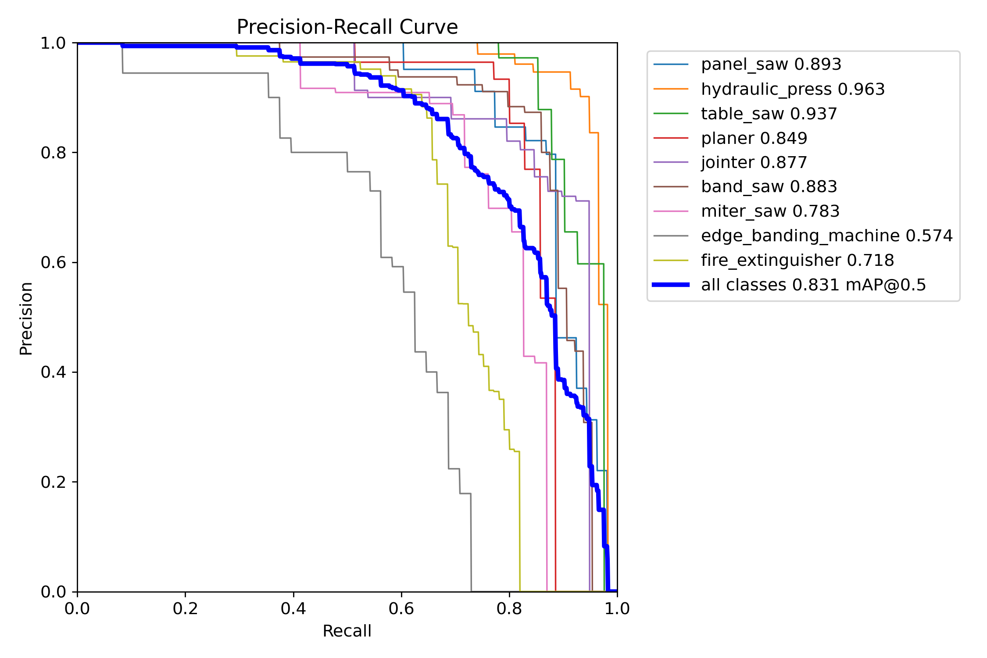
Figure 1. run5 box precision-recall curves per class (all classes 0.831 mAP@0.5). Source: runs/run5_9class_clean_finetune/BoxPR_curve.png
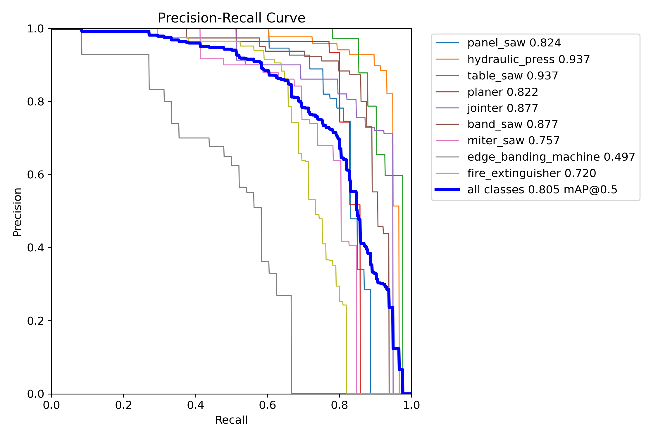
Figure 2. run5 mask precision-recall curves per class (all classes 0.805 mAP@0.5). Source: runs/run5_9class_clean_finetune/MaskPR_curve.png
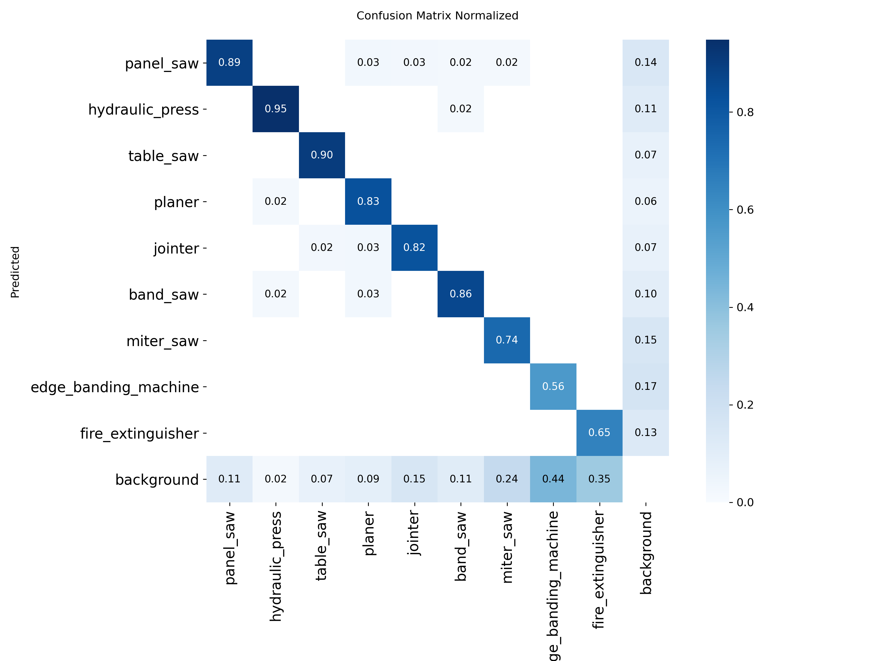
Figure 3. run5 normalised confusion matrix. Source: runs/run5_9class_clean_finetune/confusion_matrix_normalized.png

Re-baselining
Table 25. run5 across validation-set versions
Validation set | Box mAP50 | Mask mAP50 | Box / mask mAP50-95 | Source
Training-time val (original labels, 482 images) | 0.825 (final) | 0.802 | 0.711 / 0.679 | results.csv
Catalog val, 2026-10-19 label build, imgsz 960 | 0.821 | 0.798 | 0.706 / 0.679 | run7 report §3
Cleaned val, 2026-10-21 (461 images) | 0.789 | 0.741 | 0.665 / 0.632 | docs/todo.md
Curated val, 2026-10-21 after datasetchange (450 images) | not yet measured | – | – | re-measure before comparing with run8

Real-world generalisation
- Workshop clip (Screen Recording 2026-09-28 124839.mp4, the camera view cropped and restored to the 480×360 stream): panel_saw 0.56, 0.61 and 0.63 on frames 186, 1210 and 1303 at imgsz 960.
- The same clip, sampled differently (run7 report, 200 frames, conf 0.05, imgsz 960): run5 finds the saw in 200 of 200 frames, max 0.70, but names it table_saw. The machine is recognised and the class boundary is the problem (Section 10.2).
- Factory benchmark: mask mAP50 0.054 at imgsz 640 and 0.010 at imgsz 960. run5 does not yet work on the factory cameras.
Architectural discovery: why run5 stays the parent
run5 is the only checkpoint that detects the held-out workshop saw strongly, that produces no extinguisher false alarms on Camera 03, and that keeps the best catalog localisation at imgsz 960 (box mAP50-95 0.706). Every later run that changed the data mix lost at least one of these.

5.3 Run 6: The “CCTV-Robust” Fine-tune & Uncovered Regressions
Configuration (from `args.yaml`): fine-tuned from run5, imgsz 1280, batch 4, 50 epochs (best = final = 50), patience 15, AMP, optimizer=auto (AdamW, lr 0.000769), degrees=10, perspective=0.0005, scale=0.9, translate=0.2, erasing=0.4, hsv_s/v=0.5. The train list held 301 negatives (9.1%), all other machinery. Albumentations was not installed, so no codec, blur or greyscale augmentation ran, and erasing does nothing for segmentation.
Table 26. run6 validation metrics
Metric (epoch 50, 482 images / 490 instances) | Box | Mask
mAP50 | 0.810 | 0.795
mAP50-95 | 0.649 | 0.654
Precision (F1-optimal conf) | 0.870 | 0.863
Recall (F1-optimal conf) | 0.718 | 0.721
Peak F1 (conf) | 0.78 (0.388) | 0.78 (0.366)

What the validation numbers hid
- Workshop clip regression: ≤ 0.18 on the frames where run5 scored 0.56–0.63, and 0 detections at conf 0.40 in all 1,398 frames.
- The hard negatives pushed the boundary away from the target. Training negatives included spindle moulders, veneer presses, CNC routers and racking: long, flat, table-and-beam machinery like the sliding-table saw.
- Extinguisher false positives on factory frames: at conf 0.15 on 40 native factory frames, run6 fired fire_extinguisher 29 times in 16 frames (max 0.69), and 19 times at imgsz 640 (max 0.86). The scenes contain no extinguishers.
- Mask head: train segmentation loss halved (1.714 → 0.777) while validation segmentation loss stayed flat (1.345 → 1.438). The mask head memorised polygon detail that does not transfer.
- Edge banders: 26 of 49 validation instances missed, with 0 confusions with other classes. The labels, 45% of them frame-filling, were the cause.
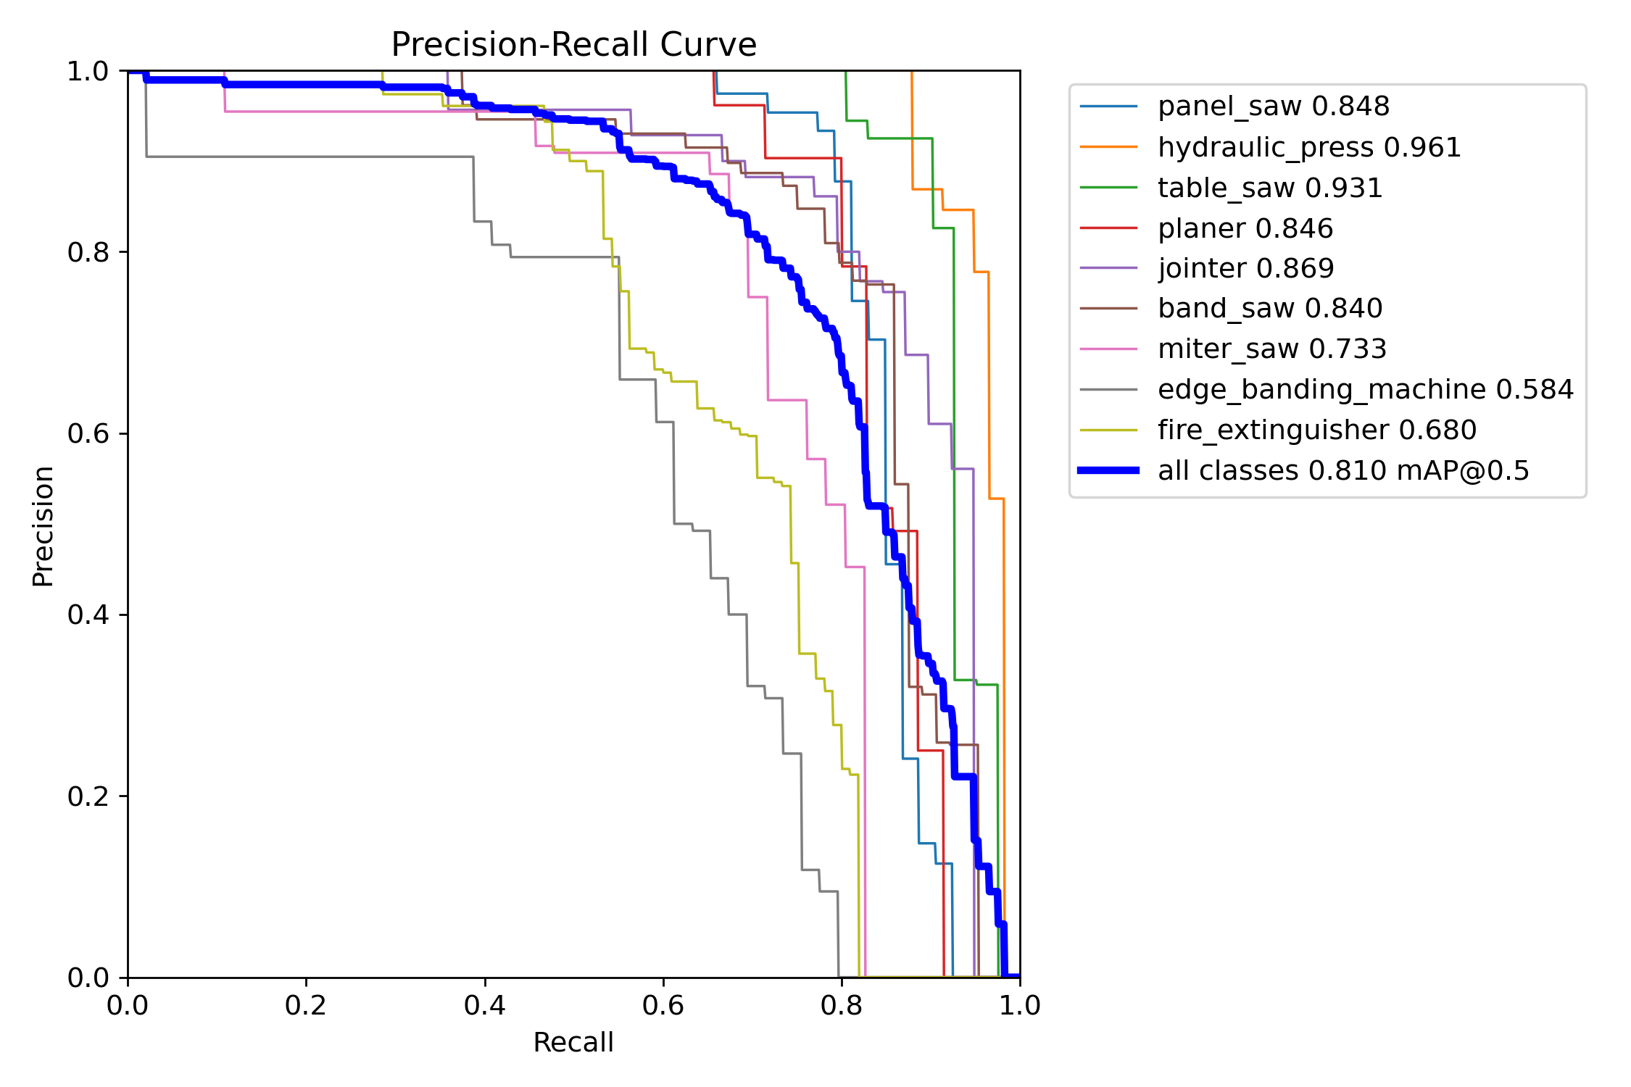
Figure 4. run6 box precision-recall curves per class. Source: runs/run6_9class_cctv_robust/BoxPR_curve.png

5.4 Run 7: CCTV Pilot Hybrid Experiment & Catastrophic Overfitting Breakdown
Setup: run5 weights, AdamW, lr0 2e-4, cosine schedule, imgsz 1280, batch 4. The train list had 2,891 entries: 1,606 catalog images plus 257 Camera 05 frames repeated 5×, which made up 44% of every epoch. Validation was 71 Camera 03 frames (71 presses and 71 edge banders). Artifacts are archived in archive/run7_cctv_pilot_2026-10/.
Table 27. run7 training curve
Epoch | Train box / seg / cls loss | Val box / seg / cls loss | Val box mAP50 | Val mask mAP50-95
1 | 1.08 / 1.90 / 1.20 | 2.14 / 3.30 / 4.34 | 0.0027 | 0.0002
7 (best.pt) | 0.66 / 1.23 / 0.61 | 1.56 / 3.09 / 4.74 | 0.0090 | 0.0056
17 (stopped) | 0.58 / 1.03 / 0.51 | 1.33 / 2.38 / 4.81 | 0.0023 | 0.0004

- Early stopping was triggered by noise. Validation fitness never rose above about 0.012, and its peaks at epochs 2, 7 and 14 are statistically identical, so best.pt was chosen essentially at random. last.pt scores better on catalog val.
- Validation classification loss never improved (4.2–5.6). The model got better at “something is here” on Camera 03, never at “which class”.
- Confusion matrix on Camera 03 (conf 0.25): edge bander 71 of 71 missed; press 59 missed and 12 called edge bander; 112 `fire_extinguisher` predictions on background.

5.5 Master Training Metrics Matrix
Table 28. Final-epoch validation metrics from each run's results.csv (each on its own val set)
Run | Epochs | P (B) | R (B) | Box mAP50 | Box 50-95 | P (M) | R (M) | Mask mAP50 | Mask 50-95
run1 | 79 | 0.843 | 0.708 | 0.777 | 0.675 | – | – | 0.755 | 0.645
run2 | 20 | 0.842 | 0.729 | 0.787 | 0.687 | – | – | 0.765 | 0.659
run3 | 57 | 0.674 | 0.572 | 0.608 | 0.493 | – | – | 0.544 | 0.424
run4 | 15 | 0.686 | 0.583 | 0.611 | 0.507 | – | – | 0.552 | 0.433
run5 | 20 | 0.847 | 0.788 | 0.825 | 0.711 | – | – | 0.802 | 0.679
run6 | 50 | 0.870 | 0.718 | 0.810 | 0.649 | 0.863 | 0.721 | 0.795 | 0.654
run8 (ep 1) | 1 | 0.847 | 0.764 | 0.830 | 0.629 | 0.842 | 0.758 | 0.813 | 0.671

Table 29. Loss curves, first to last logged epoch
Run | Train box: first → last | Train seg | Train cls | Val box | Val seg | Val cls
run1 | 1.054 → 0.714 | 2.514 → 1.220 | 8.293 → 0.834 | 1.168 → 0.734 | 2.040 → 1.796 | 2.735 → 1.013
run2 | 0.621 → 0.650 | 1.222 → 1.025 | 0.790 → 0.483 | 0.854 → 0.766 | 2.209 → 1.925 | 1.099 → 1.063
run3 | 1.219 → 0.994 | 4.158 → 2.862 | 4.858 → 1.693 | 1.413 → 0.940 | 3.551 → 2.433 | 4.804 → 1.685
run4 | 0.914 → 0.866 | 2.763 → 2.065 | 1.612 → 1.073 | 0.966 → 0.909 | 2.436 → 2.562 | 1.676 → 1.623
run5 | 0.564 → 0.394 | 1.316 → 0.573 | 1.017 → 0.265 | 0.855 → 0.651 | 1.464 → 1.391 | 1.009 → 0.870
run6 | 0.957 → 0.547 | 1.714 → 0.777 | 1.447 → 0.398 | 1.091 → 0.824 | 1.345 → 1.438 | 1.225 → 0.940
run7 | 1.08 → 0.58 | 1.90 → 1.03 | 1.20 → 0.51 | 2.14 → 1.33 | 3.30 → 2.38 | 4.34 → 4.81
run8 | 1.074 (ep 1) | 2.022 | 1.304 | 0.982 | 1.374 | 0.929

Reading the loss matrix. run5 and run6 show the same pattern: train segmentation loss falls by more than half while validation segmentation loss barely moves. Mask quality on validation images is limited by label noise, not by under-training. run8's higher first-epoch train losses are expected, because the degradation augmentations now actually run. Its validation losses at epoch 1 are already at run6's final level.
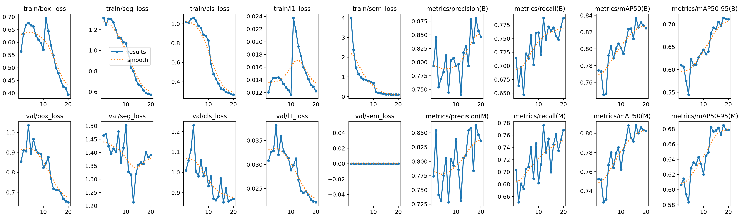
Figure 5. run5 training and validation loss and metric curves. Source: runs/run5_9class_clean_finetune/results.png

6. Deep-Dive Failure Analyses & Empirical Case Studies

6.1 Case Study 1: The Workshop Clip Panel Saw Regression (Resolution vs Viewpoint)
Input: Screen Recording 2026-09-28 124839.mp4, 1,398 frames of a sliding-table panel saw in a cluttered workshop, cropped to the camera view and restored to the 480×360 sub-stream size.
Table 30. Same frames, two checkpoints
Frame | run5 (imgsz 960) | run6 (imgsz 960) | run6 (imgsz 1280)
186 | panel_saw 0.56 | fire_extinguisher 0.20 (spurious), table_saw 0.15, panel_saw 0.11 | fire_extinguisher 0.30, panel_saw 0.18
1210 | panel_saw 0.61 | table_saw 0.16, jointer 0.13 | panel_saw 0.07
1303 | panel_saw 0.63 | fire_extinguisher 0.22, table_saw 0.14 | fire_extinguisher 0.31, panel_saw 0.13

Hypotheses tested
Table 31. Workshop-clip hypotheses
Hypothesis | Evidence | Verdict
The saw is a small object | The saw box is 266×208 px on a 480×360 frame: 55% of the width and ~32% of the area | REJECTED
Upsampling hurts | run5 on the same frame: 0.56 at imgsz 960, 0.27 at imgsz 1280 (480 px upsampled 2.7×) | CONFIRMED
run6's data mix suppressed the class | Look-alike machinery negatives; run6 ≤ 0.18 at both 960 and 1280 | CONFIRMED
Viewpoint, codec, tint and clutter gap | Present for both models; run5 still exceeds 0.5 | CONTRIBUTING
Class boundary (sliding-table saw vs table saw) | run5 names the saw table_saw at up to 0.70 on 200 sampled frames | CONFIRMED

Consequence. SAHI tiling was deprioritised, because the object is not small. Inference size is chosen per stream and never upsamples a sub-stream. Fine-tunes start from run5, and the sliding-table-saw boundary is fixed in the labels.
Implementation note: the trial recordings are not clean inputs
The CCTV tool's overlay is burned into the screen recordings. In the extinguisher clip, 41 of 65 detections at conf 0.40 are frame-filling boxes on the near-black fade-in, where only the tool's own polygon outline is visible. Both checkpoints do this. Re-record trial clips from raw RTSP with the overlay off.

6.2 Case Study 2: Camera 03 vs Camera 05 Memorization & Spatial Bias
Each labelled Camera 03 machine was matched to the highest-confidence prediction of the correct class with box IoU ≥ 0.5, at conf ≥ 0.01 (eval_run7.py).
Table 32. Camera 03 transfer (0 of 142 machines found at conf 0.25)
Model | imgsz | Presses found (of 71) at ≥0.25 / ≥0.10 / ≥0.01 | Edge banders found (of 71) | Same box, wrong class (≥0.25)
run7 best | 640 | 0 / 0 / 0 | 0 / 0 / 0 | press called edge_banding_machine 64×
run7 best | 1280 | 0 / 0 / 3 (max 0.02) | 0 / 0 / 0 | 1×
run7 last | 640 | 0 / 0 / 0 | 0 / 0 / 0 | press called edge_banding_machine 44×
run5 | 640 / 1280 | 0 / 0 / 0 | 0 / 0 / 0 | –
run6 | 1280 | 0 / 0 / 0 | 0 / 0 / 9 (max 0.03) | –

Table 33. Training camera vs unseen camera
Test | run5 | run6 | run7
Camera 05 working_panel_saw.mp4, raw squeezed, imgsz 640, 200 frames | 0/200 | 0/200 | 200/200, mean 0.97 (press 0.96, edge bander 0.82)
Same recording de-squeezed, 200 frames over 72 min | 36/200 (18%), max 0.57 | 65/200 (32%), max 0.70 | 200/200, mean 0.96 (in-sample)
Camera 03 box mAP50 (640 / 1280) | 0.000 / 0.001 | 0.000 / 0.008 | 0.010 / 0.009

The four root causes
1. A single viewpoint per class. All 257 training frames come from one fixed camera. The press, edge bander and saw occupy the same pixels in every frame, with near-identical SAM outlines. The plan's minimum for a pilot signal is ≥ 5 viewpoints per class, and this run had 1.
2. Different machine models. Camera 03's edge bander is a compact manual unit with a tape-coil plate, while Camera 05's is a long automatic line. Camera 03's press is a hot press, while Camera 05's is a large white frame press. One example per class cannot cover another model of the machine.
3. Spatial position memorisation. At imgsz 640, run7 labels the Camera 03 *press* as edge_banding_machine in 64 of 71 frames. In Camera 05 the edge bander is a long white shape at the upper centre of the image; in Camera 03 the press sits exactly there.
4. In-sample scene texture matching. run7 scores 0.96–0.97 on Camera 05 even on the raw 2:1-squeezed video, although it trained only on de-squeezed frames. Confidence that survives a 2:1 geometry change points to matching scene texture and layout, not machine shape.

6.3 Case Study 3: The Fire Extinguisher False-Alarm Explosion
Table 34. Extinguisher false alarms on a camera with no extinguishers
Model | Camera 03 extinguisher false alarms, conf ≥ 0.25, 71 frames (imgsz 640 / 1280)
run5 | 0 / 0
run6 | 32 / 2
run7 | 51 / 74

- What triggers them: run7's validation predictions place fire_extinguisher boxes on the white/yellow plastic drum, large cardboard tubes, water bottles and standing workers.
- Why they grew: run7 spent 44% of each epoch on one camera, under heavy codec and blur augmentation, with 0% hard negatives. Vertical cylinder-like shapes in that scene were never shown as negatives.
- Mitigations in run8: the 107 targeted hard negatives include yellow and blue drums, cardboard tubes, gas cylinders, water jugs, red bins, hose reels and alarm boxes. ToGray is cut to p = 0.05 so colour (red cylinder vs white drum) remains a cue.
- Still missing: CCTV-domain cylinder negatives. Camera 03 cannot supply them while it is part of the frozen benchmark.

6.4 Case Study 4: Catalog Catastrophic Forgetting During Unbalanced Fine-Tuning
Table 35. Catalog validation (2026-10-19 label build)
Model | imgsz 960: box mAP50 / box 50-95 / mask mAP50 / mask 50-95 | imgsz 1280: same order
run5 | 0.821 / 0.706 / 0.798 / 0.679 | 0.745 / 0.359 / 0.714 / 0.466
run6 | 0.825 / 0.698 / 0.813 / 0.690 | 0.810 / 0.649 / 0.795 / 0.653
run7 best (ep 7) | 0.786 / 0.597 / 0.767 / 0.633 | 0.728 / 0.509 / 0.710 / 0.553
run7 last (ep 17) | 0.792 / 0.614 / 0.771 / 0.645 | 0.770 / 0.538 / 0.744 / 0.588

- Same imgsz, run5 vs run7 at 960: −2.9 to −3.5 points of box mAP50 and −9 to −11 points of box mAP50-95; mask mAP50-95 −3.4 to −4.6. This fails the “within 2 points of run5” gate.
- Per class at 1280 (run7 vs run6): table saw 0.93 → 0.74 (best) / 0.85 (last); jointer 0.87 → 0.74 / 0.83; panel saw holds (0.85 → 0.78 / 0.85); extinguisher rises slightly (0.68 → 0.71 / 0.73).
- Replay limited the damage but did not prevent it. 56% catalog replay held mAP50 within about 3 points, but the larger mAP50-95 loss shows that localisation degraded.
- Scale caveat: run5 looks poor at 1280 only because 1280 is outside its training scale. Compare checkpoints at each one's training imgsz.

7. Critical Bug Fixes, Gotchas & Engineering Lessons

7.1 The Silent Albumentations Bypass in Ultralytics 8.4
Ultralytics builds its Albumentations block inside an import guard. If the package is missing, the whole block, including blur, median blur, ToGray, CLAHE, image compression and any custom augmentations= list, is skipped without an error. The only sign is a missing albumentations: line in the training log.
Key finding: run1 to run6 trained without photometric degradation
run1–run6 trained with no codec, blur, noise or greyscale augmentation beyond HSV jitter. erasing=0.4 in run6 is a classification-only augmentation and does nothing for segment.
Part of the CCTV gap was therefore never addressed in training, even though the recipes appeared to address it.
Fix. Albumentations 2.0.8 was installed on 2026-10-15 with --no-deps, because its dependency on opencv-python-headless would replace the GUI OpenCV build the project uses for previews. train.py now refuses to start without it:
scripts/train.py: fail fast instead of training silently without augmentation
try:
import albumentations as A
import cv2
except ImportError:
raise SystemExit(
"albumentations is not installed; Ultralytics would silently skip cctv_aug. Run:\n"
" env\\yolo-env\\Scripts\\python.exe -m pip install --no-deps albumentations albucore\n"
" env\\yolo-env\\Scripts\\python.exe -m pip install pydantic simsimd stringzilla")
Verification step for every run: confirm that the training log prints an albumentations: line listing the transforms.

7.2 Albumentations 2.x API Compatibility & Parameter Traps
Albumentations 2.x silently ignores arguments that use 1.x names and falls back to defaults. A recipe written for 1.x therefore runs, but with different strengths from the ones intended.
Table 36. 1.x to 2.x argument migration
Transform | 1.x argument (ignored in 2.x) | 2.x argument used | Conversion
ImageCompression | quality_lower=30, quality_upper=75 | quality_range=(30, 75) | Direct
Downscale | scale_min=0.4, scale_max=0.75 | scale_range=(0.4, 0.75) | Direct
GaussNoise | var_limit=(10, 50) on 0–255 pixels | std_range=(0.012, 0.028) | √10 / 255 = 0.0124; √50 / 255 = 0.0277
ShiftScaleRotate | shift_limit | not used | Geometry is left to Ultralytics

scripts/train.py (run8): the Albumentations 2.x pipeline and training call
def cctv_aug():
import albumentations as A, cv2
return [
A.OpticalDistortion(distort_limit=(-0.05, 0.25), interpolation=cv2.INTER_LINEAR,
border_mode=cv2.BORDER_REFLECT_101, p=0.35), # CCTV lens curvature
A.ImageCompression(quality_range=(30, 75), p=0.4), # H.264-like blocking
A.Downscale(scale_range=(0.4, 0.75), p=0.3), # low-res sensor / sub-stream
A.GaussNoise(std_range=(0.012, 0.028), p=0.3), # sensor noise
A.OneOf([A.MotionBlur(blur_limit=(3, 7)),
A.GaussianBlur(blur_limit=(3, 5))], p=0.15),
A.ToGray(p=0.05), # keep colour cues (red cylinders vs drums)
A.RandomBrightnessContrast(0.2, 0.2, p=0.3),
]

model.train(
data=str(args.data), epochs=50, patience=20, imgsz=960, batch=6,
device=0, workers=4, cache="ram",
optimizer="AdamW", lr0=5e-4, lrf=0.01, cos_lr=True, warmup_epochs=2,
mosaic=0.5, close_mosaic=10, scale=0.5, degrees=0.0, shear=0.0,
perspective=0.0002, translate=0.1, fliplr=0.5,
hsv_h=0.015, hsv_s=0.6, hsv_v=0.5,
copy_paste=0.3, copy_paste_mode="flip", mixup=0.0,
augmentations=cctv_aug(), project="runs", name="run8_9class_curated_cctv", exist_ok=False)
Compared with run7, the codec and sensor degradation is milder (JPEG 30–75 instead of 20–60; downscale 0.4–0.75 instead of 0.25–0.6 at p = 0.4), because run7's mAP50-95 loss pointed at localisation damage. Geometry is turned down (degrees=0, shear=0, perspective=0.0002): roll does not model CCTV pitch, and a 2D homography cannot create a 3D viewpoint.

Why optimizer=auto is dangerous
With optimizer=auto, Ultralytics ignores lr0 and momentum. It chooses SGD only for long schedules (more than 10,000 iterations); otherwise it chooses AdamW with a learning rate fitted to the class count:
Ultralytics 8.4 auto-optimizer rule
lr_fit = round(0.002 * 5 / (4 + nc), 6) # nc = 9 -> 0.01 / 13 = 0.000769
# run5 and run6 args.yaml say lr0=0.01, but both trained with AdamW at lr 0.000769
- Every run before run7 recorded lr0=0.01 (or 0.001) in args.yaml while actually training with AdamW at a learning rate 13× lower. Any hyperparameter conclusion based on lr0 from those runs is invalid.
- The rule changes silently with the class count: 23 classes give 0.000370 and 38 classes give 0.000238.
- Rule: always pass optimizer="AdamW" (or "SGD") explicitly. run8 uses AdamW, lr0 5e-4, lrf 0.01, cosine schedule.

7.3 Wide-Angle CCTV Lens Barrel Distortion Emulation
- Sign convention (verified on a grid image): in Albumentations 2.x, a negative distort_limit produces pincushion distortion and a positive one produces barrel distortion. This is the reverse of what many 1.x recipes assume.
- Wide-angle CCTV lenses produce barrel distortion, so distort_limit=(-0.05, 0.25) samples mostly barrel with a little pincushion, at p = 0.35. BORDER_REFLECT_101 avoids black corners that the model could learn as a cue.
- Labels follow the warp. Ultralytics 8.4 passes segmentation polygon vertices to Albumentations as keypoints, so polygons are distorted with the image. This was verified on rendered training batches before run8 (scripts/train.py docstring).
- Limit: distortion emulates the lens; it does not create the elevated viewpoint (Section 6.2).

7.4 Aspect Ratio Distortions: Managing 960×1080 “1080P Lite” Frames
Every factory recording is 960×1080: Hikvision's “1080P Lite” mode encodes a 16:9 picture at half width. The stream does not declare a pixel aspect ratio, so OpenCV, Ultralytics and video players show it squeezed 2:1, with machines half as wide as they really are.
- De-squeeze before labelling and evaluation. scripts/tools/sample_cctv_video.py --resize 1920x1080 resizes with cv2.INTER_CUBIC before hashing and saving. The frozen benchmark was built this way.
- Evidence of the risk: run7 still scored 0.96–0.97 on the raw squeezed video after training only on de-squeezed frames. That shows scene memorisation, and a model that has not memorised the scene sees distorted shapes.
- Sub-streams: the workshop clip is a 480×360 sub-stream. Do not upsample it to imgsz 1280 (Section 6.1).
Table 37. Native vs de-squeezed factory frames (archive/run7_cctv_pilot_2026-10/runs/inference_tests/factory_baseline)
run5 on 40 factory frames, conf 0.15 | imgsz 640 | imgsz 960 | imgsz 1280
Native squeezed 960×1080: frames with any detection | 10 | 11 | 9
De-squeezed 1920×1080: frames with any detection | 8 | 8 | 5
Native: top class (max conf) | edge bander (0.40) | edge bander (0.52) | edge bander (0.49)
De-squeezed: top class (max conf) | table saw (0.65) | edge bander (0.41) | panel saw (0.24)

All these scores are low and partly wrong-class, so the sweep cannot decide between native and de-squeezed input for run5. The recommendation follows geometry: train and infer on de-squeezed 1920×1080 frames (or their ROI crops), because those match the shapes in every catalog image. Use imgsz 960 for whole frames and the native crop size for ROIs.

7.5 NMS Independence in YOLO26 End2End Detection
- YOLO26 checkpoints run the one-to-one head by default and do not apply NMS, so iou= has no effect (ultralytics/utils/nms.py:66).
- Passing end2end=False in Python, or --nms to test_inference.py, switches to the one-to-many head with NMS at the given iou.
- Every inference summary prints the head in use, e.g. “end2end head: NMS-free, iou unused”.
- Any tuning of iou on these checkpoints so far has been a no-op. Re-run such experiments with end2end=False if the question matters.

Engineering lessons
Table 38. Lessons and the rules they produced
Lesson | Rule adopted
Validation mAP on catalog images does not predict CCTV performance (run6) | Every candidate is gated on the frozen factory benchmark and the held-out clip
Frames are not viewpoints (run7) | Weight CCTV data by distinct (camera × machine) pairs; ≤ 1–2× repeats until ≥ 5 viewpoints per class
Libraries fail silently (Albumentations, 2.x names, optimizer=auto, iou) | Fail-fast checks in train.py; explicit optimizer; verify the log
Label conventions cap accuracy (edge banders, extinguishers) | Written extent policy; instance clustering; reviewed SAM outlines
Model selection on a noise-level val picks at random (run7) | Select on catalog val or run fixed epochs; report CCTV separately
A junction makes deletes destructive | Lists define the dataset; cmd /c rmdir only

8. Edge Deployment, Real-Time Inference & Video Processing
Implementation note: status of this chapter
Sections 8.1–8.4 are the deployment design from docs/cctv_domain_adaptation_plan.md. Live RTSP ingestion, ROI cropping and the confirmation state machine have not been built or tested yet. Snippets marked as illustrative show the intended design.

8.1 Ingestion Architecture: RTSP Main Stream vs Sub-Stream Analysis
Table 39. Stream choice and inference size
Source | Resolution | Recommended inference | Notes
Sub-stream (today's trial footage) | 480×360 / 640×360 | imgsz 640; sweep {480, 640, 960}; never 1280 | Upsampling 2.7× halved run5's confidence
Main stream, 1080P Lite | 960×1080 stored, 16:9 picture | De-squeeze to 1920×1080, then imgsz 960 or ROI crops | Every factory recording so far
Main stream, full 1080p / 4 MP | 1920×1080 and up | imgsz 1280 letterboxed, or ROI crops | Machines at 25–55% of width become 270–700 px

- Record raw RTSP, never screen recordings: no overlay, no tint, no double compression. Pull the main stream. On Hikvision, channel 101 is the main stream and 102 the sub-stream; on Dahua, use subtype=0.
- Decode at 5 fps. All nine classes are stationary, and at 17–22 ms per frame one RTX 3070 Ti can serve about 8–10 cameras.
Continuous main-stream recording in 10-minute segments (PowerShell; Hikvision URL form)
ffmpeg -rtsp_transport tcp -i "rtsp://<user>:<pass>@<ip>:554/Streaming/Channels/101" `
-c copy -f segment -segment_time 600 -reset_timestamps 1 -strftime 1 `
cam01_%Y%m%d_%H%M%S.mp4

8.2 Static Camera ROI Cropping Strategy (Why SAHI was Deprioritized)
- The machines are not small: the workshop saw is 32% of the frame area. On a 480×360 stream, tiling only re-samples the same pixels, adding cost without adding information.
- SAHI's cost: a 4K frame cut into 1280 px tiles with 20% overlap needs about 6–9 forward passes. sahi is not installed.
- When SAHI would help: only on a wide-angle main stream of at least 2560 px with targets under ~3% of the frame width (under ~40 px at imgsz 1280), such as extinguishers on far walls.
- Static ROI crops instead. Cameras and machines do not move. Define 1–3 ROIs per camera once, crop each from the main stream at native resolution, run the model on the crop, and map masks back. A full-frame pass every 30th frame catches relocated items.
Per-camera ROI configuration (illustrative)
# config/cameras/cam05.yaml (illustrative; not yet implemented)
camera: cam05
stream: rtsp://<ip>:554/Streaming/Channels/101
desqueeze: [1920, 1080] # 1080P Lite source
full_frame_every: 30 # frames
rois:
- name: panel_saw_bay
xyxy: [180, 240, 1180, 900]
classes: [panel_saw]
- name: press_and_bander
xyxy: [820, 120, 1900, 760]
classes: [hydraulic_press, edge_banding_machine]

8.3 Multi-Frame Temporal Filtering: ByteTrack Association & 8-of-15 Window Rules
Because every class is stationary, the job is presence confirmation per location. Detection runs at a low threshold (conf 0.10), ByteTrack associates detections over time, and a hysteresis state machine decides presence.
Table 40. Suggested bytetrack.yaml overrides
ByteTrack parameter | Value | Effect
track_high_thresh | 0.35 | First-stage matching threshold
track_low_thresh | 0.10 | Second stage: low-confidence detections extend existing tracks
new_track_thresh | 0.45 | Confidence needed to start a track
track_buffer | 50 | 10 s at 5 fps before a lost track is dropped
match_thresh | 0.8 | Association IoU cost

- Set the tracker explicitly with model.track(..., tracker="bytetrack.yaml", persist=True, conf=0.10). The Ultralytics default here is tracktrack.yaml. BoT-SORT's camera-motion compensation is wasted on fixed mounts.
- Confirm a track when at least 8 of the last 15 frames (3 s) have a matched detection with mean confidence at or above the class threshold.
- Drop a track when 2 or fewer of the last 15 frames match, sustained for track_buffer.
- Class: a confidence-weighted vote over the track's lifetime. This prevents single-frame flips such as the table_saw/panel_saw flip at frame 186.
- Active learning: log frames where a confirmed track's confidence drops below 0.3, or where the class vote is split. They form the next labelling queue.
8-of-15 confirmation with hysteresis (illustrative)
from collections import deque
class Presence: # one per track or ROI (illustrative)
def __init__(self, thr, n=15, on=8, off=2):
self.hits, self.thr, self.on, self.off, self.state = deque(maxlen=n), thr, on, off, False
def update(self, conf): # conf = matched detection confidence, or None
self.hits.append(conf is not None and conf >= self.thr)
k = sum(self.hits)
if not self.state and k >= self.on: self.state = True
elif self.state and k <= self.off: self.state = False
return self.state

8.4 Per-Class Operational Confidence Thresholds & Decision Logic
The only per-class thresholds measured so far come from run6's catalog validation curves. They are a starting point, and must be re-derived from CCTV validation data once a held-out camera set exists.
Table 41. Operating thresholds
Class | Per-frame threshold | Basis | Status
edge_banding_machine | 0.20 | F1 peak at conf 0.16; recall collapses above 0.3 | PROVISIONAL
fire_extinguisher | 0.30 | F1 plateau 0.15–0.45 | PROVISIONAL
All other classes | 0.40 | Aggregate F1 plateau 0.20–0.50 (P ≈ 0.87, R ≈ 0.72) | PROVISIONAL
Detection floor (feeds the tracker) | 0.10 | ByteTrack second-stage matching | DESIGN

Applying per-class thresholds with the existing harness (--conf is the default for unlisted classes)
env\yolo-env\Scripts\python.exe scripts\test_inference.py ^
--weights <best.pt> --source <video> --imgsz 960 --conf 0.40 ^
--class-conf "edge_banding_machine=0.20,fire_extinguisher=0.30"
Table 42. Decision logic (proposed)
Event | Condition | Action
Machine present | Confirmed track inside its ROI (8 of 15) | Update the inventory state; no alert
Machine not seen | No confirmed track in the ROI for N minutes during working hours | Low-priority inventory alert for human check
Extinguisher confirmed | Confirmed track at a registered wall position | Mark the position as verified
Extinguisher not confirmed | No confirmed track at a registered position | Mark as unverified, queue for human review. Never raise an alarm
Low-confidence or split vote | Confirmed track with per-frame conf < 0.3, or a split class vote | Save the frame to the active-learning queue
Tiny spurious box | Machine box < 0.3% of frame area, extinguisher < 16×16 px | Discard before tracking

9. The Frozen Factory CCTV Benchmark & Production Verification Gates

9.1 Dataset Isolation Protocol: The 328-Frame Frozen Benchmark
Frozen on 2026-10-21 (docs/cctv_benchmark.md). The benchmark is a permanent, strictly held-out test set. Frames were sampled at 1 frame every 3 s, de-squeezed to 1920×1080, capped at 120 per recording, and named cctv_<camera>-<date>-<time>_f<frame>.jpg.
Table 43. Benchmark composition
Recording | Camera | Date | Frames
ch03_20260907165321 | cam03 | 2026-09-07 | 37
ch03_20260924144142 | cam03 | 2026-09-24 | 34
working_panel_saw | cam05 | 2026-09-25 | 120 (cap, spread over 72 min)
panel_saw_hydraulic_lift | cam05 | 2026-09-28 | 120 (cap)
ch05_20260928130326 | cam05 | 2026-09-28 | 17
Total | 2 cameras | 5 recordings | 328 (71 cam03 + 257 cam05)

Table 44. Benchmark labels
Class | Instances | Note
panel_saw | 257 | cam05 only
hydraulic_press | 328 | both cameras
edge_banding_machine | 328 | both cameras
Other six classes | 0 | Any detection is a false positive, especially fire_extinguisher on the Camera 03 drum

- Label method: SAM 2.1 box prompts clipped to each machine's consensus outline, with workers and on-screen text subtracted and at least 40% visibility. Spot-checked, not hand-drawn.
- Known limits: plywood lying on the saw table is inside the panel_saw outline; the far end of the sliding carriage is unlabelled; press edges are approximate behind board stacks; frames are correlated, so each camera is effectively one viewpoint.
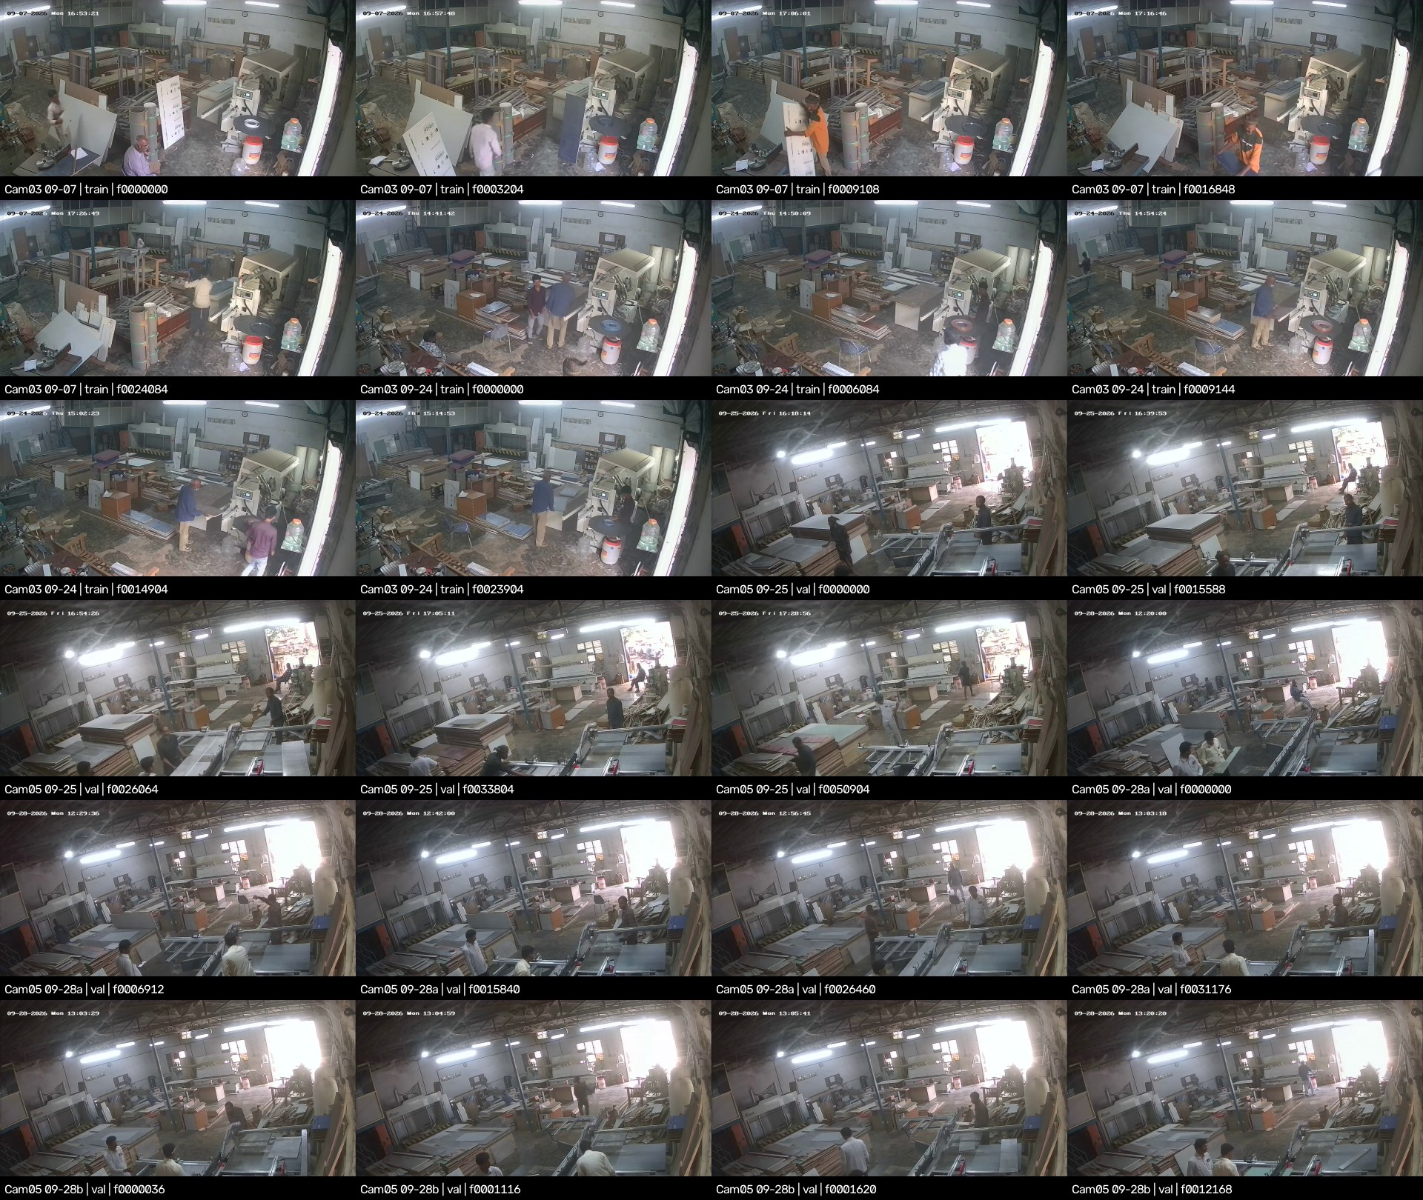
Figure 6. Contact sheet of the factory recordings (Camera 03 and Camera 05). Source: docs/factory_footage_contact_sheet.jpg
Benchmark evaluation (equivalent to the one-liner in docs/cctv_benchmark.md)
from ultralytics import YOLO # run with env\yolo-env\Scripts\python.exe
YOLO(r"<weights>").val(data=r"datasets\9class\data_9class_cctv_benchmark.yaml",
imgsz=960, plots=False)
Report: per-class and per-camera mask mAP50; recall at the operating threshold; false positives per frame for the absent classes.

9.2 Validation Rules: Zero-Tolerance Leakage Guardrails
Table 45. Leakage guardrails
Rule | Enforcement
Never train on benchmark frames, or on any other frame from Camera 03 or Camera 05 (factory_dat\) | train.py exits if the data file is the benchmark yaml or references cctv_factory_intake
Never use the benchmark for checkpoint selection, early stopping or threshold tuning | The benchmark yaml is never the val of a training data file
Never mine hard negatives from benchmark cameras | Procedure; Camera 03 drum crops are prohibited while it is in the benchmark
Split by camera, never by frame | camera_splits.yaml marks every recording test; build_cctv_hybrid_dataset.py fails if a camera lands in two splits
Retire contaminated lists | run7's hybrid lists (which trained on Camera 05) are archived in archive/run7_cctv_pilot_2026-10/datasets_9class/

Key finding: what the benchmark can and cannot show
It covers 3 of 9 classes and 2 viewpoints, so it measures transfer to these two cameras, not general CCTV readiness.
Release gate 1 asks for a CCTV test set from held-out cameras or a held-out site. The benchmark is the start of that set, and footage from at least one more camera is needed.

9.3 Gate Criteria for Champion Model Deployment
The plan (docs/cctv_domain_adaptation_plan.md §5.3) defines four gates, and all of them must pass before handoff.
Table 46. Release gates
Gate | Criterion | run5 today | run8
1. CCTV-test accuracy | Per-class mask mAP50 ≥ 0.60 and recall ≥ 0.80 at the operating threshold. Classes with < 50 test instances are reported but not gated | FAIL (0.054 / 0.010) | PENDING
2. False alarms | ≤ 1 false positive per camera-hour after temporal confirmation; ≤ 1% image-level false positives before it, on ≥ 300 negative images | NOT MEASURABLE YET | PENDING
3. No forgetting | Catalog val: mask mAP50-95 drop ≤ 2.0 points vs run5 (plan definition). Also report box mAP50 (the run7 report applied it to box mAP50) | REFERENCE | PENDING
4. Trial clips | Re-recorded from RTSP without the overlay; must beat run5 on the workshop saw | CLIPS NOT RECORDED | PENDING

- Gate 3 baseline: re-measure run5 on the current 450-image val (box, mask, and both mAP50-95) before comparing. The 2026-10-21 values (0.789 / 0.741; mAP50-95 0.665 / 0.632) belong to the 461-image val.
- Gate 2 needs data that does not exist yet: hours of empty-scene footage and a negative CCTV image set from non-benchmark cameras.

10. Current Handoff Status, Outstanding Curation & Future Roadmap

10.1 Immediate Execution Tasks: Training Run 8 & Validating Curation Lists
1. Let run8 finish. It was resumed on 2026-10-23 at 17:07 from last.pt (50 epochs planned, patience 20). Do not start another GPU job alongside it on the 8 GB card.
2. Investigate the epoch time (3,525 s for epoch 1, against run5's 111 s): check GPU utilisation during epoch 2, and the dataloader worker CPU load (Section 2.1).
3. Re-baseline run5 on the current val: YOLO(r'runs\run5_9class_clean_finetune\weights\best.pt').val(data=r'datasets\9class\data_9class.yaml', imgsz=960).
4. Evaluate run8 `best.pt` and `last.pt` on the same val at imgsz 960, on the frozen benchmark (Section 9.1) and on the workshop clip at imgsz 640 and 960. Apply the gates in Section 9.3.
5. `datasetchange` validation: done on 2026-10-21. Audit PASS; viewer VERIFY PASS; 0 quarantined images listed; 110 of 110 fixes with valid polygons. Remaining: a human pass over the before/after sheets in label_fixes/review_user_fixes/, and a decision on the 6 self-intersecting polygons.
6. Note for comparisons: edge bander now has only 22 validation instances, so its AP will be noisy.

10.2 Pending Class Boundary Refinements
Table 47. Outstanding class-boundary and curation decisions
Item | Evidence | Proposed decision | Status
Sliding-table saw vs table_saw | run5 calls the workshop sliding-table saw table_saw (max 0.70); run6 val shows 0 panel/table confusions, so the boundary problem is in the catalog labels | Re-label sliding-table saws as panel_saw; write the boundary sheet with example images | OPEN
Veneer press | 12 veneer-press negatives removed because the Camera 03 press is a woodworking hot press | Relabel them as hydraulic_press instead of leaving them out | OPEN
Drum / wide-belt sanders vs planer | 8 kept as negatives; boxy feed-through machines | Keep as negatives; add examples to the boundary sheet | POLICY
Spindle and four-sided moulders vs planer / table_saw | 14 kept as negatives | Keep as negatives; spindle moulder = negative | POLICY
64 quarantined images | 60 edge-bander collages and multi-machine scenes, 4 dense extinguisher rows | Hand re-annotation (optional; restores 16 val images) | OPEN
High-angle #5 and #94 | SAM failed on both | Hand-draw or drop | OPEN
FE_00025 hose fragment | A detached hose fragment in the label | Decide whether the hose belongs to the cylinder instance | OPEN

Procedure for restoring a quarantined image: re-draw it by hand following Chapter 4, put the corrected source label in datasets/source_38class/<split>/labels/, remove its stem from label_decisions.yaml, then re-run the build and the audit.

10.3 Long-Term Roadmap: Multi-Camera Tracking, Night IR Adaptation & Worker Perimeter Zones
Table 48. Roadmap
Horizon | Workstream | Detail | Depends on
Next | Viewpoint capture | Raw RTSP main stream for ≥ 24 h per camera across shifts and IR night; a camera inventory; pseudo-CCTV phone video (3–4 m high, pitched down 25–50°) of machines no camera covers. Target ≥ 5 viewpoints per class | Site access
Next | CCTV val and test | Assign whole cameras to train / val / test; build the hard-negative CCTV set (≥ 300 images) before any training | Capture
Next | Class-boundary sheet | Settle the Section 10.2 items before labelling CCTV | –
Mid | Option B release retrain | Retrain from COCO yolo26s-seg after the label fixes (AdamW lr0 1e-3, 150 epochs, patience 30) | Labels settled
Mid | Multi-camera presence | Per-camera ByteTrack and ROI state machines feeding a site-level registry keyed by (camera, ROI). Stationary objects need no cross-camera re-identification, only one registry entry per physical machine | Section 8 pipeline
Mid | Night IR adaptation | Collect IR-night frames; add an IR val split; raise ToGray probability for an IR model or train an IR-specific checkpoint. The earlier extinguisher sweep scored about 0 in greyscale at every size | IR footage
Mid | Worker perimeter zones | Run a COCO person detector beside the 9-class model; zone = machine mask dilated by a set margin; dwell-time rules per zone; privacy review before deployment | Confirmed machine masks
Ongoing | Active learning | Weekly labelling of logged low-confidence and split-vote frames; monthly fine-tune with replay; re-run all gates | Deployment
Optional | Synthetic elevated views | CAD or 3D renders at 2.5–5 m height and 20–55° pitch, with degradation, for classes with < 10 real viewpoints | 3D assets

10.4 Document Revision History & Technical Ownership Sign-Off
Table 49. Revision history
Version | Date | Change | Author
2.4 | 2026-10-23 | First consolidated dossier, compiled from the project reports and run artifacts listed below. Earlier versions were not issued as a single document. | Claude (Claude Code)

Table 50. Source reports
Source report | Date | Content
docs/runsummary.md | 2026-10-07/08 | run6 audit, trial-video re-test
docs/run_analysis_10q.md | 2026-10-08 | Ten technical questions with source citations
docs/cctv_domain_adaptation_plan.md | 2026-10-10 | CCTV plan, recipe, release gates
CHANGELOG_REORGANIZATION.md | 2026-10-10 | Workspace merge, junctions, rollback
docs/cctv_scrape_postmortem.md | 2026-10-15 | Web-scrape audit
docs/cctv_ingestion_runbook.md, docs/factory_footage_analysis.md | 2026-10-15/19 | Ingestion tools; factory footage
docs/run7_analysis_report.md | 2026-10-19 | run7 post-training analysis
docs/label_policy.md, docs/cctv_benchmark.md, docs/dataset_layout_9class.md | 2026-10-21 | Label overhaul, benchmark, dataset layout
docs/todo.md | 2026-10-14 to 10-21 | Handoff checklist

Sign-off. This dossier records engineering state. It does not approve deployment. Approval requires the gates in Section 9.3 and the signatures below.
Table 51. Technical ownership sign-off
Role | Name | Signature | Date
Technical owner (ML)
Data and labelling reviewer
Operations / safety stakeholder

Appendix A. Reconciliation of the Authoring Brief with Project Artifacts
The brief for this dossier listed project facts. Most matched the artifacts. The table records every difference and the value this document uses.
Table 52. Brief vs artifacts
# | Brief stated | Artifacts show | Used here
1 | run5 catalog box mAP50 82.1% | 0.821 is run5 at imgsz 960 on the 2026-10-19 label build (run7 report). Its own log ends at 0.825 (best 0.832 at epoch 18; PR legend 0.831) | All three, labelled by val set
2 | run8 is the training recipe (implied: not yet trained) | run8 started 2026-10-22 00:13; epoch 1 logged; resumed 2026-10-23 17:07 | In progress
3 | run8 negatives 11.6% | 11.6% before the datasetchange curation; 11.8% of the current 3,298-entry list | 11.8%
4 | 64 quarantined “diagrams, text-heavy collages” | 60 edge-bander images (collages, infographics, insets, multi-machine) + 4 dense extinguisher rows; plus 80 user-quarantined and 3 excluded on 2026-10-21 | Artifact breakdown
5 | Gate 3: catalog score within 2.0 points of run5 | Plan §5.3 defines it as mask mAP50-95 drop ≤ 2 points; the run7 report applied it to box mAP50 | Plan definition; report both
6 | Model family yolo26s-seg / yolo26n.pt | Every segmentation run descends from yolo26s-seg.pt; yolo26n.pt is stored but unused | yolo26s-seg
7 | Runs 1 and 2 on a Roboflow/scraped dataset | Consistent: pipeline scrape plus Roboflow polygon export | Confirmed
8 | run6 detected 0 machines at conf 0.40 across 1,398 frames | Correct, for the workshop clip only | Scoped to the clip
9 | CCTV streams are 960×1080 or 480×360 sub-streams | Factory recordings are 960×1080; the 480×360 source is the workshop screen recording restored to sub-stream size | Scoped per source
10 | Frozen benchmark: 328 frames, 71 cam03 (2 recordings), 257 cam05 (3 recordings) | Matches docs/cctv_benchmark.md | Confirmed
11 | run7: catalog box mAP50 −3 points, mAP50-95 −9 to −11 | Matches, at imgsz 960 | Confirmed
12 | Per-class P and R for run5 | Not exported by run5's training; only per-class AP50 (PR legends) | AP50 only for run5
13 | Run 5 trained “with AdamW” | optimizer=auto resolved to AdamW at lr 0.000769 (args.yaml says lr0 0.01) | Resolved values
14 | Pipeline README: 23 classes | config.py lists 38 slugs | 38

