Industrial Machine Instance Segmentation & CCTV Domain Adaptation Dossier
  - Architecture, Data Pipelines, Empirical Failure Modes, and Production Readiness for 9-Class YOLO26-seg

Project: Krish: 9-Class Industrial Woodworking Machinery Instance Segmentation & CCTV Domain Adaptation
Project Version 2.5 | Status: Active Engineering | Target: Factory Safety & Inventory
Document date: 23 October 2026 | Workspace: Krish\ project root (Windows 11, RTX 3070 Ti)
Voice: written as the Krish engineering team's account of the work. Compiled by Claude (Claude Code) from the project's own artifacts; sign-off in Section 10.4.
Architectural discovery: how to read this
This is the story of what we set out to build, where our assumptions failed, why some early metrics fooled us, and what we changed. The tables carry the numbers; the text explains why they moved.
Every figure comes from a project artifact: run logs, the reports in docs/, scripts/train.py and the pipeline source in pipeline/pipeline/. Where a brief or an earlier design document disagrees with the code or the logs, we go with the code and logs, and Appendix A lists every such case.
Contents
1. Executive Summary & System Overview
1.1 Purpose, Operational Scope & Safety Objectives
1.2 The 9-Class Taxonomy & Visual Differentiation Matrix
1.3 Chronological Milestones & Current State (October 2026)
1.4 Executive Scorecard: Run 1 through Run 8 Comparison
2. Infrastructure, Tooling & Technical Environment
2.1 Compute, GPU & Software Stack Specifications
2.2 Workspace Architecture & NTFS Junction Symlink Strategy
2.3 The YOLO26 Architecture: End-to-End Head vs Auxiliary NMS Head
2.4 Tooling Suite: Training, Evaluation Harness and Annotation Utilities
3. The I4I Data Harvesting & Curation Architecture
3.1 The Core Philosophy: Why Automated Web Harvesting
3.2 Architecture at a Glance
3.3 Stage 1: Reference Manifest & Exemplar Ingestion
3.4 Stage 2: Multi-Template Web Scraping
3.5 Stage 2c: The Batch Acceptance Gate
3.6 Stage 3: Integrity, De-duplication & Resolution Hygiene
3.7 Stage 4 & 4b: Hybrid OpenCLIP Semantic Filtering & Calibration
3.8 Stage 5: Embedding Diversity & K-Selection
3.9 Stage 6: Auto-Annotation with Gemini Vision & SAM 2
3.10 The CCTV Web-Scrape Reality Check
3.11 Lessons From Building the Engine
4. Label Engineering, Spatial Policies & Dataset Sanitization
4.1 The 2026-10-21 Label Overhaul
4.2 Class Extent Policies: Edge Banders vs Fire Extinguishers
4.3 SAM 2.1 Large and How We Used It
4.4 Quarantine, Manual Curation & Hard Negatives
4.5 Integration of High-Angle Overhead Industrial Images
5. Model Training History & Quantitative Benchmarks
5.1 Run 1–4 Historical Context (23-Class to 38-Class Habitat Experiments)
5.2 Run 5: The Generalist Champion
5.3 Run 6: The “CCTV-Robust” Fine-tune & Uncovered Regressions
5.4 Run 7: CCTV Pilot Hybrid Experiment & Catastrophic Overfitting Breakdown
5.5 Master Training Metrics Matrix
6. Deep-Dive Failure Analyses & Empirical Case Studies
6.1 Case Study 1: The Workshop Clip Panel Saw Regression (Resolution vs Viewpoint)
6.2 Case Study 2: Camera 03 vs Camera 05 Memorization & Spatial Bias
6.3 Case Study 3: The Fire Extinguisher False-Alarm Explosion
6.4 Case Study 4: Catalog Catastrophic Forgetting During Unbalanced Fine-Tuning
7. Critical Bug Fixes, Gotchas & Engineering Lessons
7.1 The Silent Albumentations Bypass in Ultralytics 8.4
7.2 Albumentations 2.x API Compatibility & Parameter Traps
7.3 Wide-Angle CCTV Lens Barrel Distortion Emulation
7.4 Aspect Ratio Distortions: Managing 960×1080 “1080P Lite” Frames
7.5 NMS Independence in YOLO26 End2End Detection
8. Edge Deployment, Real-Time Inference & Video Processing
8.1 Ingestion Architecture: RTSP Main Stream vs Sub-Stream Analysis
8.2 Static Camera ROI Cropping Strategy (Why SAHI was Deprioritized)
8.3 Multi-Frame Temporal Filtering: ByteTrack Association & 8-of-15 Window Rules
8.4 Per-Class Operational Confidence Thresholds & Decision Logic
9. The Frozen Factory CCTV Benchmark & Production Verification Gates
9.1 Dataset Isolation Protocol: The 328-Frame Frozen Benchmark
9.2 Validation Rules: Zero-Tolerance Leakage Guardrails
9.3 Gate Criteria for Champion Model Deployment
10. Current Handoff Status, Outstanding Curation & Future Roadmap
10.1 Immediate Execution Tasks: Training Run 8 & Validating Curation Lists
10.2 Pending Class Boundary Refinements
10.3 Long-Term Roadmap: Multi-Camera Tracking, Night IR Adaptation & Worker Perimeter Zones
10.4 Document Revision History & Technical Ownership Sign-Off
Appendix A. Where Briefs and Design Documents Differ From the Code

1. Executive Summary & System Overview
The big picture
We are building a model that watches fixed factory CCTV and outlines nine things: seven woodworking machines, an industrial press, and fire extinguishers. The outlines feed three uses: knowing which machines are where (inventory), drawing hazard zones around the dangerous ones, and confirming that extinguishers are on the wall.
The hard part has never been the catalog photos. Our models have scored above 80% mAP50 on those since September. The hard part is that a ceiling camera in a dusty workshop sees these machines from an angle, at a resolution and through a codec that no web photo shows. Most of this dossier is about that gap.

1.1 Purpose, Operational Scope & Safety Objectives
- Inventory and presence: confirm which machines each camera sees and that they stay put. All nine classes are stationary, so the deployment design confirms presence per location; it does not track motion.
- Safety perimeter zoning: the machine mask, dilated by a margin, becomes the hazard zone around saws, planers, jointers and presses. Detecting people is a separate model (Section 10.3).
- Fire-safety monitoring: find extinguishers and confirm they are still at their wall positions.
Key finding: what this system must never be
• It is an assistive signal, not a safety interlock. It never gates machine power.
• A missing extinguisher detection must never raise a compliance alarm. Our best validation run still missed 46% of extinguishers, and 61% in crowded scenes.

1.2 The 9-Class Taxonomy & Visual Differentiation Matrix
Class ids follow datasets/9class/data_9class.yaml. Sizes are typical industry ranges for orientation, not measurements from this project. The last column records confusions we actually measured.
Table 1. Classes, cues and measured confusions
ID | Class | Typical size | How we tell it apart | Where it gets confused (evidence)
0 | panel_saw | Carriage 2.6–3.8 m | Long sliding carriage with an outrigger crosscut table | table_saw: run5 calls the workshop sliding-table saw table_saw (up to 0.70)
1 | hydraulic_press | 2–4 m wide frame | Heavy frame, platens, cylinders | Veneer / hot presses; Camera 03's hot press vs Camera 05's frame press
2 | table_saw | 0.6×0.8 m to 1.2×2 m | Blade through a flat table, rip fence, cabinet base | panel_saw; small benchtop saws
3 | planer | 0.6–1.2 m body | Enclosed box; stock fed underneath; depth handwheel | jointer (6% of planers, run6); drum sanders, moulders
4 | jointer | 1.5–2.5 m beds | Open low beds with the cutter on top and a side fence | planer
5 | band_saw | 1.5–2.2 m tall | Two wheel housings and a continuous blade | Drill presses; mitre saws
6 | miter_saw | 0.5–0.9 m | Pivoting arm over a turntable | band_saw; 28% missed (run6)
7 | edge_banding_machine | 1.5 m (manual) to 8 m+ (line) | Enclosed body, tape coil disc, attached conveyors | Conveyors, extrusion lines; historically frame-filling labels
8 | fire_extinguisher | 0.4–0.9 m | Red cylinder with handle, hose and nozzle | Drums, gas cylinders, tubes, standing workers (run7)

1.3 Chronological Milestones & Current State (October 2026)
Table 2. Milestones
When | What happened | What we learned
Sep 15–18 | run1–run4: 23-class and 38-class web-data models | Breadth costs accuracy; the 38-class model became run5's parent
Sep 25 | run5: 9-class fine-tune | Champion; still the baseline today
Oct 5–8 | run6 “CCTV-robust” and its audit | Higher val mAP, worse on real video
Oct 10–15 | CCTV plan, workspace merge, CCTV web scrape and post-mortem | The web has almost no CCTV views of these machines
Oct 19 | Factory footage (2 cameras) and run7 | One camera per class teaches the scene, not the machine
Oct 21 | Label overhaul, frozen benchmark, high-angle images, manual curation | Labels were capping two classes
Oct 22–23 | run8 started, then resumed | In progress; not yet evaluated

Where we stand (23 October 2026): run5 is the fallback and the parent of every future fine-tune. run6 and run7 must not be deployed. run8 is training (1 of 50 epochs logged). The dataset is 2,200 / 450 / 473 labelled train / val / test images, and the train list holds 3,298 entries with 11.8% negatives. The 328-frame factory benchmark is frozen for testing only.

1.4 Executive Scorecard: Run 1 through Run 8 Comparison
Table 3. Every run at a glance (each on its own validation set)
Run | Classes / base / imgsz | Val box / mask mAP50 | On real footage | Verdict
run1 | 23 / COCO / 960 | 0.777 / 0.755 | not tested | SUPERSEDED
run2 | 23 / run1 / 960 | 0.787 / 0.765 | not tested | SUPERSEDED
run3 | 38 / COCO / 960 | 0.608 / 0.544 | not tested | RUN5'S PARENT
run4 | 38 / run3 / 960 | 0.611 / 0.552 | not tested | SUPERSEDED
run5 | 9 / run3 / 960 | 0.825 / 0.802 | Workshop saw found (0.56–0.63); 0 extinguisher false alarms | CHAMPION
run6 | 9 / run5 / 1280 | 0.810 / 0.795 | Workshop saw lost (≤ 0.18); 0 detections at 0.40 in 1,398 frames | DO NOT DEPLOY
run7 | 9 / run5 / 1280 | 0.786 / 0.767 (catalog, 960) | 100% on its training camera; 0 of 142 on an unseen one | ARCHIVED
run8 | 9 / run5 / 960 | 0.830 / 0.813 (epoch 1) | not yet tested | TRAINING

Validation sets differ between eras, and they shrank again on 2026-10-21, so read the mAP column as a trend within an era. On the current cleaned validation set, run5 scores box 0.789 / mask 0.741 (measured on 461 images before the final curation). It must be re-measured on today's 450-image set before anyone compares it with run8. On the factory benchmark, run5 scores mask mAP50 0.054 (imgsz 640) and 0.010 (imgsz 960). That gap is the real problem.

2. Infrastructure, Tooling & Technical Environment
The big picture
Everything runs on one Windows workstation with an 8 GB RTX 3070 Ti. That shaped several decisions: batch sizes, the zero-copy dataset layout, and an NMS-free model for real-time inference. This chapter keeps only what you need to reproduce a run or hand the project over.

2.1 Compute, GPU & Software Stack Specifications
Table 4. Stack
Component | What we use | Why it matters
GPU | RTX 3070 Ti, 8 GB | Batch 6 at imgsz 960, batch 4 at 1280
Environment | Python 3.10 venv env\yolo-env; torch 2.13.0+cu130; Ultralytics 8.4.123 | Pinned; the venv launchers were rebuilt after the 2026-10-10 move
Augmentation | Albumentations 2.0.8 (installed --no-deps) | Keeps the GUI OpenCV build. Without it, Ultralytics silently skips degradation (Section 7.1)
Models | yolo26s-seg lineage; SAM 2.1 Large for annotation | SAM L is the annotation default since 2026-10-21
Speed | 12–16 ms per frame inference at 1280; 17–22 ms end-to-end | 45–60 FPS, so one GPU can serve 8–10 cameras at 5 fps

Implementation note: run8 is training about 30 times slower than run5
Epoch 1 took 3,525 s, against 111 s per epoch for run5 at the same imgsz, so 50 epochs could take about two days. Our suspects are CPU-bound Albumentations with workers=4 and the RAM cache fill. We have not confirmed either; the first check is GPU utilisation during epoch 2.

2.2 Workspace Architecture & NTFS Junction Symlink Strategy
After the 2026-10-10 merge (68 logged moves, nothing deleted), the project has one root. The decision that matters is the dataset layout: each datasets\9class\<split>_9class\images is an NTFS junction to the 38-class image folder, so the 8,119 train images are stored once. The .txt lists, not the folders, define the dataset. Ultralytics reads only the listed paths and maps each one to ...\labels\ by string substitution, so unlisted images are never seen. The build rewrites the 9-class labels from scratch every time.
Key finding: the one rule that can destroy data
Deleting “unused” files inside *_9class\images deletes the originals in source_38class. Never run Remove-Item -Recurse on a junction either; remove it with cmd /c rmdir. Point training at the yaml or .txt lists, never at the images folder.
Re-link the junctions after moving the project (CHANGELOG_REORGANIZATION.md)
foreach ($s in 'train','valid','test') {
cmd /c rmdir "datasets\9class\${s}_9class\images"
New-Item -ItemType Junction -Path "datasets\9class\${s}_9class\images" -Target "$PWD\datasets\source_38class\$s\images"
}
A full rollback of the merge means replaying reorg_move_log.csv (src,dst) in reverse, then re-linking as above.

2.3 The YOLO26 Architecture: End-to-End Head vs Auxiliary NMS Head
YOLO26 trains two heads. The default one-to-one head assigns one prediction per object and skips NMS, which keeps latency flat and the output deterministic. The one-to-many head behaves like classic YOLO and needs NMS. The catch: on our checkpoints iou= does nothing unless you pass end2end=False (or --nms in test_inference.py). We set iou=0.45 for weeks before we noticed.
Still to test: whether the one-to-many head recovers crowded extinguishers. Recall is 86% for a lone cylinder but 39% when three or more share an image. Run the crowded subset with both heads at the same confidence and compare recall and duplicates.

2.4 Tooling Suite: Training, Evaluation Harness and Annotation Utilities
Table 5. The tools you will actually use
Tool | What it is for
scripts/train.py | The run8 recipe. It refuses to start without Albumentations, refuses the frozen benchmark, and never overwrites a run
scripts/test_inference.py | Image, folder or video inference with per-class thresholds (--class-conf), --nms, and CSV/JSON/Markdown logs
tools/build_clean_9class_dataset.py | Builds the 9-class labels and lists: merges, quarantines, manual fixes, negatives, junctions
tools/audit_dataset_distribution.py | Blocking dataset checks; must report PASS before training
tools/fix_user_labels.py, fix_edge_bander_labels.py, annotate_highangle.py | SAM 2.1 box-prompt re-annotation workflows with review sheets
tools/sample_cctv_video.py | De-duplicated frame sampling from CCTV video; --resize 1920x1080 un-squeezes 1080P Lite
tools/build_dataset_viewer.py | A browsable gallery of exactly what training sees (docs/viewer/index.html)

Rebuild, audit, train, test
env\yolo-env\Scripts\python.exe scripts\tools\build_clean_9class_dataset.py
env\yolo-env\Scripts\python.exe scripts\tools\audit_dataset_distribution.py
env\yolo-env\Scripts\python.exe scripts\train.py --name run9_<description>
env\yolo-env\Scripts\python.exe scripts\test_inference.py --weights <best.pt> --source <video> ^
--imgsz 960 --conf 0.40 --class-conf "edge_banding_machine=0.20,fire_extinguisher=0.30"

3. The I4I Data Harvesting & Curation Architecture
The big picture
In September we had no factory footage and almost no labelled images of edge banders, jointers or panel saws. Public datasets barely cover them. So we built an engine, I4I (now pipeline/), that harvests web images per class, filters them with CLIP, removes near-duplicates and sends the survivors through an automatic Gemini + SAM 2 labelling loop into Roboflow. That engine produced the data behind every model from run1 onwards.
It worked for what it was designed to do: clean, well-lit, recognisable photos of each machine. It could not do the one thing we later asked of it, which was to find CCTV views. This chapter explains how each stage works, what it actually does in code (some of it differs from the original design document), and where it hit its limits.

3.1 The Core Philosophy: Why Automated Web Harvesting
- Bootstrap rare classes cheaply. A 38-class detector needs hundreds of images per class. Hand-collecting them for classes like mortisers, veneer presses or edge banders would have taken weeks. A scrape-and-filter loop produces a class in hours.
- Source diversity on purpose. The design (pipeline/machine-type-classifier-prd.md) expands each class across query templates for angle, distance, workers and occlusion, rather than hoping filtering would create diversity afterwards.
- Let a person stay in the loop only where it pays. Humans pick a handful of reference images per confusable class and review contact sheets. CLIP, Gemini and SAM do the bulk work.
- We knew about the domain gap from day one. The design document warns that scraped photos are “clean, well-lit, catalog-style” while deployment is elevated CCTV, and that the gap “needs to be measured, not assumed.” It planned a small real-world canary set (5–10 images per class, dataset/real_validation/). That folder was never created, and that is one reason the gap surprised us later.

3.2 Architecture at a Glance
Table 6. The pipeline, stage by stage
Stage | Script | Input → output | Gate
1 | utils/manifest_gen.py, stage1_ingest_refs.py | Hand-picked photos → reference_images/<class>/ | ≥ 3 references per confusable class (warning)
2 | stage2_scrape.py, batch_topup_300.py | Class + templates → raw JPEGs in dataset/train/<class>/ | Keyword blocklist, decode check, min side 200 px
2c | stage2c_accept_gate.py | Tagged batch → accepted / _gate_rejected/ | Cross-class and catalog duplicates, CLIP scene and class rank
3 | stage3_clean.py | Raw → clean | Corrupt files, min side 150 px, pHash ≤ 8
4 / 4b | stage4_clip_filter.py, stage4b_calibrate.py | Clean → on-class | CLIP text ≥ 0.18; reference similarity ≥ 0.30
5 | stage5_diversity_kselect.py | On-class → diverse set | Drop if cosine > 0.95 to a kept image; floors 80 / 150
6 | upload_polygon_annotations.py + Roboflow workflow | Images → polygons in Roboflow | Gemini class check; SAM polygon

Two drivers tie the stages together. run.py walks one class through stages 2–5 interactively, asking for confirmation at each boundary. batch_topup_300.py is the unattended version: it scrapes with 8 download threads and a 4 s timeout, runs stages 3–5, and loops until each class reaches 300 clean images. All parameters live in pipeline/pipeline/config.py.

3.3 Stage 1: Reference Manifest & Exemplar Ingestion
CLIP's text understanding is too coarse to separate a planer from a jointer or a drum sander from a belt sander. So for every confusable class, a person picks a few unambiguous photos and they become the visual definition of the class.
1. python -m pipeline.utils.manifest_gen --src <folder> lists a flat folder of candidate photos into reference_manifest.csv.
2. A person fills in the class column with exact slugs from config.py.
3. python -m pipeline.stage1_ingest_refs copies them into reference_images/<class>/ and prints a coverage report (--dry-run available). Confusable classes with fewer than 3 references are flagged LOW.
Table 7. Reference images held today (pipeline/reference_images/)
Target class | References | Target class | References
planer | 30 | jointer | 11
table_saw | 21 | hydraulic_press | 9
panel_saw | 14 | band_saw | 8
miter_saw | 14 | edge_banding_machine | 8
fire_extinguisher | none (not a confusable class) | All 36 folders | 364 images

Planer has the most references for a reason: its CLIP self-similarity is the lowest of any class (as low as 0.17), so it needed the widest set of exemplars to avoid rejecting good photos.

3.4 Stage 2: Multi-Template Web Scraping

Search engine
The design document planned Bing and Google Images. In practice we started with an icrawler scraper over Bing's HTML and replaced it with DuckDuckGo image search through the `ddgs` package, which returns direct image URLs (its image results come from Bing). Every scraper in the repository now uses ddgs; there is no Google scraper.

Query templates
Table 8. Query template sets
Template set | Size | Examples | Used for
default | 15 | “{machine}”, “industrial {machine} equipment”, “{machine} in workshop factory”, “professional {machine} machine” | Original catalog harvest
Per-class lists in batch_topup_300.py | ~10 per class | “sliding panel saw machine”, “vertical panel saw machine”, “automatic edgebander machine close up detail”, “woodworking edgebander machine conveyor line” | Top-ups to 300 per class
cctv | 10 | “{machine} workshop CCTV view”, “{machine} overhead camera workshop setup”, “security camera {machine} factory” | The October CCTV attempt (Section 3.10)
highangle | 8 | “{machine} furniture factory production line”, “{machine} woodworking factory mezzanine view”, “{machine} factory tour” | Place-based replacement for cctv

Rate limiting, integrity and blocklists
- Quota: the per-class cap (400 by default) is split evenly across the templates. Each query asks for min(max(3 × quota, 60), 100) results, waits 1.5 s, and retries rate limits with exponential back-off (10 s, doubling, up to 5 attempts).
- Download integrity: HTTP 200 only; the bytes must pass Pillow's verify() and re-open cleanly; both sides must be at least 200 px; images are converted to RGB and saved as JPEG at quality 90. If the full-size URL fails, the thumbnail is tried.
- Blocklist on title and URL: diagrams, schematics, clipart, logos, sketches, blueprints, renderings, 3D models and, by default, “cctv” and “surveillance”. CCTV mode swaps those two for camera-product words (“dome camera”, “bullet camera”, “ip camera”, “nvr”, “dvr”, “camera kit”). High-angle mode adds “camera”, “infographic”, “brochure” and “spare parts”.
- Naming: img_<class>[_<tag>]_<index>_<md5(url)[:10]>.jpg. The tag keeps batches separate, so a CCTV batch never mixes with catalog images.
Implementation note: two scraper bugs we fixed on 2026-10-21
• Duplicate downloads. The old existence check compared filenames that included a running index, so it never matched, and the same URL was saved by every query and class that returned it (537 repeats in the CCTV batch). The scraper now keeps a set of seen URLs across templates and classes.
• Template quota ignored. The first query could fill 35 of 40 slots on its own, so the other templates added no diversity. Each template now stops at its quota.

3.5 Stage 2c: The Batch Acceptance Gate
Added in October for the high-angle batch, the gate checks a tagged batch before anyone spends time labelling it. Each image gets the first reason it fails, and rejects are moved, never deleted, to <class>/_gate_rejected/<reason>/.
1. Cross-class duplicate: a near-copy (dHash distance ≤ 6) exists under another class, so every copy is rejected, because we cannot know which label is right.
2. In-batch duplicate: a near-copy of an earlier image in the same class (the first is kept).
3. Catalog duplicate: a near-copy of an image already in datasets/source_38class or the intake folders.
4. Scene test (CLIP): the best “wanted” prompt (high-angle factory floor, overhead production line) must beat every “unwanted” one (white-background product shot, advert or infographic, CCTV camera product, close-up of parts, diagram, drone aerial, CAD render, collage).
5. Class test (CLIP): the expected class must rank in the top 3 of the 9 class prompts.
On the high-angle batch the gate saw 113 images and passed 99; the other 14 failed the scene test. Our review then accepted 30 of the 99 (52 instances), so the automatic gate caught the easy failures and judgement handled the rest (Section 4.5).

3.6 Stage 3: Integrity, De-duplication & Resolution Hygiene
- Corrupt files: every image must survive Image.verify() and convert to RGB; failures are deleted.
- Resolution: either side under 150 px is deleted. In practice the download step already enforces 200 px, so this stage catches files that arrived another way.
- Perceptual de-duplication: a pHash per image; anything within Hamming distance 8 of an already-kept image in the same class is deleted.
Architectural discovery: what stage 3 does not do (yet)
There is no byte-level MD5 check (the MD5 in the filename is of the URL), no cross-class duplicate check, no aspect-ratio filter, and the size floor is 150–200 px, not 400×300. The post-mortem in Section 3.10 found 27% byte-identical copies and 347 cross-class copies in one batch, so the cross-class check from stage 2c belongs in stage 3 too. Raising the floor to about 400×300 is a sensible next step for training data. We list it as a recommendation because the code does not do it today.

3.7 Stage 4 & 4b: Hybrid OpenCLIP Semantic Filtering & Calibration
All CLIP stages use OpenCLIP ViT-B-32 with the laion2b_s34b_b79k weights, batch 64, with embeddings L2-normalised so that dot products are cosine similarities.

Coarse tier: is this a photo of the machine at all?
Each image is scored against “a photo of a {display name}” and against 20 non-photo prompts (diagram, CAD drawing, schematic, specification sheet, blueprint, manual illustration, rendering, vector graphic, sketch, poster, line art, safety infographic, clipart and similar). It passes if the class score is ≥ 0.18 and it is no more than 0.05 below the best non-photo score. This tier aims for recall: it removes wrong objects and drawings, not look-alike machines.

Fine tier: does it look like our reference machines?
For confusable classes, each survivor's embedding is compared with that class's reference embeddings; the mean cosine similarity must be ≥ 0.30. For the riskiest pairs, the code also asks whether the image is closer to a rival's references than to its own, and drops it if so:
Table 9. Dual-set cross-contamination checks in stage 4
Class | Rival reference set | Rule
drum_sander | sanding_machines | Keep only if closer to drum-sander references
edge_banding_machine | cnc_router | Keep only if closer to edge-bander references
overhead_hoist / crane | crane / overhead_hoist | Each must beat the other
ppe_station | storage_racking, control_panel | Must beat both

There is no dual-set rule for band saw vs drill press, or edge bander vs panel saw (the design document lists the latter). Those confusions surfaced later in model results and were handled with negatives (Section 4.4).

Calibration (stage 4b)
Raw CLIP scores are much lower than intuition suggests, so we calibrate rather than guess. stage4b_calibrate.py embeds a hand-sorted good and bad sample for one class, prints both distributions and saves a histogram to logs/calibration_<class>.png. The suggested cut-offs are:
- Coarse: the midpoint between the bad set's maximum and the good set's 1st percentile. If they overlap, the script says the coarse tier cannot separate them, recommends a loose floor (about 0.20), and leaves the work to the fine tier.
- Fine: the good set's 1st percentile.
- This is a recall-first rule, not a precision-first one: it keeps 99% of known-good images and accepts some look-alikes, which later stages and human review must catch. Calibration is why the fine threshold dropped from 0.55 to 0.30: planer references are only 0.17 similar to each other, so 0.55 rejected correct planers.

3.8 Stage 5: Embedding Diversity & K-Selection
Stock photos get re-uploaded, cropped and watermarked across dozens of sites, and pHash misses many of those copies. Stage 5 works in CLIP space instead:
1. Rank every image by its CLIP score for “a photo of a {class}”, best first.
2. Walk down the list and keep an image only if its cosine similarity to every already-kept image is ≤ 0.95. This is a greedy threshold filter. It is not K-Means and not farthest-point sampling.
3. Check the floor: 80 images for standard classes and 150 for confusable ones. A class below its floor is flagged, not padded, in logs/stage5_kselect_log.json.
Its limit: the 0.95 threshold removes near-identical images, but it does nothing about *genre*. If 80% of the web shows a machine on a white background, 80% of what survives will too. The October post-mortem measured exactly that: the scraped images were the same kind of photo as the existing dataset (mean nearest-neighbour similarity 0.78, against 0.835 inside the dataset). Balancing by viewpoint would need clustering plus per-cluster quotas, which the stage does not have.

3.9 Stage 6: Auto-Annotation with Gemini Vision & SAM 2
The last stage turns a folder of verified photos into segmentation labels without a person drawing polygons. upload_polygon_annotations.py sends each image, with its expected class, to a Roboflow serverless workflow (gemini-machine-instance-auto-label-2):
1. Gemini Vision verifies the class. If Gemini's answer conflicts with the expected class, the workflow flags it for manual review, and the image is skipped. A small synonym table accepts known variants (drill press = drilling; sander or belt sander = sanding machines).
2. SAM traces the outline of the verified object and returns polygon points.
3. The script uploads a COCO polygon to the Roboflow project, using 4 worker threads and a deterministic per-class 70 / 15 / 15 train / val / test split (seed 42). Each class gets a JSON log of OK, skipped and failed images.
Labels from this loop, together with later uploads for the added classes (upload_12_new_classes_roboflow.py), fed the Roboflow project whose 38-class export is datasets/source_38class (8,119 / 1,718 / 1,747 images). The 9-class build reads that export today.
Key finding: three limits we only understood months later
• One polygon per image. The script uploads only the first prediction. In any image it labelled with two saws or a row of extinguishers, every other instance silently became background. Not every label in the export came through this script (some images carry several extinguisher instances), but the pattern matches the missing-instance fixes in Chapter 4, and we think it contributed.
• SAM does not know the label policy. On white product shots SAM often selects the background, as we saw again when re-annotating in October. Unreviewed outlines of that kind are a likely source of the over-large edge-bander labels that the later merge step turned into frame-filling slabs.
• Split by image, not by source. The random split runs after de-duplication within each class only, so a near-copy can land in both train and val. We have not measured how often it happens.

3.10 The CCTV Web-Scrape Reality Check
After run6 failed on real video, we pointed the engine at the problem: the cctv template set, 300 images per class, 2,677 images in total, scraped from 10 to 14 October. The review on 15 October (docs/cctv_scrape_postmortem.md) was blunt.
Table 10. CCTV scrape audit
What we measured | Result
Byte-identical copies within the batch | 723 of 2,677 (27%)
… of which the same URL saved twice (the scraper bug) | 537
Identical files saved under two different classes | 347 files in 116 groups
Near-copies of images already in the dataset | 311 (12%)
Camera hardware, NVR adverts and security graphics | ~279 (~10%)
Catalog or eye-level photos | ~1,700 (~63%)
Images that actually look like CCTV of a target machine | ~5, and none clearly shows one of the nine machines

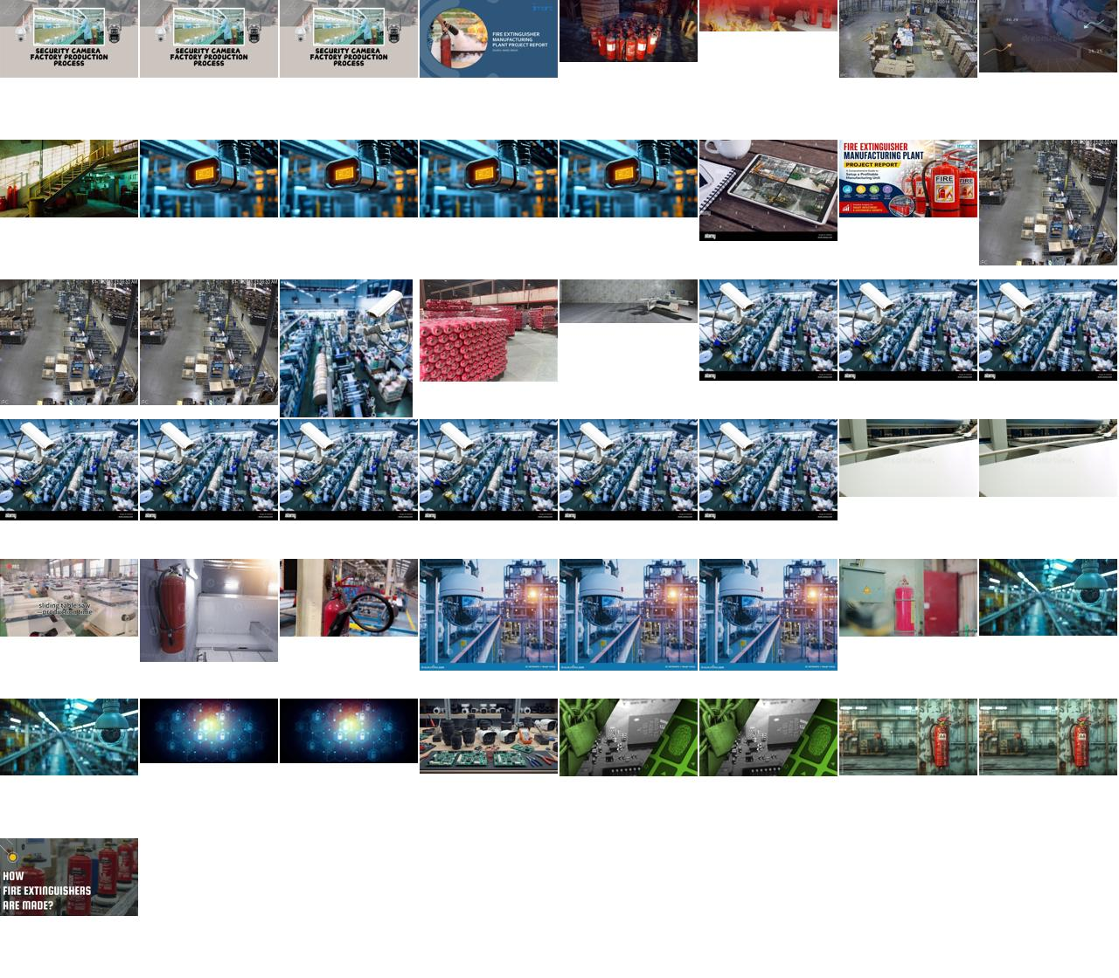
Figure 1. The 49 images CLIP rated closest to “CCTV footage”: repeated stock photos of security cameras, extinguisher-factory adverts, and only a handful of real overhead frames. Source: pipeline/logs/cctv_scrape_analysis/sheet_cctv_candidates.jpg

Why it failed
- The images do not exist on the open web. Real CCTV of a panel saw sits on private NVRs or inside videos. Image search ranks by page text, and no page says “CCTV still of a panel saw”.
- Our own query words attracted the wrong pages. “Surveillance camera” found pages about cameras. “High angle” and “from above” are photographers' words that captions rarely use.
- One page of results. DDGS returned about 35 results per query, so popular stock photos dominated.
- Almost nothing was rejected. CCTV mode removed “cctv” from the blocklist, product titles like “Dahua WiFi 4MP” matched no blocked phrase, and stage 4 had not run yet.
- Viewpoint is the real gap, and text cannot fix it. Even the good results were front-on photos. A ceiling camera sees the table top and carriage from above, with the front face foreshortened; those pixels are not in a front-on photo, and no filter or augmentation can create them.

What we changed
- Fixed the URL de-duplication and the template quota (Section 3.4).
- Replaced camera words with place words (the highangle set) and added the stage 2c gate. The result was 30 usable high-angle images out of 113: helpful, but a supplement, not a solution.
- Accepted the lesson: only footage from our own cameras, or pseudo-CCTV video shot from 3–4 m up, matches the deployment domain. The web engine stays the tool for catalog breadth and new classes.

3.11 Lessons From Building the Engine
Table 11. Engine lessons
Lesson | What we would do differently
Filtering removes junk; it cannot add a missing viewpoint | Measure the domain gap with a real canary set before training, as the design asked
Duplicates hide everywhere (URLs, mirrors, crops, classes) | De-duplicate by URL, bytes and perceptual hash, across all classes, before saving
Auto-labels inherit the labeller's blind spots | Upload every instance, not just the first; review crowded images by hand
Calibrated thresholds beat intuition | Keep the 4b histograms with the dataset so thresholds can be audited
Diversity by threshold is not diversity by viewpoint | Cluster embeddings and set per-cluster quotas

4. Label Engineering, Spatial Policies & Dataset Sanitization
The big picture
When run6's audit came back, the two weakest classes were not short of data. They were badly labelled. 45% of validation edge-bander labels covered the whole image, so the model learned “edge bander = the whole photo” and scored 0 of 15 on small ones. Touching extinguishers had been merged into blobs. On 21 October we rebuilt the labels around a written policy and fixed what we could with SAM 2.1. Everything below is recorded in datasets/9class/label_fixes/label_decisions.yaml and applied by build_clean_9class_dataset.py.
Key finding: who reviewed this
Every SAM proposal, negative drop and re-annotation was checked visually on overlay sheets by Claude, not by a human annotator. The sheets are in datasets/9class/label_fixes/ and deserve a human spot check before a release.

4.1 The 2026-10-21 Label Overhaul
Table 12. What changed on 21 October
Change | What it fixed | Result
Morphological merge turned off | Fused cylinders; ballooned edge-bander fragments | Instance clustering instead (label_instances.py)
Edge-bander outlines tightened with SAM | Frame-filling polygons | Boxes > 80% of the image: train 48% → 20%, val 59% → 18%
Per-cylinder extinguishers | One blob per row | Instances 435 / 105 / 96 → 606 / 129 / 147
64 images quarantined | Unlabelable collages and dense rows | 38 / 16 / 10 out of the build
Negative audit; 107 hard negatives | Hidden targets; look-alike false positives | Section 4.4
30 high-angle images | No elevated views at all | Section 4.5
Manual curation (datasetchange) | Specific bad images and bad labels | 80 removed, 110 re-drawn, 3 excluded

Backups of the labels before each step are in archive/dataset_backups/9class_labels_pre_run8_2026-10-21/ and archive/dataset_backups/9class_labels_pre_user_curation_2026-10-21/.

4.2 Class Extent Policies: Edge Banders vs Fire Extinguishers
Table 13. Extent policy
Class | Include | Exclude
Edge banding machine: one polygon per machine | Chassis and base, hood, gluing / trimming / buffing units, attached infeed and outfeed conveyors, tape coil disc, control arm | Panels on the conveyors, floor and walls, text and spec tables, inset or collage tiles, people, hoses that leave the machine
Fire extinguisher: one polygon per cylinder | The cylinder's own hose, nozzle, handle and wall strap | Gas cylinders, drums, water jugs, red bins, hose reels, alarm points (these are hard negatives)
Saws, jointers, planers | Bed, fences, frame, attached extension tables and guards | Loose stock, people, the room

- Two machines are two instances; touching extinguishers are separate instances. Never merge them.
- Label a partly hidden object only if at least 40% is visible, and trace only what is visible.
- A polygon covering more than 80% of the image is allowed only for a genuine close-up. If wall, floor or white background is inside, it is wrong.

4.3 SAM 2.1 Large and How We Used It
We compared SAM 2.1 Base and Large by prompting both with the ground-truth boxes of 222 validation instances.
Table 14. SAM 2.1 Base vs Large (box prompts, 222 instances)
 | Mean IoU | Boundary F1 | Jointer | Band saw | Mitre saw | Edge bander | ms / prompt | GPU MB
SAM 2.1 Base | 0.880 | 0.794 | 0.928 | 0.890 | 0.914 | 0.776 | 108 | 776
SAM 2.1 Large | 0.886 | 0.802 | 0.971 | 0.920 | 0.877 | 0.774 | 271 | 1,423

Large is our default, but the gain is small (+0.006 IoU), it is 2.5× slower, and it loses on mitre saws. So we still review every mask. Three habits made SAM usable:
- Clip every mask to its prompt box. That removes room, floor and stock in one step.
- Invert a mask only for boxes covering more than 80% of the image. Inverting smaller ones flipped correct masks.
- Skip SAM on white studio shots. It often picks the background there, so the fg mode cuts the object out of the non-white pixels instead.

4.4 Quarantine, Manual Curation & Hard Negatives

The 64 quarantined images
These are not all diagrams. 60 are edge-bander images the policy cannot label (collages, infographics, inset photos, rooms with several machines), and 4 are dense, blurred rows of extinguishers. They stay out of the build until someone re-draws them by hand.

Manual curation through datasetchange
A manual review produced two lists in datasetchange: images whose labels were wrong, and images that should not be in the dataset at all. parse_user_curation.py cleaned them up (113 unique fix stems; 87 removal lines, 80 unique).
- 80 bad images went into user_quarantine: dropped from every list at build time, never deleted from source_38class.
- 110 labels re-drawn with SAM 2.1 L from reviewed boxes (fix_user_labels.py), giving 128 instances, 62 of them edge banders. Some fixes added machines the old labels had missed. 28 first-pass proposals were wrong (mostly white backgrounds); 27 were redone and 1 excluded.
- 3 excluded because nothing labelable was there: an extrusion-line infographic, a roller-conveyor collage, and a table saw under 40% visible.
- Checks passed: audit PASS; 0 quarantined images still listed; 110 of 110 fixes carry valid polygons; 6 re-drawn polygons self-intersect (warning only).

Negatives: auditing the old ones, adding targeted ones
We ran all 420 sampled negatives through run5 and run6 at conf 0.10 and reviewed every hit. Two kinds had to go: 5 images that actually contained a target machine (a benchtop planer, a panel saw at the edge, background band saws), and all 12 veneer-press images, because the Camera 03 press is a woodworking hot press and we would have been teaching the model that it is background. Negatives went from 295 / 60 / 65 to 283 / 58 / 62.
We then collected 107 targeted hard negatives (datasets/hard_negatives/): about 10 each of red bins, yellow and blue drums, gas cylinders, water jugs, cardboard tubes, hose reels, alarm call boxes, empty floors and ceilings, plus 7 workbenches. They aim squarely at run7's extinguisher false alarms. Together the negatives make up 11.8% of the 3,298-entry train list.

4.5 Integration of High-Angle Overhead Industrial Images
From the 99 high-angle images that passed the stage 2c gate, we accepted 30 images with 52 instances: mitre saw 12, press 9, panel saw 7, table saw 6, edge bander 6, band saw 5, extinguisher 4, planer 2, jointer 1. The 69 rejects were mostly unlabelable scenes (14), ambiguous classes (13), part close-ups (12) and images with no target (10). SAM failed on two (#5, #94), which still need hand drawing. The images are train-only and added once (train_highangle_9class.txt). They are the first elevated views the model has ever seen, and still far short of the ≥ 5 viewpoints per class that real CCTV needs.

5. Model Training History & Quantitative Benchmarks
The big picture
Eight runs, three eras. The 23-class and 38-class runs taught us that breadth costs accuracy but builds useful features. run5 narrowed to nine classes and became the model to beat. run6 and run7 were our attempts to make it CCTV-ready, and both made it worse in ways the validation numbers did not show. run8 is the first run built on clean labels and working augmentation. The tables below carry the numbers; the text explains why they moved.

5.1 Run 1–4 Historical Context (23-Class to 38-Class Habitat Experiments)
Table 15. The early runs (imgsz 960, batch 8)
Run | Data | Base | Epochs | Box / mask mAP50 | Train time
run1 | 23-class web dataset (oversampled) | COCO yolo26s-seg | 79 of 100 | 0.777 / 0.755 | 10.6 h
run2 | 23-class, cleaned labels | run1 | 20 | 0.787 / 0.765 | 5.2 h
run3 | 38-class “habitat” (machines + infrastructure + safety) | COCO yolo26s-seg | 57 of 100 | 0.608 / 0.544 | 11.7 h
run4 | 38-class, unified labels | run3 | 15 | 0.611 / 0.552 | 2.6 h

Going from 23 to 38 classes dropped mean mAP by about 17 points: more classes, many of them small infrastructure items. But run3 learned what factory context looks like, which is why it, and not run2, became run5's parent. Every run in this period used optimizer=auto, so the lr0 in its settings file was never actually used (Section 7.2).

5.2 Run 5: The Generalist Champion
A 20-epoch fine-tune of run3 on the 9-class catalog data at imgsz 960. It reached box mAP50 0.832 at its best epoch and 0.825 at the end, in 37 minutes. Three things keep it the champion:
- It is the only model that finds the held-out workshop saw (0.56–0.63 on the test frames at imgsz 960).
- It produces zero extinguisher false alarms on Camera 03.
- It has the best catalog localisation at its training size (box mAP50-95 0.706).
Its known flaw: on 200 sampled workshop frames it finds the saw every time (max 0.70), but calls it table_saw. The machine is recognised, and the class boundary in our catalog labels is wrong (Section 10.2).
Table 16. Per-class AP50, run5 vs run6 (training-time validation, before the cleanup; run6 recall read off its curves)
Class | run5 box | run5 mask | run6 box | run6 mask | run6 R | Δ box
panel_saw | 0.893 | 0.824 | 0.848 | 0.820 | ~0.75 | −0.045
hydraulic_press | 0.963 | 0.937 | 0.961 | 0.916 | ~0.88 | −0.002
table_saw | 0.937 | 0.937 | 0.931 | 0.904 | ~0.83 | −0.006
planer | 0.849 | 0.822 | 0.846 | 0.846 | ~0.80 | −0.003
jointer | 0.877 | 0.877 | 0.869 | 0.869 | ~0.80 | −0.008
band_saw | 0.883 | 0.877 | 0.840 | 0.830 | ~0.78 | −0.043
miter_saw | 0.783 | 0.757 | 0.733 | 0.724 | ~0.70 | −0.050
edge_banding_machine | 0.574 | 0.497 | 0.584 | 0.558 | ~0.41 | +0.010
fire_extinguisher | 0.718 | 0.720 | 0.680 | 0.693 | ~0.52 | −0.038
all | 0.831 | 0.805 | 0.810 | 0.795 | 0.718 | −0.021

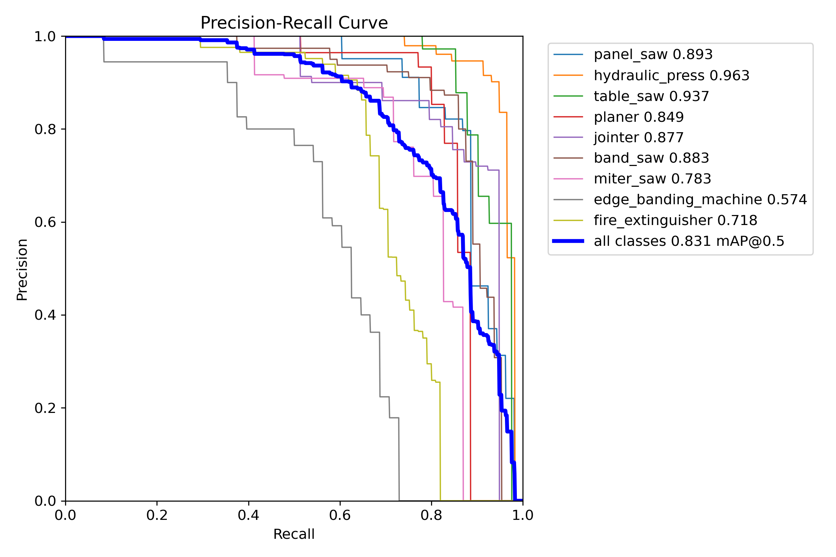
Figure 2. run5 box precision-recall per class. Edge bander and extinguisher trail every other class. Source: runs/run5_9class_clean_finetune/BoxPR_curve.png
Table 17. One model, four validation sets: why baselines must be re-measured
run5 measured on | Box mAP50 | Mask mAP50
Its own training-time val (482 images) | 0.825 | 0.802
Catalog val, 19 Oct labels, imgsz 960 | 0.821 | 0.798
Cleaned val, 21 Oct (461 images) | 0.789 | 0.741
Curated val, after datasetchange (450 images) | re-measure | re-measure

5.3 Run 6: The “CCTV-Robust” Fine-tune & Uncovered Regressions
We fine-tuned run5 at imgsz 1280 for 50 epochs with 301 machinery negatives and heavier geometric augmentation. Validation looked fine: box 0.810, mask 0.795, precision 0.87. On real video it failed: the workshop saw dropped from 0.56–0.63 to ≤ 0.18, with 0 detections at conf 0.40 in all 1,398 frames, and on factory frames it started calling things extinguishers (29 false detections in 16 of 40 frames).
Why the numbers lied:
- The negatives pushed the wrong boundary. Spindle moulders, veneer presses, CNC routers and racking are long, flat, table-and-beam machines, just like a sliding-table saw. We taught the model that this shape is background.
- The degradation we thought we added never ran. Albumentations was not installed, so there was no blur, codec or greyscale augmentation, and erasing does nothing for segmentation (Section 7.1).
- The validation set could not see the problem. It held catalog photos only: no CCTV, no desks, no ceilings.
- The mask head was memorising. Train segmentation loss halved (1.71 → 0.78) while validation segmentation loss stayed flat (1.35 → 1.44).

5.4 Run 7: CCTV Pilot Hybrid Experiment & Catastrophic Overfitting Breakdown
Our first run with real factory frames: run5 plus 257 Camera 05 frames repeated 5×, which was 44% of every epoch (lr0 2e-4, imgsz 1280), validated on Camera 03. On Camera 05 it scored about 0.97 on 100% of frames. On Camera 03 it found 0 of 142 machines, raised 51–74 extinguisher false alarms, and lost 3 points of catalog box mAP50 and 9–11 points of mAP50-95. Validation fitness never rose above 0.012, so early stopping picked best.pt essentially at random (epoch 7 of 17). Chapter 6 explains why.

5.5 Master Training Metrics Matrix
Table 18. Final-epoch metrics from each run's results.csv (own validation sets)
Run | Ep. | P (box) | R (box) | Box mAP50 | Box 50-95 | Mask mAP50 | Mask 50-95 | Val seg loss first → last
run1 | 79 | 0.843 | 0.708 | 0.777 | 0.675 | 0.755 | 0.645 | 2.04 → 1.80
run2 | 20 | 0.842 | 0.729 | 0.787 | 0.687 | 0.765 | 0.659 | 2.21 → 1.92
run3 | 57 | 0.674 | 0.572 | 0.608 | 0.493 | 0.544 | 0.424 | 3.55 → 2.43
run4 | 15 | 0.686 | 0.583 | 0.611 | 0.507 | 0.552 | 0.433 | 2.44 → 2.56
run5 | 20 | 0.847 | 0.788 | 0.825 | 0.711 | 0.802 | 0.679 | 1.46 → 1.39
run6 | 50 | 0.870 | 0.718 | 0.810 | 0.649 | 0.795 | 0.654 | 1.34 → 1.44
run7* | 17 | – | – | 0.002 | – | – | 0.000 | 3.30 → 2.38
run8 | 1 | 0.847 | 0.764 | 0.830 | 0.629 | 0.813 | 0.671 | 1.37 (epoch 1)

* run7 validated on Camera 03 only, so its numbers measure transfer to an unseen camera, not catalog quality. Read the last column as the recurring theme: from run5 onwards, validation segmentation loss barely moves while training loss halves. Mask quality is limited by label noise, which is why Chapter 4 mattered more than more epochs. run8's first epoch already matches run6's final validation losses, with augmentation that now actually runs.

6. Deep-Dive Failure Analyses & Empirical Case Studies
The big picture
Four failures taught us most of what we know about this problem. Each case study gives the symptom, what we suspected, what the evidence said, and what we changed.

6.1 Case Study 1: The Workshop Clip Panel Saw Regression (Resolution vs Viewpoint)
Symptom: run6 lost a saw that run5 found (frames 186 / 1210 / 1303: run5 0.56 / 0.61 / 0.63; run6 ≤ 0.18, mostly as table saw or a spurious extinguisher).
Table 19. Workshop-clip diagnosis
What we suspected | What the evidence said | Verdict
The saw is too small, so try SAHI tiling | It is 266×208 px on a 480×360 frame: 32% of the area | WRONG
Inference resolution | Same frame, run5: 0.56 at imgsz 960, 0.27 at 1280. Upsampling 480 px 2.7× creates blurry giants the model never saw | RIGHT
run6's data mix | Look-alike machinery negatives; run6 fails at every size | RIGHT
Class boundary | run5 recognises the saw but calls it table saw (max 0.70) | RIGHT

What changed: fine-tunes start from run5; we never upsample a sub-stream; SAHI was dropped for static ROI crops; the sliding-table-saw boundary goes into the labels. A side lesson: the trial recordings had the CCTV tool's overlay burned in, and both models fired on it. Test clips must come from raw RTSP.

6.2 Case Study 2: Camera 03 vs Camera 05 Memorization & Spatial Bias
Table 20. Training camera vs unseen camera
Test | run5 | run6 | run7
Camera 05 (run7's training camera), raw, 200 frames | 0 / 200 | 0 / 200 | 200 / 200 at ~0.97
Camera 03 machines found at ≥ 0.25 (of 142) | 0 | 0 | 0
Camera 03: press labelled edge_banding_machine (imgsz 640) | – | – | 64 of 71 frames

Lowering the threshold to 0.01 recovered 3 of 142 machines, so this was a failure to transfer, not a threshold problem. We traced it to four root causes:
1. One viewpoint per class. 257 frames from one fixed camera amount to roughly one view of information. We repeated it 5×, and the model rewarded us by memorising it.
2. Different machines. Camera 03 has a compact manual edge bander and a hot press. Camera 05 has a long automatic line and a white frame press. One example per class cannot cover another model of the machine.
3. Position, not appearance. In Camera 05, the edge bander is a long white shape at the upper centre of the frame. In Camera 03, the press sits exactly there, and run7 called it an edge bander 64 times.
4. Scene texture. run7 scored 0.96–0.97 even on the 2:1-squeezed raw video it never trained on. Confidence that survives that distortion is matching the scene, not the machine.

6.3 Case Study 3: The Fire Extinguisher False-Alarm Explosion
On Camera 03, which has no extinguishers, false alarms at conf 0.25 went from 0 (run5) to 32 / 2 (run6) to 51 / 74 (run7) at imgsz 640 / 1280. run7 put them on a white and yellow plastic drum, cardboard tubes, water bottles and standing workers: vertical, cylinder-ish shapes it had never been told were background, after 44% of every epoch on a single scene with 0% hard negatives. run8 answers with the 107 targeted negatives (drums, tubes, cylinders, bins) and keeps ToGray at p = 0.05 so colour stays a cue. What is still missing is CCTV-domain cylinder negatives, which Camera 03 cannot supply while it is in the benchmark.

6.4 Case Study 4: Catalog Catastrophic Forgetting During Unbalanced Fine-Tuning
Table 21. Forgetting under a one-camera fine-tune
Model (catalog val, imgsz 960) | Box mAP50 | Box 50-95 | Mask mAP50 | Mask 50-95
run5 | 0.821 | 0.706 | 0.798 | 0.679
run6 | 0.825 | 0.698 | 0.813 | 0.690
run7 best (ep 7) | 0.786 | 0.597 | 0.767 | 0.633
run7 last (ep 17) | 0.792 | 0.614 | 0.771 | 0.645

56% catalog replay held mAP50 within about 3 points, but box mAP50-95 fell 9–11 points: the model still found machines, just with sloppier boxes. That fails the “within 2 points of run5” gate. Two practical notes: run5 looks bad at imgsz 1280 only because that is outside its training scale, so always compare checkpoints at their training size; and replay limits forgetting but does not prevent it when one domain dominates the epoch.

7. Critical Bug Fixes, Gotchas & Engineering Lessons
The big picture
The most expensive bugs in this project never raised an error. A missing package, renamed arguments, an “auto” setting and an ignored parameter each made a training recipe mean something other than what it said. Each section below is one silent failure and the guard we put in place.

7.1 The Silent Albumentations Bypass in Ultralytics 8.4
Ultralytics wraps its Albumentations block in an import guard. Without the package, blur, compression, greyscale and any custom augmentations= list are skipped with no error. run1–run6 therefore trained with no photometric degradation beyond HSV jitter. We installed Albumentations 2.0.8 on 15 October (with --no-deps, to keep the GUI OpenCV build), and train.py now refuses to start without it:
scripts/train.py: fail fast (message shortened)
try:
import albumentations as A
import cv2
except ImportError:
raise SystemExit("albumentations is not installed; Ultralytics would silently skip cctv_aug.")
Habit: check every training log for the albumentations: line.

7.2 Albumentations 2.x API Compatibility & Parameter Traps
Albumentations 2.x silently ignores 1.x argument names and falls back to defaults, so a 1.x recipe runs, just with different strengths from the ones written down. We rewrote the pipeline with 2.x names:
Table 22. Argument migration
Transform | 1.x (ignored) | 2.x (used)
ImageCompression | quality_lower=30, quality_upper=75 | quality_range=(30, 75)
Downscale | scale_min=0.4, scale_max=0.75 | scale_range=(0.4, 0.75)
GaussNoise | var_limit=(10, 50) | std_range=(0.012, 0.028) (√10/255, √50/255)

cctv_aug in scripts/train.py (run8)
A.OpticalDistortion(distort_limit=(-0.05, 0.25), interpolation=cv2.INTER_LINEAR,
border_mode=cv2.BORDER_REFLECT_101, p=0.35), # CCTV lens curvature
A.ImageCompression(quality_range=(30, 75), p=0.4), # H.264-like blocking
A.Downscale(scale_range=(0.4, 0.75), p=0.3), # low-res sensor / sub-stream
A.GaussNoise(std_range=(0.012, 0.028), p=0.3), # sensor noise
A.OneOf([A.MotionBlur(blur_limit=(3, 7)), A.GaussianBlur(blur_limit=(3, 5))], p=0.15),
A.ToGray(p=0.05), # keep colour cues
A.RandomBrightnessContrast(0.2, 0.2, p=0.3),
The degradation is deliberately milder than run7's, because run7's mAP50-95 loss pointed at localisation damage. run8 also uses explicit AdamW (lr0 5e-4, cosine), imgsz 960, batch 6, and turned-down geometry (degrees=0, perspective=0.0002).

Why optimizer=auto is dangerous
With optimizer=auto, Ultralytics ignores lr0 and picks AdamW with a learning rate fitted to the class count, round(0.002 × 5 / (4 + nc), 6). For our nine classes that is 0.000769. run5 and run6 both list lr0=0.01 in their settings and trained 13× slower than that. Any conclusion about learning rate drawn from those runs is void. Rule: always set the optimizer explicitly.

7.3 Wide-Angle CCTV Lens Barrel Distortion Emulation
We checked on a grid image that in Albumentations 2.x a negative distort_limit gives pincushion and a positive one gives barrel, which is the opposite of what many older recipes assume. Wide-angle CCTV lenses barrel, so we sample (-0.05, 0.25), mostly barrel, at p = 0.35, with reflected borders so the model cannot learn black corners as a cue. Ultralytics 8.4 passes polygon vertices to Albumentations as keypoints, so labels warp with the image. Distortion emulates the lens. It does not create the elevated viewpoint.

7.4 Aspect Ratio Distortions: Managing 960×1080 “1080P Lite” Frames
Every factory recording is 960×1080: Hikvision's “1080P Lite” stores a 16:9 picture at half width, without declaring the pixel aspect ratio, so every tool shows machines at half their real width. We de-squeeze to 1920×1080 before labelling and evaluation (sample_cctv_video.py --resize 1920x1080, cubic interpolation), and the frozen benchmark is built that way. On 40 factory frames, run5's scores were too low to choose between native and de-squeezed input (at most 11 of 40 frames with any detection either way), so we follow geometry: de-squeezed frames match the shapes the model learned from catalog photos.

7.5 NMS Independence in YOLO26 End2End Detection
Our checkpoints run the NMS-free one-to-one head, so iou= has no effect (ultralytics/utils/nms.py:66). end2end=False, or --nms in the harness, switches to the one-to-many head with NMS. Every inference summary now prints which head ran. Any past experiment that tuned iou was a no-op and should be rerun if the question still matters.
Table 23. What the silent failures taught us
Lesson | Guard we adopted
Catalog validation mAP does not predict CCTV performance | Gate every candidate on the factory benchmark and the held-out clip
Frames are not viewpoints | Weight CCTV data by camera × machine pairs; at most 1–2× repeats
Libraries fail silently | Fail-fast checks; explicit optimizer; read the training log
Labels cap accuracy | A written extent policy and reviewed SAM outlines
Noise-level validation picks checkpoints at random | Select on catalog val or run fixed epochs; report CCTV separately
Junctions make deletes destructive | The lists define the dataset; cmd /c rmdir only

8. Edge Deployment, Real-Time Inference & Video Processing
The big picture
Nothing in this chapter is running yet. It is the deployment design we will build once a checkpoint passes the gates in Chapter 9. Its core idea is simple: every object we detect is stationary, so we confirm presence at known locations over seconds, rather than chasing every frame.

8.1 Ingestion Architecture: RTSP Main Stream vs Sub-Stream Analysis
Table 24. Stream and size
Source | Inference recipe
Sub-stream 480×360 / 640×360 | imgsz 640 (sweep 480 / 640 / 960). Never 1280: upsampling halved run5's confidence
Main stream, 1080P Lite (960×1080) | De-squeeze to 1920×1080, then imgsz 960 or ROI crops
Main stream, full 1080p / 4 MP | imgsz 1280 letterboxed, or ROI crops

Record raw RTSP, never screen recordings (no overlay, no double compression). On Hikvision the main stream is channel 101 and the sub-stream 102; on Dahua, use subtype=0. Decode at 5 fps: at 17–22 ms per frame, one RTX 3070 Ti serves about 8–10 cameras.

8.2 Static Camera ROI Cropping Strategy (Why SAHI was Deprioritized)
SAHI tiles a frame to find small objects. Our machines are not small (the workshop saw is 32% of the frame), tiling a 480×360 stream only re-samples the same pixels, and a 4K frame costs 6–9 forward passes. Instead, because cameras and machines do not move, we define 1–3 regions of interest per camera once, crop them from the main stream at native resolution, and map the masks back. A full-frame pass every 30th frame catches anything that moved. SAHI stays an option only for far-wall extinguishers under about 40 px on a wide main stream.

8.3 Multi-Frame Temporal Filtering: ByteTrack Association & 8-of-15 Window Rules
- Detect low, decide slowly: detection at conf 0.10, ByteTrack association (track_high_thresh 0.35, track_low_thresh 0.10, new_track_thresh 0.45, track_buffer 50 = 10 s at 5 fps). Set the tracker explicitly; the Ultralytics default is tracktrack.yaml.
- Confirm a track when at least 8 of the last 15 frames match above the class threshold. Drop it when 2 or fewer match for the whole buffer.
- Class by vote: a confidence-weighted vote over the track's lifetime, which stops single-frame table-saw / panel-saw flips.
- Learn from doubt: frames with a confirmed track below 0.3 confidence, or a split vote, go to the labelling queue.

8.4 Per-Class Operational Confidence Thresholds & Decision Logic
Table 25. Provisional thresholds
Class | Threshold | Basis (run6 catalog curves; re-derive on CCTV val)
edge_banding_machine | 0.20 | F1 peaks at 0.16; recall collapses above 0.3
fire_extinguisher | 0.30 | F1 plateau 0.15–0.45
All other classes | 0.40 | Aggregate F1 plateau 0.20–0.50

Table 26. Decision logic (proposed)
Event | Action
Machine confirmed in its ROI | Update inventory; no alert
No confirmed machine for N minutes in working hours | Low-priority check request
Extinguisher confirmed at its position | Mark verified
Extinguisher not confirmed | Mark unverified for human review. Never alarm
Tiny box (machine < 0.3% of frame, extinguisher < 16×16 px) | Discard before tracking

9. The Frozen Factory CCTV Benchmark & Production Verification Gates
The big picture
run7 taught us that a camera used in training can never again tell you anything about generalisation. So on 21 October we froze all the factory frames we have as a test-only benchmark, with guards in code, and wrote down the gates a model must pass before anyone deploys it.

9.1 Dataset Isolation Protocol: The 328-Frame Frozen Benchmark
Table 27. Benchmark composition (docs/cctv_benchmark.md)
Camera | Recordings | Frames | Labelled instances
cam03 | ch03_20260907165321 (37), ch03_20260924144142 (34) | 71 | press 71, edge bander 71
cam05 | working_panel_saw (120), panel_saw_hydraulic_lift (120), ch05_20260928130326 (17) | 257 | panel saw 257, press 257, edge bander 257
Total | 5 recordings, 1 frame / 3 s, de-squeezed to 1920×1080 | 328 | panel saw 257, press 328, edge bander 328

- Absent classes: the other six classes do not appear, so any detection of them is a false positive, especially an extinguisher on Camera 03's drum.
- Labels: SAM 2.1 box prompts clipped to each machine's consensus outline, with workers and on-screen text removed; spot-checked, not hand-drawn.
- Limits: 3 of 9 classes and 2 viewpoints, so it measures transfer to these cameras, not general CCTV readiness.
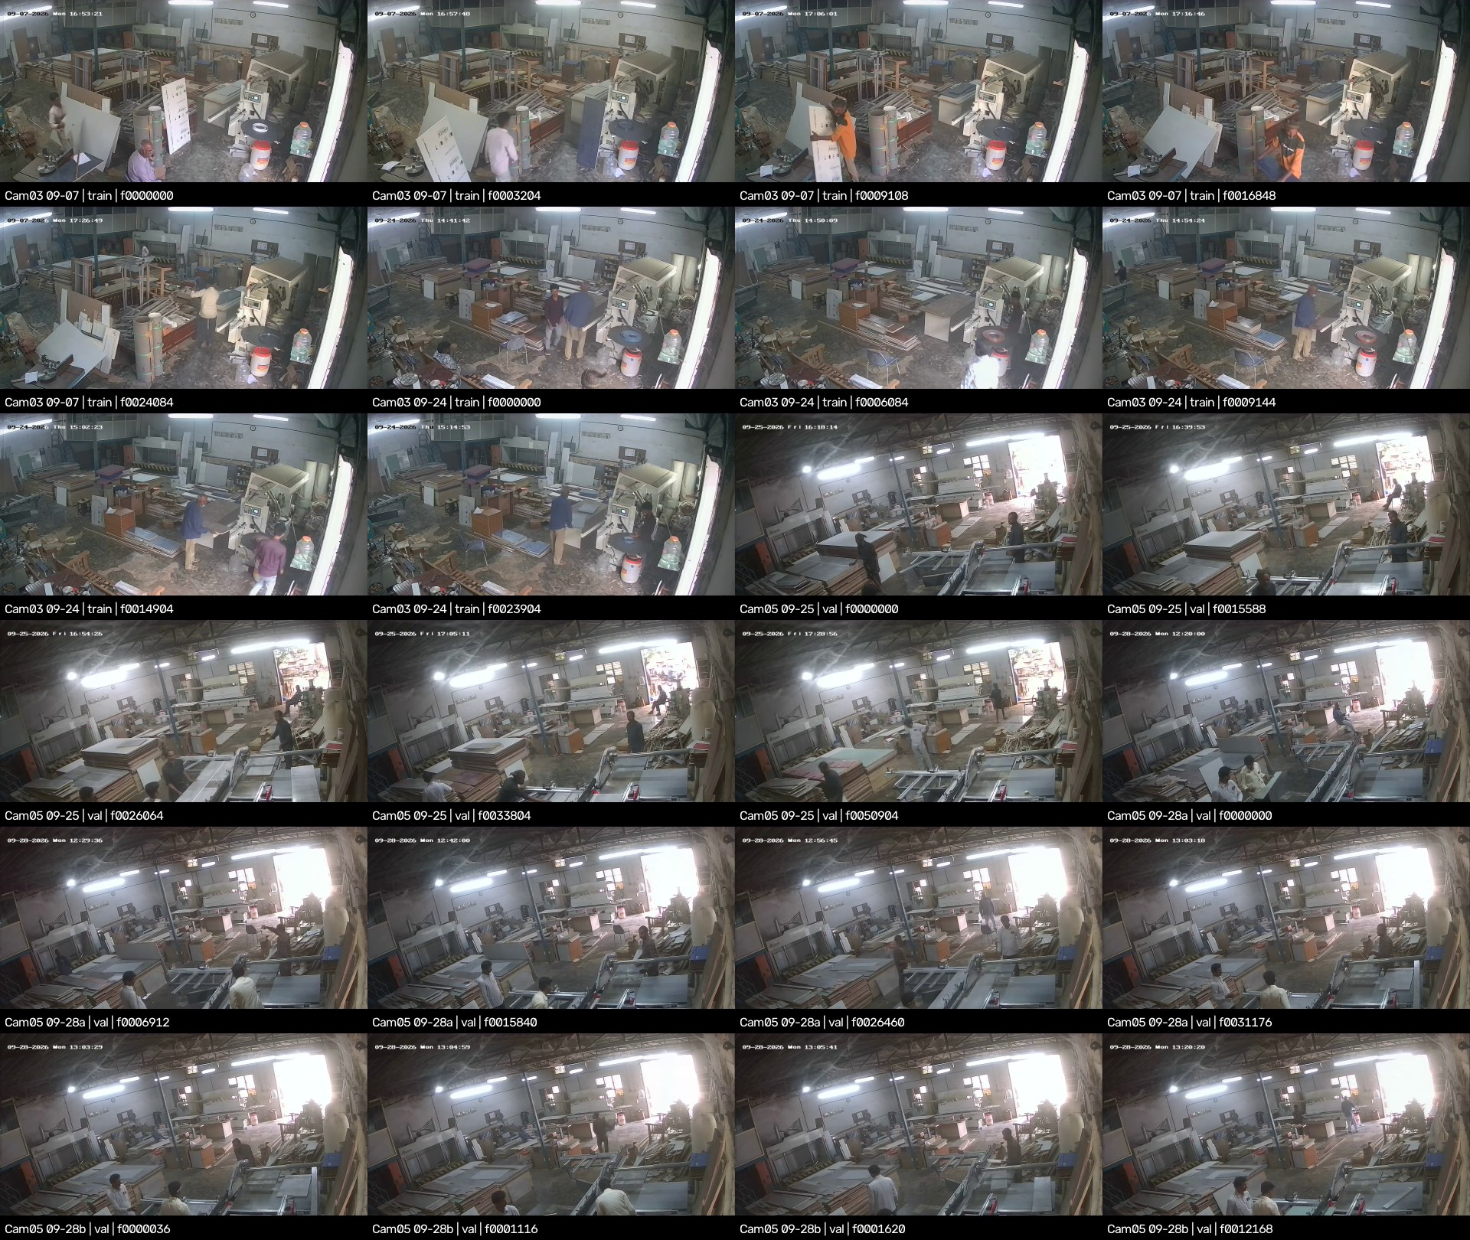
Figure 3. The two factory cameras behind the benchmark. Source: docs/factory_footage_contact_sheet.jpg
Benchmark evaluation
from ultralytics import YOLO
YOLO(r"<weights>").val(data=r"datasets\9class\data_9class_cctv_benchmark.yaml", imgsz=960, plots=False)

9.2 Validation Rules: Zero-Tolerance Leakage Guardrails
- Never train on benchmark frames, or on any other footage from Camera 03 or 05. train.py exits if the data file is the benchmark or mentions cctv_factory_intake.
- Never use the benchmark for checkpoint selection, early stopping, threshold tuning or hard-negative mining.
- Split by camera, never by frame. camera_splits.yaml marks every recording as test, and the hybrid builder fails if a camera lands in two splits.
- run7's contaminated training lists are archived in archive/run7_cctv_pilot_2026-10/.

9.3 Gate Criteria for Champion Model Deployment
Table 28. Release gates (all four must pass)
Gate | Criterion | run5 today
1. CCTV accuracy | Per-class mask mAP50 ≥ 0.60 and recall ≥ 0.80 on held-out cameras (classes with < 50 instances reported, not gated) | FAIL (0.054 / 0.010)
2. False alarms | ≤ 1 per camera-hour after confirmation; ≤ 1% image-level on ≥ 300 negatives | NO DATA YET
3. No forgetting | Catalog val mask mAP50-95 within 2.0 points of run5 (plan definition; we also report box mAP50) | BASELINE
4. Trial clips | Raw RTSP clips without overlay; beat run5 on the workshop saw | CLIPS NOT RECORDED

run8 has not been evaluated against any gate yet. Gate 3 needs run5 re-measured on the current 450-image val first, and gate 2 needs empty-scene footage and negatives from cameras outside the benchmark.

10. Current Handoff Status, Outstanding Curation & Future Roadmap
The big picture
If you are picking this project up, here is the short version: let run8 finish, measure it honestly against run5 on the current validation set and the frozen benchmark, then spend your effort on viewpoints, not epochs. The model is not the bottleneck. Real elevated views of these machines are.

10.1 Immediate Execution Tasks: Training Run 8 & Validating Curation Lists
1. Let run8 finish (resumed from last.pt on 23 Oct at 17:07 and again at 18:03; 50 epochs planned). Do not run another GPU job alongside it on the 8 GB card.
2. Find out why it is slow: 3,525 s for epoch 1 against run5's 111 s. Check GPU utilisation and dataloader CPU load.
3. Re-baseline run5 on the current 450-image val at imgsz 960.
4. Evaluate run8 (best.pt and last.pt) on that val, on the frozen benchmark, and on the workshop clip at imgsz 640 and 960, then apply the gates.
5. Curation lists: datasetchange is applied and audited (PASS). What remains is a human pass over label_fixes/review_user_fixes/ and a decision on the 6 self-intersecting polygons.

10.2 Pending Class Boundary Refinements
Table 29. Decisions waiting on the team
Open question | Why it matters | Our recommendation
Sliding-table saw: panel_saw or table_saw? | run5 finds the workshop saw but calls it table saw | Label sliding-table saws as panel_saw, with an example sheet
Veneer press | 12 images removed because they resemble the Camera 03 press | Relabel them as hydraulic_press
Moulders and drum sanders | Look like planers and table saws | Keep them as negatives; add them to the boundary sheet
64 quarantined images | 16 are val images | Hand re-annotation (optional)
High-angle #5 and #94; FE_00025 hose fragment | SAM failed; a detached hose fragment in one label | Hand-draw, or drop

10.3 Long-Term Roadmap: Multi-Camera Tracking, Night IR Adaptation & Worker Perimeter Zones
Table 30. Roadmap
Horizon | Work | Why
Next | Record raw RTSP for ≥ 24 h per camera (day, night, IR), plus pseudo-CCTV phone video from 3–4 m up; target ≥ 5 viewpoints per class | Viewpoint diversity decided run7
Next | Build CCTV val / test and ≥ 300 CCTV negatives from cameras outside the benchmark | Gates 1 and 2 need them
Mid | Release retrain from COCO weights once labels settle (AdamW lr0 1e-3, 150 epochs) | Remove biases inherited from old labels
Mid | Multi-camera presence: per-camera ROI state machines feeding one site registry | Stationary objects need no re-identification
Mid | Night IR: an IR val split and greyscale-heavy training | Extinguishers scored about 0 in greyscale tests
Mid | Worker perimeter zones: a COCO person detector plus dilated machine masks and dwell rules; privacy review first | The safety use case
Ongoing | Active learning: label doubtful frames weekly, fine-tune monthly with replay | Keeps the model current

10.4 Document Revision History & Technical Ownership Sign-Off
Table 31. Revision history
Version | Date | Change
2.4 | 2026-10-23 | First consolidated dossier, compiled from project reports and run artifacts
2.5 | 2026-10-23 | Rewritten in the team's narrative voice; condensed; data-harvesting pipeline expanded into Chapter 3

Primary sources: docs/runsummary.md, docs/run7_analysis_report.md, docs/cctv_domain_adaptation_plan.md, docs/label_policy.md, docs/cctv_benchmark.md, docs/cctv_scrape_postmortem.md, pipeline/machine-type-classifier-prd.md and the pipeline/pipeline/ source.
This dossier records engineering state; it does not approve deployment. That needs the gates in Section 9.3 and the signatures below.
Table 32. Sign-off
Role | Name | Signature | Date
Technical owner (ML)
Data and labelling reviewer
Operations / safety stakeholder

Appendix A. Where Briefs and Design Documents Differ From the Code
Each row records a claim from an authoring brief or a design document, what the artifacts actually show, and the value this dossier uses.
Table 33. Claims vs artifacts
# | Claim | What the artifacts show | Used here
1 | run5 catalog box mAP50 82.1% | 0.821 is run5 at imgsz 960 on the 19 Oct labels; its own log ends at 0.825 (best 0.832) | All, labelled by val set
2 | run8 not yet trained | Started 22 Oct; resumed 23 Oct (17:07, 18:03) | In progress
3 | run8 negatives 11.6% | 11.8% after the datasetchange curation | 11.8%
4 | 64 quarantined “diagrams” | 60 edge-bander collages and multi-machine scenes + 4 dense extinguisher rows | Breakdown
5 | Gate 3: within 2.0 points of run5 | Plan defines it as mask mAP50-95; the run7 report used box mAP50 | Plan definition, report both
6 | Scraping via Bing / Google | All scrapers use ddgs (DuckDuckGo; Bing-backed results). An icrawler/Bing HTML scraper was replaced; there is no Google scraper | ddgs
7 | MD5 byte-level de-duplication | MD5 is only of the URL, for filenames; de-duplication is by URL set, pHash (stage 3) and dHash (stage 2c) | As implemented
8 | Minimum resolution 400×300; aspect-ratio checks | Download floor 200 px, stage 3 floor 150 px; no aspect-ratio check | As implemented; 400×300 recommended
9 | Stage 5 uses K-Means / farthest-point sampling | Greedy filter: ranked by CLIP text score, drop if cosine > 0.95 to any kept image | As implemented
10 | Calibration uses precision-first cut-offs | Recall-first: good-set 1st percentile (fine) and the bad-max / good-p1 midpoint (coarse) | As implemented
11 | Fine filter rejects drill presses vs band saws | No band-saw/drill-press dual check; dual checks exist for 4 other class pairs | As implemented
12 | SAM generates polygons from prompt boxes (stage 6) | SAM runs inside a Roboflow workflow after Gemini verification; its prompt configuration is not in the repository. Only the first polygon per image is uploaded | As implemented
13 | Pipeline README: 23 classes | config.py lists 38 class slugs | 38
14 | Per-class precision and recall for run5 | Not exported by run5; only per-class AP50 | AP50 only

