Industrial Machine Instance Segmentation & CCTV Domain Adaptation Dossier
  - Architecture, Data Pipelines, Empirical Failure Modes, and Production Readiness for 9-Class YOLO26-seg

Project Version 2.6 | Status: Active Engineering | Target: Factory Safety & Inventory
Date: 23 October 2026 | Written as the Krish team's account; compiled by Claude (Claude Code) from project artifacts.

1. Executive Overview & the 9-Class Taxonomy
The big picture
Catalog photos are a solved problem: our models have scored above 80% mAP50 on them since September. Real factory CCTV is not: our best model scores 0.054 mask mAP50 on the factory benchmark. This document is about that gap.

1.1 Project Goal
- Inventory: know which machines each fixed camera sees, and that they stay put.
- Safety zones: turn each machine's mask into a hazard perimeter around saws, planers, jointers and presses.
- Fire safety: confirm extinguishers are on the wall. This is an assistive signal, never a compliance alarm: our best run still misses 46% of them.

1.2 The Nine Classes
ID | Class | How we recognise it | Main risk (measured)
0 | panel_saw | Long sliding carriage + outrigger table | Called table_saw by run5 (up to 0.70)
1 | hydraulic_press | Heavy frame, platens, cylinders | Veneer / hot presses look the same
2 | table_saw | Blade through a flat table, rip fence | Panel saws; benchtop saws
3 | planer | Enclosed box, stock fed underneath | Jointers (6% swapped), sanders
4 | jointer | Long open beds, cutter on top, fence | Planers
5 | band_saw | Two wheel housings, vertical blade | Drill presses, mitre saws
6 | miter_saw | Pivoting arm over a turntable | 28% missed (run6)
7 | edge_banding_machine | Long enclosed body, tape coil, conveyors | Lowest AP; old labels covered whole images
8 | fire_extinguisher | Red cylinder, handle, hose | Drums, tubes, workers (run7 false alarms)

1.3 Executive Scorecard
Run | Classes / base / imgsz | Box mAP50 | Mask mAP50 | Verdict
run1 | 23 / COCO / 960 | 0.777 | 0.755 | SUPERSEDED
run2 | 23 / run1 / 960 | 0.787 | 0.765 | SUPERSEDED
run3 | 38 / COCO / 960 | 0.608 | 0.544 | RUN5'S PARENT
run4 | 38 / run3 / 960 | 0.611 | 0.552 | SUPERSEDED
run5 | 9 / run3 / 960 | 0.825 | 0.802 | CHAMPION: FINDS THE REAL SAW
run6 | 9 / run5 / 1280 | 0.810 | 0.795 | FAKE WIN: 0 DETECTIONS ON VIDEO
run7 | 9 / run5 / 1280 | 0.786* | 0.767* | MEMORISED ONE CAMERA
run8 | 9 / run5 / 960 | 0.830† | 0.813† | TRAINING

- Read within an era: each era validates on a different set. *run7: catalog val at imgsz 960. †run8: epoch 1 only.
- Today's baseline: run5 = box 0.789 / mask 0.741 on the cleaned val (461 images). Re-measure it on the current 450-image val before comparing with run8.

2. Core Tech Stack & System Architecture
The big picture
One Windows workstation with an 8 GB GPU. That shaped our batch sizes, the zero-copy dataset layout and the choice of an NMS-free model.

2.1 Stack
- Hardware: RTX 3070 Ti (8 GB), Windows 11. Batch 6 at imgsz 960, batch 4 at 1280.
- Software: Python 3.10 venv env\yolo-env, PyTorch 2.13.0+cu130, Ultralytics 8.4.123, Albumentations 2.0.8.
- Model: YOLO26s-seg with an end-to-end, NMS-free head: 12–16 ms per frame at 1280 (45–60 FPS end-to-end), so one GPU serves 8–10 cameras at 5 fps.
- The head's catch: iou= does nothing unless you pass end2end=False (or --nms). That is worth testing on crowded extinguishers, where recall drops to 39% with three or more in the frame.

2.2 Workspace Layout
Path | What it is
datasets\9class\*_9class\images | NTFS junction to source_38class images (stored once, never copied)
datasets\9class\*_9class\labels | 9-class labels, rewritten on every build
datasets\9class\*.txt, data_9class.yaml | The dataset definition: training reads only the listed images
datasets\cctv_factory_intake\ | Frozen factory benchmark: test only

Key finding: two rules that protect the data
• **Never delete inside *_9class\images:** it deletes the originals in source_38class.
• Never Remove-Item -Recurse a junction: use cmd /c rmdir. If the project moves, re-link with the loop in CHANGELOG_REORGANIZATION.md.

2.3 Tools You Will Actually Use
Tool | Job
scripts/train.py | run8 recipe; refuses to run without Albumentations, refuses the benchmark, never overwrites a run
scripts/test_inference.py | Image / folder / video inference; per-class thresholds, --nms, CSV + Markdown logs
tools/build_clean_9class_dataset.py | Builds labels and lists from source_38class: quarantines, fixes, negatives
tools/fix_user_labels.py | SAM 2.1 box-prompt re-annotation with before/after review sheets
tools/sample_cctv_video.py | De-duplicated CCTV frame sampling; --resize 1920x1080 un-squeezes 1080P Lite
tools/build_dataset_viewer.py | Browsable gallery of exactly what training sees (docs/viewer/)

2.4 Essential Commands
env\yolo-env\Scripts\python.exe scripts\tools\build_clean_9class_dataset.py # rebuild labels and lists
env\yolo-env\Scripts\python.exe scripts\tools\audit_dataset_distribution.py # must say PASS
env\yolo-env\Scripts\python.exe scripts\train.py --name run9_<description> # run8 recipe, from run5
env\yolo-env\Scripts\python.exe scripts\test_inference.py --weights <best.pt> --source <video> ^
--imgsz 960 --conf 0.40 --class-conf "edge_banding_machine=0.20,fire_extinguisher=0.30"

3. The I4I Web Scraping & Ingestion Engine
The big picture
Before we had plant access, we had no images of most of these machines. I4I (pipeline/) harvests web photos per class, filters them with CLIP, removes duplicates and auto-labels them with Gemini + SAM 2. It built the data behind every model from run1 onwards. It could not find CCTV views, and Section 3.8 explains why.

3.1 Why Scrape?
- Bootstrap rare classes: edge banders, jointers and panel saws barely exist in public datasets. A scrape-and-filter loop builds a class in hours.
- Diversity by design: each class is expanded across query templates (angle, distance, workers, occlusion) instead of hoping for variety.
- Known risk: the design document warned that web photos are “catalog-style” and CCTV is not. Its real-world canary set (dataset/real_validation/) was never built.
Stage | Script | Gate
1 References | stage1_ingest_refs.py | ≥ 3 hand-picked exemplars per confusable class
2 Scrape | stage2_scrape.py, batch_topup_300.py | Keyword blocklist, decode check, ≥ 200 px
3 Clean | stage3_clean.py | Corrupt files, ≥ 150 px, pHash ≤ 8
4 / 4b CLIP | stage4_clip_filter.py, stage4b_calibrate.py | Text ≥ 0.18; reference similarity ≥ 0.30
5 Diversity | stage5_diversity_kselect.py | Drop if cosine > 0.95 to a kept image
6 Auto-label | upload_polygon_annotations.py | Gemini class check, then a SAM polygon

3.2 Stage 1: Reference Exemplars
- What: a person lists unambiguous photos in reference_manifest.csv; stage1_ingest_refs.py copies them to reference_images/<class>/ (364 images across 36 classes today).
- Why: CLIP's text sense cannot separate a planer from a jointer. The references become the visual definition of each confusable class.
- Example: planer has 30 references, the most of any class, because its photos are the least alike (self-similarity as low as 0.17).

3.3 Stage 2: Multi-Query Scraping
- Engine: DuckDuckGo through ddgs, whose image results are Bing-backed. It returns direct image URLs and needs no API key. It replaced an earlier icrawler/Bing HTML scraper; there is no Google scraper.
- Query expansion: 15 generic templates, hand-written per-class lists (“sliding panel saw machine”, “automatic edgebander machine close up detail”), plus cctv (10) and highangle (8) sets.
- Politeness: the class cap is split across templates; 1.5 s between queries; exponential back-off (10 s, doubling, 5 tries).
- Integrity: HTTP 200 only, Pillow verify(), both sides ≥ 200 px, re-saved as JPEG at quality 90.
- Blocklist: diagrams, clipart, logos, renders; in CCTV mode, camera-product terms (dome / bullet / IP camera, NVR, DVR).
- Fixed on 21 Oct: URLs are now de-duplicated across templates and classes (537 repeat downloads), and each template stops at its quota.

3.4 Stage 3: Integrity & De-duplication
- URL hashing: files are named img_<class>_<tag>_<idx>_<md5(url)>.jpg; together with the seen-URL set, this stops repeat downloads.
- Hygiene: corrupt files and anything under 150 px are deleted (the download step already enforces 200 px).
- Perceptual de-dup: pHash, Hamming distance ≤ 8, within each class.
- Gap: no byte-level or cross-class check. The CCTV batch had 27% byte copies and 347 files saved under two classes.

3.5 Stage 4 & 4b: OpenCLIP Filtering
- Coarse tier (text): cosine to “a photo of a {class}” ≥ 0.18, and not beaten by 20 non-photo prompts (diagram, CAD, clipart) by more than 0.05. Removes junk, not look-alikes.
- Fine tier (image): for confusable classes, mean similarity to the class's references (a dot product with the reference centroid) must be ≥ 0.30.
- Rival checks: drop an image if it is closer to a rival's references: drum vs belt sander, edge bander vs CNC router, hoist vs crane, PPE station vs racking.
- Calibration (4b): histograms of a hand-sorted good and bad sample. Coarse cut = midpoint of the bad max and the good 1st percentile; fine cut = the good 1st percentile. It favours recall, and it moved the fine cut from 0.55 to 0.30 after it rejected real planers.

3.6 Stage 5: Diversity Ceiling
- Rule: rank by CLIP text score, then keep an image only if its cosine similarity to everything already kept is ≤ 0.95.
- Floors: 80 images for standard classes, 150 for confusable ones; shortfalls are flagged, not padded.
- Limit: it kills re-uploads, not genre. White-background catalog shots still dominate what survives.

3.7 Stage 6: Auto-Labelling (Gemini Vision + SAM 2 in Roboflow)
- Loop: a Roboflow workflow, where Gemini verifies the expected class (conflicts go to review), SAM traces the polygon, and the script uploads it as COCO (70/15/15 per-class split, seed 42).
- Output: this loop, plus later uploads for the added classes, fed the 38-class Roboflow export (source_38class) we still build from.
Key finding: one mask per image
The script uploads only the first prediction. In an image with two saws or a row of extinguishers, every other instance silently became background. That likely contributed to the crowded-extinguisher and multi-machine fixes in Chapter 4.

3.8 The CCTV Reality Check
After run6 failed on video, we pointed the engine at CCTV: 2,677 images from the cctv templates (10–14 Oct).
Finding | Result
Byte-identical copies | 723 (27%), 537 of them a scraper bug
Camera hardware and NVR adverts | ~279 (~10%)
Catalog or eye-level photos | ~1,700 (~63%)
Real CCTV views of a target machine | ~5, none clearly one of our nine

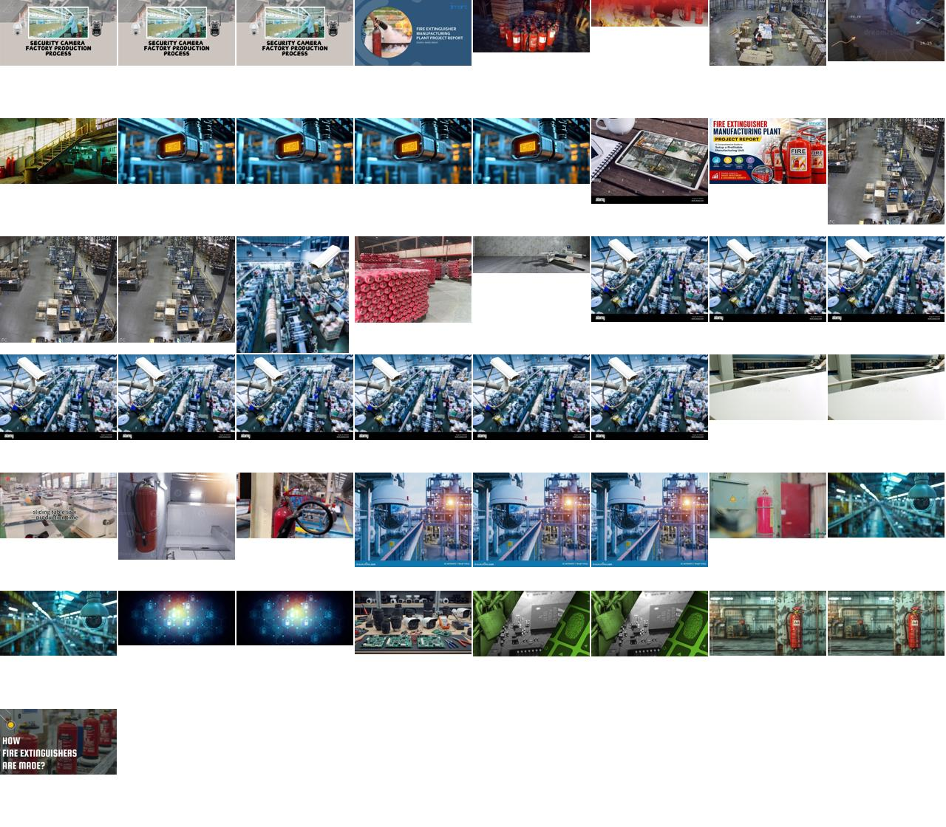
Figure 1. What CLIP rated “most CCTV-like”: security-camera stock photos and extinguisher-factory adverts. Source: pipeline/logs/cctv_scrape_analysis/sheet_cctv_candidates.jpg
- Why it failed: real CCTV of these machines lives on private NVRs, not the indexed web; “surveillance” queries found pages *about cameras*; and even good hits were front-on, studio-lit photos.
- The deeper problem: a ceiling camera sees the table top from above. Those pixels are not in any front-on photo, and no filter can create them.
- The fix: place-based highangle queries plus an acceptance gate (30 usable images of 113), and, above all, footage from our own cameras or pseudo-CCTV video shot from 3–4 m up.

4. Label Cleanup & Spatial Policy Overhaul
The big picture
run6's two weakest classes were not short of data; they were badly labelled. 45% of val edge-bander labels covered the whole image, and touching extinguishers were merged into blobs. On 21 October we rebuilt the labels around a written policy (label_decisions.yaml, applied by build_clean_9class_dataset.py).

4.1 Edge Banders: One Machine, One Polygon
- The problem: a morphological “merge” step closed gaps of 0.5–1.2% of the image diagonal, so fragments ballooned into slabs. The model learned “edge bander = the whole photo” and found 0 of 15 small ones.
- The policy: chassis, hood, gluing and trimming units, attached conveyors and the tape coil are in. Panels on the conveyor, the room, text banners and collage tiles are out. Two machines means two polygons.
- The fix: merge turned off. SAM 2.1 re-proposed all 175 frame-filling polygons: 68 accepted, 47 kept as genuine close-ups, 60 quarantined.
- The result: boxes over 80% of the image fell from 48% to 20% (train) and from 59% to 18% (val).

4.2 Fire Extinguishers: Every Cylinder Counts
- The problem: 348 fragments in one image fused into a single blob covering three cylinders. Recall was 86% for a lone cylinder and 39% with three or more.
- The policy: one polygon per cylinder, including its own hose, handle and strap. Label every one that is at least 40% visible.
- The fix: label_instances.py keeps neighbours separate; SAM drew per-cylinder masks in 15 images; 4 dense, blurred rows were quarantined.
- The result: instances went from 435 / 105 / 96 to 606 / 129 / 147 (train / val / test), and are 586 / 109 / 140 after the final curation.

4.3 SAM 2.1 Base vs Large
Model | Mean IoU | Boundary F1 | Jointer | Mitre saw | ms / prompt | GPU MB
SAM 2.1 Base | 0.880 | 0.794 | 0.928 | 0.914 | 108 | 776
SAM 2.1 Large | 0.886 | 0.802 | 0.971 | 0.877 | 271 | 1,423

- Verdict: Large is the default, but the gain is small (+0.006 IoU), it is 2.5× slower, and it loses on mitre saws, so every mask is still reviewed.
- House rules: clip every mask to its prompt box; invert a mask only when the box covers more than 80% of the image; on white studio shots, cut the object out of the non-white pixels instead of using SAM.

4.4 Quarantine, Negatives & Manual Curation
- 64 quarantined: 60 edge-bander collages, infographics and multi-machine scenes, plus 4 dense extinguisher rows (38 train / 16 val / 10 test). They wait for hand re-annotation.
- Veneer presses removed from the negatives: the Camera 03 press is a woodworking hot press, so 12 veneer-press negatives were teaching it to be background. 5 more negatives turned out to contain real target machines. Negatives went from 295 / 60 / 65 to 283 / 58 / 62.
- 107 hard negatives: drums, cardboard tubes, gas cylinders, water jugs, red bins, hose reels, alarm boxes, floors, ceilings and workbenches, aimed squarely at extinguisher false alarms.
- datasetchange curation: 80 bad images removed at build time, 110 labels re-drawn with SAM 2.1 L (128 instances), 3 excluded. Audit: PASS.
- High-angle images: 30 web images (52 instances), train only. They are the first elevated views the model has seen.
- Caveat: every review was done by Claude, not a human annotator. Spot-check the sheets in label_fixes/ before a release.

5. The Trial of the Models: Runs 5, 6, 7 & 8
The big picture
run5 set the bar. run6 and run7 were our attempts to make it CCTV-ready, and both made it worse in ways validation could not see. run8 is the first run built on clean labels and augmentation that actually runs.

5.1 Run 5: The Baseline Champion
- Recipe: 20-epoch fine-tune of the 38-class run3 on 9-class catalog data, imgsz 960, 37 minutes.
- Why it works: it is the only model that finds the held-out workshop saw (0.56–0.63 at imgsz 960), and it raises zero extinguisher false alarms on Camera 03.
- Its flaw: on 200 sampled frames it finds that saw every time but calls it table_saw (max 0.70). The class boundary in our labels is wrong, not the model.
- Status: deployment fallback and the parent of every fine-tune. Factory benchmark: still only 0.054 mask mAP50.
Box AP50 | panel | press | table | planer | jointer | band | mitre | edge b. | extinguisher | all
run5 | 0.893 | 0.963 | 0.937 | 0.849 | 0.877 | 0.883 | 0.783 | 0.574 | 0.718 | 0.831
run6 | 0.848 | 0.961 | 0.931 | 0.846 | 0.869 | 0.840 | 0.733 | 0.584 | 0.680 | 0.810

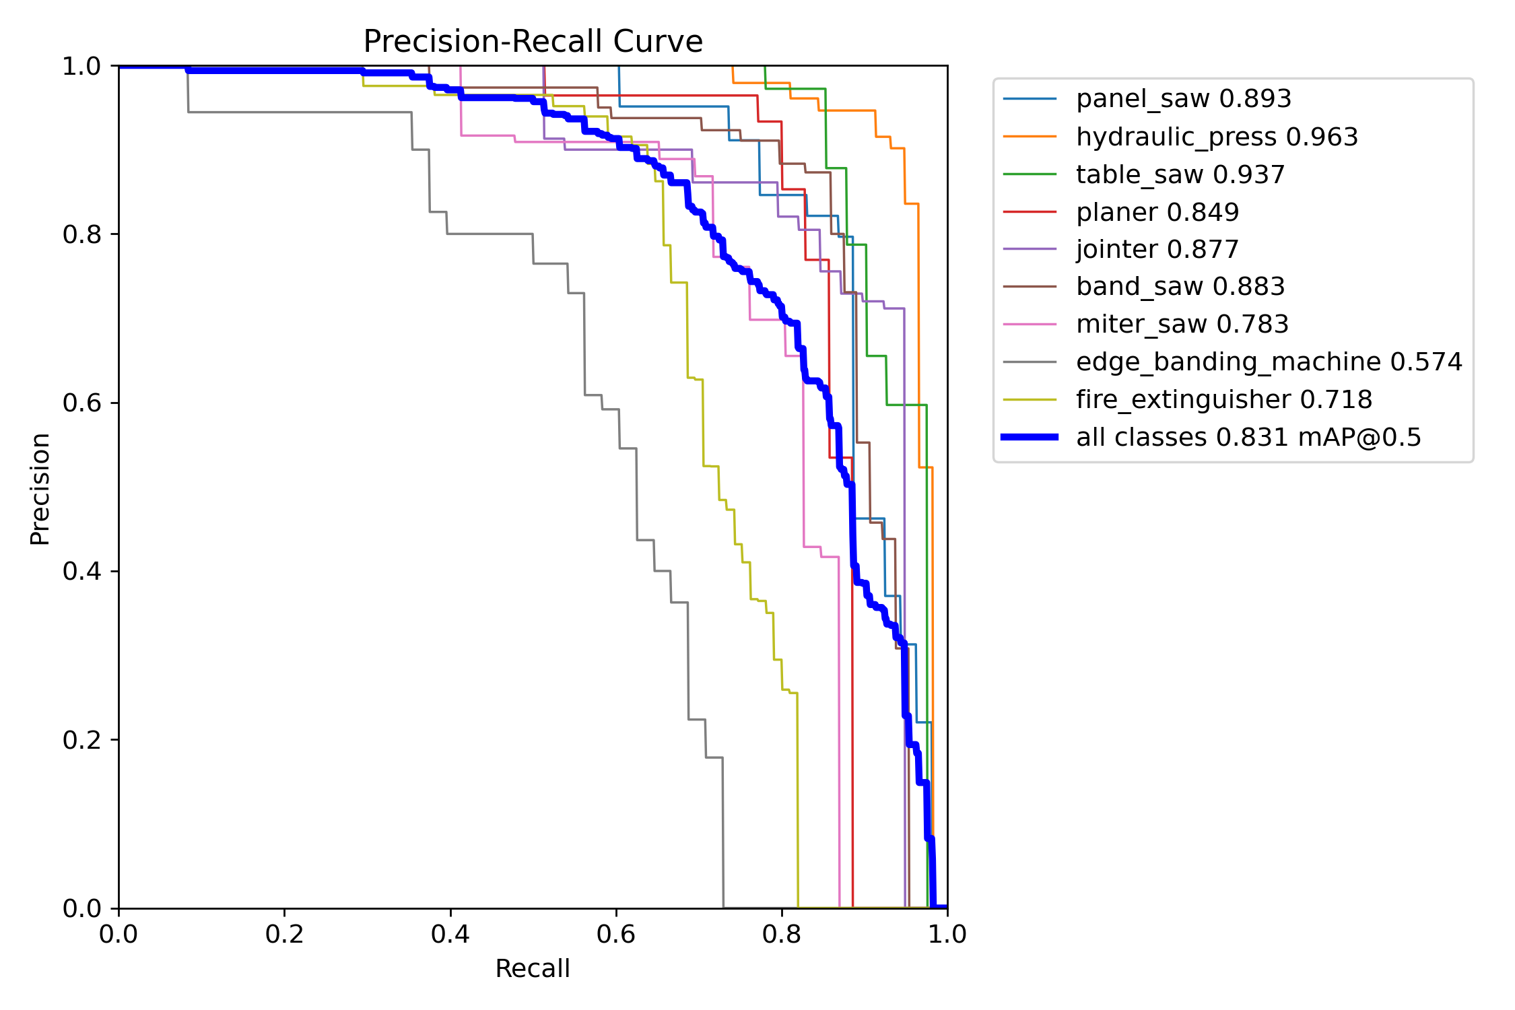
Figure 2. run5 per-class precision-recall: edge bander (0.574) and extinguisher (0.718) trail every machine class. Source: runs/run5_9class_clean_finetune/BoxPR_curve.png

5.2 Run 6: The Fake Win
- Recipe: run5 at imgsz 1280, 50 epochs, 301 machinery negatives, heavier geometric augmentation.
- On paper: box 0.810 / mask 0.795, precision 0.87. Looks like a solid model.
- On video: the workshop saw fell to ≤ 0.18, with 0 detections at conf 0.40 in 1,398 frames, plus 29 false extinguishers in 16 of 40 factory frames.
- Why it failed: spindle moulders, CNC routers and racking, used as negatives, share the sliding-table saw's long, flat shape, so we taught that shape to be background. The degradation augmentation never ran (Albumentations was missing). And the val set held no CCTV, so it could not see any of this.

5.3 Run 7: The Memorization Disaster
- Recipe: run5 plus 257 Camera 05 frames repeated 5× (44% of every epoch), validated on Camera 03.
- Result: 100% of Camera 05 frames at ~0.97; 0 of 142 machines on Camera 03, even at conf 0.01. Extinguisher false alarms rose to 51–74, and catalog scores fell 3 points (mAP50) and 9–11 points (mAP50-95).
Test | run5 | run6 | run7
Camera 05 (run7's training camera), 200 raw frames | 0 / 200 | 0 / 200 | 200 / 200 at ~0.97
Camera 03 machines found at ≥ 0.25 (of 142) | 0 | 0 | 0
Camera 03 extinguisher false alarms (imgsz 640 / 1280) | 0 / 0 | 32 / 2 | 51 / 74
Catalog box mAP50 / mAP50-95 (imgsz 960) | 0.821 / 0.706 | 0.825 / 0.698 | 0.786 / 0.597

The four root causes:
1. One viewpoint per class: 257 frames from one fixed camera are roughly one view of information.
2. Different machines: Camera 03 has a manual edge bander and a hot press; Camera 05 has an inline line and a frame press.
3. Position, not appearance: Camera 03's press sits where Camera 05's edge bander does, and run7 called it an edge bander in 64 of 71 frames.
4. Scene texture: it scored 0.97 even on the 2:1-squeezed raw video it never trained on.
- The lesson: count viewpoints, not frames. We need ≥ 5 per class before CCTV training, with at most 1–2× repeats.

5.4 Run 8: The Production Recipe
- Base: run5, never run6 or run7.
- Data: cleaned and curated labels, 30 high-angle images, 107 hard negatives. Negatives are 11.8% of the 3,298-entry list (11.6% before the 21 Oct curation).
- Recipe: explicit AdamW (lr0 5e-4, cosine), imgsz 960, batch 6, 50 epochs, patience 20, geometry turned down (degrees=0, perspective=0.0002).
- cctv_aug (Albumentations 2.x): barrel lens distortion, JPEG 30–75, downscale 0.4–0.75, sensor noise, mild blur, rare greyscale.
- Status: epoch 1 scored 0.830 / 0.813 on the 450-image val; resumed on 23 Oct. Epoch 1 took 3,525 s, against 111 s per epoch for run5, so about two days for the full run unless the cause is found.

6. Critical Engineering Traps & Bug Post-Mortems
The big picture
Our most expensive bugs never raised an error. Each one made a training recipe mean something different from what it said.

6.1 The Silent Albumentations Bypass
- The problem: Ultralytics wraps Albumentations in an import guard. If the package is missing, blur, compression and greyscale are skipped without any error.
- The impact: run1–run6 trained with no degradation beyond HSV jitter. The CCTV-robust run was never robust.
- The fix: we installed 2.0.8 with --no-deps (keeping the GUI OpenCV build), and train.py now refuses to start without it. Check every training log for the albumentations: line.

6.2 Albumentations 2.x Breaking Names
Transform | 1.x (silently ignored) | 2.x (what we use)
ImageCompression | quality_lower, quality_upper | quality_range=(30, 75)
Downscale | scale_min, scale_max | scale_range=(0.4, 0.75)
GaussNoise | var_limit=(10, 50) | std_range=(0.012, 0.028)

- Barrel vs pincushion: in 2.x a *negative* distort_limit gives pincushion. CCTV lenses barrel, so we use (-0.05, 0.25). Polygons warp with the image.
- optimizer=auto too: it ignores lr0 and picks AdamW at 0.000769 for nine classes. run5 and run6 list lr0 0.01 but never used it. Always set the optimizer explicitly.

6.3 The “1080P Lite” Squeeze & the Upscaling Trap
- The squeeze: every factory recording is 960×1080, a 16:9 picture stored at half width with no aspect flag, so every tool shows machines half as wide as they are.
- The fix: de-squeeze to 1920×1080 before labelling or inference (sample_cctv_video.py --resize 1920x1080). The benchmark is built that way.
- The upscaling trap: on the 480×360 workshop sub-stream, run5 scored 0.56 at imgsz 960 and 0.27 at 1280. Upsampling 2.7× creates blurry giants the model never saw.
- Rule: imgsz 640 for sub-streams, 960 for de-squeezed main streams, or native-size ROI crops.

6.4 The Small Object Myth
- The assumption: the workshop saw was “small and distant”, so SAHI tiling should help.
- The measurement: it is 266×208 px on a 480×360 frame, 32% of the image. The gap is viewpoint, codec and clutter, not size.
- The decision: we dropped SAHI (6–9 forward passes per 4K frame) for static ROI crops: fixed cameras, fixed machines, 1–3 regions per camera at native resolution.
- Exception: SAHI is reconsidered only for far-wall extinguishers under ~40 px on a wide main stream.

6.5 The Ignored iou Parameter
- The problem: our checkpoints run YOLO26's NMS-free head, so iou=0.45 did nothing for weeks (ultralytics/utils/nms.py:66).
- The fix: end2end=False (or --nms in the harness) switches to the one-to-many head with NMS, and every inference summary now prints which head ran.

6.6 What the Traps Taught Us
Lesson | Guard we adopted
Catalog val mAP does not predict CCTV performance | Gate on the factory benchmark and the held-out clip
Frames are not viewpoints | Weight CCTV data by camera × machine pairs; ≤ 1–2× repeats
Libraries fail silently | Fail-fast checks; explicit optimizer; read the training log
Labels cap accuracy | Written extent policy; reviewed SAM outlines
Noise-level val picks checkpoints at random (run7) | Select on catalog val or run fixed epochs

7. Deployment, Benchmark & Release Gates
The big picture
run7 proved that a camera used in training can never again measure generalisation. So we froze our factory footage as a test-only benchmark and wrote down the gates a model must pass.

7.1 The Frozen Factory Benchmark (328 Frames)
Camera | Recordings | Frames | Labels
cam03 | 2 (07 and 24 Sep) | 71 | press, edge bander
cam05 | 3 (25 and 28 Sep) | 257 | panel saw, press, edge bander
Total | 5, de-squeezed to 1920×1080 | 328 | panel saw 257, press 328, edge bander 328

- Absent classes: the other six never appear, so any detection of them is a false positive (watch Camera 03's plastic drum).
- Zero leakage: train.py refuses the benchmark; it is never used for checkpoint selection, threshold tuning or negative mining; splits are by camera, never by frame.
- Limits: 3 of 9 classes and 2 viewpoints, so it measures transfer to these cameras, not general readiness.
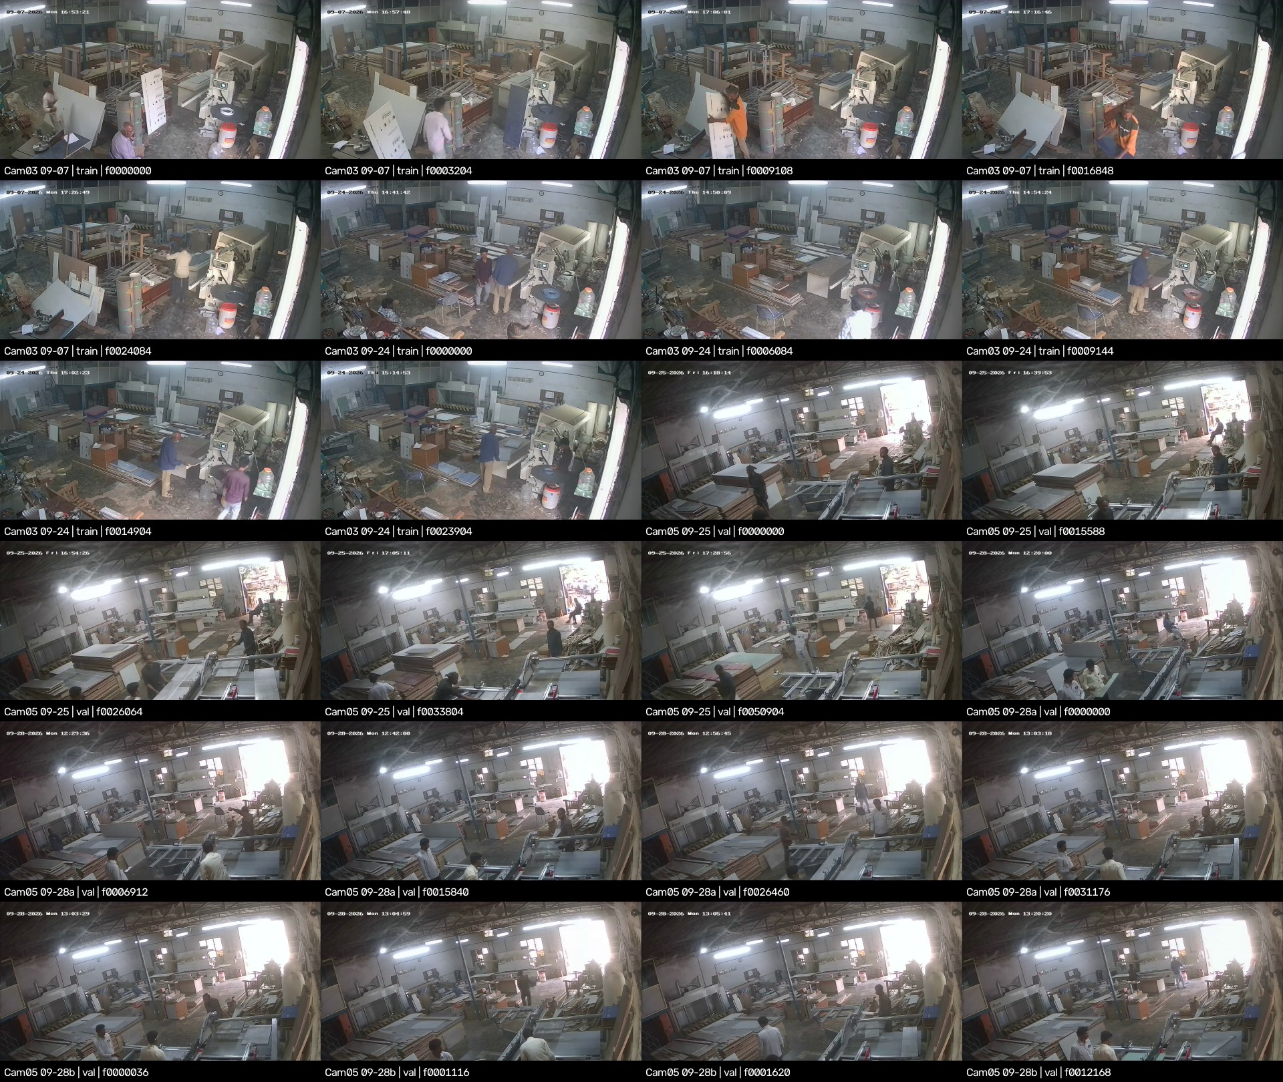
Figure 3. The two factory cameras behind the benchmark. Source: docs/factory_footage_contact_sheet.jpg

7.2 Multi-Frame Temporal Filtering (Design, Not Yet Built)
- Detect low, decide slowly: decode at 5 fps, detect at conf 0.10, and associate with ByteTrack (high 0.35, low 0.10, new track 0.45, buffer 10 s).
- 8-of-15 rule: confirm a track when at least 8 of the last 15 frames match above the class threshold; drop it at 2 or fewer.
- Class by vote: a confidence-weighted vote over the track's life stops table-saw / panel-saw flicker.
- Thresholds (provisional): edge bander 0.20, extinguisher 0.30, others 0.40. Re-derive them on CCTV val.
- Extinguisher not confirmed: mark it *unverified* for human review. Never raise an alarm.

7.3 Release Gates
Gate | Criterion | run5 today
1. CCTV accuracy | Per-class mask mAP50 ≥ 0.60 and recall ≥ 0.80 on held-out cameras | FAIL (0.054)
2. False alarms | ≤ 1 per camera-hour after temporal confirmation | NO DATA YET
3. Catalog retention | Mask mAP50-95 within 2.0 points of run5 | BASELINE
+ Trial clips | Raw RTSP clips without overlay; must beat run5 on the workshop saw | NOT RECORDED

The plan lists the trial-clip check as a fourth gate. run8 has not been scored against any gate yet.

8. Immediate Handoff & Action Items
The big picture
Let run8 finish, measure it honestly, then spend effort on viewpoints, not epochs. The model is not the bottleneck; real elevated views are.
- ☐ Monitor run8: resumed 23 Oct with 50 epochs planned. Do not run other GPU jobs on the 8 GB card meanwhile. Find out why epoch 1 took 3,525 s (check GPU utilisation and dataloader CPU load).
- ☐ Re-baseline, then evaluate: run5 on the current 450-image val, then run8 best.pt / last.pt on that val, the frozen benchmark and the workshop clip (imgsz 640 and 960).
- ☐ Human review of datasetchange: check the before/after sheets in label_fixes/review_user_fixes/ and decide on the 6 self-intersecting polygons.
- ☐ Settle class boundaries: sliding-table saw = panel_saw; veneer press → hydraulic_press.
- ☐ Record raw RTSP: ≥ 24 h per camera (day, night, IR) with the overlay off, plus pseudo-CCTV phone video from 3–4 m up. Target ≥ 5 viewpoints per class.
- ☐ Build CCTV negatives: ≥ 300 frames from cameras outside the benchmark, for gate 2.
- ☐ Pipeline hardening: cross-class and byte-level de-dup in stage 3; upload every SAM instance, not just the first.

Document Control
Version | Date | Change
2.4 | 2026-10-23 | First consolidated dossier
2.5 | 2026-10-23 | Narrative voice; scraping pipeline expanded
2.6 | 2026-10-23 | Condensed to a bullet-driven brief; table of contents and appendix removed

Role | Name | Signature | Date
Technical owner (ML)
Data and labelling reviewer
Operations / safety stakeholder

Sources: run logs in runs/, docs/runsummary.md, docs/run7_analysis_report.md, docs/label_policy.md, docs/cctv_benchmark.md, docs/cctv_scrape_postmortem.md, pipeline/.

