An Explainable Knowledge Graph-Enhanced Recommender for Informal Gig Worker–Job Matching in Kenya (Capstone)

Kemoi, Kristina Chebet
168652
ICS 4A

Supervisor Name
Mr. Kevin Ochieng’ Omondi

An Informatics and Computer Science Final Project Documentation Submitted to the School of Computing and Engineering Sciences in Partial Fulfillment of the Requirements for the Award of a Degree in Bachelor of Science in Informatics and Computer Science

School of Computing and Engineering Sciences
Strathmore University
Nairobi, Kenya

September 2026

Declaration and Approval
I declare that this work has not been previously submitted and approved for the award of a degree by this or any other University. To the best of my knowledge and belief, the research documentation contains no material previously published or written by another person except where due reference is made in the research proposal itself.

Student Name: Kristina Chebet Kemoi
Admission Number: 168652
Student Signature: _________________________ Date: ________________________

The Documentation of Kemoi, Kristina Chebet has been reviewed and approved by Mr. Kevin Ochieng’ Omondi
Supervisor Signature: _________________________ Date: ________________________

Acknowledgement
I would like to express my sincere gratitude to my supervisor, Mr. Kevin Ochieng’ Omondi, for his invaluable guidance, constructive feedback, and continuous support throughout this research project. His insights and encouragement greatly contributed to the development of this study. Finally, to my family particularly my mother and sister for their unwavering support, patience, and encouragement during my studies. Their belief in me has been a constant source of motivation.

Abstract
Kenya's informal gig economy provides livelihoods for millions of artisans, technicians, freelancers, and casual labourers. Digital platforms have emerged to connect these workers with clients, yet effective worker–job matching remains persistently difficult due to limited worker histories, sparse interaction data, and limited transparency in recommendation decisions. Existing platforms rely heavily on behavioural data, making them ineffective for new users and leaving them unable to explain why a match was made.
This study proposes a recommender that leverages a knowledge graph–enhanced model for informal gig worker–job matching in Kenya. The model combines rule-based and semantic similarity matching, enriched through a domain-specific knowledge graph extended with Kenya’s informal trade vocabulary, to improve worker–job matching. By modelling relationships between workers, skills, occupations, and jobs, the approach is intended to mitigate cold‑start challenges from the moment a worker or job joins the platform. The knowledge graph also supports transparent recommendations by exposing the relationships that contribute to a match. The proposed solution will be evaluated against a keyword-matching baseline using Precision@K and Mean Reciprocal Rank on a tiered dataset strategy comprising job posting and worker profile data intended to be sourced through collaboration with Webmasters Kenya, supplementary job-side data from the Job Skill Set dataset, and synthetic worker profiles where needed. The expected outcome is an explainable worker–job matching system that improves recommendation relevance under limited-data conditions while increasing transparency in recommendation decisions for Kenya's informal labour market.
Keywords: Knowledge Graphs, Hybrid Recommender Systems, Gig Worker–Job Matching, Informal Labour Markets, Cold-Start Problem, Explainable Recommender Systems.
Table of Contents
Declaration and Approval ii
Acknowledgement iii
Abstract iv
List of Figures ix
List of Tables x
List of Equations xi
List of Abbreviations xii
Chapter 1: Introduction 1
1.1 Background Information 1
1.2 Problem Statement 2
1.3 Research Objectives 2
1.3.1 General Objective 2
1.3.2 Specific Objectives 3
1.4 Research Questions 3
1.5 Justification 3
1.6 Scope 4
1.7 Limitations and Delimitations 5
1.7.1 Limitations 5
1.7.2 Delimitations 6
Chapter 2: Literature Review 7
2.1 Introduction 7
2.2 Worker–Job Matching Approaches 7
2.2.1 Rule-Based Matching Approaches 7
2.2.2 Content-Based and Collaborative Filtering Approaches 8
2.2.3 Hybrid Recommender Approaches 8
2.2.4 Knowledge Graph-Enhanced Recommender Approaches 8
2.2.5 Key Challenges in Worker–Job Matching 9
2.3 Related Works 10
2.3.1 Fuzu 10
2.3.2 JobMatchAI 11
2.3.3 Knowledge Graph Recommendation Research 11
2.3.4 ESCO and Tabiya 12
2.3.5 OKRA 12
2.4 Gaps in Related Works 14
2.5 Conceptual Framework 14
Chapter 3: Methodology 16
3.1 Introduction 16
3.2 Research Paradigm 16
3.2.1 Data Acquisition 17
3.2.2 Data Processing 17
3.2.3 Model Training 19
3.2.4 Model Validation and Testing 20
3.3 System Development Methodology 21
3.4 Methodology Diagram and Justification 22
3.4.1 Product Backlog 23
3.4.2 Sprint Planning Meeting 23
3.4.3 Sprint Backlog 23
3.4.4 Sprint Development 23
3.4.5 Daily Stand-Up 23
3.4.6 Sprint Review and Retrospective 24
3.4.7 Finished Work 24
3.4.8 Justification of OOAD and Scrum 24
3.5 Analysis Diagrams 25
3.5.1 Use Case Diagram 25
3.5.2 Sequence Diagram 25
3.5.3 Entity-Relationship Diagram 26
3.5.4 Activity Diagram 26
3.5.5 Class Diagram 26
3.6 Design Diagrams 26
3.6.1 Database Design 27
3.6.2 System Architecture Diagram 27
3.6.3 Knowledge Graph Design 27
3.6.4 User Interface Wireframes 28
3.7 Deliverables 28
3.7.1 Hybrid Recommender System 28
3.7.2 Knowledge Graph 28
3.7.3 System Documentation 28
3.8 Tools and Techniques 28
3.8.1 Python 28
3.8.2 Pandas and NumPy 29
3.8.3 Scikit-learn 29
3.8.4 NetworkX 29
3.8.5 Sentence Transformers 29
3.8.6 Next.js, React and TypeScript 29
3.8.7 Draw.io 30
3.8.8 PostgreSQL 30
3.8.9 Flask 30
Chapter 4: System Analysis and Design 31
4.1 Introduction 31
4.2 System Requirements 31
4.2.1 Functional Requirements 31
4.2.2 Non-Functional Requirements 32
4.2.3 Data Requirements 33
4.2.4 Interface and Integration Requirements 34
4.3 System Analysis Diagrams 34
4.3.1 Use Case Diagram 34
4.3.2 Sequence Diagram 35
4.3.3 Entity Relationship Diagram (ERD) 36
4.3.4 Activity Diagram 37
4.3.5 Class Diagram 37
4.4 System Design Diagrams 37
References 38
Appendices: 41
Appendix 1: Gantt Chart for April – June Semester 1 41
Appendix 2: Gantt Chart for July – November Semester 2 41
Appendix 3: Similarity Report 42

List of Figures
Figure 2.1 Conceptual Framework 15
Figure 3.1 Scrum Process Methodology (Schwaber & Sutherland, 2020) 22
Figure 4.1 Use Case Diagram 35
Figure 4.2 Sequence Diagram 36

List of Tables
Table 2.1 Comparative Synthesis of Reviewed Systems and Studies 13

List of Equations
Equation 3.1 Hybrid Scoring Computation 20

List of Abbreviations
AI – Artificial Intelligence
API – Application Programming Interface
BM25 – Best Match 25 (probability ranking function)
CF – Collaborative Filtering
CV – Curriculum Vitae
ERD – Entity-Relationship Diagram
ESCO – European Skills, Competences, Qualifications and Occupations
ILO – International Labour Organization
ISCO – International Standard Classification of Occupations
KG – Knowledge Graph
KGCN – Knowledge Graph Convolutional Networks
KNBS – Kenya National Bureau of Statistics
LLM – Large Language Model
MRR – Mean Reciprocal Rank
NDCG – Normalised Discounted Cumulative Gain
OOAD – Object-Oriented Analysis and Design

Introduction

Background Information
Kenya's informal economy is the dominant employment channel in the country and a structurally significant component of the labour market. In 2025, the informal sector accounted for approximately 83.6% of employment in Kenya, representing about 17.4 million workers (Kenya National Bureau of Statistics, 2025). Within this informal economy, gig work – short‑term, task‑based labour mediated by online platforms – has become a significant income source for millions of Kenyans across trades such as construction, transport, domestic services, and technology (International Labour Organization, 2025).
The growth of digital labour platforms has created new opportunities for connecting workers with clients. Worldwide, an estimated 154 million to 435 million people engage in online gig work, while demand for gig labour in Sub‑Saharan Africa grew by 130% between 2016 and 2020 (Datta et al., 2023). In Kenya, platforms such as Fuzu have emerged to support digital labour matching. However, these platforms primarily target formal white‑collar employment, leaving the informal trades sector underserved by digital matching platforms (Kwanya & Wakunuma, 2023).
Despite the emergence of digital platforms, effective worker–job matching in Kenya’s informal gig market remains a persistent challenge. Most informal workers still rely on manual, socially mediated channels such as word‑of‑mouth or personal networks, which are limited in reach and inconsistent (Lynk, 2025). Where platforms do exist, their recommendation approaches depend on accumulated behavioural data, making them ineffective for new workers or newly posted jobs, a failure known as the cold‑start problem (Zhang et al., 2025). Furthermore, existing systems offer no explanation for why a match was made, leaving users unable to evaluate or trust the outcomes (Zerilli et al., 2022). Finally, the vernacular occupational vocabulary of Kenya’s informal sector – terms such as fundi wa umeme (electrician) and mama fua (laundry worker) – is often not adequately represented in standard skill taxonomies, causing a systematic mismatch between how workers describe their skills and how clients’ articulate requirements.
Knowledge graphs have emerged as a promising approach to address such challenges. By structuring relationships between workers, skills, and jobs, knowledge graphs have shown potential to improve recommendation performance in sparse‑data environments, and enhance transparency by modelling how entities are connected (Guo et al., 2020; Wang et al., 2019). However, although knowledge graph‑based recommenders have been applied in domains such as movies, books, and e‑commerce, limited research has explored their use for informal gig worker–job matching within the Kenyan labour market. This study therefore proposed a knowledge graph‑enhanced hybrid recommender for informal gig worker–job matching in Kenya, with the aim of improving matching relevance, mitigating cold‑start challenges, and increasing transparency in recommendation decisions.

Problem Statement
Effective worker–job matching systems should connect workers and clients using skills and job requirements, provide transparent recommendations, and function without prior platform history. Kenya’s informal gig labour market does not consistently achieve these characteristics. Matching remains manual through personal connections and word-of-mouth referrals, which are limited in reach and inconsistent (Kwanya & Wakunuma, 2023). Digital platforms may depend on accumulated behavioural data, making them ineffective for new workers or posted jobs, contributing to the cold-start problem (Zhang et al., 2025). Moreover, existing systems may not explain why a match was made, limiting users’ ability to trust or evaluate recommendations (Zerilli et al., 2022). Occupational terminology in Kenya's informal sector is poorly represented in standard skill classifications, creating mismatch between worker and client descriptions.
Consequently, new workers have reduced visibility, jobs may go unfilled, and users may not understand or contest recommendations. This study proposes an explainable knowledge graph-enhanced recommender, in which a domain-specific knowledge graph, extended with Kenya's informal trade vocabulary, enriches worker and job profiles at registration, reducing dependence on prior interaction history and mitigating the cold-start problem. Profiles are matched using rule-based and semantic similarity methods, while underlying graph relationships expose the specific skills and terms contributing to each match, addressing limited transparency. Mapping vernacular terms such as fundi wa umeme to their formal occupational equivalents, further addresses vocabulary mismatch between workers and client descriptions.

Research Objectives

General Objective
To design, develop, and evaluate a knowledge graph-enhanced hybrid recommender for informal gig worker-job matching in Kenya.

Specific Objectives
- To review worker–job matching approaches and their limitations in Kenya's informal gig labour market.
- To analyse knowledge graph-based, semantic matching, and explainable recommender techniques relevant to worker–job matching.
- To determine gaps in existing worker–job matching and recommender system approaches relevant to Kenya's informal gig labour market.
- To design and develop an explainable knowledge graph-enhanced recommender for informal gig worker-job matching in Kenya.
- To test and validate the performance of the proposed recommender against a keyword-matching baseline under limited-data conditions.

Research Questions
- What worker–job matching approaches are used in Kenya's informal gig labour market, and what limitations do they exhibit?
- What knowledge graph-based, semantic matching, and explainable recommender techniques are relevant to worker–job matching?
- What gaps exist in worker–job matching and recommender system approaches relevant to Kenya's informal gig labour market?
- How can an explainable knowledge graph-enhanced recommender be designed and developed to support informal gig worker-job matching in Kenya?
- How does the proposed recommender perform compared to a keyword-matching baseline under limited-data conditions?

Justification
Knowledge graph‑based recommender systems have been shown to improve recommendation quality in sparse‑data environments and to provide explainable recommendations by modelling relationships between entities (Guo et al., 2020; Wang et al., 2019). In addition, hybrid recommender approaches that combine multiple matching techniques have demonstrated improved recommendation performance compared to single-method approaches, particularly in situations where interaction data is limited. Digital labour platforms have expanded globally, creating new opportunities for worker–job matching (Datta et al., 2023).
Despite these advances, limited research has explored the application of knowledge graph-enhanced hybrid recommenders to informal gig worker–job matching in Kenya. Existing matching approaches depend on accumulated behavioural interaction data (Guo et al., 2020), making them less effective for new workers or newly posted jobs – a challenge known as the cold‑start problem (Zhang et al., 2025). Furthermore, recommendation processes are frequently opaque and may not adequately represent the occupational terminology used within Kenya's informal sector. These limitations can reduce the visibility of new workers, hinder effective matching between workers and clients, and make recommendation decisions difficult to understand or trust. Consequently, informal workers may face reduced access to employment opportunities while clients face challenges in identifying suitable workers.
This study addressed these challenges by investigating a knowledge graph‑enhanced hybrid recommender for informal gig worker–job matching in Kenya. The proposed approach combined knowledge graph relationships with rule-based and semantic similarity techniques to support matching under limited-data conditions while providing more transparent recommendations. The study expected to benefit informal gig workers and clients by improving worker–job matching to contribute empirical evidence on the application of knowledge graph-enhanced hybrid recommenders in a low-resource labour market context.

Scope
This study covered the review of worker–job matching approaches and their limitations, as well as the design, development, and evaluation of an explainable knowledge graph-enhanced hybrid recommender for informal gig worker–job matching in Kenya. The system modelled relationships between workers, skills, occupations, and job opportunities using a domain-specific knowledge graph enhanced with Kenya-specific informal trade vocabulary, and combined rule-based and semantic similarity matching techniques to generate explainable recommendations.
The study employed a tiered data acquisition strategy comprising complementary data sources, subject to their availability and suitability for the study. The primary data source was intended to be job posting and worker profile data obtained through collaboration with the industry partner, Webmasters Kenya. Where such data were unavailable or insufficient, supplementary job data from the Job Skill Set (Mutlu, 2024) dataset were considered for proof-of-concept evaluation, particularly for the representation of job titles, descriptions, categories, and skill requirements. Because this supplementary dataset is not specific to Kenya's informal gig labour market and does not contain worker profiles, it was not treated as a substitute for the primary worker–job dataset. Synthetic worker profiles and, where necessary, job postings were used to support controlled experiments under limited-data and cold-start conditions. The knowledge graph used the ESCO skills taxonomy as a foundation and was extended with Kenya-specific informal trade terminology. Recommendation performance was evaluated using Precision@K and Mean Reciprocal Rank (MRR), with the proposed recommender compared against a keyword-matching baseline.
The study was conducted between April and November 2026, covering the phases of requirements analysis, system design, dataset preparation, implementation, evaluation, and documentation, within the allocated research timeframe. The study does not include live platform deployment, user authentication, payment processing, dispute resolution, or other production-level platform features. Collaborative filtering and Learning to Rank approaches were outside the scope of the study because they require historical interaction data that is not available in the target context. The system was designed as a proof-of-concept prototype for evaluation purposes and was not intended for production deployment within this study period.

Limitations and Delimitations

Limitations
The use of synthetic worker profiles may not fully capture the diversity and complexity of real-world informal gig worker descriptions. Where industry-provided worker and job data are available, their coverage and completeness may also constrain the extent to which the system can be evaluated using real-world Kenyan informal gig data. The supplementary Job Skill Set (Mutlu, 2024) dataset, where used, provides job-side information but is not specific to Kenya's informal gig labour market and does not contain corresponding worker profiles. Consequently, findings obtained from this supplementary corpus may have limited direct applicability to the target context. The Kenya-specific informal trade vocabulary incorporated into the knowledge graph may not represent all occupational terms used across different regions, trades, and sectors in Kenya. In addition, the controlled datasets and synthetic profiles used to examine limited-data and cold-start conditions may not fully reproduce the behaviour and diversity of a newly deployed platform with real users.
The weighting scheme used within the rule-based component was based on domain-informed assumptions rather than an established weighting framework for Kenya’s informal gig labour market. Although sensitivity analysis was conducted to examine the impact of alternative weight configurations, the selected weights may not fully reflect real-world worker and client preferences. Furthermore, the pre-trained semantic similarity model is primarily trained on English-language text and may be less effective when processing Swahili, code-switched, or informal occupational terminology commonly used within Kenya’s gig economy. Consequently, findings should be interpreted within the context of the datasets, vocabulary coverage, and modelling assumptions used in the study.
The use of an LLM for vocabulary discovery may generate informal terms that are plausible but not authentically used by Kenyan workers. Although candidate terms were subjected to source-based validation and manual review, this process may not capture the full range of terminology used by Kenyan informal gig workers. This does not constitute large scale field validation with gig workers across different regions, which remains outside the scope of this study. Additionally, the study does not include user acceptance testing; conclusions about explainability are therefore limited to technical coverage metrics rather than user trust or comprehension.

Delimitations
The study was confined to Kenya's informal gig labour market and does not seek to generalise its findings to formal employment sectors or other national contexts. The system focused on worker–job matching using worker and job attributes, including skills, occupational information, location, availability, and relevant job requirements. The study used industry-provided data where such data was available and authorised for research use. Where the industry data was unavailable or insufficient for experiments, the Job Skill Set (Mutlu, 2024) dataset was used only as a supplementary job corpus for job-side information and proof-of-concept evaluation. Synthetic worker profiles and, where necessary, synthetic job postings were used for controlled experiments, including evaluation under limited-data and cold-start conditions. The synthetic data are not treated as a substitute for representative real-world Kenyan informal gig worker data.
The study is limited to a knowledge graph-enhanced matching approach combining rule-based scoring and semantic similarity. Collaborative filtering and Learning to Rank approaches are excluded because they require historical interaction data that falls outside the scope of the study. The evaluation is conducted offline using predefined datasets and controlled experimental conditions rather than through live deployment with real users. Production-level platform features, including user authentication, payment processing, dispute resolution, and large-scale operational deployment, are outside the scope of the study.

Literature Review

Introduction
This chapter reviewed literature relevant to digital worker–job matching, recommender systems, knowledge graphs, semantic matching, and explainable artificial intelligence. The review examined worker–job matching approaches and their limitations, evaluated related systems and studies related to the research problem, and identified the gaps that motivate the proposed study. The chapter concludes with the conceptual framework, which synthesises the reviewed literature into a model guiding the development of the proposed knowledge graph-enhanced recommender system.

Worker–Job Matching Approaches
Worker–job matching systems have emerged as a critical component of digital labour platforms, enabling efficient connections between workers and employment opportunities (Datta et al., 2023; Raza et al., 2024). The growth of online gig work and digital recruitment has created a need for matching mechanisms capable of aligning worker attributes such as skills, experience, location, and availability, with job requirements while operating under conditions of limited historical interaction data (Zhang et al., 2025). Researchers have proposed various approaches ranging from rule-based scoring and content-based filtering to collaborative filtering, hybrid recommenders, and knowledge graph-enhanced systems. This section examined the main approaches currently used in worker–job matching, outlining their key strengths and limitations, with particular attention to their applicability in informal labour market contexts.

Rule-Based Matching Approaches
Rule-based approaches compute compatibility using predefined matching criteria such as skills, location, budget, and availability, often combining these criteria through weighted scoring mechanisms (Tang et al., 2025). Their primary advantage is interpretability, as recommendation decisions can be traced directly to the underlying scoring rules. Consequently, rule-based approaches have been widely adopted in decision-support and recruitment contexts where transparency and controllability are important considerations (Raza et al., 2024). However, their effectiveness depends heavily on the selection of matching criteria and manually assigned weights, which may not adequately capture complex relationships between worker attributes and job requirements (Tang et al., 2025).

Content-Based and Collaborative Filtering Approaches
Content-based approaches match workers and jobs by comparing profile features without using interaction data from other users. More recent approaches employ dense neural embeddings, such as Sentence‑BERT (Reimers & Gurevych, 2019), which convert text descriptions into semantic vectors, enabling similarity comparisons that go beyond exact keyword matching. Semantic embedding approaches have been increasingly adopted in recruitment and talent matching because they can identify similarity between worker profiles and job descriptions even when different terminology is used. Nevertheless, content‑based methods remain limited by their reliance on the completeness of profile content and cannot leverage interaction patterns that might improve accuracy (Guo et al., 2020).
Collaborative filtering (CF) bases recommendations on interaction patterns among users. By exploiting collective behavioural patterns across many users, collaborative filtering can uncover latent preferences that are not explicitly represented in profile attributes. CF can benefit from sufficient interaction data, but its effectiveness is substantially limited under cold-start conditions, where a new worker or job has little or no interaction history (Zhang et al., 2025). This limitation is especially severe in emerging platforms where new registrations are continuous.

Hybrid Recommender Approaches
Hybrid recommender systems combine content‑based and collaborative signals to mitigate cold‑start. Switching hybrids, for example, default to content‑based matching for new users and progressively incorporate collaborative signals as interaction data accumulates (Raza et al., 2024). Hybridisation improves robustness, but most hybrid approaches still depend on either profile completeness or behavioural data accumulation, and few are designed for domains with highly informal or non‑standardised vocabulary. In this study, hybridisation refers specifically to the combination of rule-based scoring and semantic similarity rather than the combination of content-based and collaborative filtering signals. This formulation is appropriate for the target context because the proposed system is designed to operate under limited interaction data.

Knowledge Graph-Enhanced Recommender Approaches
Knowledge graph‑enhanced recommenders represent a more recent generation. A knowledge graph (KG) is a structured network of entities and typed relationships. In job matching, entities can include workers, skills, occupations, and locations; relationships encode semantic associations such as is_subskill_of, requires, and local_name_for. The literature identifies three commonly reported advantages of KG‑enhanced recommenders: improved handling of sparse data, support for cold‑start recommendation through entity relationships, and increased explainability through graph traversal paths (Guo et al., 2020). Wang et al. (2019) demonstrated that aggregating neighbourhood information from a KG improves recommendation accuracy in movie, book, and music domains.
Of particular relevance to worker–job matching, JobMatchAI (Vyas et al., 2026) integrates transformer‑based semantic embeddings, a skill knowledge graph, and interpretable re‑ranking. The system first retrieves candidates using semantic similarity before enriching matches through graph‑based skill relationships and generating factor‑wise explanations. Their evaluation on a benchmark of US civil‑service job postings achieved an NDCG@10 of 0.81 – a 7% relative improvement over a BM25 keyword baseline – while maintaining explainability. However, the study was conducted using formal employment data from a high‑resource environment and did not address informal labour market challenges such as vernacular occupational vocabulary, limited worker histories, or labour market contexts characteristic of developing economies.

Key Challenges in Worker–Job Matching
Despite advances in worker–job matching systems, several challenges remain unresolved, particularly within informal labour market contexts.
A persistent challenge is the cold-start problem, where meaningful recommendations cannot be generated for users or items with little or no interaction history (Zhang et al., 2025). Collaborative filtering approaches are especially affected because they depend on accumulated behavioural data. Although hybrid recommenders partially mitigate this limitation through content‑based signals, newly launched platforms and marketplaces with limited interaction histories are particularly affected by this problem. This challenge is particularly relevant in contexts where workers frequently join platforms without prior digital employment histories.
Another challenge concerns vocabulary mismatch. Informal labour markets often rely on vernacular and context‑specific terminology that differs from standard occupational taxonomies. Workers may describe their trades using local terms for example, “fundi wa umeme” for electrician, while employers use formal occupational labels. Systems that rely primarily on lexical matching may fail to identify semantically equivalent skills, potentially reducing recommendation accuracy and limiting worker visibility. The European Commission (2026a) notes that adapting formal taxonomies such as ESCO to informal work descriptions in East Africa requires explicit vocabulary bridging, and organisations such as Tabiya (2025) have developed methodologies to extend ESCO to “unseen economy” occupations. These efforts highlight the gap between formal skill classifications and the terminology used by informal workers and clients.
Explainability remains an additional concern. Although recommendation accuracy is a primary evaluation criterion, increasing attention has been directed towards explainability because highly accurate recommendations may still be rejected if users cannot understand the reasoning behind them (Zerilli et al., 2022). Within worker–job matching contexts, the absence of explanations may make it difficult for workers to understand how recommendations are generated or how they might improve their visibility within the platform.
Collectively, these challenges indicate that existing worker–job matching approaches remain constrained by data sparsity, semantic inconsistency, and limited transparency. The literature suggests that approaches capable of modelling semantic relationships while providing interpretable recommendations may offer a promising direction for addressing these limitations.

Related Works
This section critically examined existing systems and studies that are closely related to the proposed knowledge graph‑based recommender. The selection is guided by Objective (ii), which focuses on knowledge graph-based, semantic matching, and explainable recommender techniques relevant to worker–job matching. Each work was evaluated for its contribution, limitations, and relevance to informal gig worker–job matching in Kenya.

Fuzu
Fuzu is a recruitment platform operating in Kenya, Uganda, and Nigeria that uses search and CV analysis to match candidates (Finnfund, 2019). It targets formal white‑collar employment and aims to “develop and formalise the job market”. Publicly available documentation does not describe any specific cold‑start mitigation strategy or explainability mechanism. Consequently, it is difficult to assess how the platform addresses challenges commonly reported in recommender systems literature, including cold‑start and recommendation transparency (Zerilli et al., 2022; Zhang et al., 2025). Moreover, Fuzu’s documentation primarily focuses on formal employment categories and does not indicate support for informal occupational terminology such as fundi wa umeme (electrician); the European Commission (2026a) notes that bringing such vocabulary gaps is a recognised challenge. No peer‑reviewed evaluation of Fuzu’s matching accuracy was identified in the literature reviewed for this study. Thus, Fuzu illustrates the gaps that a system for informal gig work must address cold‑start vulnerability, opacity, vocabulary mismatch, and the absence of publicly validated benchmarks.

JobMatchAI
JobMatchAI (Vyas et al., 2026) integrates transformer‑based semantic embeddings, a skill knowledge graph, and interpretable re‑ranking into a unified job‑matching pipeline. Evaluated on the JobSearch‑XS benchmark (derived from NYC civil‑service job postings), it achieves an NDCG@10 of 0.81 – a 7% relative improvement over a BM25 keyword baseline – and provides factor‑wise explanations for each recommendation (Vyas et al., 2026).
Unlike traditional recruitment platforms such as Fuzu, which provide limited information regarding recommendation logic, JobMatchAI explicitly incorporates explainable ranking mechanisms alongside semantic and graph‑based matching. This demonstrates the potential of combining recommendation accuracy with transparency. The architecture is particularly relevant because it combines the same three components proposed in this study: semantic similarity, knowledge graph enrichment, and explainable recommendation. Consequently, JobMatchAI serves as the closest architectural precedent for the present study, although significant adaptation is required to accommodate informal labour market conditions and Kenya‑specific occupational vocabulary. The system was developed and evaluated using formal employment data from a high‑resource environment and assumes the availability of richly structured candidate profiles. Furthermore, the knowledge graph is derived from formal occupational data and does not account for vernacular trade terminology commonly used in informal labour markets. No evaluation is reported in African or low‑resource gig economy contexts.

Knowledge Graph Recommendation Research
Knowledge graph recommendation research provides the theoretical basis for applying graph structures within recommendation systems. Guo et al. (2020), in a comprehensive survey of KG‑based recommenders, conclude that knowledge graphs can alleviate sparsity, improve cold‑start performance, and enhance explainability through explicit semantic relationships. These findings provide theoretical support for incorporating graph structures into recommendation pipelines.
Empirical evidence for these benefits is provided by Wang et al. (2019) through the Knowledge Graph Convolutional Network (KGCN), which aggregates information from neighbouring graph entities to enrich item representations. Their evaluation across movie, book, and music recommendation datasets demonstrated improvements over traditional collaborative filtering approaches. Although these studies establish the effectiveness of graph‑based recommendation conceptually and empirically, neither investigates labour market applications, informal employment contexts, nor multilingual occupational vocabularies. Consequently, while they justify the use of knowledge graphs, they provide limited guidance regarding the specific challenges of worker–job matching in low‑resource labour markets.

ESCO and Tabiya
The ESCO taxonomy provides a multilingual classification of 13,890 skills and occupations, cross‑referenced to ISCO‑08 (European Commission, 2026b). It is widely used as a vocabulary backbone for AI‑driven skills matching, but it was designed for formal European labour markets. The European Commission (2026a) acknowledges that bridging ESCO’s formal vocabulary with informal work descriptions in East Africa is a primary challenge. Terms such as fundi wa umeme (electrician), fundi wa maji (plumber), and mama fua (laundry worker) are not directly represented in base ESCO.
Tabiya (2025) addresses this gap by providing vocabulary mappings and alignment tools for low‑resource African labour markets, describing its work as “extending the ESCO taxonomy by including the unseen economy”. Critically, neither ESCO nor Tabiya constitutes a recommendation system. ESCO provides a vocabulary; Tabiya provides an extension methodology. Neither includes a matching pipeline, a recommendation engine, or any algorithmic component for connecting workers to jobs.

OKRA
OKRA (Occupational Knowledge-based Recommender using Attention) is an explainable, heterogeneous, multi-stakeholder job recommender system built on graph neural networks and a knowledge graph, providing recommendation and explanations to both candidates (Schellingerhout et al., 2025). Evaluated on two recruitment datasets, OKRA outperformed six baseline models on nDCG, while also measuring fairness, finding that tested models showed a bias towards candidates and vacancies located in urban areas. OKRA demonstrates that knowledge graph-based matching can be combined with multi-stakeholder explainability and fairness evaluation but was developed and tested using formal recruitment data from the Netherlands, with no consideration of informal or low-resource labour contexts.
The comparative analysis presented in Table 2.1 reveals that although existing studies address individual aspects of recommendation accuracy, explainability, semantic matching, or skills representation, no single approach addresses all these requirements simultaneously within the context of informal gig labour markets. Three research gaps are therefore identified.
Table 2.1 Comparative Synthesis of Reviewed Systems and Studies
System | Strengths | Critical Gaps
Fuzu  (Deployed platform) | Operates in target market; formal-sector matching | No documented cold‑start or explainability; no informal vocabulary; no published evaluation
JobMatchAI (Vyas et al., 2026)  (Research system) | Combines semantic embeddings, KG, explainable ranking, strong empirical results | Assumes rich candidate profiles; no informal vocabulary; no African or low‑resource evaluation
Guo et al. (2020)  (Academic survey) | Comprehensive taxonomy; establishes KG benefits (sparsity, cold start, explainability) | No labour‑market application; no informal or low‑resource context
Wang et al. (2019)  (Academic paper) | Demonstrates value of graph‑structural neighbourhood aggregation | Evaluated only on e‑commerce data; not job matching
ESCO & Tabiya  (Vocabulary infrastructure) | ESCO: 13,890 skills, multilingual, open access; Tabiya: methodology for informal economies | Neither includes a recommendation engine; ESCO lacks African informal trade coverage
OKRA (Schellingerhout et al., 2025)  (Research system) | Heterogeneous KG with graph attention; multistakeholder explainability; fairness evaluation; strong empirical results | Evaluated only on formal Dutch recruitment data; no informal or low-resource labour context

Gaps in Related Works
The reviewed literature demonstrates significant advances in semantic matching, knowledge graph recommendation, and explainable recommendation systems. JobMatchAI (Vyas et al., 2026) provides evidence that combining semantic embeddings with knowledge graphs can improve recommendation performance while maintaining transparency. Guo et al. (2020) and Wang et al. (2019) establish the theoretical and empirical value of graph‑based recommendation more broadly. ESCO and Tabiya provide foundations for skills representation and vocabulary extension in labour‑market contexts. However, three gaps remain evident.
First, existing worker–job matching systems have largely been evaluated within formal employment environments and assume structured candidate histories. The reviewed evidence does not establish how Fuzu or JobMatchAI perform under persistent cold-start conditions characteristic of informal gig platforms, where worker profiles may be sparse and historical interaction data may be unavailable. Second, within the systems and studies reviewed in this chapter, no approach was identified that integrates knowledge graph-based recommendation with Kenya-specific informal labour vocabulary. While ESCO and Tabiya address vocabulary infrastructure, they do not provide a recommendation engine. Conversely, JobMatchAI includes a recommendation engine but uses a knowledge graph built on formal US occupational data, with no representation of vernacular African trade terms. Third, although explainability has received increasing attention, existing explainable worker–job matching systems have been developed primarily for formal employment environments. Limited evidence exists regarding how explainability mechanisms perform in informal labour markets characterised by sparse data, non‑standard occupational vocabulary, and low digital literacy. These gaps directly motivate the development of a knowledge graph‑based recommender for informal gig worker–job matching in Kenya, which is described in the conceptual framework that follows.

Conceptual Framework
The conceptual framework for this study illustrates how the proposed system transforms worker and job information into recommendation outcomes, and is organised into five linked stages, with each connecting arrow labelled with the specific data element it carries. In the Users stage, a worker submits skills, biography, location, availability, and rate expectation, while a client submits job requirements, category, budget, and location. This information passes into Data Acquisition and Profile Collection, alongside the ESCO taxonomy and the Kenyan-specific informal vocabulary extension, producing raw worker and job profiles. These raw profiles, together with the vocabulary mappings, feed into Knowledge Graph Enrichment, where the ESCO formal taxonomy backbone and a Kenya-specific vocabulary extension that maps informal trade terms for example fundi wa umeme → electrician, to their formal equivalents. This enrichment is intended to address vocabulary mismatch and make profiles graph-traversable from the first registration, thereby providing structured information that may help mitigate cold-start conditions. These enriched profiles then pass into the Hybrid Matching Engine where rule-based scoring and semantic similarity matching each generate a score, which are linearly combined into a single composite match score. Separately, the Knowledge Graph Enrichment stage also feeds graph traversal paths directly into the recommendation output, which is what enables explainability.
Finally, the recommendation output stage returns ranked matches and an explainable match report combining the composite match scores with the graph traversal paths behind them, back to the worker and client. Collectively, these outputs represent recommendation quality and the extent to which recommendations are accurate and explainable. The framework proposes that knowledge graph enrichment can help address vocabulary mismatch and provide useful, structured information under cold-start conditions, while hybrid matching is expected to combine complementary rule-based and semantic signals for recommendation ranking.
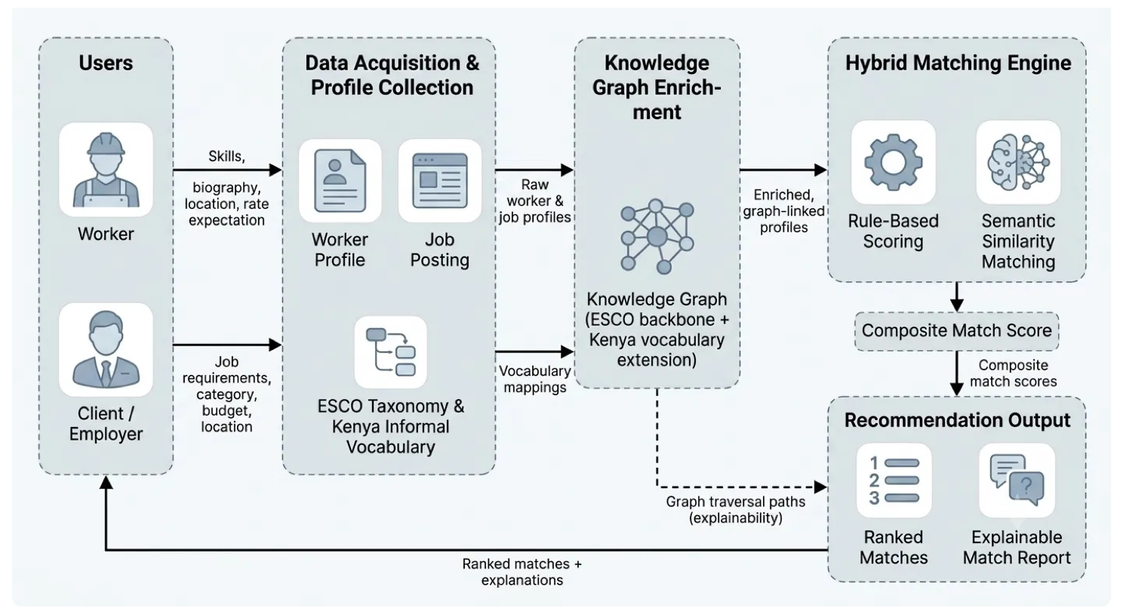
Figure 2.1 Conceptual Framework

Methodology

Introduction
This chapter presents the methodology adopted for the design, development, and evaluation of the proposed knowledge graph-enhanced hybrid recommender system for informal gig worker–job matching in Kenya. It describes the research paradigm, data acquisition and processing procedures, knowledge graph construction process, recommendation model development, system development methodology, testing and evaluation procedures, tools, and system deliverables. The study adopted an experimental research paradigm to evaluate whether knowledge graph enrichment and hybrid matching improve recommendation quality (Creswell & Creswell, 2018). The system was developed using the Object-Oriented Analysis and Design (OOAD) paradigm (Satzinger et al., 2016) and implemented through Scrum framework with evolutionary prototyping (Schwaber & Sutherland, 2020), which supports the iterative development and refinement of intelligent recommendation systems.

Research Paradigm
This study adopted an experimental research paradigm (Creswell & Creswell, 2018). Experimental research was appropriate because it enabled the systematic evaluation of whether specific system components produced measurable differences in recommendation performance. In this study, the experimental factors were knowledge graph enrichment and matching strategy, while recommendation quality was the primary outcome of interest. The experimental design was guided by the conceptual framework presented in Section 2.5. The study investigated two primary propositions derived from the conceptual framework. First, it examined whether knowledge graph enrichment improves recommendation performance by addressing vocabulary mismatch and providing additional structured relationships under limited-data conditions. Second, it examined whether hybrid matching, which combines rule‑based and semantic similarity techniques, improves recommendation performance compared with either component independently.
The independent variables were therefore knowledge graph enrichment and matching strategy. Knowledge graph enrichment was varied by comparing matching configurations with and without knowledge graph enrichment, while matching strategy included rule-based, semantic similarity, and hybrid approaches. The primary dependent variables were recommendation performance measured by Precision@K and Mean Reciprocal Rank (MRR). Explainability was assessed separately using explanation coverage and the traceability of recommendation justifications to the factors and knowledge graph relationships contributing to the resulting recommendations. The proposed recommender was evaluated against a keyword-matching baseline that uses skill keyword matching without knowledge graph enrichment or semantic similarity. Where sufficient data were available, additional configurations were used to distinguish the contribution of rule-based matching, semantic similarity, hybrid scoring, and knowledge graph enrichment.

Data Acquisition
The study employed a tiered data acquisition strategy comprising complementary data sources, applied according to their availability and suitability for the study. The industry partner, Webmasters Kenya, provided technical and system requirements documentation that informed the design of the prototype; however, no proprietary worker or job dataset was provided for research use. Consequently, the study did not rely on industry-partner data for model development.
The Job Skill Set (Mutlu, 2024) dataset was used as a supplementary job corpus for proof-of-concept evaluation. The dataset contains job titles, job descriptions, categories, and associated skill sets, providing structured job-side information for developing and evaluating the matching pipeline. However, because the dataset is not specific to Kenya's informal gig labour market and does not provide corresponding worker profiles, it was not treated as a complete worker–job dataset. Its use was therefore limited to supplementing job-side information and supporting controlled evaluation where appropriate.
Where additional worker–job records were required for controlled experimental evaluation, particularly for simulating limited-data and cold-start conditions, synthetic worker profiles and, where necessary, synthetic job postings were generated programmatically. The synthetic records were grounded in occupational classifications published by the Kenya National Bureau of Statistics (KNBS), the ESCO skills taxonomy, and selected Kenya-specific informal trade terminology. Synthetic profiles were constructed using predefined occupational specifications and independently defined relevance conditions so that the evaluation does not rely solely on the scores produced by the proposed recommender. This enabled controlled assessment of recommendation performance under limited-data conditions while reducing the risk of circular evaluation.

Data Processing
Data processing involved preparing the available worker and job data for knowledge graph construction, recommendation, and evaluation. Because the study used complementary data sources with different structures and levels of completeness, processing was performed according to the characteristics of each source before the datasets were integrated for the relevant experiments. The first stage is data cleaning. Textual fields such as worker biographies, skill descriptions, job titles, and job descriptions were cleaned to remove unnecessary whitespace, inconsistent formatting, and other artefacts that could interfere with subsequent processing. Duplicate records were identified and removed where appropriate. Missing values were retained where their absence was meaningful, while records were excluded only when missing information prevented their use in a particular experiment.
The second stage was skill and terminology normalisation. Skills contained in worker profiles and job postings were standardised and mapped to canonical ESCO skill identifiers where a suitable correspondence existed. Kenya-specific informal trade terms were processed using the vocabulary mappings developed for the knowledge graph, allowing local occupational terms and their corresponding formal occupational concepts to be represented consistently. Terms that could not be mapped reliably were retained as textual attributes rather than assigned an unsupported classification. For the supplementary Job Skill Set (Mutlu, 2024) corpus, processing focused on the available job-side attributes, including job titles, job descriptions, categories, and associated skill sets. These fields were cleaned, deduplicated, and normalised before being mapped to the relevant ESCO skills or occupations where possible. Because the dataset did not contain corresponding worker profiles, it was not processed as though it were a complete worker–job dataset.
Synthetic records were generated using predefined occupational specifications based on the selected occupations, ESCO skills, and Kenya-specific informal trade terminology. The generation process was controlled to provide sufficient representation of the selected occupations and matching scenarios required for evaluation. The generated records contained structured attributes required by the matching system, such as occupation, skills, location, availability, and rate or budget information where applicable. Natural-language worker biographies and job descriptions were also prepared from these attributes for use by the semantic similarity component.
Finally, the processed records were converted into structured representations suitable for knowledge graph construction and recommendation. Worker attributes were associated with worker entities, while job requirements were associated with job entities. Skills, occupations, locations, and relevant vocabulary mappings were represented as structured concepts that could be linked within the knowledge graph. The resulting datasets were checked for consistency, including duplicate entities, invalid skill mappings, missing required fields, and incompatible attribute formats, before being used in the subsequent knowledge graph construction, matching, and evaluation stages.

Model Training
The proposed system encompassed the construction of the knowledge graph and the development and calibration of the hybrid recommendation components. The knowledge graph was implemented using NetworkX, a Python library for graph manipulation, with entities and relationships represented as nodes and edges. The graph included workers, jobs, skills, occupations, and locations as entity types. Relationships represented associations such as workers having skills, jobs requiring skills, and Kenya-specific informal trade terms being mapped to corresponding ESCO occupations or skills. This structure was intended to provide the relationships required for vocabulary-aware matching and explanation generation (Hogan et al., 2021).
The knowledge graph was constructed in three main stages. First, an ESCO-based backbone was incorporated by importing the relevant skills and occupations while preserving the relationships required for skill and occupational representation. Only concepts relevant to the selected occupations and matching task were incorporated where appropriate to maintain a manageable graph. Second, the Kenya-specific vocabulary extension was incorporated by linking selected informal trade terms to their corresponding ESCO concepts. Third, the available worker and job profiles were linked to the graph by associating workers with their relevant skills and occupations and jobs with their required skills and occupations. Location information was also represented where available.
The recommendation model combined two complementary matching components: rule-based matching and semantic similarity matching. Both components operated on profiles enriched through the knowledge graph. The knowledge graph enrichment layer provided additional structured relationships and mapped terminology before recommendation scores were calculated rather than functioning as an independent scoring component. The rule-based component calculated a structured match score using criteria including skill overlap, location compatibility, budget or rate compatibility, and availability, subject to the availability of these attributes in the relevant dataset. Each criterion contributed to the overall rule-based score according to an assigned weight. The weights were examined through sensitivity analysis and, where appropriate, calibrated using designated validation data rather than being treated as fixed assumptions. The semantic similarity component used a pre-trained sentence-transformer model, all-MiniLM-L6-v2, to generate dense vector representations of relevant worker and job text. Cosine similarity was then used to estimate semantic relatedness between the representations. This component was intended to capture meaningful similarities that might not be identified through exact or normalised skill overlap alone.
Knowledge graph enrichment supported both matching components by connecting equivalent or related concepts. For example, an informal occupational term such as “fundi wa stima” could be linked to the ESCO occupation “Electrician” and associated skills such as “Electrical Installation”. A worker profile containing the mapped informal term could therefore be represented using both the original terminology and corresponding structured concepts. This enrichment was intended to reduce vocabulary mismatch and provide additional information for recommendation and explanation generation. The final hybrid recommendation score was calculated as a weighted combination of the rule-based and semantic similarity scores:
$$Hybrid Scoring= α\left(Score Rule\right)+ β(Score Semantic)$$
Equation 3.1 Hybrid Scoring Computation
The weights α and β were determined empirically using the validation data and sensitivity analysis to determine an appropriate configuration for the matching task. The recommendation process therefore followed the sequence of profile processing, knowledge graph enrichment, rule-based and semantic scoring, hybrid score computation, ranking, and explanation generation. The explanation component used the relationships and score contributions that contributed to a recommendation to provide traceable reasons for the resulting match. Behavioural recommendation signals, such as click history or application patterns, remained outside the scope of the present scope and were identified as a potential future enhancement.

Model Validation and Testing
Model validation was conducted through offline evaluation and system testing. The experimental data comprised synthetic worker profiles and, where applicable, synthetic job postings, supplemented by job-side information from the Job Skill Set dataset (Mutlu, 2024). Where sufficient data were available for the relevant experiment, the data were divided into training (70%), validation (15%), and testing (15%) subsets. The validation subset was used to examine the weighting parameters of the rule-based and hybrid scoring components, while the test subset was reserved for final performance evaluation.
The recommendation system was assessed using Precision@K and Mean Reciprocal Rank (MRR). Precision@K measured the of relevant items among the top-K recommendations, while MRR measured the reciprocal rank of the first relevant recommendation in the ranked list. Relevance for synthetic worker–job pairs were determined using independently defined compatibility conditions established during synthetic data generation rather than using the recommendation scores produced by the proposed system. This approach reduced the risk of circular evaluation. Where supplementary job-side data were used without corresponding worker profiles or independently established relevance labels, the data were used for controlled proof-of-concept evaluation rather than treated as a complete ground-truth worker–job dataset.
System performance was also assessed using response time and explanation coverage. Response time measured the time required to generate recommendations, while explanation coverage assessed the proportion of recommendations for which the system could provide traceable justifications based on the matching factors and knowledge graph relationships contributing to the recommendation. The proposed system was evaluated against multiple matching configurations. These included a keyword-matching baseline using skill keyword overlap without knowledge graph enrichment or semantic similarity, a rule-based configuration, a semantic similarity configuration, and a hybrid configuration combining rule-based and semantic similarity scores without knowledge graph enrichment. The full proposed configuration incorporated knowledge graph enrichment together with rule-based and semantic similarity matching. This experimental design enabled the contribution of the individual matching components and the knowledge graph enrichment to be examined separately.
Functional testing was performed using black-box techniques to verify that the system operated correctly from the user perspective, including profile creation, job posting, recommendation generation, explanation viewing, and error handling. White-box testing focused on internal functions such as data processing, scoring, knowledge graph traversal, and explanation generation. Integration testing ensured that the frontend, backend, database, knowledge graph, and recommendation components operated together as intended.

System Development Methodology
This project used an Object-Oriented Analysis and Design (OOAD) approach together with the Scrum framework to develop the knowledge graph-enhanced hybrid recommender system for informal gig worker–job matching in Kenya (Satzinger et al., 2016; Schwaber & Sutherland, 2020). OOAD was chosen because the system comprises multiple interacting components including knowledge graph enrichment, rule-based matching, semantic similarity, and an explainability module, which can be modelled as discrete objects, each with defined attributes and methods. This modularity made the system easier to design, organise, and maintain. Scrum was used because the system incorporates knowledge graph traversal and semantic similarity techniques that require iterative testing and progressive refinement, which the sprint-based development model directly supports.
The development was organised into six two-week sprints. The first sprint focused on requirements analysis and knowledge graph schema design, including development environment setup. The second sprint covered data acquisition and preprocessing: preparing the Job Skill Set (Mutlu, 2024) corpus, generating synthetic profiles where necessary, importing the ESCO taxonomy, and developing and validating the Kenya-specific vocabulary extension.. The third sprint involved knowledge graph construction and implementation of the rule-based matching engine. The fourth sprint integrated semantic embedding using the sentence-transformer model and implement the hybrid scoring function. The fifth sprint developed the explainability module and integrated the recommendation engine with the web-based user interface. The sixth sprint focused on evaluation computing Precision@K and MRR against the keyword-matching baseline, and on final project documentation and defense preparation.

Methodology Diagram and Justification
Figure 3.1 presents the Scrum process methodology adopted for this study, illustrating the iterative sprint cycle from Product Backlog through Sprint Planning, Sprint Development, Sprint Review and Retrospective, to Finished Work.
Figure 3.1 Scrum Process Methodology (Schwaber & Sutherland, 2020)

Product Backlog
The Product Backlog contained all functional and non-functional requirements identified during the analysis phase of the study. These requirements include synthetic data generation, knowledge graph construction, vocabulary extraction and validation, rule-based matching, semantic similarity matching, hybrid recommendation generation, explainability mechanisms, user management, and user interface development. The backlog served as the primary source of development tasks throughout the project lifecycle.

Sprint Planning Meeting
Sprint Planning Meetings were conducted at the beginning of each sprint to determine the development activities to be completed during the iteration. During these meetings, backlog items were prioritised according to project objectives and implementation dependencies. Tasks selected for implementation were broken down into manageable activities and assigned estimated completion timelines.

Sprint Backlog
The Sprint Backlog consisted of the subset of Product Backlog items selected for completion within a specific sprint. Each sprint backlog contained clearly defined development activities such as importing ESCO occupational data, generating synthetic worker and job profiles, constructing the knowledge graph, implementing recommendation algorithms, developing explainability mechanisms, and conducting system testing. The Sprint Backlog guided day-to-day development activities during each iteration.

Sprint Development
Sprint Development represents the implementation phase during which selected backlog items are developed and integrated into the system. Development activities included knowledge graph construction, implementation of rule-based matching algorithms, integration of semantic similarity models, development of hybrid scoring mechanisms, and development and integration of the web-based user interface. At the end of each sprint, a functional system increment was produced and prepared for review.

Daily Stand-Up
Daily Stand-Up meetings were conducted to monitor project progress and identify challenges encountered during development. These short review sessions provided an opportunity to evaluate completed tasks, discuss ongoing activities, and identify obstacles that may affect sprint objectives. The meetings supported continuous monitoring and facilitated timely resolution of implementation issues.

Sprint Review and Retrospective
At the conclusion of each sprint, a Sprint Review was conducted to evaluate the completed functionality against the planned sprint objectives. The developed components were tested and assessed to determine whether they satisfy the specified requirements. Following the review, a Sprint Retrospective was undertaken to identify lessons learned, challenges encountered, and opportunities for improving future development activities. This process supported continuous improvement throughout the project lifecycle.

Finished Work
Each completed sprint produced a functional increment of the proposed system. These increments gradually contributed towards the development of the complete knowledge graph-enhanced hybrid recommender system. Examples of completed outputs include the synthetic dataset generation module, knowledge graph implementation, recommendation engine, explainability component, user interface, and evaluation framework. The final integrated system was produced after the successful completion of all planned sprints.

Justification of OOAD and Scrum
Object-Oriented Analysis and Design (OOAD) is appropriate for this study because the proposed system consists of multiple interacting entities such as workers, jobs, skills, occupations, recommendations, and knowledge graph components. OOAD facilitates the modelling of these entities as objects with clearly defined attributes, behaviours, and relationships, thereby improving system modularity, maintainability, and reusability (Satzinger et al., 2016).
Scrum is appropriate because recommender systems require continuous experimentation, testing, and refinement throughout development. The iterative nature of Scrum enables incremental implementation and evaluation of system components, allowing improvements to be incorporated based on testing outcomes and feedback. This approach is particularly beneficial for systems involving artificial intelligence techniques, knowledge graphs, and semantic similarity models, where performance optimisation often occurs throughout the development process (Hron & Obwegeser, 2022). As this project was undertaken by a single developer rather than a team, the standard Scrum roles of Product Owner, Scrum Master, and Development team are consolidated into the developer. The supervisor provided advisory and review input at project milestones and sprint reviews. Activities such as Sprint Planning and Sprint Review were retained, while Daily Stand-Ups were adapted into brief self-review checkpoints rather than team synchronisation meetings. This adaption preserves the iterative, feedback-driven structure that makes Scrum suitable for a project requiring continuous refinement, while adjusting its team-oriented activities to solo development context.
The combination of OOAD and Scrum therefore provides both a structured design foundation and a flexible development framework, making it suitable for the development of the proposed knowledge graph-enhanced hybrid recommender system for informal gig worker-job matching in Kenya.

Analysis Diagrams
Analysis diagrams were used to examine and document the requirements of the proposed knowledge graph‑enhanced hybrid recommender system for informal gig worker–job matching in Kenya. These diagrams facilitated the identification of stakeholder needs, the analysis of business processes, the understanding of information flows, and the determination of the data requirements necessary for effective worker–job matching.

Use Case Diagram
The Use Case Diagram was used to analyse the functional requirements of the proposed recommender system by identifying the primary users and their interactions with the system. The diagram represents workers and clients as the main actors involved in the matching process. Workers can submit profile information, obtain recommended jobs, and view explanations for generated matches, while clients can submit job requirements, obtain recommended workers, and view the explanations associated with those recommendations. The diagram therefore defines the functional boundary of the proposed system and identifies the core services required to support worker–job matching, knowledge graph enrichment, recommendation generation, and explainable recommendation output.

Sequence Diagram
The Sequence Diagram was used to analyse the chronological interactions between users and the major components of the proposed recommender system during recommendation generation. It illustrates how a worker or client submits profile or job information through the web interface, how the backend processes the request, and how the knowledge graph, rule-based matching, semantic similarity, and explanation components contribute to the generation of ranked recommendations. The diagram clarifies the order of interactions and the responsibilities of the system components involved in producing recommendations and their corresponding explanations.

Entity-Relationship Diagram
The Entity-Relationship Diagram (ERD) was used to analyse the structured data requirements of the proposed system by identifying the principal entities and relationships required for storing worker profiles, job postings, skills, and recommendation results. The diagram provides a basis for organising the relational data used by the recommendation system and for maintaining relationships between worker and job information and their associated skills. The ERD therefore supports the design of the PostgreSQL database used alongside the knowledge graph and recommendation components.

Activity Diagram
The Activity Diagram was used to model the workflow of the major recommendation processes within the proposed system. It illustrates the activities involved in submitting worker or job information, validating and enriching the submitted information through the knowledge graph, generating rule-based and semantic matching scores, ranking recommendations, and producing explanations for the resulting matches. The diagram also represents the key decision points within the workflow, such as input validation and the availability of information required for matching. This provides a behavioural representation of how the proposed system processes information from submission to recommendation output.

Class Diagram
The Class Diagram was used to analyse the structural requirements of the proposed system from an object-oriented perspective. It identifies the principal classes involved in representing worker and job information and in performing recommendation, knowledge graph, and explanation functions. The diagram defines the attributes, operations, and relationships associated with these classes and provides a basis for organising the implementation of the proposed system according to the OOAD approach adopted in the study.

Design Diagrams
Design diagrams were used during the system design phase to define the structure, behaviour, and architecture of the proposed solution. These diagrams transformed the requirements identified during the analysis phase into a detailed blueprint that guided the implementation of the knowledge graph-enhanced recommender system for informal gig worker–job matching in Kenya.

Database Design
The database design was developed to define how structured information required by the proposed system would be organised, stored, and retrieved. It includes structures for managing worker profiles, job postings, skills, recommendation results, and other data required for system operation and evaluation. The design supports efficient retrieval of worker and job information for recommendation generation while maintaining data consistency and integrity. The relational database operates alongside the knowledge graph, which represents the semantic relationships used for vocabulary-aware matching and explanation generation.

System Architecture Diagram
The system architecture diagram provides a high-level representation of the major components of the proposed solution and the interactions among them. The architecture comprises a web-based frontend, a Python-based backend API, the hybrid recommendation engine, the knowledge graph, and the relational database. Users interact with the system through the web interface, while requests are transmitted to the backend API for processing. The recommendation engine processes worker and job information using knowledge graph enrichment, rule-based matching, and semantic similarity before producing ranked recommendations and traceable explanations. PostgreSQL is used to manage structured system data, while the knowledge graph provides the relationships required for vocabulary-aware matching and explanation generation. The architecture separates the presentation, application, recommendation, and data layers to support maintainability and integration of the proposed recommender within a web-based system.

Knowledge Graph Design
The knowledge graph design was developed to model relationships among entities such as workers, skills, jobs, occupations, locations, and Kenya-specific informal trade terms. The diagram illustrates how these entities are interconnected and how relationship paths can support the generation of explanations for recommendations. The design incorporates the ESCO taxonomy as a structured occupational and skills representation and extends it with selected Kenya-specific vocabulary mappings. These relationships provide the structured information used by the recommendation and explanation components to identify relevant associations between worker profiles and job requirements.

User Interface Wireframes
User interface wireframes were created to visualise the layout and functionality of the proposed system prior to implementation. The wireframes include interfaces for worker profile submission, job posting, recommendation presentation, explanation viewing, and other core interactions required by the prototype. Their use supported the early consideration of usability and ensured that the proposed interface provided appropriate interaction points for workers and clients. The wireframes therefore provided a visual basis for implementing the web-based interface through which users interact with the recommendation system.

Deliverables

Hybrid Recommender System
A major deliverable of this study was a knowledge graph‑enhanced hybrid recommender system capable of generating intelligent worker–job matching recommendations within informal gig labour market contexts. The system integrated rule‑based matching, semantic similarity, and knowledge graph enrichment to improve the accuracy, transparency, and effectiveness of matching decisions

Knowledge Graph
The study also delivered a knowledge graph that models relationships among workers, jobs, skills, occupations, locations, and informal trade terminology. The knowledge graph supported contextual reasoning and provided the explainability mechanisms required to justify recommendation outcomes generated by the hybrid recommender system.

System Documentation
Comprehensive system documentation was produced to support the implementation and maintenance of the proposed solution. The documentation described the system architecture, database design, recommendation methodology, knowledge graph structure, implementation procedures, testing activities, and deployment requirements. This deliverable facilitated future enhancements and ensured reproducibility of the study.

Tools and Techniques

Python
Python was used as the primary programming language for implementing the proposed system. It supported the development of the hybrid recommendation algorithms, knowledge graph processing mechanisms, system logic, and evaluation procedures. Python was selected because of its extensive support for data science, machine learning, and graph processing libraries, making it suitable for the development of intelligent recommendation solutions.

Pandas and NumPy
Pandas and NumPy were utilised for data preparation and numerical computations within the system. Pandas facilitated the organisation, cleaning, and transformation of datasets containing worker information, job details, skills, and synthetic profiles. NumPy supported mathematical operations and matrix manipulations required during recommendation generation and performance evaluation.

Scikit-learn
Scikit-learn was used to support selected numerical processing and evaluation tasks within the recommendation pipeline. Its utilities were used where appropriate for similarity calculations, data processing, and evaluation of recommendation performance using metrics such as Precision@K and Mean Reciprocal Rank (MRR). The library complemented the custom rule-based and hybrid matching components implemented in Python.

NetworkX
NetworkX was employed to construct and analyse the knowledge graph used within the proposed system. Workers, jobs, skills, occupations, and locations were represented as nodes, while their relationships among entities were modelled as relationships. Through graph analysis techniques, the library enabled the identification of meaningful connections that can be used to provide explanations for recommendations generated by the system.

Sentence Transformers
The Sentence Transformers library (Reimers & Gurevych, 2019) was used to generate semantic embeddings for worker biographies and job descriptions. The all‑MiniLM‑L6‑v2 model was employed to balance semantic quality and computational efficiency.

Next.js, React and TypeScript
Next.js, React, and TypeScript were used to develop the web-based user interface for the proposed system. React provided a component-based approach for constructing interactive interface elements, while Next.js provided the application framework for organising the web application. TypeScript was used to provide static typing and improve code organisation and maintainability. The frontend communicates with the Python-based backend through API requests to support profile management, job posting, recommendation generation, and explanation presentation.

Draw.io
Draw.io was used to create the analysis and design diagrams required throughout the project. These include use case diagrams, activity diagrams, sequence diagrams, class diagrams, entity‑relationship diagrams, system architecture diagrams, and wireframes. The diagrams developed supported clear communication of system requirements, documentation of design decisions, and guidance during the system implementation process.

PostgreSQL
PostgreSQL served as the relational database management system for storing worker profiles, job postings, skills, and match records. The pgvector extension was used to store and query the dense vector embeddings generated by the sentence‑transformer model, enabling efficient similarity search. PostgreSQL is chosen for its reliability, support for structured data, and the vector similarity capabilities provided by pgvector.

Flask
Flask was used as the backend web framework to handle API requests between the Next.js/React frontend and the recommendation engine. It provides a lightweight, flexible layer for managing routing, request processing, and database interactions. Flask was selected for its simplicity and compatibility with Python‑based machine learning components.

System Analysis and Design

Introduction
This chapter presents the analysis and design of the proposed knowledge graph-enhanced recommender system for informal gig worker–job matching in Kenya. It defines the system's functional, non-functional, data, and interface requirements, and presents the analysis and design diagrams used to communicate the system's structure and behaviour. The system was developed using an Object-Oriented Analysis and Design (OOAD) approach, implemented through the Scrum framework, as justified in Chapter 3. Consistent with this paradigm, this chapter presents Unified Modelling Language (UML) diagrams appropriate to an object-oriented system: a Use Case Diagram, a Sequence Diagram, an Entity-Relationship Diagram, an Activity Diagram, and a Class Diagram, followed by a logical database schema and user interface wireframes for the Next.js/React frontend. Each diagram is preceded by a narrative explaining its relevance and scope and followed by an interpretation of its key relationships and implications for the proposed system.

System Requirements
System requirements describe the capabilities, qualities, data, and interfaces the proposed system must satisfy as a proof-of-concept prototype. Consistent with the Scope defined in Chapter 1, these requirements exclude user authentication, payment processing, and other production-level platform features, and instead focus on the core matching, enrichment, and explanation capabilities that this study evaluates. The system requirements identified for this project are presented in the following subsections.

Functional Requirements
Functional requirements describe what the system must do under specified conditions. As this is a proof-of-concept prototype without user authentication, functions are described at the level of the worker, client, and system roles rather than authenticated user sessions.
- FR-01: The system shall allow a worker to submit a profile through the web interface, consisting of skills, biography, location, availability, and rate expectation.
- FR-02: The system shall allow a client to submit a job posting through the web interface, consisting of required skills, category, budget, and location.
- FR-03: The system shall map informal trade terms present in a worker or job profile to their corresponding formal ESCO occupation or skill, using the Kenya-specific vocabulary extension.
- FR-04: The system shall enrich a submitted worker or job profile by linking it to related entities within the knowledge graph, including corresponding skills, occupations, and vocabulary mappings.
- FR-05: The system shall compute a rule-based match score between a worker profile and a job posting based on skill overlap, location, budget, and availability.
- FR-06: The system shall compute a semantic similarity score between a worker's biography and a job's description using sentence-embedding comparison.
- FR-07: The system shall combine the rule-based score and the semantic similarity score into a single composite match score.
- FR-08: The system shall display a ranked list of the top-K matches for a given worker or job through the web interface.
- FR-09: The system shall generate an explanation for each recommended match, derived from the knowledge graph relationships and score components that contributed to it, and display this explanation to the user.
- FR-10: The system shall process profiles containing unmapped informal trade terms using the available matching information without rejecting the profile solely because a vocabulary mapping is unavailable.

Non-Functional Requirements
Non-functional requirements describe how well the system must operate and the constraints under which it must work. As this study evaluates a proof-of-concept prototype rather than a production system, the following requirements are scoped to what is necessary to support meaningful evaluation, not production-grade service levels.
- NFR-01: Under a single-query workload on the evaluation dataset, the system shall return a ranked list of top-K matches to the frontend within 5 seconds, as measured by end-to-end response time from request submission to result display.
- NFR-02: The system shall generate an interpretable explanation for at least 85%of top-K recommendations where sufficient matching factors and knowledge graph relationships are available.
- NFR-03: The backend shall use separable components for knowledge graph enrichment, rule-based scoring, semantic similarity, and explanation generation, with clear interfaces between components to support maintainability and modification.
- NFR-04: The web interface shall provide clear input and output flows that allow users to submit worker or job information and view ranked recommendations without requiring technical knowledge.
- NFR-05: The web interface shall render correctly on current versions of at least two major browsers (Safari and Google Chrome), consistent with standard React/Next.js browser support.

Data Requirements
Data requirements describe the data the system needs, produces, protects, and retains, consistent with the three-tier data strategy defined in Chapter 3.
- DR-01: Worker profile data shall include skills, biography text, location, availability, and rate expectation, sourced from programmatically generated synthetic profiles for the controlled evaluation experiments.
- DR-02: Job posting data shall include required skills, category, budget, location, and free-text description. Job-side information shall be obtained from the supplementary Job Skill Set dataset (Mutlu, 2024) where applicable and from programmatically generated synthetic job postings for controlled evaluation experiments.
- DR-03: The knowledge graph shall store the ESCO taxonomy backbone and the Kenya-specific informal trade vocabulary extension, with each vocabulary mapping validated through the validation process defined in Chapter 3.
- DR-04: Missing or incomplete fields in a worker or job profile shall be handled without discarding the record, consistent with the data cleaning approach in Chapter 3, unless the missing data prevents any meaningful scoring.
- DR-05: Synthetic worker and job profiles shall be generated using predefined occupational specifications grounded in KNBS occupational classifications, the ESCO taxonomy, and validated Kenya-specific informal trade terminology.
- DR-06: The system shall retain evaluation datasets and computed match scores for the duration of the study to support reproducibility of Precision@K and MRR results.
- DR-07: The study shall not intentionally collect or store personally identifiable information from real workers or clients. Synthetic profiles used for controlled evaluation shall contain no real personal identifiers..

Interface and Integration Requirements
Interface and integration requirements describe how users, external services, and system components interact with the proposed system.
- IR-01: The system shall provide a Next.js/React-based web interface through which workers and clients can submit profiles and postings and view recommendations.
- IR-02: The frontend shall communicate with the backend exclusively through a Flask-based REST API, exchanging data in JSON format.
- IR-03: The backend shall connect to a PostgreSQL database (with the pgvector extension) for storage and retrieval of structured profile data, and vector similarity search over semantic embeddings.
- IR-04: The knowledge graph component shall expose an interface (internal, not externally networked) through which the matching and explainability components can query graph relationships.
- IR-05: Where the Job Skill Set dataset (Mutlu, 2024) is used, it shall be accessed as a static, locally stored file rather than a live external API, since the dataset is not updated during the study period.
- IR-06: The backend shall implement appropriate timeout and error-handling mechanisms for requests involving the semantic similarity model and database, ensuring that component failures are handled gracefully and communicated through appropriate error responses.

System Analysis Diagrams

Use Case Diagram
The use case diagram shows how workers and clients interact with the proposed system. A worker can submit a worker profile and view recommendations, while a client can submit a job posting and view recommendations. Both actors can additionally view the explanation behind a match, shown as an <<extend>> relationship to View Recommendations, since an explanation is an optional elaboration of a recommendation result rather than a mandatory step in retrieving one. Knowledge graph enrichment, rule-based scoring, semantic similarity scoring, and score combination are not modelled as separate use cases, as these are internal system behaviours triggered by Submit Profile/Posting and View Recommendations rather than actions initiated directly by an actor; they are instead detailed in the sequence and activity diagrams that follow.
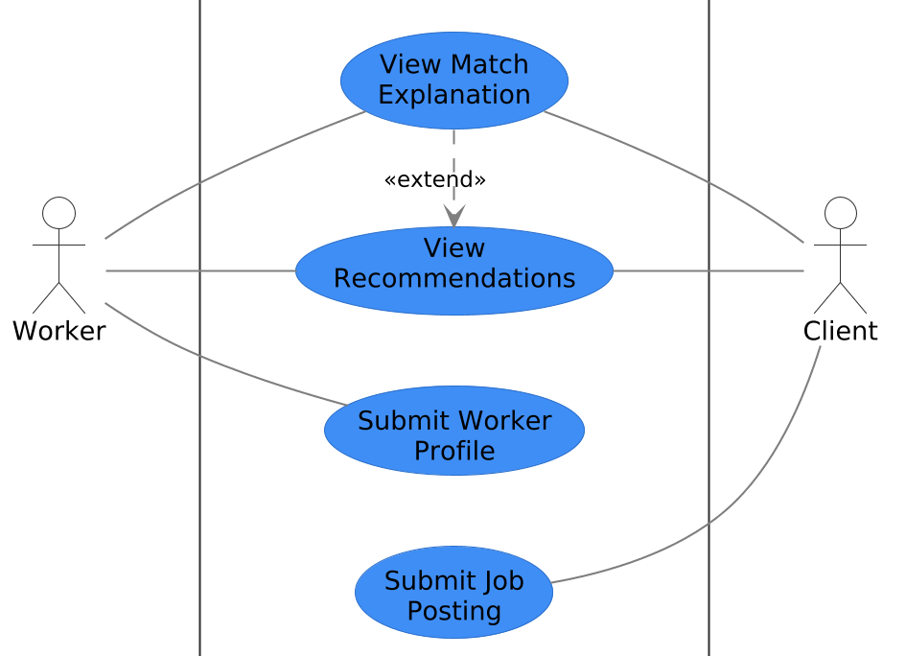
Figure 4.1 Use Case Diagram
Both actor types share two of the four use cases; View Recommendations and View Match Explanation, reflecting that the system serves workers and clients symmetrically rather than through distinct interfaces. The <<extend>> relationship indicates that viewing an explanation is only meaningful once a recommendation has already been generated and is not itself a standalone entry point into the system.

Sequence Diagram
Because a worker and a client are matched against different pools; a worker receives ranked job postings, while a client receives ranked worker profiles, the sequence diagram is presented as two distinct flows, shown in Figure 4.2(a) and (b), rather than a single generalised interaction. Both flows exercise the same underlying components (knowledge graph enrichment, rule-based scoring, semantic similarity scoring, hybrid combination, and explanation generation), but operate on inputs specific to the requesting actor, and return results named accordingly (rankedJobMatches for a worker, rankedWorkerMatches for a client).
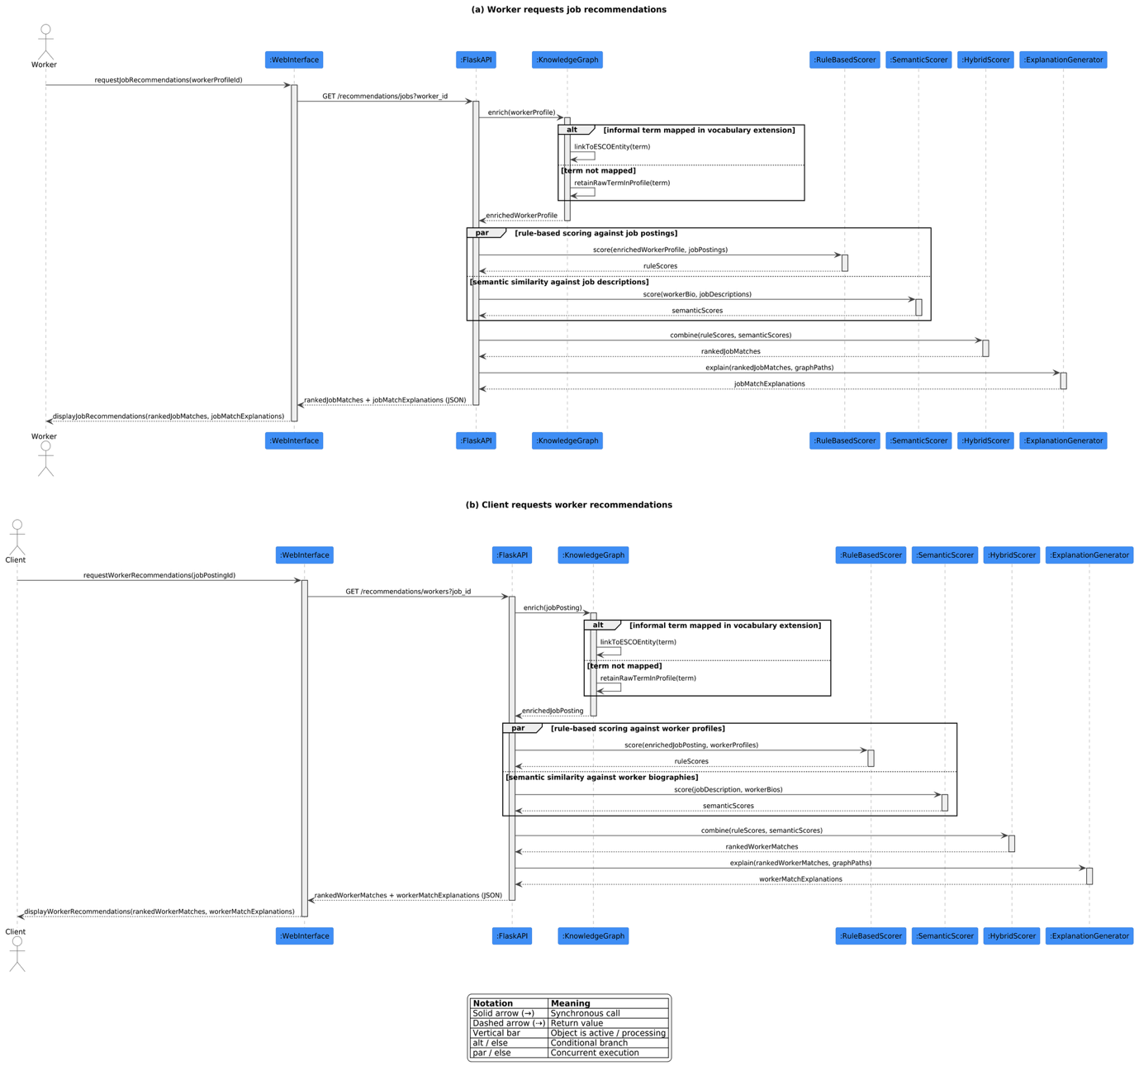
Figure 4.2 Sequence Diagram
Both flows follow the same structure through the backend: the submitted profile or posting is first enriched via the knowledge graph, with an alt block showing the two possible outcomes when an informal trade term is encountered, either linked to its ESCO equivalent or retained as-is if unmapped. Rule-based and semantic similarity scoring then run concurrently, shown as a par block, since neither scoring method depends on the other's result. The two scores are combined into a ranked list, which is passed to the explanation generator before being returned to the requesting actor's interface. The symmetry between (a) and (b) reflects that the system treats worker-to-job and client-to-worker matching as the same underlying mechanism applied in opposite directions, rather than two separately implemented pipelines.

Entity Relationship Diagram (ERD)
The entity-relationship diagram represents the core entities, relationships, and attributes relevant to the proposed system independently of how they will later be implemented in a relational database. Four entities are modelled: WorkerProfile, JobPosting, Skill, and MatchScore. Relationships are shown as diamonds rather than as separate junction entities, since associative tables such as WorkerSkill and JobRequiredSkill are an implementation-level concern addressed in the logical database schema (Section 4.4.1), not a conceptual one.
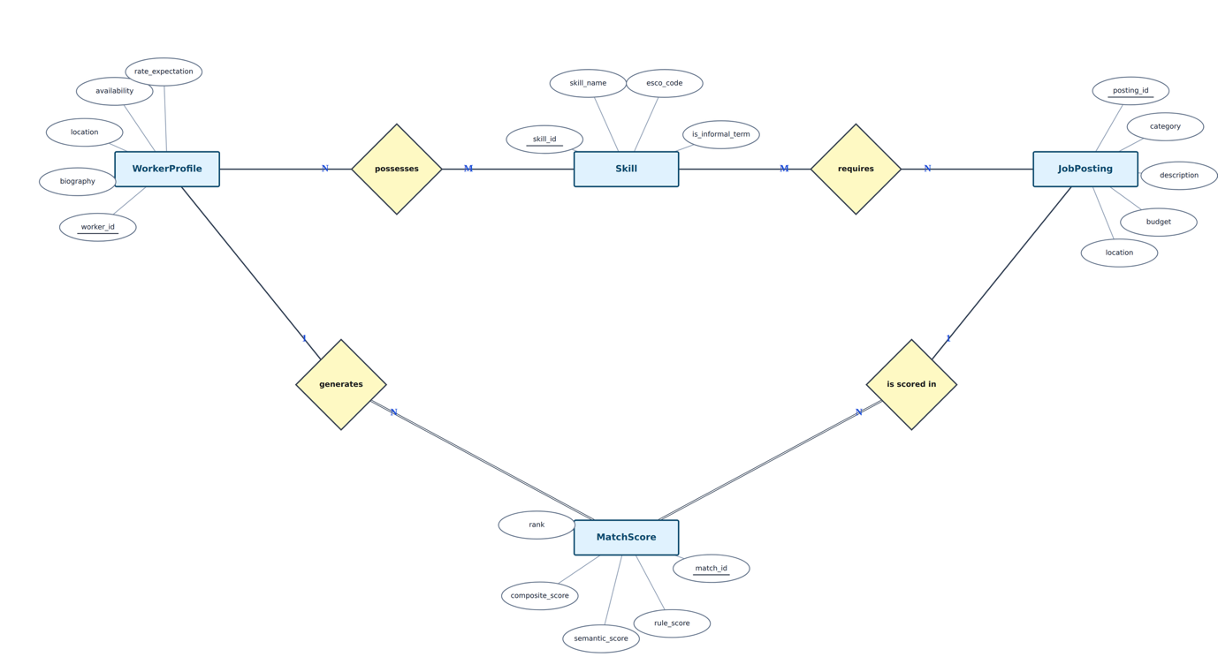
Figure 4.3 Entity Relationship Diagram (ERD)
A worker possesses skills and a job requires skills, both many-to-many relationships between WorkerProfile/JobPosting and Skill. A worker generates match scores and a job is scored in match scores, reflecting that every worker–job pair evaluated by the system produces a corresponding MatchScore record. Primary key attributes are underlined; no foreign keys are shown at this level, since foreign keys are a logical-schema construct that follows from, rather than defines, the conceptual relationships shown here.

Activity Diagram
The activity diagram models the end-to-end workflow triggered when a worker or client submits information to the system, from initial input through to displayed recommendations. Two decision points are included to reflect real data-handling conditions rather than an idealised straight-line process: the first checks whether submitted input is valid before any processing occurs, and the second reflects the vocabulary-mapping outcome described in Chapter 3, whether an informal trade term is successfully linked to its ESCO equivalent or retained in its raw form when unmapped. Rule-based scoring and semantic similarity scoring are modelled as concurrent activities using a fork/join, since FR-05 and FR-06 compute independently of one another before their results are combined in FR-07.
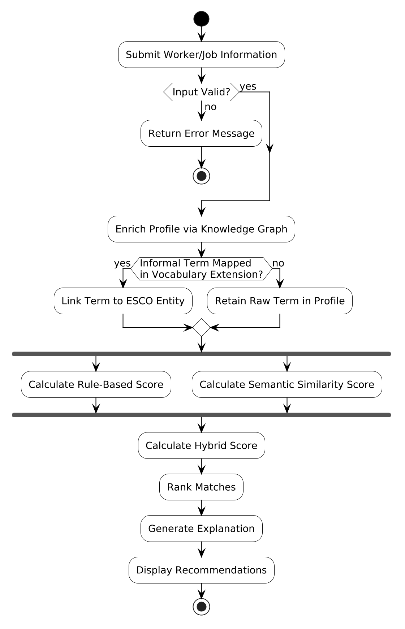
Figure 4.4 Activity Diagram
Invalid input terminates the flow early with an error message, preventing incomplete or malformed data from reaching the knowledge graph or matching components. Whether or not an informal term is successfully mapped, the flow continues to scoring, reflecting NFR-03's requirement that the system does not fail or exclude a profile solely because a term is unmapped. The fork/join shows that rule-based and semantic scoring do not depend on each other's output and may be computed in parallel, converging only at the point where they are combined into the hybrid score, ranked, explained, and returned to the user.

Class Diagram
The class diagram presents the structural design of the proposed system's backend, derived from the actual module organisation of the implementation. It shows how a worker or job posting, once submitted, is transformed into a ranked, explainable recommendation through a series of collaborating classes: DataLoader for data acquisition, KnowledgeGraphBuilder and VocabularyExtension for knowledge graph enrichment, RuleBasedScorer and SemanticScorer for independent scoring, HybridScorer for score combination, and ExplanationGenerator for producing traceable justifications. The diagram addresses FR-03 through FR-09 and reflects the maintainability requirement in NFR-03, which specifies that these components remain separable with clear interfaces between them.
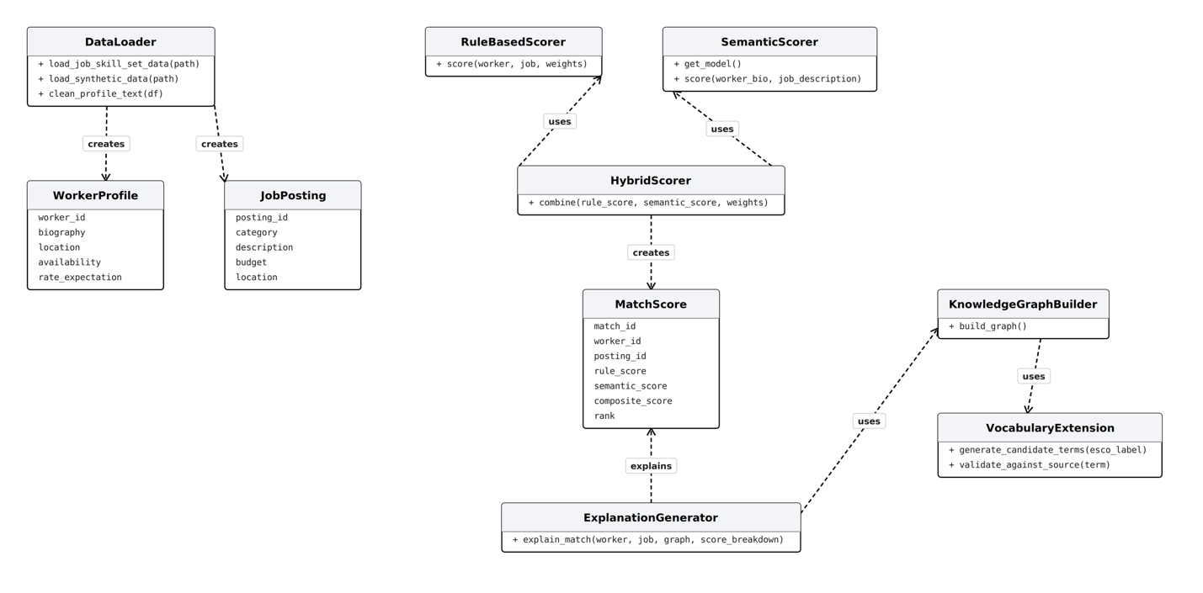
Figure 4.5 Class Diagram
DataLoader creates WorkerProfile instances from synthetic generation and JobPosting instances from the supplementary Job Skill Set dataset (Mutlu, 2024)and synthetic generation, consistent with DR-01 and DR-02; it does not load data from Webmasters Kenya, which served only as a source of technical and system requirements documentation rather than a research dataset. RuleBasedScorer and SemanticScorer each depend on a worker profile and job posting to compute their respective scores, and HybridScorer in turn depends on both scorers to produce a MatchScore, consistent with FR-05 through FR-07. Scoring weights are passed as parameters to score() and combine() rather than modelled as separate classes, since they represent tunable configuration rather than structural components of the system. KnowledgeGraphBuilder depends on VocabularyExtension to incorporate the Kenya-specific vocabulary mappings described in Chapter 3, validated through the source-based validation process referenced in Data Requirement DR-03, and is itself depended upon by ExplanationGenerator to traverse the graph and produce the explanation for a given MatchScore, consistent with FR-09. All relationships are modelled as UML dependencies rather than associations, since no class holds a persistent reference to another as a stored attribute, each class instead calls another's method and consumes its return value, with the arrow in each case pointing from the dependent class to the class it depends on.

System Design Diagrams

Database Design
The logical database schema translates the conceptual entity-relationship model in Figure 4.3 into a relational structure suitable for implementation in PostgreSQL. The two many-to-many relationships identified conceptually; a worker possessing skills and a job requiring skills, are each resolved into an associative table, WorkerSkill and JobRequiredSkill, following standard relational normalisation practice, since a relational database cannot represent a many-to-many relationship directly.
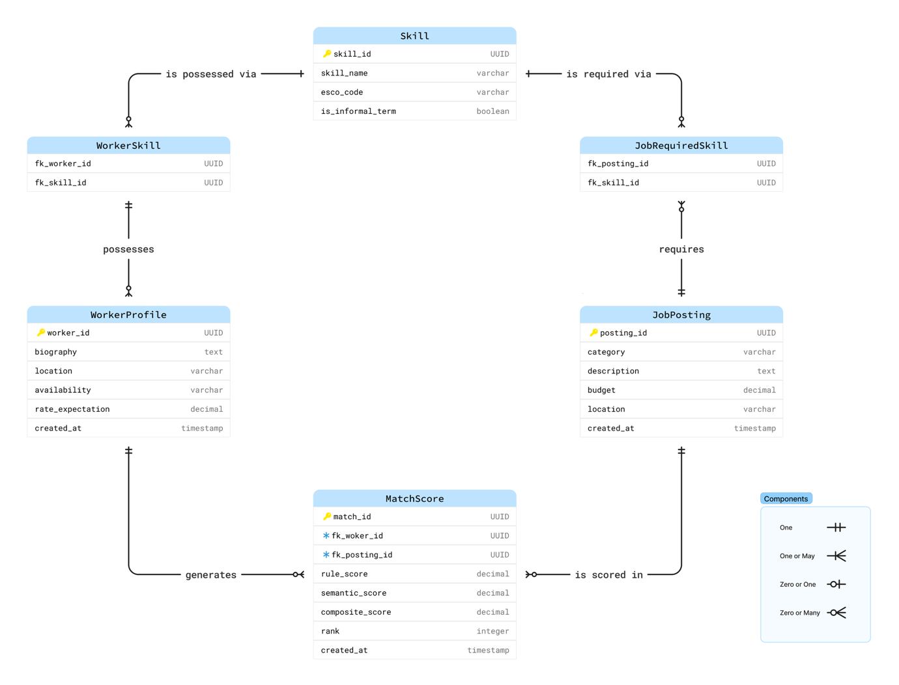
Figure 4.6 Database Design
Skill is deliberately kept as a single reference table covering both formal ESCO skills and validated informal-term mappings, rather than splitting formal and informal vocabulary into separate tables, since both are queried identically by the matching components described in Chapter 3. MatchScore stores foreign keys to both WorkerProfile and JobPosting directly rather than through an associative table, since a match score belongs to exactly one worker–job pair rather than expressing a many-to-many relationship. No table for accepted or confirmed matches is included, consistent with the proof-of-concept scope defined in Chapter 1, which excludes a live matching-acceptance workflow.

Knowledge Graph Design
The knowledge graph design is presented as two connected layers, following the standard distinction between a knowledge graph's schema (organising principles) and its instance data. The schema layer shows the occupational taxonomy the graph is built on, individual occupations such as Electrician, grouped under broader occupational categories via TYPE_OF relationships, sourced from the ESCO taxonomy described in Chapter 3. The instance layer shows a concrete worked example: a worker's profile, an informal trade term, its formal equivalent, and a job posting, connected through HAS_SKILL, MAPS_TO, and REQUIRES_SKILL relationships.
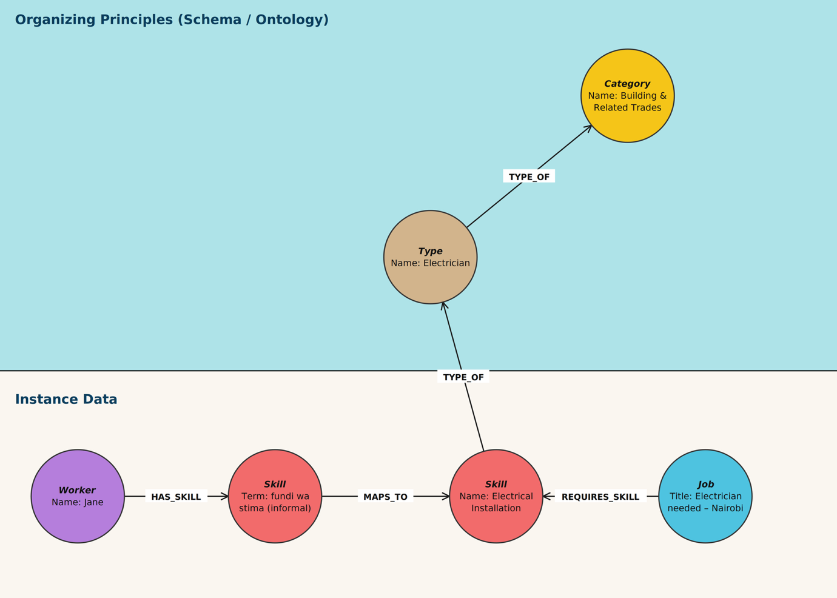
Figure 4.7 Knowledge Graph Design
This example illustrates directly how the knowledge graph addresses vocabulary mismatch: a worker describing their skill using the informal term ‘fundi wa stima’ and a job posting specifying the formal skill "Electrical Installation" are connected through a single MAPS_TO relationship, allowing the two to be matched despite using different vocabulary. The TYPE_OF relationships extending upward into the schema layer allow the system to reason about occupational context beyond the immediate skill, for instance, recognising that Electrical Installation falls under Building and Related Trades, which supports the graph traversal underlying the explanation mechanism described in Section 4.3.5.

UI Wireframes

References
Creswell, J. W., & Creswell, J. D. (2018). Research Design: Qualitative, Quantitative, and Mixed Methods Approaches (5th edn). SAGE Publications.
Datta, N., Rong, C., Singh, S., Stinshoff, C., Iacob, N., Nigatu, N. S., Nxumalo, M., & Klimaviciute, L. (2023). Working Without Borders: The Promise and Peril of Online Gig Work. https://doi.org/10.1596/40066
European Commission. (2026a, March 30). CPASS Use of ESCO for AI-native skills verification platform. https://esco.ec.europa.eu/en/news/cpass-use-esco-ai-native-skills-verification-platform
European Commission. (2026b, May 26). Occupations | European Skills, Competences, Qualifications and Occupations (ESCO). https://esco.ec.europa.eu/en/classification/occupation_main
Finnfund. (2019, May). Fuzu. Finnfund. https://www.finnfund.fi/en/hankkeet/fuzu/
Guo, Q., Zhuang, F., Qin, C., Zhu, H., Xiong, H., He, Q., & Xie, X. (2020). A Survey on Knowledge Graph-Based Recommender Systems. https://doi.org/10.1109/TKDE.2020.3028705
Hogan, A., Blomqvist, E., Cochez, M., D’amato, C., Melo, G. D., Gutierrez, C., Kirrane, S., Gayo, J. E. L., Navigli, R., Neumaier, S., Ngomo, A.-C. N., Polleres, A., Rashid, S. M., Rula, A., Schmelzeisen, L., Sequeda, J., Staab, S., & Zimmermann, A. (2021). Knowledge Graphs. ACM Computing Surveys (CSUR), 54(4), 71:1-71:37. https://doi.org/10.1145/3447772
Hron, M., & Obwegeser, N. (2022). Why and how is Scrum being adapted in practice: A systematic review. Journal of Systems and Software, 183, 111110. https://doi.org/10.1016/j.jss.2021.111110
International Labour Organization. (2025). Exploring the gig economy: Challenges and opportunities ([1st ed.]). ILO. https://doi.org/10.54394/NMBW0887
Kenya National Bureau of Statistics. (2025). Kenya Economic Survey 2025. https://www.knbs.or.ke/wp-content/uploads/2025/05/2025-Economic-Survey.pdf
Kwanya, T., & Wakunuma, K. J. (2023). Regulation of digital platforms for a socially-just gig economy in Kenya. https://doi.org/10.5281/zenodo.7588795
Lynk. (2025, January 10). MIT Solve. SOLVE. https://solve.mit.edu/solutions/3332#content
Mutlu, B. (2024). Job-skill-set (Version 2) [Data set]. Kaggle. https://doi.org/10.34740/KAGGLE/DSV/10201355
Raza, S., Rahman, M., Kamawal, S., Toroghi, A., Raval, A., Navah, F., & Kazemeini, A. (2024). A Comprehensive Review of Recommender Systems: Transitioning from Theory to Practice (Version 4). arXiv. https://doi.org/10.48550/ARXIV.2407.13699
Reimers, N., & Gurevych, I. (2019). Sentence-BERT: Sentence Embeddings using Siamese BERT-Networks (arXiv:1908.10084). arXiv. https://doi.org/10.48550/arXiv.1908.10084
Satzinger, J. W., Jackson, R. B., & Burd, S. D. (2016). Systems Analysis and Design in a Changing World (7th edn). Cengage Learning.
Schellingerhout, R., Barile, F., & Tintarev, N. (2025). OKRA: An Explainable, Heterogeneous, Multi-Stakeholder Job Recommender System (arXiv:2504.07108). arXiv. https://doi.org/10.48550/arXiv.2504.07108
Schwaber, K., & Sutherland, J. (2020). Scrum Guide | Scrum Guides. https://scrumguides.org/scrum-guide.html
Tabiya. (2025, March 3). Tabiya Documentation. https://docs.tabiya.org/overview/about-tabiya
Tang, F., Zhu, R., Yao, F., Wang, J., Luo, L., & Li, B. (2025). Explainable person–job recommendations: Challenges, approaches, and comparative analysis. Frontiers in Artificial Intelligence, 8. https://doi.org/10.3389/frai.2025.1660548
Vyas, M., Chakraborty, A., & Gupta, V. (2026). JobMatchAI An Intelligent Job Matching Platform Using Knowledge Graphs, Semantic Search and Explainable AI (Version 2). arXiv. https://doi.org/10.48550/ARXIV.2603.14558
Wang, H., Zhao, M., Xie, X., Li, W., & Guo, M. (2019). Knowledge Graph Convolutional Networks for Recommender Systems. The World Wide Web Conference, 3307–3313. https://doi.org/10.1145/3308558.3313417
Zerilli, J., Bhatt, U., & Weller, A. (2022). How transparency modulates trust in artificial intelligence. Patterns, 3(4), 100455. https://doi.org/10.1016/j.patter.2022.100455
Zhang, W., Bei, Y., Yang, L., Zou, H. P., Zhou, P., Liu, A., Li, Y., Chen, H., Wang, J., Wang, Y., Huang, F., Zhou, S., Bu, J., Lin, A., Caverlee, J., Karray, F., King, I., & Yu, P. S. (2025). Cold-Start Recommendation towards the Era of Large Language Models (LLMs): A Comprehensive Survey and Roadmap (arXiv:2501.01945). arXiv. https://arxiv.org/pdf/2501.01945

Appendices:

Appendix 1: Gantt Chart for April – June Semester 1
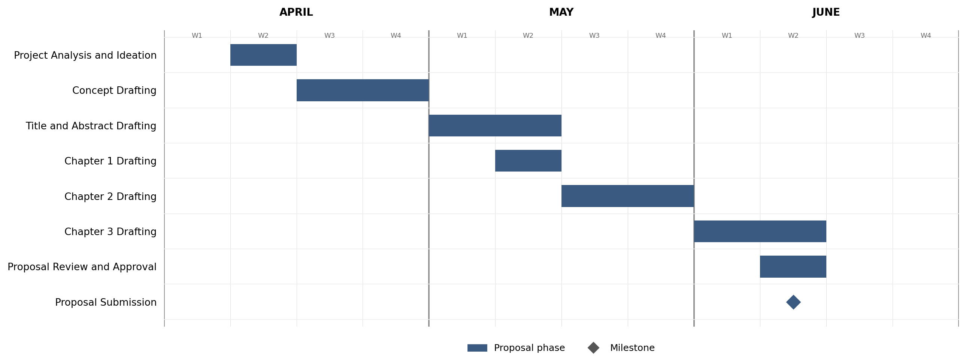

Appendix 2: Gantt Chart for July – November Semester 2
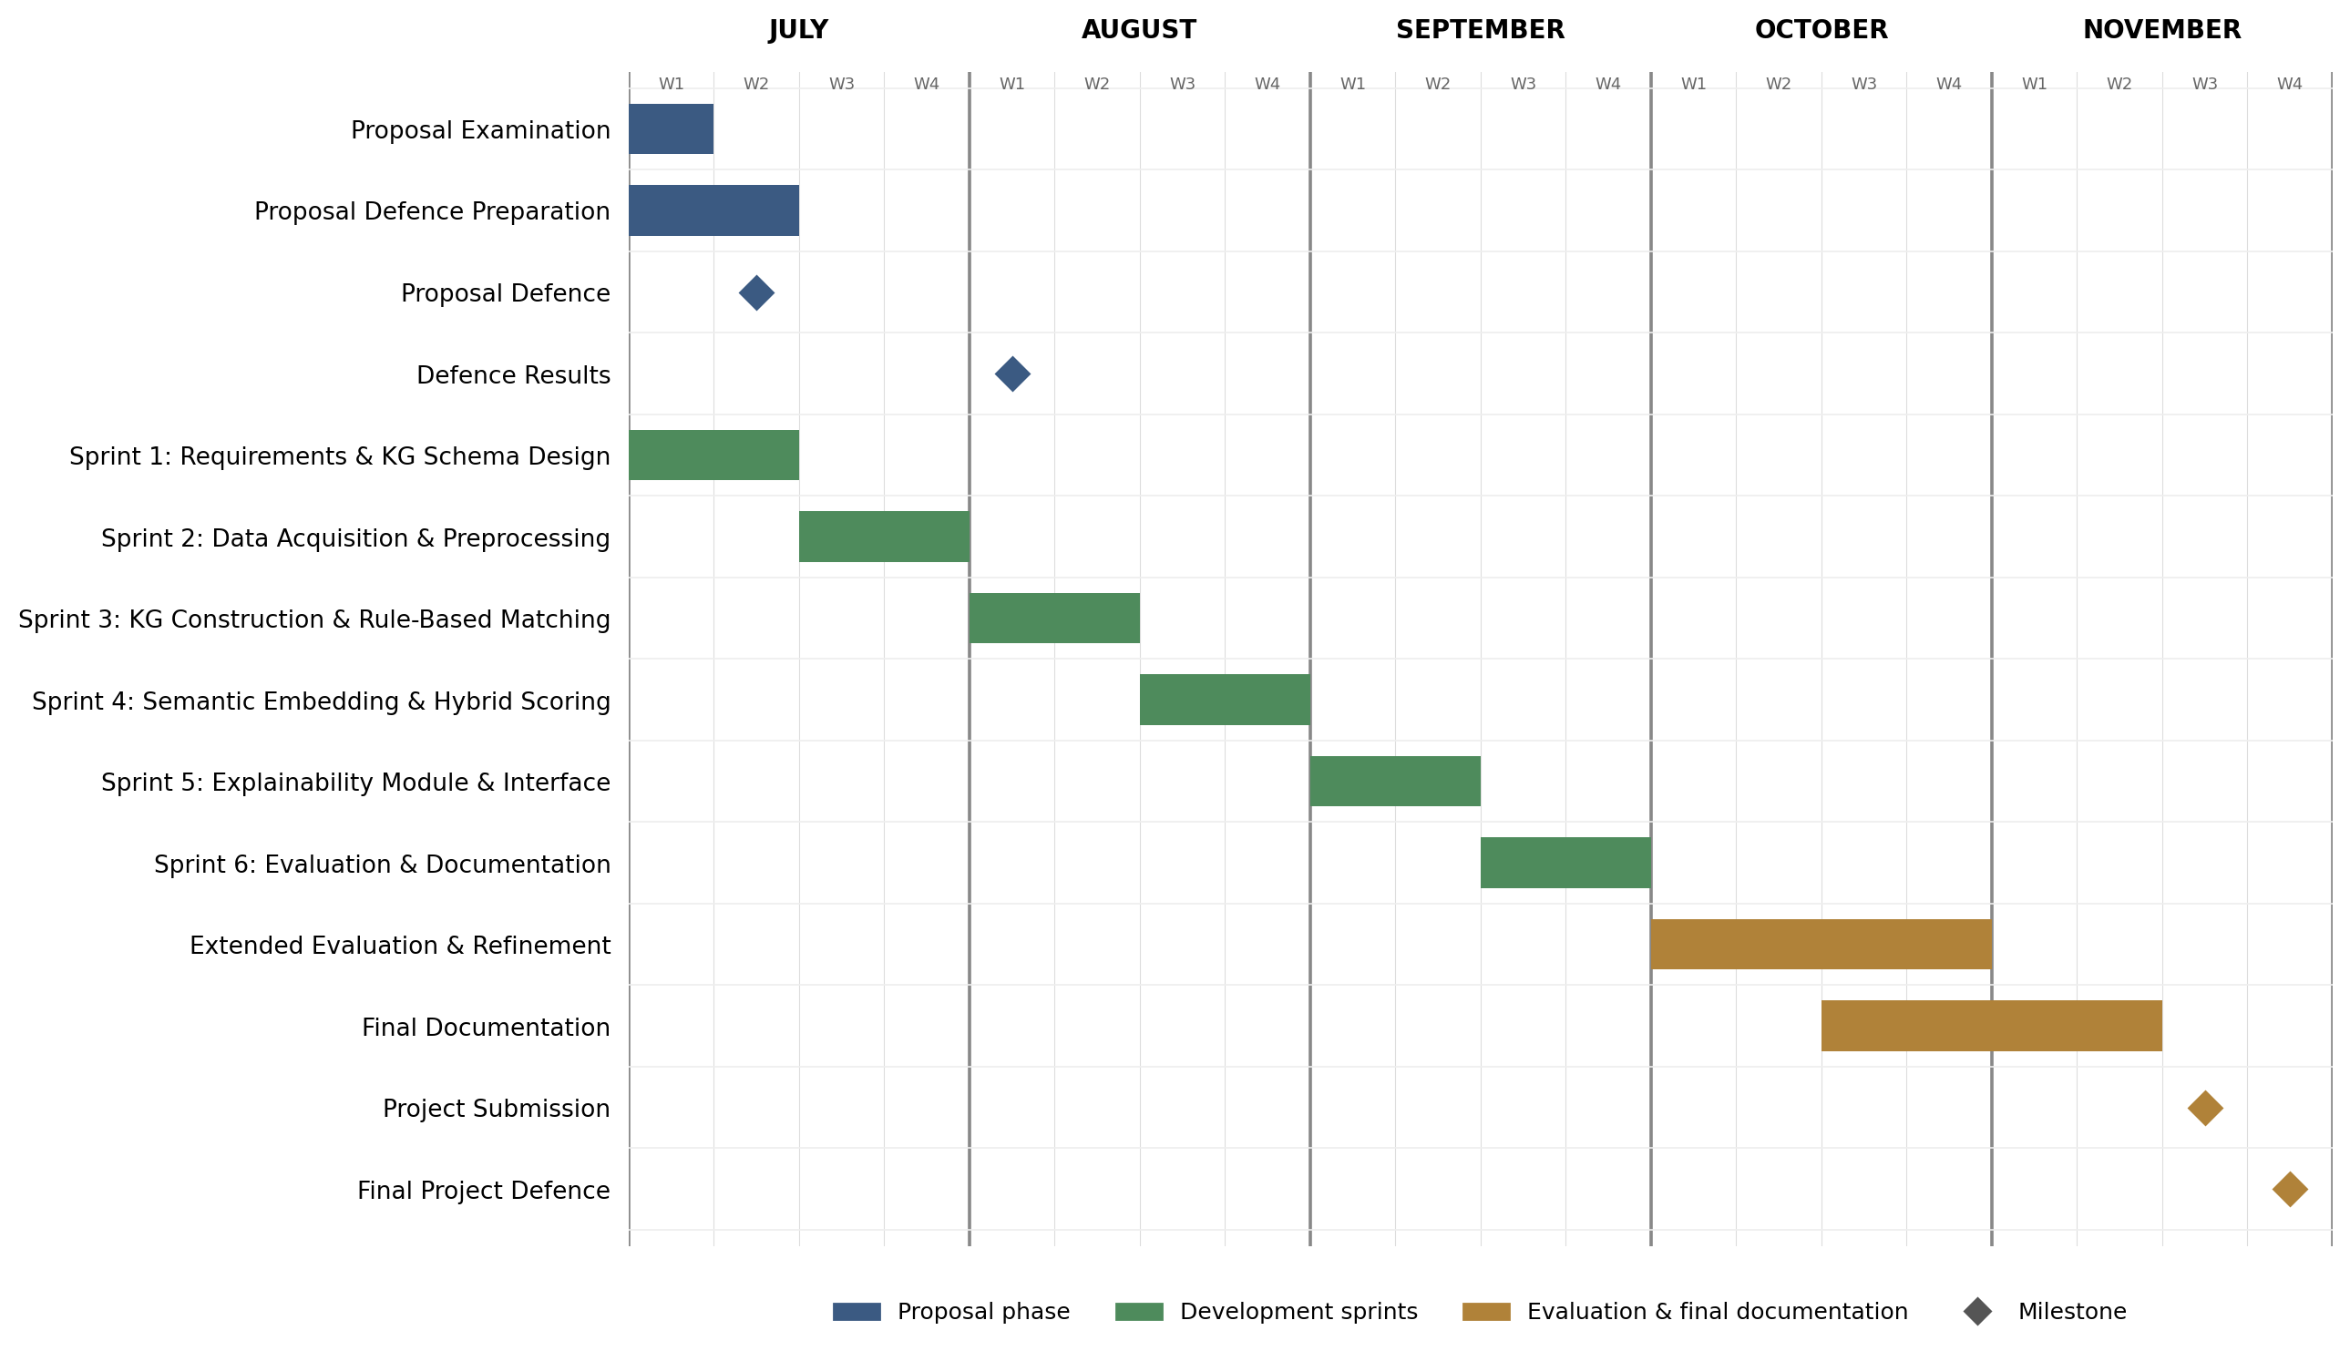

Appendix 3: Similarity Report
