Adding the Spacebase Repository to your System.  
  
Derelict Games currently uses SourceTree for its Windows based Git Handling and GitLab for the repo storage.  
  
Install and open SourceTree, then click on “Clone/New” in the top left corner and follow the steps.

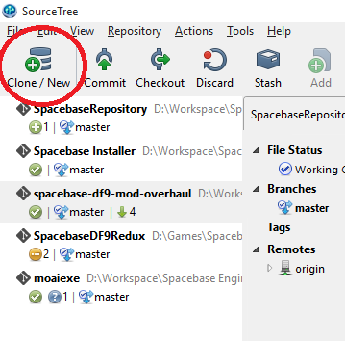

1. Fill out the details using the Source Path/URL being : <https://gitlab.com/derelictgames/spacebase-v2-updated-code.git>
2. Your destination path should be a folder/directory that should be completely empty or one that can be created.
3. Set the name you would like to use for the repository if you wish to change it, if not, click Clone

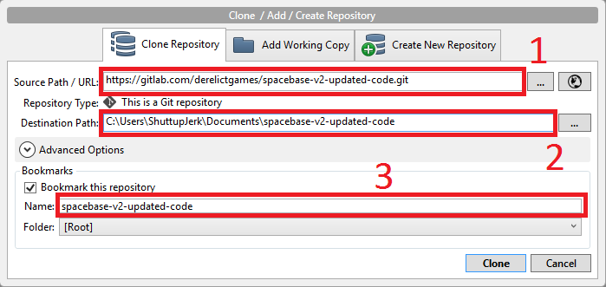

Your repository should show up on your bookmarks list on the left. It should automatically draw everything needed from the repository as well as the log/history of the updates we have created.

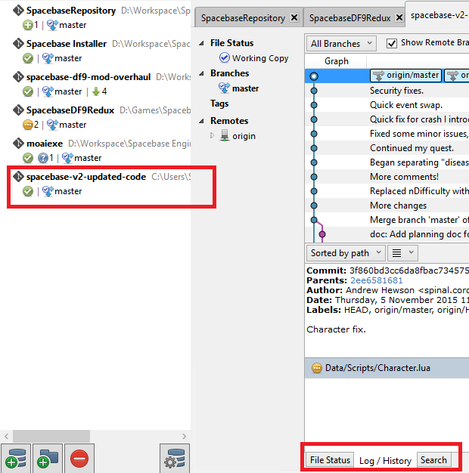

When you’re ready, upload the changes you’ve made which will notify the core derelict team to review your changes and upload as requested.