What is JDBC ?

It’s a J2AEE API , which is used to connect to any data base from the java code

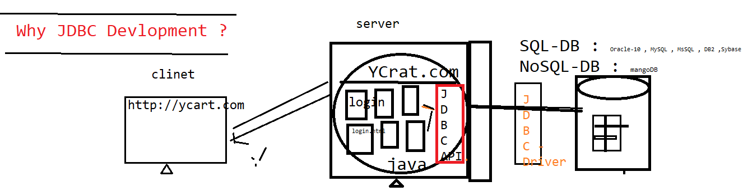



**Why JDBC in Devlopment ?**

JDBC helps java program to store / retrieve data from the physical database

In Real time, every application required data base to store/retrieve the user information in data base

**What is JDBC Drivers & JDBC API ?**

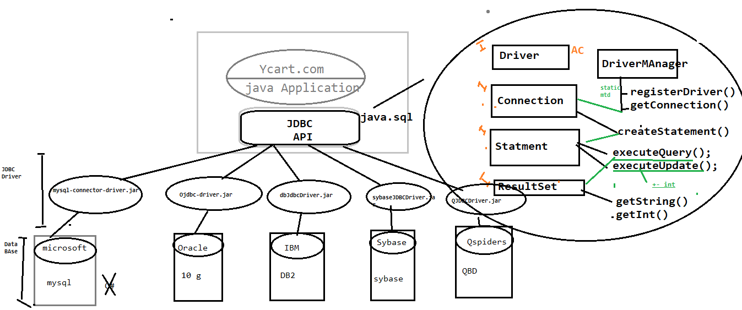

JDBC API : its an API’s available in java.sql package , which is collection interfaces with abstract method & class , & it’s database independent

JDBC Driver : its implementation class of JDBC API provided by data base vender . it’s a db dependent

**There are types of database**

1. SQL Database

* Data will be stored in form of table

EG : mysql , MsSql , Oracle 11 g , DB2 ,

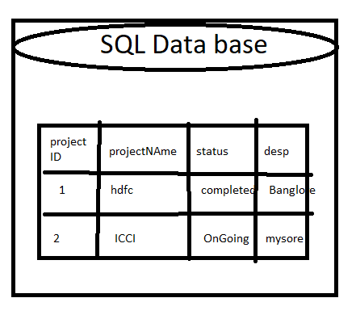

1. No SQL Database

* Data will be stored in the from JSON format

EG : Mango db , Casandra , NoSQL

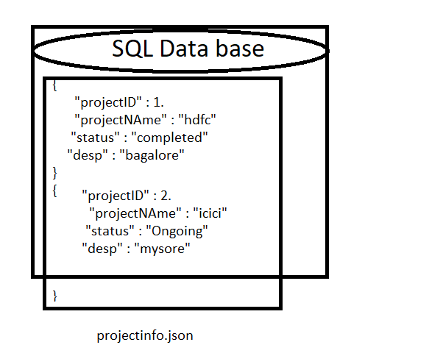

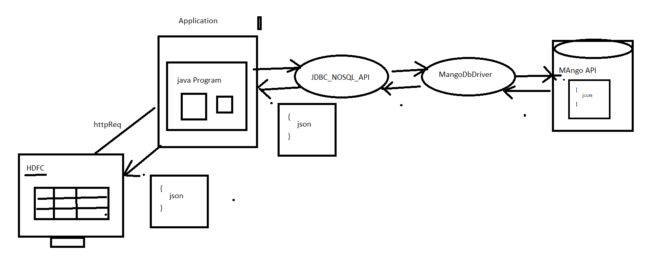

**Dependency code to get MYSQL drivers**

<dependency>

<groupId>mysql</groupId>

<artifactId>mysql-connector-java</artifactId>

<version>8.0.27</version>

</dependency>

**There are two types Query ?**

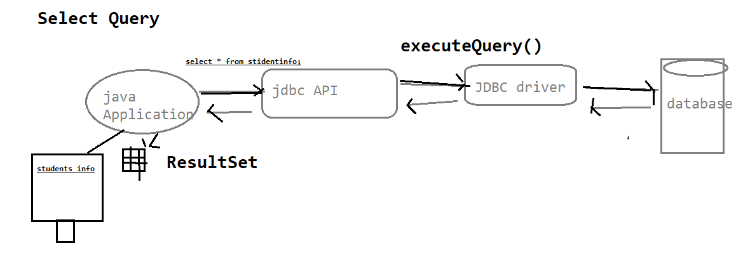

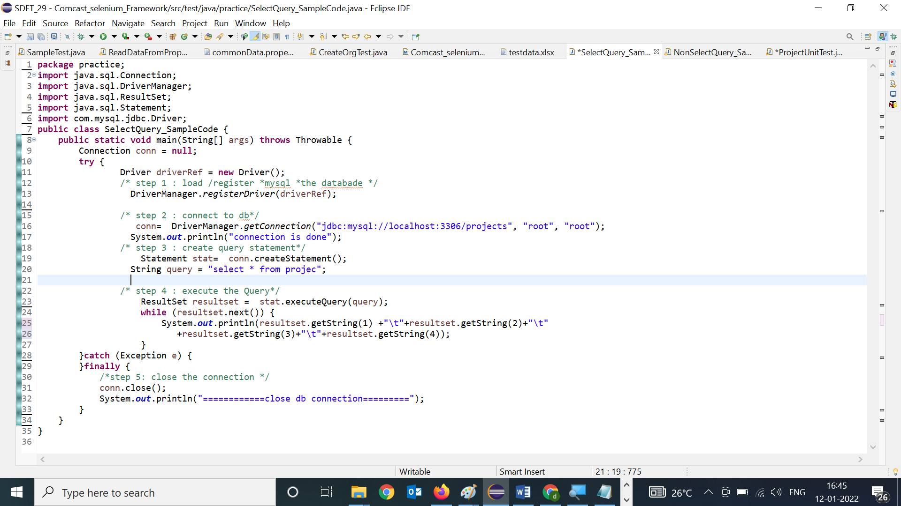

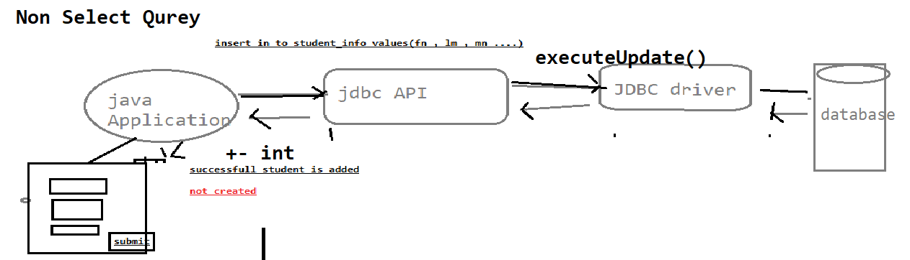

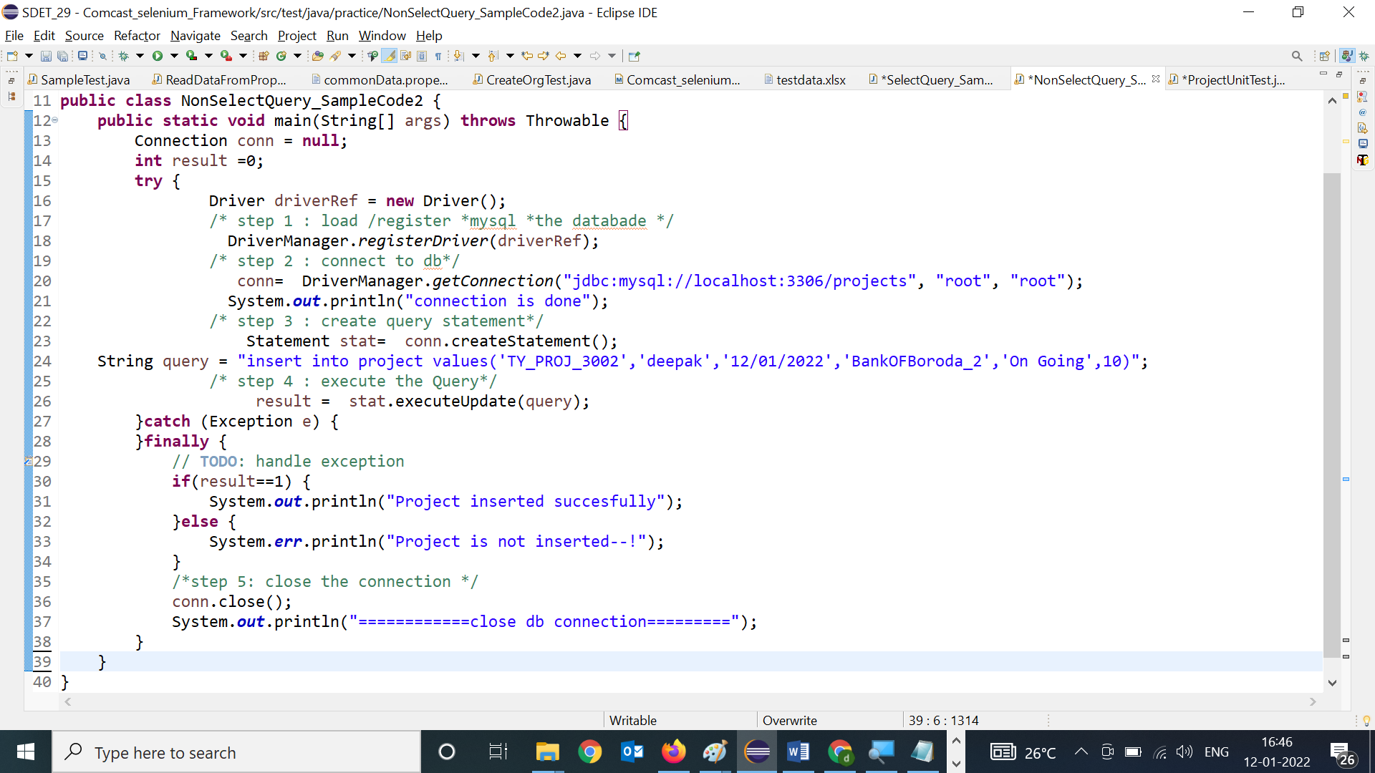

Why JDBC in Automation ?

In Automation also required JDBC Connection , Most of the test case Preconditions , required few set of data in Database & also validation GUI WRT Database

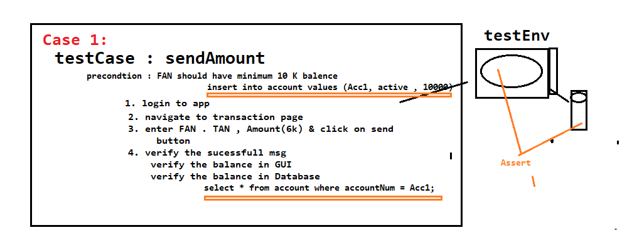

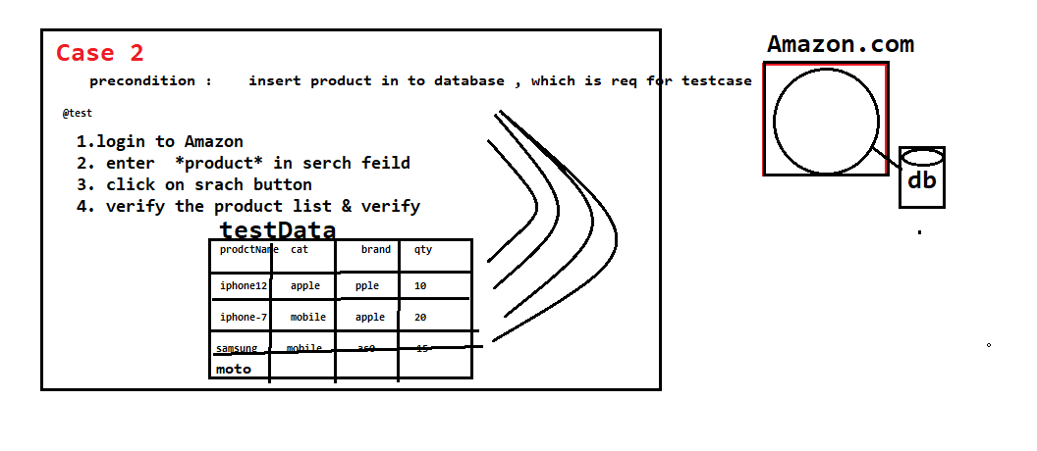

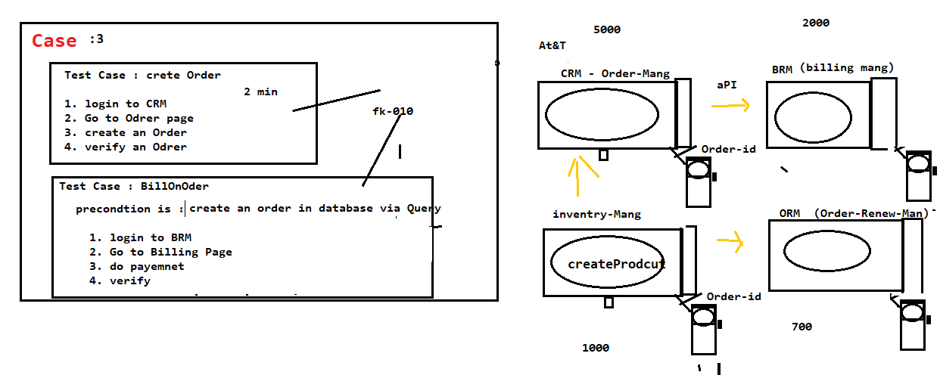

**JDBC usage in UNIT Testing[White box Testing]**

In case unit testing , [jdbc]database code is required to connect to database & get the data ten verify the data WRT to business logic



