Jenkins [CI/CD tool]

Why Jenkins is required in development team/ DevOps Team?

Continiuos devlopment : continious monither the git source code repository & create a new build if any changes happened in the git source code

Continiuos deployment : get the latest build from git location & deploy the build in to testing env

Continiuos Delivery : get the latest build from git location & deploy the build in to UAT env

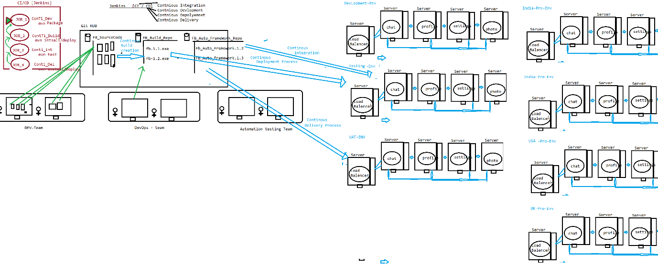

Why Jenkins is required in Agile Processes?

Continious Intergration : execute selenium test scripts in testing env

1. **Installation Steps :**
2. Download Jenkins & install
3. Precondition 1 : Login to Jenkins & install below Plugin

Jenkins 🡺 Manager Jenkins 🡺 Manage Plugin🡺 Select “Available”

Search & install below Plugins

. Maven Integration Plugin

GitHub Integration Plugin

PipleLine- Plugin

1. Precondition 2 : Configure Env variables in Jenkins for below env

Jenkins 🡺 Manager Jenkins🡺 Global tool Configuration

. JDK : C:\Program Files\Java\jdk1.8.0_161

. Maven : D:\apache-maven-3.5.2-bin\apache-maven-3.5.2

.Git : C:\Program Files\Git\bin\git.exe

1. What is use of Jenkins in Testing

Jenkins is a Continuous integration tool where continuously monitor the framework Build in git location, then perform appropriate action based on request

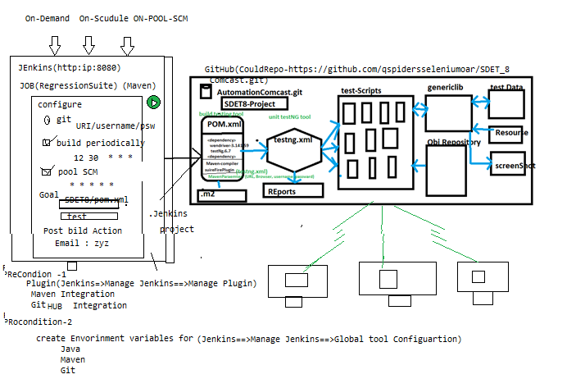

Advantages of Jenkins

1. Jenkins Provide 3 level of execution

. On demand : based on Customer demand we can start the execution

. On Scheduling: based on scheduled time , start the execution automatically

. POOL SCM : where continuously monitor the SCM(GitHub) & automatically start the execution whenever we get new Build / one new test script is getting added to Git

1. Email Notification:

. Jenkins sends out an execution Report via email, once execution is completed

. Jenkins also Send Build broken Email, when Compilation issue between the framework component

1. Jenkins also support run time **parameter**
2. **Jenkins also support PipleLines Job**
3. **How to create a Job in Jenkins :**

🡺 login to Jenkins

🡺 click on “new Item”

🡺select “Maven Project” & enter the Job Name

🡺click on OK button

1. **How to LINK selenium Framework which is available in GITHub , to Jenkins ?**

* **Login to Jenkins**
* **Get inside the Job**
* **Click on “Configure” link**
* **“click” git radio button & enter git information**

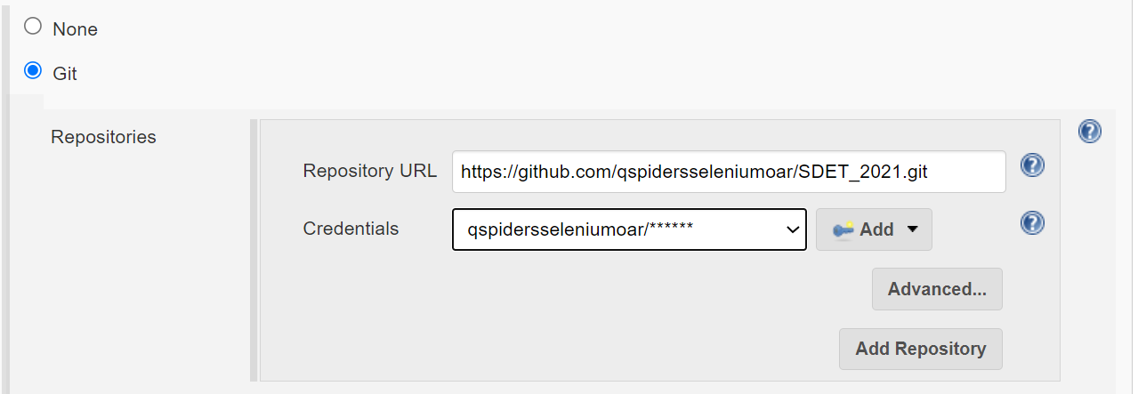

* Scroll down , go to build Division & provide the POM.xml path & goal

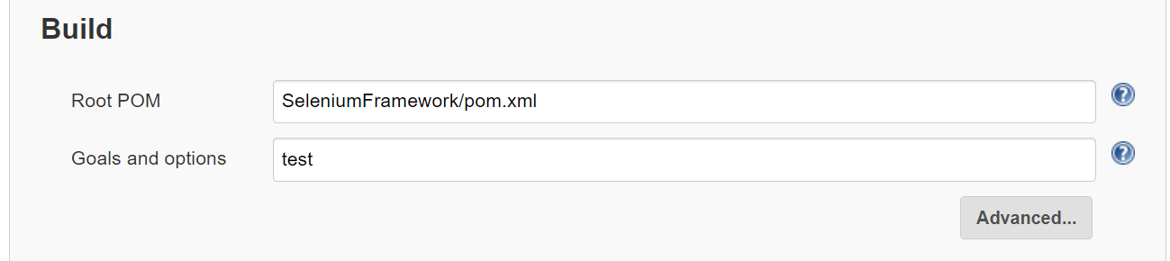

🡺Click on “save” button

1. **How to Execute Jenkins “job”?**

* **Login to Jenkins**
* **Get the inside Jenkins job**
* **Click on “Build now” button**

1. **How to see the Job Result in Jenkins after the Execution ?**

* Get the inside the Job
* Go to build history
* We can see all the Result with time stamp
* click on latest link
* click on “console OutPut”

1. **How to Schedule a Job in Jenkins**

* **Login to Jenkins**
* **Get the inside Jenkins job**
* **Click on configure file**
* **Click on “Build periodically” checkbox**
* **Provide the time based on * * * * * separated by space**

**EG :**

MINUTE HOUR DOM MONTH DOW

|  |  |
| --- | --- |
| MINUTE | Minutes within the hour (0–59) |
| HOUR | The hour of the day (0–23) |
| DOM | The day of the month (1–31) |
| MONTH | The month (1–12) |
| DOW | The day of the week (0–7) where 0 and 7 are Sunday. |

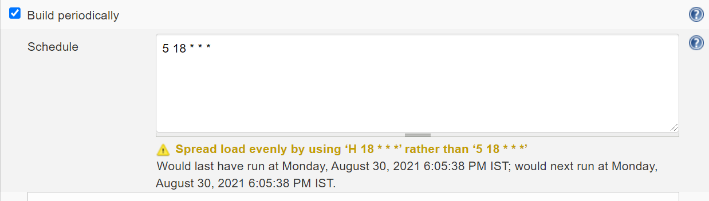

1. **How to configure Poll-SCM execution?**

* **Login to Jenkins**
* **Get the inside Jenkins job**
* **Click on configure file**
* **Click on “Poll-SCM” checkbox**
* **Provide the time based on * * * * * separated by space**

**What is Jenkins Pipeline?**

Execute multiple job sequentially one after the other Is called Jenkins Pipeline

Note : make sure “build pipeline” plugin should be installed in Jenkins

Steps to create Pipeline jobs

1. Login to Jenkins
2. Go to “configure” file of First “Job”
3. Scroll down in “Configure” file
4. Click on “post build action” dropdown
5. Select build other project , shown in below image

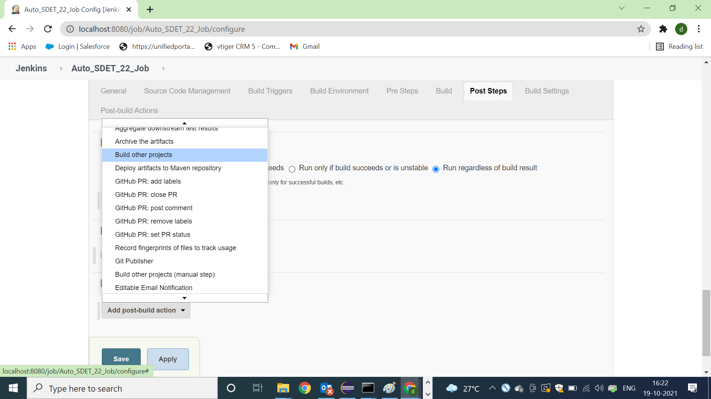

1. Enter the dependent “Job Name”
2. Continue same for other “jobs” as Well

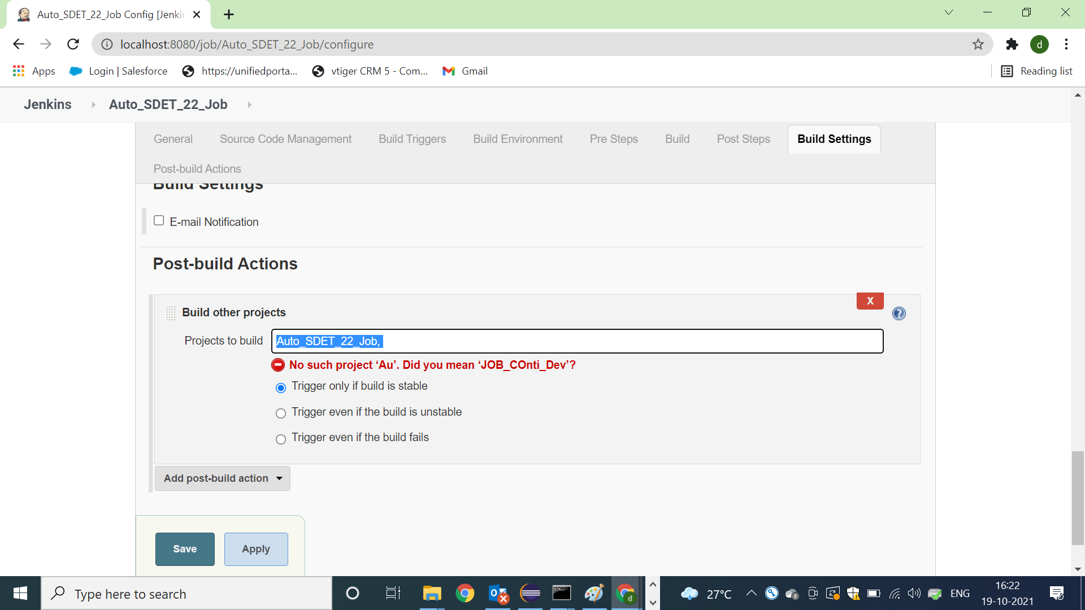

Result after the pipeline execution

Steps to execute Pipeline jobs:

1. Install “pipleline plugin”
2. Click on “+” button sown in below image

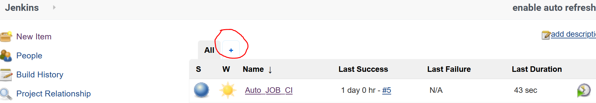

1. Select build pipleline view radio Button & enter the name

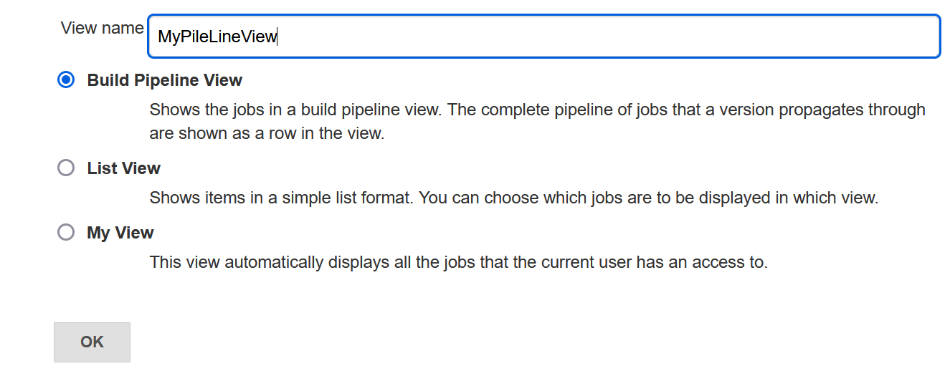

1. Enter initial job [Which you want execute first] , then click on save Button
2. Then click on “build now” to execute pipleline jobs

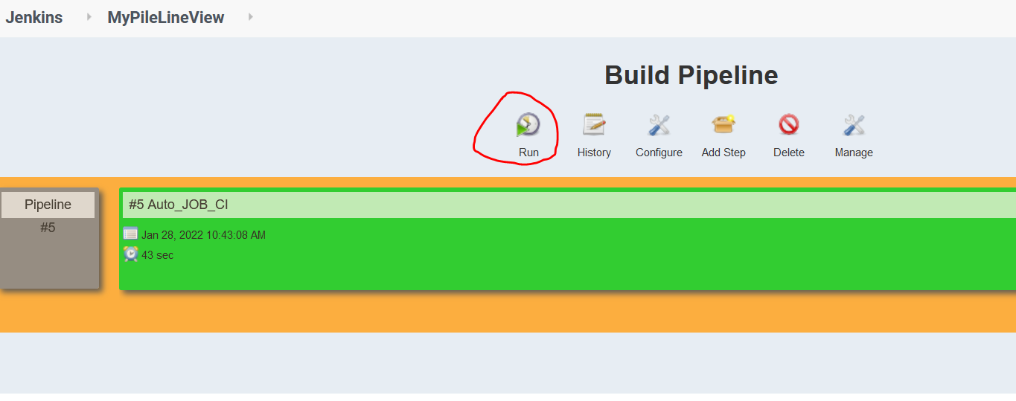

Job 1 -Build creation 🡺Job2- Build-Deployed🡺Job3-SmokeTest🡺Job4-Regressiontest🡺job4-Delivery;

EG : below example is the list job’s are pipelined , & it mean just execute 1 st job then automatically all the jobs executed which is available in pipeline.

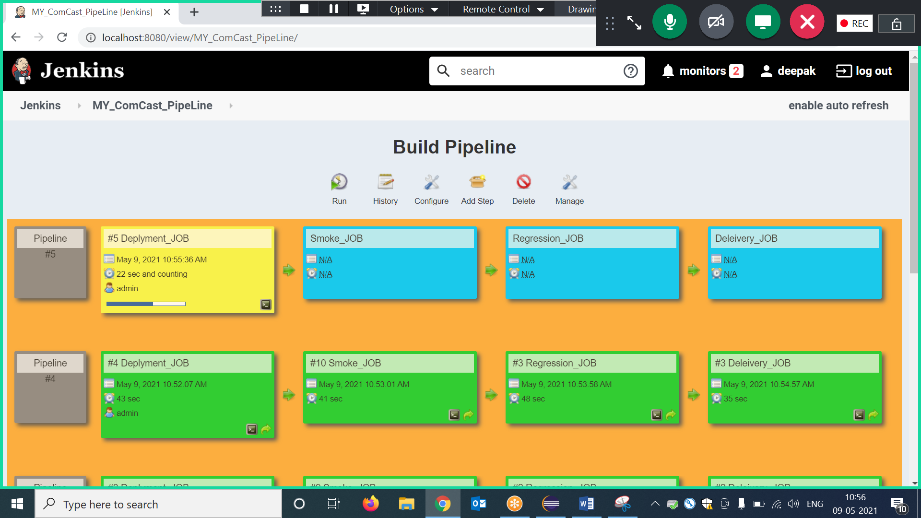

1. **How to Set Jenkins parameter?**

Jenkins parameter help us to pass data in to test suite in run Time from Jenkins itself

* Login to Jenkins
* Get inside the Job
* Click on configure
* Click on “This project is parameterized” checkbox
* Click on add Parameter with 🡺 choice parameter option
* Enter the below details

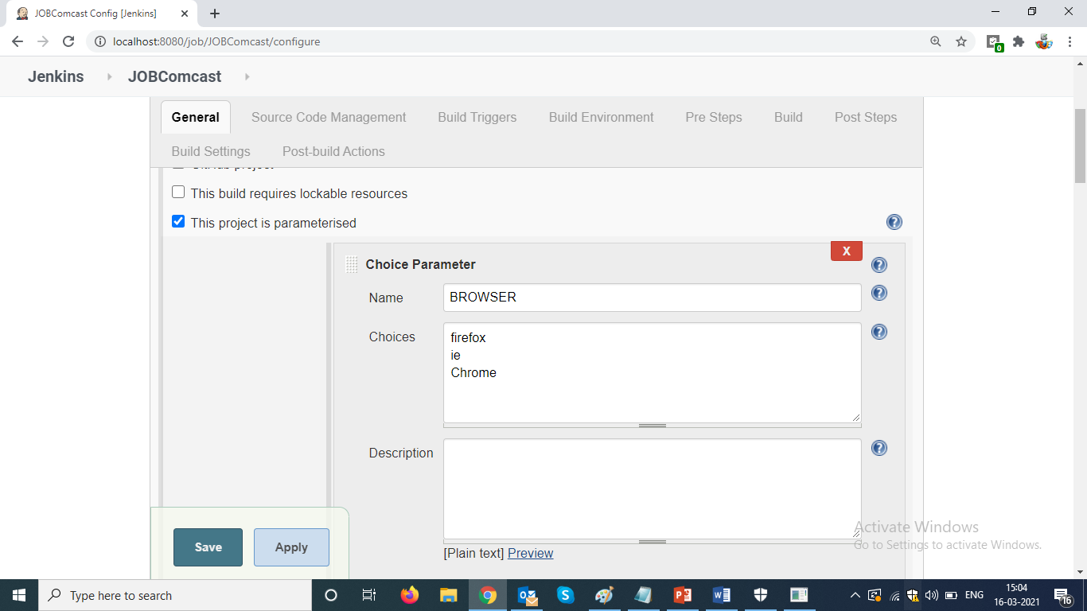

* Go to build option , & edit Goal to use Jenkins Paramters ,

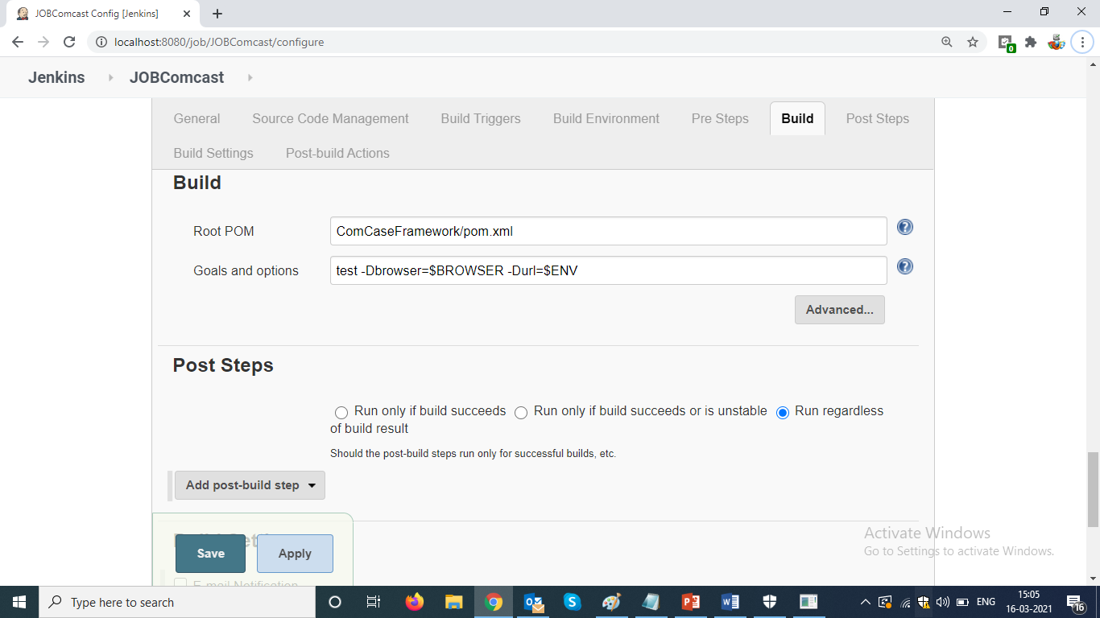

* Execute job with “build with parameter”

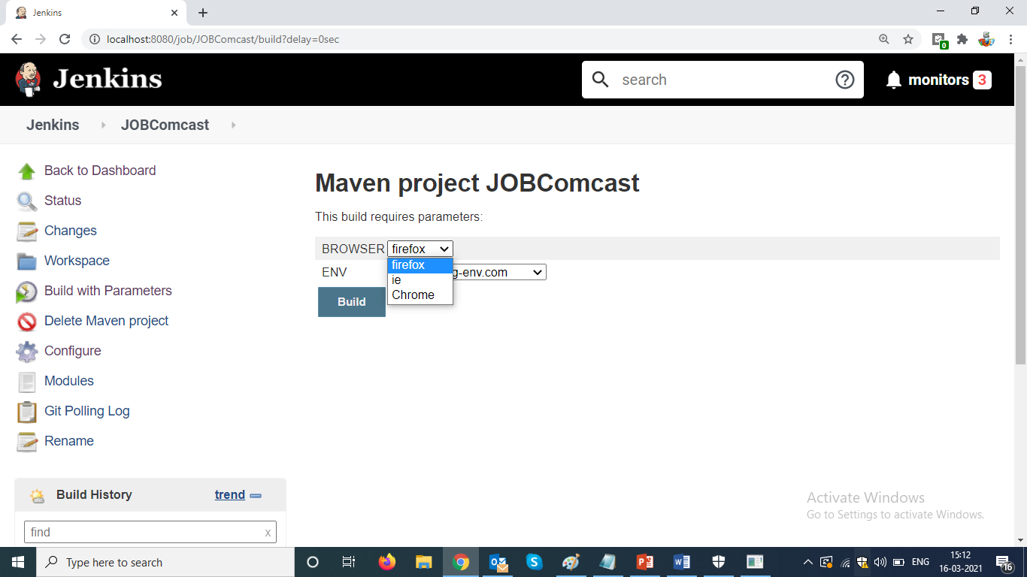

Note :

We should use maven parameter in Selenium Farmework :

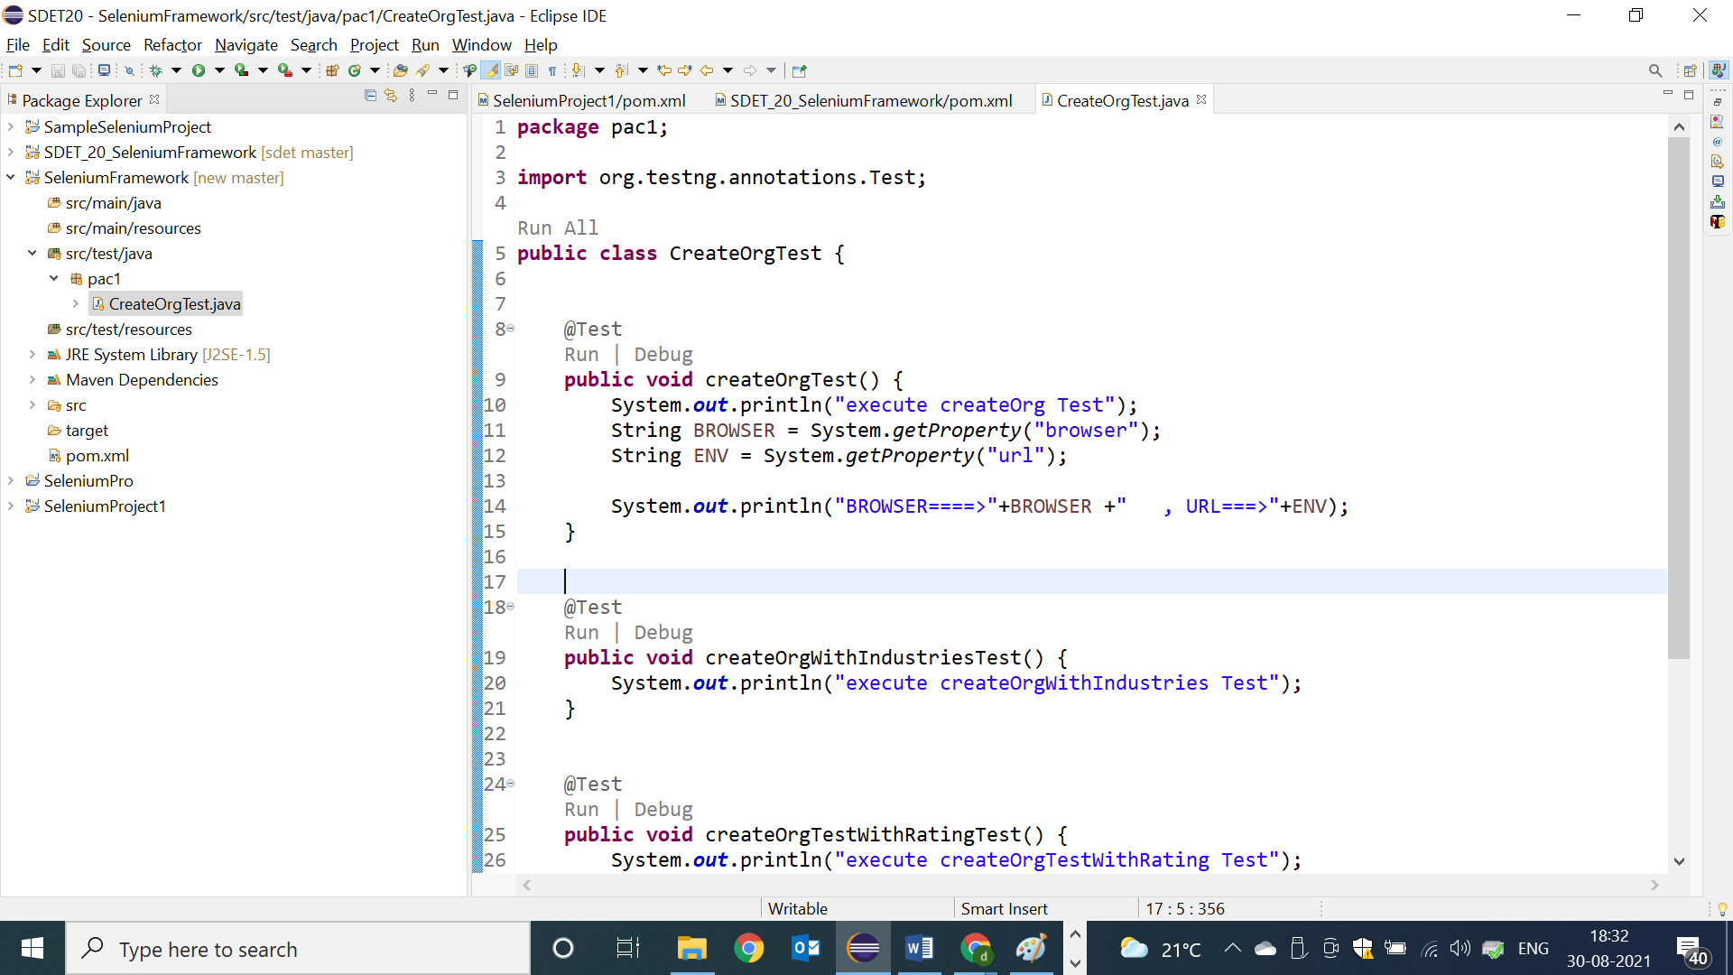

* To pass same paremter from the CMD
* 