**Maven**

1. Why Maven used in Development?

In case of development, maven will be used for & build testing& build creation & deployment processes

Build testing: testing compilation issue in entire project & provide message called build successful if no compilation issue , or else build failure (broken)

Build creation process: processes of converting source Code format in to executable format

Build Deployment: processes of installing the build in to testing Server/ any other Environment

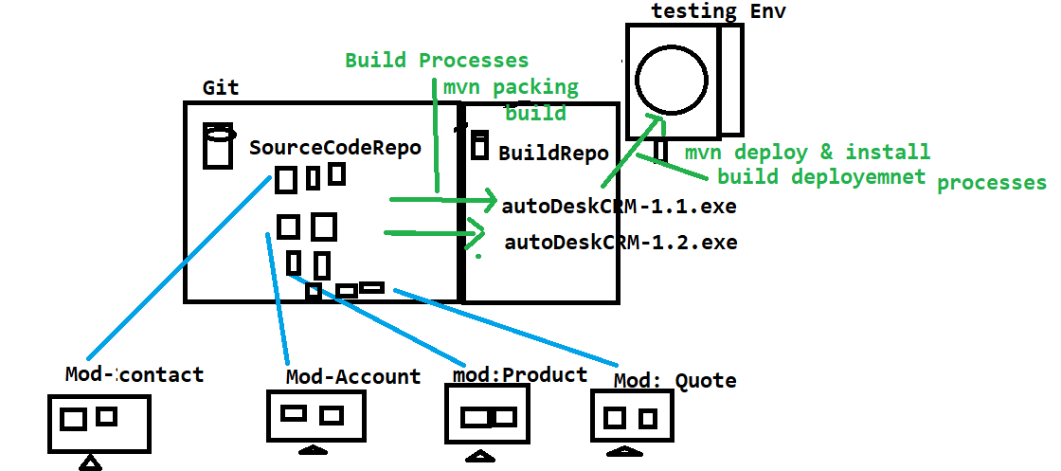

1. Why maven if required?

When multiple engineer working with the same framework , their might be chances one engineer modification might affect entire framework , in order to avoid this kind issue we go for Maven

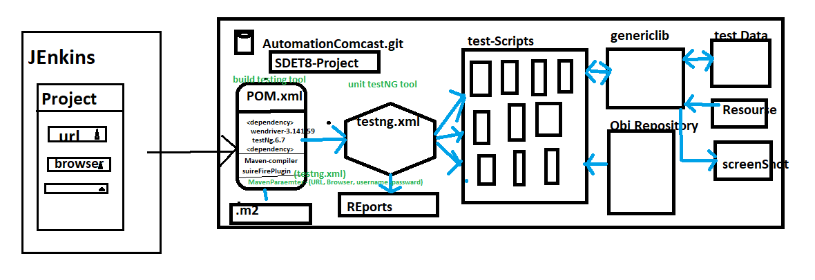

1. Advantages of Maven
2. Check the integration & compilation issue between the framework component whenever modification, addition deletion happened in the framework
3. handle dependencies jars
4. create framework configuration quick setup for new engineers (because all the required dependencies jar. Versions declared in POM.xml, you just to get the framework from the GIT & savethe POM file
5. provide framework folder structure
6. we can run the test script in command Line without Eclipse
7. Which is used to check framework build is broken or not ?
8. Maven majorly support in Jenkins for CD/CI[Jenkins]
9. Maven also support Profiling (we can have multiple testing.xml file in one Project, so that we go for Profile to execute specific xml file via CMD)

i. Maven also support Command Line parameters

1. What all the Maven Software required to handle maven Project in real time?

* Two software available in Maven

1. Maven Ellipse Plugin

🡺 Maven Ellipse Plugin : it’s a default plugin available in Eclipse Ide , used to create maven project in Eclipse

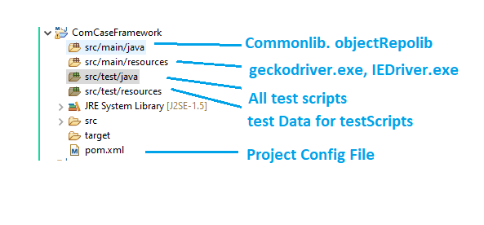

1. Maven Command Line Plugin

🡺Maven Command Line Plugin : it’s should be installed explicitly in all local computers , used to handle the Maven project in CMD line

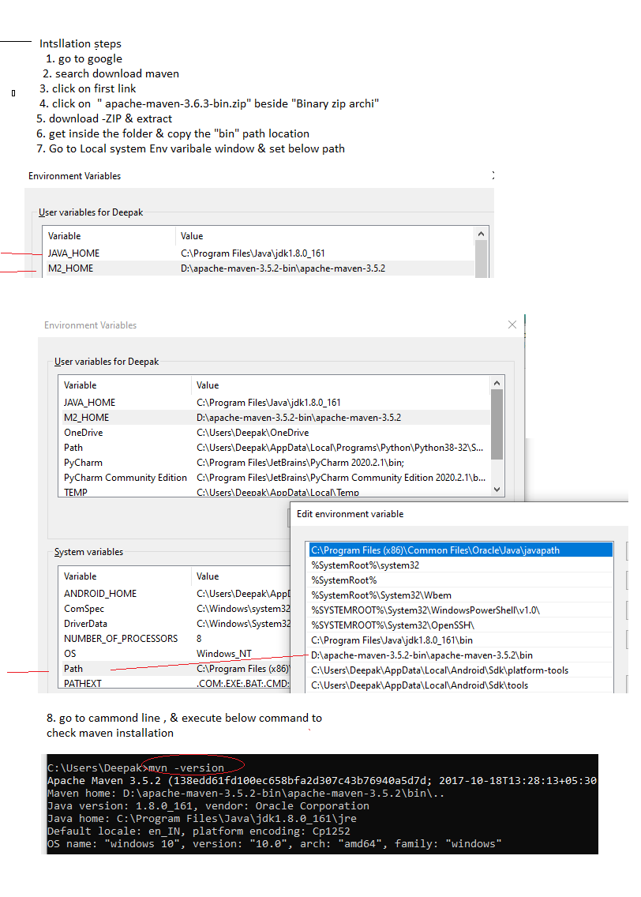

1. what dependency in Maven ?

Dependency is advance feature in maven which is used to get all the required jars from the Global repository(http://mvnrepository.com) to Local repository(C://user/.m2) & attach all jars to the project automatically.

1. How to handle Dependencies?
2. Create maven project
3. Go to POM.xml
4. Inside the Pom.xml , insert <dependencies> tag
5. Go to global repository [http://mvnrepository.com]
6. Search for required tool like “selenium-java” & “testng” & “apache-poi” , “apache-poi-ooxml” & “mysql-connector” , “common-io” , “extend-report”
7. copy the dependency code for all above tools
8. paste the dependency code inside POM.xml
9. save the file

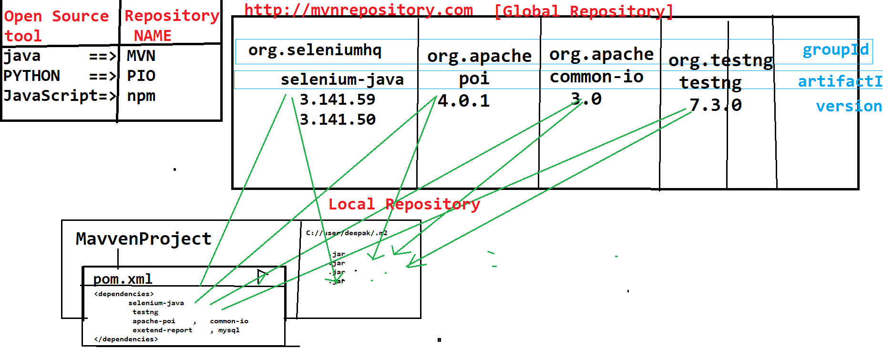

EG :

<project xmlns=*"http://maven.apache.org/POM/4.0.0"* xmlns:xsi=*"http://www.w3.org/2001/XMLSchema-instance"* xsi:schemaLocation=*"http://maven.apache.org/POM/4.0.0 https://maven.apache.org/xsd/maven-4.0.0.xsd"*>

<modelVersion>4.0.0</modelVersion>

<groupId>SDET_20_SeleniumFramework</groupId>

<artifactId>SDET_20_SeleniumFramework</artifactId>

<version>0.0.1-SNAPSHOT</version>

<dependencies>

<!-- https://mvnrepository.com/artifact/org.seleniumhq.selenium/selenium-java -->

<dependency>

<groupId>org.seleniumhq.selenium</groupId>

<artifactId>selenium-java</artifactId>

<version>3.141.59</version>

</dependency>

<!-- https://mvnrepository.com/artifact/org.apache.poi/poi -->

<dependency>

<groupId>org.apache.poi</groupId>

<artifactId>poi</artifactId>

<version>4.0.0</version>

</dependency>

<dependency>

<groupId>org.apache.poi</groupId>

<artifactId>poi-ooxml</artifactId>

<version>4.0.0</version>

</dependency>

<!-- https://mvnrepository.com/artifact/commons-io/commons-io -->

<dependency>

<groupId>commons-io</groupId>

<artifactId>commons-io</artifactId>

<version>2.11.0</version>

</dependency>

<!-- https://mvnrepository.com/artifact/org.testng/testng -->

<dependency>

<groupId>org.testng</groupId>

<artifactId>testng</artifactId>

<version>7.4.0</version>

<scope>test</scope>

</dependency>

</dependencies>

</project>

What is group ID & ArtifactID

Group Id : name of the org or name of the Opensource community

ArtifactID : name of the project inside the Group

Version : version of the project which you need to download

1. How to execute testscripts in CMD
2. Go to MavenProject🡺 RightClick🡺 properties 🡺 copy the Project location

EG : C:\Users\Deepak\eclipse-workspace\ComCaseFramework

1. Open CMD & paste the location

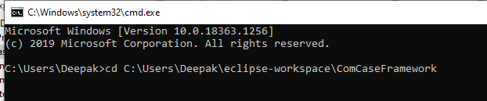

1. Execute Maven life cycle commands
2. Explain maven Build Life Cylcle

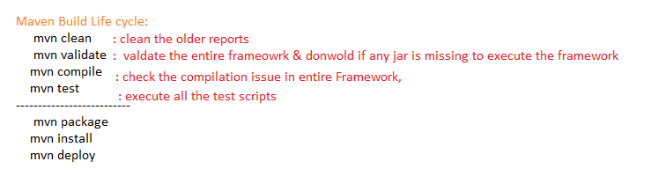

1. How to execute TESTNG.xml file via POM.xml ?

In order to execute TESTNG.xml file via pom.xml , we have to insert sure-fire plugin inside the POM.xml , via sure-fire plugin we can invoke TESTNG.xml

<project xmlns=*"http://maven.apache.org/POM/4.0.0"* xmlns:xsi=*"http://www.w3.org/2001/XMLSchema-instance"* xsi:schemaLocation=*"http://maven.apache.org/POM/4.0.0 https://maven.apache.org/xsd/maven-4.0.0.xsd"*>

<modelVersion>4.0.0</modelVersion>

<groupId>SDET_20_SeleniumFramework</groupId>

<artifactId>SDET_20_SeleniumFramework</artifactId>

<version>0.0.1-SNAPSHOT</version>

<dependencies>

<!-- https://mvnrepository.com/artifact/org.seleniumhq.selenium/selenium-java -->

<dependency>

<groupId>org.seleniumhq.selenium</groupId>

<artifactId>selenium-java</artifactId>

<version>3.141.59</version>

</dependency>

<!-- https://mvnrepository.com/artifact/org.apache.poi/poi -->

<dependency>

<groupId>org.apache.poi</groupId>

<artifactId>poi</artifactId>

<version>4.0.0</version>

</dependency>

<dependency>

<groupId>org.apache.poi</groupId>

<artifactId>poi-ooxml</artifactId>

<version>4.0.0</version>

</dependency>

<!-- https://mvnrepository.com/artifact/org.testng/testng -->

<dependency>

<groupId>org.testng</groupId>

<artifactId>testng</artifactId>

<version>7.4.0</version>

</dependency>

<!-- https://mvnrepository.com/artifact/commons-io/commons-io -->

<dependency>

<groupId>commons-io</groupId>

<artifactId>commons-io</artifactId>

<version>2.11.0</version>

</dependency>

</dependencies>

<build>

<plugins>

<!-- Below plug-in is used to execute tests -->

<plugin>

<groupId>org.apache.maven.plugins</groupId>

<artifactId>maven-surefire-plugin</artifactId>

<version>2.18.1</version>

<configuration>

<suiteXmlFiles>

<!-- TestNG suite XML files -->

<suiteXmlFile>regionalRegression.xml</suiteXmlFile>

</suiteXmlFiles>

</configuration>

</plugin>

</plugins>

</build>

</project>

1. How to execute only one test using maven Cmd

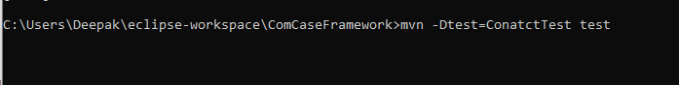

1. What is Maven Parameter & Why its Required?

Maven Parameter help us to Pass the Parameter from the command line without eclipse ,

So that all the test scripts can be executed based on run time parameter ,which is also used Jeninks

-Dkey = value

Useage in java/Selenium Code

String var = system.getProperty(“Key”)

Eclipse Usage

Right Click on testing File -> Run Configuration 🡺

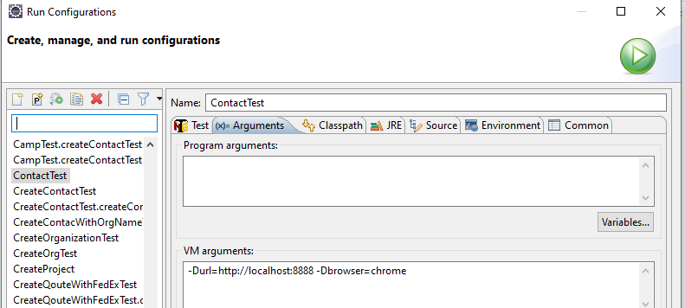

1. What is Maven Profiling & why it’s Required?

Profiling help us to execute specific testing.xml via Pom File , when we have multiple testing.xml available in same Project

