**Question 1.** Are the HTML tags and elements the same thing? **Answer:** No HTML tags and elements are not the same thing. An element consists of opening tag, closing tag and content between them. HTML tags are starting and ending part of HTML.

**Question 2**. What are tags and attributes in HTML? **Answer:** Tags are starting and ending part of HTML enclosed by angle brackets. Attributes are inside the opening tag and provides extra details about the element to modify its default behavior.

**Question 3.** What are void elements in HTML? **Answer:** Void elements in HTML are the tags that do not have any content or the closing tag, also called as empty tags

**Question 4**. What are HTML Entities? **Answer**: HTML entities are special characters that can be used to display symbols, icons or characters that are not available on a normal keyboard.

**Question 5**. What are different types of lists in HTML? **Answer**: There are 3 types of lists in HTML Ordered list, Unordered list, Description list

**Question 6**. What is the 'class' attribute in HTML? **Answer:** HTML class attribute is often used to point to a class name in a style sheet. Classes are used by CSS

**Question 7.** What is the difference between the 'id' attribute and the 'class' attribute of HTML elements? **Answer:** HTML id attribute is used to specify a unique id for an HTML element. A class name can be used by multiple HTML elements, while an id name must only be used by one HTML element within the page.

**Question 8**. What are the various formatting tags in HTML? **Answer:** Formatting tags in HTML are elements that are used to change the appearance or meaning of the text. Examples: <b>, <strong>,<em>,<i>,<u>,<s>, etc.

**Question 9.** How is Cell Padding different from Cell Spacing? **Answer:** Cell spacing will determine space between the cells while cell padding will determine space between content and it's cell borders.

**Question 10**. How can we club two or more rows or columns into a single row or column in an HTML table? **Answer:** Colspan and Rowspan are attributes that can be used in tables for clubbing together two or more columns and rows respectively.

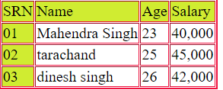

**Question 11**. What is the difference between a block-level element and an inline element? **Answer:** A block level element always starts on a new line and takes up the full width available, while an inline element continues on the same line and only takes up width as necessary.

**Question 12.** How to create a hyperlink in html ? **Answer:** To make create a hyperlink in an html page, use the <a>/and</a> tags used to define the links. Example- <a href="https://www.amazon.com/">

**Question 13**. What is the use of an iframe tag? **Answer:** The <iframe> tag specifies an inline frame. An inline frame is used to embed another document within the current html document . Example-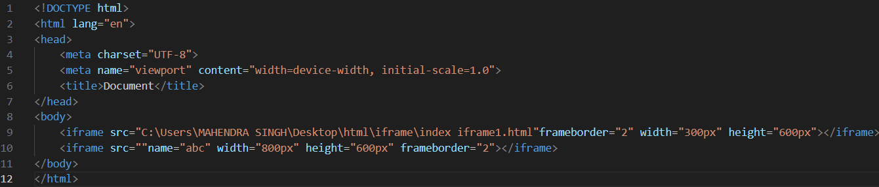

**Question 14.** What is the use of a span tag? Explain with example? **Answer:** the span tag is a generic inline container element. You use this element to wrap sections of text for styling purposes or to add attributes to a section of text without creating a new line of content. Example: <td><span style="color: rgb(196, 37, 37);">x &#10084;</span></td>

Question 15. How to insert a picture in to a background image of a web page? With Example Answer

**Question 16.** How are active links different from normal links? **Answer:** A normal link is just a line of code that contains a pointer to another resource. An active link is that line of code in action, opening that other resource.

**Question 17**. What are the different tags to separate sections to text? **Answer:** <br> tag It is used to separate the line of text. It breaks the current line and shifts the flow of the text to a new line. <p> tag–This tag is used to write a paragraph of text.

**Question 18**. What is SVG? **Answer:** The SVG file format is a popular tool for displaying two-dimensional graphics, charts and illustrations on websites. Plus, as a vector file, it can be scaled up or down without losing any of its resolution.

**Question 19.** What is difference between HTML and XHTML? **Answer:** HTML is the standard markup language for creating web pages, while XHTML is a stricter and more standardized version of HTML. Both HTML and XHTML include a wide range of features, such as support for multimedia, styling, and scripting.

**Question 20.** What are logical and physical tags in HTML? **Answer:** Physical and Logical tags are used in HTML for better visibility and understanding of the text by the user on the web page. However, both tags differ from each other as suggested by their names. Logical Tags : Logical Tags are used in HTML to display the text according to the logical styles.